Lesson 3: Roots of Unity

Student Outcomes
- Students determine the complex roots of polynomial equations of the form $x^{n}=1$ and, more generally, equations of the form $x^{n}=k$ positive integers $n$ and positive real numbers $k$.
- Students plot the $n^{th}$ roots of unity in the complex plane.

Lesson Notes
This lesson ties together work from Algebra II Module 1 where students studied the nature of the roots of polynomial equations and worked with polynomial identities and their recent work with the polar form of a complex number to find the $n^{th}$ roots of a complex number in Precalculus Module 1 Lessons 18 and 19. The goal here is to connect work within the algebra strand of solving polynomial equations to the geometry and arithmetic of complex numbers in the complex plane. Students will be determining solutions to polynomial equations using various methods and interpreting the results in the real and complex plane. Students will need to extend factoring to the complex numbers (N-CN.C.8) and more fully understand the conclusion of the fundamental theorem of algebra (N-CN.C.9) by seeing that a polynomial of degree $n$ has $n$ complex roots when they consider the roots of unity graphed in the complex plane. This lesson helps students cement the claim of the fundamental theorem of algebra that the equation $x^{n}=1$ should have $n$ solutions as students find all $n$ solutions of the equation, not just the obvious solution $x=1$. Students plot the solutions in the plane and discover their symmetry.
GeoGebra can be a powerful tool to explore these types of problems and will really help students to see that the roots of unity correspond to the vertices of a polygon inscribed in the unit circle with one vertex along the positive real axis.

Classwork
Opening Exercise (3 minutes)
Scaffolding:
At this level of mathematics, students may struggle to remember formulas or theorems from previous grades. A quick reference sheet or anchor chart can come in handy. The Lesson Summary boxes from the following Algebra II and Precalculus lessons would be helpful to have handy during this lesson.
- Precalculus Module 1 Lessons 13, 18, 19
- Algebra II Module 1 Lessons 6, 40
Form students into small groups of 3–5 students each depending on the size of your classroom. Much of this activity is exploration. Start the conversation by having students discuss and respond to the exercises in the opening. Part (c) is an important connection to make for students. More information on the fundamental theorem of algebra can be found in Algebra II Module 1 Lessons 38–40. This information was also reviewed in Lesson 1 of this module. The amount that students recall as they work on these exercises with their groups can inform decisions about how much scaffolding will be necessary as students work through the rest of this lesson. If students are struggling to make sense of the first two problems, ask them to quickly find real number solutions to these equations by inspection: $x=1$, $x^{2}=1$, $x^{3}=1$, and $x^{4}=1$.

Opening Exercise
Consider the equation $x^{n}=1$ for positive integers $n$.
  - Must an equation of this form have a real solution? Explain your reasoning.
The number $1$ will always be a solution to $x^{n}=1$ because $1^{n}=1$ for any positive integer $n$.

  - Could an equation of this form have two real solutions? Explain your reasoning.
When $n$ is an even number, both $1$ and $-1$ will be solutions. The number $1$ is a solution because $1^{n}=1$ for any positive integer. The number $-1$ is a solution because ${\left(-1\right)}^{n}={\left(-1\right)}^{2k}$ where $k$ is a positive integer if $n$ is even and
MP.3
$${\left(-1\right)}^{2k}={\left({\left(-1\right)}^{2}\right)}^{k}=1^{k}=1.$$

  - How many complex solutions will there be for an equation of this form? Explain how you know.
We can rewrite the equation in the form $x^{n}-1=0$. The solutions to this polynomial equation are the roots of the polynomial $p\left(x\right)=x^{n}-1$. The fundamental theorem of algebra says that the polynomial $p\left(x\right)=x^{n}-1$ factors over the complex numbers into the product of $n$ linear terms. Each term identifies a complex root of the polynomial. Thus, a polynomial equation of degree $n$ has at most $n$ solutions.

Exploratory Challenge (10 minutes)
In this Exploratory Challenge, students should work to apply multiple methods to find the solutions to the equation
$x^{3}=1$. Give teams sufficient time to consider more than one method. Make sure to present and discuss the second method below, especially if most groups did not attempt the problem, when you debrief the solution methods students found.
Exploratory Challenge
Consider the equation $x^{3}=1$.
  - Use the graph of $f\left(x\right)=x^{3}-1$ to explain why $1$ is the only real number solution to the equation $x^{3}=1$.
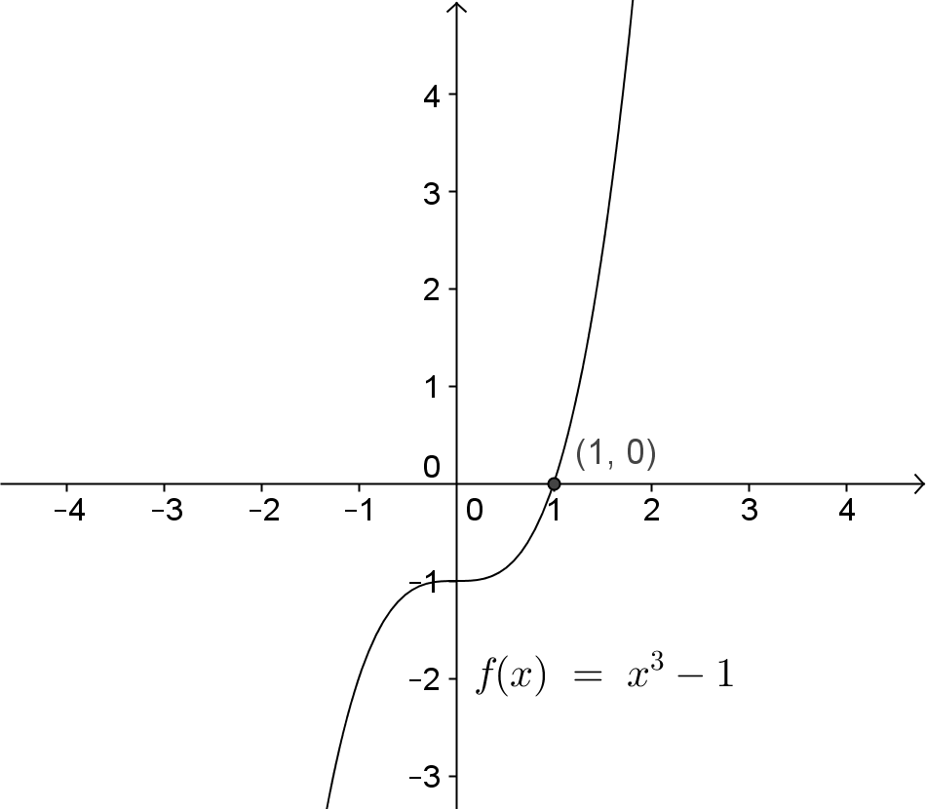
From the graph, you can see that the point $(1,0)$ is the $x$-intercept of the function. That means that $1$ is a zero of the polynomial function and thus is a solution to the equation $x^{3}-1=0$.

  - Find all of the complex solutions to the equation $x^{3}=1$. Come up with as many methods as you can for finding the solutions to this equation.
Method 1: Factoring Using a Polynomial Identity and Using the Quadratic Formula
Rewrite the equation in the form $x^{3}-1=0$, and use the identity $a^{3}-b^{3}=(a-b)(a^{2}+ab+b^{2})$ to factor $x^{3}-1$.
$$x^{3}-1=0$$
$$\left(x-1\right)\left(x^{2}+x+1\right)=0$$
Then
$x-1=0$ or $x^{2}+x+1=0$.
The solution to the equation $x-1=0$ is $1$. The quadratic formula gives the other solutions.
$$x=\frac{-1±\sqrt{-3}}{2}=\frac{-1±i\sqrt{3}}{2}$$
So the solution set is
$$\left\{1,-\frac{1}{2}+\frac{\sqrt{3}}{2}i,-\frac{1}{2}-\frac{\sqrt{3}}{2}i\right\}.$$

Method 2: Using the Polar Form of a Complex Number
The solutions to the equation $x^{3}=1$ are the cube roots of $1$.
The number $1$ has modulus $1$ and argument $0$ (or any rotation that terminates along the positive real axis such as $2π$ or $4π$, etc.).
The modulus of the cube roots of $1$ will be $\sqrt[3]{1}=1$. The arguments will be solutions to
$$3θ=0$$
$$3θ=2π$$
$$3θ=4π$$
$$3θ=6π.$$

The solutions to these equations are $0$, $\frac{2π}{3}$, $\frac{4π}{3}$, $2π$, … Since the rotations cycle back to the same locations in the complex plane after the first three, we only need to consider $0$, $\frac{2π}{3}$, and $\frac{4π}{3}$.
The solutions to the equation $x^{3}=1$ are
$$1\left(\cos\left(0\right)+i\sin\left(0\right)\right)=1$$
$$1\left(\cos\left(\frac{2π}{3}\right)+i\sin\left(\frac{2π}{3}\right)\right)=-\frac{1}{2}+\frac{\sqrt{3}}{2}i$$
$$1\left(\cos\left(\frac{4π}{3}\right)+i\sin\left(\frac{4π}{3}\right)\right)=-\frac{1}{2}-\frac{\sqrt{3}}{2}i.$$

Method 3: Using the Techniques of Lessons 1 and 2 from This Module
Let $x=a+bi$; then ${\left(a+bi\right)}^{3}=1+0i$.
Expand ${\left(a+bi\right)}^{3}$, and equate the real and imaginary parts with $1$ and $0$.
$${\left(a+bi\right)}^{3}=\left(a+bi\right)\left(a^{2}+2abi-b^{2}\right)=a^{3}+3a^{2}bi-3ab^{2}-b^{3}i$$
The real part of ${\left(a+bi\right)}^{3}$ is $a^{3}-3ab^{2}$, and the imaginary part is $3a^{3}b-b^{3}$. Thus, we need to solve the system
$$a^{3}-3ab^{2}=1$$
$$3a^{2}b-b^{3}=0.$$
Rewriting the second equation gives us
$$b\left(3a^{2}-b^{2}\right)=0.$$
If $b=0$, then $a^{3}=1$ and $a=1$. So, a solution to the equation $x^{3}=1$ is $1+0i=1$.
If $3a^{2}-b^{2}=0$, then $b^{2}=3a^{2}$, and by substitution,
$$a^{3}-3a\left(3a^{2}\right)=1 \\ -8a^{3}=1 \\ a^{3}=-\frac{1}{8}.$$
This equation has one real solution: $-\frac{1}{2}$. If $=$ $-\frac{1}{2}$, then $b^{2}=3$ ${\left(-\frac{1}{2}\right)}^{2}=\frac{3}{4}$, so $b=$ $\frac{\sqrt{3}}{2}$ or $=$ $-\frac{\sqrt{3}}{2}$. The other two solutions to the equation $x^{3}=1$ are $-\frac{1}{2}+=$ $\frac{\sqrt{3}}{2}$ $i$ and $-\frac{1}{2}-=$ $\frac{\sqrt{3}}{2}$ $i$.

Have different groups present their solutions. If no groups present Method 2, share that with the class. You can also review the formula derived in Module 1 Lesson 19 that is shown below.
Given a complex number $z$ with modulus $r$ and argument $θ$, the $n$th roots of $z$ are given by
$$\sqrt[n]{r}\left(\cos\left(\frac{θ}{n}+\frac{2πk}{n}\right)+i\sin\left(\frac{θ}{n}+\frac{2πk}{n}\right)\right)$$
for integers $k$ and $n$ such that $n>0$ and $0≤k<n$.
Present the next few questions giving students time to discuss each one in their groups before asking for whole class responses.
- Which methods were you most inclined to use, and why?
  - Solving using factoring and the quadratic formula was the easiest way to do this provided you know the polynomial identity for the difference of two cubes.
- What are some potential limitations to each method?
  - It can be difficult to solve equations by factoring as the value of $n$ gets largers. If $n=5$, then we can’t really factor $x^{5}-1$ beyond $(x-1)(x^{4}+x^{3}+x^{2}+x+1)$ easily. The other algebraic method using
$x=a+bi$ is also challenging as the value of $n$ increases. The polar form method works well if you know your unit circle and the proper formulas and definitions.
- Which of these approaches will be the easiest to use for positive integers $n>3$ in the equation $x^{n}=1$?
  - If you know the proper formulas and relationships between powers of complex numbers in polar form, working with the polar form of the complex solutions would be the easiest approach as $n$ gets larger.

Exercises 1–4 (15 minutes)
Next, read and discuss the definition of the roots of unity.
- Why do you think the solutions are called the roots of unity?
  - Because the word unity implies the number $1$. It is also like the unit circle, which has a radius of $1$.
Have students work on the next three exercises. If time is running short, assign each group only one of the exercises, but make sure at least one group is working on each one. Have them present their solutions on the board as they finish to check for errors and to prepare for Exercise 4.
Exercises 1–4
Solutions to the equation $x^{n}=1$ for positive integers $n$ are called the $n$^{th} roots of unity.
- What are the square roots of unity?
The square roots of unity are the real numbers $1$ and $-1$.

- What are the fourth roots of unity? Solve this problem by creating and solving a polynomial equation. Show work to support your answer.
The fourth roots of unity are $1$, $-1$, $i$, $-i$.
$$x^{4}=1$$
$$x^{4}-1=0$$
$$\left(x^{2}-1\right)\left(x^{2}+1\right)=0$$
The solutions to $x^{2}-1=0$ are $1$ and $-1$. The solutions to $x^{2}+1=0$ are $i$ and $-i$.

- Find the sixth roots of unity by creating and solving a polynomial equation. Show work to support your answer.
$$x^{6}-1=0$$
$$\left(x^{3}+1\right)\left(x^{3}-1\right)=0$$
$$\left(x+1\right)\left(x^{2}-x+1\right)\left(x-1\right)\left(x^{2}+x+1\right)=0$$
By inspection, $1$ and $-1$ are sixth roots. Using the quadratic formula to find the solutions to $x^{2}-x+1=0$ and $x^{2}+x+1=0$ gives the other four roots: $\frac{1}{2}+\frac{i\sqrt{3}}{2}$, $\frac{1}{2}-\frac{i\sqrt{3}}{2}$, $-\frac{1}{2}+\frac{i\sqrt{3}}{2}$, and $-\frac{1}{2}-\frac{i\sqrt{3}}{2}$.

Start a chart on the board like the one shown below. As groups finish, have them record their responses on the chart. You or volunteer students can record the polar forms of these numbers. Notice that the fifth roots of unity cannot be written as easily recognizable numbers in rectangular form. Ask students to look at the patterns in this table as they finish their work and begin to make a generalization about the fifth roots of unity.
MP.8
$$n$$ | $n$^{th} roots of unity in rectangular form | $n$^{th} roots of unity in polar form
$$2$$ | $1$ and $-1$ | $1(\cos\left(0\right)+i\sin{(0))}$ and $1\left(\cos\left(π\right)+i\sin\left(π\right)\right)$
$$3$$ | $1$, $-\frac{1}{2}+\frac{\sqrt{3}}{2}i$, and $-\frac{1}{2}-\frac{\sqrt{3}}{2}i$ | $1(\cos\left(0\right)+i\sin{(0))}$  $1\left(\cos\left(\frac{2π}{3}\right)+i\sin\left(\frac{2π}{3}\right)\right)$  $1\left(\cos\left(\frac{4π}{3}\right)+i\sin\left(\frac{4π}{3}\right)\right)$
$$4$$ | $1, -1, i, -i$ | $1(\cos\left(0\right)+i\sin{(0))}$  $1\left(\cos\left(\frac{π}{2}\right)+i\sin\left(\frac{π}{2}\right)\right)$  $1(\cos\left(π\right)+i\sin{(π))}$  $1\left(\cos\left(\frac{3π}{2}\right)+i\sin\left(\frac{3π}{2}\right)\right)$
$$5$$ | $$1$$
$$6$$ | $1$, $\frac{1}{2}+\frac{\sqrt{3}}{2}i$, $-\frac{1}{2}+\frac{\sqrt{3}}{2}i$,  $-1$, $-\frac{1}{2}-\frac{\sqrt{3}}{2}i$, and $\frac{1}{2}-\frac{\sqrt{3}}{2}i$ | $1(cos(0)+i sin(0))$  $1\left(cos\left(\frac{π}{3}\right)+i sin\left(\frac{π}{3}\right)\right)$  $1\left(cos\left(\frac{2π}{3}\right)+sin\left(\frac{2π}{3}\right)\right)$  $1(\cos\left(π\right)+i\sin{(π))}$  $1\left(cos\left(\frac{4π}{3}\right)+i sin\left(\frac{4π}{3}\right)\right)$  $1\left(cos\left(\frac{5π}{3}\right)+i sin\left(\frac{5π}{3}\right)\right)$
MP.8
- Without using a formula, what would be the polar forms of the fifth roots of unity? Explain using the geometric effect of multiplication complex numbers.
The modulus would be $1$ because dividing $1$ into the product of six equal numbers still means each number must be $1$. The arguments would be sixths of $2π$, so $0$, $\frac{π}{5}$, $\frac{2π}{5}$, $\frac{3π}{5}$, and $\frac{4π}{5}$. The fifth roots of $z$, when multiplied together, must equal $z^{1}=z^{\frac{1}{5}}∙z^{\frac{1}{5}}∙z^{\frac{1}{5}}∙z^{\frac{1}{5}}∙z^{\frac{1}{5}}$ . That would be like starting with the real number $1$ and rotating it by $\frac{1}{5}$ of $2π$ and dilating it by a factor of $1$ so that you ended up back at the real number $1$ after $5$ repeated multiplications.

If students are struggling to understand the geometric approach, you can also use the formula developed in Lesson 19. Early finishers could be asked to verify that the formula also provides the correct roots of unity.
The modulus will be $1$ because $\sqrt[5]{1}=1$. For $k=0$ to $4$, the arguments will be
$$\frac{0}{5}+\frac{2π∙0}{5}=0$$
$$\frac{0}{5}+\frac{2π∙1}{5}=\frac{2π}{5}$$
$$\frac{0}{5}+\frac{2π∙2}{5}=\frac{4π}{5}$$
$$\frac{0}{5}+\frac{2π∙3}{5}=\frac{6π}{5}$$
$$\frac{0}{5}+\frac{2π∙4}{5}=\frac{8π}{5}.$$

The fifth roots of unity are
$$1(\cos\left(0\right)+i\sin{(0))}$$
$$1\left(\cos\left(\frac{2π}{5}\right)+i\sin\left(\frac{2π}{5}\right)\right)$$
$$1\left(\cos\left(\frac{4π}{5}\right)+i\sin\left(\frac{4π}{5}\right)\right)$$
$$1\left(\cos\left(\frac{6π}{5}\right)+i\sin\left(\frac{6π}{5}\right)\right)$$
$$1\left(\cos\left(\frac{8π}{5}\right)+i\sin\left(\frac{8π}{5}\right)\right).$$

Discussion (8 minutes)
Scaffolding:
- For students that need a more concrete approach, provide polar grid paper, and have them plot the roots of unity by hand.
- Have students plot the roots of unity on their own using GeoGebra if technology is available. Encourage them to use the transformations menu to plot the roots of unity as rotations of $1+0i$.
Display the roots of unity for $n>2$. You can do this using GeoGebra or by showing the diagrams below. To create these graphics in GeoGebra, enter the complex number
$z=1+0i$. Then, rotate this point about the origin by $\frac{2π}{n}$ to get the next root of unity, and then rotate that point about the origin by $\frac{2π}{n}$ to get the next root of unity, etc. Then, draw segments connecting adjacent points. Ask students to discuss their observations in their small groups. Have them summarize their responses below each question.
The Cube Roots of Unity. The numbers are in rectangular form.
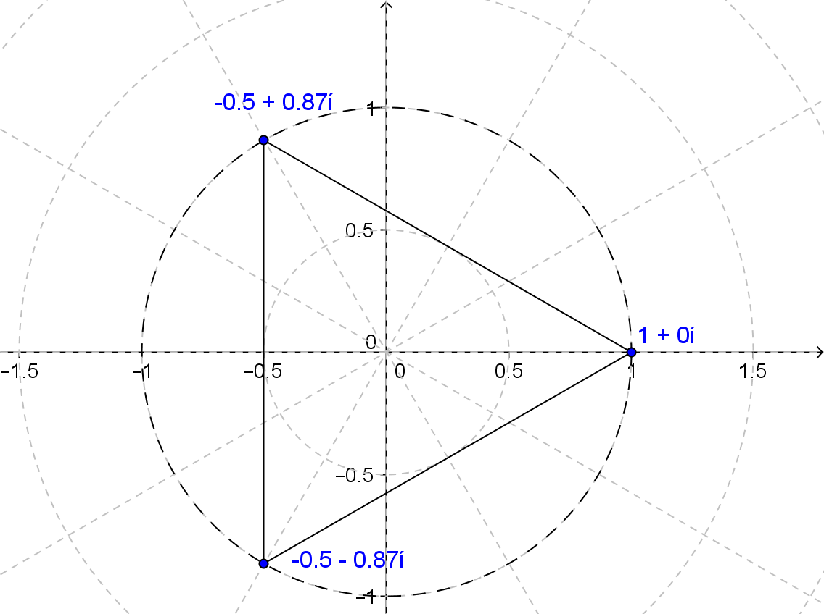

The Fourth Roots of Unity
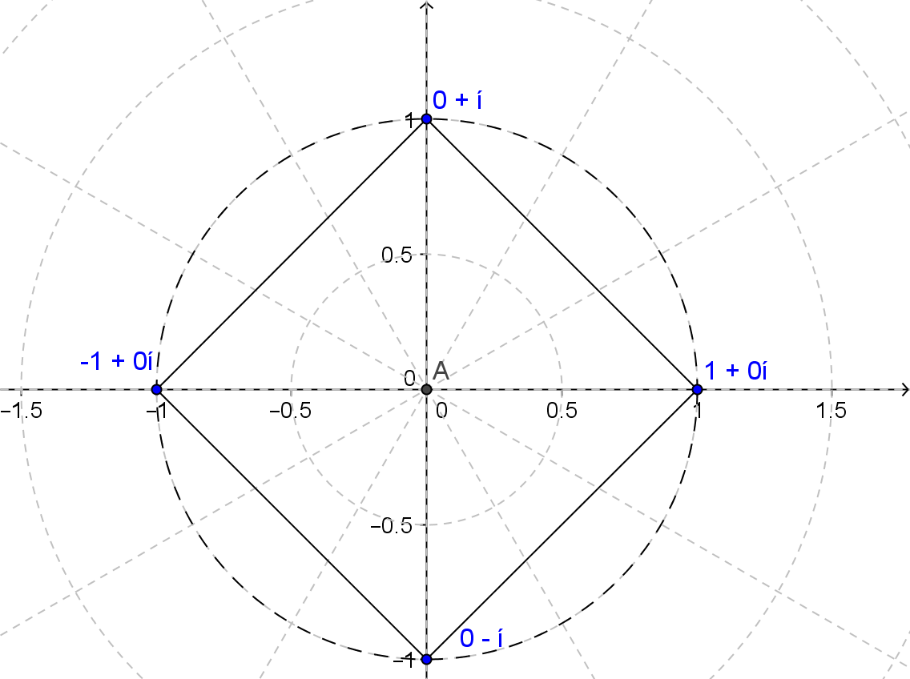
The Fifth Roots of Unity
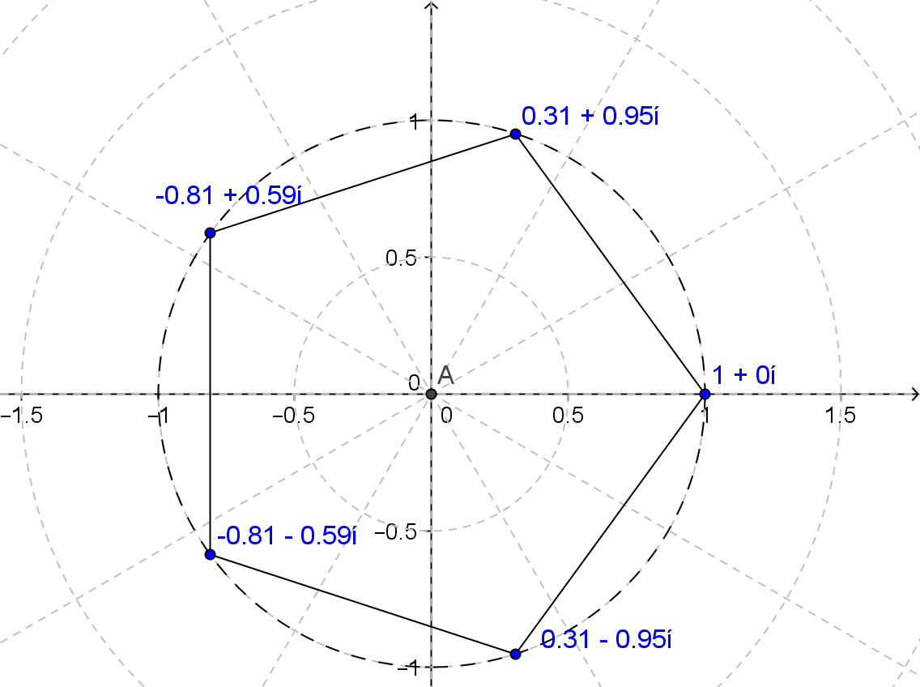

Discussion
What is the modulus of each root of unity regardless of the value of $n$? Explain how you know.
The modulus will always be $1$ because the $n$th root of $1$ is equal to $1$. The points are on the unit circle, and the radius is always $1$.
MP.7
&
MP.8

How could you describe the location of the roots of unity in the complex plane?
They are points on a unit circle, evenly spaced every $\frac{2π}{n}$ units starting from $1$ along the positive real axis.

The diagram below shows the solutions to the equation $x^{3}=27$. How do these numbers compare to the cube roots of unity (e.g., the solutions to $x^{3}=1$)?
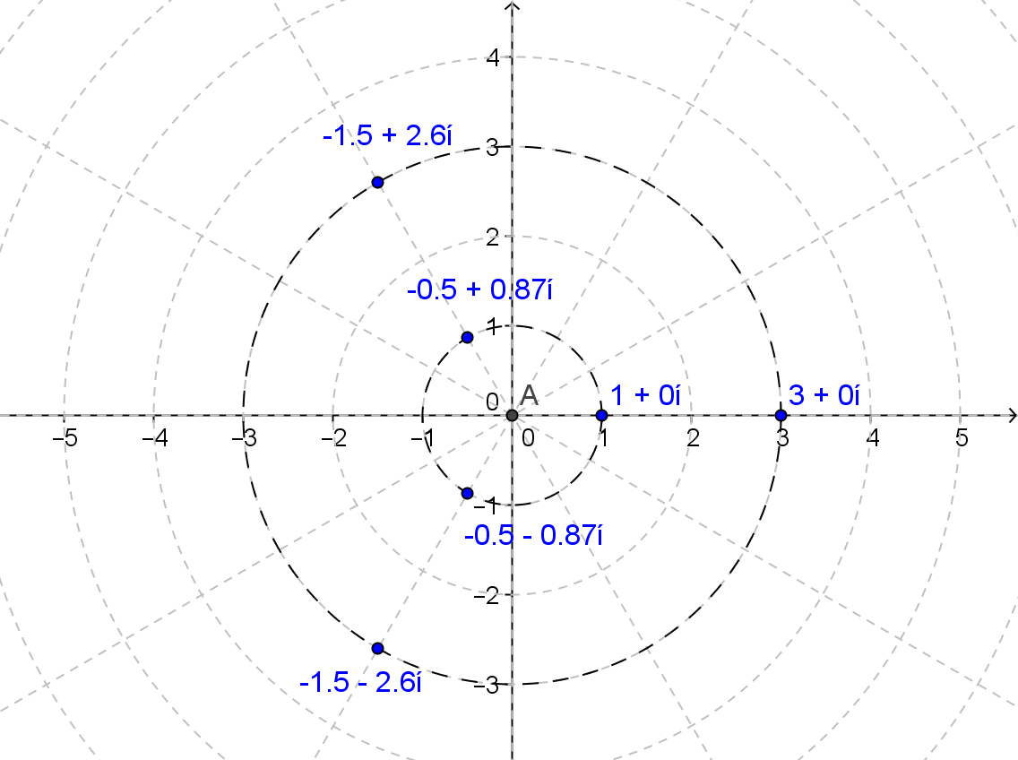
MP.7
&
MP.8
They are points on a circle of radius $3$ since the cube root of $27$ is $3$. Each one is a scalar multiple (by a factor of $3$) of the cube roots of unity. Thus, they have the same arguments but a different modulus.

Closing (5 minutes)
Use the questions below to help students process the information in the Lesson Summary. They can respond to them individually or with a partner.
- What are the $n^{th}$ roots of unity?
  - They are the $n$ complex solutions to an equation of the form $x^{n}=1$, where $n$ is a positive integer.
- How can you tell how many real solutions an equation of the form $x^{n}=1$ or $x^{n}=k$ for integers $n$ and positive real numbers $k$ will have? How many complex solutions will there be?
  - The real number $1$ (or $\sqrt[n]{k}$) is a solution to $x^{n}=1$ (or $x^{n}=k$) regardless of the value of $n$. The real number $-1$ (or $-\sqrt[n]{k}$) is also a solution when $n$ is an even number. The fundamental theorem of algebra says that a degree $n$ polynomial function will have $n$ roots, so these equations will have $n$ complex solutions.
- How can the polar form of a complex number and the geometric effect of complex multiplication help you to find all the complex solutions to equations of the form $x^{n}=1$ and $x^{n}=k$ for positive integers $n$ and a positive real number $k$?
  - One solution to $x^{n}=1$ will always be the complex number $1+0i$. Every other solution can be obtained by $n-1$ subsequent rotations of the complex number clockwise about the origin by $\frac{2π}{n}$ radians. For the equation $x^{n}=k$, there will be $n$ solutions with modulus $\sqrt[n]{k}$ and arguments of $\left\{0, \frac{2π}{n}, \frac{4π}{n}, \frac{6π}{n},…,\frac{2π(n-1)}{n}\right\}$.

Lesson Summary
The solutions to the equation $x^{n}=1$ for positive integers $n$ are called the $n$th roots of unity. For any value of $n>2$, the roots of unity are complex numbers of the form $z_{k}=a_{k}+b_{k}i$ for positive integers $1<k<n$ with the corresponding points $(a_{k},b_{k})$ at the vertices of a regular $n$-gon centered at the origin with one vertex at $(1,0)$.
The fundamental theorem of algebra guarantees that an equation of the form $x^{n}=k$ will have $n$ complex solutions. If $n$ is odd, then the real number $\sqrt[n]{k}$ is the only real solution. If $n$ is even, then the equation will have exactly two real solutions: $\sqrt[n]{k}$ and $-\sqrt[n]{k}$.
Given a complex number $z$ with modulus $r$ and argument $θ$, the $n$th roots of $z$ are given by
$$\sqrt[n]{r}\left(\cos\left(\frac{θ}{n}+\frac{2πk}{n}\right)+i\sin\left(\frac{θ}{n}+\frac{2πk}{n}\right)\right)$$
for integers $k$ and $n$ such that $n>0$ and $0≤k<n$.
Exit Ticket (4 minutes)

Name Date
Lesson 3: Roots of Unity

Exit Ticket

1. What is a fourth root of unity? How many fourth roots of unity are there? Explain how you know.

2. Find the polar form of the fourth roots of unity.

3. Write $x^{4}-1$ as a product of linear factors, and explain how this expression supports your answers to
Problems 1 and 2.

Exit Ticket Sample Solutions

- What is a fourth root of unity? How many fourth roots of unity are there? Explain how you know.
The fourth root of unity is a number that multiplied by itself 4 times is equal to $1$. There are $4$ fourth roots of unity. $x^{4}=1$ results in solving the polynomial $x^{4}-1=0$. The fundamental theorem of algebra guarantees four roots since that is the degree of the polynomial.

- Find the polar form of the fourth roots of unity.
For the fourth roots of unity, $n=4$ and $r=1$, so each root has modulus 1, and the arguments are $0$, $\frac{2π}{4}$, $\frac{4π}{4}$, and $\frac{6π}{4}$. We can rewrite the arguments as $0$, $\frac{π}{2}$, $π$, and $\frac{3π}{2}$. Then, the fourth roots of unity are
$$x_{1}=cos\left(0\right)+i sin\left(0\right)=1 \\ x_{2}=cos\left(\frac{π}{2}\right)+i sin\left(\frac{π}{2}\right)=i \\ x_{3}=cos\left(π\right)+i sin\left(π\right)=-1 \\ x_{4}=cos\left(\frac{3π}{2}\right)+i sin\left(\frac{3π}{2}\right)=-i.$$

- Write $x^{4}-1$ as a product of linear factors, and explain how this expression supports your answers to
Problems 1 and 2.
Since there are four roots of unity, there should be four linear factors.
$$x^{4}-1=(x-1)(x-i)(x+1)(x+i)$$

Problem Set Sample Solutions

- Graph the $n$^{th} roots of unity in the complex plane for the specified value of $n$.
  - $n=3$
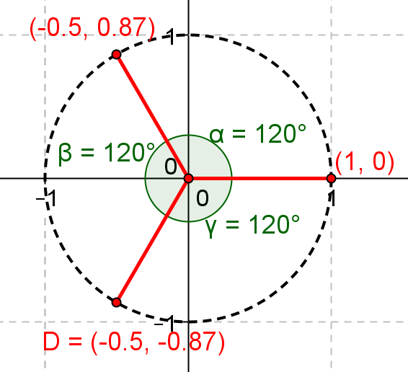

  - $n=4$
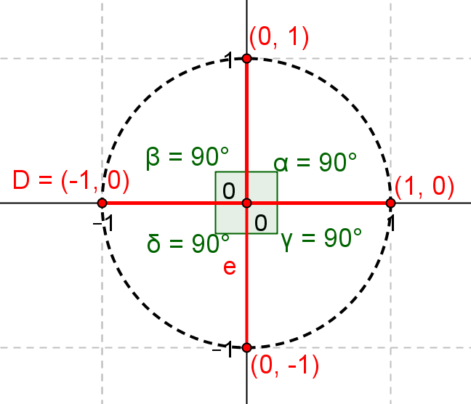

  - $n=5$
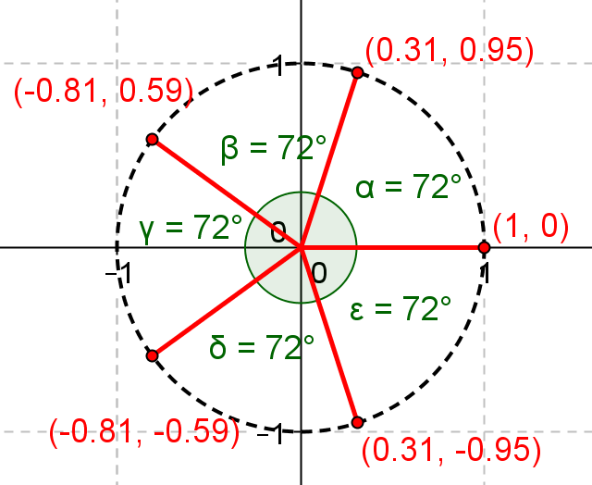

  - $n=6$
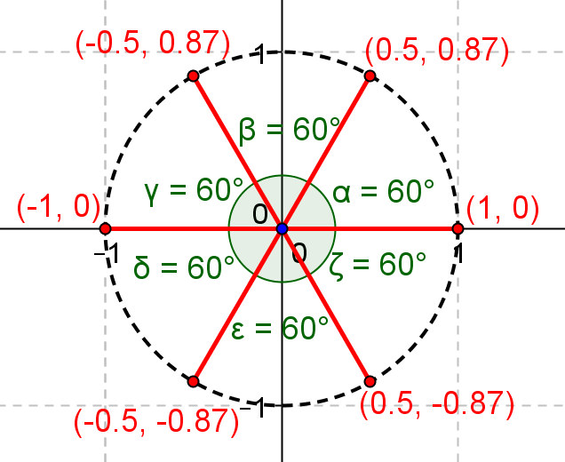

- Find the cube roots of unity by using each method stated.
  - Solve the polynomial equation $x^{3}=1$ algebraically.
$x^{3}-1=0$, $\left(x-1\right)\left(x^{2}+x+1\right)=0$, $x=1$, $x^{2}+x+1=0$, $x=\frac{-1±\sqrt{1-4}}{2}=-\frac{1}{2}±\frac{\sqrt{3}i}{2}$
The roots of unity are $1$, $-\frac{1}{2}+\frac{\sqrt{3}}{2}i$, $-\frac{1}{2}-\frac{\sqrt{3}}{2}i$.

  - Use the polar form $z^{3}=r\left(cos θ+sin θ\right)$, and find the modulus and argument of $z$.
$z^{3}=1$, $r^{3}=1$, $r=1$
$3θ=0$, $3θ=2π$, $3θ=4π$ or …; therefore, $θ=0$, $\frac{2π}{3}$, $\frac{4π}{3}$, $2π$, …
$z=\sqrt[3]{r}\left(cos(θ)+i sin(θ)\right)$
$z_{1}=1\left(cos(0)+i sin(0)\right)=1$
$$z_{2}=1\left(cos\left(\frac{2π}{3}\right)+i sin\left(\frac{2π}{3}\right)\right)=-\frac{1}{2}+\frac{\sqrt{3}}{2}i$$
$$z_{3}=1\left(cos\left(\frac{4π}{3}\right)+i sin\left(\frac{4π}{3}\right)\right)=-\frac{1}{2}-\frac{\sqrt{3}}{2}i$$
The roots of unity are $1$, $-\frac{1}{2}+\frac{\sqrt{3}}{2}i$, $-\frac{1}{2}-\frac{\sqrt{3}}{2}i$.

  - Solve ${\left(a+bi\right)}^{3}=1$ by expanding ${\left(a+bi\right)}^{3}$ and setting it equal to $1+0i$.
${\left(a+bi\right)}^{3}=1$, $a^{3}+3a^{2}bi-3ab^{2}-b^{3}i=1$; therefore, $a^{3}-3ab^{2}=1$ and $3a^{2}b-b^{3}=0$.
For $3a^{2}b-b^{3}=0$, $b\left(3a^{2}-b^{2}\right)=0$, we have either $b=0$ or $a^{2}-b^{2}=0$.
For $b=0$, we plug it in $a^{3}-3ab^{2}=1$, $a^{3}=1$, $a=1$; therefore, we have $1+0i$.
For $3a^{2}-b^{2}=0$, $b^{2}=3a^{2}$, we plug it in $a^{3}-3ab^{2}=1$, $a^{3}-9a^{3}=1$, $a^{3}=\frac{-1}{8}$, $a=-\frac{1}{2}$.
For $=-\frac{1}{2}$, we plug it in $b^{2}=3a^{2}$, and we get $b=±\frac{\sqrt{3}}{2}$. Therefore, we have $\frac{1}{2}+\frac{\sqrt{3}}{2}i$ and $\frac{1}{2}-\frac{\sqrt{3}}{2}i$.
The roots of unity are $1$, $-\frac{1}{2}+\frac{\sqrt{3}}{2}i$, $-\frac{1}{2}-\frac{\sqrt{3}}{2}i$.

- Find the fourth roots of unity by using the method stated.
  - Solve the polynomial equation $x^{4}=1$ algebraically.
$x^{4}-1=0$, $\left(x^{2}+1\right)\left(x+1\right)\left(x-1\right)=0$, $x=±i$, $x=±1$
The roots of unity are $1$, $i$, $-1$, $-i$.

  - Use the polar form $z^{4}=r\left(cos θ+sin θ\right)$, and find the modulus and argument of $z$.
$z^{4}=1$, $r^{4}=1$, $r=1$
$4θ=0$, $4θ=2π$, $4θ=4π$, $4θ=6π$, $4θ=8π$, …; therefore, $θ=0$, $\frac{π}{2}$, $π$, $\frac{3π}{2}$, $2π$…
$z=\sqrt[3]{r}\left(cos(θ)+i sin(θ)\right)$
$z_{1}=1\left(cos(0)+i sin(0)\right)=1$
$$z_{2}=1\left(cos\left(\frac{π}{2}\right)+i sin\left(\frac{π}{2}\right)\right)=i$$
$$z_{3}=1\left(cos(π)+i sin(π)\right)=-1$$
$$z_{4}=1\left(cos\left(\frac{3π}{2}\right)+i sin\left(\frac{3π}{2}\right)\right)=-i$$
The roots of unity are $1$, $i$, $-1$, $-i$.

  - Solve ${\left(a+bi\right)}^{4}=1$ by expanding ${\left(a+bi\right)}^{4}$ and setting it equal to $1+0i$.
${\left(a+bi\right)}^{4}=1$, $a^{4}+4a^{3}bi-6a^{2}b^{2}-4ab^{3}i+b^{4}=1$;
therefore, $a^{4}-6a^{2}b^{2}+b^{4}=1$ and $4a^{3}b-4ab^{3}=0$.
For $4a^{3}b-4ab^{3}=0$, $4ab\left(a^{2}-b^{2}\right)=0$, we have either $a=0$, $b=0$, or $a^{2}-b^{2}=0$.
For $a=0$, we plug it in $a^{4}-6a^{2}b^{2}+b^{4}=1$, $b^{4}=1$, $b=±1$;
therefore, we have fourth roots of unity $i$ and $–i$.
For $b=0$, we plug it in $a^{4}-6a^{2}b^{2}+b^{4}=1$, $a^{4}=1$, $a=±1$; for $a$. $b∈R$;
therefore, we have fourth roots of unity $1$ and $–1$.
For $a^{2}-b^{2}=0$, $a^{2}=b^{2}$, we plug it in $a^{4}-6a^{2}b^{2}+b^{4}=1$, $b^{4}-6b^{4}+b^{4}=1$,
$4b^{4}=-1$; there is no solution for $b$ for $a$. $b∈R$;
The roots of unity are $1$, $i$, $-1$, $-i$.

- Find the fifth roots of unity by using the method stated.
Use the polar form $z^{5}=r(cos θ+sin θ)$, and find the modulus and argument of $z$.
$z^{5}=1$, $r^{5}=1$, $r=1$
$5θ=0$, $5θ=2π$, $5θ=4π$, $5θ=6π$, $5θ=8π$, $5θ=10π$,…; therefore,
$θ=0$, $\frac{2π}{5}$, $\frac{4π}{5}$, $\frac{6π}{5}$, $\frac{8π}{5}$ $2π$, …
$z_{1}=1\left(cos 0+i sin 0\right)=1$
$$z_{2}=1\left(cos\left(\frac{2π}{5}\right)+i sin\left(\frac{2π}{5}\right)\right)=0.309+0.951i$$
$$z_{3}=1\left(cos\left(\frac{4π}{5}\right)+i sin\left(\frac{4π}{5}\right)\right)=-0.809+0.588i$$
$$z_{4}=1\left(cos\left(\frac{6π}{5}\right)+i sin\left(\frac{6π}{5}\right)\right)=-0.809-0.588i$$
$$z_{5}=1\left(cos\left(\frac{8π}{5}\right)+i sin\left(\frac{8π}{5}\right)\right)=0.309-0.951i$$
The roots of unity are $1$, $0.309+0.951i$, $-0.809+0.588i$, $-0.809-0.588i$, $0.309-0.951i$, $1$.

- Find the sixth roots of unity by using the method stated.
  - Solve the polynomial equation $x^{6}=1$ algebraically.
$x^{6}-1=0$, $\left(x+1\right)\left(x^{2}-x+1\right)\left(x-1\right)\left(x^{2}+x+1\right)=0$, $x=±1$, $x=\frac{1}{2}±\frac{\sqrt{3}i}{2}$, $x=-\frac{1}{2}±\frac{\sqrt{3}i}{2}$
The roots of unity are $1$, $-1$, $\frac{1}{2}+\frac{\sqrt{3}i}{2}$, $\frac{1}{2}-\frac{\sqrt{3}i}{2}$, $-\frac{1}{2}+\frac{\sqrt{3}i}{2}$, $-\frac{1}{2}-\frac{\sqrt{3}i}{2}$.

  - Use the polar form $z^{6}=r(cos θ+sin θ)$, and find the modulus and argument of $z$.
$z^{6}=1$, $r^{6}=1$, $r=1$
$6θ=0$, $6θ=2π$, $6θ=4π$, $6θ=6π$, $6θ=8π$, $6θ=10π$, $6θ=12π$, $6θ=14π$ …;
therefore, $θ=0$, $\frac{π}{3}$, $\frac{2}{3}$, $π$, $\frac{4π}{3}$, $\frac{5π}{3}$, $2π$, $\frac{7π}{3}$ …
$$z_{1}=1\left(cos\left(0\right)+i sin(0)\right)=1$$
$$z_{2}=1\left(cos\left(\frac{π}{3}\right)+i sin\left(\frac{π}{3}\right)\right)=\frac{1}{2}+\frac{\sqrt{3}}{2}i$$
$$z_{3}=1\left(cos\left(\frac{2π}{3}\right)+i sin\left(\frac{2π}{3}\right)\right)=-\frac{1}{2}+\frac{\sqrt{3}}{2}i$$
$$z_{4}=1\left(cos(π)+i sin(π)\right)=-1$$
$$z_{5}=1\left(cos\left(\frac{4π}{3}\right)+i sin\left(\frac{4π}{3}\right)\right)=-\frac{1}{2}-\frac{\sqrt{3}}{2}i$$
$$z_{6}=1\left(cos\left(\frac{5π}{3}\right)+i sin\left(\frac{5π}{3}\right)\right)=\frac{1}{2}-\frac{\sqrt{3}}{2}i$$
The roots of unity are $1$, $\frac{1}{2}+\frac{\sqrt{3}}{2}i$, $-\frac{1}{2}+\frac{\sqrt{3}}{2}i$, $-1$, $-\frac{1}{2}-\frac{\sqrt{3}}{2}i$, $\frac{1}{2}+\frac{\sqrt{3}}{2}i$.

- Consider the equation $x^{N}=1$ where $N$ is a positive whole number.
  - For which value of $N$ does $x^{N}=1$ have only one solution?
$N=1$

  - For which value of $N$ does $x^{N}=1$ have only $±1$ as solutions?
$N=2$

  - For which value of $N$ does $x^{N}=1$ have only $±1$ and $±i$ as solutions?
$N=4$

  - For which values of $N$ does $x^{N}=1$ have $±1$ as solutions?
Any even number $N$ will produce solutions $±1$.

- Find the equation that will have the following solutions.

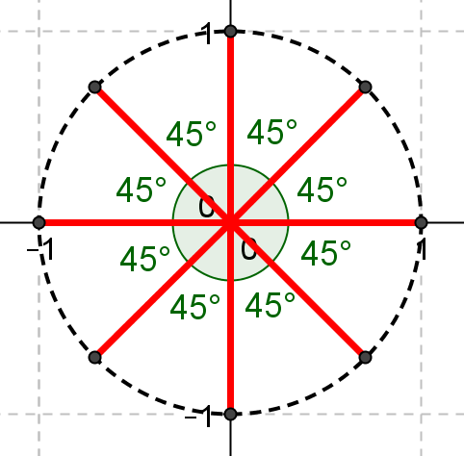
$x^{8}=1$

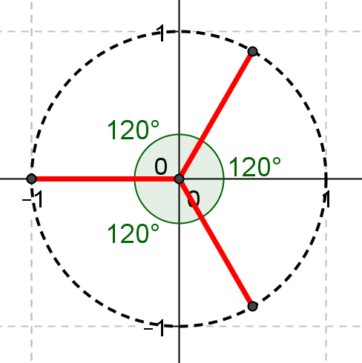
$x^{3}=-1$

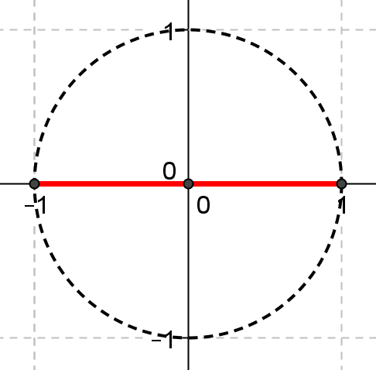
$x^{2}=1$

- Find the equation ${\left(a+bi\right)}^{N}=c$ that has solutions shown in the graph below.
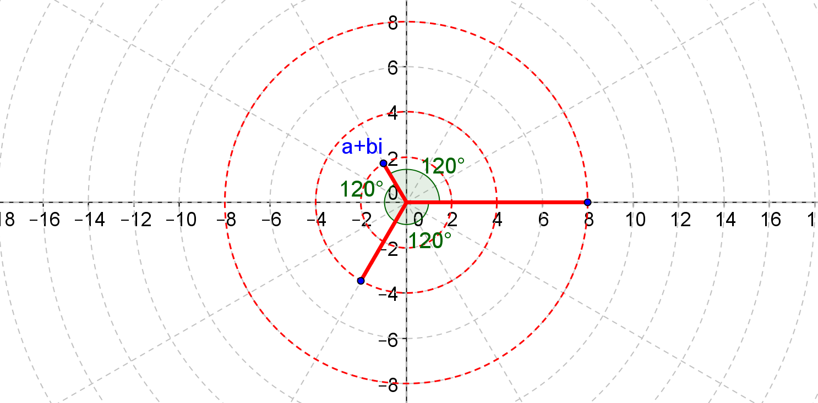
${\left(-1+\sqrt{3}i\right)}^{3}=8$

