Lesson 3: Roots of Unity

Classwork
Opening Exercise
Consider the equation $x^{n}=1$ for positive integers $n$.
  - Must an equation of this form have a real solution? Explain your reasoning.

  - Could an equation of this form have two real solutions? Explain your reasoning.

  - How many complex solutions will there be for an equation of this form? Explain how you know.

Exploratory Challenge
Consider the equation $x^{3}=1$.
  - Use the graph of $f\left(x\right)=x^{3}-1$ to explain why $1$ is the only real number solution to the equation $x^{3}=1$.
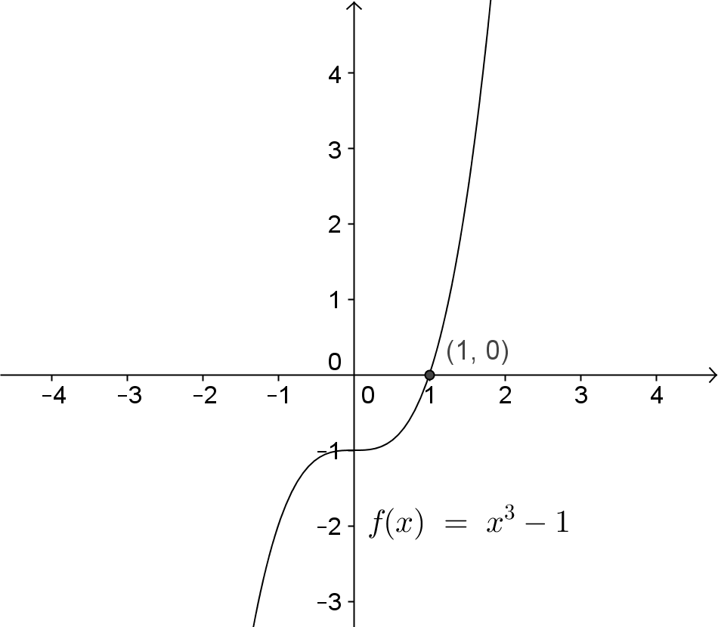

  - Find all of the complex solutions to the equation $x^{3}=1$. Come up with as many methods as you can for finding the solutions to this equation.

Exercises 1–4
Solutions to the equation $x^{n}=1$ for positive integers $n$ are called the $n^{th}$ roots of unity.
- What are the square roots of unity?

- What are the fourth roots of unity? Solve this problem by creating and solving a polynomial equation. Show work to support your answer.

- Find the sixth roots of unity by creating and solving a polynomial equation. Show work to support your answer.

- Without using a formula, what would be the polar forms of the fifth roots of unity? Explain using the geometric effect of multiplication complex numbers.

Discussion
What is the modulus of each root of unity regardless of the value of $n$? Explain how you know.

How could you describe the location of the roots of unity in the complex plane?

The diagram below shows the solutions to the equation $x^{3}=27$. How do these numbers compare to the cube roots of unity (e.g., the solutions to $x^{3}=1$)?
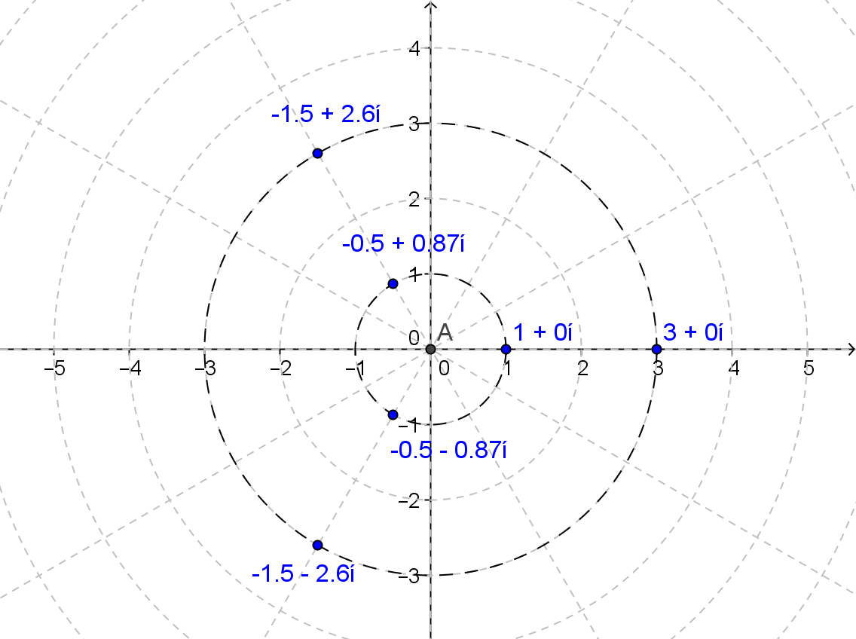

Lesson Summary
The solutions to the equation $x^{n}=1$ for positive integers $n$ are called the $n$th roots of unity. For any value of $n>2$, the roots of unity are complex numbers of the form $z_{k}=a_{k}+b_{k}i$ for positive integers $1<k<n$ with the corresponding points $(a_{k},b_{k})$ at the vertices of a regular $n$-gon centered at the origin with one vertex at $(1,0)$.
The fundamental theorem of algebra guarantees that an equation of the form $x^{n}=k$ will have $n$ complex solutions. If $n$ is odd, then the real number $\sqrt[n]{k}$ is the only real solution. If $n$ is even, then the equation will have exactly two real solutions: $\sqrt[n]{k}$ and $-\sqrt[n]{k}$.
Given a complex number $z$ with modulus $r$ and argument $θ$, the $n$th roots of $z$ are given by
$$\sqrt[n]{r}\left(\cos\left(\frac{θ}{n}+\frac{2πk}{n}\right)+i\sin\left(\frac{θ}{n}+\frac{2πk}{n}\right)\right)$$
for integers $k$ and $n$ such that $n>0$ and $0≤k<n$.

Problem Set

- Graph the $n$^{th} roots of unity in the complex plane for the specified value of $n$.
  - $n=3$
  - $n=4$
  - $n=5$
  - $n=6$

- Find the cube roots of unity by using each method stated.
  - Solve the polynomial equation $x^{3}=1$ algebraically.
  - Use the polar form $z^{3}=r\left(cos θ+sin θ\right)$, and find the modulus and argument of $z$.
  - Solve ${\left(a+bi\right)}^{3}=1$ by expanding ${\left(a+bi\right)}^{3}$ and setting it equal to $1+0i$.

- Find the fourth roots of unity by using the method stated.
  - Solve the polynomial equation $x^{4}=1$ algebraically.
  - Use the polar form $z^{4}=r\left(cos θ+sin θ\right)$, and find the modulus and argument of $z$.
  - Solve ${\left(a+bi\right)}^{4}=1$ by expanding ${\left(a+bi\right)}^{4}$ and setting it equal to $1+0i$.

- Find the fifth roots of unity by using the method stated.
Use the polar form $z^{5}=r(cos θ+sin θ)$, and find the modulus and argument of $z$.

- Find the sixth roots of unity by using the method stated.
  - Solve the polynomial equation $x^{6}=1$ algebraically.
  - Use the polar form $z^{6}=r(cos θ+sin θ)$, and find the modulus and argument of $z$.

- Consider the equation $x^{N}=1$ where $N$ is a positive whole number.
  - For which value of $N$ does $x^{N}=1$ have only one solution?
  - For which value of $N$ does $x^{N}=1$ have only $±1$ as solutions?
  - For which value of $N$ does $x^{N}=1$ have only $±1$ and $±i$ as solutions?
  - For which values of $N$ does $x^{N}=1$ have $±1$ as solutions?

- Find the equation that will have the following solutions.

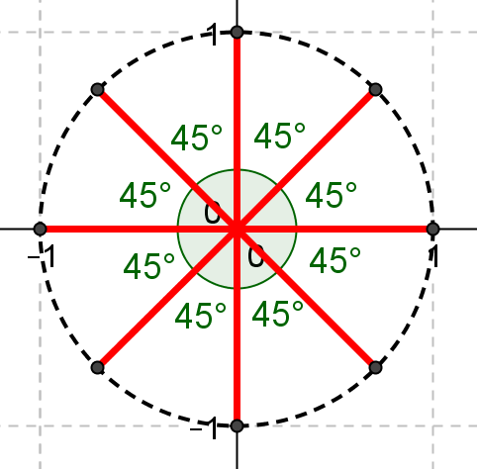

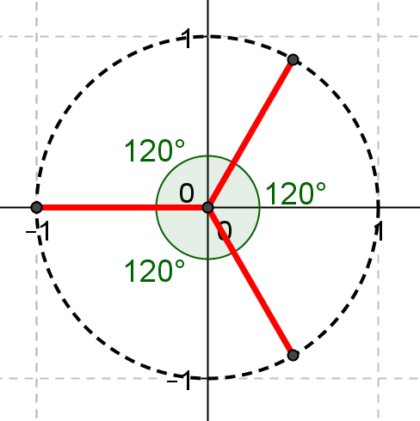

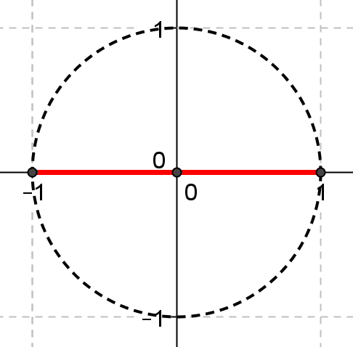

- Find the equation ${\left(a+bi\right)}^{N}=c$ that has solutions shown in the graph below.

