Lesson 21: Ptolemy’s Theorem

Student Outcomes
- Students determine the area of a cyclic quadrilateral as a function of its side lengths and the acute angle formed by its diagonals.
- Students prove Ptolemy’s theorem, which states that for a cyclic quadrilateral $ABCD$, $AC⋅BD=AB⋅CD+BC⋅AD$. They explore applications of the result.

Lesson Notes
In this lesson, students work to understand Ptolemy’s theorem, which says that for a cyclic quadrilateral $D,$ $AC⋅BD=AB⋅CD+BC⋅AD$. As such, this lesson focuses on the properties of quadrilaterals inscribed in circles. Ptolemy’s single result and the proof for it codify many geometric facts; for instance, the Pythagorean theorem (G-GPE.A.1, G-GPE.B.4), area formulas, and trigonometry results. Therefore, it serves as a capstone experience to our year-long study of geometry. Students will use the area formulas they established in the previous lesson to prove the theorem. A set square, patty paper, compass, and straight edge are needed to complete the Exploratory Challenge.

Classwork
Opening (2 minutes)
The Pythagorean theorem, credited to the Greek mathematician Pythagoras of Samos (ca. 570–ca. 495 BCE), describes a universal relationship among the sides of a right triangle. Every right triangle (in fact every triangle) can be circumscribed by a circle. Six centuries later, Greek mathematician Claudius Ptolemy (ca. 90–ca. 168 CE) discovered a relationship between the side-lengths and the diagonals of any quadrilateral inscribed in a circle. As we shall see, Ptolemy’s result can be seen as an extension of the Pythagorean theorem.

Opening Exercise (5 minutes)
Students are given the statement of Ptolemy’s theorem and are asked to test the theorem by measuring lengths on specific cyclic quadrilaterals they are asked to draw. Students conduct this work in pairs and then gather to discuss their ideas afterwards in class as a whole.
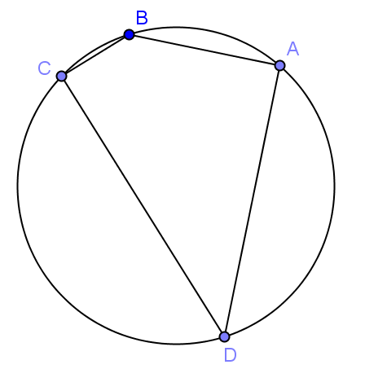
Opening Exercise
Ptolemy’s theorem says that for a cyclic quadrilateral $ABCD$,
$AC⋅BD=AB⋅CD+BC⋅AD$.
MP.7
With ruler and a compass, draw an example of a cyclic quadrilateral. Label its vertices $A$, $B$, $C$, and $D$.
Draw the two diagonals $\overline{AC}$ and $\overline{BD}$.

With a ruler, test whether or not the claim that$AC⋅BD=AB⋅CD+BC⋅AD$ seems to hold true.
MP.7
Repeat for a second example of a cyclic quadrilateral.
Challenge: Draw a cyclic quadrilateral with one side of length zero. What shape is the this cyclic quadrilateral? Does Ptolemy’s claim hold true for it?
Students will see that the relationship $AC⋅BD=AB⋅CD+BC⋅AD$seems to hold, within measuring error. For a quadrilateral with one side of length zero, the figure is a triangle inscribed in a circle. If the length $AB=0$, then the points $A$ and $B$ coincide, and Ptolemy’s theorem states $AC⋅AD=0⋅CD+AC⋅AD$, which is true.

Exploratory Challenge (30 minutes): A Journey to Ptolemy’s Theorem
This Exploratory Challenge will lead students to a proof of Ptolemy’s theorem. Students should work in pairs. The teacher will guide as necessary.
Exploratory Challenge: A Journey to Ptolemy’s Theorem
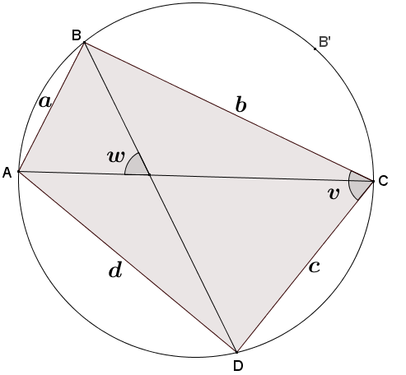
The diagram shows cyclic quadrilateral $ABCD$ with diagonals $\overline{AC}$ and $\overline{BD}$ intersecting to form an acute angle with degree measure $w$. $AB=a$, $BC=b$, $CD=c$, and $DA=d$.
  - From last lesson, what is the area of quadrilateral $ABCD$ in terms of the lengths of its diagonals and the angle $w$? Remember this formula for later on!
$Area\left(ABCD\right)=\frac{1}{2}AC⋅BD⋅\sin{w}$

  - Explain why one of the angles, $∠BCD$or $∠BAD$, has a measure less than or equal to $90°$.
Opposite angles of a cyclic quadrilateral are supplementary. These two angles cannot both have measures greater than $90°$.

  - Let’s assume that $∠BCD$ in our diagram is the angle with a measure less than or equal to $90°$. Call its measure $v$ degrees. What is the area of triangle $BCD$ in terms of $b$, $c$, and $v$? What is the area of triangle $BAD$ in terms of $a$, $d$, and $v$? What is the area of quadrilateral $ABCD$ in terms of $a$, $b$, $b$, $d$, and $v$?
Scaffolding:
- For part (c) of the Exploratory Challenge, review Exercises 4 and 5 from Lesson 20 which show that the area formula for a triangle, $Area\left(ABC\right)=\frac{1}{2}ab\sin{(c)}$, can be used where $c$ represents an obtuse angle with a targeted small group.
- Allow advanced learners to work through and struggle with the exploration on their own.
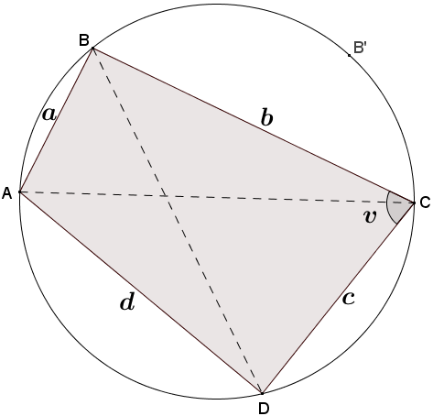
If $v$ represents the degree measure of an acute angle, then $180-v$ would be the degree measure of angle $BAD$ since opposite angles of a cyclic quadrilateral are supplementary. The area of triangle $BCD$ could then be calculated using $\frac{1}{2}bc⋅\sin{(v)}$, and the area of triangle $ABD$ could be calculated by $\frac{1}{2}ad⋅\sin\left(180-\left(180-v\right)\right)$, or $\frac{1}{2}ad⋅\sin{(v)}$. So, the area of the quadrilateral $ABCD$ is the sum of the areas of triangles $ABD$ and $BCD$, which provides the following:
$$Area\left(ABCD\right)=\frac{1}{2}ad⋅\sin{v}+\frac{1}{2}bc⋅\sin{v}\text{.}$$

  - We now have two different expressions representing the area of the same cyclic quadrilateral $ABCD$. Does it seem to you that we are close to a proof of Ptolemy’s claim?
Equating the two expressions gives as a relationship that does, admittedly, use the four side lengths of the quadrilateral and the two diagonal lengths, but we also have terms that involve $sin(w)$ and $sin(v)$. These terms are not part of Ptolemy’s equation.
Scaffolding:
The argument provided in part (e), (ii) follows the previous lesson. An alternative argument is that the perpendicular bisector of a chord of a circle passes through the center of the circle. Reflecting a circle or points on a circle about the perpendicular bisector of the chord is, therefore, a symmetry of the circle; thus, $B$ must go to a point $B'$ on the same circle.
In order to reach Ptolemy’s conclusion, in Exploratory Challenge, parts (e)–(j), students will use rigid motions to convert the cyclic quadrilateral $ABCD$ to a new cyclic quadrilateral of the same area with the same side-lengths (but in an alternative order) and with its matching angle $v$ congruent to angle $w$ in the original diagram. Equating the areas of these two cyclic quadrilaterals will yield the desired result. Again, have students complete this work in homogeneous pairs or small groups. Offer to help students as needed.

  - Trace the circle and points $A$, $B$, $C$, and $D$ onto a sheet of patty paper. Reflect triangle $ABC$ about the perpendicular bisector of diagonal $\overline{AC}$. Let $A'$, $B'$, and $C'$ be the images of the points $A$, $B$, and $C$, respectively.
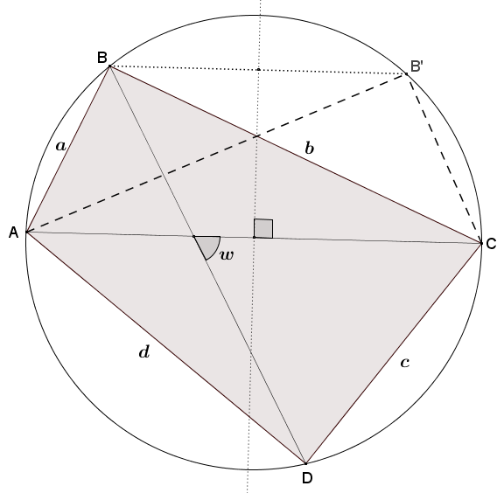

    - What does the reflection do with points $A$ and $C$?
Because the reflection was done about the perpendicular bisector of the chord $\overline{AC}$, the endpoints of the chord are images of each other; i.e., $A=C'$ and $C=A'$.

    - Is it correct to draw $B'$ as on the circle? Explain why or why not.
Reflections preserve angle measure. Thus, $∠AB'C≅∠ABC$. Also, $∠ABC$ is supplementary to $∠CDA$. Thus, $∠AB'C$ is, too. This means that $AB'CD$ is a quadrilateral with one pair (and, hence, both pairs) of opposite angles supplementary. Therefore, it is cyclic. This means that $B'$ lies on the circle that passes through $A$, $C$, and $D$. And this is the original circle.

    - Explain why quadrilateral $AB'CD$ has the same area as quadrilateral $ABCD$.
Triangle $AB'C$ is congruent to triangle $ABC$ by a congruence transformation, so these triangles have the same area. It now follows that the two quadrilaterals have the same area.

  - The diagram shows angles having degree measures $u$,$w$,$x$,$y$, and $z$.
Find and label any other angles having degree measures $u$, $w$, $x$, $y$, or $z$, and justify your answers.
See diagram. Justifications include the inscribed angle theorem and vertical angles.
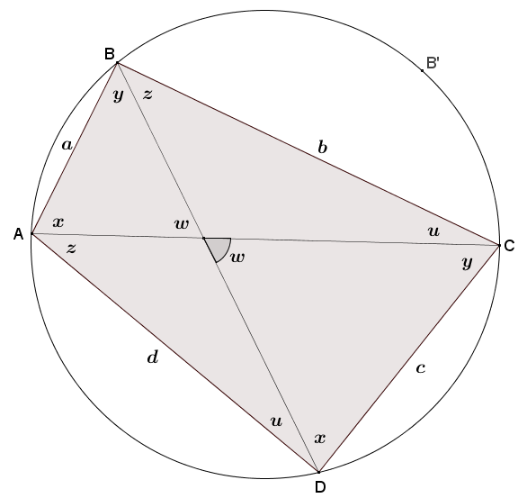

  - Explain why $w=u+z$in your diagram from part (f).
The angle with degree measure $w$ is an exterior angle to a triangle with two remote interior angles $u$ and $z$. It follows that $w=u+z$.

  - Identify angles of measures $u$,$x$,$y$,$z$, and $w$ in your diagram of the cyclic quadrilateral $AB'CD$ from part (e). See diagram below.
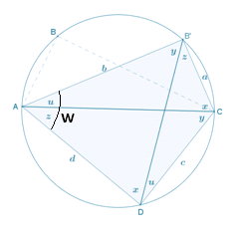

  - Write a formula for the area of triangle $B^{'}AD$ in terms of $b$,$d$, and $w$. Write a formula for the area of triangle $B^{'}CD$in terms of $a$,$c$, and $w$.
$Area\left(B^{'}AD\right)=bd⋅\sin\left(w\right)$
and
$Area\left(B^{'}CD\right)=ac⋅\sin{(w)}$

  - Based on the results of part (i), write a formula for the area of cyclic quadrilateral $ABCD$ In terms of $a$, $b$, $c$, $d$, and $w$.
$Area\left(ABCD\right)=Area\left(AB^{'}CD\right)=\frac{1}{2}bd⋅sin\left(w\right)+\frac{1}{2}ac⋅\sin{(w)}$
  - Going back to part (a), now establish Ptolemy’s theorem.
$\frac{1}{2}AC⋅BD⋅\sin{(w)}=\frac{1}{2}bd⋅\sin{(w)}+\frac{1}{2}ac⋅\sin{(w)}$ The two formulas represent the same area.
$\frac{1}{2}⋅\sin{(w)}⋅(AC⋅BD)=\frac{1}{2}⋅\sin{(w)}⋅(bd+ac)$ Distributive property
$AC⋅BD=bd+ac$ Multiplicative property of equality
or
$AC⋅BD=\left(BC⋅AD\right)+\left(AB⋅CD\right)$ Substitution

Closing (3 minutes)
Gather the class together and ask the following questions:
- What was most challenging in your work today?
  - Answers will vary. Students might say that it was challenging to do the algebra involved or to keep track of congruent angles, for example.
- Are you convinced that this theorem holds for all cyclic quadrilaterals?
  - Answers will vary, but students should say “yes.”
- Will Ptolemy’s theorem hold for all quadrilaterals? Explain.
  - At present, we don’t know! The proof seemed very specific to cyclic quadrilaterals, so we might suspect it holds only for these types of quadrilaterals. (If there is time, students can draw an example of non-cyclic quadrilateral and check that the result does not hold for it.)
Lesson Summary
Theorems
Ptolemy’s theorem: For a cyclic quadrilateral$ABCD$, $AC⋅BD=AB⋅CD+BC⋅AD$.
Relevant Vocabulary
Cyclic Quadrilateral: A quadrilateral with all vertices lying on a circle is known as a cyclic quadrilateral.

Exit Ticket (5 minutes)
Name Date
Lesson 21: Ptolemy’s Theorem

Exit Ticket

What is the length of the chord $\overline{AC}$? Explain your answer.
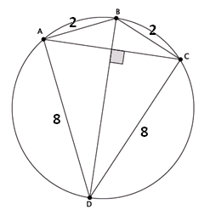

Exit Ticket Sample Solutions

What is the length of the chord $\overline{AC}$? Explain your answer.
Chord $\overline{BD }$is a diameter of the circle, and $BD=\sqrt{2^{2}+8^{2}}=\sqrt{68}$. By Ptolemy’s theorem: $AC∙\sqrt{68}=2∙8+2∙8$, giving $AC=\frac{32}{\sqrt{68 }}$.

Problem Set Sample Solutions

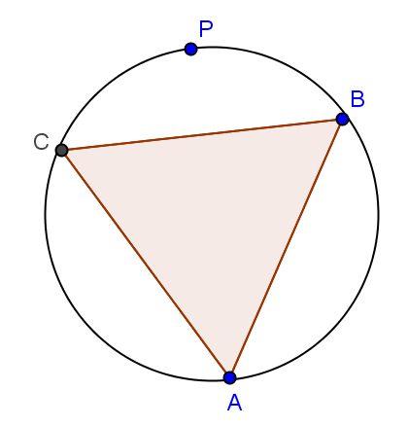
- An equilateral triangle is inscribed in a circle. If $P$ is a point on the circle, what does Ptolemy’s theorem have to say about the distances from this point to the three vertices of the triangle?
It says that the sum of the two shorter distances is equal to the longer distance.

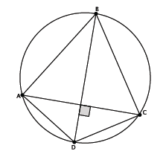
- Kite $ABCD$ is inscribed in a circle. The kite has an area of $108 sq. in.$, and the ratio of the lengths of the non-congruent adjacent sides is $3∶1$. What is the perimeter of the kite?
$$\frac{1}{2}AC⋅BD=108$$$AC⋅BD=AB⋅CD+BC⋅AD=216$
Since $AB=BC$ and $AD=CD$, then
$AC⋅BD=AB⋅CD+AB⋅CD=2AB⋅CD=216$ $AB⋅CD=108.$
Let $x$ be the length of $CD$, then
$$x⋅3x=108 \\ 3x^{2}=108 \\ x^{2}=36 \\ x=6.$$
The length $CD=AD=6$, and the length $AB=BC=18$. Therefore, the perimeter of kite $ABCD$ is $48 in.$

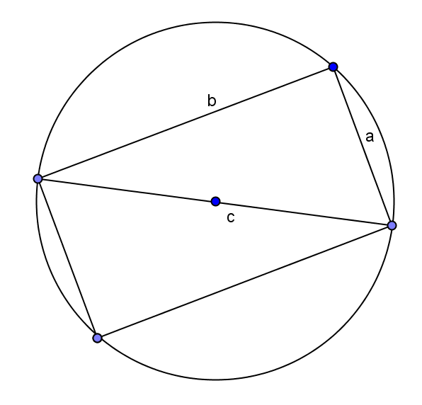
- Draw a right triangle with leg lengths $a$ and $b$, and hypotenuse length $c$. Draw a rotated copy of the triangle such that the figures form a rectangle. What does Ptolemy have to say about this rectangle?
We get $a^{2}+b^{2}=c^{2}$, the Pythagorean theorem!

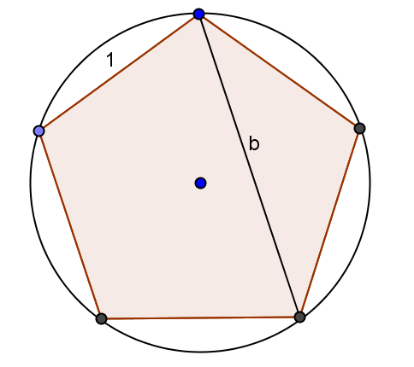
- Draw a regular pentagon of side length $1$ in a circle. Let $b$be the length of its diagonals. What does Ptolemy’s theorem say about the quadrilateral formed by four of the vertices of the pentagon?
$b^{2}=b+1$, so$b=\frac{\sqrt{5}+1}{2}$. (This is the famous golden ratio!)

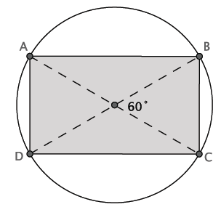
- The area of the inscribed quadrilateral is $\sqrt{300} mm^{2}$. Determine the circumference of the circle.
Since $ABCD$ is a rectangle, then $AD⋅AB=\sqrt{300}$, and the diagonals are diameters of the circle.
The length of $AB=2r\sin{60}$, and the length of $BC=2r\sin{30}$, so $\frac{AB}{AD}=\sqrt{3}$, and $AB=\sqrt{3}\left(AD\right)$.
$$AD⋅\sqrt{3}\left(AD\right)=\sqrt{300} \\ AD^{2}=100 \\ AD=10 \\ AB=10\sqrt{3}$$
$$AB⋅DC+AD⋅BC=AC⋅BD \\ 10\sqrt{3}⋅10\sqrt{3}+10⋅10=AC⋅AC \\ 300+100=AC^{2} \\ 400=AC^{2} \\ 20=AC$$
Since $AC=20$, the radius of the circle is $10$, and the circumference of the circle is $20π mm$.

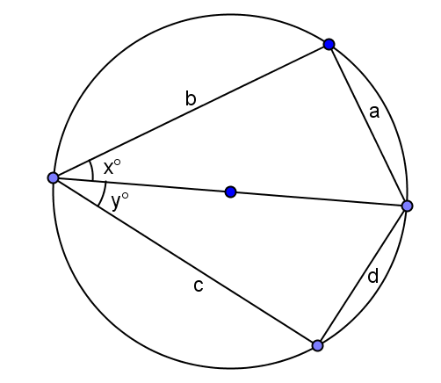
- Extension: Suppose $x$ and $y$ are two acute angles, and the circle has a diameter of$1$ unit. Find $a$, $b$, $c$, and $d$ in terms of $x$ and $y$. Apply Ptolemy’s theorem, and determine the exact value of $sin(75°)$.
Use scaffolded questions below as needed.

  - Explain why $\frac{a}{sin\left(x\right)}$ equals the diameter of the circle.
If the diameter is $1$, this is a right triangle because it is inscribed in a semicircle, so $sin\left(x\right)=\frac{a}{1}$, or the $1=\frac{a}{sin\left(x\right)}$. Since the diameter is $1$, the diameter is equal to $\frac{a}{sin\left(x\right)}$.
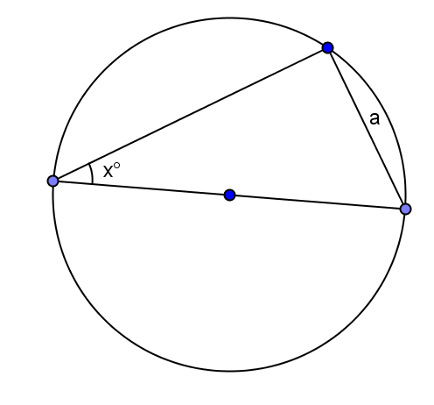
  - If the circle has a diameter of $1$, what is $a$?
$$a=sin(x)$$

  - Use Thales’ theorem to write the side lengths in the original diagram in terms of $x$ and $y$.
Since both are right triangles, the side lengths are $a=sin\left(x\right)$,$b=cos\left(x\right)$, $c=cos\left(y\right)$, and $d=sin\left(y\right)$.

  - If one diagonal of the cyclic quadrilateral is $1$, what is the other?
$$sin(x+y)$$

  - What does Ptolemy’s theorem give?
$$1∙sin\left(x+y\right)=sin\left(x\right)cos\left(y\right)+cos\left(x\right)sin(y)$$

  - Using the result from part (e), determine the exact value of $sin(75°)$.
$$sin\left(75\right)=sin\left(30+45\right)=sin\left(30\right)cos\left(45\right)+cos\left(30\right)sin\left(45\right)=\frac{1}{2}∙\frac{\sqrt{2}}{2}+\frac{\sqrt{3}}{2}∙\frac{\sqrt{2}}{2}= \frac{\sqrt{2}+\sqrt{6}}{4}$$

