Lesson 21: Ptolemy’s Theorem

Classwork
Opening Exercise
Ptolemy’s theorem says that for a cyclic quadrilateral $ABCD$, $AC⋅BD=AB⋅CD+BC⋅AD$.
With ruler and a compass, draw an example of a cyclic quadrilateral. Label its vertices $A$, $B$, $C$, and $D$.
Draw the two diagonals $\overline{AC}$ and $\overline{BD}$.

With a ruler, test whether or not the claim that$AC⋅BD=AB⋅CD+BC⋅AD$ seems to hold true.
Repeat for a second example of a cyclic quadrilateral.
Challenge: Draw a cyclic quadrilateral with one side of length zero. What shape is the this cyclic quadrilateral? Does Ptolemy’s claim hold true for it?

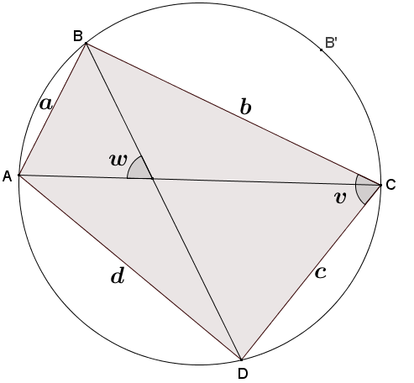
Exploratory Challenge: A Journey to Ptolemy’s Theorem
The diagram shows cyclic quadrilateral $ABCD$ with diagonals $\overline{AC}$ and $\overline{BD}$ intersecting to form an acute angle with degree measure $w$. $AB=a$, $BC=b$, $CD=c$, and $DA=d$.
  - From last lesson, what is the area of quadrilateral $ABCD$ in terms of the lengths of its diagonals and the angle $w$? Remember this formula for later on!

  - Explain why one of the angles, $∠BCD$or $∠BAD$, has a measure less than or equal to $90°$.

  - Let’s assume that $∠BCD$ in our diagram is the angle with a measure less than or equal to $90°$. Call its measure $v$ degrees. What is the area of triangle $BCD$ in terms of $b$, $c$, and $v$? What is the area of triangle $BAD$ in terms of $a$, $d$, and $v$? What is the area of quadrilateral $ABCD$ in terms of $a$, $b$, $c$, $d$, and $v$?
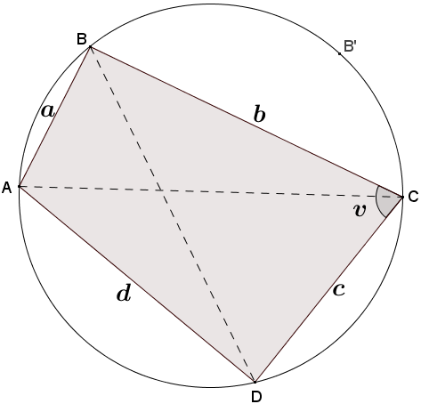

  - We now have two different expressions representing the area of the same cyclic quadrilateral $ABCD$. Does it seem to you that we are close to a proof of Ptolemy’s claim?

  - Trace the circle and points $A$, $B$, $C$, and $D$ onto a sheet of patty paper. Reflect triangle $ABC$ about the perpendicular bisector of diagonal $\overline{AC}$. Let $A'$, $B'$, and $C'$ be the images of the points $A$, $B$, and $C$, respectively.
    - What does the reflection do with points $A$ and $C$?

    - Is it correct to draw $B'$ as on the circle? Explain why or why not.

    - Explain why quadrilateral $AB'CD$ has the same area as quadrilateral $ABCD$.

  - The diagram shows angles having degree measures $u$, $w$, $x$,$y$, and $z$. Find and label any other angles having degree measures $u$,$w$,$x$, $y$, or $z$, and justify your answers.
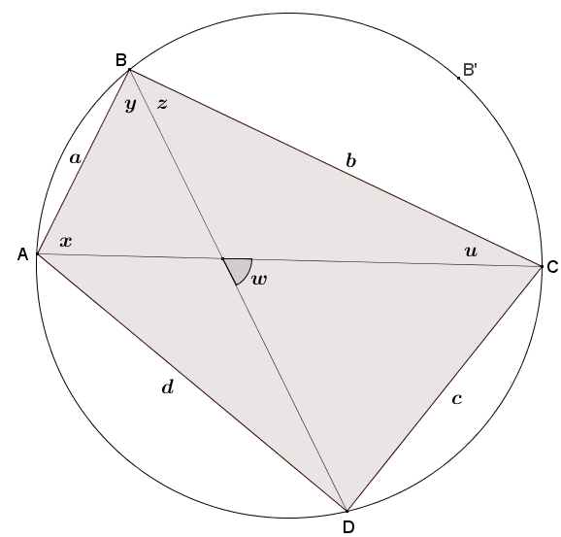

  - Explain why $w=u+z$in your diagram from part (f).

  - Identify angles of measures $u$, $x$, $y$,$z$, and $w$ in your diagram of the cyclic quadrilateral $AB'CD$ from part (e).

  - Write a formula for the area of triangle $B^{'}AD$ in terms of $b$, $d$, and $w$. Write a formula for the area of triangle $B^{'}CD$in terms of $a$,$c$, and $w$.

  - Based on the results of part (i), write a formula for the area of cyclic quadrilateral $ABCD$ In terms of $a$, $b$,$c$, $d$, and $w$.

  - Going back to part (a), now establish Ptolemy’s theorem.

Lesson Summary
Theorems
Ptolemy’s theorem: For a cyclic quadrilateral$ABCD$, $AC⋅BD=AB⋅CD+BC⋅AD$.
Relevant Vocabulary
Cyclic Quadrilateral: A quadrilateral with all vertices lying on a circle is known as a cyclic quadrilateral.

Problem Set

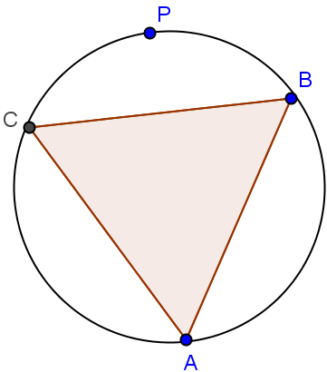
- An equilateral triangle is inscribed in a circle. If $P$ is a point on the circle, what does Ptolemy’s theorem have to say about the distances from this point to the three vertices of the triangle?

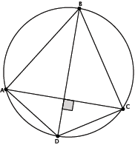
- Kite $ABCD$ is inscribed in a circle. The kite has an area of $108 sq. in.$, and the ratio of the lengths of the non-congruent adjacent sides is $3∶1$. What is the perimeter of the kite?

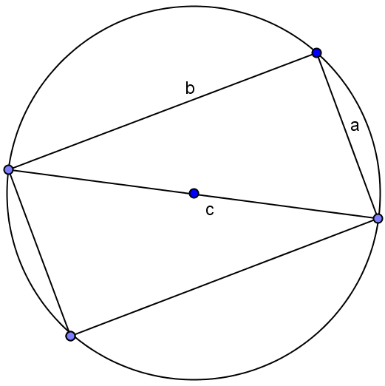
- Draw a right triangle with leg lengths $a$ and $b$, and hypotenuse length $c$. Draw a rotated copy of the triangle such that the figures form a rectangle. What does Ptolemy have to say about this rectangle?

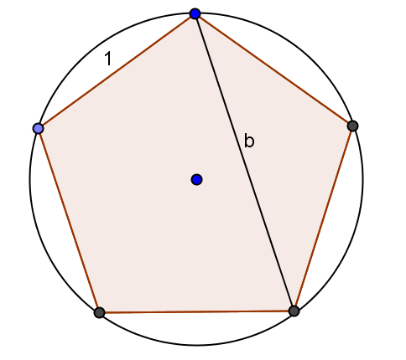
- Draw a regular pentagon of side length $1$ in a circle. Let$b$ be the length of its diagonals. What does Ptolemy’s theorem say about the quadrilateral formed by four of the vertices of the pentagon?

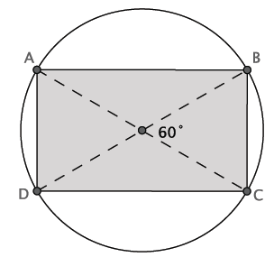
- The area of the inscribed quadrilateral is $\sqrt{300} mm^{2}$. Determine the circumference of the circle.

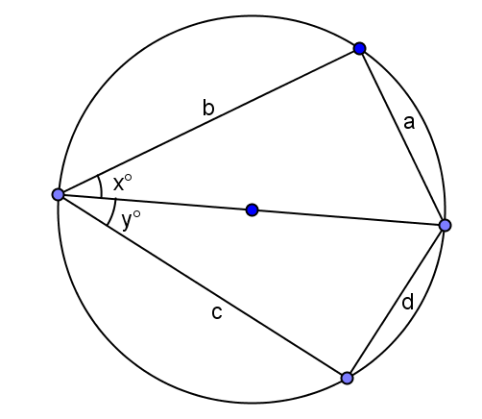
- Extension: Suppose $x$ and $y$ are two acute angles, and the circle has a diameter of $1$ unit. Find $a$, $b$, $c$, and $d$ in terms of $x$ and $y$. Apply Ptolemy’s theorem, and determine the exact value of $\sin\left(75°\right)$.
  - Explain why $\frac{a}{sin\left(x\right)}$ equals the diameter of the circle.
  - If the circle has a diameter of $1$, what is $a$?
  - Use Thales’ theorem to write the side lengths in the original diagram in terms of $x$ and $y$.
  - If one diagonal of the cyclic quadrilateral is $1$, what is the other?
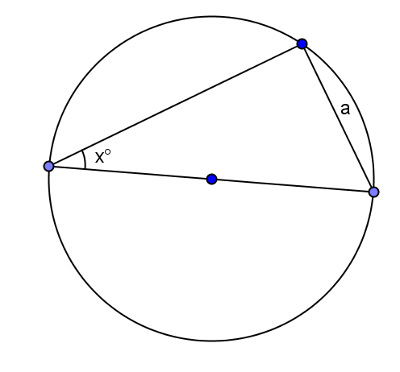
  - What does Ptolemy’s theorem give?
  - Using the result from part (e), determine the exact value of $\sin\left(75°\right)$.

