Lesson 20: Cyclic Quadrilaterals

Student Outcomes
- Students show that a quadrilateral is cyclic if and only if its opposite angles are supplementary.
- Students derive and apply the area of cyclic quadrilateral $ABCD$ as $\frac{1}{2}AC⋅BD⋅\sin{(w)}$, where $w$ is the measure of the acute angle formed by diagonals $AC$ and $BD$.

Lesson Notes
In Lessons 20 and 21, students experience a culmination of the skills they learned in the previous lessons and modules to reveal and understand powerful relationships that exist among the angles, chord lengths, and areas of cyclic quadrilaterals. Students will apply reasoning with angle relationships, similarity, trigonometric ratios and related formulas, and relationships of segments intersecting circles. They begin exploring the nature of cyclic quadrilaterals and use the lengths of the diagonals of cyclic quadrilaterals to determine their area. Next, students construct the circumscribed circle on three vertices of a quadrilateral (a triangle) and use angle relationships to prove that the fourth vertex must also lie on the circle (G-C.A.3). They then use these relationships and their knowledge of similar triangles and trigonometry to prove Ptolemy’s theorem, which states that the product of the lengths of the diagonals of a cyclic quadrilateral is equal to the sum of the products of the lengths of the opposite sides of the cyclic quadrilateral.

Classwork
Opening (5 minutes)
Students first encountered a cyclic quadrilateral in Lesson 5, Exercise 1, part (a), though it was referred to simply as an inscribed polygon. Begin the lesson by discussing the meaning of a cyclic quadrilateral.
- Quadrilateral $ABCD$ shown in the Opening Exercise is an example of a cyclic quadrilateral. What do you believe the term cyclic means in this case?
  - The vertices$A$,$B$, $C$, and $D$ lie on a circle.
- Discuss the following question with a shoulder partner and then share out: What is the relationship of $x$ and $y$ in the diagram?
  - $x$ and $y$ must be supplementary since they are inscribed in two adjacent arcs that form a complete circle.
Make a clear statement to students that a cyclic quadrilateral is a quadrilateral that is inscribed in a circle.

Opening Exercise (5 minutes)
Opening Exercise
MP.7
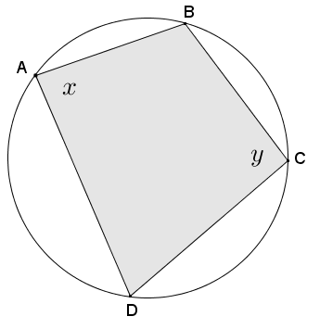
Given cyclic quadrilateral $ABCD$ shown in the diagram, prove that $x+y=180°$.
Statements | Reasons/Explanations
- $\left(m\hat{BCD}\right)+\left(m\hat{DAB}\right)=360°$ | - Arc$\hat{BCD}$ and arc$\hat{DAB}$ are non-overlapping arcs that form a complete circle.
- $\frac{1}{2}\left[\left(\hat{mBCD}\right)+\left(m\hat{DAB}\right)\right]=\frac{1}{2}\left(360°\right)$ | - Multiplicative property of equality
- $\frac{1}{2}\left(\hat{mBCD}\right)+\frac{1}{2}(m\hat{DAB}) =180°$ | - Distributive property
- $x=\frac{1}{2}(m\hat{BCD})$ and $y=\frac{1}{2}(m\hat{DAB})$ | - Inscribed angle theorem
- $x+y=180°$ | - Substitution

Example 1 (7 minutes)
Pose the question below to students before starting Example 1, and ask them to hypothesize their answers.
Scaffolding:
- Remind students that a triangle can be inscribed in a circle or a circle can be circumscribed about a triangle. This allows us to draw a circle on three of the four vertices of the quadrilateral. It is our job to show that the fourth vertex also lies on the circle.
- Have students create cyclic quadrilaterals and measure angles to see patterns. This will support concrete work.
- Explain proof by contradiction by presenting a simple proof such as $2$ points define a line, and have students try to prove this is not true.
- The Opening Exercise shows that if a quadrilateral is cyclic, then its opposite angles are supplementary. Let’s explore the converse relationship. If a quadrilateral has supplementary opposite angles, is the quadrilateral necessarily a cyclic quadrilateral?
  - Yes.
- How can we show that your hypothesis is valid?
  - Student answers will vary.
Example 1
Given quadrilateral $ABCD$ with $m∠A+m∠C=180°$, prove that quadrilateral $ABCD$ is cyclic; in other words, prove that points $A$,$B$,$C$, and $D$ lie on the same circle.
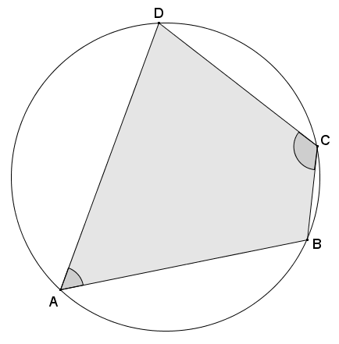

- First, we are given that angles $A$ and $C$ are supplementary. What does this mean about angles $B$ and $D$, and why?
MP.7
  - The angle sum of a quadrilateral is $360°$, and since it is given that angles $A$ and $C$ are supplementary, Angles $B$ and $D$ must then have a sum of $180°$.
- We, of course, can draw a circle through point $A$, and we can further draw a circle through points $A$ and $B$ (infinitely many circles, actually). Can we draw a circle through points $A$, $B$, and $C$?
  - Three non-collinear points can determine a circle, and since the points were given to be vertices of a quadrilateral, the points are non-collinear; so, yes!
- Can we draw a circle through points $A$, $B$, $C$, and $D$?
  - Not all quadrilaterals are cyclic (e.g., a non-rectangular parallelogram), so we cannot assume that a circle can be drawn through vertices $A$, $B$, $C$, and $D$.
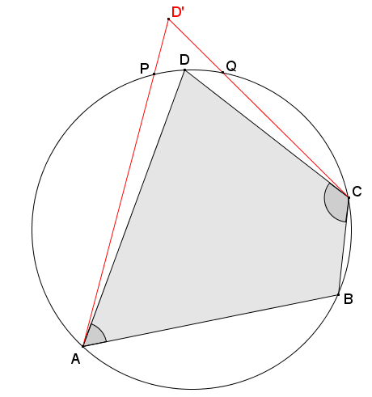
- Where could point $D$ lie in relation to the circle?
  - $D$ could lie on the circle, in the interior of the circle, or on the exterior of the circle.
- To show that $D$ lies on the circle with $A$, $B$, and $C$, we need to consider the cases where it is not, and show that those cases are impossible. First, let’s consider the case where $D$ is outside the circle. On the diagram, use a red pencil to locate and label point $D'$ such that it is outside the circle; then, draw segments $CD'$ and $AD'$.
- What do you notice about sides $AD'$ and $CD'$ if vertex $D'$ is outside the circle?
  - The sides intersect the circle and are, therefore, secants.

Statements | Reasons/Explanations
- $m∠A+m∠C=180°$ | - Given
- Assume point $D'$ lies outside the circle determined by points $A$, $B$, and $C$. | - Stated assumption for case 1.
- Segments $CD'$ and $AD'$ intersect the circle at distinct points $P$ and $Q$; thus, $m\hat{PQ}>0°$. | - If the segments intersect the circle at the same point, then $D'$ lies on the circle, and the stated assumption (Statement 2) is false.
- $m∠D^{'}=\frac{1}{2}\left(m\hat{ABC}-m\hat{PQ}\right)$ | - Secant angle theorem: exterior case
- $m∠B=\frac{1}{2}(m\hat{APC})$ | - Inscribed angle theorem
- $m∠A+m∠B+m∠C+m∠D'=360°$ | - The angle sum of a quadrilateral is $360°.$
- $m∠B+m∠D'=180°$ | - Substitution (Statements 1 and 6)
- $\frac{1}{2}\left(m\hat{APC}\right)+\frac{1}{2}\left(m\hat{ABC}-m\hat{PQ}\right)=180°$ | - Substitution (Statements 4, 5, and 7)
- $360°-m\hat{APC}=m\hat{ABC}$ | - Arcs $\hat{APC}$ and $\hat{ABC}$ are non-overlapping arcs that form a complete circle with a sum of $360°.$
- $\frac{1}{2}\left(m\hat{APC}\right)+\frac{1}{2}\left(\left(360°-m\hat{APC}\right)-m\hat{PQ}\right)=180°$ | - Substitution (Statements 8 and 9)
- $\frac{1}{2}\left(m\hat{APC}\right)+180°-\frac{1}{2}\left(m\hat{APC}\right)-m\hat{PQ}=180°$ | - Distributive property
- $m\hat{PQ}=0°$ | - Subtraction property of equality
- $D'$ cannot lie outside the circle. | - Statement 12 contradicts our stated assumption that $P$ and $Q$ are distinct with $m\hat{PQ}>0°$ (Statement 3).
Exercise 1 (5 minutes)
Students use a similar strategy to show that vertex $D$ cannot lie inside the circle.
Exercises
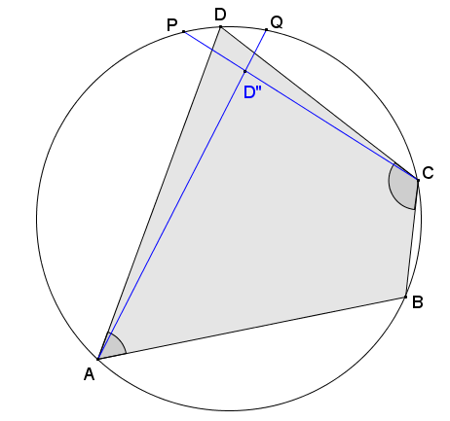
- Assume that vertex $D''$ lies inside the circle as shown in the diagram. Use a similar argument to Example 1 to show that vertex $D''$ cannot lie inside the circle.

Statements | Reasons/Explanations
- $m∠A+m∠C=180°$ | - Given
- Assume point $D'$ lies inside the circle determined by points $A$, $B$, and $C$. | - Stated assumption for case 2
- $\overset{⃡}{CD''}$ and $\overset{⃡}{AD''}$ intersect the circle at points $P$ and $Q$ respectively, thus $m\hat{PQ}>0$. | - If the segments intersect the circle at the same point, then $D'$ lies on the circle, and the stated assumption (Statement 2) is false.
- $m∠D^{''}=\frac{1}{2}\left(m\hat{PQ}+m\hat{ABC}\right)$ | - Secant angle theorem: interior case
- $m∠B=\frac{1}{2}\left(m\hat{APC}\right)$ | - Inscribed angle theorem
- $m∠A+m∠B+m∠C+m∠D^{''}=360°$ | - The angle sum of a quadrilateral is $360°.$
- $m∠B+m∠D^{''}=180°$ | - Substitution (Statements 1 and 6)
- $\frac{1}{2}\left(m\hat{APC}\right)+\frac{1}{2}\left(m\hat{PQ}+m\hat{ABC}\right)=180°$ | - Substitution (Statements 4, 5, and 7)
- $m\hat{ABC}=360°-m\hat{APC}$ | - Arcs $\hat{APC}$ and $\hat{ABC}$ are non-overlapping arcs that form a complete circle with a sum of $360°.$
- $\frac{1}{2}\left(m\hat{APC}\right)+\frac{1}{2}\left(m\hat{PQ}+\left(360°-m\hat{APC}\right)\right)=180°$ | - Substitution (Statements 8 and 9)
- $\frac{1}{2}\left(m\hat{APC}\right)+\frac{1}{2}\left(m\hat{PQ}\right)+180°-\frac{1}{2}\left(m\hat{APC}\right)=180°$ | - Distributive property
- $m\hat{PQ}=0°$ | - Subtraction property of equality
- $D''$ cannot lie inside the circle. | - Statement 12 contradicts our stated assumption that $P$ and $Q$ are distinct with $m\hat{PQ}>0°$ (Statement 3).

- In Example 1 and Exercise 1, we showed that the fourth vertex $D$ cannot lie outside the circle or inside the circle. What conclusion does this leave us with?
  - The fourth vertex must then lie on the circle with points $A$, $B$, and $C$.

- In the Opening Exercise, you showed that the opposite angles in a cyclic quadrilateral are supplementary. In Example 1 and Exercise 1, we showed that if a quadrilateral has supplementary opposite angles, then the vertices must lie on a circle. This confirms the following theorem:
Theorem: A quadrilateral is cyclic if and only if its opposite angles are supplementary.
- Take a moment to discuss with a shoulder partner what this theorem means and how we can use it.
  - Answers will vary.

Exercises 2–3 (5 minutes)
Students now apply the theorem about cyclic quadrilaterals.

- Quadrilateral $PQRS$ is a cyclic quadrilateral. Explain why $△PQT \sim △SRT$.
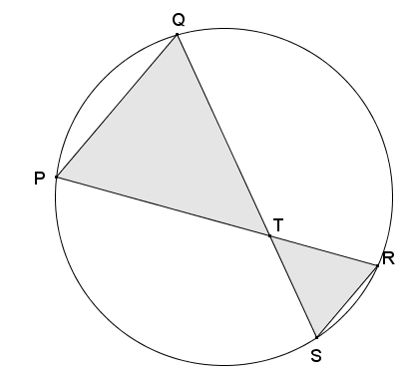
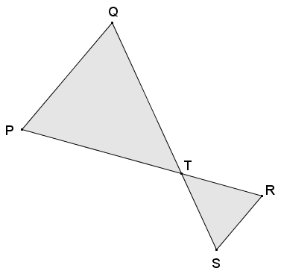
If $PQRS$ is a cyclic quadrilateral, draw circle on points $P$, $Q$,$R$, and $S$. Then $∠PQS$ and $∠PRS$ are angles inscribed in the same arc $\hat{SP}$; therefore, they are equal in measure. Also, $∠QPR$ and $∠QSR$ are both inscribed in the same arc $\hat{QR}$; therefore, they are equal in measure. Therefore, by AA criterion for similar triangles, $△PQT \sim △SRT$.
(Students may also use vertical angles relationship at $T$.)

- A cyclic quadrilateral has perpendicular diagonals. What is the area of the quadrilateral in terms of $a$,$b$,$c$, and $d$ as shown?
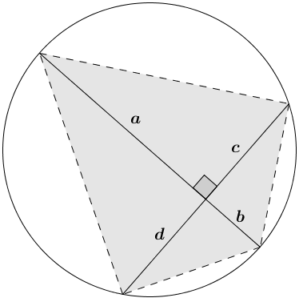
Using the area formula for a triangle $Area=base⋅height$, the area of the quadrilateral is the sum of the areas of the four right triangular regions.
$$Area=\frac{1}{2}ac+\frac{1}{2}cb+\frac{1}{2}bd+\frac{1}{2}da$$ OR
$$Area=\frac{1}{2}\left(ac+cb+bd+da\right)$$

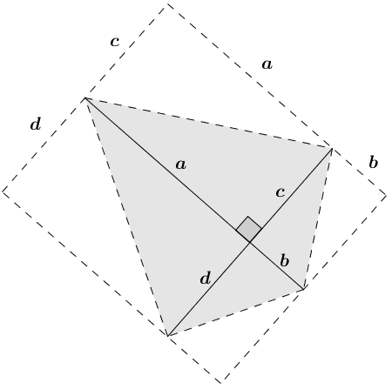
Discussion (5 minutes)
Redraw the cyclic quadrilateral from Exercise 3 as shown in diagram to the right.
- How does this diagram relate to the area(s) that you found in Exercise 3 in terms of $a$,$b$,$c$, and $d$?
  - Each right triangular region in the cyclic quadrilateral is half of a rectangular region. The area of the quadrilateral is the sum of the areas of the triangles, and also half the area of the sum of the four smaller rectangular regions.
- What are the lengths of the sides of the large rectangle?
  - The lengths of the sides of the large rectangle are $a+b$ and $c+d$.
- Using the lengths of the large rectangle, what is its area?
  - $Area=(a+b)(c+d)$
- How is the area of the given cyclic quadrilateral related to the area of the large rectangle?
  - The area of the cyclic quadrilateral is $\frac{1}{2}\left[\left(a+b\right)\left(c+d\right)\right]$.
- What does this say about the area of a cyclic quadrilateral with perpendicular diagonals?
  - The area of a cyclic quadrilateral with perpendicular diagonals is equal to one-half the product of the lengths of its diagonals.
- Can we extend this to other cyclic quadrilaterals (for instance, cyclic quadrilaterals whose diagonals intersect to form an acute angle $w°$)? Discuss this question with a shoulder partner before beginning Example 2.

Exercises 4–5 (Optional, 5 minutes)
These exercises may be necessary for review of the area of a non-right triangle using one acute angle. You may assign these as an additional problem set to the previous lesson because the skills have been taught before. If students demonstrate confidence with the content, go directly to Exercise 6.

- Show that the triangle in the diagram has area $\frac{1}{2}ab\sin\left(w\right)$.
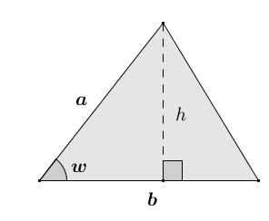
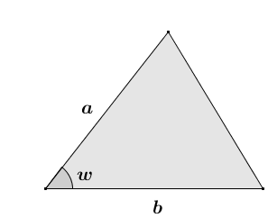
Draw altitude to side with length $b$ as shown in the diagram to form adjacent right triangles. Using right triangle trigonometry, the sine of the acute angle with degree measure $w$ is:
$\sin{w}=\frac{h}{a}$ where $h$ is the length of the altitude to side $b$.
It then follows that $h=a\sin{w}$.
Using the area formula for a triangle $Area=\frac{1}{2}×base×height$:
$Area=\frac{1}{2}b\left(a\sin\left(w\right)\right)$
$Area=\frac{1}{2}ab\sin\left(w\right)$

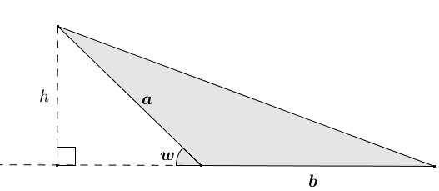
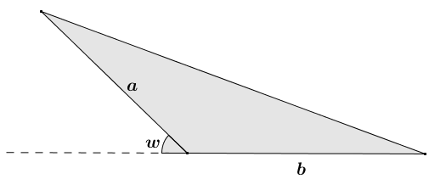
- Show that the triangle with obtuse angle $(180-w)°$ has area $\frac{1}{2}ab\sin\left(w\right)$.
Draw altitude to the line that includes the side of the triangle with length $b$. Using right triangle trigonometry:
$\sin\left(w\right)=\frac{h}{a}$ where $h$ is the length of the altitude drawn.
It follows then that $h=a\sin\left(w\right)$.
Using the area formula for a triangle
$Area=\frac{1}{2}×base×height$:
$Area=\frac{1}{2}b\left(a\sin\left(w\right)\right)$
$Area=\frac{1}{2}ab\sin\left(w\right)$

Exercise 6 (5 minutes)
Students in pairs apply the area formula $Area=\frac{1}{2}ab\sin\left(w\right)$, first encountered in Lesson 31 of Module 2, to show that the area of a cyclic quadrilateral is one-half the product of the lengths of its diagonals and the sine of the acute angle formed by their intersection.

- Show that the area of the cyclic quadrilateral shown in the diagram is $Area=\frac{1}{2}(a+b)(c+d)\sin\left(w\right)$.
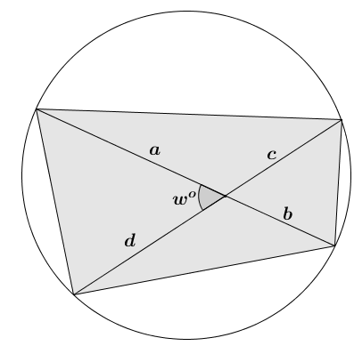
Using the area formula for a triangle $Area=\frac{1}{2}ab⋅\sin\left(w\right)$:
$Area_{1}=\frac{1}{2}ad⋅\sin{(w)}$
$Area_{2}=\frac{1}{2}ac⋅\sin{(w)}$
$Area_{3}=\frac{1}{2}bc⋅sin{(w})$
$Area_{4}=\frac{1}{2}bd⋅sin\left(w\right)$
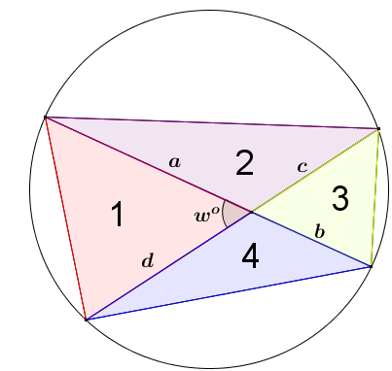
$Area_{total}=Area_{1}+Area_{2}+Area_{3}+Area_{4}$
$$Area_{total}=\frac{1}{2}ad⋅\sin\left(w\right)+\frac{1}{2}ac⋅\sin\left(w\right)+\frac{1}{2}bc⋅sin{(w})+\frac{1}{2}bd⋅sin\left(w\right)$$
$$Area_{total}=\left[\frac{1}{2}\sin\left(w\right)\right]\left(ad+ac+bc+bd\right)$$
$$Area_{total}=\left[\frac{1}{2}\sin\left(w\right)\right]\left[\left(a+b\right)\left(c+d\right)\right]$$
$$Area_{total}=\frac{1}{2}\left(a+b\right)\left(c+d\right)\sin\left(w\right)$$

Closing (3 minutes)
Ask students to verbally provide answers to the following closing questions based on the lesson:
- What angle relationship exists in any cyclic quadrilateral?
  - Both pairs of opposite angles are supplementary.
- If a quadrilateral has one pair of opposite angles supplementary, does it mean that the quadrilateral is cyclic? Why?
  - Yes. We proved that if the opposite angles of a quadrilateral are supplementary, then the fourth vertex of the quadrilateral must lie on the circle through the other three vertices.
- Describe how to find the area of a cyclic quadrilateral using its diagonals.
  - The area of a cyclic quadrilateral is one-half the product of the lengths of the diagonals and the sine of the acute angle formed at their intersection.
Lesson Summary
Theorems:
Given a convex quadrilateral, the quadrilateral is cyclic if and only if one pair of opposite angles is supplementary.
The area of a triangle with side lengths $a$ and $b$ and acute included angle with degree measure $w$:
$$Area=\frac{1}{2}ab⋅\sin\left(w\right).$$

The area of a cyclic quadrilateral $ABCD$ whose diagonals $\overline{AC}$ and $\overline{BD}$ intersect to form an acute or right angle with degree measure $w$:
$$Area\left(ABCD\right)=\frac{1}{2}⋅AC⋅BD⋅\sin\left(w\right).$$

Relevant Vocabulary
Cyclic Quadrilateral: A quadrilateral inscribed in a circle is called a cyclic quadrilateral.

Exit Ticket (5 minutes)

Name Date
Lesson 20: Cyclic Quadrilaterals

Exit Ticket

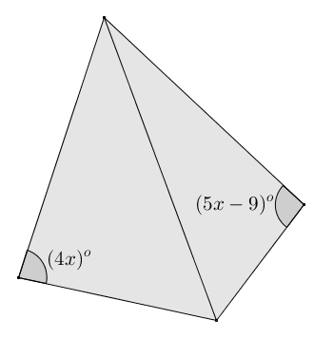
- What value of $x$ guarantees that the quadrilateral shown in the diagram below is cyclic? Explain.

- Given quadrilateral $GKHJ$, $m∠KGJ+m∠KHJ=180°$, $m∠HNJ=60°$, $KN=4$, $NJ=48$, $GN=8$, and $NH=24$, find the area of quadrilateral $GKHJ$. Justify your answer.
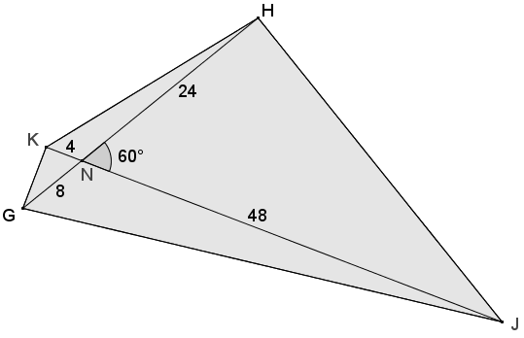
Exit Ticket Sample Solutions

- What value of $x$ guarantees that the quadrilateral shown in the diagram below is cyclic? Explain.
$$4x+5x-9=180 \\ 9x-9=180 \\ 9x=189 \\ x=21$$
If $x=21$, then the opposite angles shown are supplementary, and any quadrilateral with supplementary opposite angles is cyclic.

- Given quadrilateral $GKHJ$, $m∠KGJ+m∠KHJ=180°$, $m∠HNJ=60°$, $KN=4$, $NJ=48$, $GN=8$, and $NH=24$, find the area of quadrilateral $GKHJ$. Justify your answer.
Opposite angles $KGJ$ and $KHJ$ are supplementary, so quadrilateral $GKHJ$ is cyclic.
The area of a cyclic quadrilateral:
$$Area=\frac{1}{2}\left(4+48\right)\left(8+24\right)⋅\sin\left(60\right) \\ Area=\frac{1}{2}(52)(32)⋅\frac{\sqrt{3}}{2} \\ Area=\frac{\sqrt{3}}{4}⋅1664 \\ Area=416\sqrt{3}$$
The area of quadrilateral $GKHJ$ is $416\sqrt{3}$ square units.

Problem Set Sample Solutions
The problems in this Problem Set get progressively more difficult and require use of recent and prior skills. The length of the Problem Set may be too time consuming for students to complete in its entirety. Problems 10–12 are the most difficult and may be passed over, especially for struggling students.

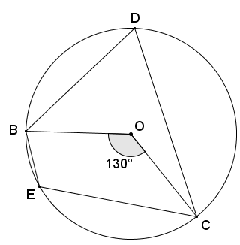
- Quadrilateral $BDCE$ is cyclic, $O$ is the center of the circle, and $m∠BOC=130°$. Find $m∠BEC$.
By the inscribed angle theorem, $m∠BDC=\frac{1}{2}m∠BOC$, so $m∠BDC=65°$.
Opposite angles of cyclic quadrilaterals are supplementary, so
$m∠BEC+65°=180°$. Thus, $m∠BEC=115°$.

- Quadrilateral $FAED$ is cyclic, $AX=8$, $FX=6$, $XD=3$, and $m∠AXE=130°$. Find the area of quadrilateral $FAED$.
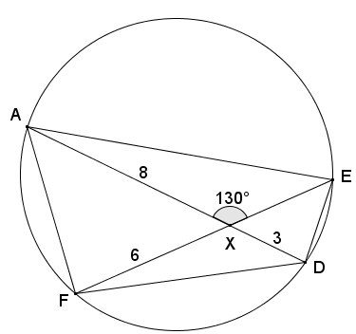
Using the two-chord power rule, $\left(AX\right)\left(XD\right)=(FX)(XE)$.
$8\left(3\right)=6\left(XE\right)$, thus $XE=4$.
The area of a cyclic quadrilateral is equal to the product of the lengths of the diagonals and the sine of the acute angle formed by them. The acute angle formed by the diagonals is $50°$.
$Area=(8+3)(6+4)⋅\sin\left(50\right)$
$Area=(11)(10)⋅\sin{(50)}$
$Area≈84.3$

- In the diagram below, $\overline{BE}∥\overline{CD}$, and $m∠BED=72°$. Find the value of $s$ and $t$.
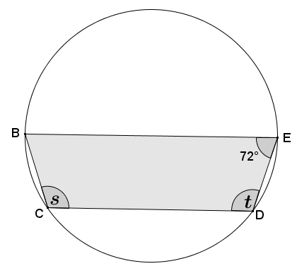
Quadrilateral $BCDE$ is cyclic, so opposite angles are supplementary.
$$s+72°=180° \\ s=108°$$
Parallel chords $BE$ and $CD$ intercept congruent arcs $\hat{CB}$ and $\hat{ED}$. By angle addition, $m\hat{CBE}=m\hat{BED}$, so it follows by the inscribed angle theorem that $s=t=108°$.

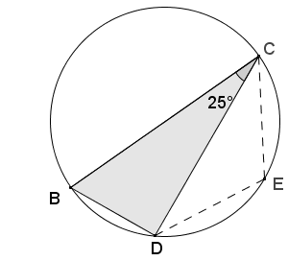
- In the diagram below, $\overline{BC}$ is the diameter, $m∠BCD=25°$, and $\overline{CE}≅\overline{DE}$. Find $m∠CED$.
Triangle $BCD$ is inscribed in a semicircle. By Thales’ theorem, $∠BDC$ is a right angle. By the angle sum of a triangle, $m∠DBC=65°$. Quadrilateral $BCED$ is cyclic, so opposite angles are supplementary.
$$65°+m∠CED=180° \\ m∠CED=115°$$
Triangle $CED$ is isosceles since $\overline{CE}≅\overline{DE}$, and by base $∠$’s, $∠EDC≅∠ECD$.
$2\left(m∠EDC\right)=180°-115°$, by the angle sum of a triangle.
$m∠EDC=32.5°$

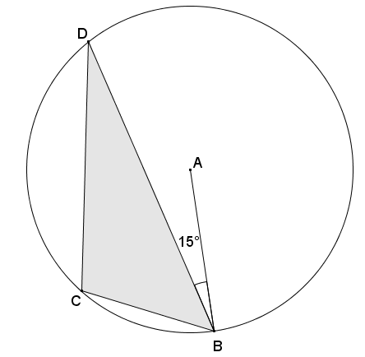
- In circle$A$, $m∠ABD=15°$. Find $m∠BCD$.
Draw diameter $\overline{BAX}$ such that $X$ is on the circle, then draw $\overline{DX}$. Triangle $BDX$ is inscribed in a semicircle; therefore, angle $BDX$ is a right angle. By the angle sum of a triangle, $m∠BXD=75°$.
Quadrilateral $BCDX$ is a cyclic quadrilateral, so its opposite angles are supplementary.
$$m∠BCD+m∠BXD=180° \\ m∠BCD+75°=180° \\ m∠BCD=105°$$

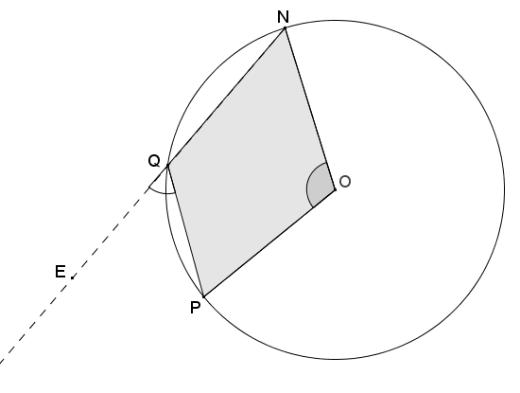
- Given the diagram below, $O$ is the center of the circle. If $m∠NOP=112°$, find $m∠PQE$.
Draw point $X$ on major arc $\hat{NP}$, and draw chords $\overline{XN}$ and $\overline{XP}$ to form cyclic quadrilateral $QNXP$. By the inscribed angle theorem, $m∠NXP=\frac{1}{2}m∠NOP$, so $m∠NXP=56°$.
An exterior angle $PQE$ of cyclic quadrilateral $QNXP$ is equal in measure to the angle opposite from vertex $Q$, which is $∠NXP$. Therefore, $m∠PQE=56°$.

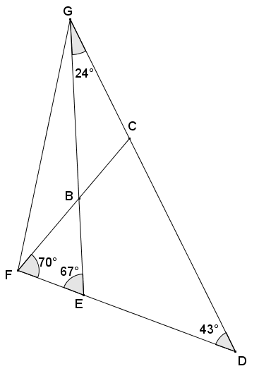
- Given the angle measures as indicated in the diagram below, prove that vertices $C$, $B$,$E$, and $D$ lie on a circle.
Using the angle sum of a triangle, $m∠FBE=43°$. Angles $GBC$ and $FBE$ are vertical angles and, therefore, have the same measure. Angles $GBF$ and $EBC$ are also vertical angles and have the same measure. Angles at a point sum to $360°$, so $m∠CBE=m∠FBG=137°$. Since $137+43=180$, angles $EBC$ and $EDC$ of quadrilateral $BCDE$ are supplementary. If a quadrilateral has opposite angles that are supplementary, then the quadrilateral is cyclic, which means that vertices $C$,$B$,$E$, and $D$ lie on a circle.

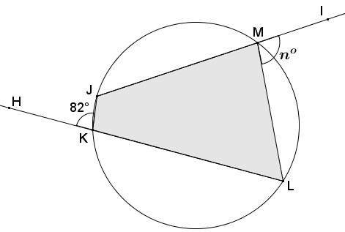
- In the diagram below, quadrilateral $JKLM$ is cyclic. Find the value of $n$.
Angles $HKJ$ and $LKJ$ form a linear pair and are supplementary, so angle $LKJ$ has measure of $98°$.
Opposite angles of a cyclic quadrilateral are supplementary; thus, $m∠JML=m∠JKH=82°$.
Angles $JML$ and $IML$ form a linear pair and are supplementary, so angle $IML$ has measure of $98°$. Therefore, $n=98$.

- Do all four perpendicular bisectors of the sides of a cyclic quadrilateral pass through a common point? Explain.
Yes. A cyclic quadrilateral has vertices that lie on a circle, which means that the vertices are equidistant from the center of the circle. The perpendicular bisector of a segment is the set of points equidistant from the segment’s endpoints. Since the center of the circle is equidistant from all of the vertices (endpoints of the segments that make up the sides of the cyclic quadrilateral), the center lies on all four perpendicular bisectors of the quadrilateral.

- The circles in the diagram below intersect at points $A$ and $B$. If $m∠FHG=100°$ and $m∠HGE=70°$, find $m∠GEF$ and $m∠EFH$.
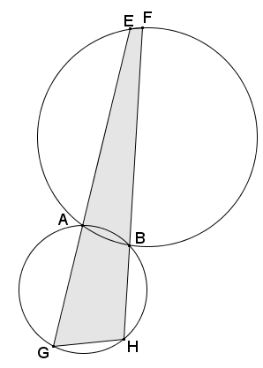
Quadrilaterals $GHBA$ and $EFBA$ are both cyclic since their vertices lie on circles. Opposite angles in cyclic quadrilaterals are supplementary.
$$m∠GAB+m∠FHG=180° \\ m∠GAB+100°=180° \\ m∠GAB=80°$$
$∠EAB$ and $∠GAB$ are supplementary since they form a linear pair, so
$m∠EAB=100°$.
$∠EAB$ and $∠EFB$ are supplementary since they are opposite angles in a cyclic quadrilateral, so $m∠EFB=80°$.
Using a similar argument:
$m∠HGE+m∠HBA=m∠HBA+m∠FBA=m∠FBA+m∠GEF=180°$
$m∠HGE+m∠HBA=m∠HBA+m∠FBA=m∠FBA+m∠GEF=180°$
$$m∠HGE+m∠GEF=180° \\ 70°+m∠GEF=180° \\ m∠GEF=110°$$

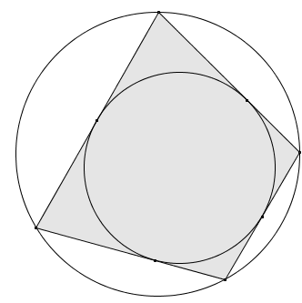
- A quadrilateral is called bicentric if it is both cyclic and possesses an inscribed circle. (See diagram to the right.)
  - What can be concluded about the opposite angles of a bicentric quadrilateral? Explain.
Since a bicentric quadrilateral must be also cyclic, its opposite angles must be supplementary.

  - Each side of the quadrilateral is tangent to the inscribed circle. What does this tell us about the segments contained in the sides of the quadrilateral?
Two tangents to a circle from an exterior point form congruent segments. The distances from a vertex of the quadrilateral to the tangent points where it meets the inscribed circle are equal.

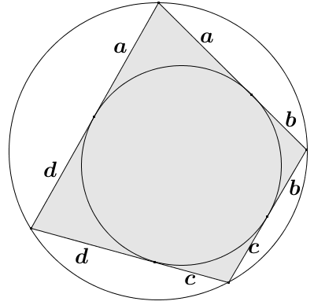
  - Based on the relationships highlighted in part (b), there are four pairs of congruent segments in the diagram. Label segments of equal length with $a$, $b$,$c$, and $d$.
See diagram on the right.

  - What do you notice about the opposite sides of the bicentric quadrilateral?
The sum of the lengths of one pair of opposite sides of the bicentric quadrilateral is equal to the sum of the lengths of the other pair of opposite sides:
$\left(a+b\right)+\left(c+d\right)=\left(d+a\right)+\left(b+c\right).$
- Quadrilateral $PSRQ$ is cyclic such that $\overline{PQ}$ is the diameter of the circle. If $∠QRT≅∠QSR$, prove that $∠PTR$ is a right angle, and show that $S$,$X$,$T$, and $P$ lie on a circle.
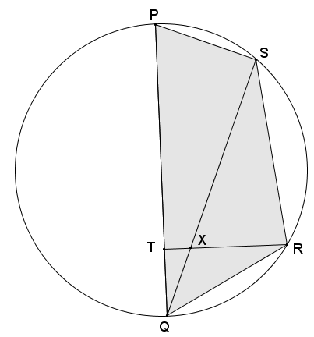
Angles $RQX$ and $SQR$ are congruent since they are the same angle. Since it was given that $∠QRT≅∠QSR$, it follows that $△QXR\sim △QRS$ by AA similarity criterion. Corresponding angles in similar figures are congruent, so
$∠QRS≅∠QXR$, and by vert.$∠$'s, $∠QXR≅∠TXS$.
Quadrilateral $PSRQ$ is cyclic, so its opposite angles $QPS$ and $QRS$ are supplementary. Since $∠QXR≅∠TXS$, it follows that angles $TXS$ and $QPS$ are supplementary. If a quadrilateral has a pair of opposite angles that are supplementary, then the quadrilateral is cyclic. Thus, quadrilateral $SXTP$ is cyclic.
Angle $PSQ$ is a right angle since it is inscribed in a semi-circle. If a quadrilateral is cyclic, then its opposite angles are supplementary; thus, angle $PTR$ must be supplementary to angle $PSQ$. Therefore, it is a right angle.

