Lesson 20: Cyclic Quadrilaterals

Classwork
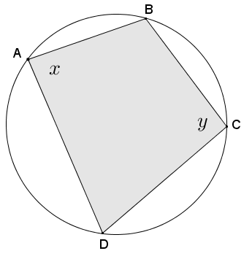
Opening Exercise
Given cyclic quadrilateral $ABCD$ shown in the diagram, prove that $x+y=180°$.

Example 1:
Given quadrilateral $ABCD$ with $m∠A+m∠C=180°$, prove that quadrilateral $ABCD$ is cyclic; in other words, prove that points $A, B, C,$ and $D$ lie on the same circle.
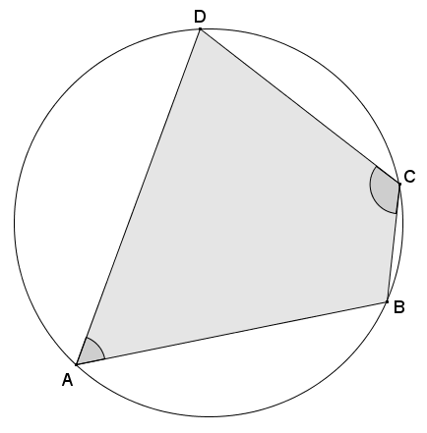

Exercises
- Assume that vertex $D''$ lies inside the circle as shown in the diagram. Use a similar argument to Example 1 to show that vertex $D''$ cannot lie inside the circle.
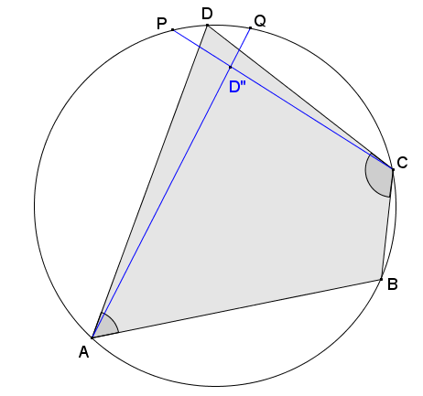

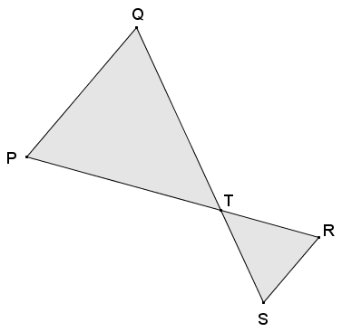
- Quadrilateral $PQRS$ is a cyclic quadrilateral. Explain why $△PQT \sim △SRT$.

- A cyclic quadrilateral has perpendicular diagonals. What is the area of the quadrilateral in terms of $a$, $b$,$c$, and $d$ as shown?
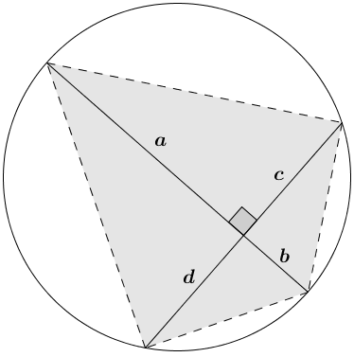

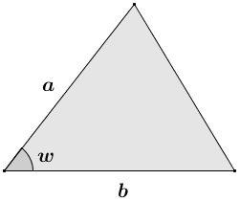
- Show that the triangle in the diagram has area $\frac{1}{2}ab\sin\left(w\right)$.

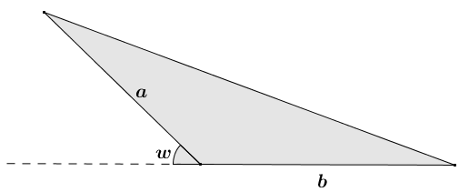
- Show that the triangle with obtuse angle $(180-w)°$ has area $\frac{1}{2}ab\sin\left(w\right)$.

- Show that the area of the cyclic quadrilateral shown in the diagram is $Area=\frac{1}{2}(a+b)(c+d)\sin\left(w\right)$.
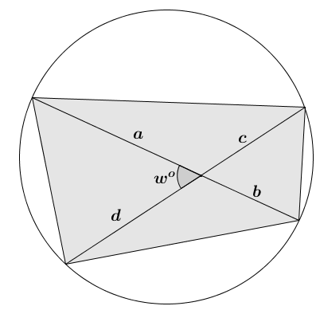

Lesson Summary
Theorems:
Given a convex quadrilateral, the quadrilateral is cyclic if and only if one pair of opposite angles is supplementary.
The area of a triangle with side lengths $a$ and $b$ and acute included angle with degree measure $w$:
$Area=\frac{1}{2}ab⋅\sin\left(w\right).$

The area of a cyclic quadrilateral $ABCD$ whose diagonals $\overline{AC}$ and $\overline{BD}$ intersect to form an acute or right angle with degree measure $w$: $Area\left(ABCD\right)=\frac{1}{2}⋅AC⋅BD⋅\sin\left(w\right).$

Relevant Vocabulary
Cyclic Quadrilateral: A quadrilateral inscribed in a circle is called a cyclic quadrilateral.

Problem Set

- Quadrilateral $BDCE$ is cyclic, $O$ is the center of the circle, and $m∠BOC=130°$. Find $m∠BEC$.
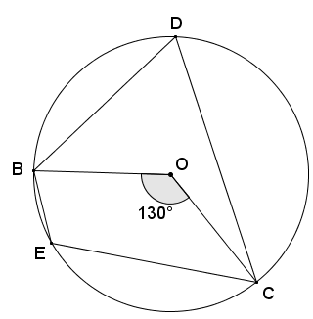

- Quadrilateral $FAED$ is cyclic, $AX=8$, $FX=6$, $XD=3$, and $m∠AXE=130°$. Find the area of quadrilateral $FAED$.
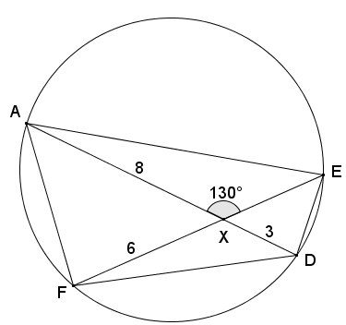

- In the diagram below, $\overline{BE}∥\overline{CD}$, and $m∠BED=72°$. Find the value of $s$ and $t$.
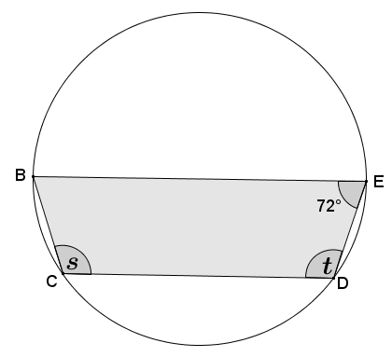

- In the diagram below, $\overline{BC}$ is the diameter, $m∠BCD=25°$, and $\overline{CE}≅\overline{DE}$. Find $m∠CED$.
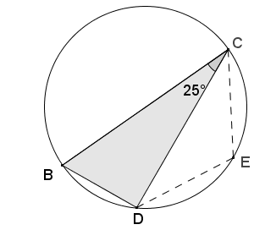

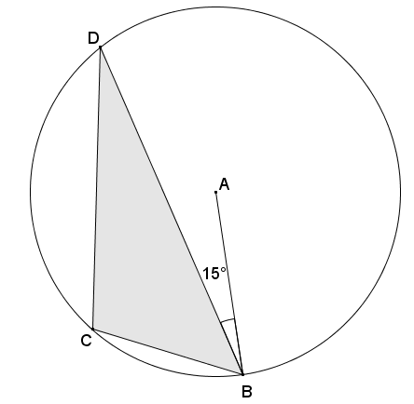
- In circle$A$, $m∠ABD=15°$. Find $m∠BCD$.

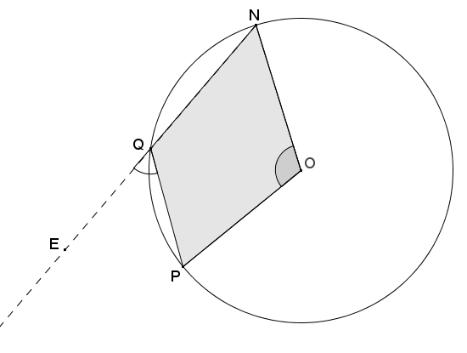
- Given the diagram below, $O$ is the center of the circle. If $m∠NOP=112°$, find $m∠PQE$.

- Given the angle measures as indicated in the diagram below, prove that vertices $C$,$B$,$E$, and $D$ lie on a circle.
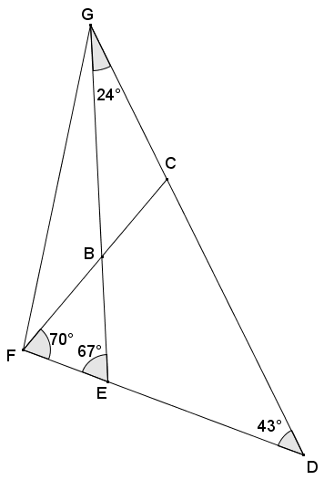

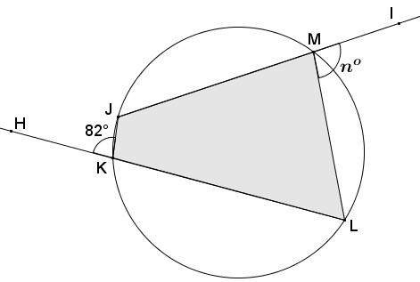
- In the diagram below, quadrilateral $JKLM$ is cyclic. Find the value of $n$.

- Do all four perpendicular bisectors of the sides of a cyclic quadrilateral pass through a common point? Explain.

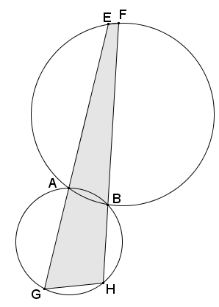
- The circles in the diagram below intersect at points $A$ and $B$. If $m∠FHG=100°$ and $m∠HGE=70°$, find $m∠GEF$ and $m∠EFH$.

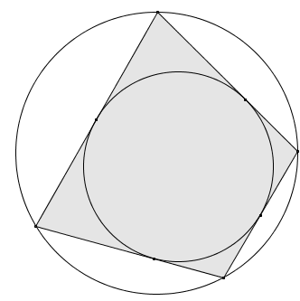
- A quadrilateral is called bicentric if it is both cyclic and possesses an inscribed circle. (See diagram to the right.)
  - What can be concluded about the opposite angles of a bicentric quadrilateral? Explain.
  - Each side of the quadrilateral is tangent to the inscribed circle. What does this tell us about the segments contained in the sides of the quadrilateral?
  - Based on the relationships highlighted in part (b), there are four pairs of congruent segments in the diagram. Label segments of equal length with $a$, $b, c,$ and $d$.
  - What do you notice about the opposite sides of the bicentric quadrilateral?

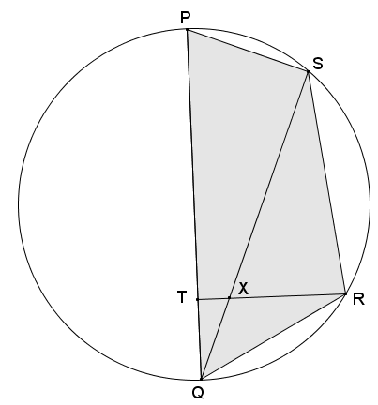
- Quadrilateral $PSRQ$ is cyclic such that $\overline{PQ}$ is the diameter of the circle. If $∠QRT≅∠QSR$, prove that $∠PTR$ is a right angle, and show that $S$,$X$,$T$, and $P$ lie on a circle.

