Lesson 19: Equations for Tangent Lines to Circles

Classwork
Opening Exercise
A circle of radius $5$ passes through points $A(-3,3)$ and $B(3,1)$.
  - What is the special name for segment $AB$?

  - How many circles can be drawn that meet the given criteria? Explain how you know.

  - What is the slope of $\overline{AB}$?

  - Find the midpoint of $\overline{AB}$.

  - Find the equations of the line containing a diameter of the given circle perpendicular to $\overline{AB}$.

  - Is there more than one answer possible for part (e)?

Example 1
Consider the circle with equation ${(x-3)}^{2}+{(y-5)}^{2}=20$. Find the equations of two tangent lines to the circle that each have slope $-\frac{1}{2}$.
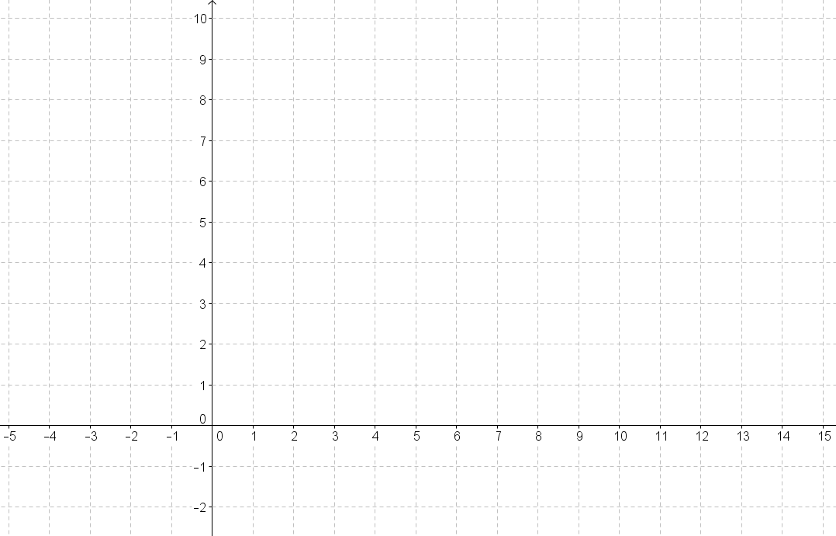

Exercise 1
Consider the circle with equation ${(x-4)}^{2}+{(y-5)}^{2}=20$. Find the equations of two tangent lines to the circle that each have slope $2$.

Example 2
Refer to the diagram below.
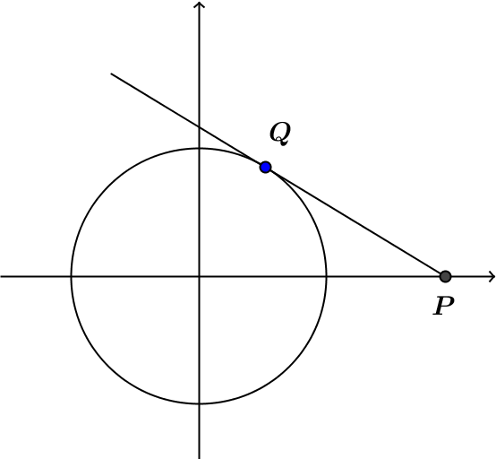
Let $p>1$. What is the equation of the tangent line to the circle $x^{2}+y^{2}=1$ through the point $(p,0)$ on the $x$-axis with a point of tangency in the upper half-plane?

Exercises
- Use the same diagram from Example 2 above, but label the point of tangency in the lower half-plane as $Q'$.
  - What are the coordinates of $Q^{'}?$

  - What is the slope of $\overline{OQ'}$?

  - What is the slope of $\overline{Q'P}$?

  - Find the equation of the second tangent line to the circle through $(p,0)$.

- Show that a circle with equation ${\left(x-2\right)}^{2}+{\left(y+3\right)}^{2}=160$ has two tangent lines with equations
$y+15=\frac{1}{3}(x-6)$ and $y-9=\frac{1}{3}\left(x+2\right).$

- Could a circle given by the equation ${\left(x-5\right)}^{2}+{\left(y-1\right)}^{2}=25$ have tangent lines given by the equations $y-4=\frac{4}{3}(x-1)$ and $y-5=\frac{3}{4}(x-8)?$ Explain how you know.

Lesson Summary
Theorems
A tangent line to a circle is perpendicular to the radius of the circle drawn to the point of tangency.

Relevant Vocabulary
Tangent to a circle. A tangent line to a circle is a line in the same plane that intersects the circle in one and only one point. This point is called the point of tangency.

Problem Set

- Consider the circle ${(x-1)}^{2}+{(y-2)}^{2}=16$. There are two lines tangent to this circle having a slope of $0$.
  - Find the coordinates of the points of tangency.
  - Find the equations of the two tangent lines.

- Consider the circle $x^{2}-4x+y^{2}+10y+13=0$. There are two lines tangent to this circle having a slope of $\frac{2}{3}$.
  - Find the coordinates of the two points of tangency.
  - Find the equations of the two tangent lines.

- What are the coordinates of the points of tangency of the two tangent lines through the point $(1,1)$ each tangent to the circle $x^{2}+y^{2}=1$?

- What are the coordinates of the points of tangency of the two tangent lines through the point $(-1,-1)$ each tangent to the circle $x^{2}+y^{2}=1$?

- What is the equation of the tangent line to the circle $x^{2}+y^{2}=1$ through the point $(6,0)$?

- D’Andre said that a circle with equation ${\left(x-2\right)}^{2}+{\left(y-7\right)}^{2}=13$ has a tangent line represented by the equation $y-5=-\frac{3}{2}\left(x+1\right).$ Is he correct? Explain.

- Kamal gives the following proof that $y-1=\frac{8}{9}(x+10)$ is the equation of a line that is tangent to a circle given by ${\left(x+1\right)}^{2}+{\left(y-9\right)}^{2}=145.$
The circle has center $(-1,9)$ and radius $12.$ The point $(-10,1)$ is on the circle because
$${\left(-10+1\right)}^{2}+{\left(1-9\right)}^{2}={\left(-9\right)}^{2}+{\left(-8\right)}^{2}=145.$$
The slope of the radius is $\frac{9-1}{-1—10}=\frac{8}{9}$; therefore, the equation of the tangent line is $y-1=\frac{8}{9}\left(x+10\right).$
  - Kerry said that Kamal has made an error. What was Kamal’s error? Explain what he did wrong.
  - What should the equation for the tangent line be?

- Describe a similarity transformation that maps a circle given by $x^{2}+6x+y^{2}-2y=71$ to a circle of radius $3$ that is tangent to both axes in the first quadrant.

