|  |
| --- |
|  |

Lesson 18: Recognizing Equations of Circles

Student Outcomes

* Students complete the square in order to write the equation of a circle in center-radius form.
* Students recognize when a quadratic in and is the equation for a circle.

Lesson Notes

This lesson builds from the understanding of equations of circles in Lesson 17. The goal is for students to recognize when a quadratic equation in and is the equation for a circle. The Opening Exercise reminds students of algebraic skills that are needed in this lesson, specifically multiplying binomials, factoring trinomials, and completing the square. Throughout the lesson, students will need to complete the square (**A-SSE.3b**) in order to determine the center and radius of the circle. Completing the square was taught in Grade 9, Module 4, Lessons 11 and 12.

Classwork

Opening Exercise (6 minutes)

It is important that students can factor trinomial squares and complete the square in order to recognize equations of circles. Use the following exercises to determine which students may need remediation of these skills.

Opening Exercise

* 1. Express this as a trinomial:

*Scaffolding:*

* For English language learners and students that may be below grade level, a visual approach may help students understand completing the square.
* For example, students may view an equation such as first by developing a visual that supports the left side of the equation.
* Students then view solving the equation as finding the missing piece (literally, completing the square).



* 1. Express this as a trinomial:
  2. Factor the trinomial :
  3. Complete the square to solve the following equation:

Ask students to share answers and discuss parts that they may have found challenging.

**Example 1 (4 minutes)**

Example 1

The following is the equation of a circle with radius and center Do you see why?

**MP.1**

Provide time for students to think about this in pairs or small groups. If necessary, guide their thinking by telling students that parts (a)–(c) in the Opening Exercise are related to the work they will be doing in this example. Allow individual students or groups of students to share their reasoning as to how they make the connection between the information given about a circle and the equation. Once students have shared their thinking, continue with the reasoning below.

*Scaffolding:*

Ask students to identify a point (perhaps by sketching the graph) that should be on the circle, and verify that it satisfies the equation given.

* We know that the equation is a circle with radius and center because when we multiply out the equation we get .

Provide students time to verify that these equations are equal.

* Recall the equation for a circle with center and radius from the previous lesson.
* Multiply out each of the binomials to write an equivalent equation.
* Sometimes equations of circles are presented in this simplified form. To easily identify the center and the radius of the graph of the circle, we sometimes need to factor and/or complete the square in order to rewrite the equation back in its standard form

Exercise 1 (3 minutes)

Use the exercise below to assess students’ understanding of the content in Example 1.

Exercise

*Scaffolding:*

* Students can draw squares as in the Opening Exercise to complete the square.
* For advanced learners, offer equations with coefficients on one or both of the squared terms. For example,

1. Rewrite the following equations in the form

**Example 2 (5 minutes)**

Example 2

What is the center and radius of the following circle?

Provide time for students to think about this in pairs or small groups. If necessary, guide their thinking by telling students that part (d) in the Opening Exercise is related to the work they will be doing in this example. Allow individual students or groups of students to share their reasoning as to how they determine the radius and center of the circle.

* We can complete the square, twice, in order to rewrite the equation in the necessary form.

First,

**MP.1**

Second,

Then,

Therefore, the center is at and the radius is

Exercises 2–4 (6 minutes)

Use the exercise below to assess students’ understanding of the content in Example 2.

Exercises

1. Identify the center and radius for each of the following circles.

The center is and the radius is

The center is , and the radius is .

*Scaffolding:*

* Allow accelerated groups of students time to complete the square on their own.
* For students who are struggling, ask questions such as the following:
* “What is the final form we are trying to put this equation in?”
* “What would we need to add to to create a perfect square trinomial?”

1. Could the circle with equation have a radius of ? Why or why not?

Yes, the radius is .

1. Stella says the equation has a center of and a radius of . Is she correct? Why or why not?

The center is , but the radius is . She did not add the values to the left that she added to the right when completing the square.

**Example 3 (8 minutes)**

Example 3

Could represent a circle?

Let students think about this. Answers will vary.

* The goal is to be able to recognize when the graph of an equation is, in fact, a circle. Suppose we look at another way:
* This equation can be rewritten using the commutative and associative properties of addition. We will also use the subtraction property of equality to set the equation equal to zero:
* What is the equation of a circle?
* Expand the equation.
* Now rearrange terms using the commutative and associative properties of addition to match .
* What expressions are equivalent to , , and ?
  + , and  *where and are constants.*
* So, could represent a circle?
  + *Yes*.
* The graph of the equation is a circle, a point, or an empty set. We want to be able to determine which of the three possibilities is true for a given equation.
* Let’s begin by completing the square:
* Just as the discriminant is used to determine how many times a graph will intersect the -axis, we use the right side of the equation above to determine what the graph of the equation will look like.
* If the fraction on the right is positive, then we can identify the center of the circle as and the radius as
* What do you think it means if the fraction on the right is zero?
  + *It means we could locate a center, but the radius is therefore, the graph of the equation is a point, not a circle.*
* What do you think it means if the fraction on the right is negative?
  + *It means that we have a negative length of a radius, which is impossible.*
* When the fraction on the right is negative, we have an empty set. That is, there are no possible solutions to this equation because the sum of two squared numbers cannot be negative. If there are no solutions, then there are no ordered points to graph.
* We can apply this knowledge to equations whose graphs we cannot easily identify. For example, write the equation in the form of
  + *Since the right side of the equation is zero, then the graph of the equation is a point,*

Exercise 5 (6 minutes)

Use the exercise below to assess students’ understanding of the content in Example 3.

1. Identify the graphs of the following equations as a circle, a point, or an empty set.

The right side of the equation is positive, so the graph of the equation is a circle.

The right side of the equation is negative, so the graph of this equation cannot be a circle; it is an empty set.

The right side of the equation is equal to zero, so the graph of the equation is a point.

Closing (2 minutes)

Have students summarize the main points of the lesson in writing, by talking to a partner, or as a whole class discussion. Use the questions below, if necessary.

* Describe the algebraic skills that were necessary to work with equations of circles that were not of the form .
* Given the graph of a quadratic equation in and how can we recognize it as a circle or something else?

Exit Ticket (5 minutes)

Name Date

Lesson 18: Recognizing Equations of Circles

Exit Ticket

1. The graph of the equation below is a circle. Identify the center and radius of the circle.
2. Describe the graph of each equation. Explain how you know what the graph will look like.

Exit Ticket Sample Solutions

1. The graph of the equation below is a circle. Identify the center and radius of the circle.

The center is and the radius is

1. Describe the graph of each equation. Explain how you know what the graph will look like.

The graph of this equation is a point. I can place a center at , but the radius is equal to zero. Therefore, the graph is just a single point.

The right side of the equation is negative, so its graph cannot be a circle; it is an empty set.

The graph of this equation is a circle with center and radius Since the equation can be put in the form I know the graph of it is a circle.

Problem Set Sample Solutions

1. Identify the center and radii of the following circles.

The center is and the radius is

The center is and the radius is

The center is and the radius is

The center is and the radius is

**The center is and the radius is**

1. Sketch a graph of the following equations.

The right side of the equation is negative, so its graph cannot be a circle; it is an empty set, and since there are no solutions, there is nothing to graph.

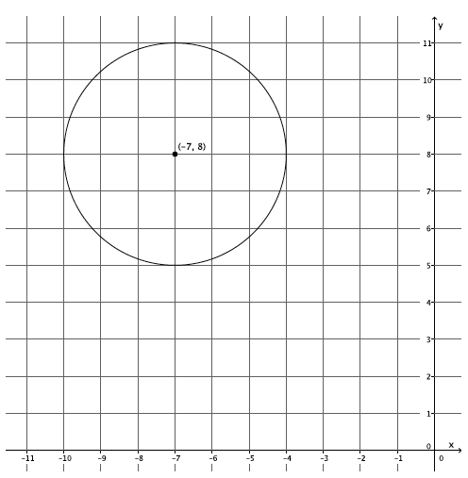The graph of the equation is a circle with center and radius

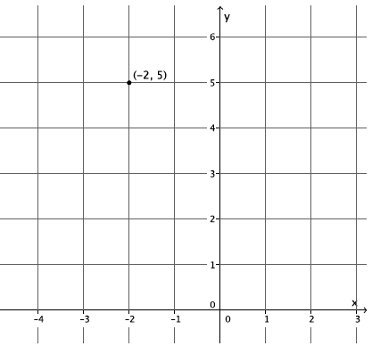The graph of this equation is a point at .

1. Chante claims that two circles given by and are externally tangent. She is right. Show that she is.

This graph of this equation is a circle with center and radius

This graph of this equation is a circle with center and radius

By the distance formula, the distance between the two centers is which is precisely the sum of the radii of the two circles. Therefore, these circles will touch only at one point. Put differently, they are externally tangent.

1. Draw a circle. Randomly select a point in the interior of the circle; label the point . Construct the greatest radius circle with center that lies within the circular region defined by the original circle. Hint: Draw a line through the center, the circle, and point

Constructions will vary. Ensure that students have drawn two circles such that the circle with center is in the interior and tangent to the original circle.