|  |
| --- |
|  |

Lesson 17: Writing the Equation for a Circle

Student Outcomes

* Students write the equation for a circle in center-radius form, using the Pythagorean Theorem or the distance formula.
* Students write the equation of a circle given the center and radius. Students identify the center and radius of a circle given the equation.

Lesson Notes

In this lesson, students deduce the equation for a circle in center-radius form, using what they already know about the Pythagorean Theorem and the distance formula: the distance between two points, and is . Exercise 11 foreshadows the work of the next lesson where students will need to complete the square in order to determine the equation of a circle.

Classwork

Opening Exercise (4 minutes)

Opening Exercise

1. 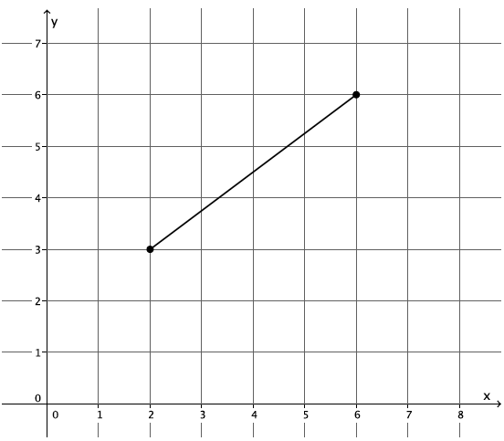What is the length of the segment shown on the coordinate plane below?

Students may use the Pythagorean Theorem or the distance formula to determine the length of the segment to be units.

1. Use the distance formula to determine the distance between points and

**Example 1 (10 minutes)**

Example 1

If we graph all of the points whose distance from the origin is equal to , what shape will be formed?

By definition, the set of all points in the plane whose distance from the origin is units is called a circle.

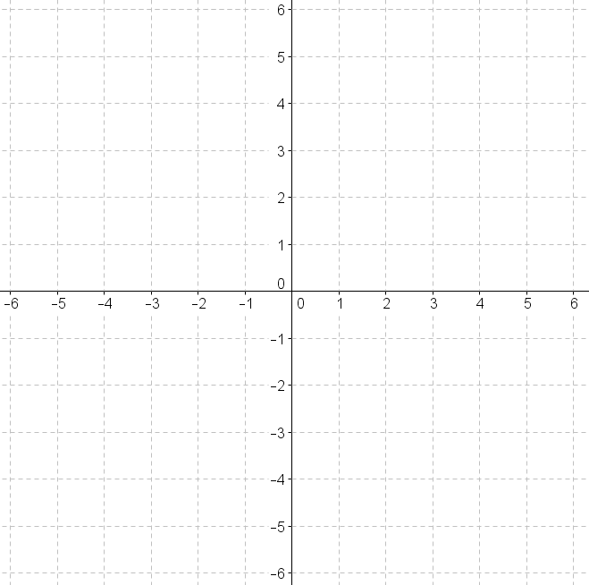

* Our goal now is to find the coordinates of eight of those points that comprise the circle. Four are very easy to find. What are they?

Provide time for students to think and discuss how to find the coordinates of the four “easy” points. Have students explain how they got their coordinates.

* + *The four points are and To find these points, we went right, left, up, and down units from the origin.*
* Now we need to locate four more points on the circle. We need the distance from the origin, i.e., the center of the circle, to be Graphically, we are looking for the coordinates that are exactly units from the center of the circle:
* 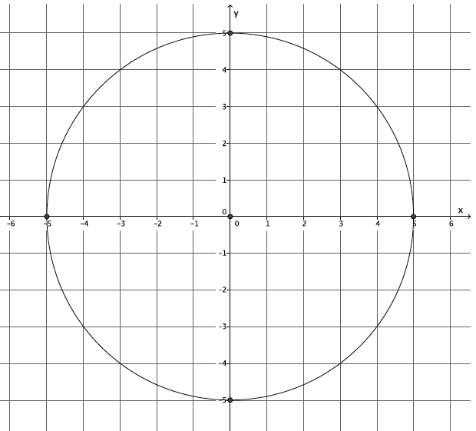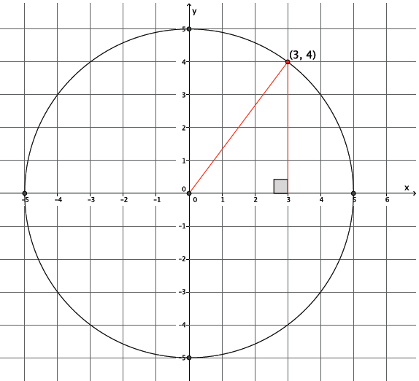Identify one other point on the circle that appears to be units from the center of the circle.
  + *Students may identify or*
* What can we do to be sure that the distance between the center of the circle and the identified point is in fact

Provide time for students to discuss the answer to this question. Some students may say they could use the Pythagorean Theorem and others may say they could use the distance formula. Since the distance formula is derived from the Pythagorean Theorem, both answers are correct. Encourage students to explain their use of either strategy. For example, using the Pythagorean Theorem and point we have the following:

Using the coordinates, we know that one leg of the right triangle formed above has length and the other has length . We must check that the hypotenuse is equal to To that end, is true, and the point is units from the center of the circle. This process can be repeated to check the three other points, but it is not necessary.

*Scaffolding:*

Using a chart to organize calculations could be helpful. See example below.

The distance formula will bring students to the same conclusion. To find the distance between the origin and the point , we must calculate . We must show that the distance between the two points is . Make clear to students that using the distance formula in this case, where the center is at the origin, is no different from the strategy of using the Pythagorean Theorem because

* Based on our work using the Pythagorean Theorem, we can say that any point on this circle whose center is at the origin and whose radius is must satisfy the equation In other words, all solutions to the equation are the points of the circle.

**Example 2 (10 minutes)**

Example 2

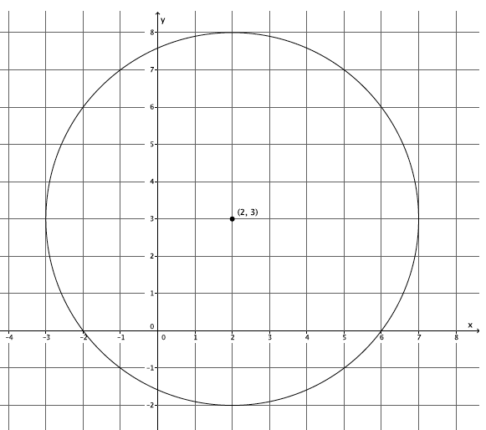Let’s look at another circle, one whose center is not at the origin. Shown below is a circle with center with radius

* Again, there are four points that are easy to locate and others that can be verified using the Pythagorean Theorem or distance formula. What are the differences between this circle and the one we just looked at in Example 1?

Provide students time to discuss the answer to this question.

* + *Both of the circles have a radius of , but their centers are different, which makes the points that comprise the circles different.*
* Are the circles congruent? Is there a sequence of basic rigid motions that would take this circle to the origin? Explain.

**MP.3**

* + *Yes, the circles are congruent because both have a radius equal to We could map one circle onto the other using a translation. For example, we could translate the circle with center at to the origin by translating along a vector from point to point*

*Scaffolding:*

Give students specific points to compare. For example, compare the point from the circle above to the point on the circle whose center is at the origin.

* What effect does the translation have on all of the points from the circle above?

Show the circles side by side. Provide time for students to discuss this with partners.

* + *Each -coordinate is decreased by and each -coordinate is decreased by*
* The effect that translation has on the points can be expressed as the following. Let be any point on the circle with center Then, the coordinates of all of the points after the translation are:
* Since the radius is equal to , we can locate any point on the circle using the Pythagorean Theorem as we did before.

The solutions to this equation are all the points of a circle whose radius is and center is at

* What do the numbers and represent in the equation above?
  + *The and represent the location of the center and the is the radius.*
* Assume we have a circle with radius whose center is at What is an equation whose graph is that circle?

Provide time for students to discuss this in pairs.

* + *The circle with radius and center at is given by the graph of the equation .*
* Assume we have a circle with radius whose center is at What is an equation whose graph is that circle?

Provide time for students to discuss this in pairs.

* + *The circle with radius and center at is given by the graph of the equation .*
* The last equation, is the general equation for any circle with radius and center

Exercises 3–11 (12 minutes)

Students should be able to complete Exercises 3–5 independently. Check that the answers to Exercises 3–5 are correct before assigning the remaining exercises in the set.

Exercises

1. Write an equation for the circle whose center is at and has radius
2. 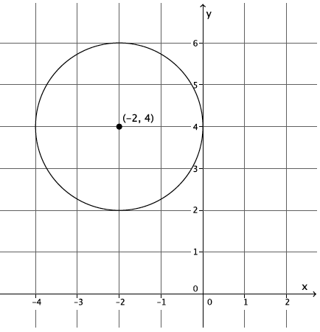Write an equation whose graph is the circle below.
3. What is the radius and center of the circle given by the equation

The radius is and the center is

1. Petra is given the equation and identifies its graph as a circle whose center is and radius is Has Petra made a mistake? Explain.

Petra did not identify the correct center. The general form for the equation of a circle is given by where is the center and is the radius. Petra noted the value of as when it is really and the value of as when it is really Therefore, Petra should have identified the center as . The radius was identified correctly.

* 1. What is the radius of the circle with center that passes through
  2. What is the equation of this circle?

1. A circle with center is tangent to the -axis.
   1. What is the radius of the circle?

* 1. What is the equation of the circle?

1. Two points in the plane, and , represent the endpoints of the diameter of a circle.
   1. What is the center of the circle? Explain.

; the midpoint of the diameter.

* 1. What is the radius of the circle? Explain.

; the distance from one endpoint to the center.

* 1. Write the equation of the circle.

1. Consider the circles with equations:
   1. What are the radii of the circles?

The radii are and .

* 1. What is the distance between the centers of the circles?
  2. 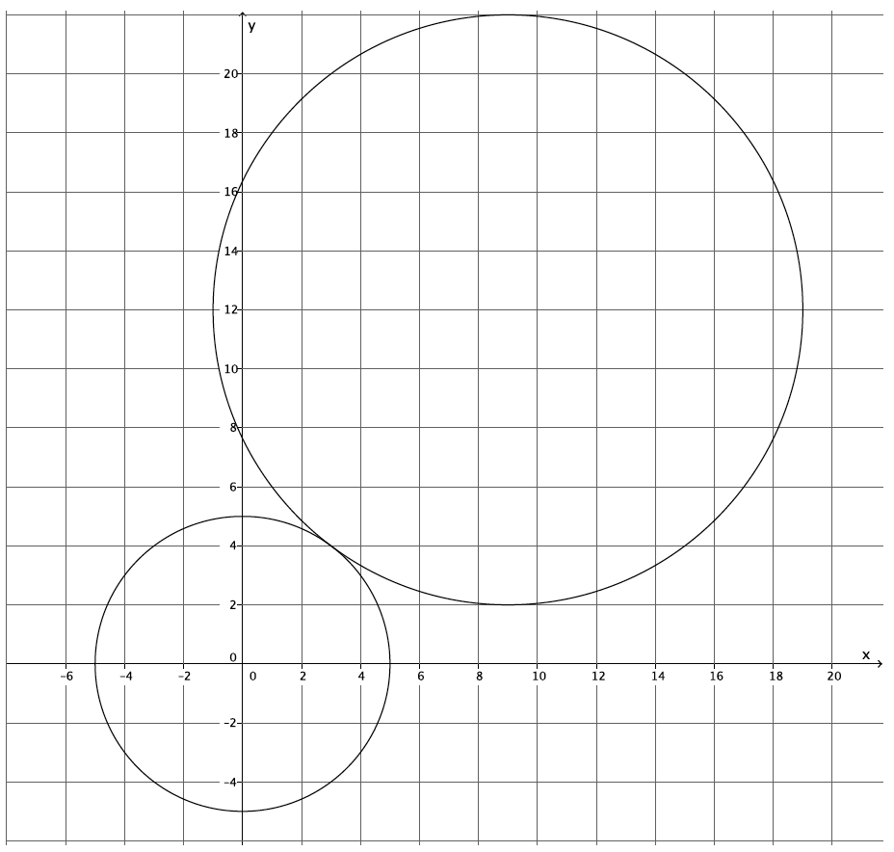Make a rough sketch of the two circles to explain why the circles must be tangent to one another.

The circles must be tangent because there is just one point that is common to both graphs (or there is only one solution that satisfies both equations), i.e.,

*Scaffolding:*

* If students are struggling, have them practice factoring perfect square trinomials.
* Factor

1. **A** circle is given by the equation
   1. What is the center of the circle?

The center is at

* 1. What is the radius of the circle?

The radius is

* 1. Describe what you had to do in order to determine the center and the radius of the circle.

I had to factor each of the trinomials to get the equation in the proper form in order to identify the center of the circle. To get the radius, I had to take the square root of

Closing (4 minutes)

Have students summarize the main points of the lesson in writing, by talking to a partner, or as a whole class discussion. Use the questions below, if necessary.

* Which fundamental theorem was critical for allowing us to write the equation of a circle?
* The equation of a circle can always be rewritten into what form?
* What parts of the equation give information about the center of the circle? The radius?

Lesson Summary

is the general equation for any circle with radius and center

Exit Ticket (5 minutes)

Name Date

Lesson 17: Writing the Equation for a Circle

Exit Ticket

1. Describe the circle given by the equation
2. Write the equation for a circle with center and radius
3. Write the equation for the circle shown below.

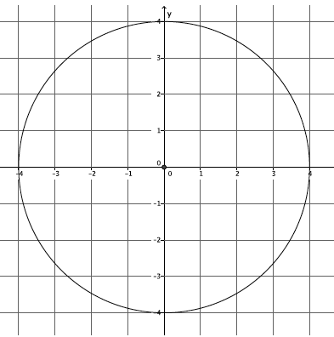

1. A circle has a diameter with endpoints at and Write the equation for the circle.

Exit Ticket Sample Solutions

1. Describe the circle given by the equation

The circle has a center at and a radius of

1. Write the equation for a circle with center and radius
2. Write the equation for the circle shown below.



1. A circle has a diameter with endpoints at and Write the equation for the circle.

Problem Set Sample Solutions

1. Write the equation for a circle with center and radius
2. What is the center and radius of the circle given by the equation

The center is located at and the radius is

1. A circle is given by the equation Which of the following points are on the circle?

This point is on the circle.

This point is on the circle.

This point is not on the circle.

This point is not on the circle.

This point is on the circle.

1. Determine the center and radius of each circle:

The center is at and the radius is

The center is at and the radius is

The center is at and the radius is

1. A circle has center and passes through the point
   1. What is the radius of the circle?
   2. Write the equation of the circle.
2. Two points in the plane, and represent the endpoints of the diameter of a circle.
   1. What is the center of the circle?
   2. What is the radius of the circle?
   3. Write the equation of the circle.
3. Write the equation of the circle shown below.

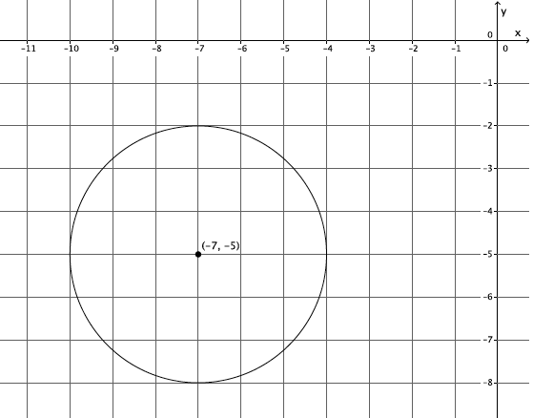

1. Write the equation of the circle shown below.

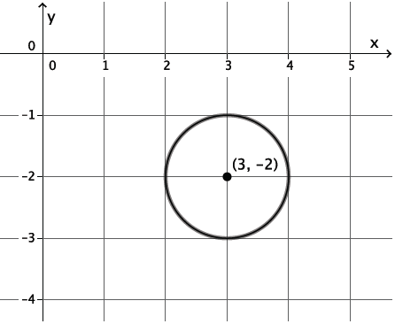

1. Consider the circles with equations:
   1. What are the radii of the two circles?

The radii are and

* 1. What is the distance between their centers?
  2. 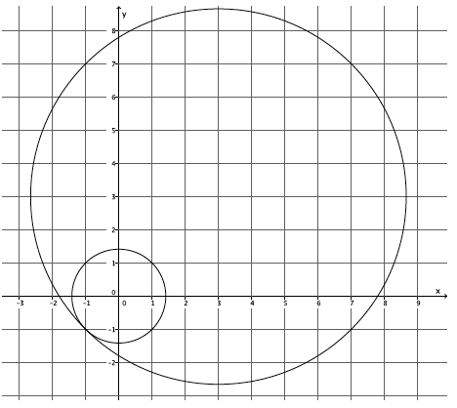Make a rough sketch of the two circles to explain why the circles must be tangent to one another.

The circles must be tangent because there is just one point that is common to both graphs (or there is only one solution that satisfies both equations), i.e.,