Lesson 17: Writing the Equation for a Circle

Classwork
Opening Exercise
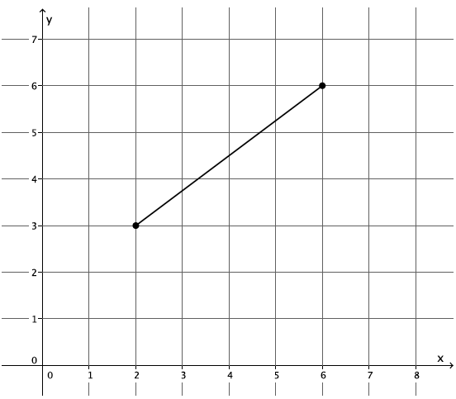
- What is the length of the segment shown on the coordinate plane below?

- Use the distance formula to determine the distance between points $(9, 15)$ and $\left(3, 7\right).$

Example 1
If we graph all of the points whose distance from the origin is equal to $5$, what shape will be formed?

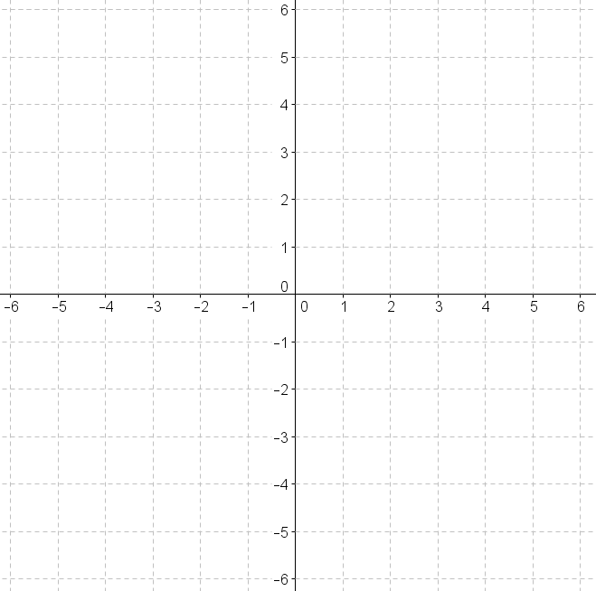

Example 2
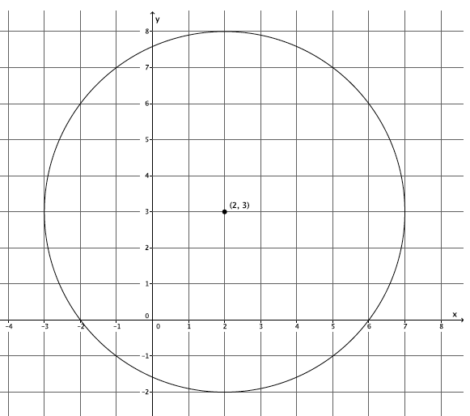
Shown below is a circle with center $(2, 3)$ with radius $5.$

Exercises
- Write an equation for the circle whose center is at $(9, 0)$ and has radius $7.$

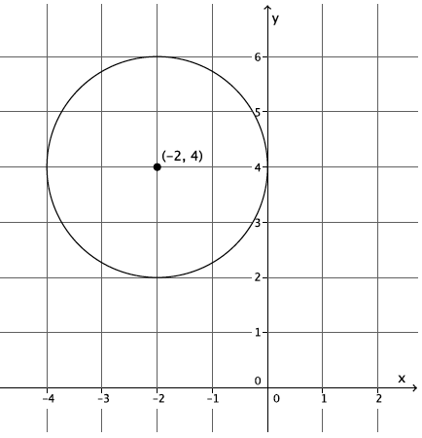
- Write an equation whose graph is the circle below.

- What is the radius and center of the circle given by the equation ${\left(x+12\right)}^{2}+{\left(y-4\right)}^{2}=81?$

- Petra is given the equation ${\left(x-15\right)}^{2}+{\left(y+4\right)}^{2}=100$ and identifies its graph as a circle whose center is $(-15, 4)$ and radius is $10.$ Has Petra made a mistake? Explain.

  - What is the radius of the circle with center $\left(3, 10\right)$ that passes through $\left(12, 12\right)?$

  - What is the equation of this circle?

- A circle with center $(2, -5)$ is tangent to the $x$-axis.
  - What is the radius of the circle?

  - What is the equation of the circle?

- Two points in the plane, $A=(-3,8)$ and $B=(17,8)$, represent the endpoints of the diameter of a circle.
  - What is the center of the circle? Explain.

  - What is the radius of the circle? Explain.

  - Write the equation of the circle.

- Consider the circles with equations:
$$x^{2}+y^{2}=25 and$$
$${\left(x-9\right)}^{2}+{\left(y-12\right)}^{2}=100.$$
  - What are the radii of the circles?

  - What is the distance between the centers of the circles?

  - Make a rough sketch of the two circles to explain why the circles must be tangent to one another.

- A circle is given by the equation $\left(x^{2}+2x+1\right)+\left(y^{2}+4y+4\right)=121.$
  - What is the center of the circle?

  - What is the radius of the circle?

  - Describe what you had to do in order to determine the center and the radius of the circle.

Lesson Summary
${\left(x-a\right)}^{2}+{\left(y-b\right)}^{2}=r^{2}$ is the general equation for any circle with radius $r$ and center $\left(a,b\right).$

Problem Set

- Write the equation for a circle with center $\left(\frac{1}{2},\frac{3}{7}\right)$and radius $\sqrt{13}.$

- What is the center and radius of the circle given by the equation $x^{2}+{\left(y-11\right)}^{2}=144?$

- A circle is given by the equation $x^{2}+y^{2}=100.$ Which of the following points are on the circle?
  - $\left(0, 10\right)$
  - $\left(-8, 6\right)$
  - $\left(-10, -10\right)$
  - $\left(45, 55\right)$
  - $(-10, 0)$

- Determine the center and radius of each circle:
  - $3x^{2}+3y^{2}=75$
  - $2{\left(x+1\right)}^{2}+2{\left(y+2\right)}^{2}=10$
  - $4{\left(x-2\right)}^{2}+4{\left(y-9\right)}^{2}-64=0$

- A circle has center $(-13,π)$ and passes through the point $\left(2, π\right).$
  - What is the radius of the circle?
  - Write the equation of the circle.

- Two points in the plane, $A=(19,4)$ and $B=\left(19,-6\right),$ represent the endpoints of the diameter of a circle.
  - What is the center of the circle?
  - What is the radius of the circle?
  - Write the equation of the circle.

- Write the equation of the circle shown below.
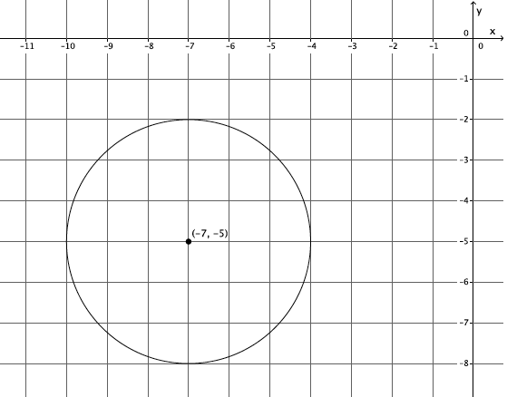

- Write the equation of the circle shown below.
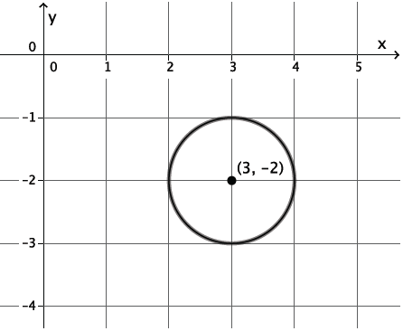

- Consider the circles with equations:
$$x^{2}+y^{2}=2 and$$
$${\left(x-3\right)}^{2}+{\left(y-3\right)}^{2}=32.$$
  - What are the radii of the two circles?
  - What is the distance between their centers?
  - Make a rough sketch of the two circles to explain why the circles must be tangent to one another.

