Lesson 16: Similar Triangles in Circle-Secant (or Circle-Secant-Tangent) Diagrams

Student Outcomes
- Students find “missing lengths” in circle-secant or circle-secant-tangent diagrams.

Lesson Notes
The Opening Exercise reviews Lesson 15, secant lines that intersect outside of circles. In this lesson, students continue the study of secant lines and circles, but the focus changes from angles formed to segment lengths and their relationships to each other. Examples 1 and 2 allow students to measure the segments formed by intersecting secant lines and develop their own formulas. Example 3 has students prove the formulas that they developed in the first two examples.
This lesson will focus heavily on MP.8, as students work to articulate relationships among segment lengths by noticing patterns in repeated measurements and calculations.

Classwork
Opening Exercise (5 minutes)
We have just studied several relationships between angles and arcs of a circle. This exercise should be completed individually and asks students to state the type of angle and the angle/arc relationship, and then find the measure of an arc. Use this as an informal assessment to monitor student understanding.
Opening Exercise
Identify the type of angle and the angle/arc relationship, and then find the measure of $x$.
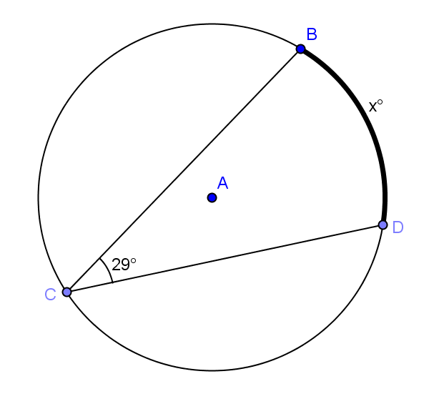  $x = 58$; inscribed angle is equal to half intercepted | 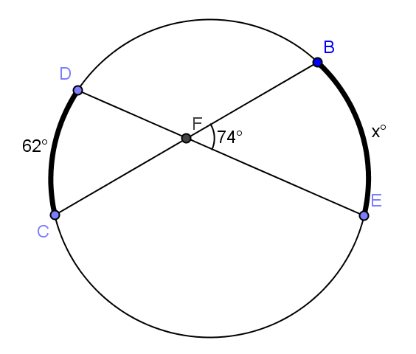  $x = 86$; angle with vertex inside arc. circle is half sum of arcs intercepted by angle and its vertical angle.
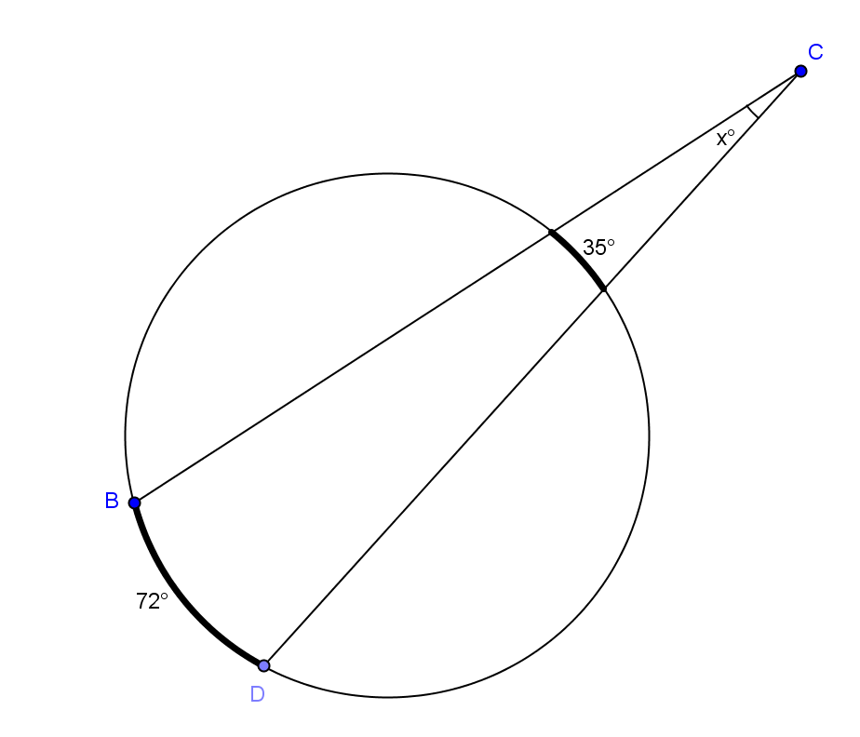  $x=18.5$; angle with vertex outside circle has measure of half the difference of larger intercepted arc. | 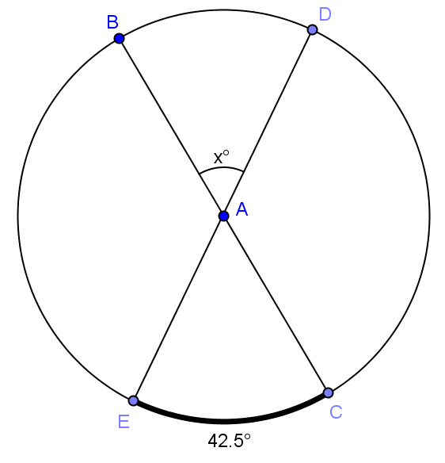  $x=42.5$; central angle has measure of intercepted arc.

Example 1 (10 minutes)
Scaffolding:
- Model the process of measuring and recording values.
- Ask advanced students to generate an additional diagram that illustrates the pattern shown and explain it.
In Example 1, we study the relationships of segments of secant lines intersecting inside of circles. Students will measure and then find a formula. Allow students to work in pairs and have them construct more circles with secants crossing at exterior points until they see the relationship. Students will need a ruler.
If chords of a circle intersect, the product of the lengths of the segments of one chord is equal to the product of the lengths of the segments of the other chord. $a∙b=c∙d.$
Example 1
Measure the lengths of the chords in centimeters and record them in the table.
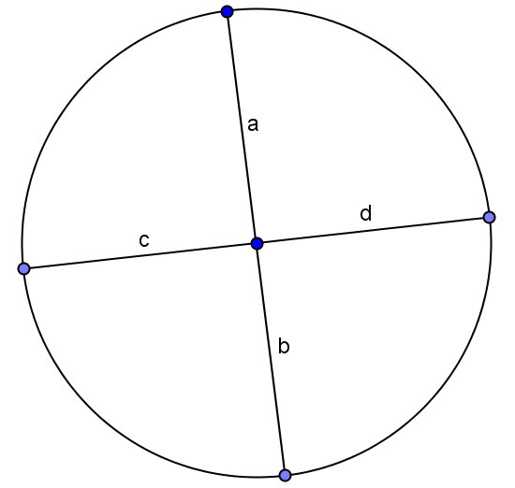 | 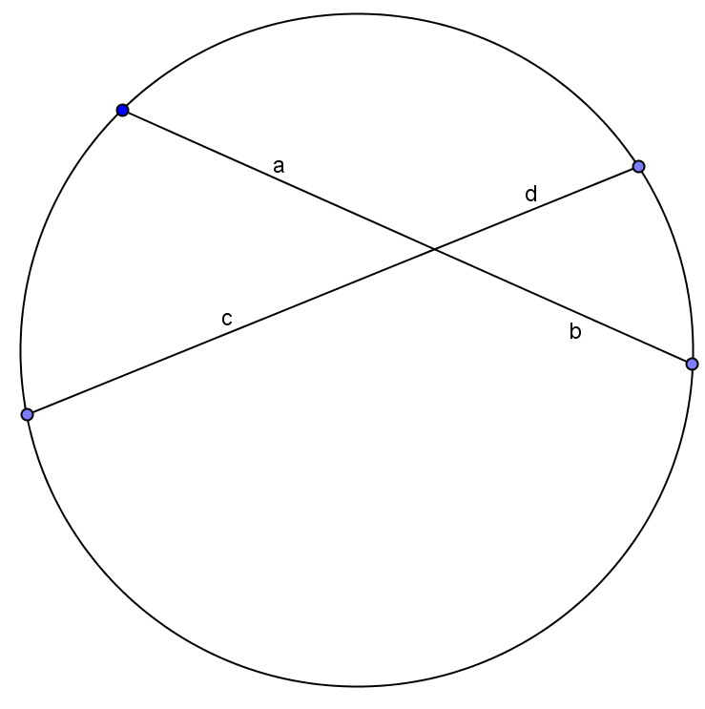
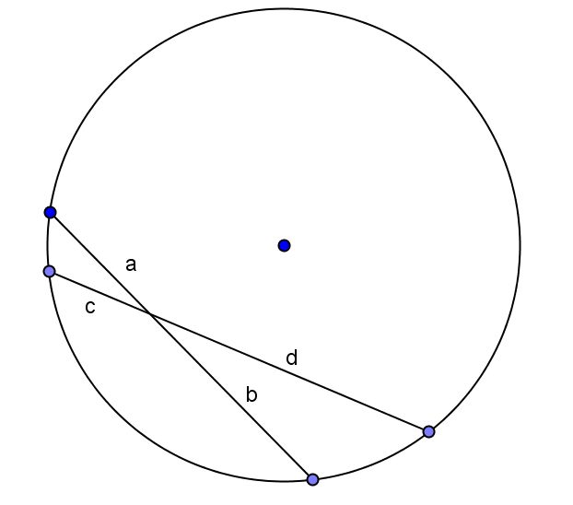 | 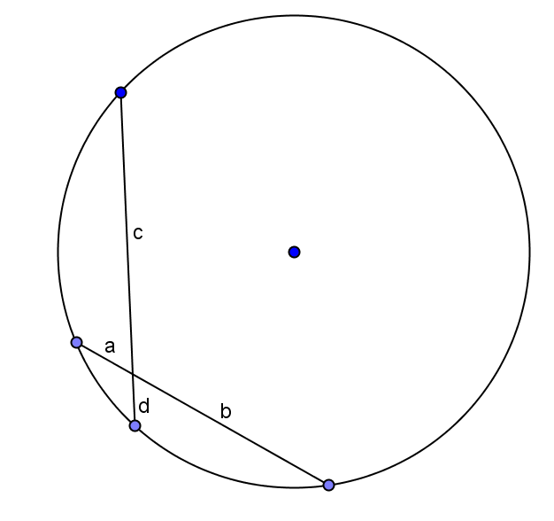

Circle # | $a$ (cm) | $b$ (cm) | $c$ (cm) | $d$ (cm) | Do you notice a relationship?
a | 2.5 | 2.5 | 2.5 | 2.5 | All are the same measure.
b | 2.5 | 2 | 3.2 | 1.6 | Not sure.
c | 1.4 | 2.3 | 1.1 | 3 | $a∙b=c∙d$
d | 0.8 | 2.2 | 2.8 | 0.6 | $a∙b=c∙d$
MP.8
- What relationship did you discover?
  - $a∙b=c∙d.$
- Say that to your neighbor in words.
  - If chords of a circle intersect, the product of the lengths of the segments of one chord is equal to the product of the lengths of the segments of the other chord.

Example 2 (10 minutes)
In the second example, the point of intersection is outside of the circle and students try to develop an equation that works. Students should continue this work in groups.
Example 2
Measure the lengths of the chords in centimeters and record them in the table.
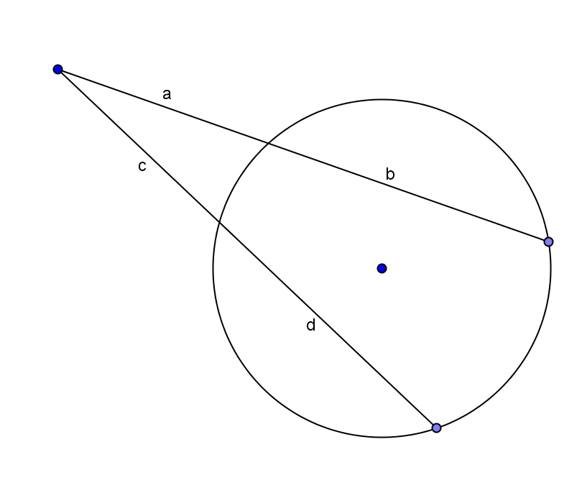 | 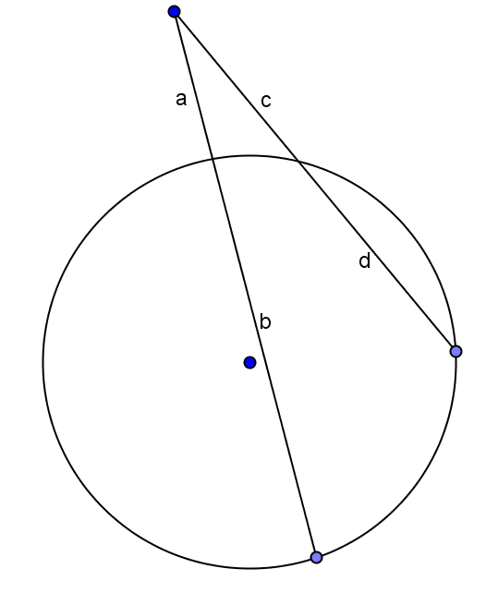
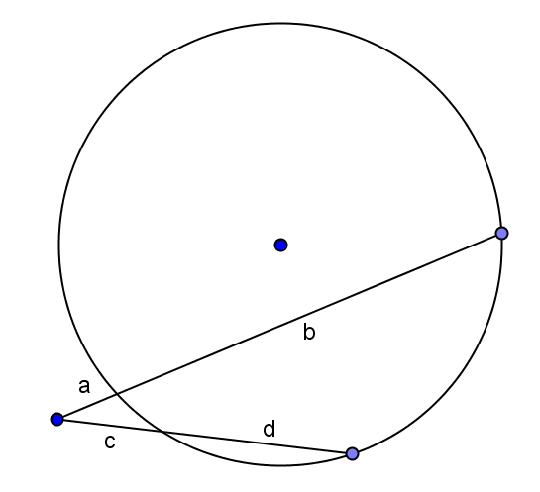 | 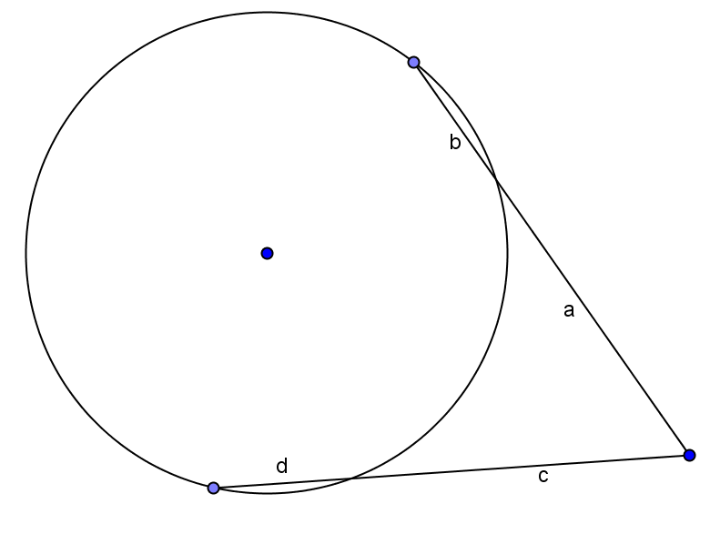

Circle # | $a$ (cm) | $b$ (cm) | $c$ (cm) | $d$ (cm) | Do you notice a relationship?
a | 2.3 | 3 | 2.3 | 3 | Product of a and b is equal to product of c and d.
b | 1.4 | 3.6 | 1.7 | 2.2 | Products aren’t equal for these measurements.
c | 0.5 | 3.8 | 1 | 1.8 | $a\left(a+b\right)=c(c+d)$
d | 2.6 | 1.1 | 2.6 | 1.1 | $a\left(a+b\right)=c(c+d)$

- Does the same relationship hold?
  - No.
MP.8
- Did you discover a different relationship?
  - Yes, $a\left(a+b\right)=c(c+d)$.
- Explain the two relationships that you just discovered to your neighbor and when to use each formula.
  - When secant lines intersect inside a circle, use $a∙b=c∙d$.
  - When secant lines intersect outside of a circle, use $a\left(a+b\right)=c(c+d)$.
Example 3 (12 minutes)
Students have just discovered relationships between the segments of secant and tangent lines and circles. In Example 3, they will prove why the formulas work mathematically.
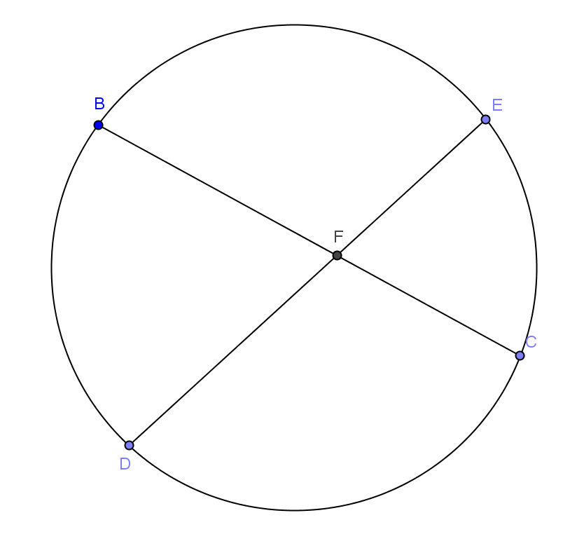
Display the diagram at right on the board.
- We are going to prove mathematically why the formulas we found in Examples 1 and 2 are valid using similar triangles.
- Draw $\overline{BD} and \overline{EC}$.
- Take a few minutes with a partner and prove that $∆BFD$ is similar to $∆EFC$.
- Allow students time to work while you circulate around the room. Help groups that are struggling. Bring the class back together and have students share their proofs.
  - $m∠BFD=m∠EFC$ Vertical angles
  - $m∠BDF=m∠ECF$ Inscribed in same arc
  - $m∠DBF=m∠CEF$ Inscribe in same arc
  - $∆BFD\sim ∆EFC$ AA
- What is true about similar triangles?
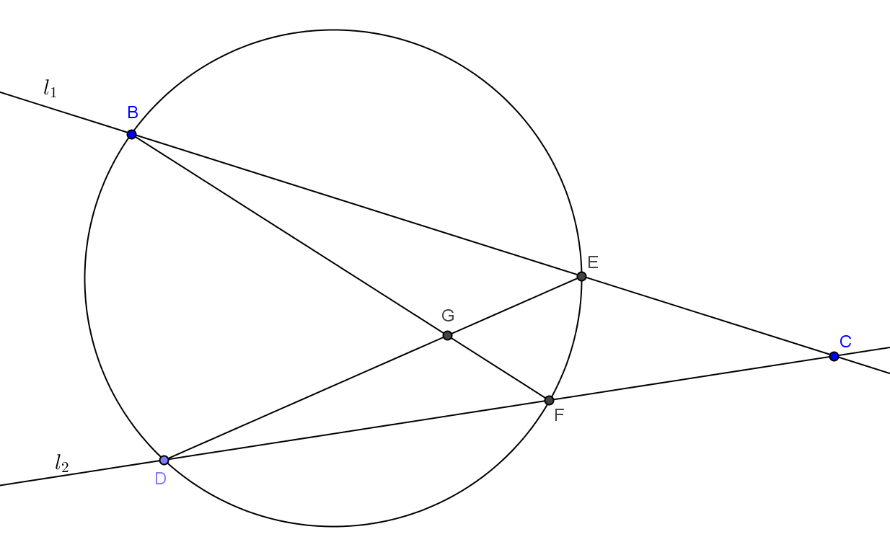
  - Corresponding sides are proportional.
- Write a proportion involving sides $\overline{BF}, \overline{FC}, \overline{DF},$ and $\overline{FE}$.
  - $\frac{BF}{FE}=\frac{DF}{FC}$
- Can you rearrange this to prove the formula discovered in Example 1?
  - $(BF)(FC)=(DF)(FE)$
- Display the next diagram on the board.
- Display the diagram at right on the board.
- Now let’s try to prove the formula we found in Example 2.
- Name two triangles that could be similar.
  - $∆CFB$ and $∆CED$
- Take a few minutes with a partner and prove that $∆CFB$ is similar to $∆CED$.

- Allow students time to work while you circulate around the room. Help groups that are struggling. Bring the class back together and have students share their proofs.
  - $m∠C=m∠C$ Common angle
  - $m∠CBF=m∠CDE$ Inscribed in same arc
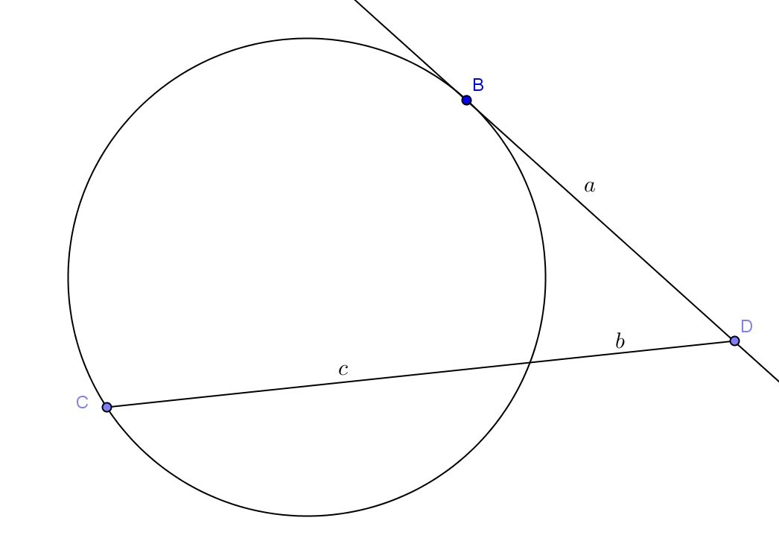
  - $∆CFB\sim ∆CED$ AAA
- Write a proportion that will be true.
  - $\frac{CB}{CD}=\frac{CF}{CE}$
- Can you rearrange this to prove the formula discovered in Example 2?
  - $(CE)(CB)=(CF)(CD)$
- What if one of the lines is tangent and the other is secant? Show diagram.
  - Students should be able to reason that $a∙a=b\left(b+c\right)$
  - $a^{2}=b\left(b+c\right)$
  - $a=\sqrt{b(b+c)}.$

Closing (3 minutes)
We have just concluded our study of secant lines, tangent lines, and circles. In Lesson 15, you completed a table about angle relationships. This summary completes the table adding segment relationships. Complete the table below and compare your answers with your neighbor. Bring class back together to discuss answers to ensure students have the correct formulas in their tables.
Lesson Summary:
The inscribed angle theorem and its family:
Diagram | How the two shapes overlap | Relationship between $a$,$b, c$ and $d$
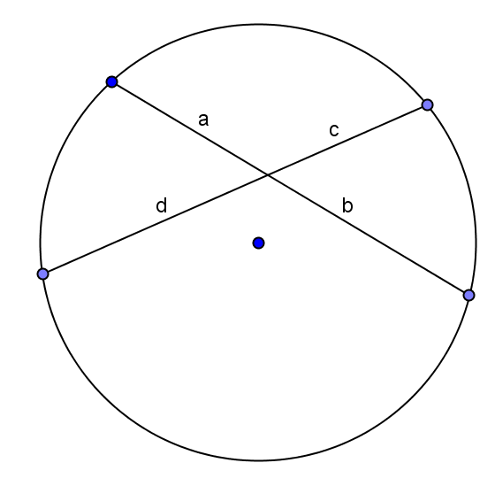 | Intersection is in the interior of the circle. | $$a∙b=c ∙d$$
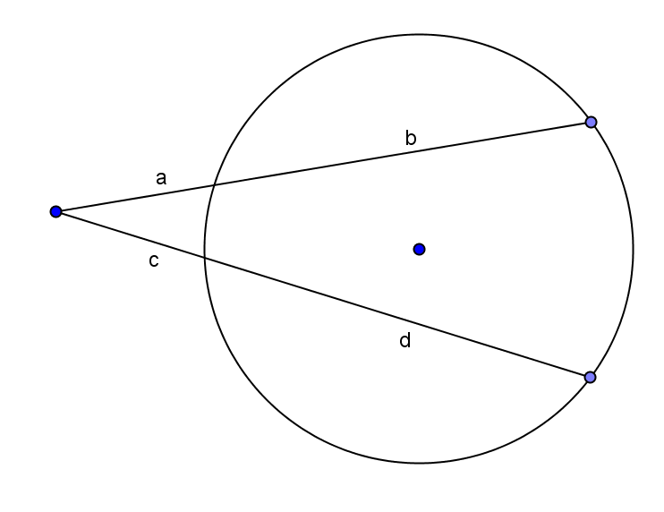 | Intersection is on the exterior of the circle. | $$a\left(a+b\right)=c(c+d)$$
 | Tangent and secant are intersecting. | $$a^{2}=b(b+c)$$
Lesson Summary
Theorems:
- When secant lines intersect inside a circle, use $a∙b=c∙d$.
- When secant lines intersect outside of a circle, use $a\left(a+b\right)=c(c+d)$.

Relevant Vocabulary
Secant to a circle: A secant line to a circle is a line that intersects a circle in exactly two points.

Exit Ticket (5 minutes)
Name Date
Lesson 16: Similar Triangles in Circle-Secant (or Circle-Secant-Tangent) Diagrams

Exit Ticket

- In the circle below, $m\hat{GF}=30°$, $m\hat{DE}=120°$, $CG=6$, $GH=2$, $FH=3$, $CF=4$, $HE=9$, and $FE=12$.

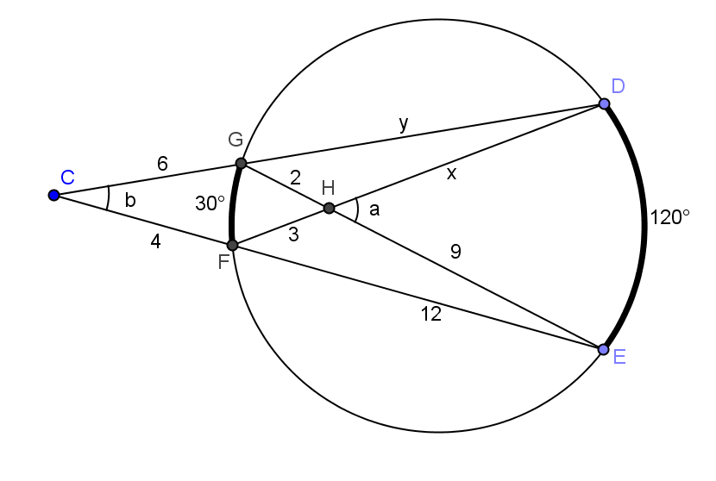
  - Find $a$ ($m∠DHE$).

  - Find $b$ ($m∠DCE$) and explain your answer.

  - Find $x$ ($HD$) and explain your answer.

  - Find $y$ ($DG$).

Exit Ticket Sample Solutions

- In the circle below, $m\hat{GF}=30°$, $m\hat{DE}=120°$, $CG=6$, $GH=2$, $FH=3$, $CF=4$, $HE=9$, and $FE=12$.
- Find $a$ ($m∠DHE$).
$$a=75°$$

- Find $b$ ($m∠DCE$).
$b=45°$; $b$ is an angle with vertex outside of the circle, so it has measure half the difference between its larger and smaller intercepted arcs.

- Find $x$ ($HD$).
$x=6$; x is part of a secant line inside the circle, so $2∙9=3∙x$.

- Find $y$ ($DG$).
$$y= \frac{14}{3}=4\frac{2}{3}$$

Problem Set Sample Solutions

- Find $x$.  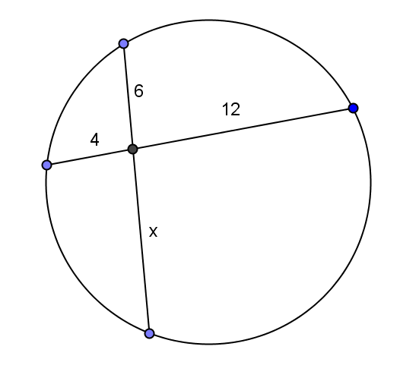  $$x=8$$ | - Find $x$.  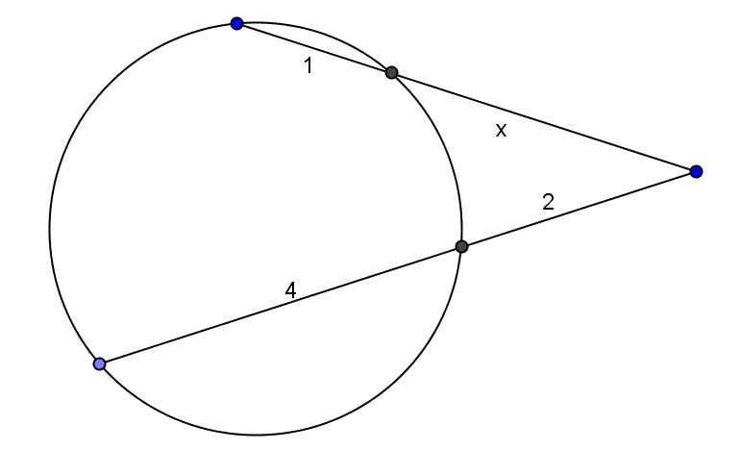  $$x=3$$
- $DF< FB, DF≠1, DF<FE$. Prove $DF=3$  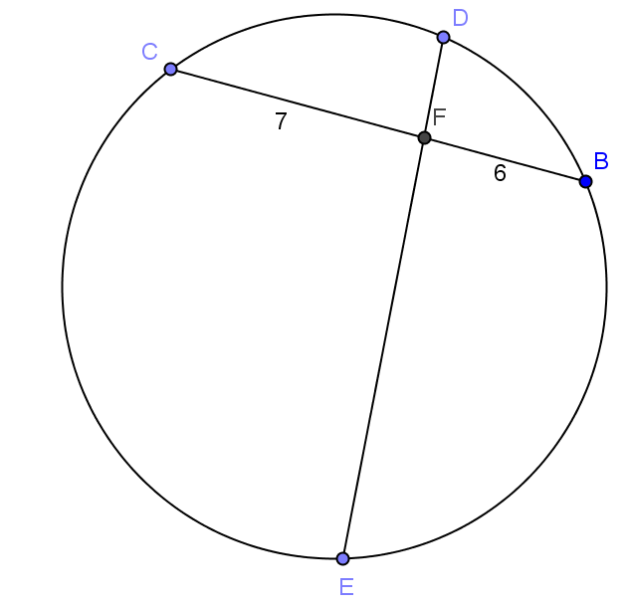  $7⋅6=42$, so $DF⋅FE$ must equal $42$. IF $DF<FE$, $DF$ could equal $1$, $3$, or $6$. $DF≠1$ and $DF<FB$, so $DF$ must equal $3$. | - $CE=6$, $CB=9$, $CD=18$. Show $CF=3$.  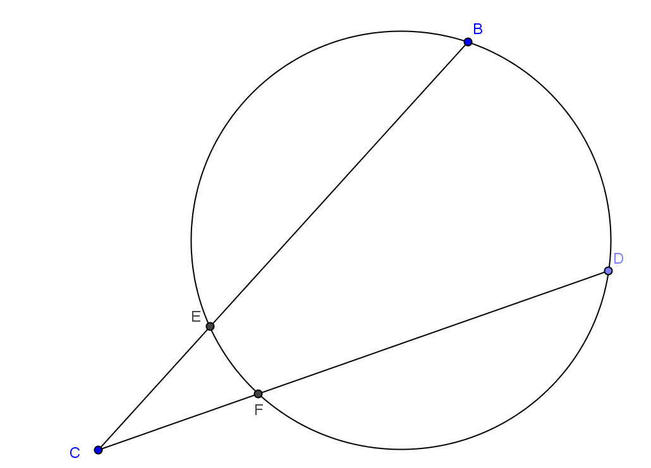  $6⋅9=54$ and $18⋅CF=54$. This means $CF=3$.
- Find $x$.  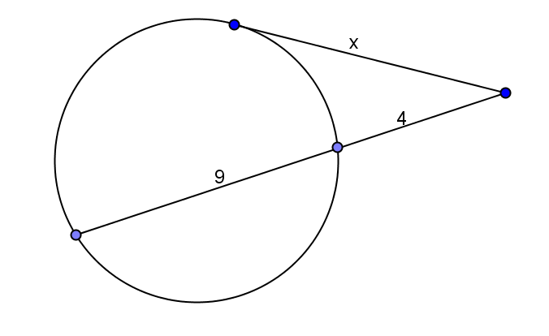  $$x=2\sqrt{13}$$ | - Find $x$.  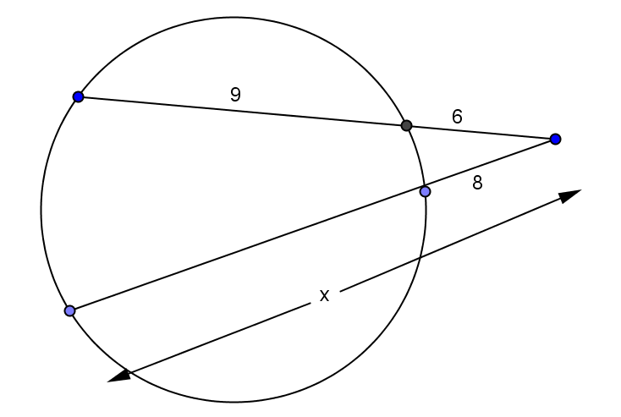  $$x=11.25$$
- Find $x$.  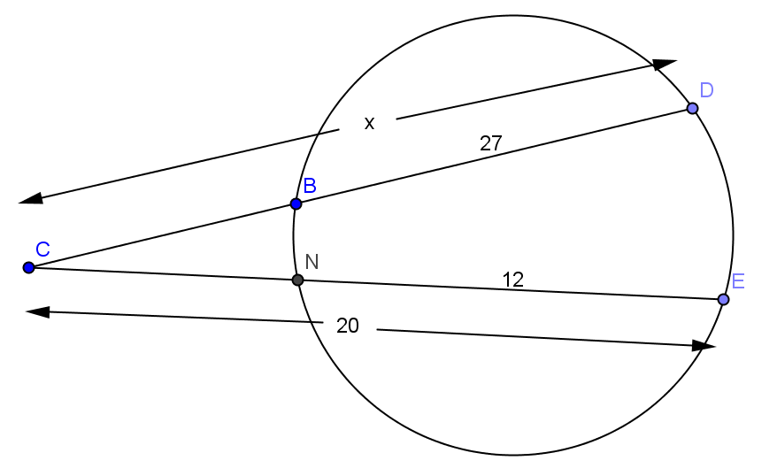  $$x=32$$ | - Find $x$.  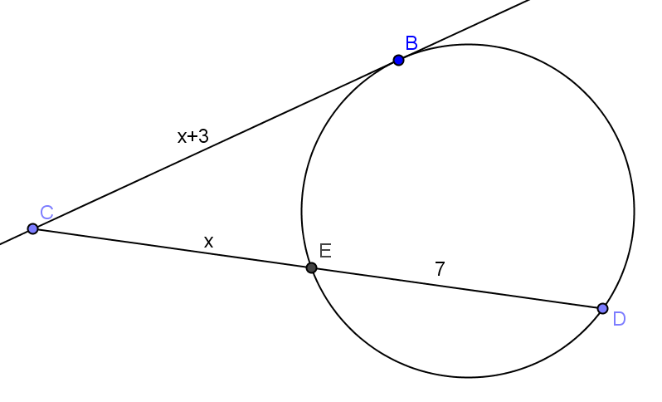  $$x=9$$

- In the circle shown, $DE=11$, $BC=10$, $DF=8$. Find $FE$, $BF$, $FC$.
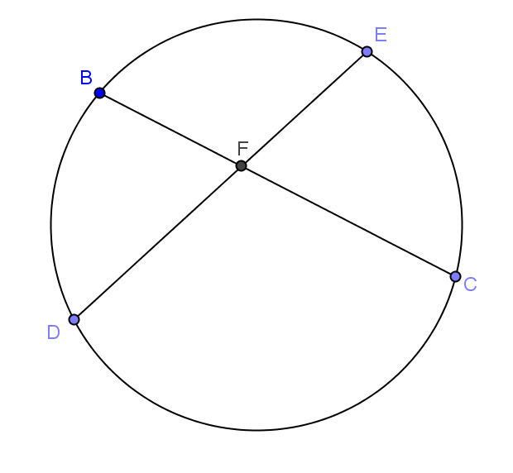
$FE=3$, $BF=4$, $FC=6$

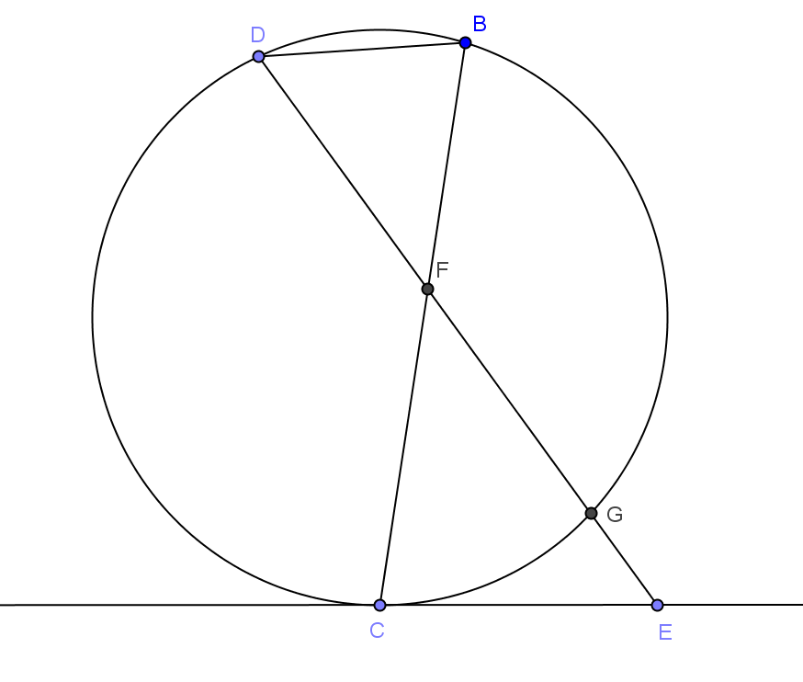
- In the circle shown, $m\hat{DBG}=150°, m\hat{DB}=30°, m∠CEF=60°,$
$DF=8, DB=4, GF=12.$
- Find $m∠GDB$.
$$60°$$

- Prove $∆DBF\sim ∆ECF$.
$m∠BDF=m∠CEF$ Angles have same measure.
$m∠DFB=m∠EFC$ Vertical angles are congruent.
$∆DBF\sim ∆EFC$ AA

- Set up a proportion using sides $\overline{CE}$ and $\overline{GE}$.
$\frac{8}{GE+12}=\frac{4}{CE}$ or $2CE=GE=12$

- Set up an equation with $\overline{CE}$ and $\overline{GE}$ using a theorem for segment lengths from this section.
$${CE}^{2}=GE(GE+12)$$

- Solve for $CE$ and $GE$.
$CE=8$, $GE=4$

