Lesson 16: Similar Triangles in Circle-Secant (or Circle-Secant-Tangent) Diagrams

Classwork

Opening Exercise

Identify the type of angle and the angle/arc relationship, and then find the measure of .

|  |  |
| --- | --- |
|  |  |
|  |  |

**Example 1**

Measure the lengths of the chords in centimeters and record them in the table.

|  |  |
| --- | --- |
| * 1. s |  |
|  |  |

|  |  |  |  |  |  |
| --- | --- | --- | --- | --- | --- |
| Circle # | (cm) | (cm) | (cm) | (cm) | Do you notice a relationship? |
| a |  |  |  |  |  |
| b |  |  |  |  |  |
| c |  |  |  |  |  |
| d |  |  |  |  |  |

**Example 2**

Measure the lengths of the chords in centimeters and record them in the table.

|  |  |
| --- | --- |
|  |  |
|  |  |

|  |  |  |  |  |  |
| --- | --- | --- | --- | --- | --- |
| Circle # | (cm) | (cm) | (cm) | (cm) | Do you notice a relationship? |
| a |  |  |  |  |  |
| b |  |  |  |  |  |
| c |  |  |  |  |  |
| d |  |  |  |  |  |

**The inscribed angle theorem and its family**:

|  |  |  |
| --- | --- | --- |
| Diagram | How the two shapes overlap | Relationship between , and |
|  |  |  |
|  |  |  |
|  |  |  |

Lesson Summary

Theorems:

* When secant lines intersect inside a circle, use *.*
* When secant lines intersect outside of a circle, use .

Relevant Vocabulary

**Secant to a circle:** A *secant line to a circle* is a line that intersects a circle in exactly two points.

Problem Set

|  |  |
| --- | --- |
| 1. Find . | 1. Find . |
| 1. Prove | 1. , , . Show . |
| 1. Find . | 1. Find . |
| 1. Find . | 1. Find . |

1. 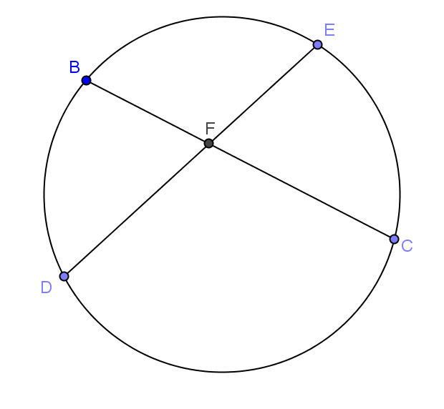In the circle shown, , , . Find , , .
2. In the circle shown,
   1. Find .
   2. 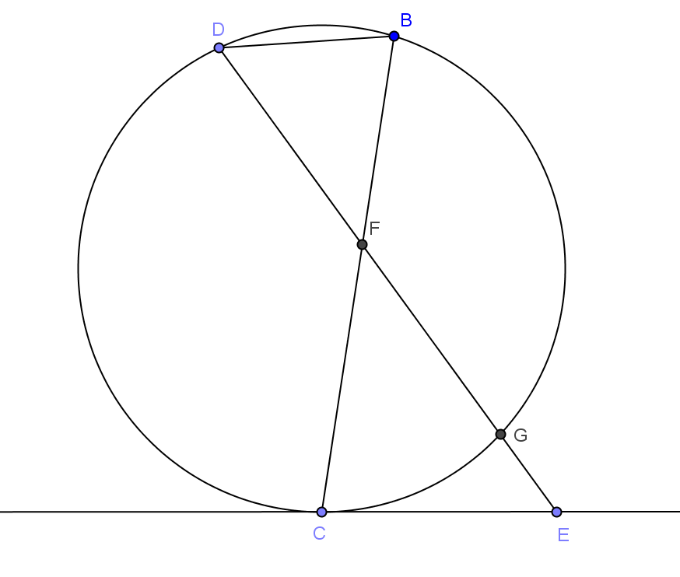Prove .
   3. Set up a proportion using sides and .
   4. Set up an equation with and using a theorem for segment lengths from this section.
   5. Solve for and .