Lesson 15: Secant Angle Theorem, Exterior Case

Student Outcomes
- Students find the measures of angle/arcs and chords in figures that include two secant lines meeting outside a circle, where the measures must be inferred from other data.

Lesson Notes
The Opening Exercise reviews and solidifies the concept of secants intersecting inside of the circle and the relationships between the angles and the subtended arcs. Students then extend that knowledge in the remaining examples. Example 1 looks at a tangent and secant intersecting on the circle. Example 2 moves the point of intersection of two secant lines outside of the circle and continues to allow students to explore the angle/arc relationships.

Classwork
Opening Exercise (10 minutes)
This Opening Exercise reviews Lesson 14, secant lines that intersect inside circles. Students must have a firm understanding of this concept to extend this knowledge to secants intersecting outside the circle. Students need a protractor for this exercise. Have students initially work individually and then compare answers and work with a partner. Use this as a way to informally assess student understanding.
Opening Exercise
- Shown below are circles with two intersecting secant chords.
Scaffolding:
- Post pictures of the different types of angle and arc relationships that we have studied so far with the associated formulas to help students.
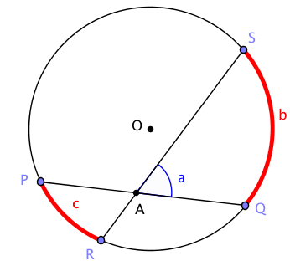 | 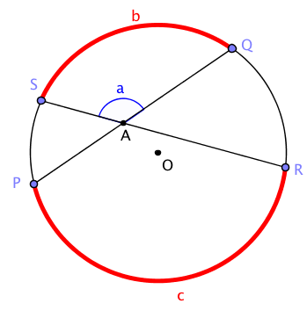
Measure $a$,$b$, and $c$ in the two diagrams. Make a conjecture about the relationship between them.

$$a$$ | $$b$$ | $$c$$
$$60°$$ | $$80°$$ | $$40°$$
$$130°$$ | $$100°$$ | $$160°$$

CONJECTURE about the relationship between $a$, $b$, and $c$:
$a=\frac{b+c}{2}$. The measure $a$ is the average of $b$ and $c$.

- We will prove the following.
Secant angle theorem: Interior case. The measure of an angle whose vertex lies in the interior of a circle is equal to half the sum of the angle measures of the arcs intercepted by it and its vertical angle.
We can interpret this statement in terms of the diagram below. Let $b$ and $c$ be the angle measures of the arcs intercepted by the angles $∠SAQ$ and $∠PAR$. Then measure $a$ is the average of $b$ and $c$; that is, $a=\frac{b+c}{2}$.
  - Find as many pairs of congruent angles as you can in the diagram below. Express the measures of the angles in terms of $b$ and $c$ whenever possible.
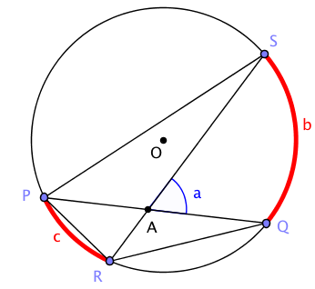
$$m∠PQR=m∠PSR=\frac{1}{2}c$$
$$m∠QPS=m∠QRS=\frac{1}{2}b$$

  - Which triangles in the diagram are similar? Explain how you know.
$ΔPSA∼ΔRQA$. All angles in each pair have the same measure.

  - See if you can use one of the triangles to prove the secant angle theorem: interior case. (Hint: Use the exterior angle theorem.)
MP.3
By the exterior angle theorem, $a=m∠PQR+m∠QRS$. We can conclude $a=\frac{1}{2}(b+c)$.
Turn to your neighbor and summarize what we've learned so far in this exercise.

Example 1 (10 minutes)
Scaffolding:
- For advanced learners, this example could be given as individual or pair work without leading questions.
- Use scaffolded questions with a targeted small group.
- For example: Look at the table that you created. Do you see a pattern between the sum of $b$ and $c$ and the value of $a$?

For example: Look at the table that you created. Do you see a pattern between the sum of b and c and the value of a?and the value of a?
We have shown that the inscribed angle theorem can be extended to the case when one of the angle’s rays is a tangent segment and the vertex is the point of tangency. Example 1 develops another theorem in the inscribed angle theorem’s family, the secant angle theorem: exterior case.
Theorem (secant angle theorem: exterior case). The measure of an angle whose vertex lies in the exterior of the circle, and each of whose sides intersect the circle in two points, is equal to half the difference of the angle measures of its larger and smaller intercepted arcs.
Example 1
Shown below are two circles with two secant chords intersecting outside the circle.
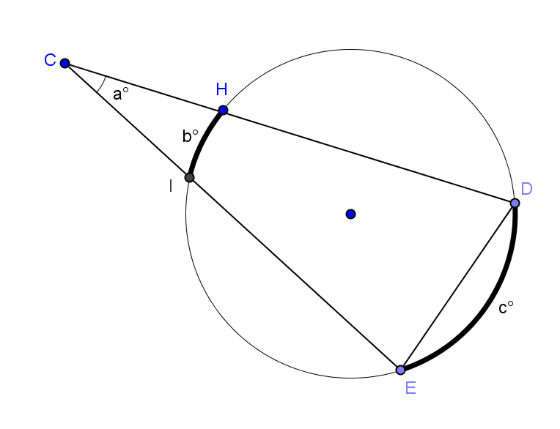
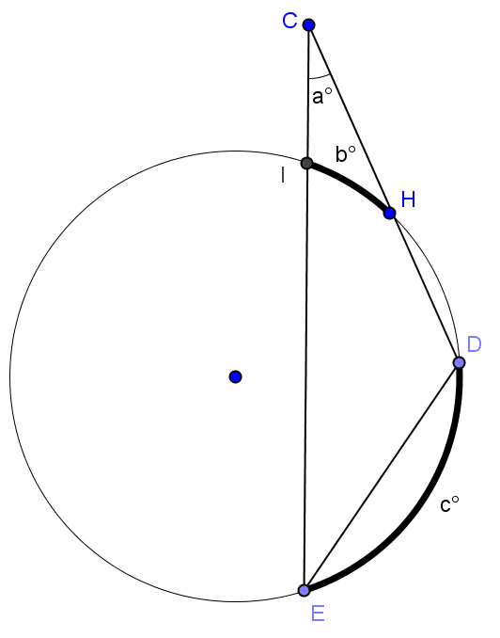

Measure $a$,$b$, and $c$. Make a conjecture about the relationship between them.
$$a$$ | $$b$$ | $$c$$
Conjecture about the relationship between $a$, $b$, and $c$:

Test your conjecture with another diagram.

Example 2 (7 minutes)
In this example, we will rotate the secant lines one at a time until one and then both are tangent to the circle. This should be easy for students to see but can be shown with dynamic geometry software.
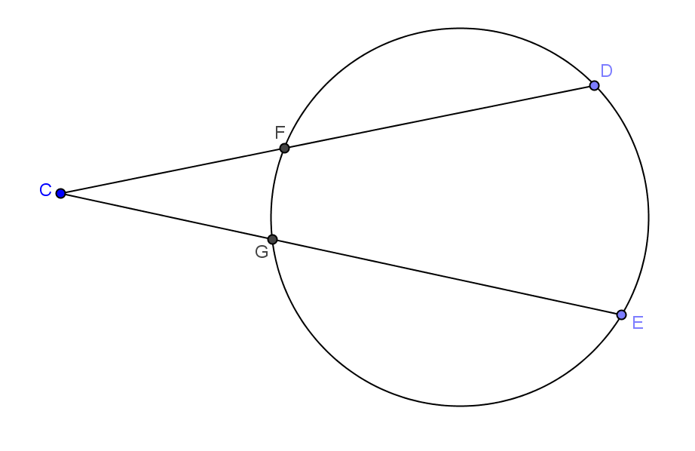
- Let’s go back to our circle with two secant lines intersecting in the exterior of the circle (show circle at right).
- Remind me how I would find the measure of angle $C$.
  - Half the difference between the longer intercepted arc and the shorter intercepted arc.
  - $\frac{1}{2}(m\hat{DE}-m\hat{FG)}$
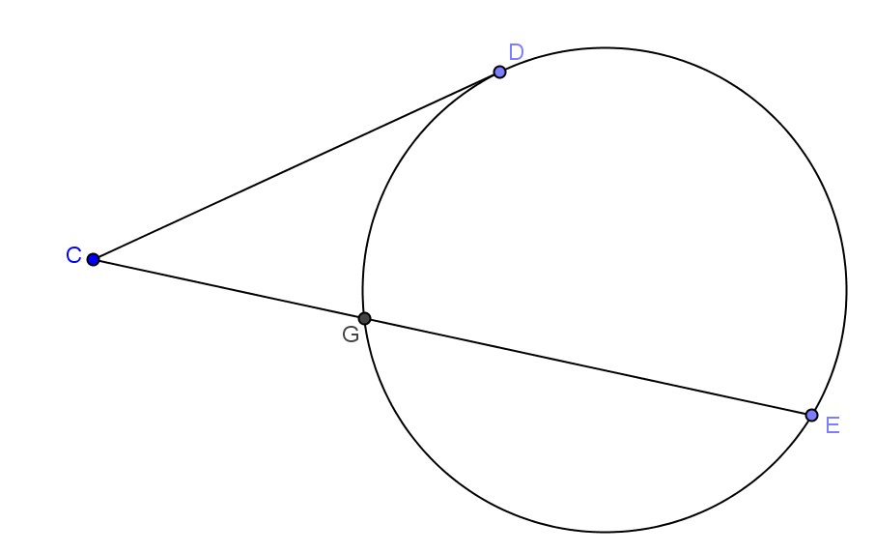
- Rotate one of the secant segments so that it becomes tangent to the circle (show circle at right).
- Can we apply the same formula?
  - Answers will vary, but the answer is yes.
- What is the longer intercepted arc? The shorter intercepted arc?
  - The longer arc is $\hat{DE}$. The shorter arc is $\hat{DG}$.
- So do you think we can apply the formula? Write the formula.
  - Yes. $\frac{1}{2}(m\hat{DE}-m\hat{DG)}$
- Why is it not identical to the first formula?
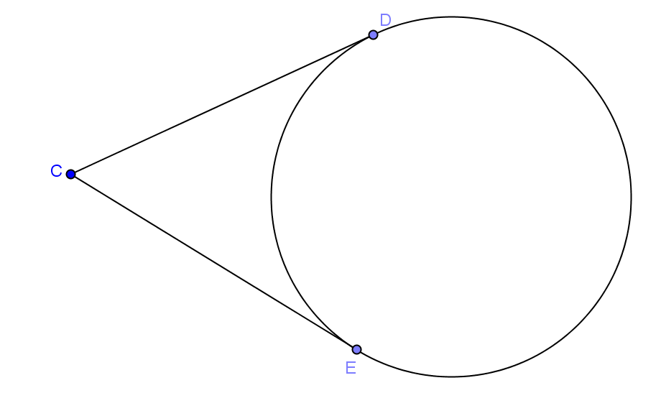
  - Point $D$ is an endpoint that separates the two arcs.
- Now rotate the other secant line so that it is tangent to the circle. (Show circle at right).
- Does our formula still apply?
  - Answers will vary, but the answer is yes.
- What is the longer intercepted arc? The shorter intercepted arc?
  - The longer arc is $\hat{DE}$. The shorter arc is $\hat{ED}$.
- How can they be the same?
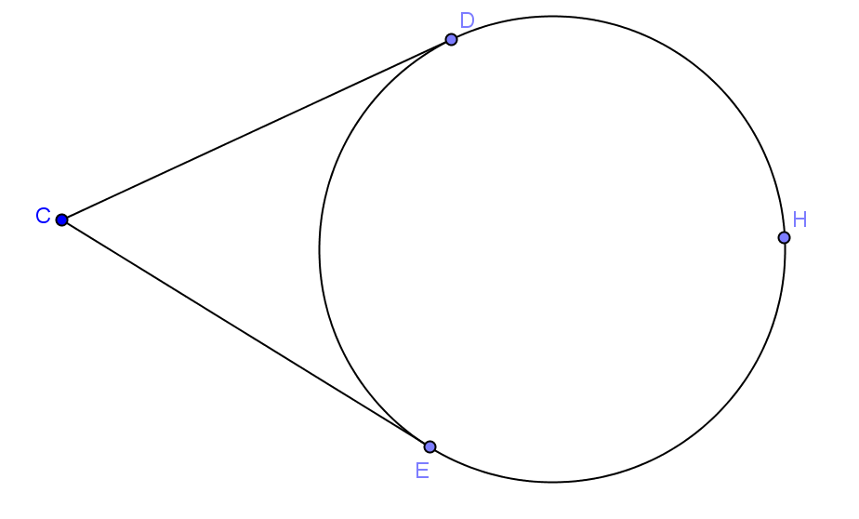
  - They aren’t. We need to add a point in between so that we can show they are two different arcs.
- So what is the longer intercepted arc? The shorter intercepted arc?
  - The longer arc is $\hat{DHE}$. The shorter arc is $\hat{ED}$.
- So do you think we can apply the formula? Write the formula.
  - Yes. $\frac{1}{2}(m\hat{DHE}-m\hat{ED})$.

- Why is this formula different from the first two?
  - Points $D$ and $E$ are the endpoints that separate the two arcs.
Turn to your neighbor and summarize what you have learned in this exercise.

Exercises (8 minutes)
Have students work on the exercises individually and check their answers with a neighbor. Use this as an informal assessment and clear up any misconceptions. Have students present problems to the class as a wrap-up.
Exercises
Find $x$, $y$, and/or $z$.
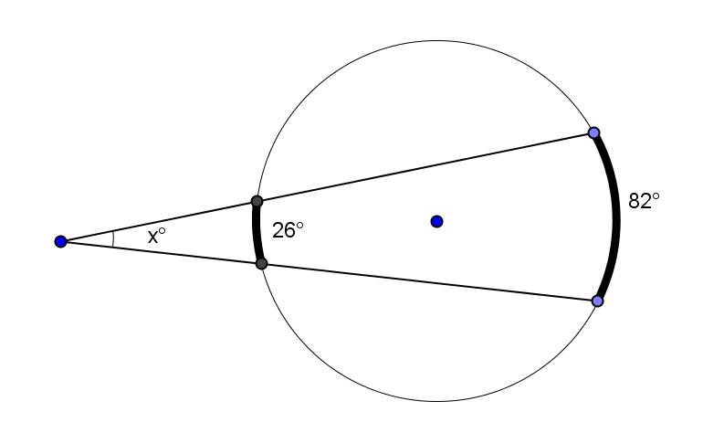 | 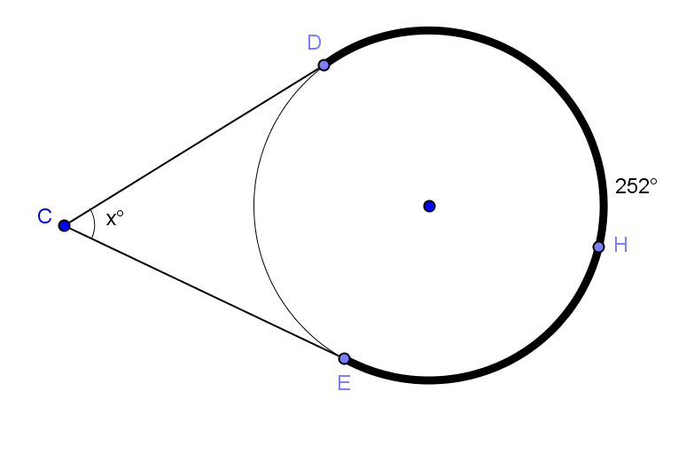
$$x=28$$ | $$x=72$$
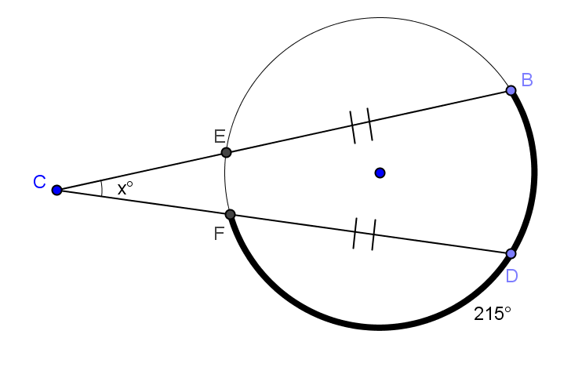 | 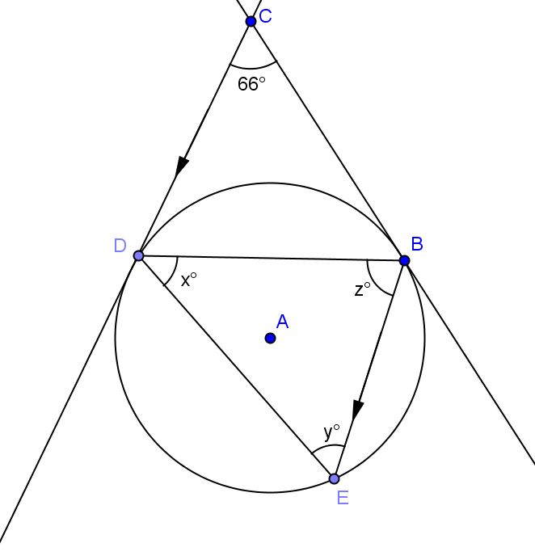
$$x=35$$ | $x=66$, $y=57$, $z=57$

Closing (5 minutes)
Have students complete the summary table, and then share as a class to make sure students understand concepts.

Lesson Summary:
We have just developed proofs for an entire family of theorems. Each theorem in this family deals with two shapes and how they overlap. The two shapes are two intersecting lines and a circle.
In this exercise, you’ll summarize the different cases.

The Inscribed Angle Theorem and its Family of Theorems
Diagram | How the two shapes overlap | Relationship between $a$, $b, c,$ and $d$
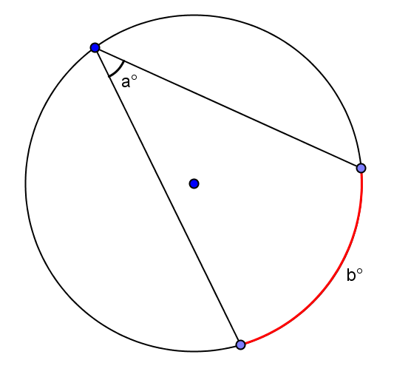  (Inscribed Angle Theorem) | Intersection is on circle. | $$a=\frac{1}{2}b$$
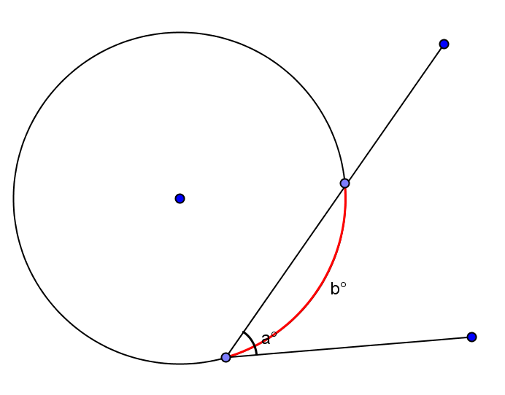  (Secant – Tangent) | Intersection is on the circle. | $$a=\frac{1}{2}b$$
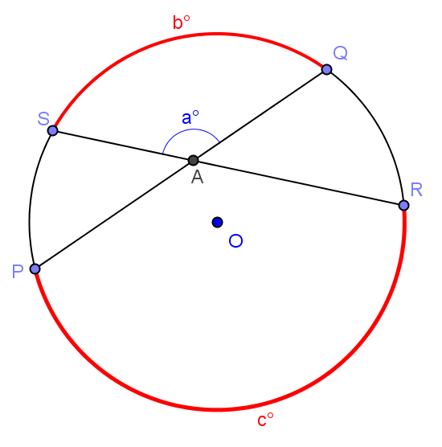  (Secant Angle Theorem: Interior) | Intersection is in the interior of the circle. | $$a=\frac{b+c}{2}$$
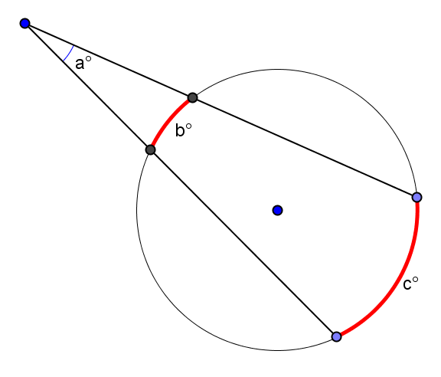  (Secant Angle Theorem: Exterior) | Intersection is exterior to the circle. | $$a=\frac{c-b}{2}$$
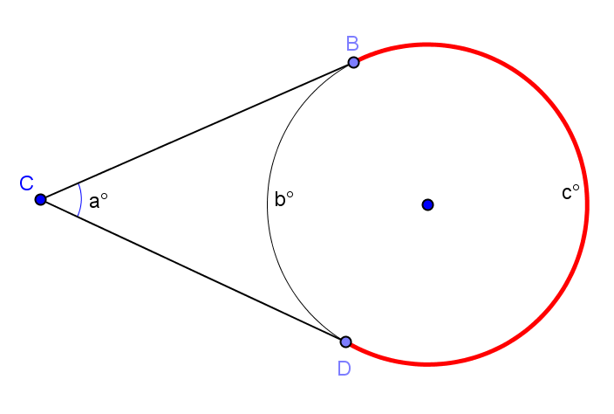  (Two Tangent Lines) | Intersection of two tangent lines to a circle. | $$a=\frac{c-b}{2}$$

Lesson Summary
Theorems:
- Secant angle theorem: Interior case. The measure of an angle whose vertex lies in the interior of a circle is equal to half the sum of the angle measures of the arcs intercepted by it and its vertical angle.
- Secant angle theorem: Exterior case. The measure of an angle whose vertex lies in the exterior of the circle, and each of whose sides intersect the circle in two points, is equal to half the difference of the angle measures of its larger and smaller intercepted arcs.
Relevant Vocabulary
Secant to a circle: A secant line to a circle is a line that intersects a circle in exactly two points.

Exit Ticket (5 minutes)

Name Date
Lesson 15: Secant Angle Theorem, Exterior Case

Exit Ticket

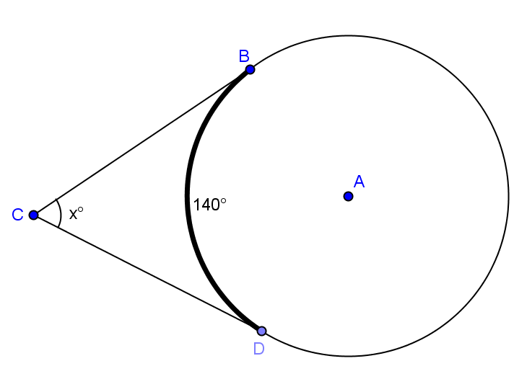
- Find $x$. Explain your answer.

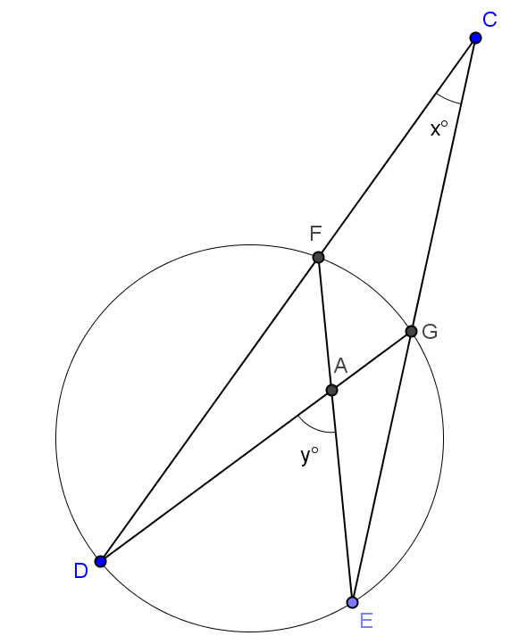

- Use the diagram to show that $m\hat{DE}=y+x$ and $m\hat{FG}=y-x$. Justify your work.

Exit Ticket Sample Solutions

- Find $x$. Explain your answer.
$x=40$. Major arc $m\hat{BD}=360-140=220$. $x=\frac{1}{2}\left(220-140\right)=40.$

- Use the diagram to show that $m\hat{DE}=y+x$ and $m\hat{FG}=y-x$. Justify your work.
$x=\frac{1}{2}\left(m\hat{DE}-m\hat{FG}\right) or 2x= m\hat{DE}-m\hat{FG}$. Angle whose vertex lies exterior of circle is equal to half the difference of the angle measures of its larger and smaller intercepted arcs.
$y=\frac{1}{2}\left(m\hat{DE}+m\hat{FG}\right) or 2y= m\hat{DE}+m\hat{FG}$. Angle whose vertex lies in a circle is equal to half the sum of the arcs intercepted by the angle and its vertical angle.
Adding the two equations gives $2x+2y=2m\hat{DE} or x+y=m\hat{DE}$.
Subtracting the two equations gives $2y-2x=2m\hat{FG} or y-x=m\hat{FG}$.

Problem Set Sample Solutions

- Find $x$. | - Find $m∠DFE$ and $m∠DGB$.
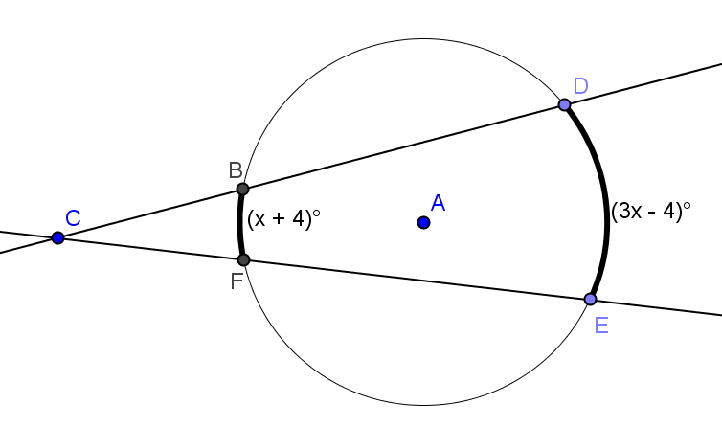 | 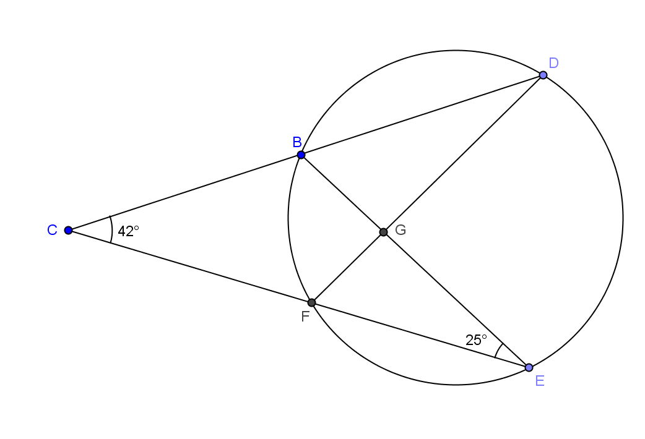
$$x=32$$ | $$m∠DFE=67°, m∠DGB=88°$$
- Find $m∠ECD, m∠DBE,$and$m∠DEB$. | - Find $m∠FGE$and$m∠FHE$.
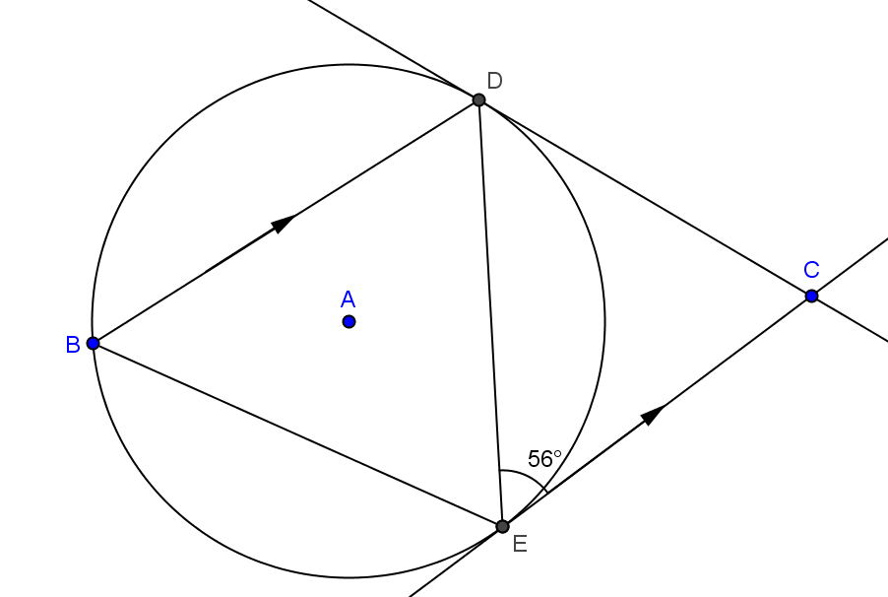 | 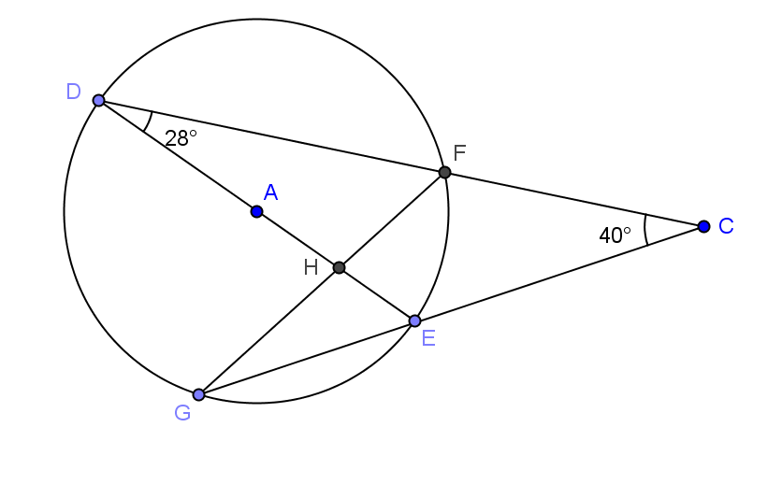
$$m∠ECD=68°, m∠DBE=56°, m∠DEB=6°$$ | $$m∠FGE=28°, m∠FHE=9°$$
- Find $x$ and $y$. | - The radius of circle $A$ is $4$. $\overline{DC}$and$\overline{CE}$ are tangent to the circle with $DC=12$. Find $m\hat{EBD}$ and the area of quadrilateral DAEC rounded to the nearest hundredth.
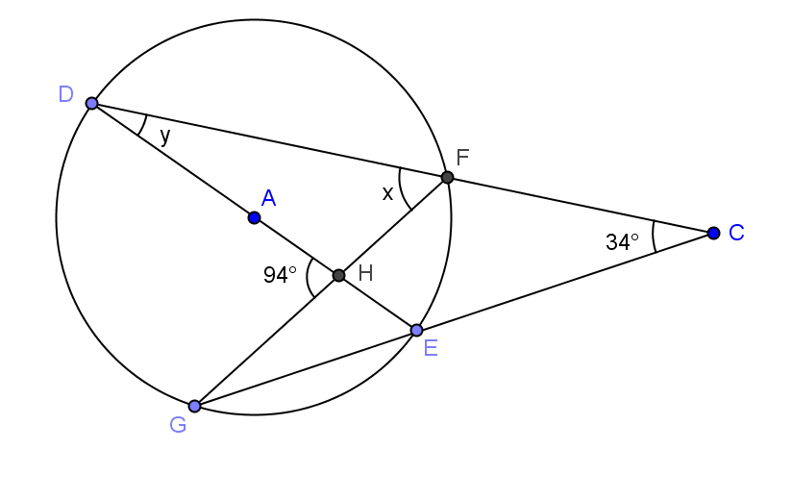 | 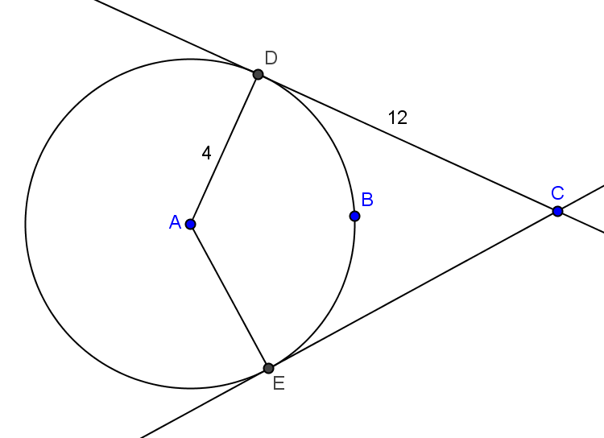
$x=64°$, $y=30°$ | $m\hat{EBD}=143.13^{0},$Area$=48$ square units
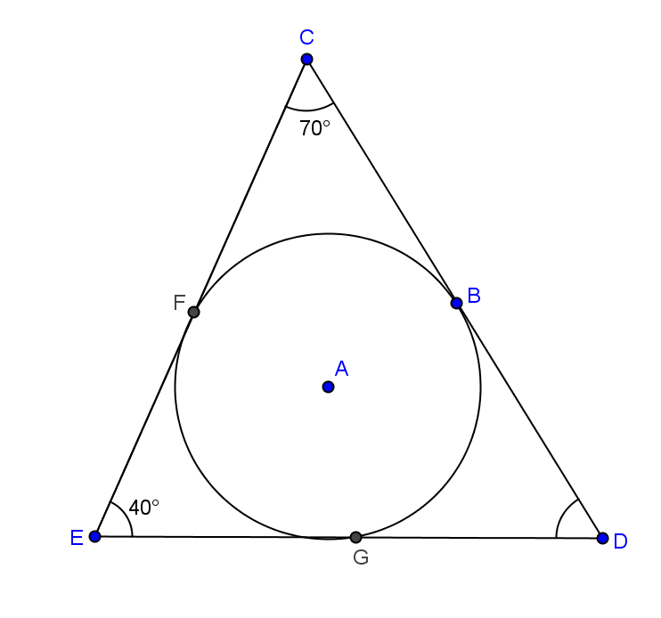 | 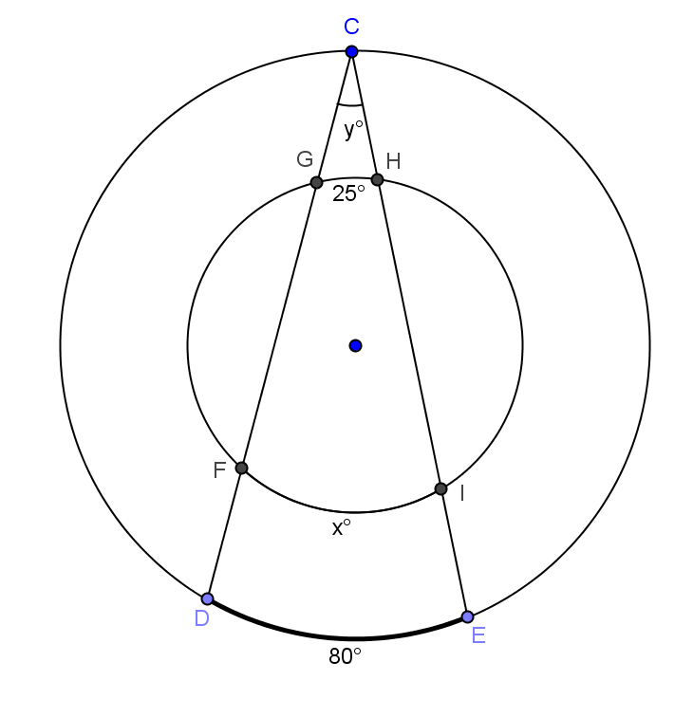
$$m\hat{BG}=m\hat{FB}=110°, m\hat{GF}=140°$$ | $x=105$, $y=40$

- The radius of a circle is $6$.
- If the angle formed between two tangent lines to the circle is $60°$, how long are the segments between the point of intersection of the tangent lines and the circle?
$$12$$

- If the angle formed between the two tangent lines is $120°$, how long are the segments between the point of intersection of the tangent lines and the circle? Round to the nearest hundredth.
$$6.93$$

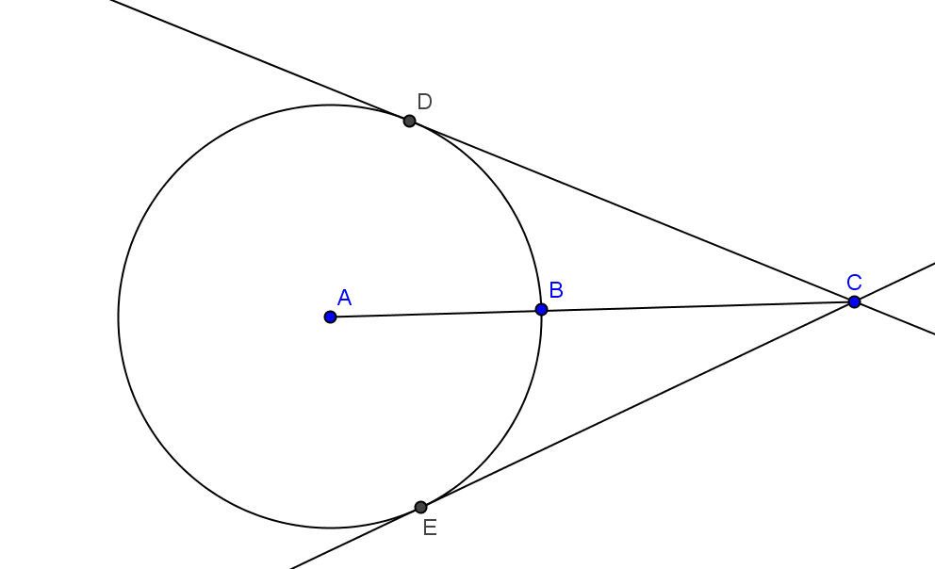
- $\overline{DC}$ and $\overline{EC}$ are tangent to circle $A$. Prove $BD=BE.$
Join $AD$, $AE$, $BD$, and $BE$.
$AD=AE$ radii of same circle
$AC=AC$ reflexive property
$m∠ADC=m∠AEC=9°$ radii perpendicular to tangent lines at point of tangency
$∆ADC≅∆AEC$ HL
$m∠CAE=m∠CAD$ CPCTC
$\hat{DB}≅\hat{EB}$ congruent angles intercept congruent arcs
$DB=EB$ congruent arcs intercept chords of equal measure

