Lesson 15: Secant Angle Theorem, Exterior Case

Classwork
Opening Exercise
- Shown below are circles with two intersecting secant chords.
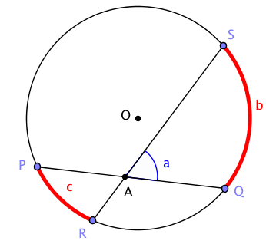 | 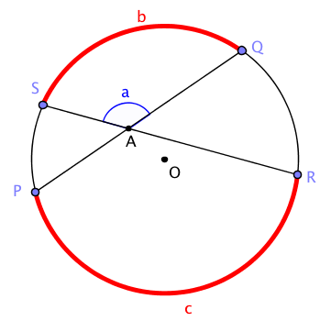

Measure $a$,$b$, and $c$ in the two diagrams. Make a conjecture about the relationship between them.

$$a$$ | $$b$$ | $$c$$

CONJECTURE about the relationship between $a$, $b$, and $c$:

- We will prove the following.
Secant angle theorem: Interior case. The measure of an angle whose vertex lies in the interior of a circle is equal to half the sum of the angle measures of the arcs intercepted by it and its vertical angle.
We can interpret this statement in terms of the diagram below. Let $b$ and $c$ be the angle measures of the arcs intercepted by the angles $∠SAQ$ and $∠PAR$. Then measure $a$ is the average of $b$ and $c$; that is, $a=\frac{b+c}{2}$.

  - Find as many pairs of congruent angles as you can in the diagram below. Express the measures of the angles in terms of $b$ and $c$ whenever possible.
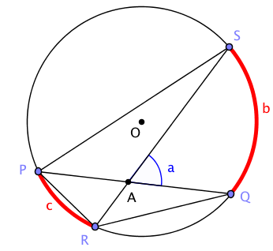

  - Which triangles in the diagram are similar? Explain how you know.

  - See if you can use one of the triangles to prove the secant angle theorem: interior case. (Hint: Use the exterior angle theorem.)

Example 1
Shown below are two circles with two secant chords intersecting outside the circle.

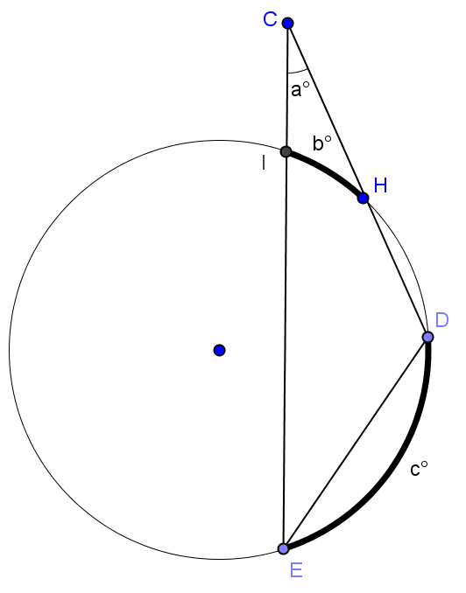
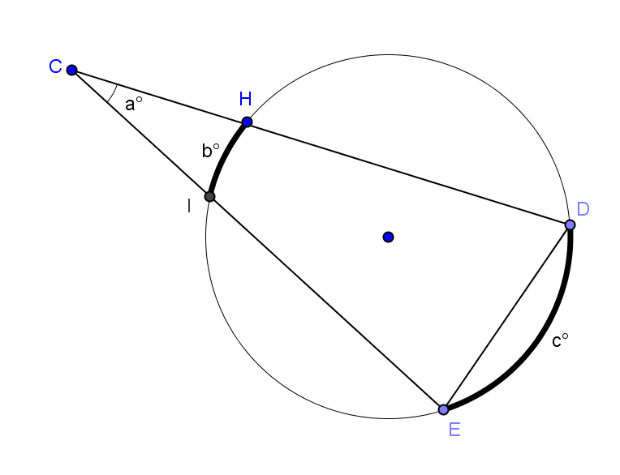

Measure $a$,$b$, and $c$. Make a conjecture about the relationship between them.

$$a$$ | $$b$$ | $$c$$

Conjecture about the relationship between $a$, $b$, and $c$:

Test your conjecture with another diagram.

Exercises
Find $x, y$, and/or $z$.
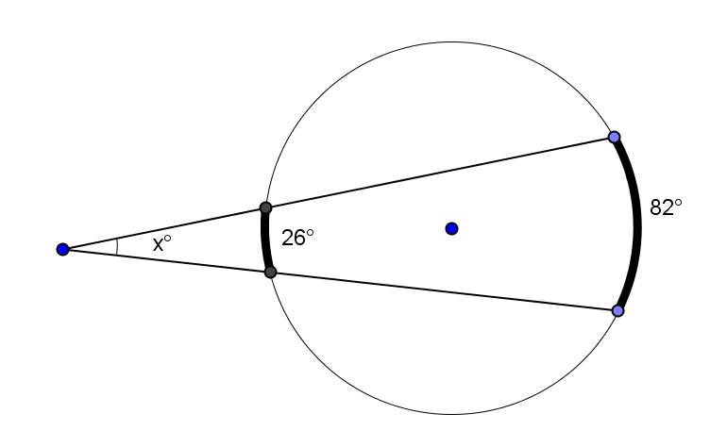 | 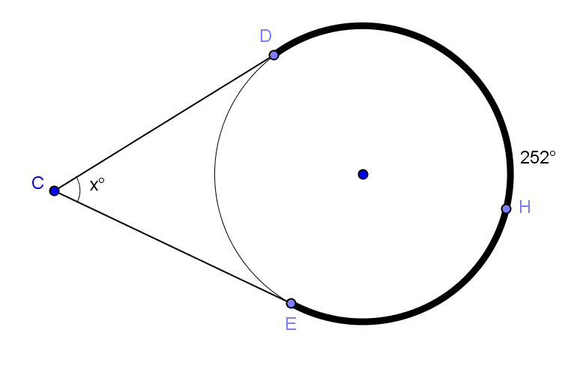
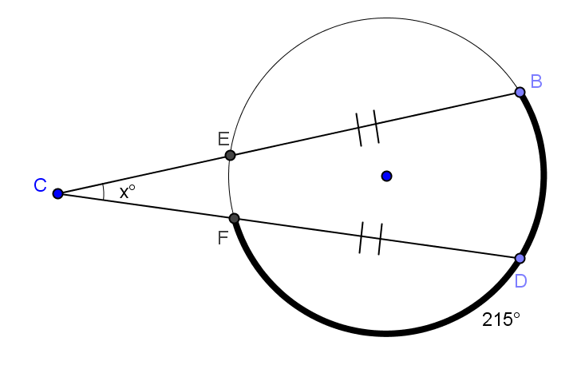 | 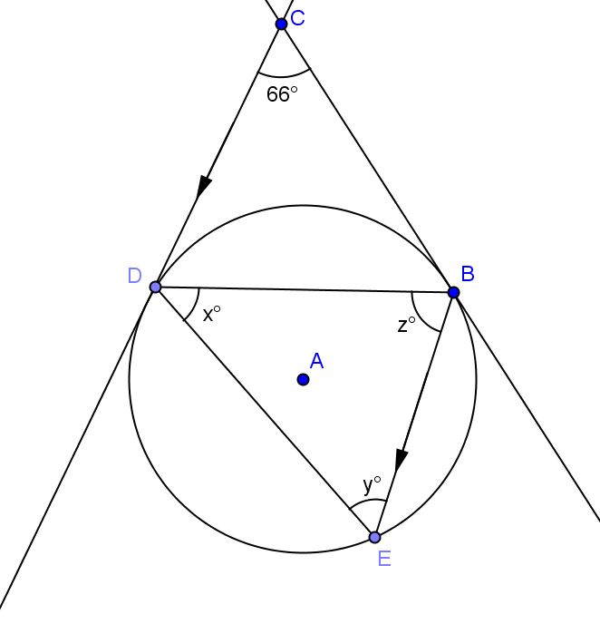

Lesson Summary:
We have just developed proofs for an entire family of theorems. Each theorem in this family deals with two shapes and how they overlap. The two shapes are two intersecting lines and a circle.
In this exercise, you’ll summarize the different cases.

The Inscribed Angle Theorem and its Family of Theorems
Diagram | How the two shapes overlap | Relationship between $a$, $b, c,$ and $d$
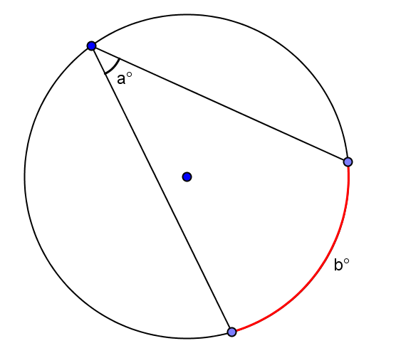
(Inscribed Angle Theorem)

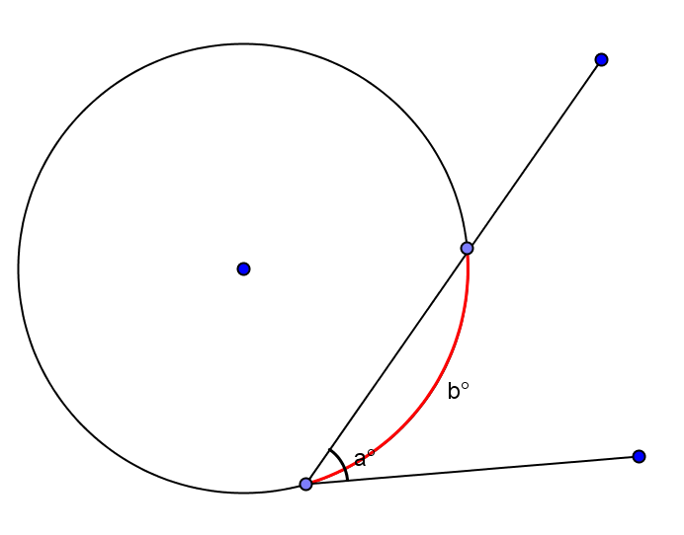
(Secant – Tangent)

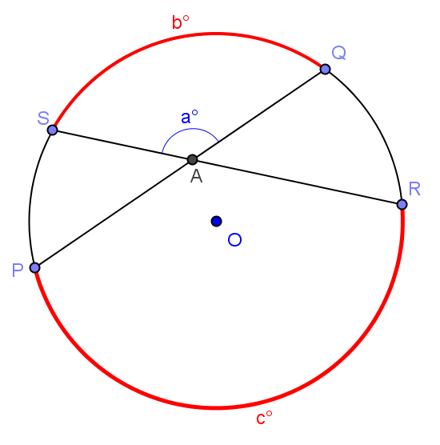
(Secant Angle Theorem: Interior)

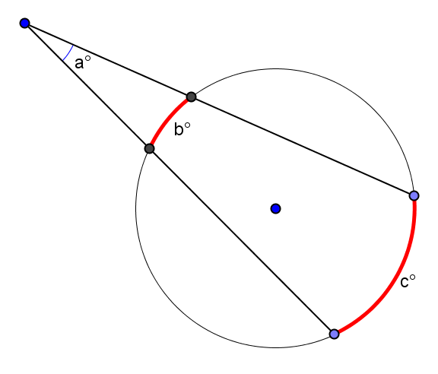
(Secant Angle Theorem: Exterior)

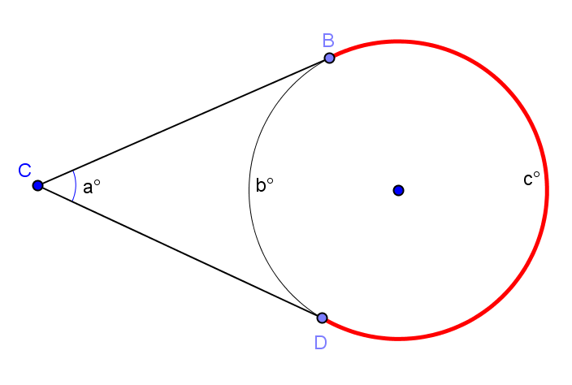
(Two Tangent Lines)

Lesson Summary
Theorems:
- Secant angle theorem: Interior case. The measure of an angle whose vertex lies in the interior of a circle is equal to half the sum of the angle measures of the arcs intercepted by it and its vertical angle.
- Secant angle theorem: Exterior case. The measure of an angle whose vertex lies in the exterior of the circle, and each of whose sides intersect the circle in two points, is equal to half the difference of the angle measures of its larger and smaller intercepted arcs.
Relevant Vocabulary
Secant to a circle: A secant line to a circle is a line that intersects a circle in exactly two points.

Problem Set

- Find $x$. | - Find $m∠DFE$ and $m∠DGB$.
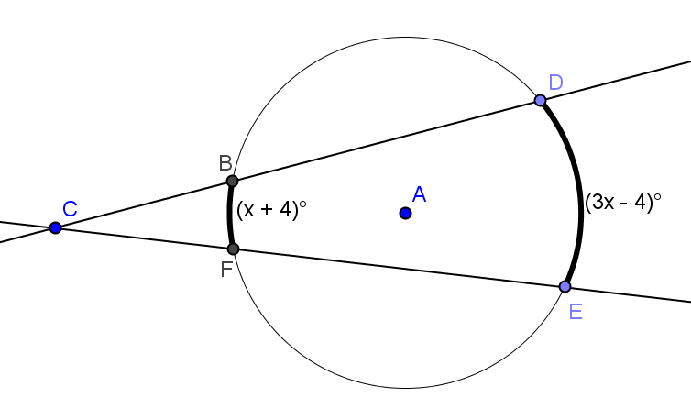 | 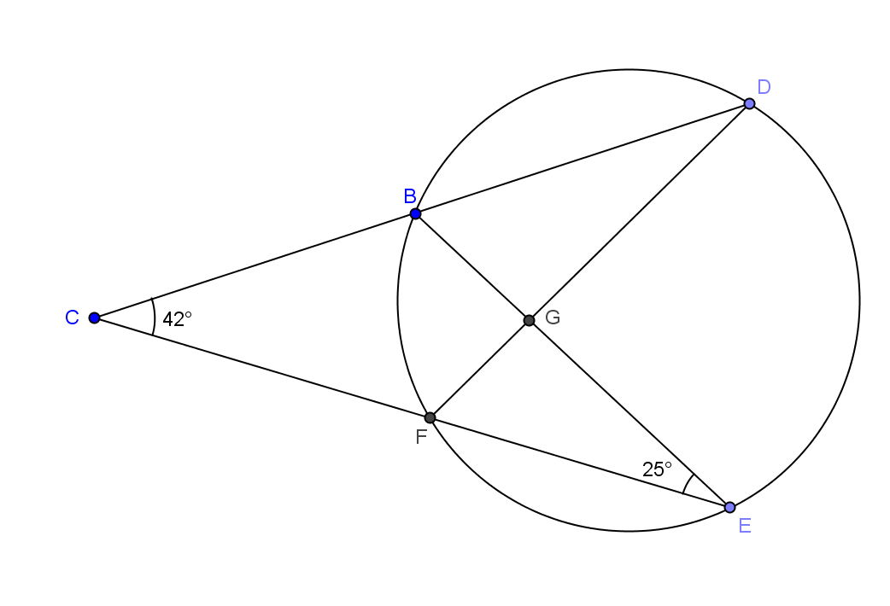
- Find $m∠ECD, m∠DBE,$and$m∠DEB$. | - Find $m∠FGE$and$m∠FHE$.
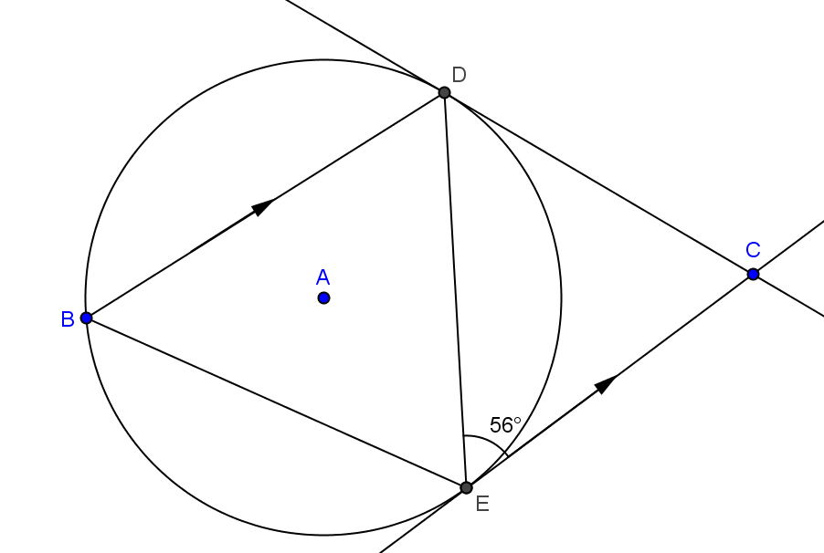 | 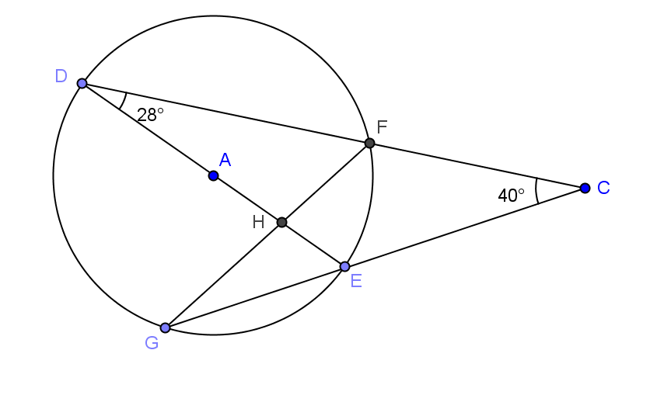
- Find $x$ and $y$. | - The radius of circle $A$ is $4$. $\overline{DC}$and$\overline{CE}$ are tangent to the circle with $DC=12$. Find $m\hat{EBD}$ and the area of quadrilateral DAEC rounded to the nearest hundredth.
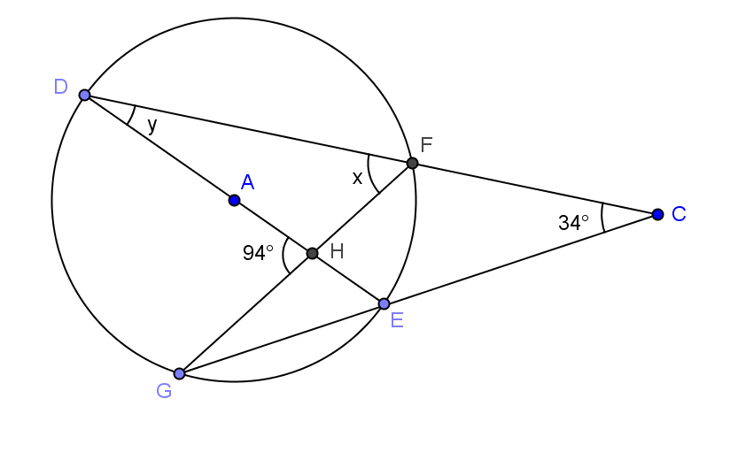 | 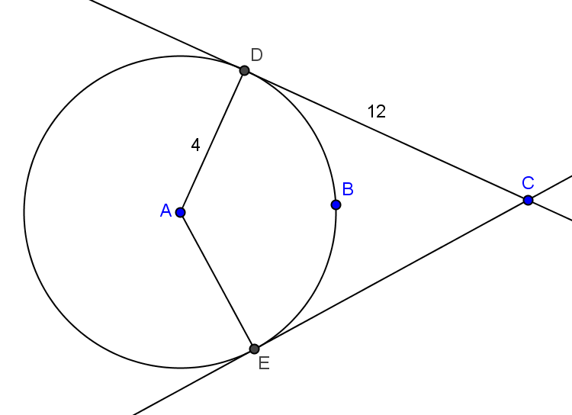
- Find $m\hat{BG}, m\hat{GF},$and$m\hat{FB}$. | - Find $x$ and $y$.
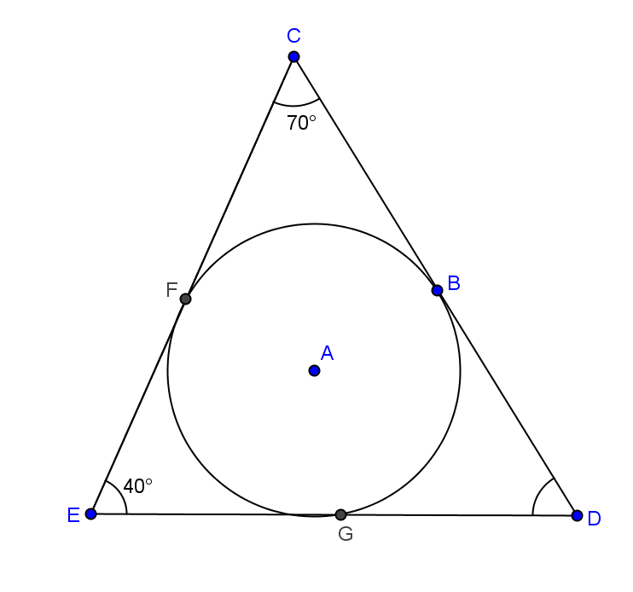 | 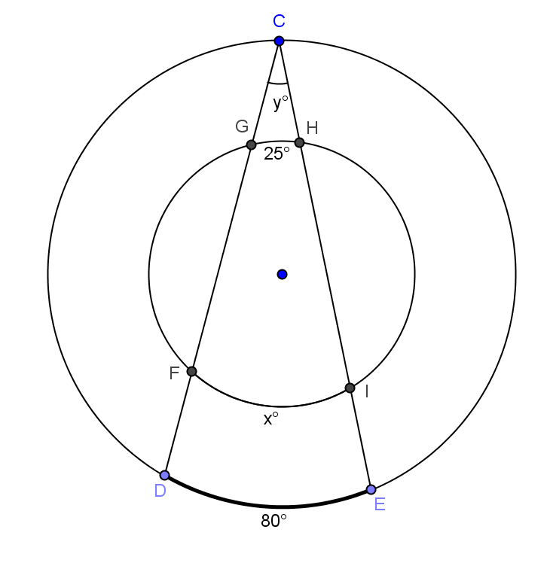
- The radius of a circle is $6$.
  - If the angle formed between two tangent lines to the circle is $60°$, how long are the segments between the point of intersection of the tangent lines and the circle?
  - If the angle formed between the two tangent lines is $120°$, how long are the segments between the point of intersection of the tangent lines and the circle? Round to the nearest hundredth.

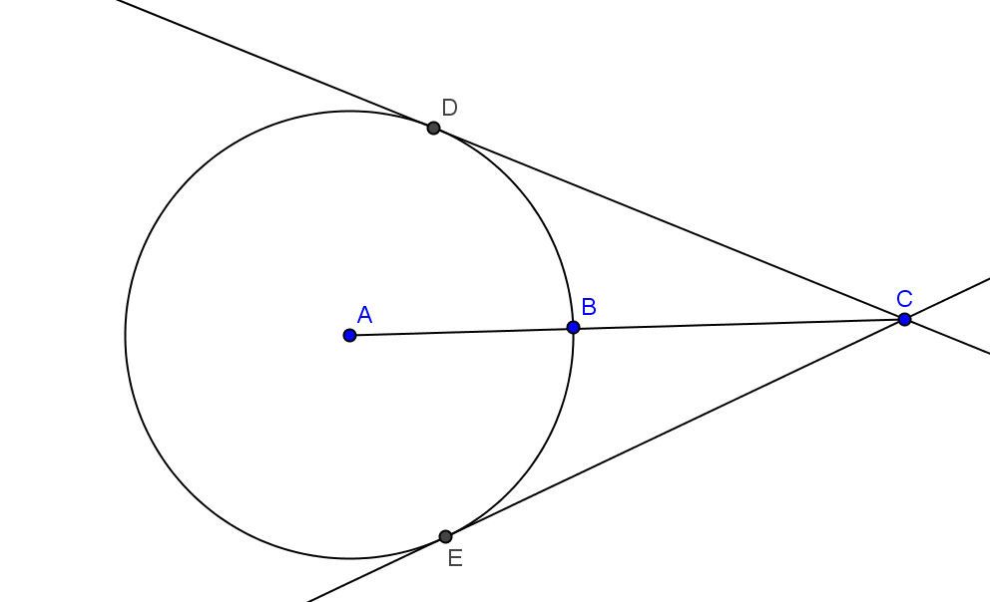
- $\overline{DC}$ and $\overline{EC}$ are tangent to circle $A$. Prove $BD=BE$.

