Lesson 14: Secant Lines; Secant Lines That Meet Inside a Circle
Student Outcomes
- Students understand that an angle whose vertex lies in the interior of a circle intersects the circle in two points and that the edges of the angles are contained within two secant lines of the circle.
- Students discover that the measure of an angle whose vertex lies in the interior of a circle is equal to half the sum of the angle measures of the arcs intercepted by it and its vertical angle.

Lesson Notes
Lesson 14 begins the study of secant lines. The study actually began in Lessons 4–6 with inscribed angles, but we did not call the lines secant then. Therefore, students have already studied the first case, lines that intersect on the circle. In this lesson, students study the second case, secants intersecting inside the circle. The third case, secants intersecting outside the circle, will be introduced in Lesson 15.

Classwork
Opening Exercise (5 minutes)
This exercise reviews the relationship between tangent lines and inscribed angles, preparing students for our work in Lesson 14. Have students work on this exercise individually and then compare answers with a neighbor. Finish with a class discussion.
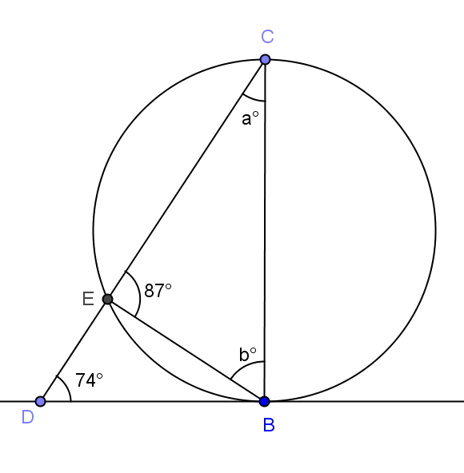
Opening Exercise
$\overset{⃡}{DB}$ is tangent to the circle as shown.
- Find the values of $a$ and $b$.
$a=13$, $b=80$

- Is $\overline{CB}$ a diameter of the circle? Explain.
No, if $\overline{CB}$ was a diameter, then $m∠CEB$would be $90°$.

Discussion (10 minutes)
In this discussion, we remind students of the definitions of tangent and secant lines and then have students draw circles and lines to see the different possibilities of where tangent and secant lines can intersect with respect to a circle. Every student should draw the sketches called for and then, as a class, classify the sketches and talk about why the classifications were chosen.
Scaffolding:
- Post the theorem definitions from previous lessons in this module on the board so that students can easily review them if necessary. Add definitions and theorems as they are studied.
- Draw a circle and a line that intersects the circle.
  - Students draw a circle and a line.
- Have the students tape their sketches to the board.
MP.7
- Let’s group together the diagrams that are alike.
  - Students should notice that some circles have lines that intersect the circle twice and others only touch the circle once, and students should separate them accordingly.

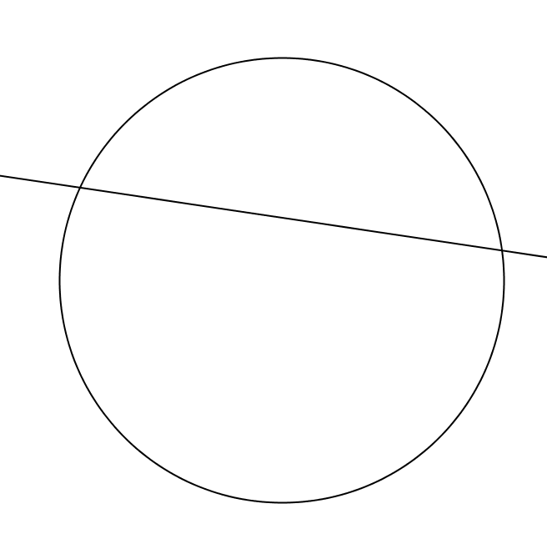
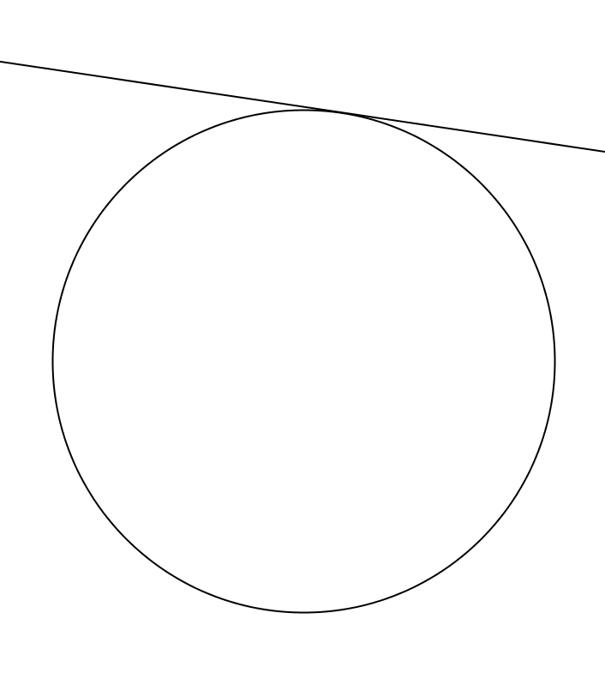

- Explain how the groups are different.
  - A line and a circle in the same plane that intersect can intersect in one or two points.
- Does anyone know what we call each of these lines?
  - A line that intersects a circle at exactly two points is called a secant line.
  - A line in the same plane that intersects a circle at exactly one point is called a tangent line.
- Label each group of diagrams as “secant lines” and “tangent lines.” Then, as a class, have students write their own definition of each.
- Secant line: A secant line to a circle is a line that intersects a circle in exactly two points.
- Tangent line: A tangent line to a circle is a line in the same plane that intersects the circle in one and only one point.
- This lesson focuses on secant lines. We studied tangent lines in Lessons 11–13.
- Starting with a new piece of paper, draw a circle and draw two secant lines. (Check to make sure that students are drawing two lines that each intersect the circle twice. This is an informal assessment of their understanding of the definition of a secant line.)
  - Students draw a circle and two secant lines.
- Again, have students tape their sketches to the board.
- Let’s group together the diagrams that are alike.
Students should notice that some lines intersect outside of the circle, others inside the circle, others on the circle, and others are parallel and don’t intersect. Teachers may want to have a case of each prepared ahead of time in case all are not created by the students.
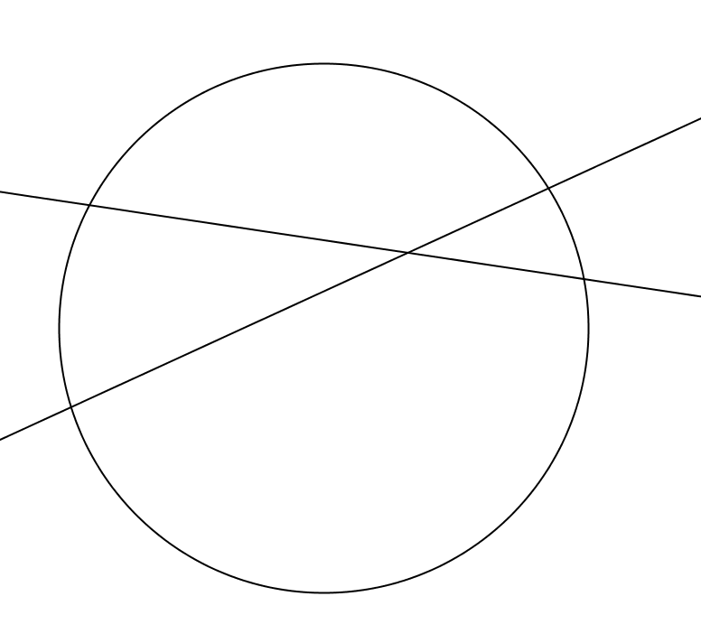
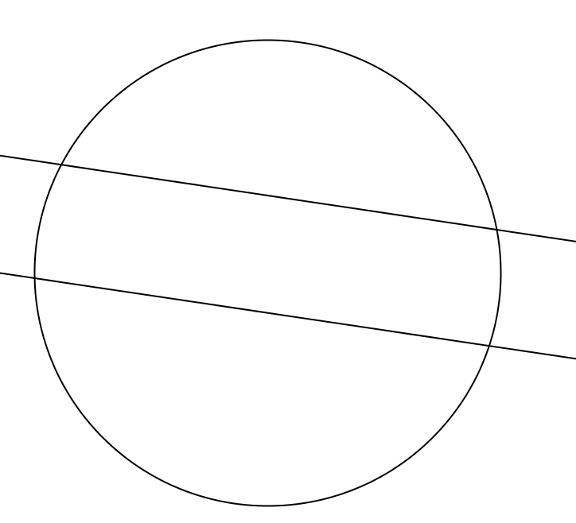
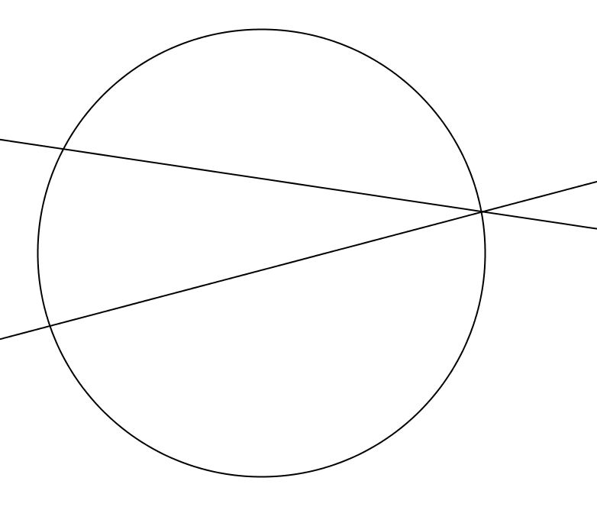

- We have four groups. Explain the differences between the groups.
  - Some lines intersect outside of the circle, others inside the circle, others on the circle, and others are parallel and don’t intersect.
- Label each group as “intersect outside the circle,” “intersect inside the circle,” “intersect on the circle,” “intersect on the circle,” and “parallel.”
- Show students that the angles formed by intersecting secant lines have edges that are contained in the secant lines.
- Today we will talk about three of the cases of secant lines of a circle and the angles that are formed at the point of intersection.

Exercises 1–2 (5 minutes)
Exercises 1–2 deal with secant lines that are parallel and secant lines that intersect on the circle (Lessons 4–6). When exercises are presented, students should realize that we already know how to determine the angles in these cases.
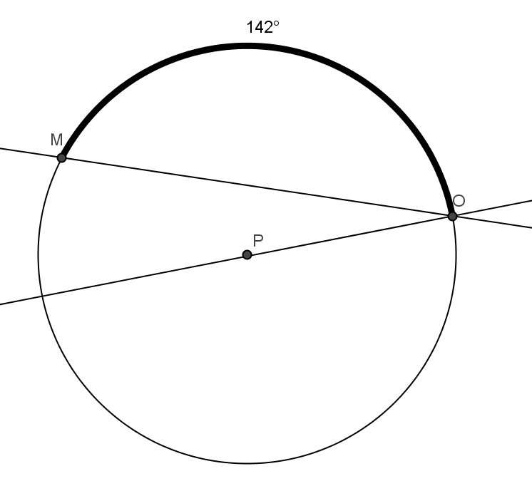
Exercises 1–2
- In circle $P$, $\overline{PO}$ is a radius, and $m\hat{MO}=142°$. Find $m∠MOP,$ and explain how you know.
$m∠MOP=1°$
Since $\overline{PO}$ is a radius and extends to a diameter, the measure of the arc intercepted by the diameter is $180°$. $m\hat{MO}=14°$, so the arc intercepted by $∠MOP$ is $°142°$ $=3°$. $∠MOP$ is inscribed in this arc, so its measure is half the degree measure of the arc or $\frac{1}{2}\left(38°\right)=1°$.

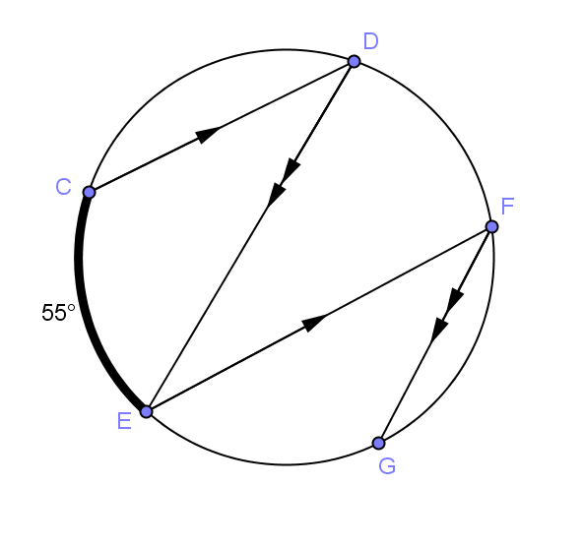
- In the circle shown, $m\hat{CE}=5°$. Find $m∠DEF$ and $m\hat{EG}$. Explain your answer.
$m∠DEF=27.5°$
$$m\hat{EG}=5°$$
$m\hat{CE}=m\hat{DF}$and$m\hat{DF}=m\hat{EG}$ because arcs between parallel lines are congruent.
By substitution, $m\hat{EG}=5°$.
m$\hat{DF}=55° so m∠DEF =\frac{1}{2}\left(55°\right)=27.°$ because it is inscribed in a $55°$ arc.
Example 1 (12 minutes)
In this example, students are introduced for the first time to secant lines that intersect inside a circle.
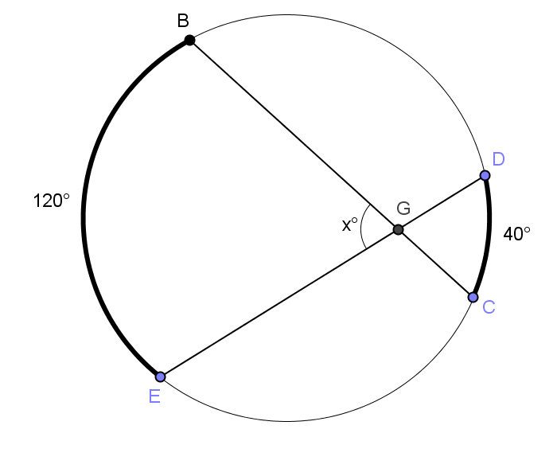
Example 1
- Find $x$. Justify your answer.
$80°$. If you draw $∆BDG,$ $m∠DBG=20°,$ and $m∠BDG=60°$ because they are half of the measures of their inscribed arcs, that means $m∠BGD=10°$ because the sums of the angles of a triangle total $180°$. $∠DGB$and$∠BGE$ are supplementary, so $m∠BGE=8°$.

- What do you think the measure of $∠BGE$ is?
  - Responses will vary and many will just guess.
  - This is not an inscribed angle or a central angle and the chords are not congruent, so students won’t actually know the answer. That is what we want them to realize – they don’t know.
- Is there an auxiliary segment you could draw that would help determine the measure of $∠BGE$?
MP.7
  - Draw chord $\overline{BD}$.
- Can you determine any of the angle measures in ∆$BDG$? Explain.
  - Yes, all of them. $m∠DBC=°$ because it is half of the degree measure of the intercepted arc, which is $40°$. $m∠BDE=°$ because it is half of the degree measure of the intercepted arc, which is $120°$. $m∠DGB=°$ because the sum of the angles of a triangle are $180°$.
- Does this help us determine $x$?
  - Yes, $∠DGB$ and $∠BDE$ are supplementary, so their sum is $180°$. That means $m∠BGE=°$.
- The angle $∠BGE$ in part (a) above is often called a secant angle because its sides are contained in two secants of the circle such that each side intersects the circle in at least one point other than the angle’s vertex.
- Is the vertical angle $∠DGC$ also a secant angle?
  - Yes, rays $\vec{GD}$ and $\vec{GC}$ intersect the circle at points $D$ and $C$ respectively.
Let’s try another problem. Have students work in groups to go through the same process to determine $x$.
Scaffolding:
- Advanced students should determine $x$ and the general result independently.
- Use scaffolded questions with the whole class or a targeted small group.

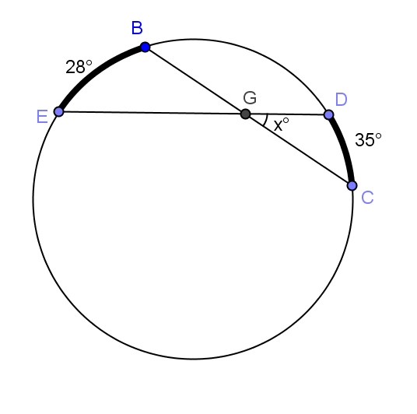
- Find$x$.
$$31.5$$

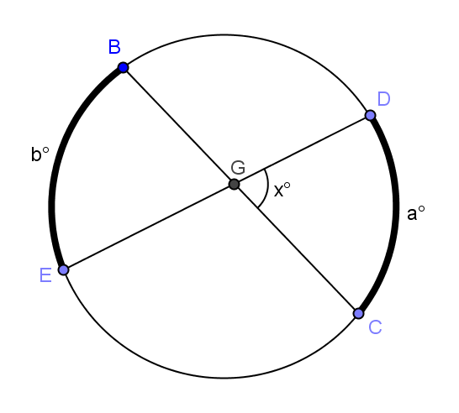
- Can we determine a general result?
- What equation would represent the result we are looking to prove?
  - $x= \frac{a+b}{2}$
- Draw $\overline{BD}.$
  - Students draw chord $BD$.
- What are the measures of the angles in $∆BDG$?
  - $m∠GBD=\frac{1}{2}a$
  - $m∠BDG= \frac{1}{2}b$
  - $m∠BGD=180-\frac{1}{2}a-\frac{1}{2}b$
- What is $x$?
  - $x = 180 – (180 - \frac{1}{2}a-\frac{1}{2}b)$
- Simplify that.
  - $x= \frac{1}{2}a+\frac{1}{2}b= \frac{a+b}{2}$
- What have we just determined? Explain this to your neighbor.
  - The measure of an angle whose vertex lies in the interior of a circle is equal to half the sum of the angle measures of the arcs intercepted by it and its vertical angle.
- Does this formula also apply to secant lines that intersect on the circle (an inscribed angle) as in Exercise 1?
- Have students look at Exercise 1 again.
- What are the angle measures of the two intercepted arcs?
  - There is only one intercepted arc and its measure is $38°$.
- The vertical angle doesn’t intercept an arc since its vertex lies on the circle. Suppose for a minute, however, that the “arc” is that vertex point. What would the angle measure of that “arc” be?
  - It would have a measure of $0°$.
- Does our general formula still work using $0°$ for the measure or the “arc” given by the vertical angle?
  - $\frac{38+0}{2}=°$. It does work.
- Explain this to your neighbor.
  - The measure of an inscribed angle is a special case of the general formula when suitably interpreted.

We can state the results of part (b) of this example as the following theorem:
Secant angle theorem: Interior case. The measure of an angle whose vertex lies in the interior of a circle is equal to half the sum of the angle measures of the arcs intercepted by it and its vertical angle.

Exercises 3–7 (5 minutes)
The first three exercises are straight forward, and all students should be able to use the formula found in this lesson to solve. The final problem is a little more challenging. Assign some students only Exercises 3–5 and others 5–7. Have students complete these individually and then compare with a neighbor. Walk around the room, and use this as an informal assessment of student understanding.
In Exercises 3–5, find $x$ and $y$.

- 4.
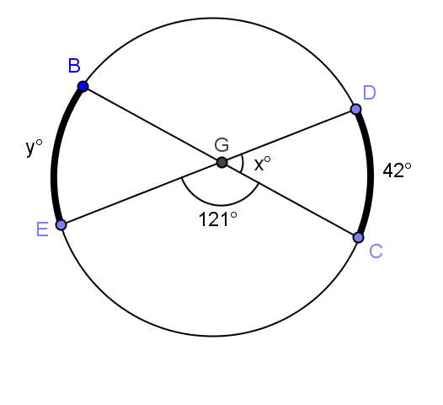
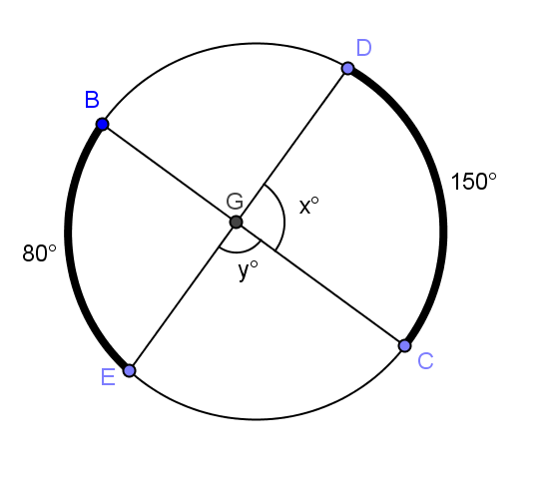

$x=115$, $y=65$ $x=59$, $y=76$

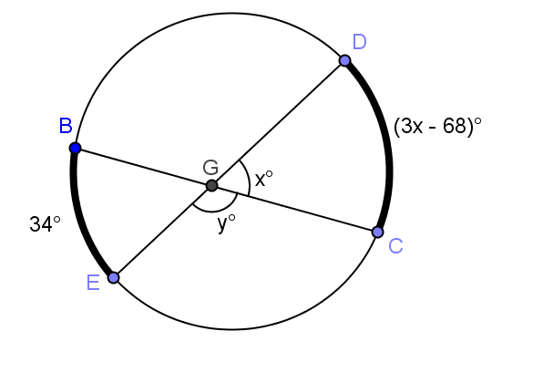
$x=34$, $y=146$

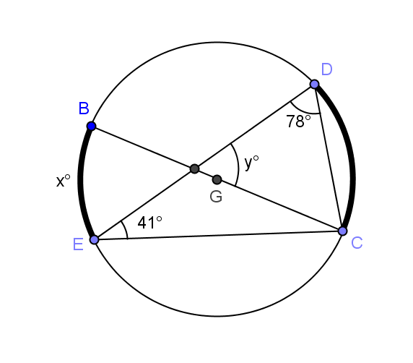

- In circle, $\overline{BC}$ is a diameter. Find $x$ and $y$.

$x=24$, $y=53$

- In the circle shown, $\overline{BC}$ is a diameter. $DC: BE=2:1$. Prove $y=180-\frac{3}{2}x$ using a two-column proof.
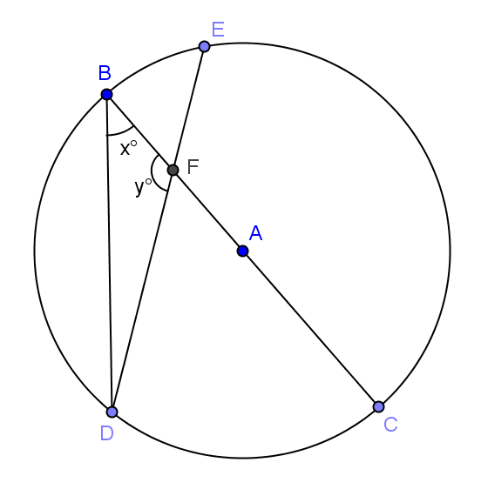
$\overline{BC}$ is a diameter of circle $A$ Given
$m∠DBC=x$ Given
$m\hat{DC}=2x$ Arc is double angle measure of inscribed angle
$m\hat{BE}=x$ DC:BE = 2:1
$m\hat{BDC}=m\hat{\hat{BEC}=180⁰}$ Semi-circle measures 180⁰
$m\hat{DB}=180-2x$ Arc addition
$m\hat{EC}=180-x$ Arc addition
$$m∠BFD= \frac{1}{2}(180-2x+180-x)$$Measure of angle whose vertex lies in a circle is half the angle measures of arcs intercepted by it and its vertical angles.
$y=180-\frac{3}{2}x$ Substitution and simplification.

Closing (3 minutes)
Project the circles below on the board, and have a class discussion with the following questions.

- What types of lines are drawn through the three circles?
  - Secant lines
- Explain the relationship between the angles formed by the secant lines and the intercepted arcs in the first two circles.
  - The first circle has angles with a vertex inside the circle. The measure of an angle whose vertex lies in the interior of a circle is equal to half the sum of the angle measures of the arcs intercepted by it and its vertical angle.
  - The second circle has an angle on the vertex, an inscribed angle. Its measure is half the angle measure of its intercepted arc.
- How is the third circle different?
  - The lines are parallel, and no angles are formed. The arcs are congruent between the lines.

Lesson Summary
Theorems:
Secant angle theorem: Interior case. The measure of an angle whose vertex lies in the interior of a circle is equal to half the sum of the angle measures of the arcs intercepted by it and its vertical angle.
Relevant Vocabulary
- Tangent to a circle: A tangent line to a circle is a line in the same plane that intersects the circle in one and only one point. This point is called the point of tangency.
- Tangent segment/ray: A segment is a tangent segment to a circle if the line that contains it is tangent to the circle and one of the end points of the segment is a point of tangency. A ray is called a tangent ray to a circle if the line that contains it is tangent to the circle and the vertex of the ray is the point of tangency.
- Secant to a circle: A secant line to a circle is a line that intersects a circle in exactly two points.

Exit Ticket (5 minutes)
Name Date
Lesson 14: Secant Lines; Secant Lines That Meet Inside a Circle

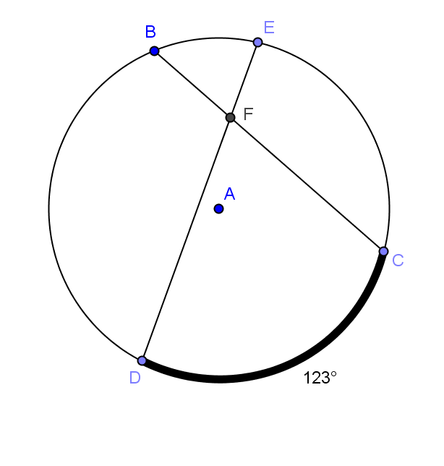
Exit Ticket

- Lowell says that $m∠DFC= \frac{1}{2}\left(123\right)=°$ because it is half of the intercepted arc. Sandra says that you can’t determine the measure of $∠DFC$ because you don’t have enough information. Who is correct and why?

2. If $m∠EFC=°$, find and explain how you determined your answer.
- $m∠BFE$

- $m\hat{BE}$
Exit Ticket Sample Solutions

- Lowell says that $m∠DFC=\frac{1}{2}\left(123\right)=61.°$ because it is half of the intercepted arc. Sandra says that you can’t determine the measure of $∠DFC$ because you don’t have enough information. Who is correct and why?
Sandra is correct. We would need more information to determine the answer. Lowell is incorrect because $∠DFC$ is not a central angle.

- If $m∠EFC=9°$, find and explain how you determined your answer.
  - $m∠BFE$
$81°$, $m∠EFC+m∠BFE=18°$ (supplementary angles), so $180-99 = m∠BFE$.

  - $m\hat{BE}$
$39°$, $81=\frac{1}{2}(y+123)$ using formula for an angle with vertex inside a circle.

Problem Set Sample Solutions

Problems 1–4 are more straightforward. The other problems are more challenging and could be given as a student choice or specific problems assigned to different students.

In Problems 1–4, find $x$.
- 2.
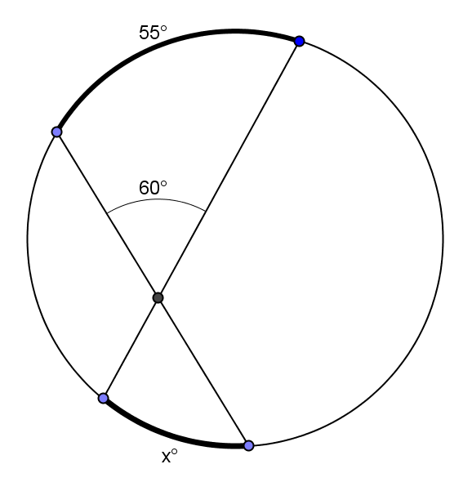
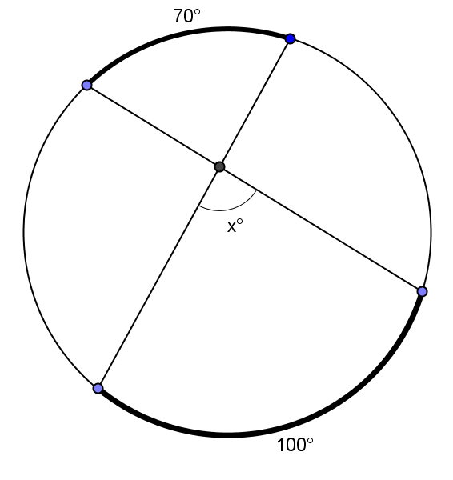

$x=85$ $x=65$
- 4.
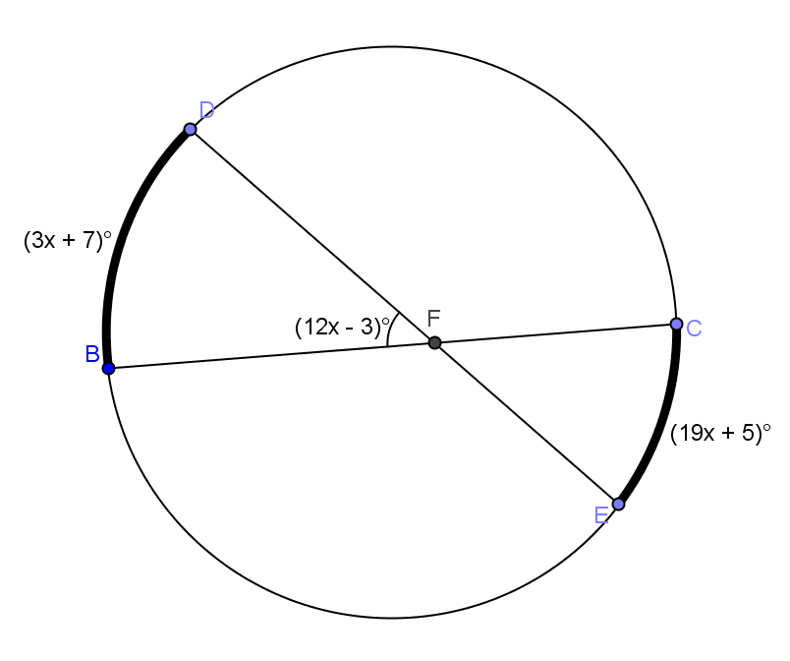
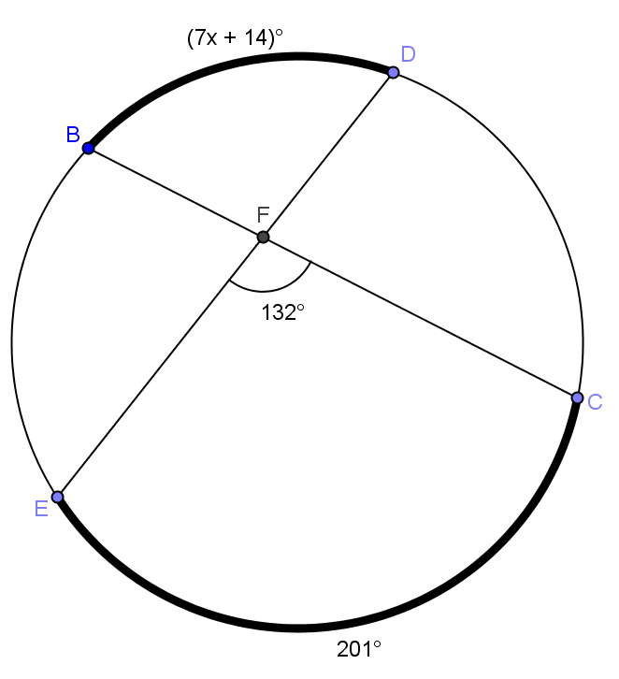

$x=7$ $x=9$

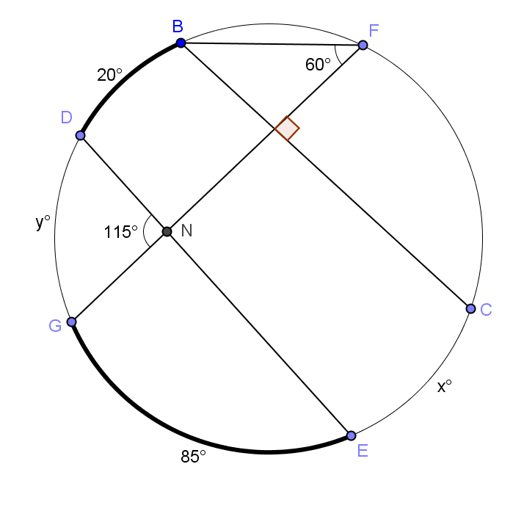
- Find $x$($m\hat{CE})$ and $y(m\hat{DG})$.

$x=70$, $y=100$

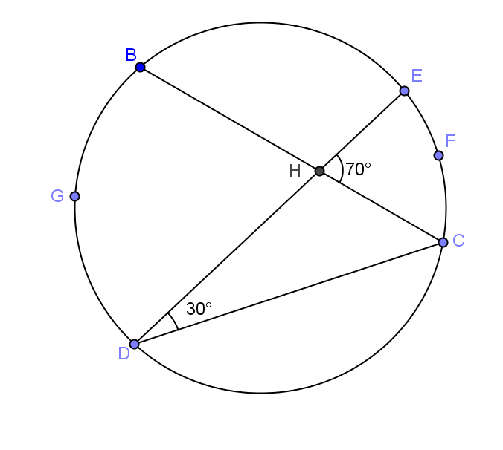
- Find the ratio of $m\hat{EFC}:m\hat{DGB}$.

$$3:4$$

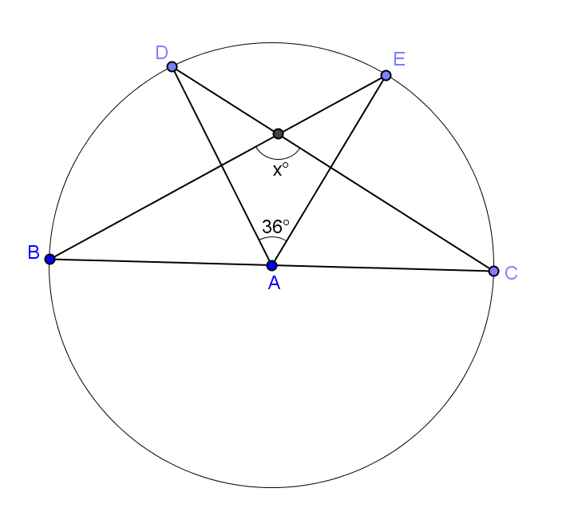
- $\overline{BC}$ is a diameter of circle $A$.

$$x=108$$

- Show that the general formula we discovered in Example 1 also works for central angles. (Hint: Extend the radii to form $2$ diameters, and use relationships between central angles and arc measure.)
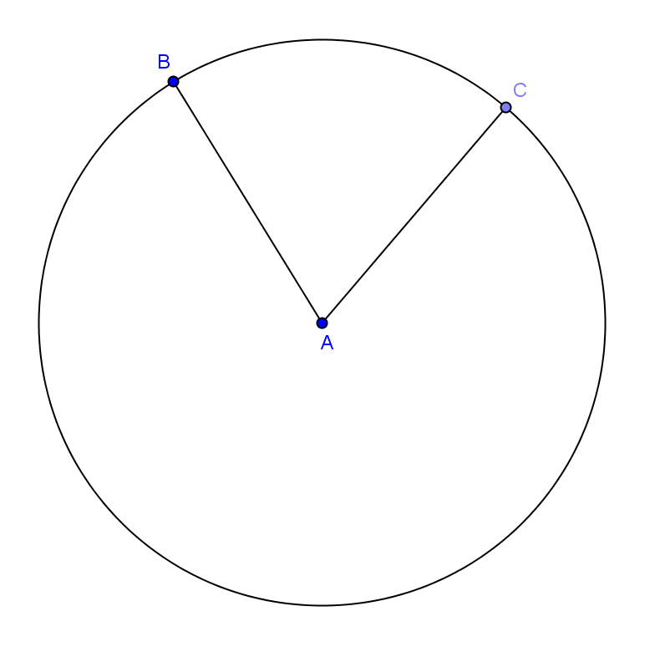
Extend the radii to form two diameters.
Let the measure of the central angle $=x°$.
The measure $m\hat{BC}=°$ because the angle measure of the arc intercepted by a central angle is equal to the measure of the central angle.
The measure of the vertical angle is also $x°$ because vertical angles are congruent.
The angle of the arc intercepted by the vertical angle is also $x° .$
The measure of the central angle is half the sum of angle measures of the arcs intercepted by the central angle and its vertical angle $(x=\frac{1}{2}\left(x+x\right))$.
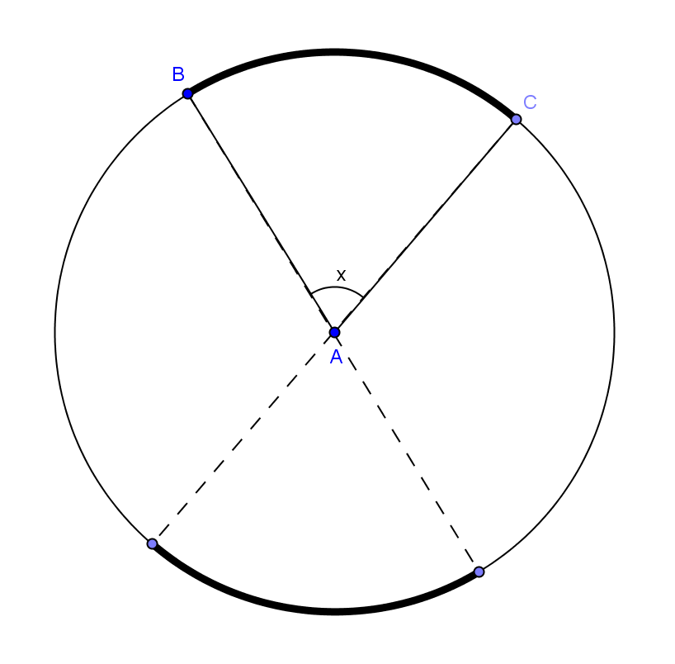
This formula also works for central angles.

