Lesson 14: Secant Lines; Secant Lines That Meet Inside a Circle

Classwork
Opening Exercise
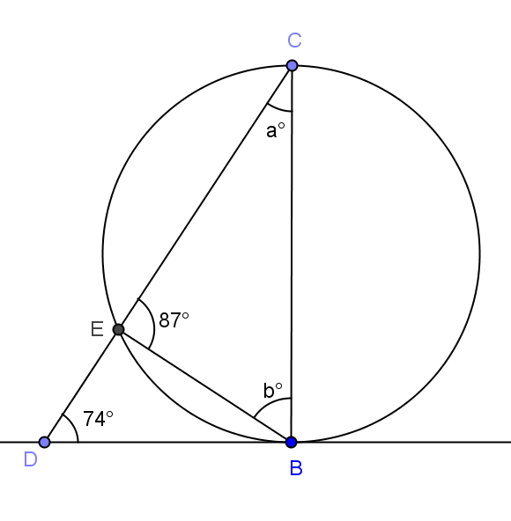
$\overset{⃡}{DB}$ is tangent to the circle as shown.
  - Find the values of $a$ and $b$.

  - Is $\overline{CB}$ a diameter of the circle? Explain.

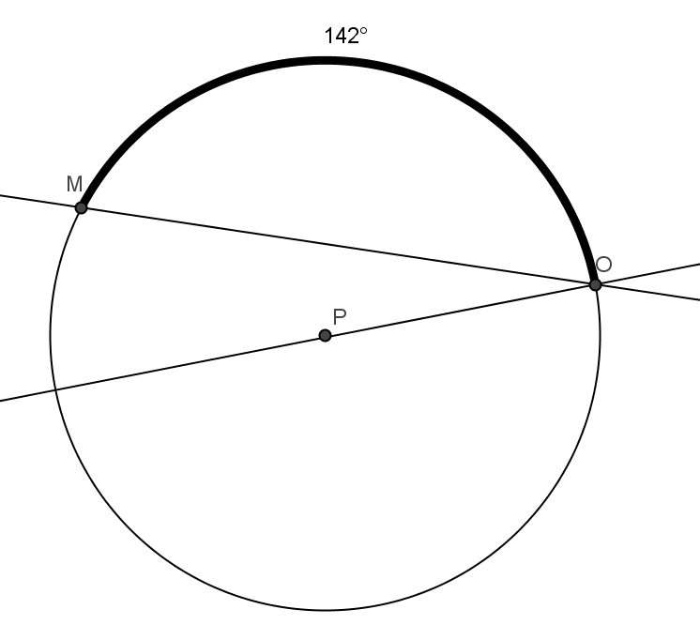
Exercises 1–2
- In circle $P$, $\overline{PO}$ is a radius, and $m\hat{MO}=14°$. Find $m∠MOP,$ and explain how you know.

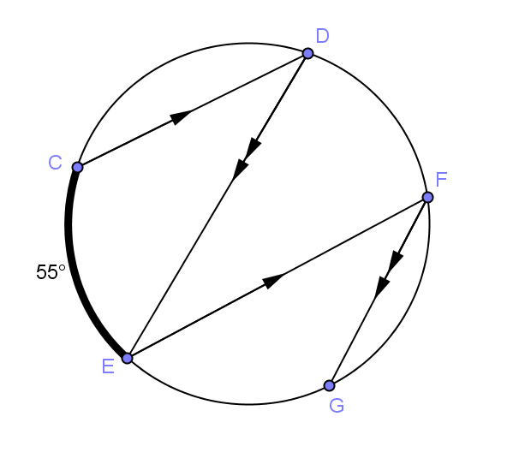
- In the circle shown, $m\hat{CE}=55°$. Find $m∠DEF$ and $m\hat{EG}$. Explain your answer.

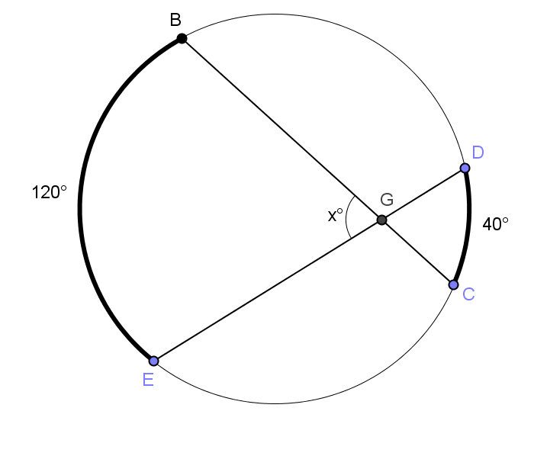
Example 1
  - Find $x$. Justify your answer.

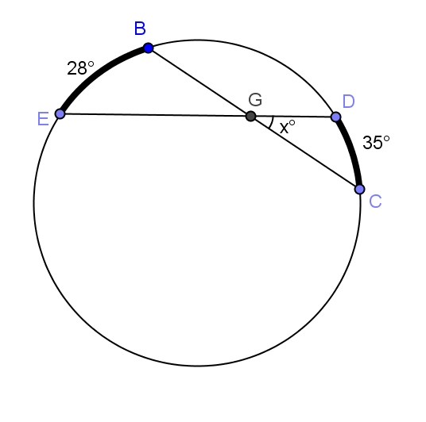
  - Find $x.$

We can state the results of part (b) of this example as the following theorem:
Secant angle theorem: interior case: The measure of an angle whose vertex lies in the interior of a circle is equal to half the sum of the angle measures of the arcs intercepted by it and its vertical angle.

Exercises 3–7
In Exercises 3–5, find $x$and$y$.

3. 4.
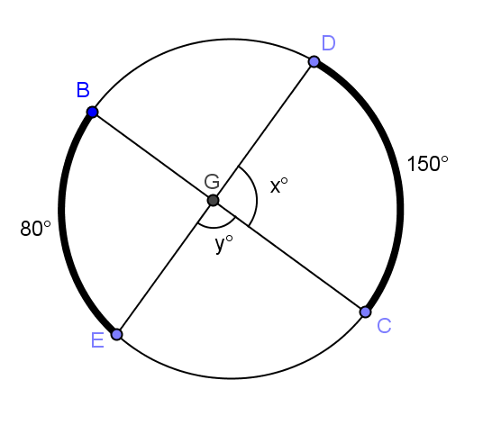
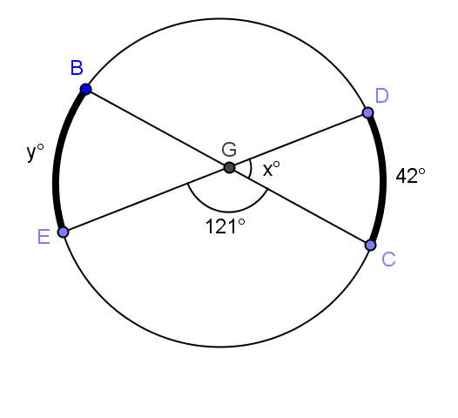

5.
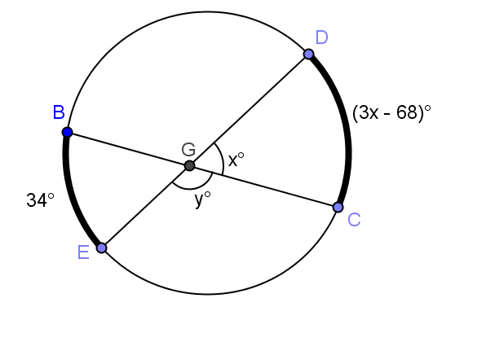

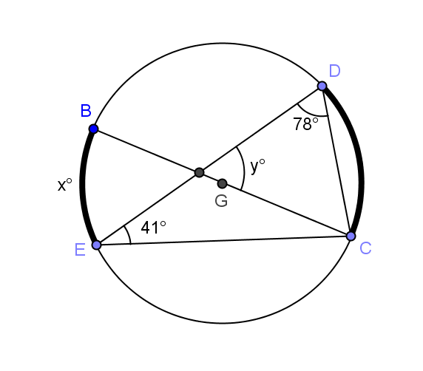
- In circle, $\overline{BC}$ is a diameter. Find $x$ and $y$.

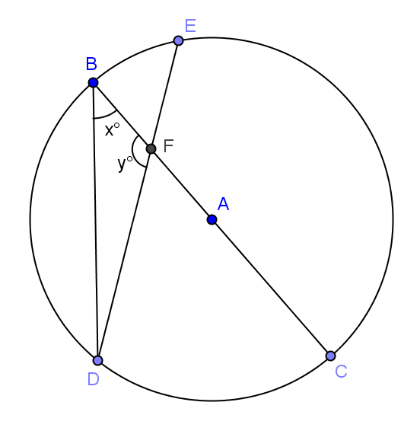
- In the circle shown, $\overline{BC}$ is a diameter$. DC: BE=2:1$. Prove
$y=180- \frac{3}{2}x$ using a two-column proof.

Lesson Summary
Theorems:
- Secant angle theorem: interior case. The measure of an angle whose vertex lies in the interior of a circle is equal to half the sum of the angle measures of the arcs intercepted by it and its vertical angle.
Relevant Vocabulary
- Tangent to a circle: A tangent line to a circle is a line in the same plane that intersects the circle in one and only one point. This point is called the point of tangency.
- Tangent segment/ray: A segment is a tangent segment to a circle if the line that contains it is tangent to the circle and one of the end points of the segment is a point of tangency. A ray is called a tangent ray to a circle if the line that contains it is tangent to the circle and the vertex of the ray is the point of tangency.
- Secant to a circle: A secant line to a circle is a line that intersects a circle in exactly two points.

Problem Set

In Problems 1–4, find $x.$

1. 2.
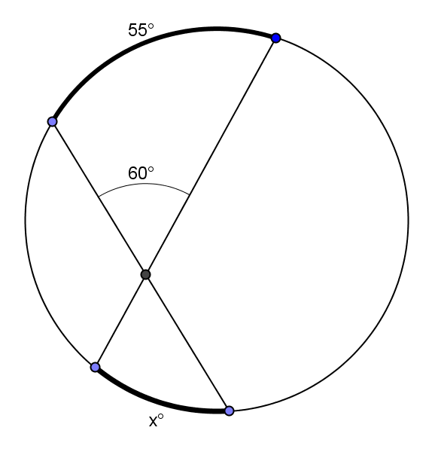
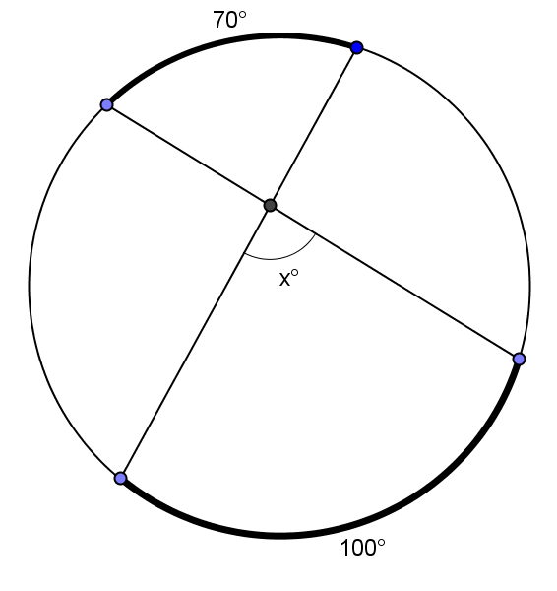

3. 4.
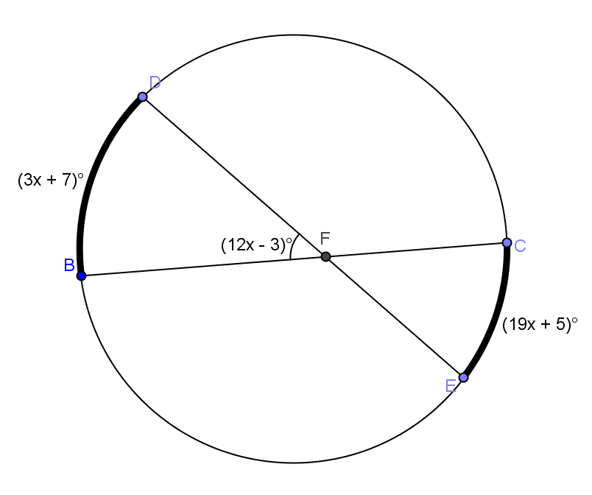
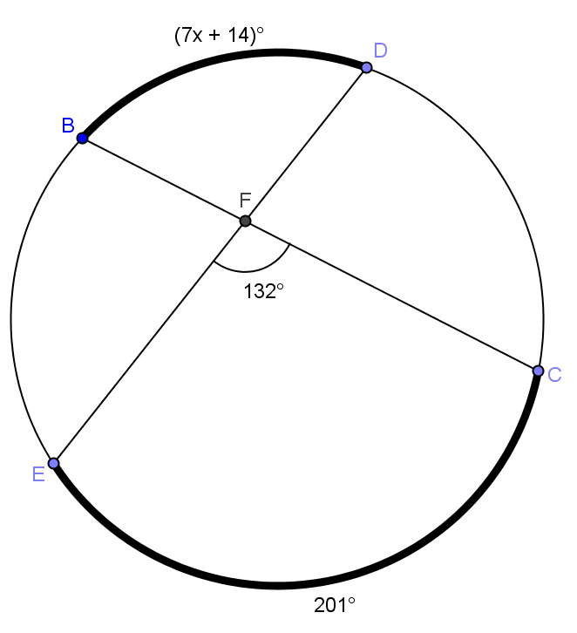

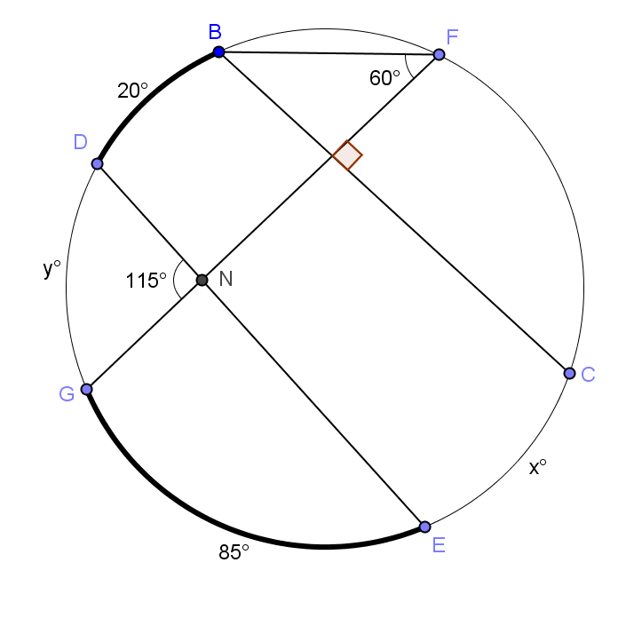
5. Find$x$ ($m\hat{CE})$ and $y (m\hat{DG})$.

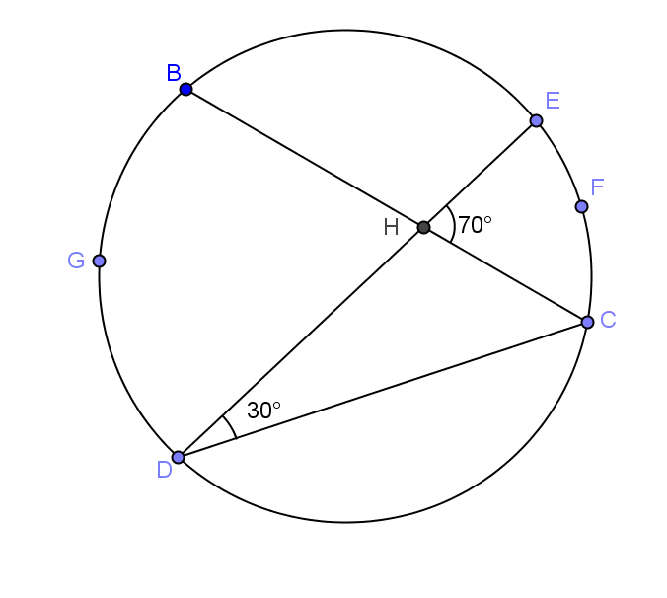
6. Find the ratio of $m\hat{EFC}:m\hat{DGB}$.

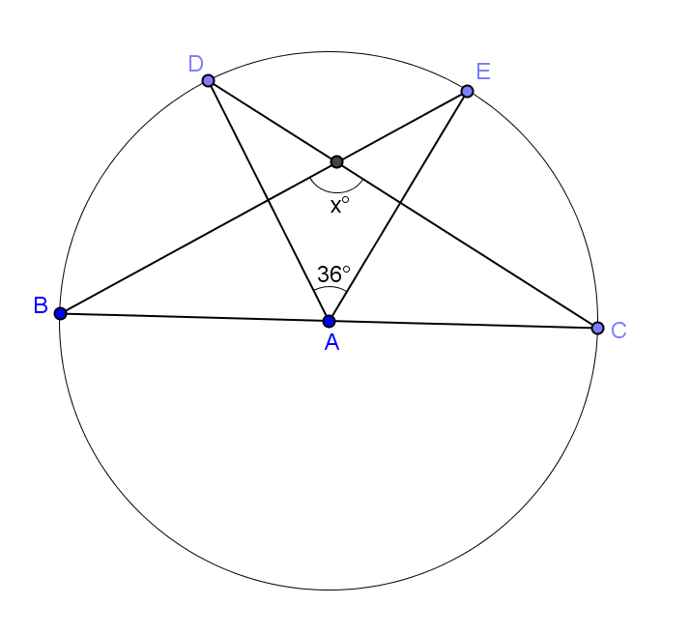
7. $\overline{BC}$ is a diameter of circle $A$. Find $x.$

- Show that the general formula we discovered in Example 1 also works for central angles. (Hint: Extend the radii to form $2$ diameters, and use relationships between central angles and arc measure.)
