Lesson 13: The Inscribed Angle Alternate a Tangent Angle

Student Outcomes
- Students use the inscribed angle theorem to prove other theorems in its family (different angle and arc configurations and an arc intercepted by an angle at least one of whose rays is tangent).
- Students solve a variety of missing angle problems using the inscribed angle theorem.

Lesson Notes
The Opening Exercise reviews and solidifies the concept of inscribed angles and their intercepted arcs. Students then extend that knowledge in the remaining examples to the limiting case of inscribed angles, one ray of the angle is tangent. Example 1 looks at a tangent and secant intersecting on the circle. Example 2 uses rotations to show the connection between the angle formed by the tangent and a chord intersecting on the circle and the inscribed angle of the second arc. Students then use all of the angle theorems studied in this topic to solve missing angle problems.
Scaffolding:
- Post diagrams showing key theorems for students to refer to.
- Use scaffolded questions with a targeted small group such as, “What do we know about the measure of the intercepted arc of an inscribed angle?”

Classwork
Opening Exercise (5 minutes)
This exercise solidifies the relationship between inscribed angles and their intercepted arcs. Have students complete this exercise individually and then share with a neighbor. Pull the class together to answer questions and discuss part (g).
In circle $A$, $m\hat{BD}=56^{0},$ and $\overline{BC}$ is a diameter. Find the listed measure, and explain your answer.
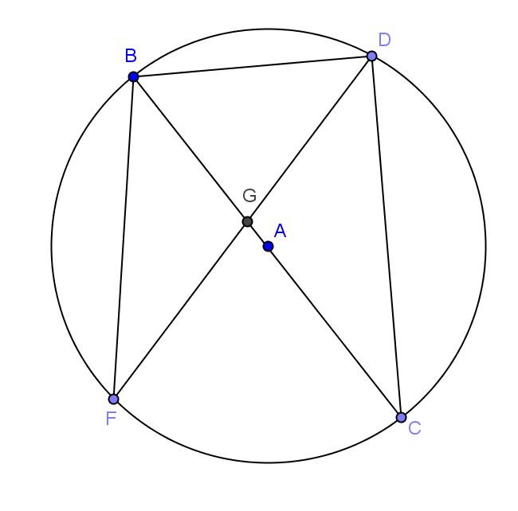
  - $m∠BDC$
$90°$, angles inscribed in a diameter

  - $m∠BCD$
$28°$, inscribed angle is half measure of intercepted arc

  - $m∠DBC$
$62°$, sum of angles of a triangle is 180⁰

  - $m∠BFG$
$28°$, inscribed angle is half measure of intercepted arc

  - $m\hat{BC}$
$180°$, semicircle

  - $m\hat{DC}$
$124°$, intercepted arc is double inscribed angle

  - Is the $m∠BGD=56°$? Explain.
No, the central angle of arc $\hat{BD}$ would be $56°$. $∠BGD$ is not a central angle because its vertex is not the center of the circle.

  - How do you think we could determine the measure of $∠BGD$?
Answers will vary. This leads to today’s lesson.

Example 1 (15 minutes)
In the Lesson 12 homework, students were asked to find a relationship between the measure of an arc and an angle. The point of Example 1 is to establish the following conjecture for the class community and prove the conjecture.
Conjecture: Let$A$ be a point on a circle, let$\vec{AB}$ be a tangent ray to the circle, and let $C$ be a point on the circle such that $\overset{⃡}{AC}$ is a secant to the circle. If $a=m∠BAC$ and $b$ is the angle measure of the arc intercepted by $∠BAC$, then $a=\frac{1}{2}b$.
The opening exercise establishes empirical evidence toward the conjecture and helps students determine whether their reasoning on the homework may have had flaws; it can be used to see how well students understand the diagram and to review how to measure arcs.
Students will need a protractor and a ruler.
Example 1
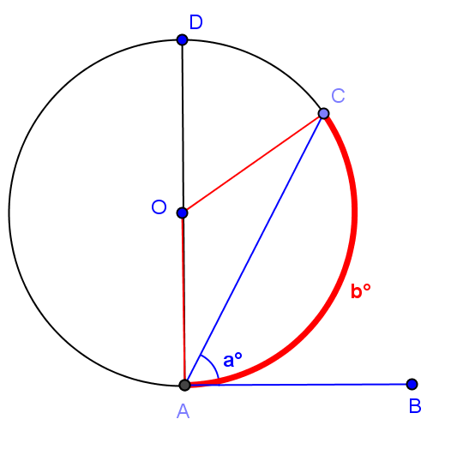
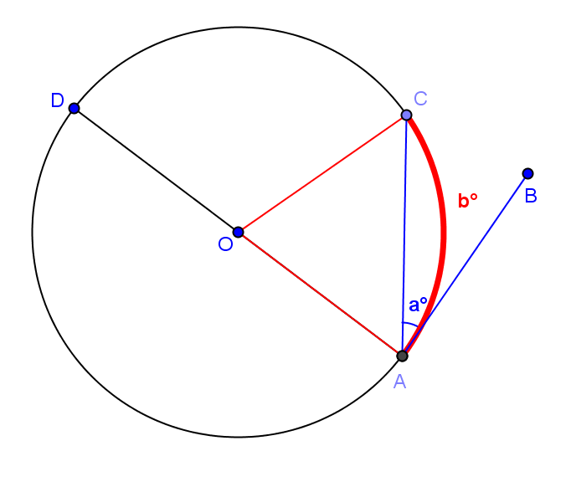
Diagram 1
Diagram 2

Examine the diagrams shown. Develop a conjecture about the relationship between $a$ and $b$.
$$a =\frac{1}{2}b$$

Test your conjecture by using a protractor to measure $a$ and $b$.
 | $$a$$ | $$b$$
Diagram 1
Diagram 2
Do your measurements confirm the relationship you found in your homework?
If needed, revise your conjecture about the relationship between $a$ and $b$:

Now test your conjecture further using the circle below.

$$a$$ | $$b$$

- What did you find about the relationship between $a$ and $b$?
  - $a=\frac{1}{2}b$. An angle inscribed between a tangent line and secant line is equal to half of the angle measure of its intercepted arc.

- How did you test your conjecture about this relationship?
  - Look for evidence that students recognized that the angle should be formed by a secant intersecting a tangent at the point of tangency and that they knew to measure the arc by taking its central angle.
- What conjecture did you come up with? Share with a neighbor.
  - Let students discuss, and then state a version of the conjecture publically.
Now, we will prove your conjecture, which is stated below as a theorem.
The tangent-secant theorem: Let$A$ be a point on a circle, let $\vec{AB}$ be a tangent ray to the circle, and let $C$ be a point on the circle such that $\overset{⃡}{AC}$ is a secant to the circle. If $a=m∠BAC$ and $b$ is the angle measure of the arc intercepted by $∠BAC$, then $a=\frac{1}{2}b$.
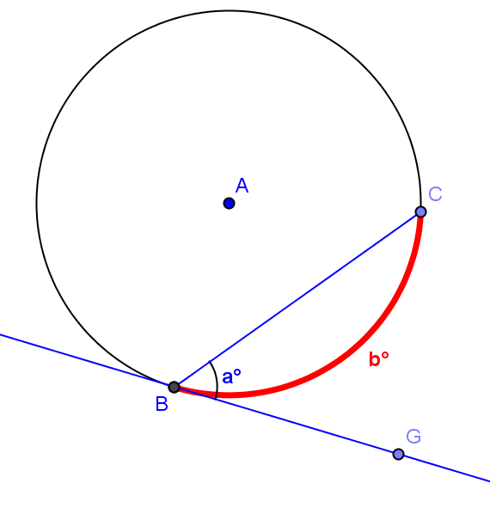
Given circle $A$ with tangent $\overset{⃡}{BG}$, prove what we have just discovered using what you know about the properties of a circle and tangent and secant lines.
- Draw triangle $ABC$. What is the measure of $∠BAC$? Explain.
$b°$ The central angle is equal to the degree measure of the arc it intercepts.

- What is the measure of $∠ABG$? Explain.
$90°$ The radius is perpendicular to the tangent line at the point of tangency.

- Express the measure of the remaining two angles of triangle $ABC$ in terms of “$a$” and explain.
The angles are congruent because the triangle is isosceles. Each angle has a measure of $(90-a)°$ since $m∠ABC+m∠CBG=90°$.

- What is the measure of $∠BAC$ in terms of “$a$”? Show how you got the answer.
The sum of the angles of a triangle is $180°$, so $90-a 90-a+b=180°$. Therefore, $b=2a or a=\frac{1}{2}b$.

- Explain to your neighbor what we have just proven.
An inscribed angle formed by a secant and tangent line is half of the angle measure of the arc it intercepts.

Example 2 (5 minutes)
We have shown that the inscribed angle theorem can be extended to the case when one of the angle’s rays is a tangent segment and the vertex is the point of tangency. Example 2 develops another theorem in the inscribed angle theorem’s family: the angle formed by the intersection of the tangent line and a chord of the circle on the circle and the inscribed angle of the same arc. This example is best modeled with dynamic Geometry software. Alternatively, the teacher may ask students to create a series of sketches that show point $E$ moving towards point $A$.

Theorem: Suppose $\overline{AB}$ is a chord of circle $C$, and $\overline{AD}$ is a tangent segment to the circle at point $A$. If $E$ is any point other than $A$ or $B$ in the arc of $C$ on the opposite side of $\overline{AB}$ from $D$, then $m∠BEA=m∠BAD$.
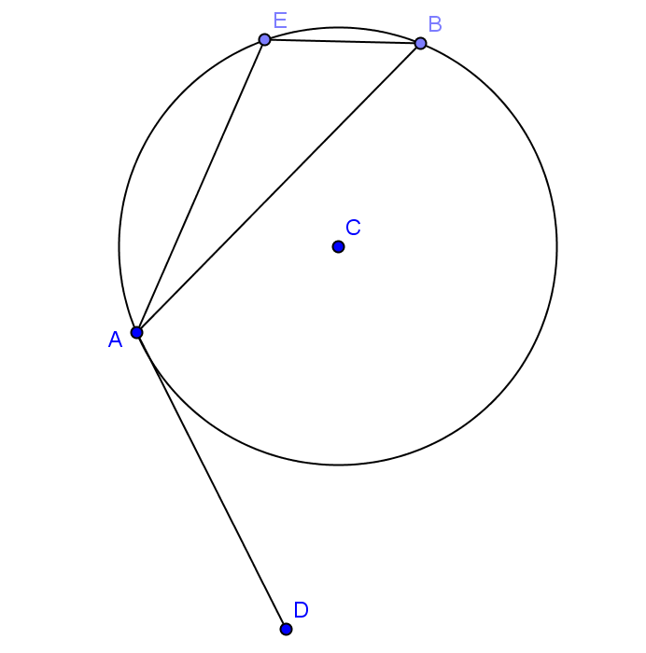
- Draw a circle and label it $C$.
  - Students draw circle $C$.
- Draw a chord $\overline{AB}$.
  - Students draw chord $AB$.
- Construct a segment tangent to the circle through point $A$, and label it $\overline{AD}$.
  - Students construct tangent segment $\overline{AD}$.
- Now draw and label point $E$ that is between $A$ and $B$ but on the other side of chord $\overline{AB}$ from $D$.
  - Students draw point $E$.
- Rotate point $E$ on the circle towards point $A$. What happens to $\overline{EB}$?
  - $\overline{EB}$ moves closer and closer to lying on top of $\overline{AB}$ as E gets closer and closer to A.
- What happens to $\overline{EA}$?
  - $\overline{EA}$ moves closer and closer to lying on top of $\overline{AD}$.
- What happens to $∠BEA$?
  - $∠BEA$ moves closer and closer to lying on top of $∠BAD$.
- Does the $m∠BEA$ change as it rotates?
  - No, it remains the same because the intercepted arc length does not change.
- Explain how these facts show that $m∠BEA = m∠BAD$?
  - The measure of angle $∠BEA$ does not change. The segments are just rotated, but the angle measure is conserved.

Exercises (12 minutes)
Students should work on the exercises individually and then compare answers with a neighbor. Walk around the room, and use this as a quick informal assessment.

Exercises
Find $x$, $y$, $a$, $b$, and/or $c$.
MP.1
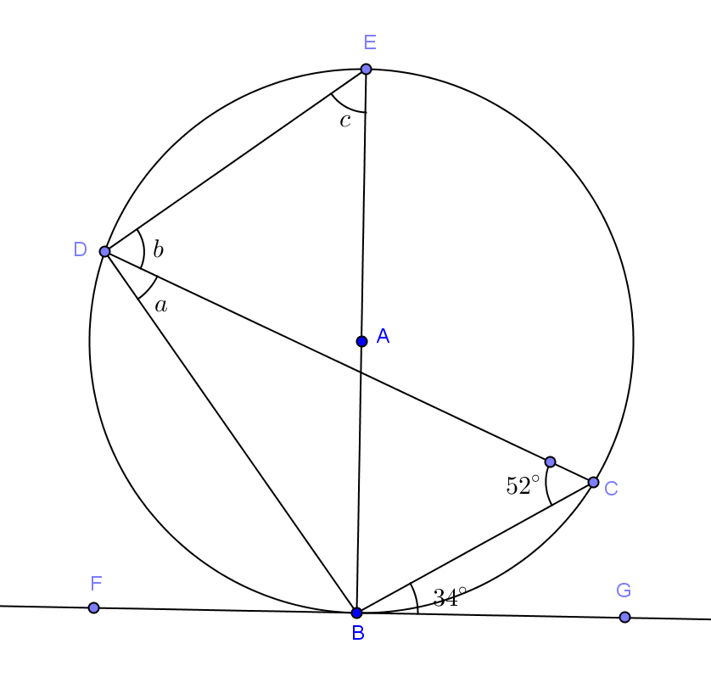 | 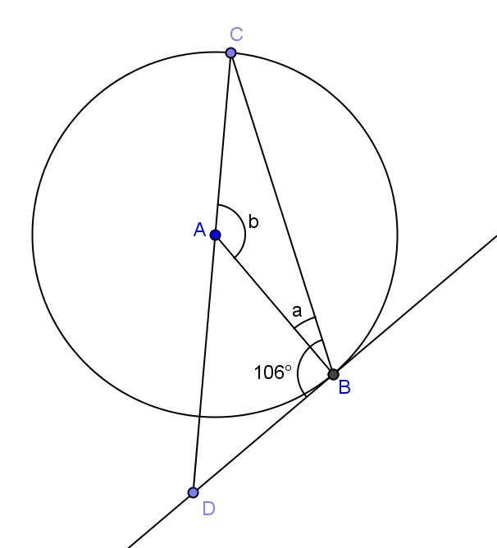
$a=34°$, $b=56°$, $c=52°$ | $a=16°$, $b=148°$
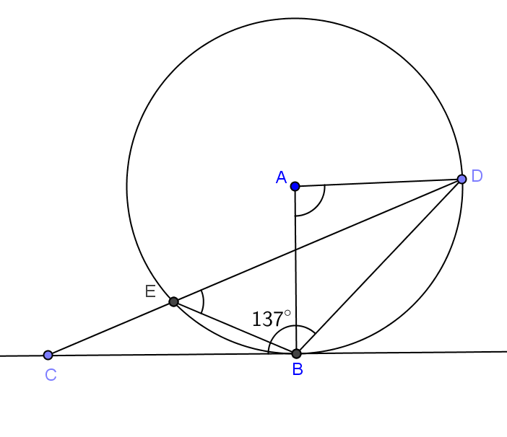  a  b | 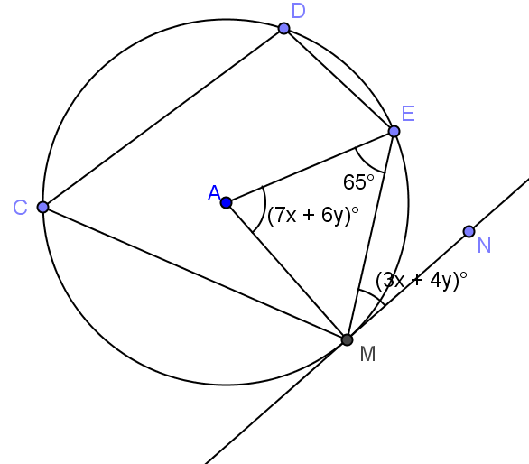
$a=86°$, $b=43°$ | $x=5$, $y=2.5$
MP.1
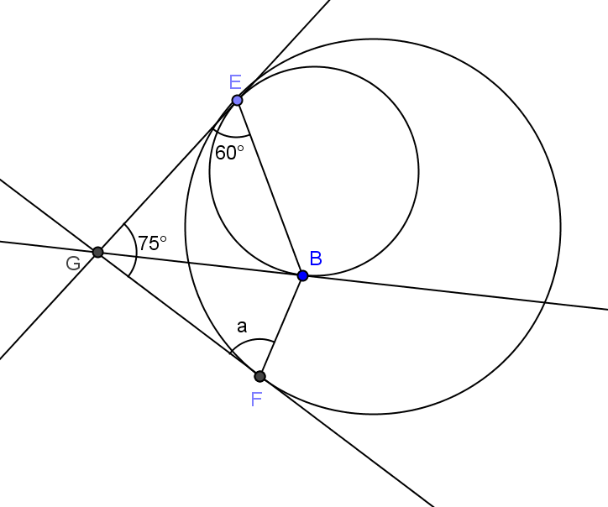
$$a=60°$$

Closing (3 minutes)
Have students do a 30-second quick write of everything that we have studied in Topic C on tangent lines to circles and their segment and angle relationships. Bring the class back together and share, allowing students to add to their list.
- What have we learned about tangent lines to circles and their segment and angle relationships?
  - A tangent line intersects a circle at exactly one point (and is in the same plane).
  - The point where the tangent line intersects a circle is called a point of tangency. The tangent line is perpendicular to a radius whose end point is the point of tangency.
  - The two tangent segments to a circle from an exterior point are congruent.
  - The measure of an angle formed by a tangent segment and a chord is $\frac{1}{2}$ the angle measure of its intercepted arc.
  - If an inscribed angle intercepts the same arc as an angle formed by a tangent segment and a chord, then the two angles are congruent.
Lesson Summary
Theorems:
- Conjecture: Let$A$ be a point on a circle, let $\vec{AB}$ be a tangent ray to the circle, and let $C$ be a point on the circle such that $\overset{⃡}{AC}$ is a secant to the circle. If $a=m∠BAC$ and $b$ is the angle measure of the arc intercepted by $∠BAC$, then $a=\frac{1}{2}b$.
- The tangent-secant theorem: Let$A$ be a point on a circle, let $\vec{AB}$ be a tangent ray to the circle, and let $C$ be a point on the circle such that $\overset{⃡}{AC}$ is a secant to the circle. If $a=m∠BAC$ and $b$ is the angle measure of the arc intercepted by $∠BAC$, then $a=\frac{1}{2}b$.
- Suppose $\overline{AB}$ is a chord of circle $C$, and $\overline{AD}$ is a tangent segment to the circle at point $A$. If $E$ is any point other than $A$ or $B$ in the arc of $C$ on the opposite side of $\overline{AB}$ from $D$, then $m∠BEA=m∠BAD$.

Exit Ticket (5 minutes)

Name Date
Lesson 13: The Inscribed Angle Alternate a Tangent Angle

Exit Ticket

Find $a$, $b$, and $c$.

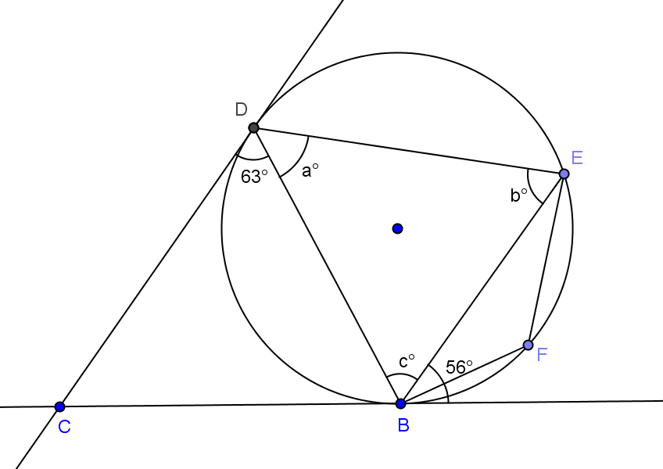
Exit Ticket Sample Solutions

Find $a$, $b$, and $c$.
$a=56°$, $b=63°$, $c=61°$

Problem Set Sample Solutions

The first 6 problems are easy entry problems and are meant to help students struggling with the concepts of this lesson. They show the same problems with varying degrees of difficulty. Problems 7–11 are more challenging. Assign problems based on student ability.
In Problems 1–9, solve for $a$, $b$, and/or $c$.
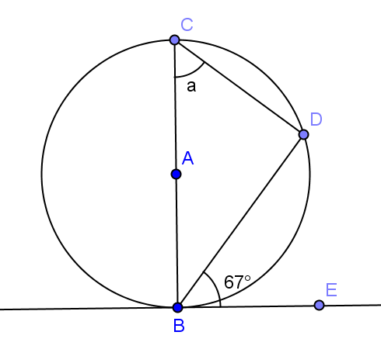 | 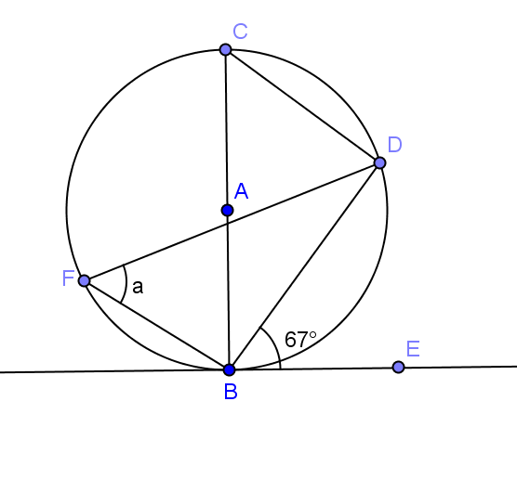 | 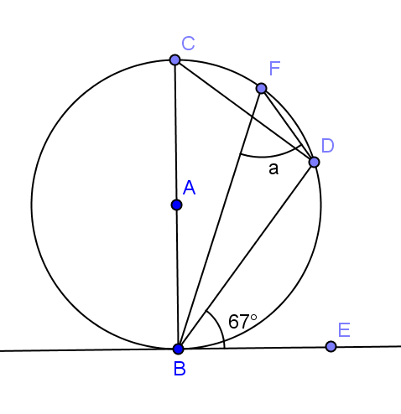
$$a=67°$$ | $$a=67°$$ | $$a=67°$$
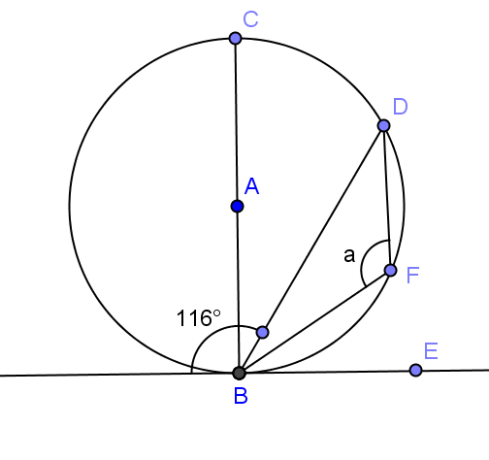 | 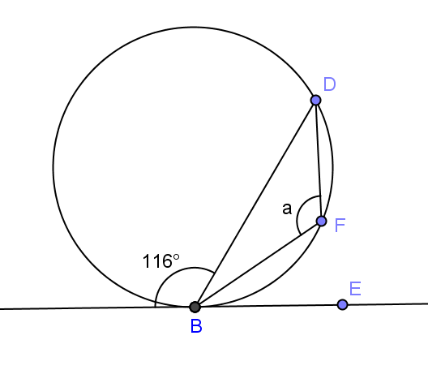 | 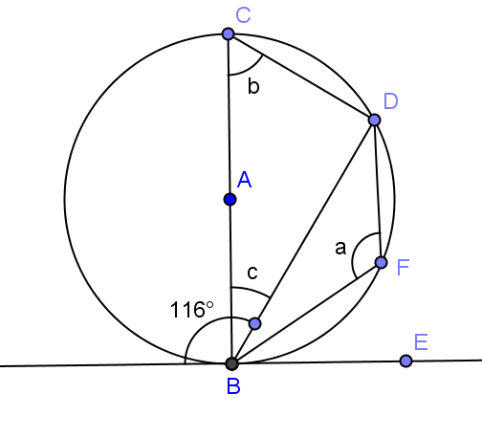
$$a=116°$$ | $$a=116°$$ | $a=116°$, $b=64°$, $c=26°$
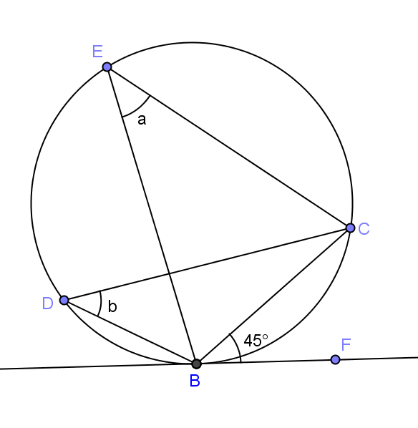 | 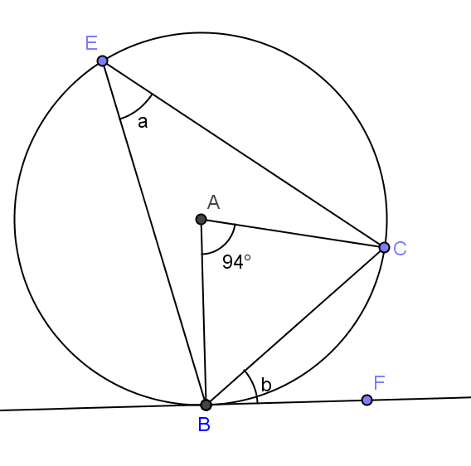 | 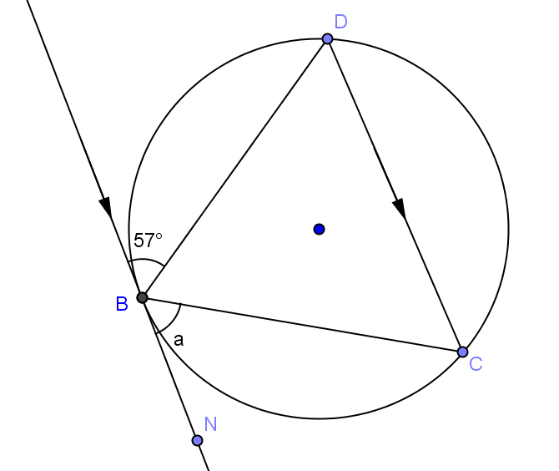
$a=45°$, $b=45°$ | $a=47°$, $b=47°$ | $a=57°$
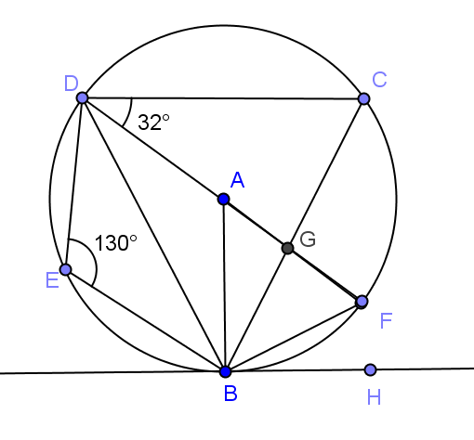
- $\overset{⃡}{BH}$ is tangent to circle $A$. $\overline{DF}$ is a diameter. Find
  - $m∠BCD$
$50°$

  - $m∠BAF$
$80°$

  - $m∠BDA$
$40°$

  - $m∠FBH$
$40°$

  - $m∠BGF$
$98°$
- $\overline{BG}$ is tangent to circle $A$. $\overline{BE}$ is a diameter. Prove: (i) $f=a$ and (ii)$d=c$

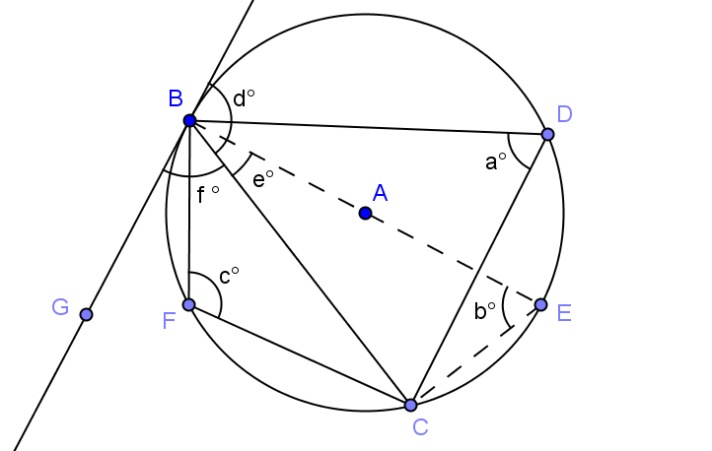

(i) $m∠EBG=90⁰$ tangent perpendicular to radius
$f=90-e$ sum of angles
$m∠ECB=90⁰$ angle inscribed in semi-circle
$In ∆ECB$,
$b+90+e=180$ sum of angles of a triangle
$b=90-e$
$a=b$ angles inscribed in same arc congruent
$a=f$ substitution
(ii) $a+c=180$ inscribed in opposite arcs
$a=f$ inscribed in same arc
$f+d=180$ linear pairs form supplementary angles
$c+f=f+d$ substitution
$c=d$

