Lesson 13: The Inscribed Angle Alternate a Tangent Angle

Classwork
Opening Exercise
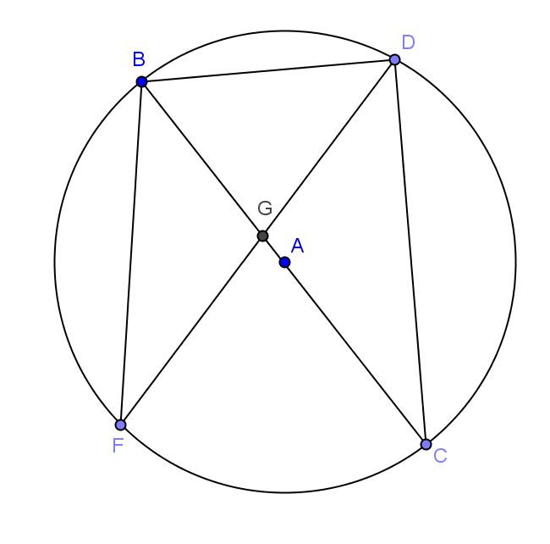
- In circle $A$, $m\hat{BD}=56°,$ and $\overline{BC}$ is a diameter. Find the listed measure, and explain your answer.
  - $m∠BDC$

  - $m∠BCD$

  - $m∠DBC$

  - $m∠BFG$

  - $m\hat{BC}$

  - $m\hat{DC}$

  - Is the $m∠BGD=56°$? Explain.

  - How do you think we could determine the measure of $∠BGD$?

Example 1
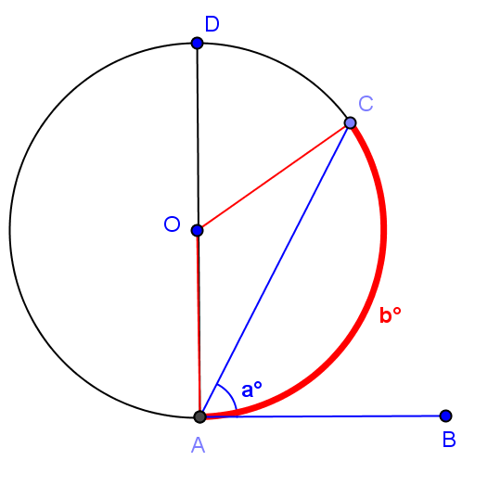
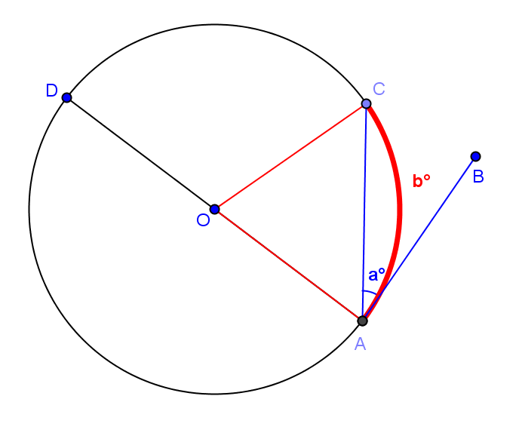
Diagram 1
Diagram 2

Examine the diagrams shown. Develop a conjecture about the relationship between $a$ and $b$.

Test your conjecture by using a protractor to measure $a$ and $b$.
 | $$a$$ | $$b$$
Diagram 1
Diagram 2

Do your measurements confirm the relationship you found in your homework?
If needed, revise your conjecture about the relationship between $a$ and $b$:

Now test your conjecture further using the circle below.

$$a$$ | $$b$$

Now, we will prove your conjecture, which is stated below as a theorem.

The tangent-secant theorem: Let$A$ be a point on a circle, let $\vec{AB}$ be a tangent ray to the circle, and let $C$ be a point on the circle such that $\overset{⃡}{AC}$ is a secant to the circle. If $a=m∠BAC$ and $b$ is the angle measure of the arc intercepted by $∠BAC$, then $a=\frac{1}{2}b$.

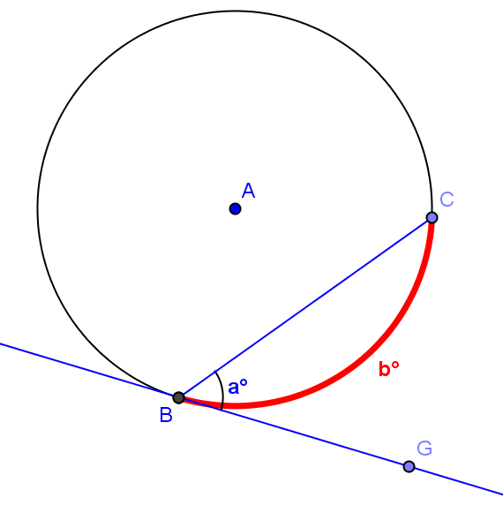
Given circle $A$ with tangent $\overset{⃡}{BG}$, prove what we have just discovered using what you know about the properties of a circle and tangent and secant lines.
        - Draw triangle $ABC$. What is the measure of $∠BAC$? Explain.

        - What is the measure of $∠ABG$? Explain.

        - Express the measure of the remaining two angles of triangle $ABC$ in terms of “$a$” and explain.

        - What is the measure of $∠BAC$ in terms of “$a$”? Show how you got the answer.

        - Explain to your neighbor what we have just proven.

Exercises
Find $x, y, a, b,$and/or $c$.
1.
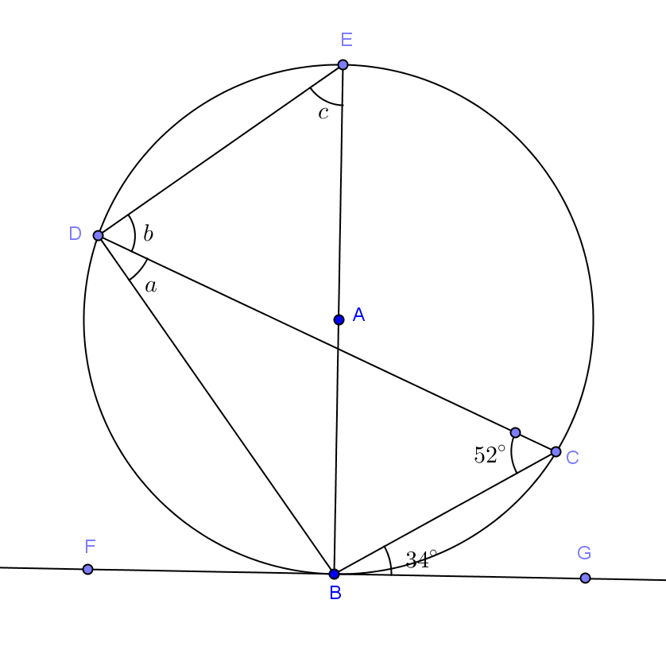

2.
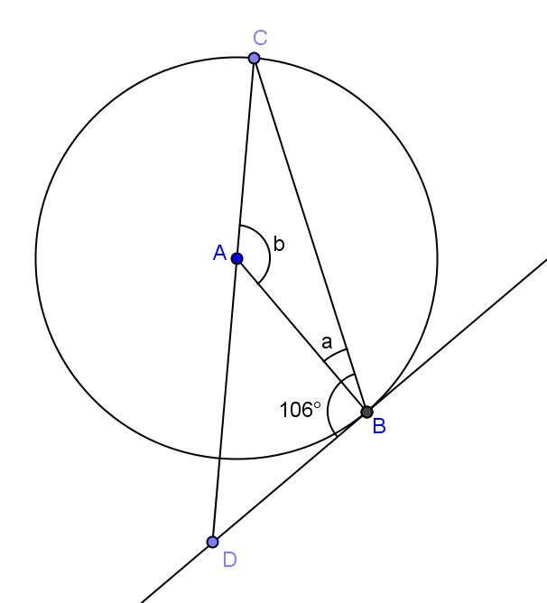

3.
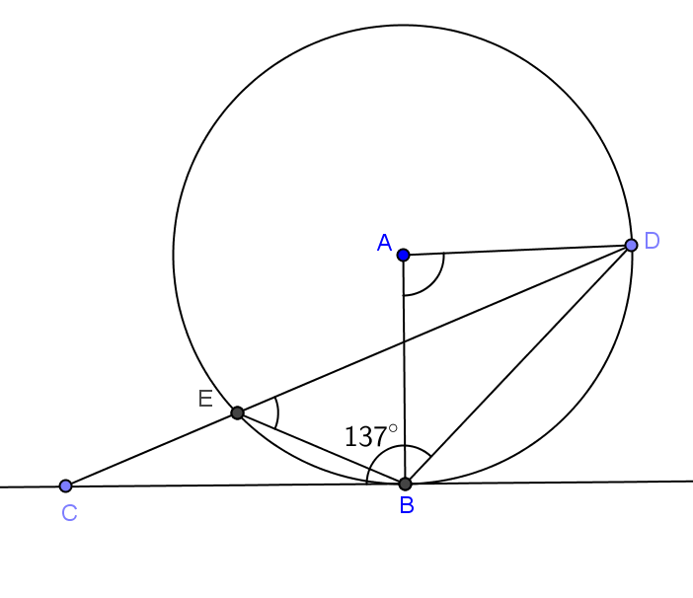
a
b

4.
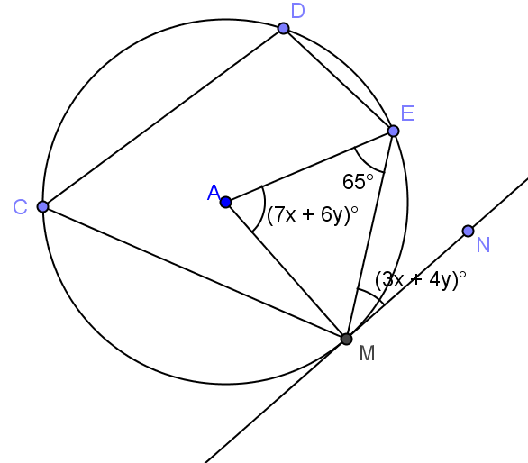

5.
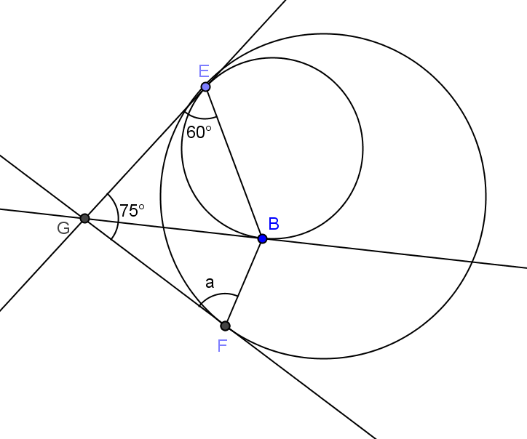

Problem Set
Lesson Summary
Theorems:
- Conjecture: Let$A$ be a point on a circle, let $\vec{AB}$ be a tangent ray to the circle, and let $C$ be a point on the circle such that $\overset{⃡}{AC}$ is a secant to the circle. If $a=m∠BAC$ and $b$ is the angle measure of the arc intercepted by $∠BAC$, then $a=\frac{1}{2}b$.
- The tangent-secant theorem: Let$A$ be a point on a circle, let $\vec{AB}$ be a tangent ray to the circle, and let $C$ be a point on the circle such that $\overset{⃡}{AC}$ is a secant to the circle. If $a=m∠BAC$ and $b$ is the angle measure of the arc intercepted by $∠BAC$, then $a=\frac{1}{2}b$.
- Suppose $\overline{AB}$ is a chord of circle $C$, and $\overline{AD}$ is a tangent segment to the circle at point $A$. If $E$ is any point other than $A$ or $B$ in the arc of $C$ on the opposite side of $\overline{AB}$ from $D$, then $m∠BEA=m∠BAD$.

In Problems 1–9, solve for $a, b$, and/or $c.$
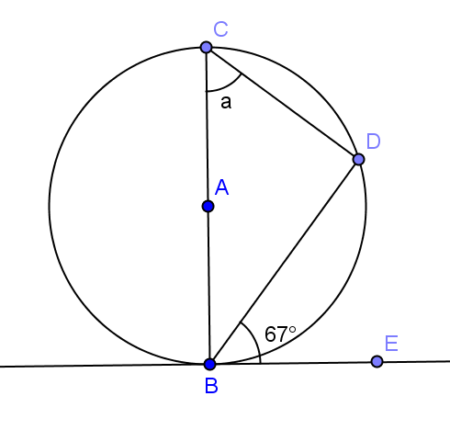 | 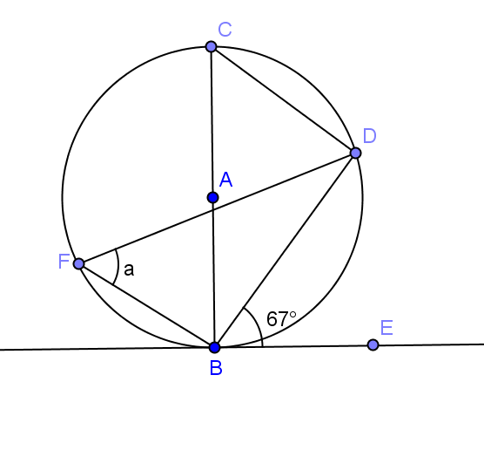 | 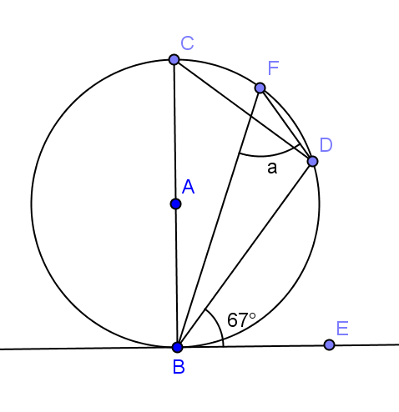
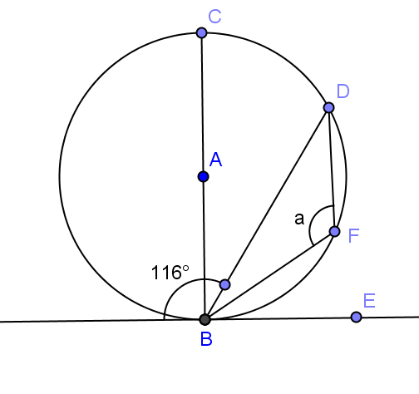 | 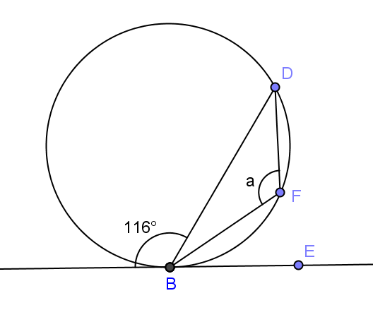 | 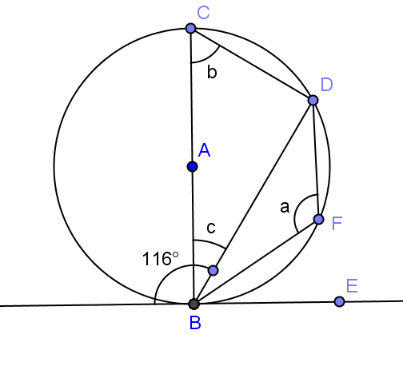
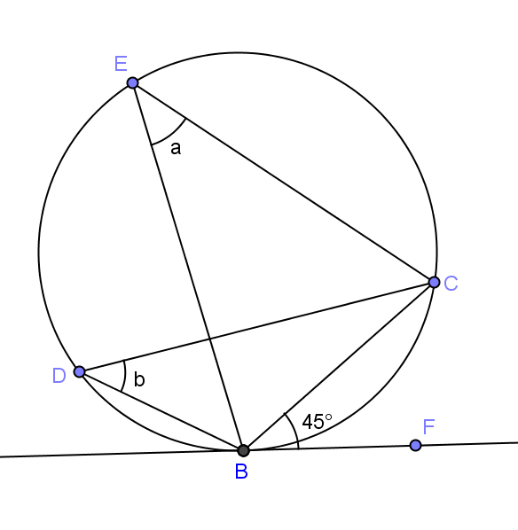 | 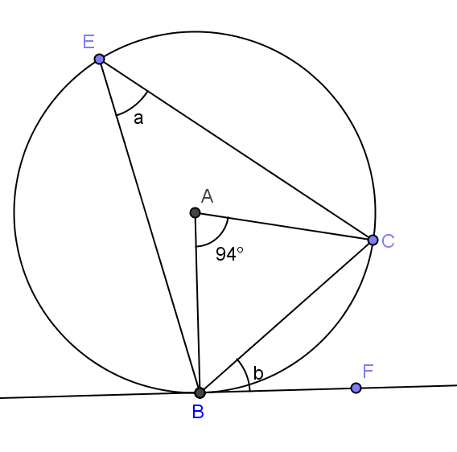 | 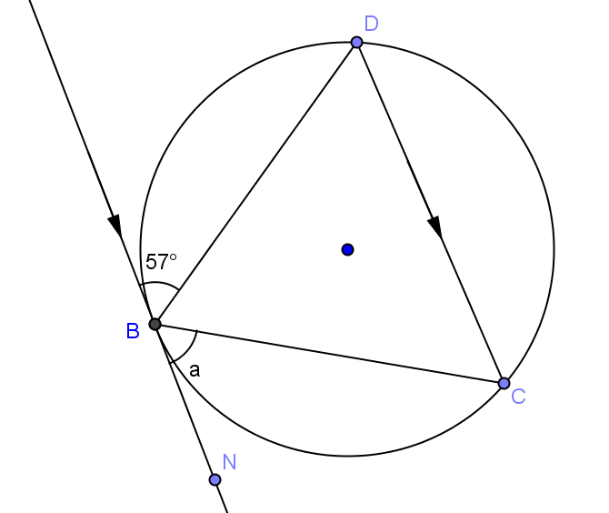

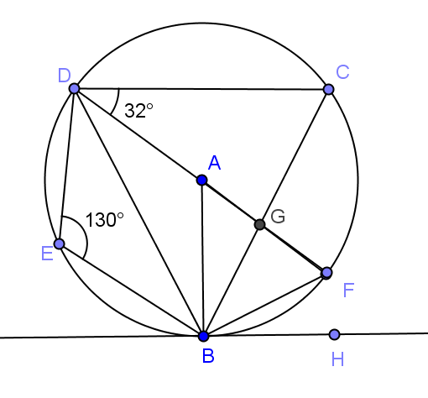
- $\overset{⃡}{BH}$is tangent to circle $A$. $\overline{DF}$ is a diameter. Find
  - $m∠BCD$
  - $m∠BAF$
  - $m∠BDA$
  - $m∠FBH$
  - $m∠BGF$

- $\overline{BG}$ is tangent to circle $A$. $\overline{BE}$ is a diameter. Prove: (i) $f=a$ and (ii)$d=c$
