Lesson 11: Properties of Tangents

Student Outcomes
- Students discover that a line is tangent to a circle at a given point if it is perpendicular to the radius drawn to that point.
- Students construct tangents to a circle through a given point.
- Students prove that tangent segments from the same point are equal in length.

Lesson Notes
Topic C begins our study of secant and tangent lines. Lesson 11 is the introductory lesson and requires several constructions to solidify concepts for students. The study of tangents continues in Lessons 12 and 13.
During the lesson, recall the following definitions if necessary:
Interior of a circle: The interior of a circle with center $O$ and radius $r$ is the set of all points in the plane whose distance from the point $O$ is less than $r$.
A point in the interior of a circle is said to be inside the circle. A disk is the union of the circle with its interior.
Exterior of a circle: The exterior of a circle with center $O$ and radius $r$ is the set of all points in the plane whose distance from the point $O$ is greater than $r$.
A point exterior to a circle is said to be outside the circle.

Classwork
Opening (8 minutes)
- Draw a circle and a line.
  - Students draw a circle and a line.
- Have the students tape their sketches to the board.
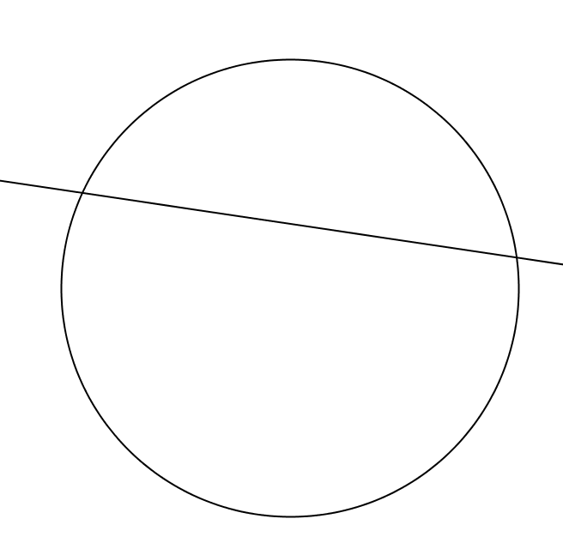
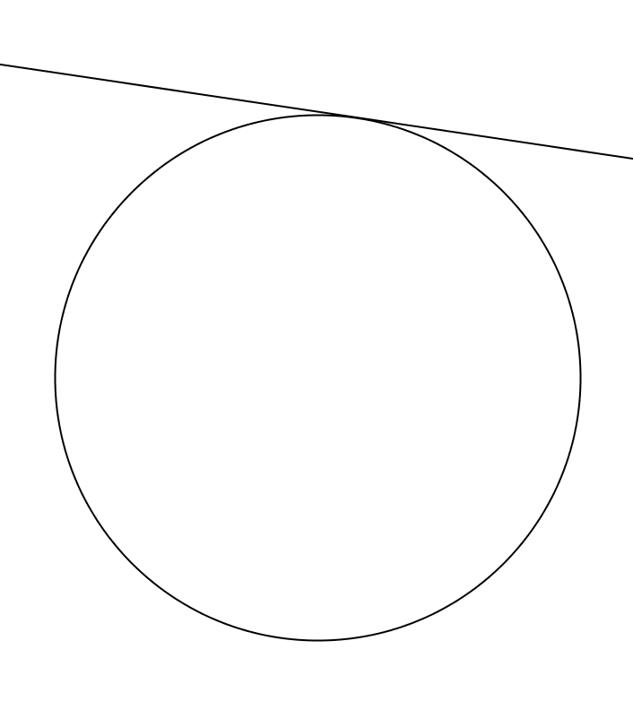
- Let’s group together the diagrams that are alike.
  - Students should notice that some circles have lines that intersect the circle twice, others only touch the circle once, and others do not intersect the circle at all. Separate them accordingly.
Scaffolding:
- Post pictures of pairs of secant lines and tangent lines on the board so students can refer to them when needed.
- Post steps for each construction on the board for easy reference.
- Provide completed or partially completed drawings for students with eye-hand or fine motor difficulties or a set square to help with perpendicular lines and segments.
- For ELL students, use a Frayer diagram for all new vocabulary words and practice with choral repetition.
- Explain how the types of circle diagrams are different.
  - A line can intersect a circle twice, only once, or not at all.
- Do you remember the name for a line that intersects the circle twice?
  - A line that intersects a circle at exactly two points is called a secant line.
- Do you remember the name for a line that intersects the circle once?
  - A line that intersects a circle at exactly one point is called a tangent line.
MP.6
- Label each group of diagrams as “secant lines,” “tangent lines,” and “don’t intersect,” and then as a class, repeat the definitions of secant and tangent lines chorally.
  - Secant line: A secant line to a circle is a line that intersects a circle in exactly two points.
  - Tangent line: A tangent line to a circle is a line in the same plane that intersects the circle in one and only one point.
  - Tangent segment: A segment is said to be a tangent segment to a circle if the line it is contained in is tangent to the circle, and one of its endpoints is the point where the line intersects the circle.
- Topic C focuses on the study of secant and tangent lines intersecting circles.
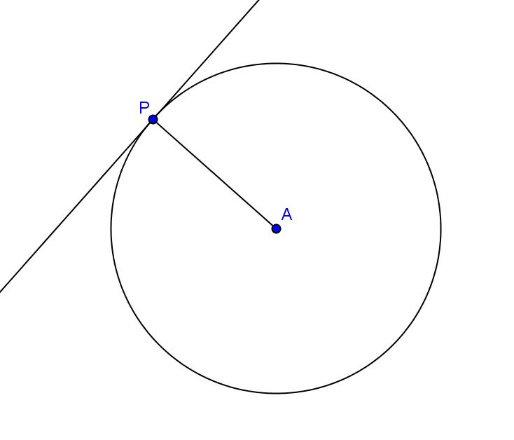
- Explain to your neighbor the difference between a secant line and a tangent line.

Exploratory Challenge (10 minutes)
In this whole class discussion, students will need a compass, protractor, and a straight edge to complete constructions.
- Draw a circle and a tangent line.
  - Students draw a circle and a tangent line.
- Draw a point where the tangent line intersects the circle. Label it $P$.
  - Students draw the point and label it $P$.
- Point $P$ is called the point of tangency. Label point$P$ as the “Point of Tangency,” and write its definition. Share your definition with your neighbor.
  - The point of intersection of the tangent line to the circle is called the point of tangency.
- Draw a radius connecting the center of the circle to the point of tangency.
  - Students draw a radius to point $P$.
- With your protractor, measure the angle formed by the radius and the tangent line. Write the angle measure on your diagram.
  - Students measure and write $90°$.
- Compare your diagram and angle measure to three people around you. What do you notice?
MP.7
&
MP.8
  - All diagrams are different, but all angles are $90°$.
- What can we conclude about the segment joining a radius of a circle to the point of tangency?
  - The radius and tangent line are perpendicular.
- Let’s think about other ways we can say this. What did we learn in Module 4 about the shortest distance between a line and a point?
  - The shortest distance from a point to a line is the perpendicular segment from the point to the line.
- So, what can we say about the center of the circle and the tangent line?
Scaffolding:
Post these steps with accompanying diagrams to assist/remind students.
Constructing a line perpendicular to a segment through a point.
- Extend the radius beyond the circle with center $A$, creating segment $\overline{AB}$.
- Draw point $P$ at the point of intersection of $\overline{AB}$ and the circle, using your compass, measure the distance from $A$ to $P$ and mark that on the extended radius.
- Draw circle $A$ with radius $AB$.
- Draw circle $B$ with radius $BA$.
- Mark the point of intersection of the circles points $C$ and $D$.
- Construct a line through $C$ and $D$.
  - The shortest distance between the center of the circle and a tangent line is at the point of tangency and is the radius.
- We will say it one more way. This time restate what we have found relating the tangent line, the point of tangency, and the radius.
  - A tangent line to a circle is perpendicular to the radius of the circle drawn to the point of tangency.
- State the converse of what we have just said.
  - If a line through a point on a circle is perpendicular to the radius drawn to that point, the line is tangent to the circle.
- Is the converse true?
  - Answers will vary.
- Try to draw a line through a point on a circle that is perpendicular to the radius that is not tangent to the circle.
  - Students will try but it will not be possible. If a student thinks he has a drawing that works show it to the class and discuss.
- Share with your neighbor everything that you have learned about lines tangent to circles.
  - The point where the tangent line intersects the circle is called the point of tangency.
  - A tangent line to a circle is perpendicular to the radius of the circle drawn to the point of tangency.
  - A line through a point on a circle is tangent at the point if, and only if, it is perpendicular to the radius drawn to the point of tangency.

Example 1 (12 minutes)
In this example, students will construct a tangent line through a given point on a circle and a tangent line to a given circle through a given point exterior to the circle (i.e., outside the circle). This lesson may have to be modified for students with eye-hand or fine motor difficulties. It could be done as a whole class activity where the teacher models the construction for everyone. Another option is to provide these students with an already complete step-by-step construction where each drawing shows only one step of the construction at a time. Students can try the next step but then will have an accurate drawing of the construction if they need assistance. Students should refer back to Module 1 for help on constructions.

Have students complete constructions individually, but pair students with a buddy who can help them if they struggle. Walk around the room and use this as an informal assessment of student understanding of constructions and lines tangent to a circle. Students will need a straight edge, a protractor, and a compass.
- Draw a circle and a radius intersecting the circle at a point labeled $P$.
  - Students draw a circle and a radius and label point $P$.
- Construct a line going through point $P$ and perpendicular to the radius. Write the steps that you followed.
  - Students draw a line perpendicular to the radius through $P$.

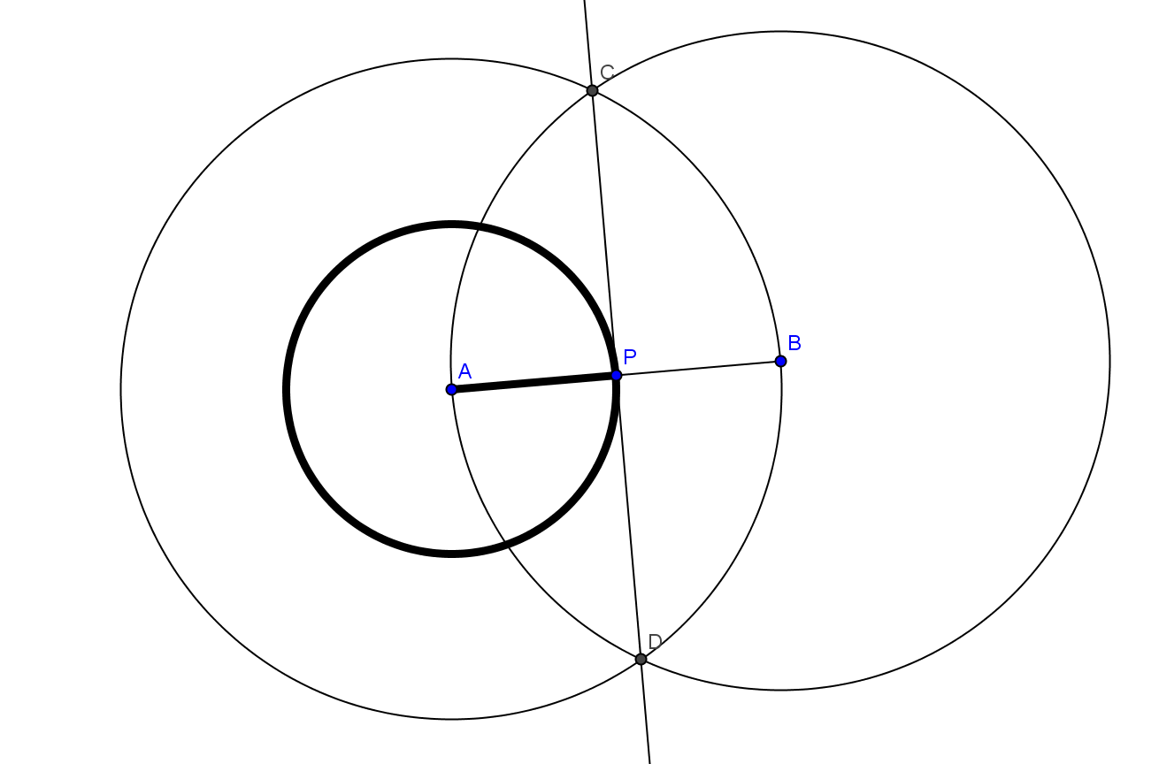

- Check students’ constructions.
- Draw a circle $A$ and a point exterior to the circle, and label it point $R$.
  - Students construct a circle $A$ and a point exterior to the circle labeled point $R$.
- Construct a line through point $R$ tangent to the circle $A$.
  - This construction is difficult. Give students a few minutes to try, and then follow with the instructions that are below.
- Draw segment $\overline{AR}$.
  - Students draw segment $\overline{AR}$.
- Construct the perpendicular bisector of $\overline{AR}$ to find its midpoint. Mark the midpoint $M$.
- Students construct the perpendicular bisector of $\overline{AR}$and mark the midpoint $M$.
- Draw an arc of radius $MA$ with center $M$ intersecting the circle. Label this point of intersection as point $B$.
  - Students draw an arc intersecting the circle and mark the point of intersection as point $B$.
- Draw line $\overset{⃡}{RB}$ and segment $\overline{AB}$.
  - Students draw line $R$ and segment $\overline{AB}$.
- Is $\overset{⃡}{RB}⊥\overline{AB}$? Verify the measurement with your protractor.
  - Students verify that the line and radius are perpendicular.
- What does this mean?
  - Line $\overset{⃡}{RB}$ is a tangent line to circle $A$ at point $B$.
- Repeat this process, and draw another line through point $R$ tangent to circle $A$, intersecting the circle at point $C$.
  - Students repeat the process, and this time the tangent line intersects the other side of the circle.
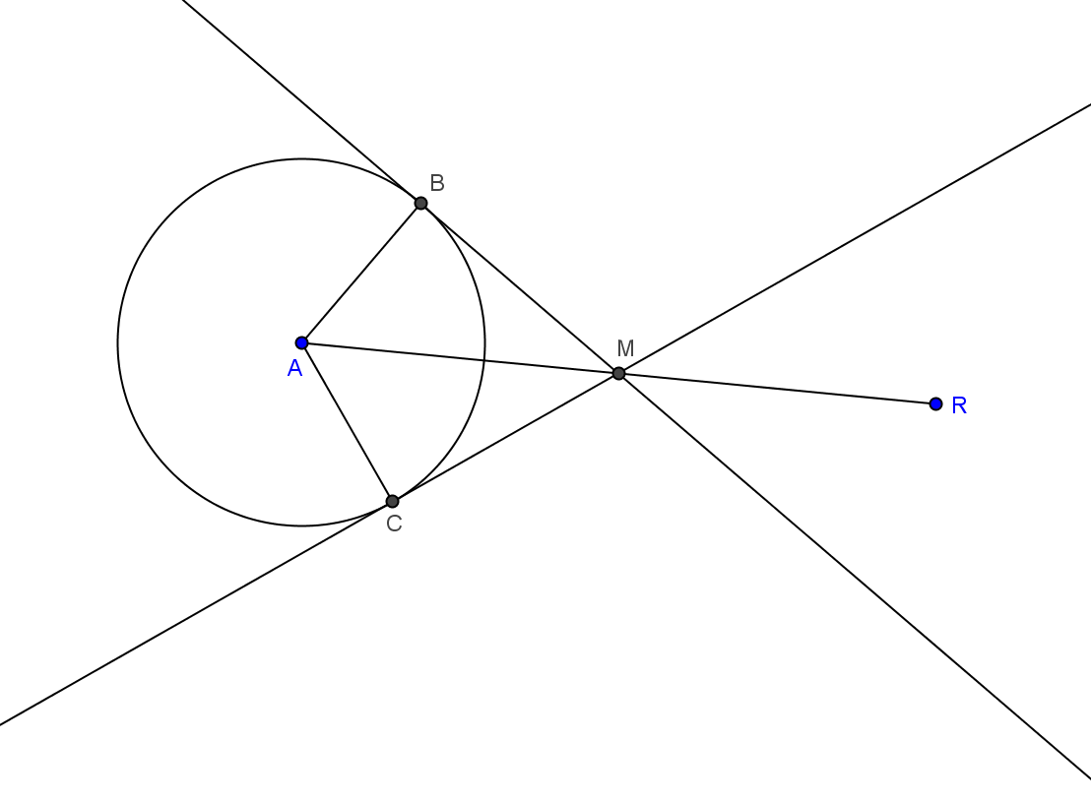

- What is true about $MB$, $MA$, $MR$, and $MC$?
  - They are all the same length.
- Let’s remember that! It may be useful for us later.

Exercises 1–3 (7 minutes)
This proof requires students to understand that tangent lines are perpendicular to the radius of a circle at the point of tangency and then to use their previous knowledge of similar right triangles to prove $a=b$. Have students work in homogeneous pairs, helping some groups if necessary. Pull the entire class together to share proofs and see different methods used. Correct any misconceptions.

Exercises 1–3
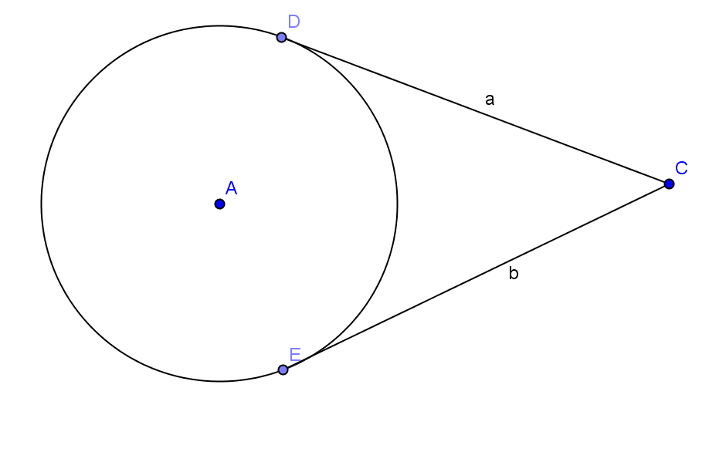
- $\overline{CD}$ and $\overline{CE}$ are tangent to circle $A$ at points $D$ and $E$ respectively. Use a two-column proof to prove $a=b$.

Draw radii $\overline{AD}$ and $\overline{AE}$ and segment $\overline{AC}$.
$CD=a$, $CE=b$ Given
$∠ADC and ∠AEC are right angles.$ Tangent lines are perpendicular to the radius at the point of tangency.
$∆ADC$ and $∆AEC$ are right triangles. Definition of a right triangle
$AD=AE$ Radii of the same circle are equal in measure.
$AC=AC$ Reflexive property
$∆ADC$ ≅ $∆AEC$. HL
$CD=CE$ CPCTC
$a=b$ Substitution
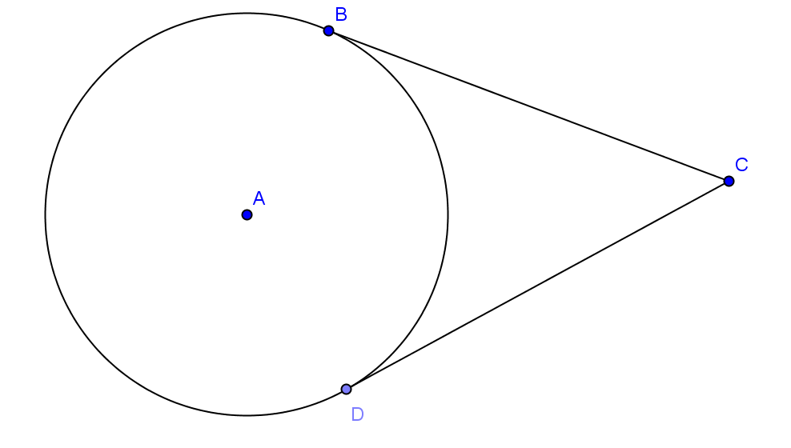
- In circle $A$, the radius is $9$ mm and $BC=12$ mm.
- Find $AC$.
$AC=15$mm

- Find the area of $∆ACD.$
$A=54$ mm²

- Find the perimeter of quadrilateral $ABCD$.
$P=42$ mm
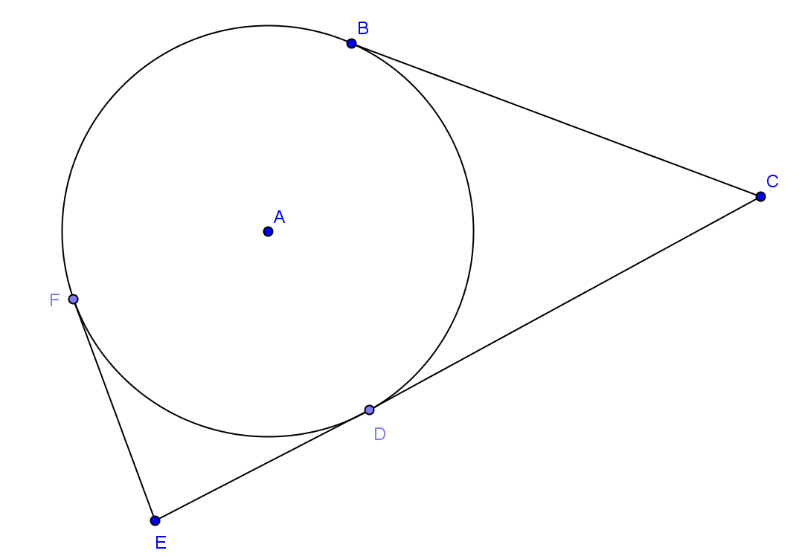
- In circle $A$, $EF=12$ and $AE=13. AE:AC=1:3$. Find
- The radius of the circle.
$5$

- $BC$ (round to the nearest whole number)
$39$

  - $EC$
$51$
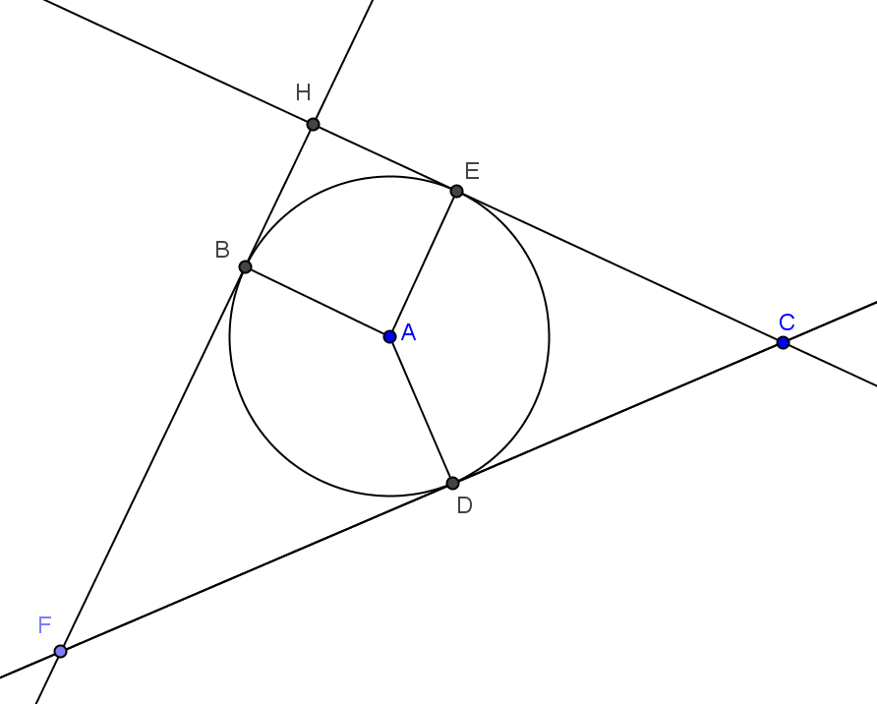
Closing (3 minutes)
Project the picture to the right. Have students do a 30 second quick write on all they know about the diagram if:
$\overset{⃡}{FB}$ is tangent to the circle at point $B$.
$\overset{⃡}{EC}$ is tangent to the circle at point $E$.
$\overset{⃡}{DC}$ is tangent to the circle at point $D$.
Then have the class as a whole share their ideas.
- $\overline{AE}⊥\overline{CE}$, $\overline{AB}⊥\overline{FB}$, $\overline{AD}⊥\overline{CD}$
- $CE=CD$
- $AB=AE=A$

Lesson Summary
Theorems:
- A tangent line to a circle is perpendicular to the radius of the circle drawn to the point of tangency.
- A line through a point on a circle is tangent at the point if, and only if, it is perpendicular to the radius drawn to the point of tangency.
Relevant Vocabulary
- Interior of a Circle: The interior of a circle with center $O$ and radius $r$ is the set of all points in the plane whose distance from the point $O$ is less than $r$.
A point in the interior of a circle is said to be inside the circle. A disk is the union of the circle with its interior.
- Exterior of a circle: The exterior of a circle with center $O$ and radius $r$ is the set of all points in the plane whose distance from the point $O$ is greater than $r$.
A point exterior to a circle is said to be outside the circle.
- Tangent to a circle: A tangent line to a circle is a line in the same plane that intersects the circle in one and only one point. This point is called the point of tangency.
- Tangent segment/ray. A segment is a tangent segment to a circle if the line that contains it is tangent to the circle and one of the end points of the segment is a point of tangency. A ray is called a tangent ray to a circle if the line that contains it is tangent to the circle and the vertex of the ray is the point of tangency.
- Secant to a circle: A secant line to a circle is a line that intersects a circle in exactly two points.
- Polygon inscribed in a circle: A polygon is inscribed in a circle if all of the vertices of the polygon lie on the circle.
- Circle inscribed in a polygon: A circle is inscribed in a polygon if each side of the polygon is tangent to the circle.

Exit Ticket (5 minutes)
Name Date
Lesson 11: Properties of Tangents

Exit Ticket

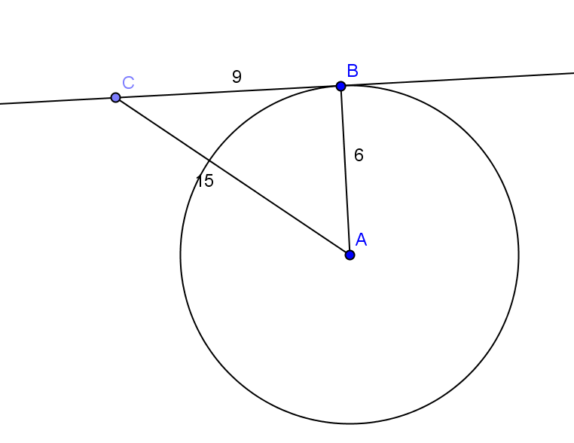
- If $BC=9$, $AB=6$, and $AC=15$, is line $\overset{⃡}{BC}$ tangent to circle $A$? Explain.

- Construct a line tangent to circle $A$ through point $B$.

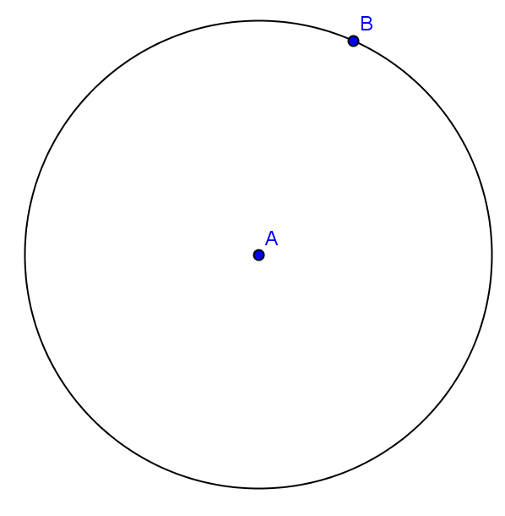
Exit Ticket Sample Solutions

- If $BC=9$, $AB=6$, and $AC=15$, is line $\overset{⃡}{BC}$ tangent to circle $A$? Explain.
No, $∆ABC$ is not a right triangle because $9^{2}+6^{2}≠{15}^{2}$. This means $\overline{AB}$ is not perpendicular to $\overline{BC}$.

- Construct a line tangent to circle $A$ through point $B$.

Problem Set Sample Solutions
Problems 1–6 should be completed by all students. Problems 7 and 8 are more challenging and can be assigned to some students for routine work and others as a student choice challenge.

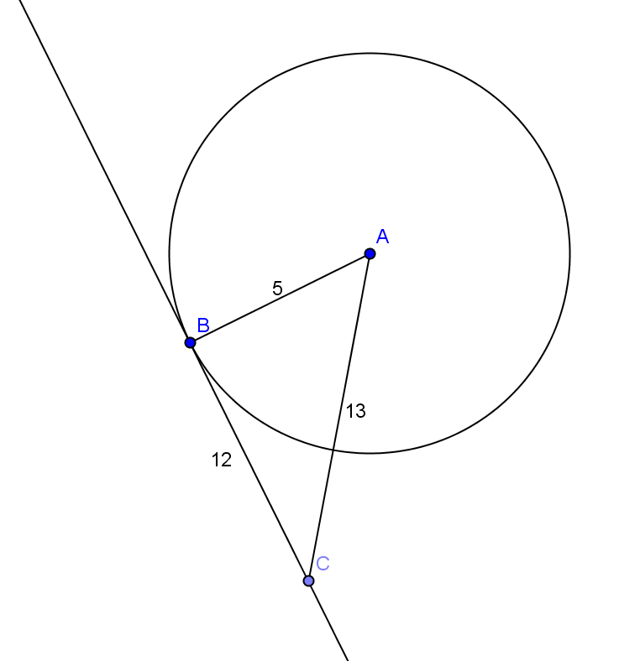
- If $AB=5$, $BC=12$, and $AC=13$, is $\overset{⃡}{BC}$ tangent to circle $A$ at point $B$? Explain.
Yes, $∆ABC$ is a right triangle because the Pythagorean theorem holds $5^{2}+{12}^{2}={13}^{2}$. Angle B is right, so $\overline{AB} ;$ therefore, $\overset{⃡}{BC}$ is tangent to circle $A$ at point $B$.

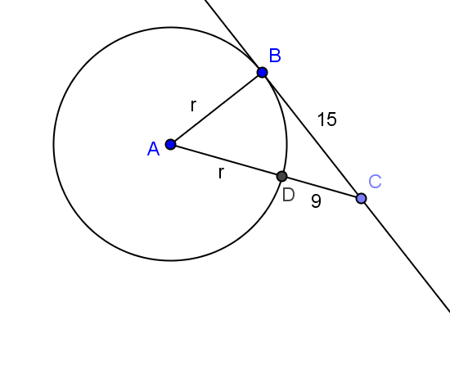
- $\overset{⃡}{BC}$ is tangent to circle $A$ at point $B$. $DC=9$ and $BC=15$.
  - Find the radius of the circle.
$$r=8$$

  - Find $AC$.
$$AC=17$$

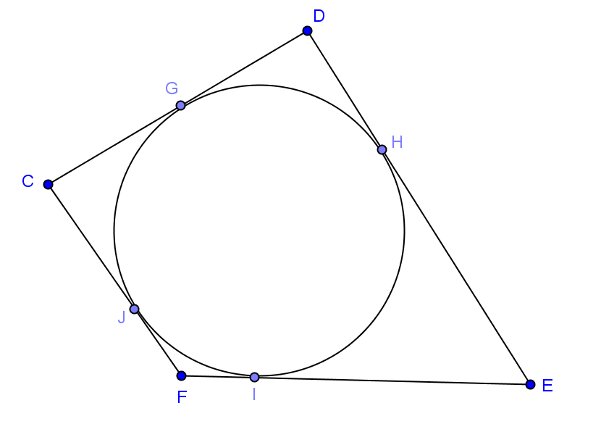
- A circular pond is fenced on two opposite sides ($\overline{CD},\overline{FE})$ with wood and the other two sides with metal fencing. If all four sides of fencing are tangent to the pond, is there more wood or metal fencing used?
There is an equal amount of wood and metal fencing because the distance from each corner to the point of tangency is the same.

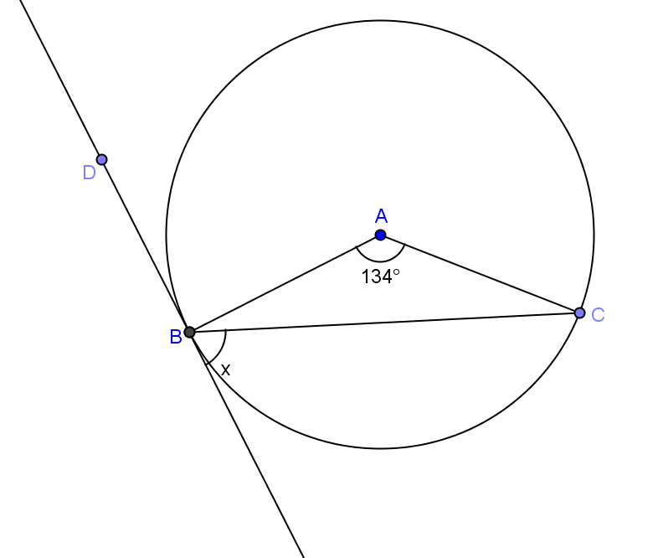
- Find $x$ if the line shown is tangent to the circle at point $B$.
$67$⁰

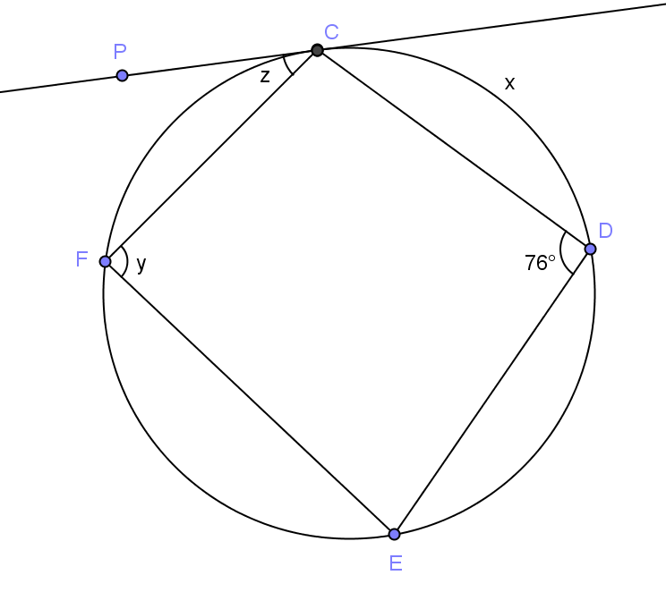
- Line $\overset{⃡}{PC}$ is tangent to the circle at point $C$, and $CD=DE$. Find
  - $x(m\hat{CD})$
$104$⁰

  - $y(m∠CFE)$
$104$⁰

  - $z(m∠PCF)$
$38$⁰

- Construct two lines tangent to circle $A$ through point $B$.

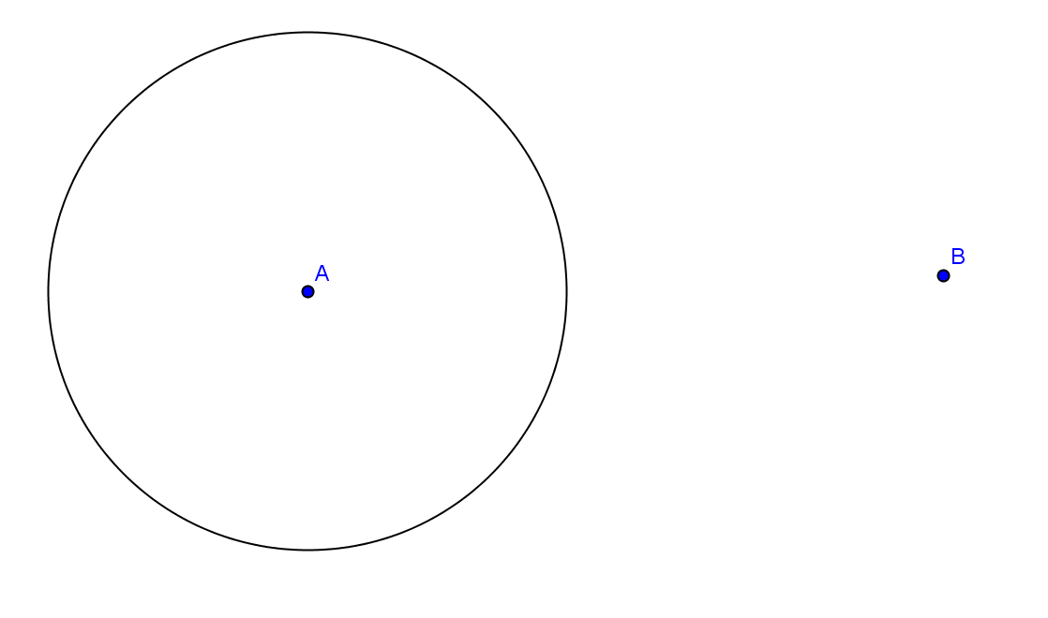
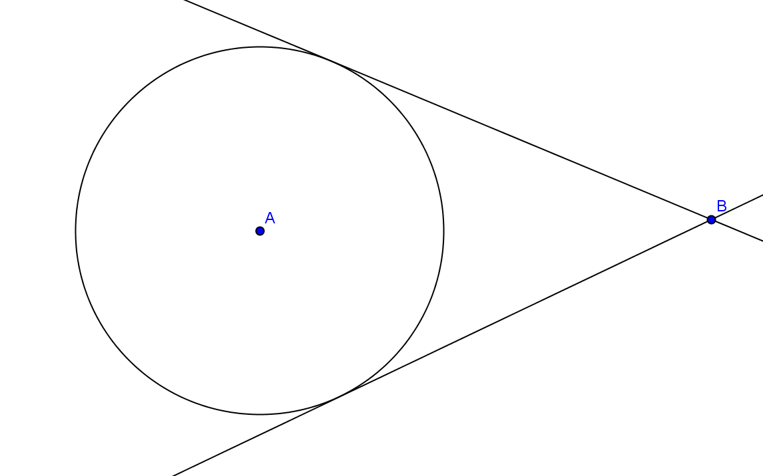

- Find $x$, the length of the common tangent line between the two circles (round to the nearest hundredth).
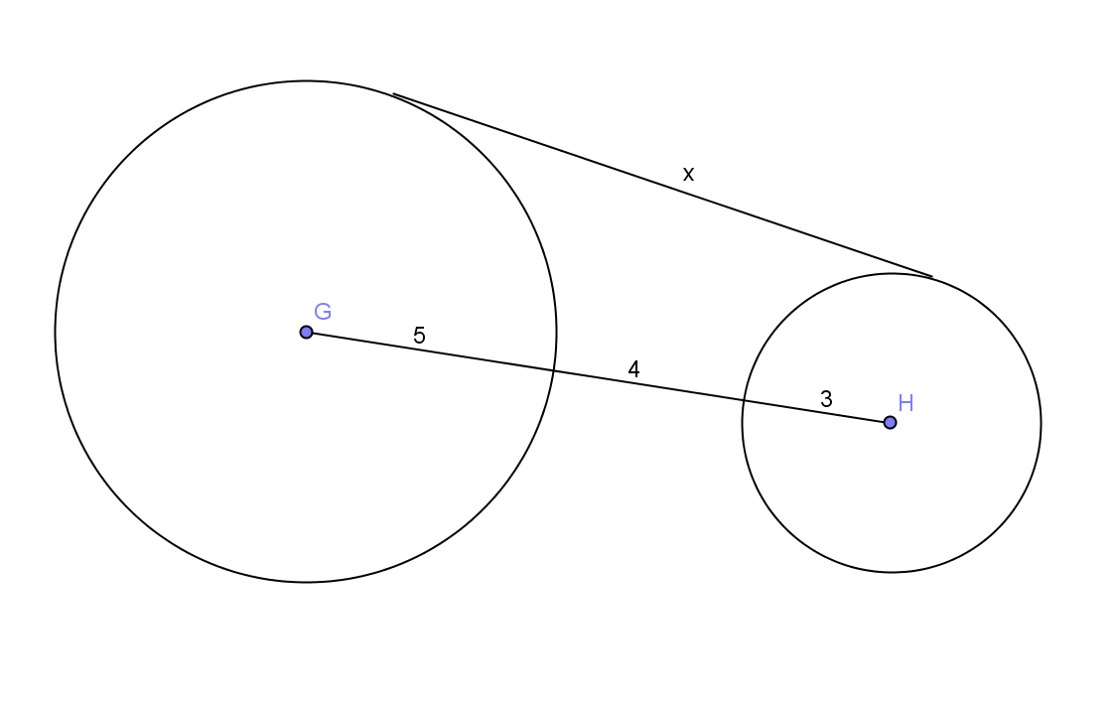
$x=11.83$

- $\overline{EF}$ is tangent to both circles $A$ and $C$. The radius of circle $A$ is $9$, and the radius of circle $C$ is $5$. The circles are $2$ units apart. Find the length of $\overline{EF}$, $x$ (round to the nearest hundredth).
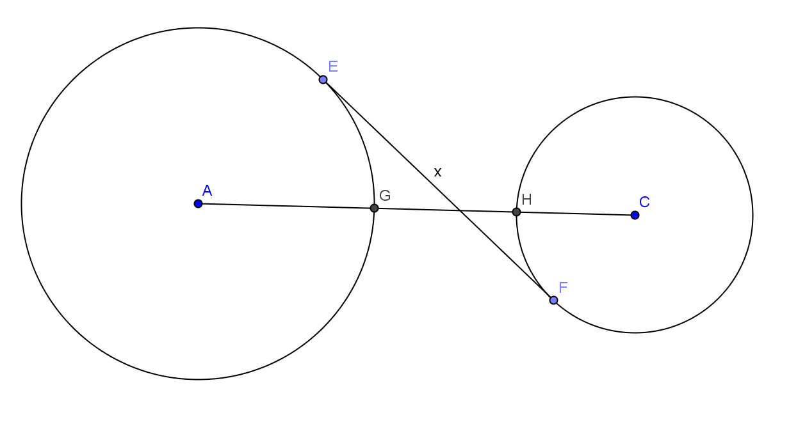
$x = 7.75$

