Lesson 11: Properties of Tangents

Classwork
Exercises 1–3
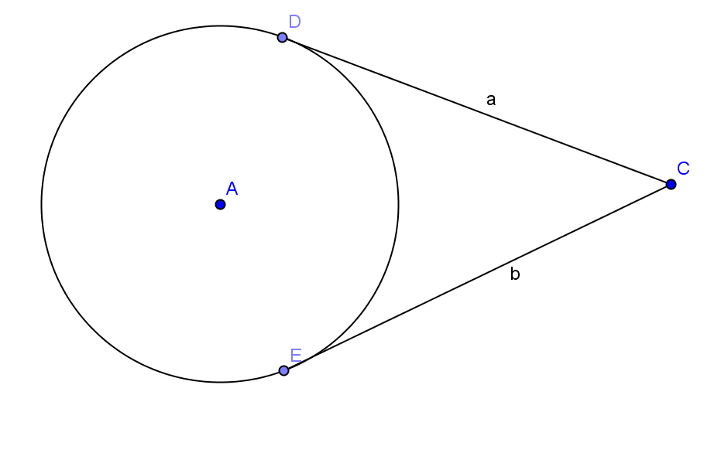
- $\overline{CD}$ and $\overline{CE}$ are tangent to circle $A$ at points $D$ and $E$ respectively. Use a two-column proof to prove $a=b$.

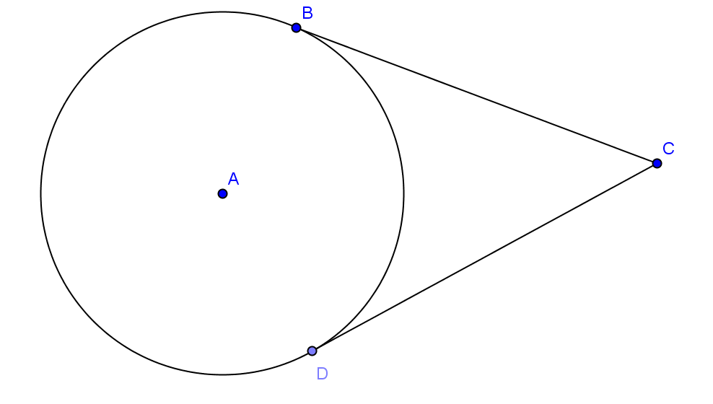
- In circle $A$, the radius is $9$ mm and $BC=12$ mm.
  - Find $AC$.

  - Find the area of $∆ACD.$

  - Find the perimeter of quadrilateral $ABCD$.

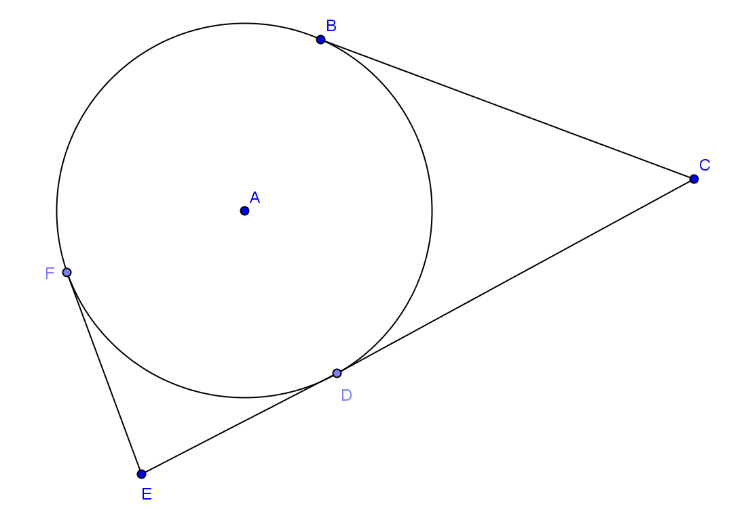
- In circle $A$, $EF=12$ and $AE=13$. $AE:AC=1:3$. Find
  - The radius of the circle.

  - $BC$ (round to the nearest whole number)

  - $EC$

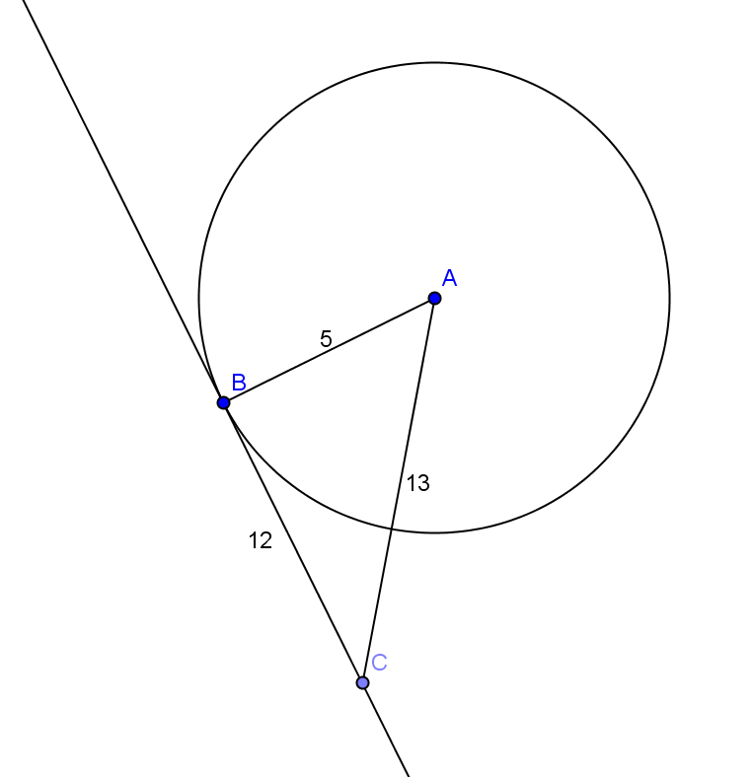
Problem Set
Lesson Summary
Theorems:
- A tangent line to a circle is perpendicular to the radius of the circle drawn to the point of tangency.
- A line through a point on a circle is tangent at the point if, and only if, it is perpendicular to the radius drawn to the point of tangency.
Relevant Vocabulary
- Interior of a circle: The interior of a circle with center $O$ and radius $r$ is the set of all points in the plane whose distance from the point $O$ is less than $r$.
A point in the interior of a circle is said to be inside the circle. A disk is the union of the circle with its interior.
- Exterior of a circle: The exterior of a circle with center $O$ and radius $r$ is the set of all points in the plane whose distance from the point $O$ is greater than $r$.
A point exterior to a circle is said to be outside the circle.
- Tangent to a circle: A tangent line to a circle is a line in the same plane that intersects the circle in one and only one point. This point is called the point of tangency.
- Tangent segment/ray: A segment is a tangent segment to a circle if the line that contains it is tangent to the circle and one of the end points of the segment is a point of tangency. A ray is called a tangent ray to a circle if the line that contains it is tangent to the circle and the vertex of the ray is the point of tangency.
- Secant to a circle: A secant line to a circle is a line that intersects a circle in exactly two points.
- Polygon Inscribed in a circle: A polygon is inscribed in a circle if all of the vertices of the polygon lie on the circle.
- Circle Inscribed in a polygon: A circle is inscribed in a polygon if each side of the polygon is tangent to the circle.

- If $AB=5$, $BC=12$, and $AC=13$, is $\overset{⃡}{BC}$ tangent to circle $A$ at point $B$? Explain.

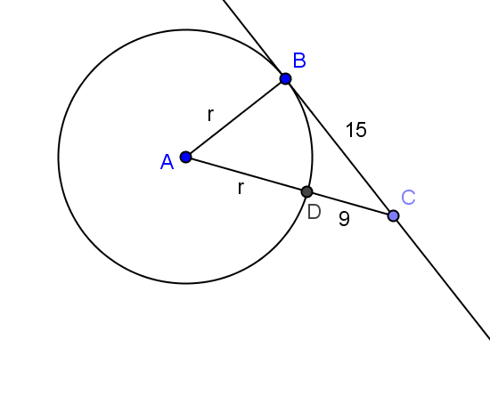
- $\overset{⃡}{BC}$ is tangent to circle $A$ at point $B$. $DC=9$ and $BC=15$.
  - Find the radius of the circle.
  - Find $AC$.

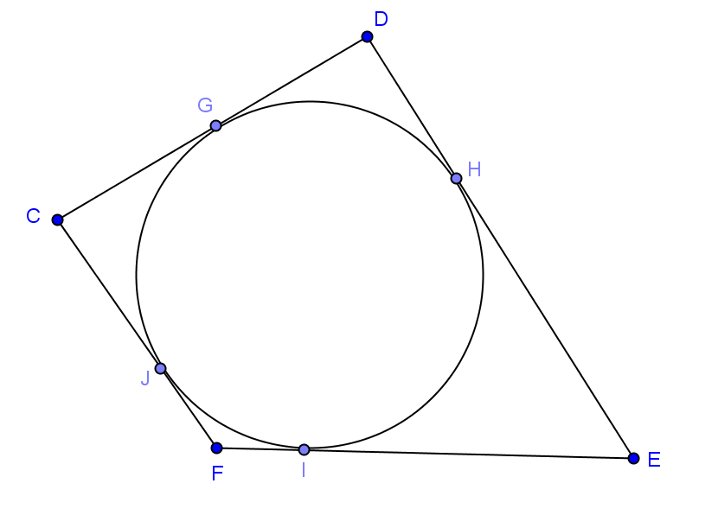
- A circular pond is fenced on two opposite sides ($\overline{CD},\overline{FE})$ with wood and the other two sides with metal fencing. If all four sides of fencing are tangent to the pond, is there more wood or metal fencing used?

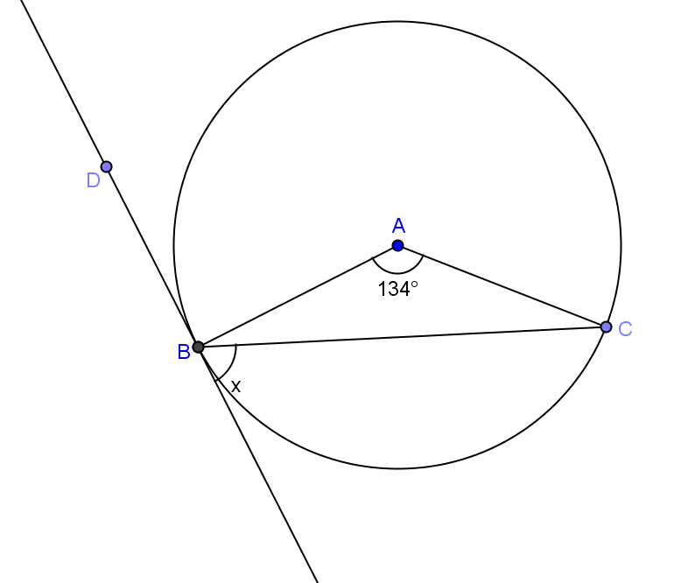
- Find $x$if the line shown is tangent to the circle at point $B$.

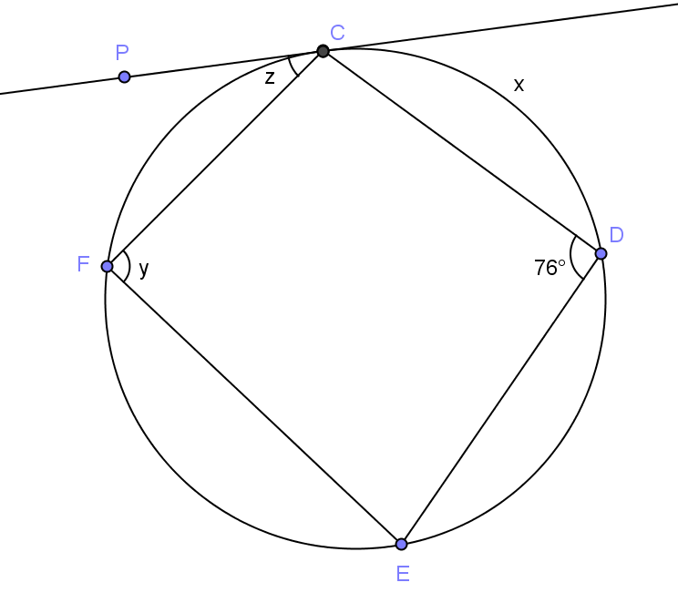
- Line $\overset{⃡}{PC}$ is tangent to the circle at point $C$, and $CD=DE$. Find
  - $x$($m\hat{CD}$)
  - $y$($m∠CFE)$
  - $z$($m∠PCF$)

- Construct two lines tangent to circle $A$ through point $B$.
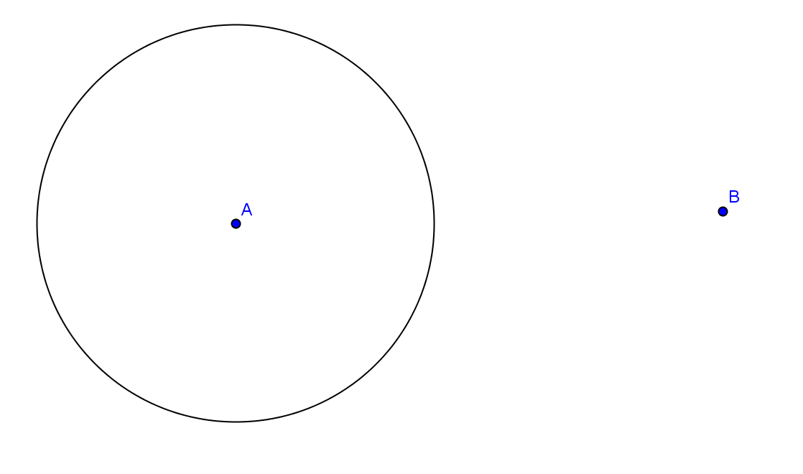

- Find $x$, the length of the common tangent line between the two circles (round to the nearest hundredth).
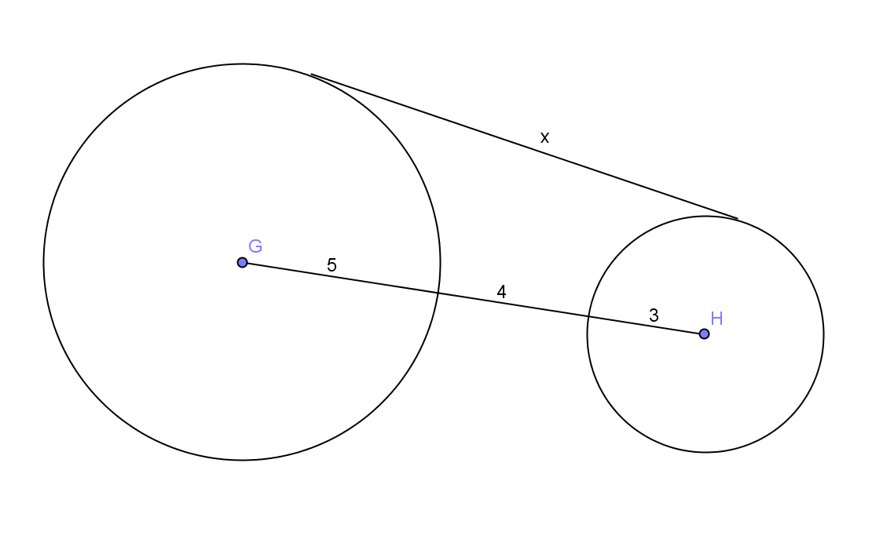

- $\overline{EF}$ is tangent to both circles $A$ and $C$. The radius of circle $A$ is $9$, and the radius of circle $C$ is $5$. The circles are $2$ units apart. Find the length of $\overline{EF}$, $x$ (round to the nearest hundredth).
