|  |
| --- |
|  |

Lesson 10: Unknown Length and Area Problems

Student Outcomes

* Students apply their understanding of *arc length* and *area of sectors* to solve problems of unknown area and length.

Lesson Notes

This lesson continues the work started in Lesson 9 as students solve problems on arc length and area of sectors. The lesson is intended to be 45 minutes of problem solving with a partner. Problems vary in level of difficulty and can be assigned specifically based on student understanding. The problem set can be used in class for some students or assigned as homework. Students who need to focus on a small number of problems could finish the other problems at home. Teachers may choose to model two or three problems with the entire class.

Exercise 4 is a modeling problem highlighting **G-MG.A.1** and MP.4.

*Scaffolding:*

* Post area of sector and arc length formulas for easy reference.
* A review of compound figures may be required before this lesson.
* Scaffold the task by asking students to compute the area of the circle with radius , then the circle with radius , and then ask how the shaded region is related to the two circles.
* Use an example with numerical values for and on the coordinate plane, and ask students to estimate the area first (see example below).

Classwork

Begin with a quick whole class discussion of an annulus. Project the figure on the right on the board.

Opening Exercise (3 minutes)

Opening Exercise

In the following figure, a cylinder is carved out from within another cylinder of the same height; the bases of both cylinders share the same center.

* 1. 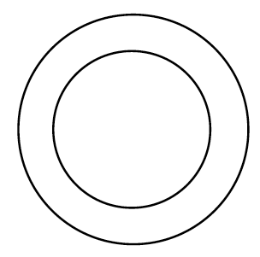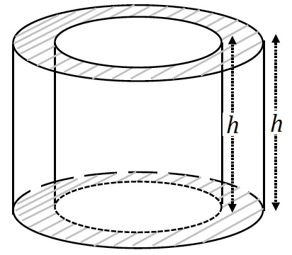Sketch a cross section of the figure parallel to the base.



Confirm that students’ sketch is correct before allowing them to proceed to part (b).

* 1. Mark and label the shorter of the two radii as and the longer of the two radii .

**MP.2**

**&**

**MP.7**

Show how to calculate the area of the shaded region and explain the parts of the expression.

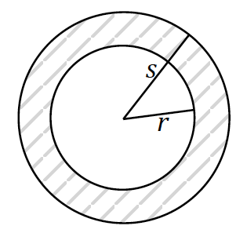

= radius of outer circle

= radius of inner circle

The figure you sketched in part (b) is called an *annulus*; it is a ring shaped region or the region lying between two concentric circles. In Latin, annulus means “little ring.”

Exercises (35 minutes)

1. Find the area of the following annulus.

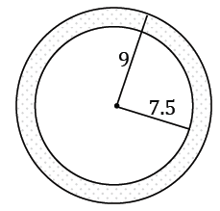

The area of the annulus is .

1. The larger circle of an annulus has a diameter of cm and the smaller circle has a diameter of cm. What is the area of the annulus?

The radius of the larger circle is cm and the radius of the smaller circle is cm.

*The area of the annulus is* .

1. 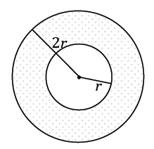In the following annulus, the radius of the larger circle is twice the radius of the smaller circle. If the area of the following annulus is , what is the radius of the larger circle?

The radius of the larger circle is twice the radius of the smaller circle or ; the radius of the larger circle is .

1. An ice cream shop wants to design a super straw to serve with their extra thick milkshakes that is double the width and thickness of a standard straw. A standard straw is mm in diameter and mm thick.

**MP.4**

1. What is the cross-sectional (parallel to the base) area of the new straw (round to the nearest hundredth)?

mm2

1. If the new straw is mm long, what is the maximum volume of milkshake that can be in the straw at one time (round to the nearest hundredth)?

mm3

1. A large milkshake is ounces (approximately mL). If Corbin withdraws the full capacity of a straw times a minute, what is the minimum amount of time that it will take him to drink the milkshake (round to the nearest minute)?

minutes

1. 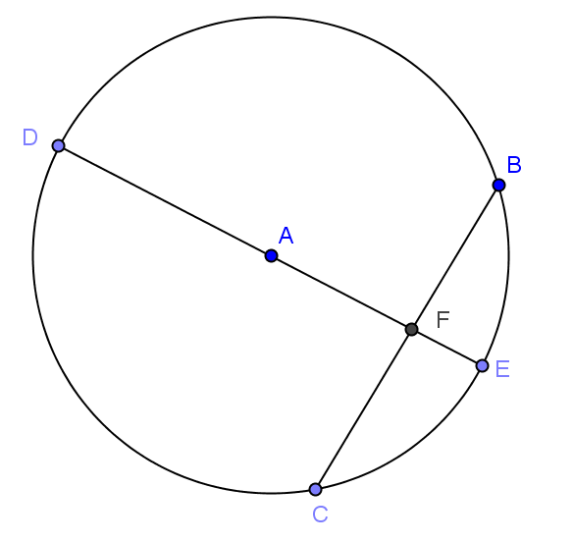In the circle given, is the diameter and is perpendicular to chord . cm and cm. Find , , , the arc length of , and the area of sector (round to the nearest hundredth, if necessary).

cm, cm, , arc length cm, area cm2

1. Given circle with , find the following (round to the nearest hundredth, if necessary):
   1. 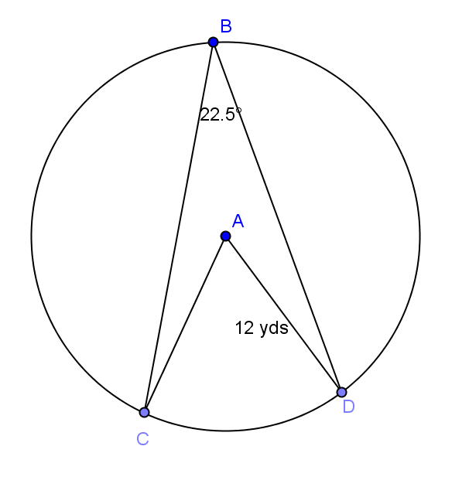
   2. Arc length

yds

* 1. Arc length

yds

* 1. Arc length

yds

* 1. Area of sector

yds2

* 1. Area of sector

yds2

* 1. Area of sector

yds2

1. Given circle , find the following (round to the nearest hundredth, if necessary):
   1. 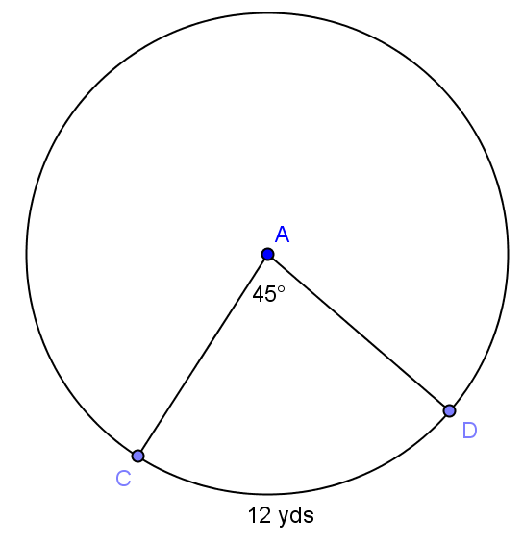Circumference of circle

yds

* 1. Radius of circle

yds

* 1. Area of sector

yds2

1. Given circle , find the following (round to the nearest hundredth, if necessary):
   1. 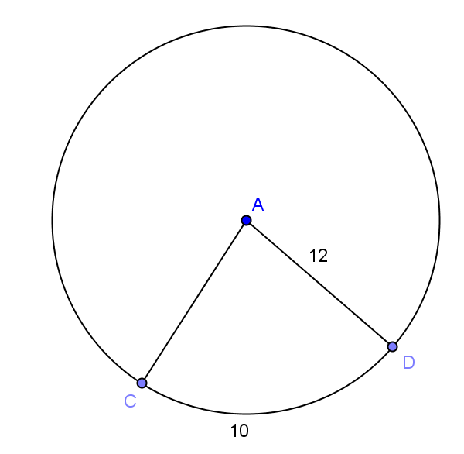
   2. Area of sector

1. 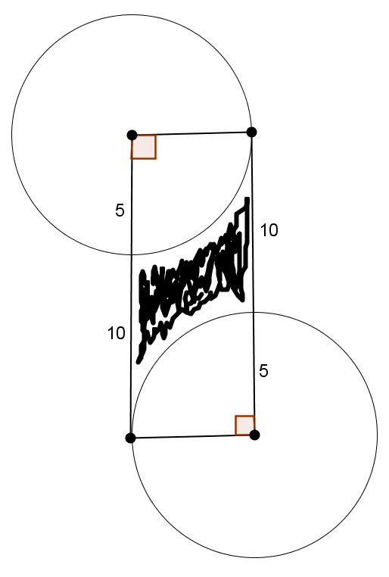Find the area of the shaded region (round to the nearest hundredth).
2. Many large cities are building or have built mega Ferris wheels. One is feet in diameter and has cars each seating up to people. Each time the Ferris wheel turns degrees, a car is in a position to load.
   1. How far does a car move with each rotation of degrees (round to the nearest whole number)?

feet

* 1. What is the value of in degrees?

1. is an equilateral triangle with edge length cm. , , and are midpoints of the sides. The vertices of the triangle are the centers of the circles creating the arcs shown. Find the following (round to the nearest hundredth):
   1. 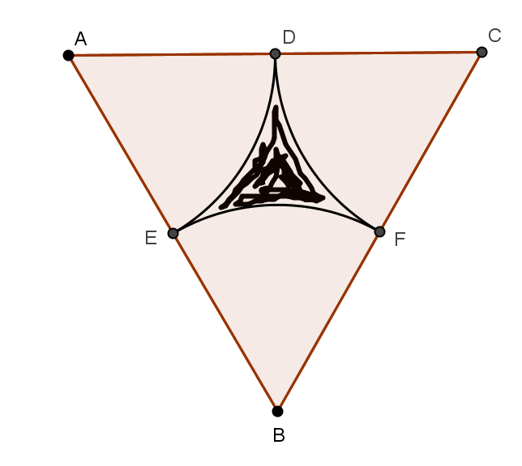The area of the sector with center .

cm2

* 1. The area of triangle .

cm2

* 1. The area of the shaded region.

cm2

* 1. The perimeter of the shaded region.

cm

1. 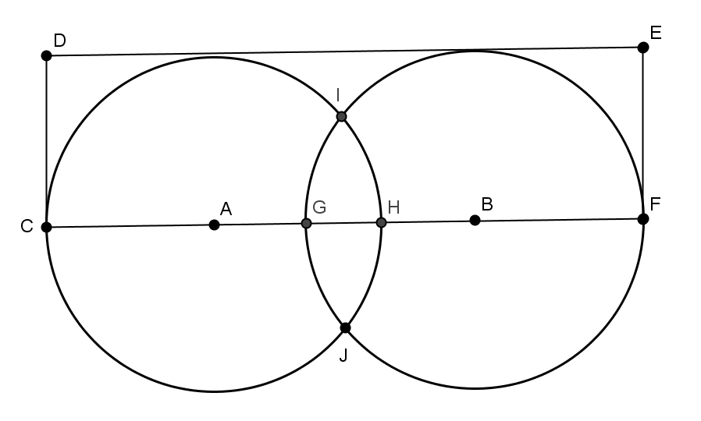In the figure shown, cm, cm, and. Find the area in the rectangle, but outside of the circles (round to the nearest hundredth).

cm2

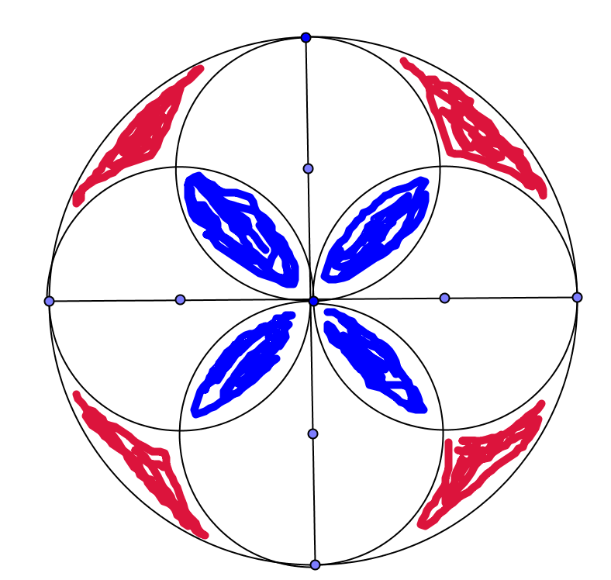

1. This is a picture of a piece of a mosaic tile. If the radius of each smaller circle is inch, find the area of red section, the white section, and the blue section (round to the nearest hundredth).

Red in2, White in2, Blue in2

Closing (2 minutes)

Present the questions to the class, and have a discussion, or have students answer individually in writing. Use this as a method of informal assessment.

* Explain how to find the area of a sector of a circle if you know the measure of the arc in degrees.
  + *Find the fraction of the circumference by dividing the measure of the arc in degrees by , and then multiply by the circumference .*
* Explain how to find the arc length of an arc if you know the central angle.
  + *Find the fraction of the area by dividing the measure of the central angle in degrees by , then multiply by the circumference .*

Exit Ticket (5 minutes)

Name Date

Lesson 10: Unknown Length and Area Problems

Exit Ticket

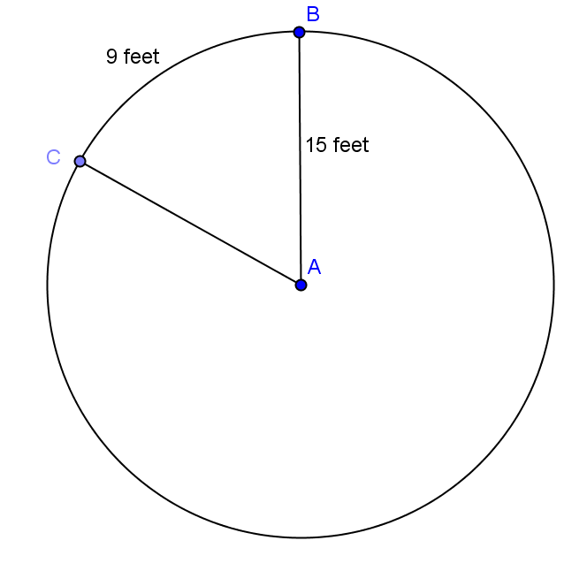

1. Given circle , find the following (round to the nearest hundredth):
   1. The in degrees.
   2. The area of sector .
2. Find the shaded area (round to the nearest hundredth).

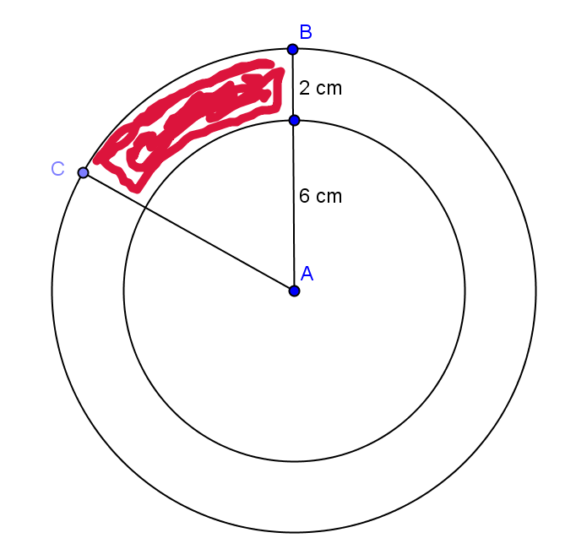

62⁰

Exit Ticket Sample Solutions

1. Given circle , find the following (round to the nearest hundredth):
   1. **The in degrees.**

1. **The area of sector .**



62⁰

1. Find the shaded area.

Problem Set Sample Solutions

Students should continue the work they began in class for homework.

1. 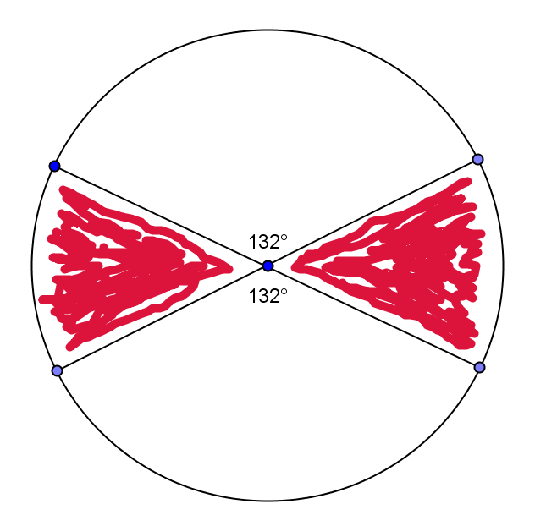Find the area of the shaded region if the diameter is inches (round to the nearest hundredth).

in2

1. 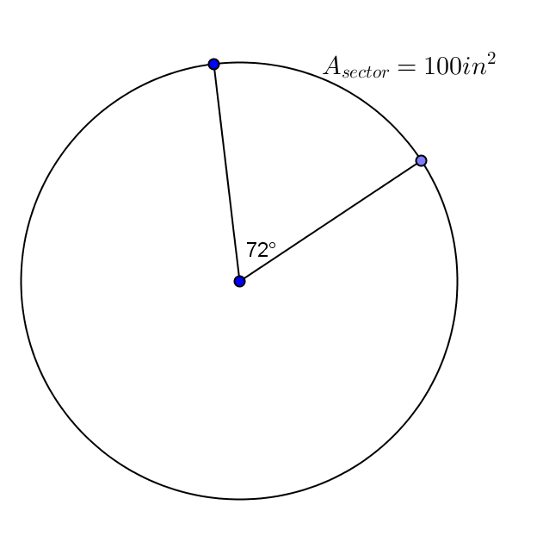Find the area of the entire circle given the area of the sector.

in2

1. 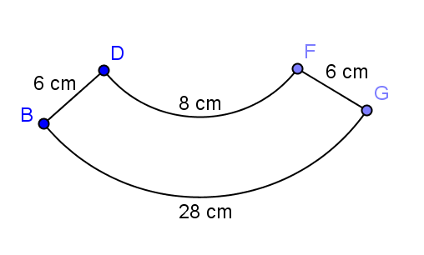 are arcs of concentric circles with and lying on the radii of the larger circle. Find the area of the region (round to the nearest hundredth).

cm2

1. 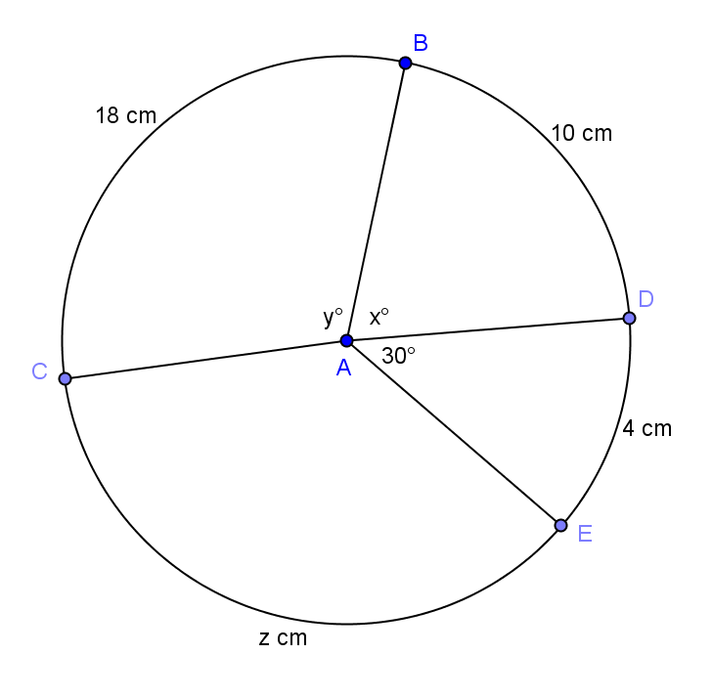Find the radius of the circle, , , and (round to the nearest hundredth).

Radius cm, , , cm

1. 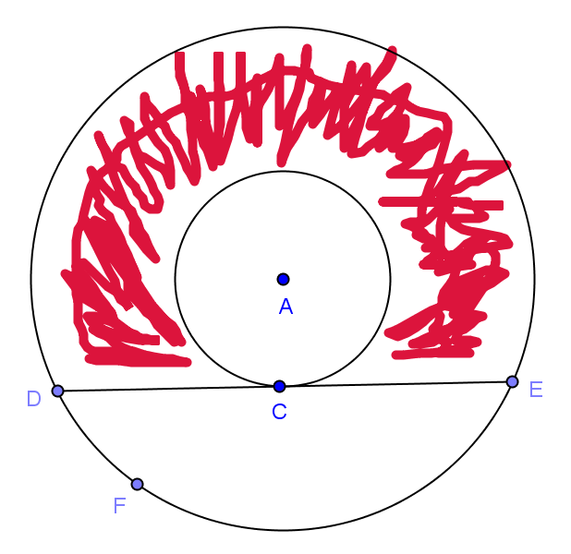In the figure, the radii of two concentric circles are cm and cm. . If a chord of the larger circle intersects the smaller circle only at , find the area of the shaded region in terms of .