Lesson 10: Unknown Length and Area Problems

Classwork
Opening Exercise
In the following figure, a cylinder is carved out from within another cylinder of the same height; the bases of both cylinders share the same center.
  - Sketch a cross section of the figure parallel to the base.
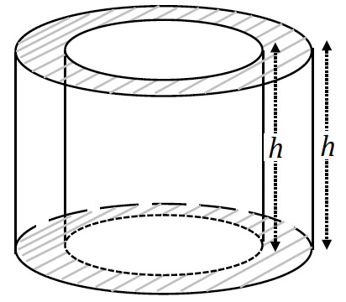

  - Mark and label the shorter of the two radii as $r$ and the longer of the two radii $s$.
Show how to calculate the area of the shaded region and explain the parts of the expression.

Exercises 1–13
- Find the area of the following annulus.

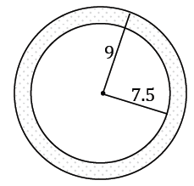

- The larger circle of an annulus has a diameter of $10$cm$,$ and the smaller circle has a diameter of $7.6$cm. What is the area of the annulus?

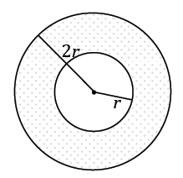
- In the following annulus, the radius of the larger circle is twice the radius of the smaller circle. If the area of the following annulus is $12π {units}^{2}$, what is the radius of the larger circle?

- An ice cream shop wants to design a super straw to serve with their extra thick milkshakes that is double the width and thickness of a standard straw. A standard straw is $8$ mm in diameter and $0.5$ mm thick.
  - What is the cross-sectional (parallel to the base) area of the new straw (round to the nearest hundredth)?

  - If the new straw is $23$ mm long, what is the maximum volume of milkshake that can be in the straw at one time (round to the nearest hundredth)?

  - A large milkshake is $32$ ounces (approximately $950$ mL). If Corbin withdraws the full capacity of a straw $10$ times a minute, what is the minimum amount of time that it will take him to drink the milkshake (round to the nearest minute)?

- In the circle given, $\overline{ED}$ is the diameter and is perpendicular to chord $\overline{CB}$. $DF=8$ cm and $FE=2$ cm. Find $AC$, $BC$, $m∠CAB$, the arc length of $\hat{CEB}$, and the area of sector $\hat{CEB}$ (round to the nearest hundredth, if necessary).
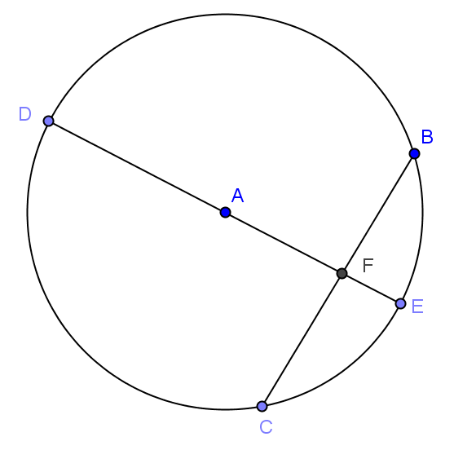

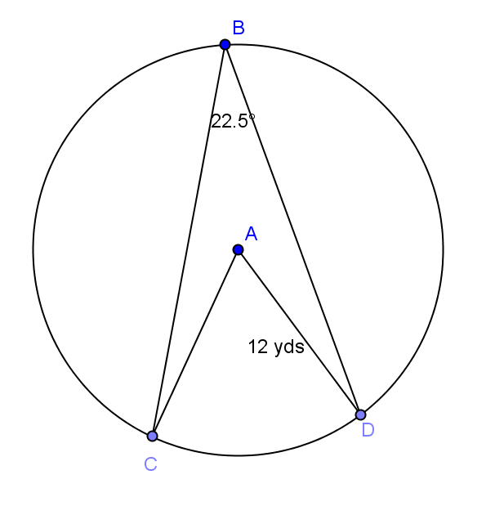
- Given circle $A$ with $∠BAC≅∠BAD$, find the following (round to the nearest hundredth, if necessary):
  - $m\hat{CD}$

  - $m\hat{CBD}$

  - $m\hat{BCD}$

  - Arc length $\hat{CD}$

  - Arc length $\hat{CBD}$

  - Arc length $\hat{BCD}$

  - Area of sector $\hat{CD}$

  - Area of sector $\hat{CBD}$

  - Area of sector $\hat{BCD}$

- Given circle $A$, find the following (round to the nearest hundredth, if necessary):
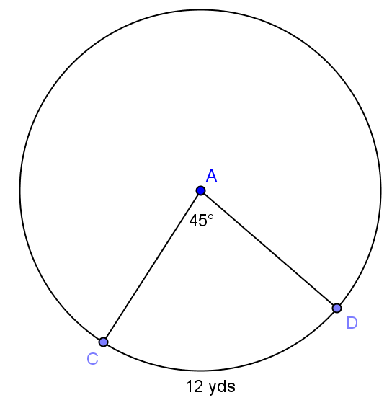
  - Circumference of circle $A$

  - Radius of circle $A$

  - Area of sector $\hat{CD}$

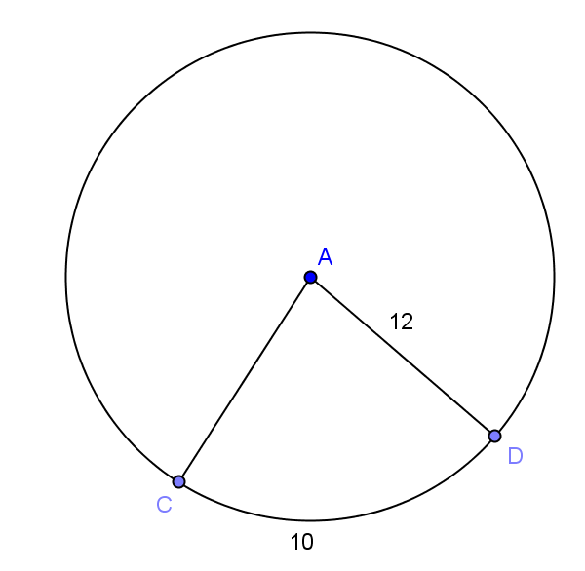
- Given circle $A$, find the following (round to the nearest hundredth, if necessary):
  - $m∠CAD$

  - Area of sector $\hat{CD}$

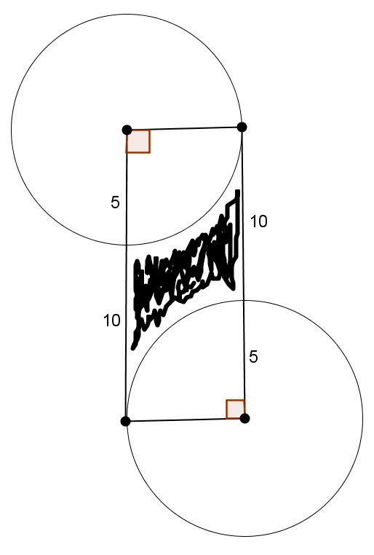
- Find the area of the shaded region (round to the nearest hundredth).

- Many large cities are building or have built mega Ferris wheels. One is $600$ feet in diameter and has $48$ cars each seating up to $20$ people. Each time the Ferris wheel turns $Ө$ degrees, a car is in a position to load.
  - How far does a car move with each rotation of $Ө$ degrees (round to the nearest whole number)?

  - What is the value of $Ө$ in degrees?

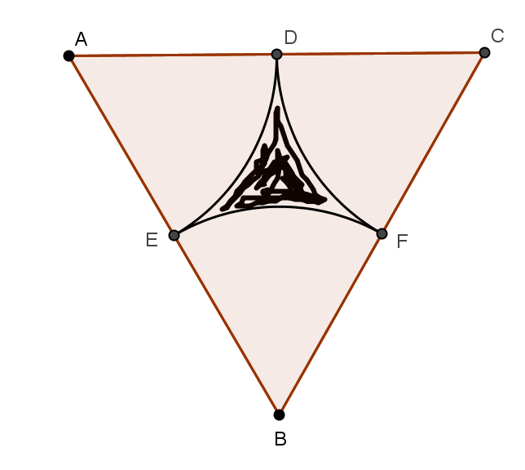
- $∆ABC$ is an equilateral triangle with edge length $20$ cm. $D$, $E$, and $F$ are midpoints of the sides. The vertices of the triangle are the centers of the circles creating the arcs shown. Find the following (round to the nearest hundredth):
  - The area of the sector with center $A$.

  - The area of triangle $ABC$.

  - The area of the shaded region.

  - The perimeter of the shaded region.

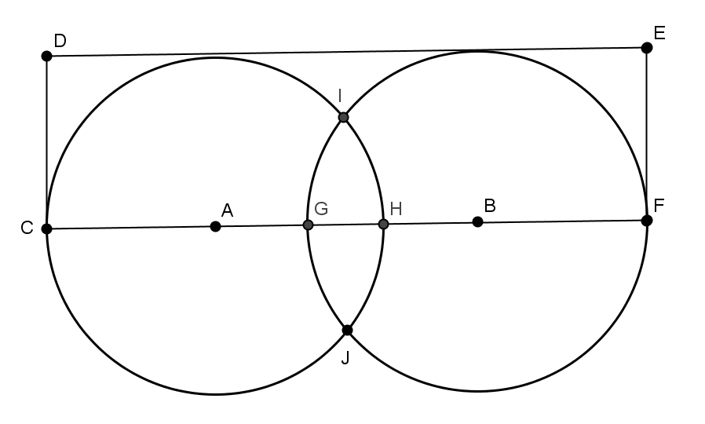
- In the figure shown, $AC=BF=5$ cm,
$GH=2$ cm, and $m∠HBI=30°$. Find the area in the rectangle, but outside of the circles (round to the nearest hundredth).

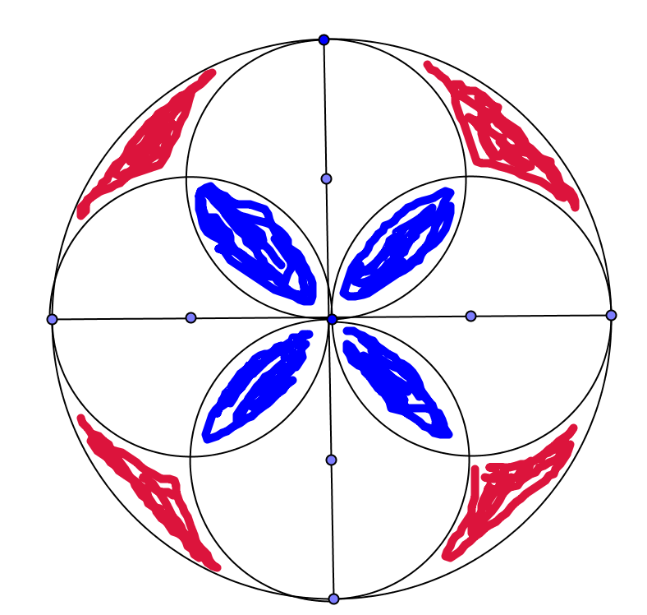
- This is a picture of a piece of a mosaic tile. If the radius of each smaller circle is $1$ inch, find the area of red section, the white section, and the blue section (round to the nearest hundredth).

Problem Set

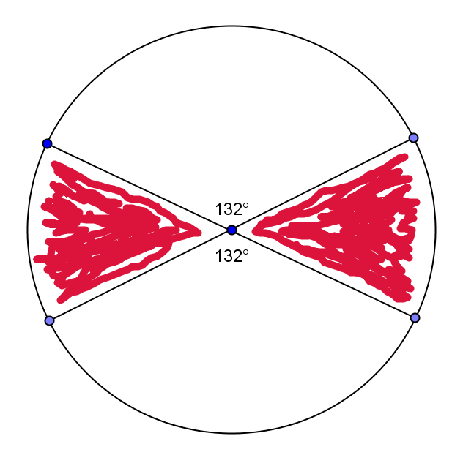
- Find the area of the shaded region if the diameter is $32$ inches (round to the nearest hundredth).

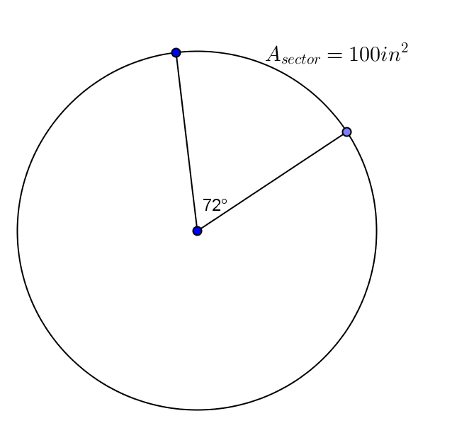
- Find the area of the entire circle given the area of the sector.

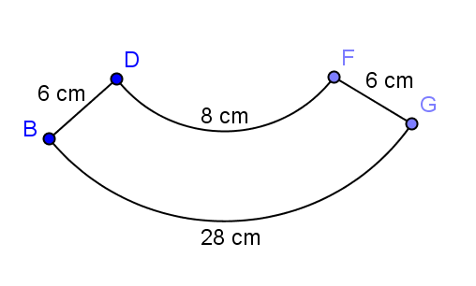
- $\hat{DF}$and$\hat{BG}$ are arcs of concentric circles with $\overline{BD}$and$\overline{FG}$ lying on the radii of the larger circle. Find the area of the region (round to the nearest hundredth).

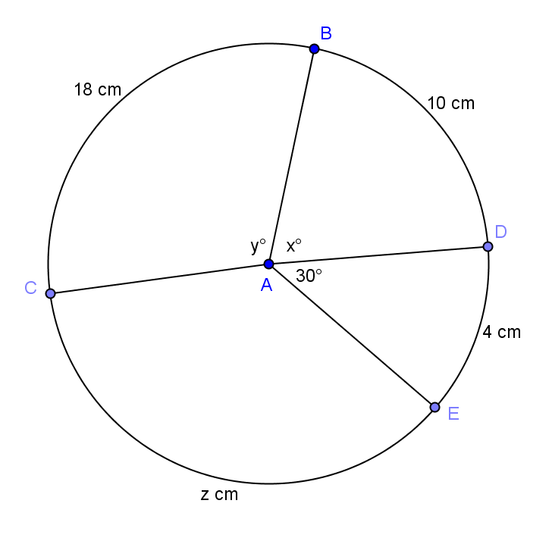
- Find the radius of the circle, $x, y,$ and $z$(round to the nearest hundredth).

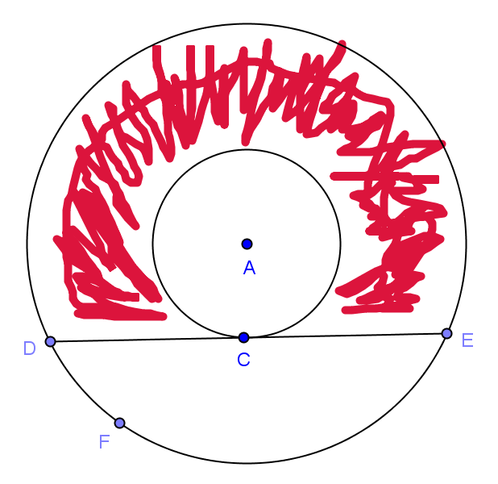
- In the figure, the radii of two concentric circles are $24$ cm and $12$ cm. $m\hat{DAE}=120°$. If a chord $\overline{DE}$ of the larger circle intersects the smaller circle only at $C$, find the area of the shaded region in terms of $π$.

