Lesson 9: Arc Length and Areas of Sectors

Student Outcomes
- When students are provided with the angle measure of the arc and the length of the radius of the circle, they understand how to determine the length of an arc and the area of a sector.

Lesson Notes
This lesson explores the following geometric definitions:
Arc: An arc is any of the following three figures—a minor arc, a major arc, or a semicircle.
Length of an Arc: The length of an arc is the circular distance around the arc.
Minor and Major Arc: In a circle with center $O$, let $A$ and $B$ be different points that lie on the circle but are not the endpoints of a diameter. The minor arc between $A$ and $B$ is the set containing $A$, $B$, and all points of the circle that are in the interior of $∠AOB$. The major arc is the set containing $A$, $B$, and all points of the circle that lie in the exterior of $∠AOB$.
Radian: A radian is the measure of the central angle of a sector of a circle with arc length of one radius length.
Sector: Let arc $\hat{AB}$ be an arc of a circle with center $O$ and radius $r$. The union of the segments $\overline{OP}$, where $P$ is any point on the arc $\hat{AB}$, is called a sector. The arc $\hat{AB}$ is called the arc of the sector, and $r$ is called its radius.
Semicircle: In a circle, let $A$ and $B$ be the endpoints of a diameter. A semicircle is the set containing $A$, $B$, and all points of the circle that lie in a given half-plane of the line determined by the diameter.

Classwork
Opening (2 minutes)
- In Lesson 7, we studied arcs in the context of the degree measure of arcs and how those measures are determined.
- Today we examine the actual length of the arc, or arc length. Think of arc length in the following way: If we laid a piece of string along a given arc and then measured it against a ruler, this length would be the arc length.

Example 1 (12 minutes)
- Discuss the following exercise with a partner.
Scaffolding:
- Prompts to help struggling students along:
- If we can describe arc length as the length of the string that is laid along an arc, what is the length of string laid around the entire circle? (The circumference, $2πr$)
- What portion of the entire circle is the arc measure $60˚$? ($\frac{60}{360}=\frac{1}{6}$; the arc measure tells us that the arc length is $\frac{1}{6}$ of the length of the entire circle.)

Example 1
MP.1
  - What is the length of the arc of degree measure $60˚$ in a circle of radius $10$cm?
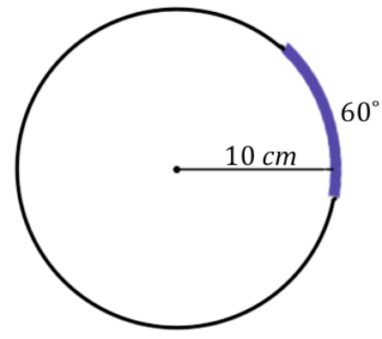
$$Arc length=\frac{1}{6}\left(2π × 10\right)$$
$$Arc length=\frac{10π}{3}$$
The marked arc length is $\frac{10π}{3}$ cm.

Encourage students to articulate why their computation works. Students should be able to describe that the arc length is a fraction of the entire circumference of the circle, and that fractional value is determined by the arc degree measure divided by $360˚$. This will help them generalize the formula for calculating the arc length of a circle with arc degree measure $x˚$ and radius $r$.

  - Given the concentric circles with center $A$ and with $m∠A=60°$, calculate the arc length intercepted by $∠A$ on each circle. The inner circle has a radius of $10$ and each circle has a radius $10$ units greater than the previous circle.
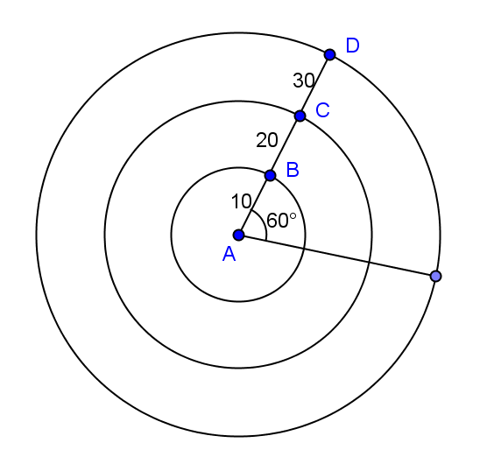
Arc length of circle with radius $\overline{AB}$ $=\left(\frac{60}{360}\right)\left(2π\right)\left(10\right)=\frac{10π}{3}$
Arc length of circle with radius $\overline{AC}$ $=\left(\frac{60}{360}\right)\left(2π\right)\left(20\right)=\frac{20π}{3}$
Arc length of circle with radius $\overline{AD}$ $=\left(\frac{60}{360}\right)\left(2π\right)\left(30\right)=\frac{30π}{3}=10π$

  - An arc, again of degree measure $60˚$, has an arc length of $5π$cm. What is the radius of the circle on which the arc sits?
$$\frac{1}{6}\left(2π × r\right)= 5π$$
$$2πr= 30π$$
$$r=15$$
The radius of the circle on which the arc sits is $15$cm.

- Notice that provided any two of the following three pieces of information–the radius, the central angle (or arc degree measure), or the arc length–we can determine the third piece of information.

  - Give a general formula for the length of an arc of degree measure $x˚$ on a circle of radius $r$.
MP.8
Arc length $=\left(\frac{x}{360}\right)2πr$

  - Is the length of an arc intercepted by an angle proportional to the radius? Explain.
Yes, the arc angle length is a constant $\frac{2πx}{360}$times the radius when x is a constant angle measure, so it is proportional to the radius of an arc intercepted by an angle.

Support parts (a)–(d) with these follow up questions regarding arc lengths. Draw the corresponding figure with each question as you pose the question to the class.
- From the belief that for any number between $0$ and $360$, there is an angle of that measure, it follows that for any length between $0$ and $2πr$, there is an arc of that length on a circle of radius$r$.
- Additionally, we drew a parallel with the $180˚$ protractor axiom (“angles add”) in Lesson 7 with respect to arcs. For example, if we have arcs $\hat{AB}$ and $\hat{BC}$ as in the following figure, what can we conclude about $m\hat{ABC}$?
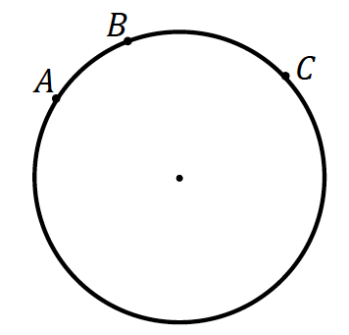

  - $m\hat{AC}=m\hat{AB}+m\hat{BC}$
- We can draw the same parallel with arc lengths. With respect to the same figure, we can say:
$$arc length\left(\hat{AC}\right)=arc length\left(\hat{AB}\right)+arc length\left(\hat{BC}\right)$$

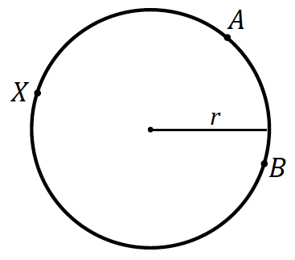
- Then, given any minor arc, such as minor arc $\hat{AB}$, what must the sum of a minor arc and its corresponding major arc (in this example major arc $\hat{AXB}$) sum to?
  - The sum of their arc lengths is the entire circumference of the circle, or $2πr$.
- What is the possible range of lengths of any arc length? Can an arc length have a length of $0$? Why or why not?
  - No, an arc has, by definition, two different endpoints. Hence, its arc length is always greater than zero.
- Can an arc length have the length of the circumference, $2πr$?

Students may disagree about this. Confirm that an arc length refers to a portion of a full circle. Therefore, arc lengths fall between $0$ and $2πr$; $0<arc length<2πr$.

- In part (a), the arc length is $\frac{10π}{3}$. Look at part (b). Have students calculate the arc length as the central angle stays the same, but the radius of the circle changes. If students write out the calculations, they will see the relationship and constant of proportionality that we are trying to discover through the similarity of the circles.
- What variable is determining arc length as the central angle remains constant? Why?
  - The radius determines the size of the circle because all circles are similar.
- Is the length of an arc intercepted by an angle proportional to the radius? If so, what is the constant of proportionality?
  - Yes, $\frac{2πx}{360}$or$\frac{πx}{180}$, where $x$ is a constant angle measure in degree, the constant of proportionality is $\frac{π}{180}$.
- What is the arc length if the central angle has a measure of $1°$?
  - $\frac{π}{180}$
- What we have just shown is that for every circle, regardless of the radius length, a central angle of $1°$ produces an arc of length $\frac{π}{180}.$ Repeat that with me.
  - For every circle, regardless of the radius length, a central angle of $1°$ produces an arc of length $\frac{π}{180}.$
- Mathematicians have used this relationship to define a new angle measure, a radian. A radian is the measure of the central angle of a sector of a circle with arc length of one radius length. Say that with me.
  - A radian is the measure of the central angle of a sector of a circle with arc length of one radius length.
- So $1°=\frac{π}{180}radians$. What does $180°$ equal in radian measure?
  - $π$ radians.
- What does $360°$ or a rotation through a full circle equal in radian measure?
  - $2π$ radians.
- Notice, this is consistent with what we found above.

Exercise 1 (5 minutes)

Exercise 1
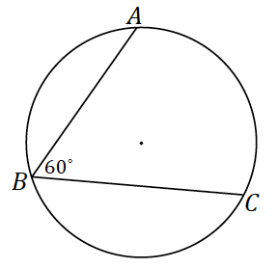
The radius of the following circle is $36$cm$,$ and the $m∠ABC=60˚$.
- What is the arc length of $\hat{AC}$?
The degree measure of arc $\hat{AC}$ is $120˚$. Then the arc length of $\hat{AC}$ is
$$Arc length=\frac{1}{3}\left(2π × 36\right)$$
$$Arc length=24π$$
The arc length of $\hat{AC}$ is $24π$cm.

- What is the radian measure of the central angle?
Arc length $=\left(angle measure of central angle in radians\right)\left(radius\right)$
$Arc length=(angle mesure of central angle in radians)(36)$
Arc length = $\left(\frac{πx}{180}\right)\left(36\right)$
$24π=36\left(angle measure of central angle in radians\right)$
The measure of the central angle in radians = $\frac{24π}{36}=\frac{2π}{3}$ radians.

Discussion (5 minutes)
Discuss what a sector is and how to find the area of a sector.
- A sector can be thought of as the portion of a disk defined by an arc.
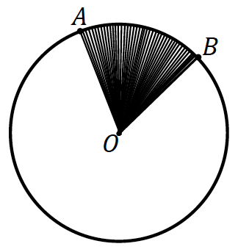
Sector: Let $\hat{AB}$ be an arc of a circle with center $O$ and radius $r$. The union of all segments $\overline{OP}$, where $P$ is any point of $\hat{AB}$, is called a sector.

Example 2 (8 minutes)
Scaffolding:
We calculated arc length by determining the portion of the circumference the arc spanned. How can we use this idea to find the area of a sector in terms of area of the entire disk?
Allow students to work in partners or small groups on the questions before offering prompts.

Example 2
  - Circle $O$ has a radius of $10$cm. What is the area of the circle? Write the formula.
$Area=\left(π{(10 cm)}^{2}\right)=100π {cm}^{2}$

  - What is the area of half of the circle? Write and explain the formula.
$Area=\frac{1}{2}\left(π{(10 cm)}^{2}\right)=50π {cm}^{2}$. $10$ is the radius of the circle, and $\frac{1}{2}=\frac{180}{360}$, which is the fraction of the circle.

  - What is the area of a quarter of the circle? Write and explain the formula.
$Area=\frac{1}{4}\left(π{(10 cm)}^{2}\right)=25π {cm}^{2}$. $10$ is the radius of the circle, and $\frac{1}{4}=\frac{90}{360}$, which is the fraction of the circle.
MP.7
  - Make a conjecture about how to determine the area of a sector defined by an arc measuring $60$ degrees.
$Area(sector AOB)=\frac{60}{360}\left(π{\left(10\right)}^{2}\right)=\frac{1}{6}\left(π{(10)}^{2}\right)$; the area of the circle times the arc measure divided by $360$
$$Area(sector AOB)=\frac{50π}{3}$$
The area of the sector $AOB$ is $\frac{50π}{3}$ ${cm}^{2}$.

Again, as with Example 1, part (a), encourage students to articulate why the computation works.

  - Circle $O$ has a minor arc $\hat{AB}$ with an angle measure of $60˚$. Sector $AOB$ has an area of $24π$. What is the radius of circle $O$?
$$24π=\frac{1}{6}\left(π{(r)}^{2}\right)$$
$$144π=\left(π{(r)}^{2}\right)$$
$$r=12$$
The radius has a length of $12$units.

  - Give a general formula for the area of a sector defined by arc of angle measure $x˚$ on a circle of radius $r$?
Area of sector $=\left(\frac{x}{360}\right)πr^{2}$

Exercises 2–3 (7 minutes)

Exercises 2–3
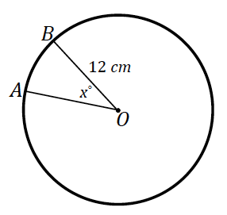
- The area of sector $AOB$ in the following image is $28π$. Find the measurement of the central angle labeled $x˚$.
$$28π=\frac{x}{360}\left(π{(12)}^{2}\right)$$
$$x=70$$
The central angle has a measurement of $70˚$.

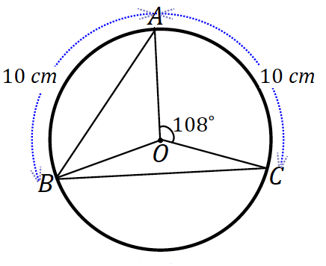
- In the following figure, circle $O$ has a radius of $8$cm, $m∠AOC=108˚$ and $\hat{AB}=\hat{AC}=10$cm. Find:
  - $∠OAB$
$$36˚$$

  - $\hat{BC}$
$$144˚$$

  - Area of sector $BOC$
$$Area(sector BOC)=\frac{144}{360}\left(π{(8)}^{2}\right)$$
$$Area(sector BOC)≈80.4$$
The area of sector $BOC$ is $80.4 {cm}^{2}$.

Closing (1 minute)
Present the following questions to the entire class, and have a discussion.
- What is the formula to find the arc length of a circle provided the radius $r$ and an arc of angle measure $x˚$?
  - $Arc length=\left(\frac{x}{360}\right)(2πr)$
- What is the formula to find the area of a sector of a circle provided the radius $r$ and an arc of angle measure $x˚$?
  - $Area of sector=\left(\frac{x}{360}\right)(πr^{2})$
- What is a radian?
  - The measure of the central angle of a sector of a circle with arc length of one radius length.
Lesson Summary
Relevant Vocabulary
- Arc: An arc is any of the following three figures—a minor arc, a major arc, or a semicircle.
- Length of an Arc: The length of an arc is the circular distance around the arc.
- Minor and Major arc: In a circle with center $O$, let $A$ and $B$ be different points that lie on the circle but are not the endpoints of a diameter. The minor arc between $A$ and $B$ is the set containing $A$, $B$, and all points of the circle that are in the interior of $∠AOB$. The major arc is the set containing $A$, $B$, and all points of the circle that lie in the exterior of $∠AOB$.
- Radian: A radian is the measure of the central angle of a sector of a circle with arc length of one radius length.
- Sector: Let arc $\hat{AB}$ be an arc of a circle with center $O$ and radius $r$. The union of the segments $\overline{OP}$, where $P$ is any point on the arc $\hat{AB}$, is called a sector. The arc $\hat{AB}$ is called the arc of the sector, and $r$ is called its radius.
- Semicircle: In a circle, let $A$ and $B$ be the endpoints of a diameter. A semicircle is the set containing $A$, $B$, and all points of the circle that lie in a given half-plane of the line determined by the diameter.

Exit Ticket (5 minutes)

Name Date
Lesson 9: Arc Length and Areas of Sectors

Exit Ticket

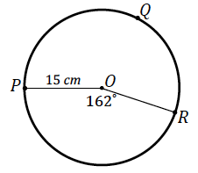

- Find the arc length of $\hat{PQR}$.

- Find the area of sector $POR$.
Exit Ticket Sample Solutions

- Find the arc length of $\hat{PQR}$.
$$Arc length(\hat{PR})=\frac{162}{360}\left(2π × 15\right)$$
$$Arc length(\hat{PR})=13.5π$$
$Circumference\left(circle O\right)=30π$
The arc length of $\hat{PQR}$ is $(30π-13.5π)$cm or $16.5π$cm.

- Find the area of sector $POR$.
$$Area(sector POR)=\frac{162}{360}\left(π{(15)}^{2}\right)$$
$$Area\left(sector POR\right)=101.25π$$
The area of sector $POR$ is $101.25π {cm}^{2}$.

Problem Set Sample Solutions

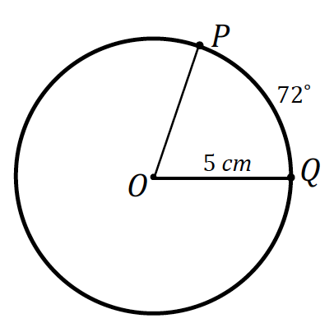
- $P$ and $Q$ are points on the circle of radius $5$cm and the measure of arc $\hat{PQ}$ is $72˚$. Find, to one decimal place each of the following:
  - The length of arc $\hat{PQ}$
$$Arc length(\hat{PQ})=\frac{72}{360}\left(2π × 5\right)$$
$$Arc length(\hat{PQ})=2π$$
The arc length of $\hat{PQ}$ is $2π$cm or approximately $6.3$cm.

  - Find the ratio of the arc length to the radius of the circle.
$\frac{π}{180}∙72=\frac{2π}{5}$radians

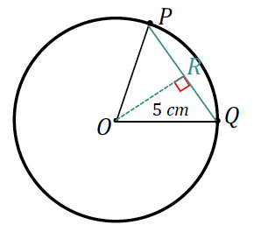
  - The length of chord $PQ$
The length of $PQ$ is twice the value of $x$ in $△OQR$.
$$x=5\sin{36}$$
$$PQ=2x=10\sin{36}$$
Chord $PQ$ has a length of $10\sin{36}cm$ or approximately $5.9 cm$.

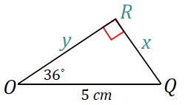
  - The distance of the chord $PQ$ from the center of the circle.
The distance of chord $PQ$ from the center of the circle is labeled as $y$ in $△OQR$.
$$y=5\cos{36}$$
The distance of chord $PQ$ from the center of the circle is $5\cos{36}cm$ or approximately $4 cm$.

  - The perimeter of sector $POQ$.
$$Perimeter(sector)=5+5+2π$$
$$Perimeter(sector)=10+2π$$
The perimeter of sector $POQ$ is $\left(10+2π\right)cm$ or approximately $16.3 cm$.

  - The area of the wedge between the chord $PQ$ and the arc $\hat{PQ}$
$$Area\left(wedge\right)=Area\left(sector\right)-Area(△POQ)$$
$$Area\left(△POQ\right)=\frac{1}{2}\left(10\sin{36}\right)\left(5\cos{36}\right)$$
$$Area(sector POR)=\frac{72}{360}\left(π{(5)}^{2}\right)$$
$$Area\left(wedge\right)=\frac{72}{360}\left(π{(5)}^{2}\right)-\frac{1}{2}\left(10\sin{36}\right)\left(5\cos{36}\right)$$
The area of sector $POQ$ is approximately $3.8 {cm}^{2}$.

  - The perimeter of this wedge
$$Perimeter\left(wedge\right)=2π+10\sin{36}$$
The perimeter of the wedge is approximately $12.2 cm$.

- What is the radius of a circle if the length of a $45˚$ arc is $9π$?
$$9π=\frac{45}{360}\left(2πr\right)$$
$$r=36$$
The radius of the circle is $36$ units.

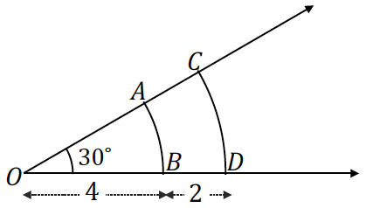
- Arcs $\hat{AB}$ and $\hat{CD}$ both have an angle measure of $30˚$, but their arc lengths are not the same. $\overline{OB}=4$ and $\overline{BD}=2$.
  - What are the arc lengths of arcs $\hat{AB}$ and $\hat{CD}$?
$$Arc length\left(\hat{AB}\right)=\frac{30}{360}\left(2π× 4\right)$$
$$Arc length\left(\hat{AB}\right)=\frac{2}{3}π$$
The arc length of $\hat{AB}$ is $\frac{2}{3}π$ units.
$$Arc length\left(\hat{CD}\right)=\frac{30}{360}\left(2π× 6\right)$$
$$Arc length\left(\hat{CD}\right)=π$$
The arc length of $\hat{CD}$ is $π$ units.

  - What is the ratio of the arc length to the radius for all of these arcs? Explain.
$\frac{30π}{180}=\frac{π}{6}$ radians, the angle is constant, so the ratio of arc length to radius will be the angle measure, $30°×\frac{π}{180}.$
  - What are the areas of the sectors $AOB$ and $COD$?
$$Area(sector AOB)=\frac{30}{360}\left(π{(4)}^{2}\right)$$
$$Area(sector AOB)=\frac{4}{3}π$$
The area of the sector $AOB$ is $\frac{4}{3}π$ ${units}^{2}$.
$$Area(sector COD)=\frac{30}{360}\left(π{(6)}^{2}\right)$$
The area of the sector $AOB$ is ${3π units}^{2}$.
- In the circles shown, find the value of $x$.
The circles shown have central angles that are equal in measure.
- b.
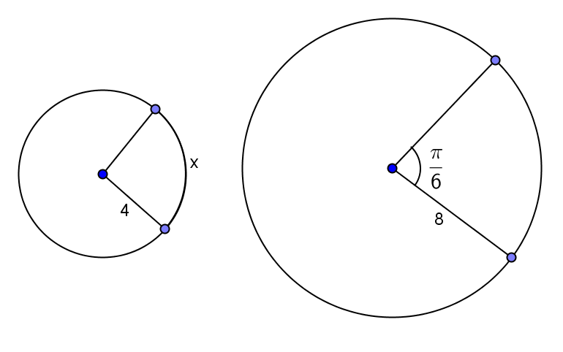
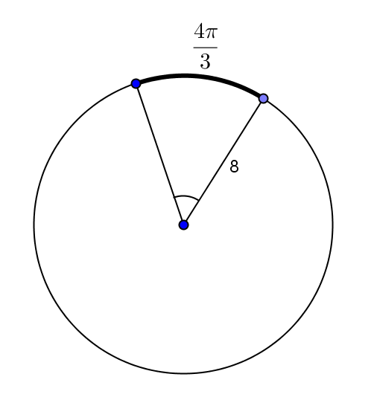

$x=\frac{2π}{3}$ radians $x=30$
- d.
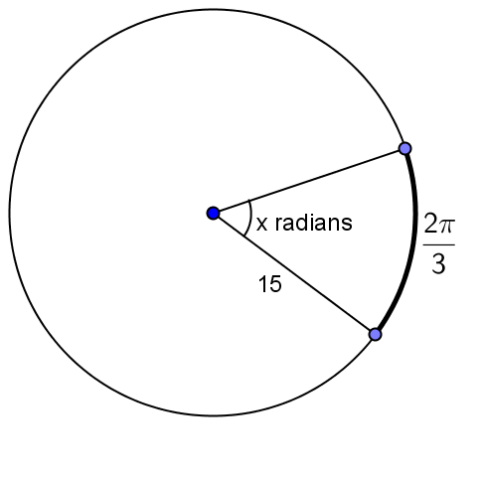
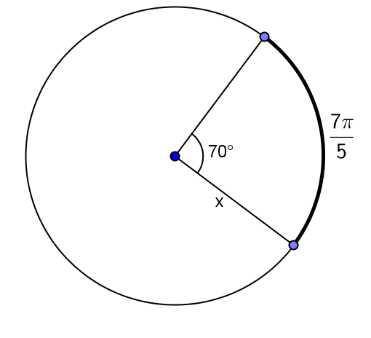

$x=\frac{18}{5}$ $x=\frac{2π}{45}$

- The concentric circles all have center $A$. The measure of the central angle is $45°$. The arc lengths are given.
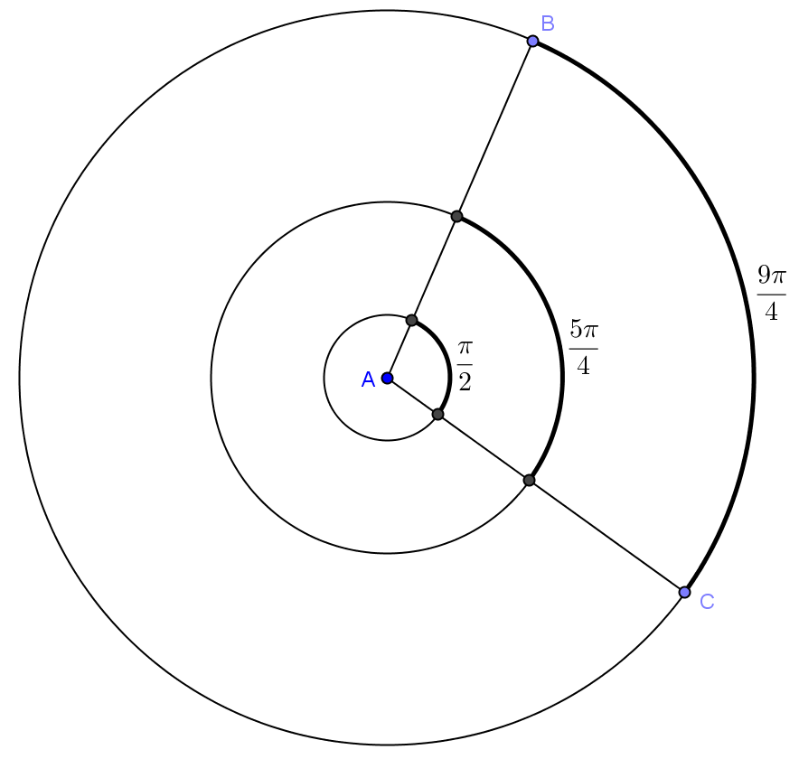
  - Find the radius of each circle.
Radius of inner circle: $\frac{π}{2}=\frac{45π}{180}r, r=2$
Radius of middle circle: $\frac{5π}{4}=\frac{45π}{180}r, r=5$
Radius of outer circle: $\frac{9π}{4}=\frac{45π}{180}r, r=9$

- Determine the ratio of the arc length to the radius of each circle, and interpret its meaning.
$\frac{π}{4}$ is the ratio of the arc length to the radius of each circle. It is the measure of the central angle in radians.
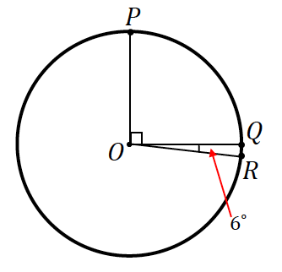
- In the figure, if $\hat{PQ}=10$cm, find the length of arc $\hat{QR}$?
Since $6˚$ is $\frac{1}{15}$ of $90˚$, then the arc length of $\hat{QR}$ is $\frac{1}{15}$ of $10$cm; the arc length of $\hat{QR}$ is $\frac{2}{3}$cm.

- Find, to one decimal place, the areas of the shaded regions.

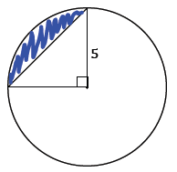

$Shaded Area=Area of sector-Area of Triangle$ (or $\frac{3}{4}\left(Area of circle\right)+Area of triangle$)
$$Shaded Area=\frac{90}{360}\left(π{(5)}^{2}\right)-\frac{1}{2}(5)(5)$$
$$Shaded Area=6.25π-12.5$$
The shaded area is approximately $.13$ ${unit}^{2}$.

  - The following circle has a radius of$2$.
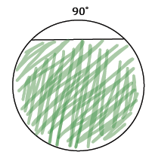

$$Shaded Area=\frac{3}{4}\left(Area of circle\right)+Area of triangle$$
Note: The triangle is a $45°-45°-95°$ triangle with legs of length $2$ (the legs are comprised by the radii, like the triangle in the previous question).
$$Shaded Area=\frac{3}{4}\left(π{(2)}^{2}\right)+\frac{1}{2}(2)(2)$$
$$Shaded Area=3π+2$$
The shaded area is approximately $.4$ ${units}^{2}$.

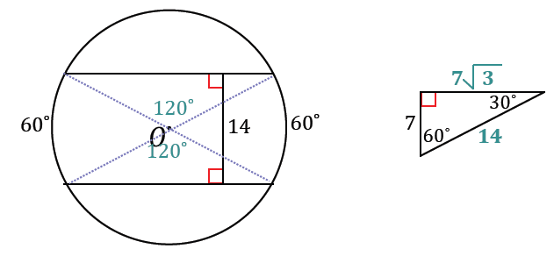
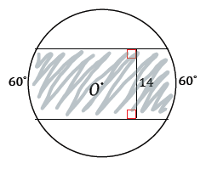

$$Shaded Area=\left(Area of 2 sectors\right)+(Area of 2 triangles)$$
$$Shaded Area=2\left(\frac{98}{3}π\right)+4\left(\frac{49\sqrt{3}}{2}\right)$$
$$Shaded Area=\frac{196}{3}π+98\sqrt{3}$$
The shaded area is approximately $.99$ ${units}^{2}$.

This definition uses the undefined term distance around a circular arc (G-CO.A.1). In grade 4, student might use wire or string to find the length of an arc.

