Lesson 9: Arc Length and Areas of Sectors

Classwork
Example 1
- What is the length of the arc of degree measure $60˚$ in a circle of radius $10$ cm?
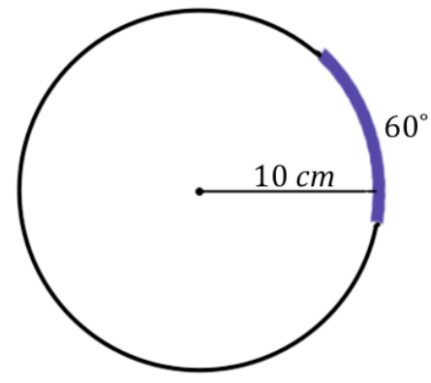

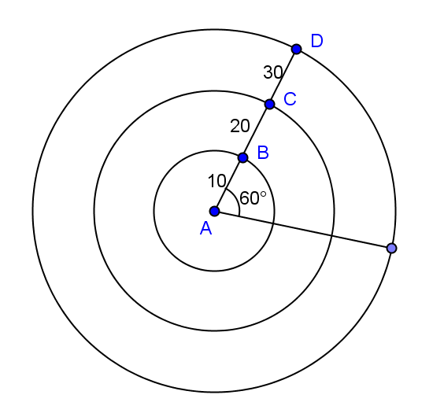
- Given the concentric circles with center $A$ and with $m∠A=60⁰$, calculate the arc length intercepted by $∠A$ on each circle. The inner circle has a radius of $10$ and each circle has a radius $10$ units greater than the previous circle.

- An arc, again of degree measure $60˚$, has an arc length of $5π$cm. What is the radius of the circle on which the arc sits?

- Give a general formula for the length of an arc of degree measure $x˚$ on a circle of radius $r$.

- Is the length of an arc intercepted by an angle proportional to the radius? Explain.

Exercise 1
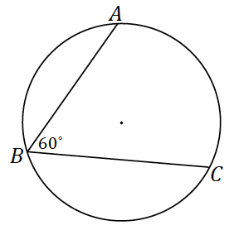
- The radius of the following circle is $36$cm, and the $m∠ABC=60˚$.
  - What is the arc length of $\hat{AC}$?

  - What is the radian measure of the central angle?

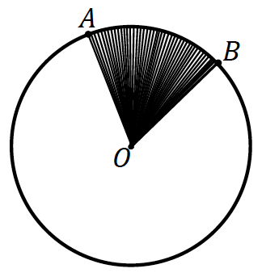
Sector: Let $\hat{AB}$ be an arc of a circle with center $O$ and radius $r$. The union of all segments $\overline{OP}$, where $P$ is any point of $\hat{AB}$, is called a sector.

Example 2
  - Circle $O$ has a radius of$10$cm. What is the area of the circle? Write the formula.

  - What is the area of half of the circle? Write and explain the formula.

  - What is the area of a quarter of the circle? Write and explain the formula.

  - Make a conjecture about how to determine the area of a sector defined by an arc measuring $60$ degrees.

  - Circle $O$ has a minor arc $\hat{AB}$ with an angle measure of $60˚$. Sector $AOB$ has an area of $24π$. What is the radius of circle $O$?

  - Give a general formula for the area of a sector defined by arc of angle measure $x˚$ on a circle of radius $r$?

Exercises 2–3
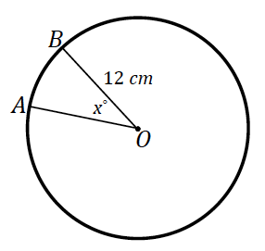
- The area of sector $AOB$ in the following image is $28π$. Find the measurement of the central angle labeled $x˚$.

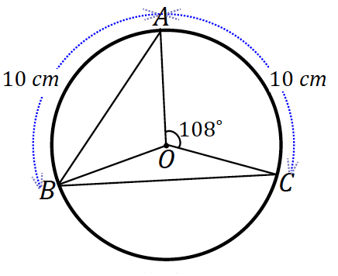
- In the following figure, circle $O$ has a radius of $8$cm, $m∠AOC=108˚$ and $\hat{AB}=\hat{AC}=10$cm. Find:
  - $∠OAB$

  - $\hat{BC}$

  - Area of sector $BOC$

Lesson Summary
Relevant Vocabulary
- Arc: An arc is any of the following three figures—a minor arc, a major arc, or a semicircle.
- Length of an arc: The length of an arc is the circular distance around the arc.
- Minor and major arc: In a circle with center $O$, let $A$ and $B$ be different points that lie on the circle but are not the endpoints of a diameter. The minor arc between $A$ and $B$ is the set containing $A$, $B$, and all points of the circle that are in the interior of $∠AOB$. The major arc is the set containing $A$, $B$, and all points of the circle that lie in the exterior of $∠AOB$.
- Radian: A radian is the measure of the central angle of a sector of a circle with arc length of one radius length.
- Sector: Let arc $\hat{AB}$ be an arc of a circle with center $O$ and radius $r$. The union of the segments $\overline{OP}$, where $P$ is any point on the arc $\hat{AB}$, is called a sector. The arc $\hat{AB}$ is called the arc of the sector, and $r$ is called its radius.
- Semicircle: In a circle, let $A$ and $B$ be the endpoints of a diameter. A semicircle is the set containing $A$, $B$, and all points of the circle that lie in a given half-plane of the line determined by the diameter.

Problem Set

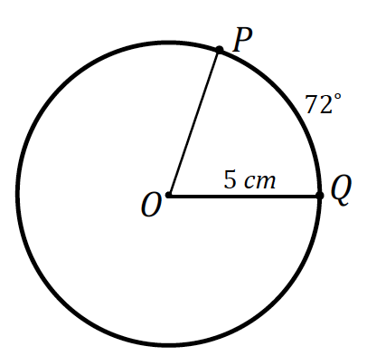
- $P$ and $Q$ are points on the circle of radius $5$cm and the measure of arc $\hat{PQ}$ is $72˚$. Find, to one decimal place each of the following:
  - The length of arc $\hat{PQ}$
  - Find the ratio of the arc length to the radius of the circle.

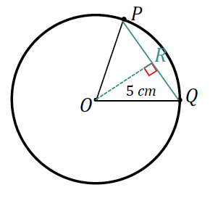
  - The length of chord $PQ$

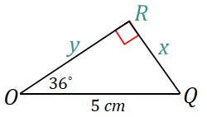
  - The distance of the chord $PQ$ from the center of the circle.

  - The perimeter of sector $POQ$.
  - The area of the wedge between the chord $PQ$ and the arc $\hat{PQ}$
  - The perimeter of this wedge.

- What is the radius of a circle if the length of a $45˚$ arc is $9π$?

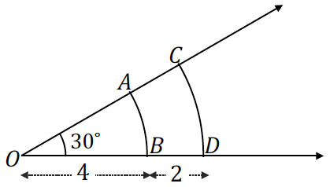
- Arcs $\hat{AB}$ and $\hat{CD}$ both have an angle measure of $30˚$, but their arc lengths are not the same. $\overline{OB}=4$ and $\overline{BD}=2$.
  - What are the arc lengths of arcs $\hat{AB}$ and $\hat{CD}$?
  - What is the ratio of the arc length to the radius for all of these arcs? Explain.
  - What are the areas of the sectors $AOB$ and $COD$?

- In the circles shown, find the value of $x$.
The circles shown have central angles that are equal in measure.
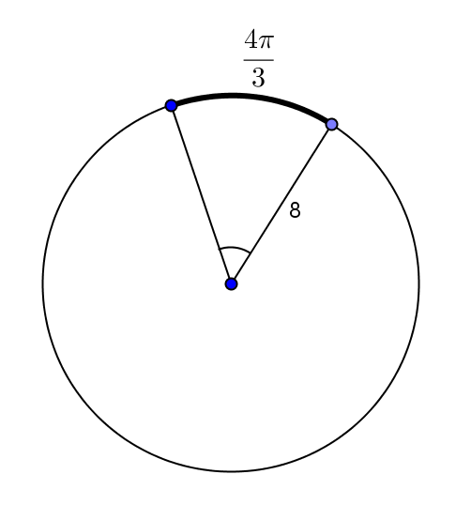
a. b.
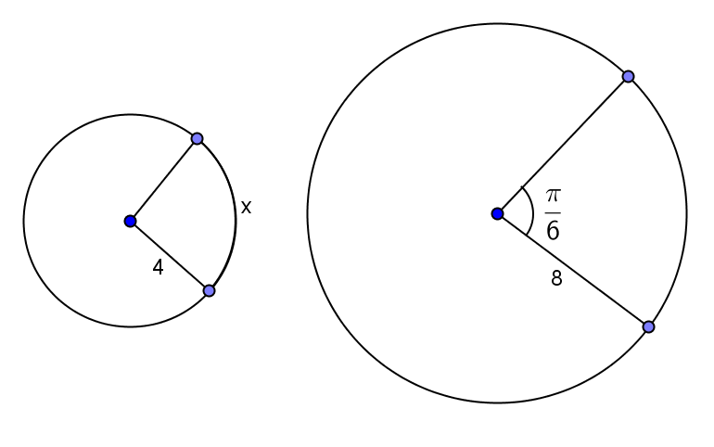

c. d.
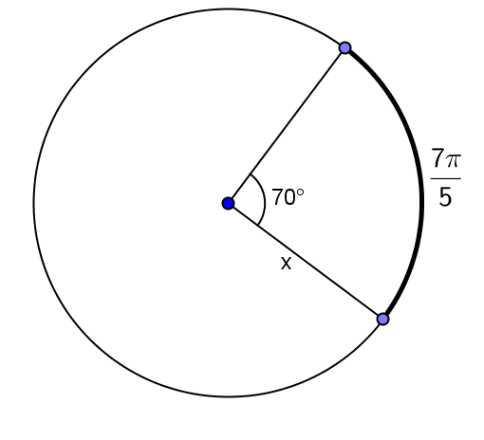
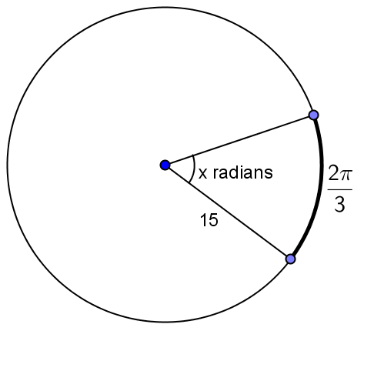

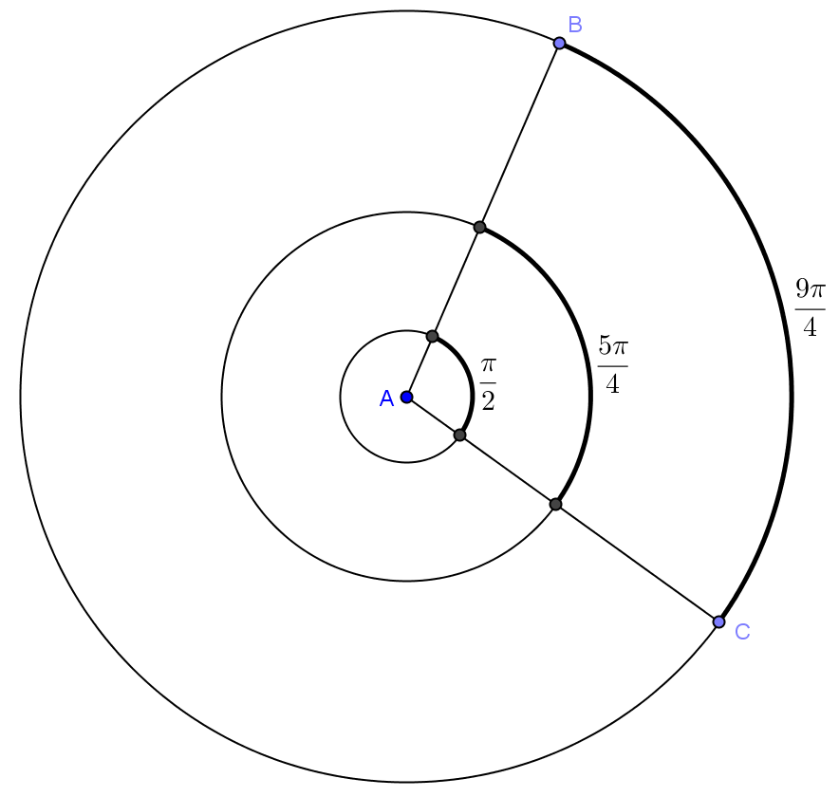
- The concentric circles all have center $A$. The measure of the central angle is $45°$. The arc lengths are given.
  - Find the radius of each circle.
  - Determine the ratio of the arc length to the radius of each circle, and interpret its meaning.

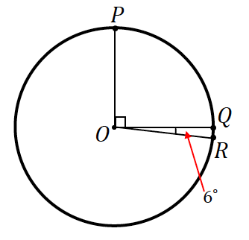
- In the figure, if $\hat{PQ}=10$cm, find the length of arc $\hat{QR}$?

- Find, to one decimal place, the areas of the shaded regions.

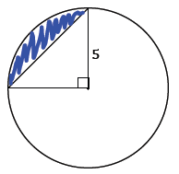

  - The following circle has a radius of$2$.
