Lesson 8: Arcs and Chords

Student Outcomes
- Congruent chords have congruent arcs, and the converse is true.
- Arcs between parallel chords are congruent.

Lesson Notes
In this lesson, students use concepts studied earlier in this module to prove three new concepts: Congruent chords have congruent arcs; congruent arcs have congruent chords; arcs between parallel chords are congruent. The proofs are designed for students to be able to begin independently, so this is a great lesson to allow students the freedom to try a proof with little help getting started.
This lesson that highlights MP.7 as students study different circle relationships and draw auxiliary lines and segments. MP.1 and MP.3 are also highlighted as students attempt a series of proofs without initial help from the teacher.

Classwork
Opening Exercise (5 minutes)
The Opening Exercise reminds students of our work in Lesson 2 relating circles, chords, and radii. It sets the stage for Lesson 8. Have students try this exercise on their own, then compare answers with a neighbor, particularly the explanation of their work. Bring the class back together, and have a couple of students present their work and do a quick review.

Opening Exercise
MP.7
&
MP.1
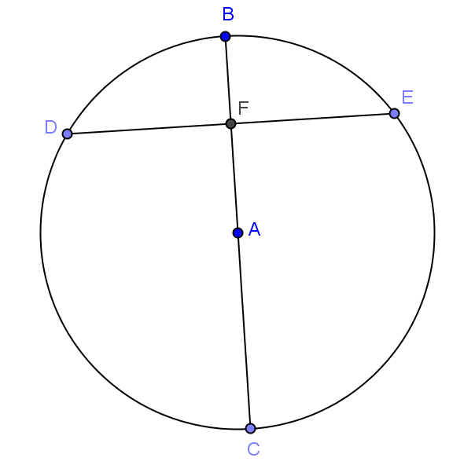
Given circle $A$ with $\overline{ BC}⊥\overline{DE}$, $FA$ $=$ $6,$ and $AC$ $=$ $10$. Find $BF$ and $DE$. Explain your work.
$BF$ $=$ $4,$ $DE$ $=$ $16$.
$AB$ is a radius with a measure of $10$. If $FA$ = $6,$ then $BF$ $=$ $10–6$ $=$ $4$.
Connect $AD$ and $AE$. In $∆DAE$, $AD$ $=$ $AE$ $=$ $10$. Both $∆DFA$ and $∆EFA$ are right triangles
and congruent, so by the Pythagorean theorem,
$DF$ $=$ $FE$ = $8$, making $DE$ $=$ $16$.

Exploratory Challenge (12 minutes)
Scaffolding:
- Display the theorems, axioms, and definitions that we have studied in this module on a word wall.
- Chorally repeat the definitions as a class.
In this example, students will use what they have learned about the relationships between chords, radii, and arcs to prove that congruent chords have congruent arcs and congruent minor arcs have congruent chords. They will then extend this to include major arcs. We are presenting the task and then letting students think through the first proof. Give students time to struggle and talk with their groups. This is not a difficult proof and can be done with concepts from Lesson 2 that they are familiar with or by using rotation. Once groups finish and talk about the first proof, they then do two more proofs that are similar. Walk around, and give help where needed, but not too quickly.
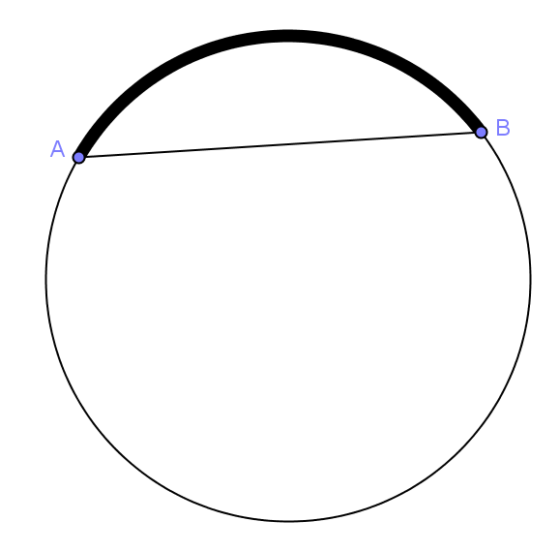
Display the picture below to the class.
Scaffolding:
- If groups are struggling with the proof, give them the following leading questions and steps:
- Draw a picture of the problem.
- Draw two triangles, one joining the center to each chord.
- What is true about the sides of the triangle connected to the center of the circle?
- Are the triangles congruent? How?
- What does that mean about the central angles?
- If we say the central angle has a measure of x°, what is the measure of each chord?
- Think about what we know about rotating figures, will that help us?
- Try drawing a picture.

- Tell me what you see in this diagram.
  - A circle, a chord, a minor arc, a major arc.
- What do you notice about the chord and the minor arc?
  - They have the same endpoints.
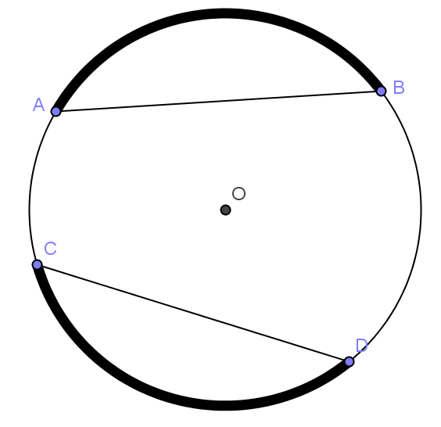
- We say that arc $\hat{AB}$is subtended by chord $\overline{AB}$. Can you repeat that with me?
  - Arc $\hat{AB}$ is subtended by chord $\overline{AB}$.
- What do you think we mean by the word “subtended”?
  - The chord cuts the circle and forms the arc. The chord and arc have the same endpoints.
- Display circle at right. What can we say about arc $\hat{CD}$?
  - Arc $\hat{CD}$is subtended by chord $\overline{CD}$.
- If $AB=CD$, what do you think would be true about $m\hat{AB}$ and $m\hat{CD}$?
  - They are equal (congruent).

Put students in heterogeneous groups of three, and present the task. Set up a 5-minute check to be sure that groups are on the right path and to give ideas to groups who are struggling. Have groups show their work on large paper or poster board and display work, then have a whole class discussion showing the various ways to achieve the proof.
- With your group, prove that if the chords are congruent, the arcs subtended by those chords are congruent.
  - Some groups will use rotations and others similar triangles similar to the work that was done in Lesson 2. Both ways are valid and sharing will expose students to each method.
- Now prove that in a circle congruent minor arcs have congruent chords.
  - Students should easily see that the process is almost the same, and that it is indeed true.
- Do congruent major arcs have congruent chords too?
  - Since major arcs are the part of the circle not included in the minor arc, if minor arcs are congruent, $360°$ minus the measure of the minor arc will also be the same.

Exercise 1 (5 minutes)
Have students try Exercise 1 individually, and then do a pair-share. Wrap up with a quick whole class discussion.

Exercises
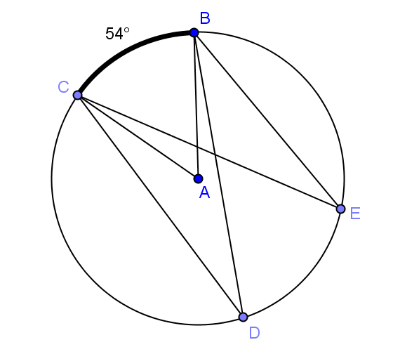
- Given circle $A$ with $m\hat{BC}=54°$ and $∠CDB≅∠DBE$, find $m\hat{DE}$. Explain your work.
$m\hat{DE}=5°$ . $m∠CAB=5°$ because the central angle has the same measure as its subtended arc. $m∠CDB=27°$ because an inscribed angle has half the measure of the central angle with the same inscribed arc. Since $∠CDB≅∠DBE,$ $m\hat{DE}=54°$ because it is double the angle inscribed in it.

Example 1 (5 minutes)
Scaffolding:
- For advanced learners, display the picture below, and ask them to prove the theorem without the provided questions, and then present their proofs in class.
In this example, students prove that arcs between parallel chords are congruent. This is a teacher led example. Students will need a compass and
straight edge to construct a diameter and a copy of the circle below.

Display the picture at right to the class.
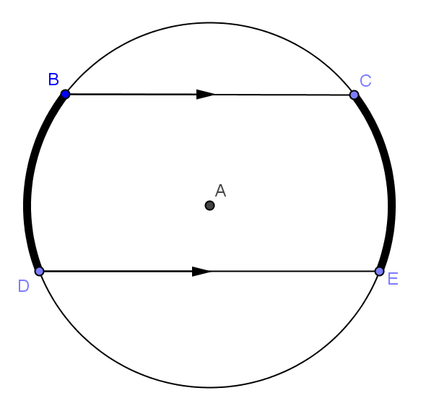
- What do you see in this diagram?
  - A circle, two arcs, a pair of parallel chords
- What looks to be true about the arcs?
  - They appear to be congruent.
- This is true, and here is the theorem: In a circle, arcs between parallel chords are congruent.
- Repeat that with me.
  - In a circle, arcs between parallel chords are congruent.
- Let’s prove this together. Construct a diameter perpendicular to the parallel chords.
  - Students construct the perpendicular diameter.
- What does this diameter do to each chord?
  - The diameter bisects each chord.
- Reflect across the diameter (or fold on the diameter). What happens to the endpoints?
  - The reflection takes the endpoints on one side to the endpoints on the other side. It therefore takes arc to arc. Distances from the center are preserved.
- What have we proven?
  - Arcs between parallel chords are congruent.
- Draw $\overline{CD}$. Can you think of another way to prove this theorem using properties of angles formed by parallel lines?
  - $m∠BCD=m∠EDC$ because alternate interior angles are congruent. This means $m\hat{CE}=m\hat{BD}$ both have inscribed angles of the same measure, so the arc angle measures are congruent and twice the measure of their inscribed angles.

Exercise 2 (5 minutes)
Scaffolding:
- Review the properties of quadrilaterals.
- For students who can’t picture the figure, provide them with this diagram.
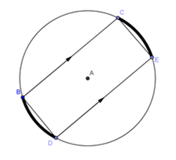

Have students work on Exercise 2 in pairs. This exercise requires use of all concepts studied today. Pull the class back together to share solutions. Use this as a way to assess student understanding.

- If two arcs in a circle have the same measure, what can you say about the quadrilateral formed by the four endpoints? Explain.
If the arcs are congruent, their endpoints can be joined to form chords that are parallel ($\overline{BC}\left\|\overline{DE}\right.$.).
The chords subtending the congruent arcs are congruent ($\overline{BD}\left\|\overline{CE}\right.$).
A quadrilateral with one pair of opposite sides parallel and the other pair of sides congruent is an isosceles trapezoid.

Exercises 3–5 (5 minutes)

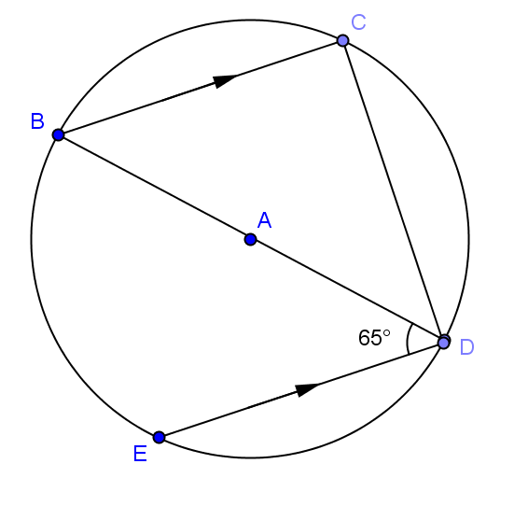
- Find the angle measure of $\hat{CD}$ and $\hat{ED}$.
$$m\hat{CD}= 130°, m\hat{ED}=50°$$

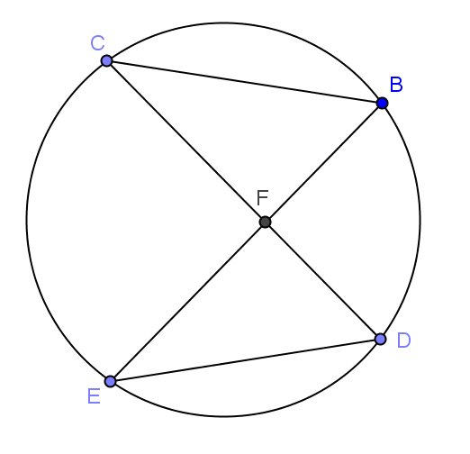
- $m\hat{CB}=m\hat{ED}$ and $m\hat{BC}:m\hat{BD}:m\hat{EC}=1:2:4$. Find
  - $m∠BCF$
$$45°$$

  - $m∠EDF$
$$90°$$

  - $m∠CFE$
$$135°$$

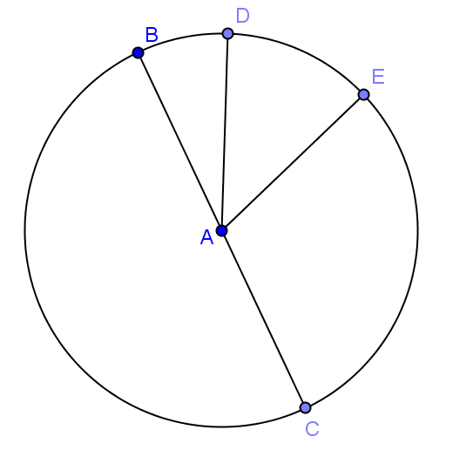
- $\overline{BC}$ is a diameter of circle $A$. $m\hat{BD}:m\hat{DE}:m\hat{EC}=1:3:5$. Find
  - $m\hat{BD}$
$$20°$$

  - $m\hat{DEC}$
$$160°$$

  - $m\hat{ECB}$
$$280°$$

Closing (3 minutes)
Have students do a 30-second Quick Write on what they have learned in this lesson about chords and arcs. Pull the class together to review, and have them add these to the circle graphic organizer started in Lesson 2.
- Congruent chords have congruent arcs.
- Congruent arcs have congruent chords.
- Arcs between parallel chords are congruent.
Lesson Summary
Theorems:
- Congruent chords have congruent arcs.
- Congruent arcs have congruent chords.
- Arcs between parallel chords are congruent.

Exit Ticket (5 minutes)
Name Date
Lesson 8: Arcs and Chords

Exit Ticket

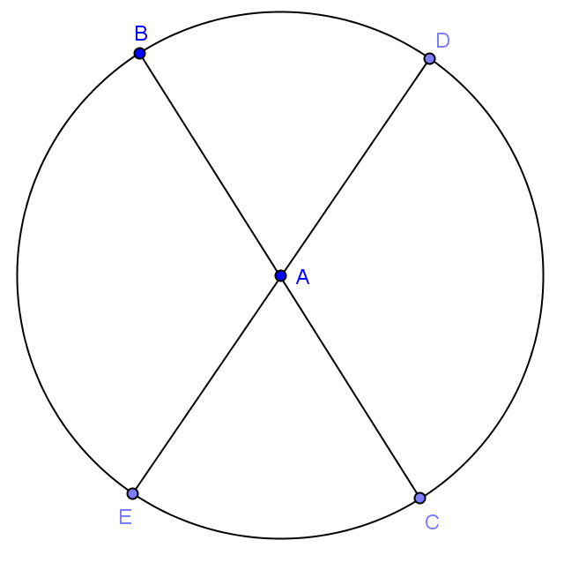
- Given circle $A$ with radius $10$, prove $BE=DC$.

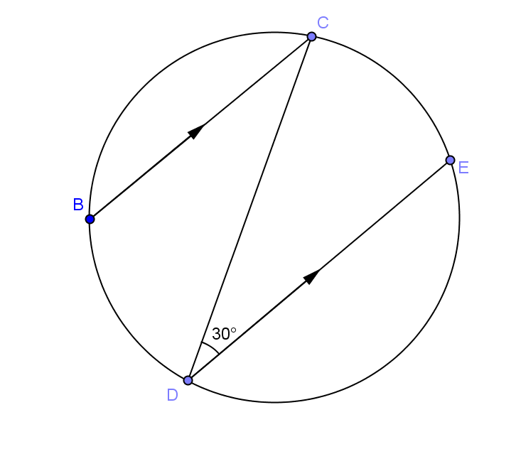
- Given the circle at right, find $m\hat{BD}$.
Exit Ticket Sample Solutions

- Given circle $A$ with radius $10$, prove $BE=DC$.
$m∠BAE=m∠DAC$ (vertical angles are congruent)
$m\hat{BE}=m\hat{DC}$ (arcs are equal in degree measure to their inscribed central angles)
$BE=DC$ (chords are equal in length if they subtend congruent arcs)

- Given the circle at right, find $m\hat{BD}$.
$60$°

Problem Set Sample Solutions
Problems 1–3 are straightforward and easy entry. Problems 5–7 are proofs and may be challenging for some students. You may consider only assigning some problems or allowing student choice while requiring some problems of all students.
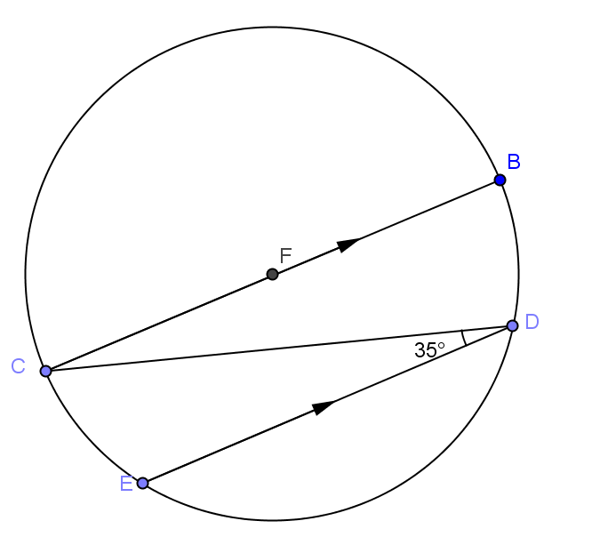
- Find
  - $m\hat{CE}$
$70°$

  - $m\hat{BD}$
$70°$

  - $m\hat{ED}$
$40°$

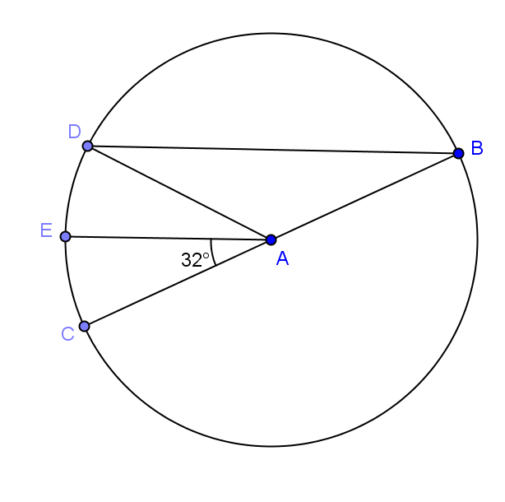
- In circle $A$, $\overline{BC}$ is a diameter, $m\hat{CE}=m\hat{ED}$, and $m∠CAE=32°$.
  - Find $m∠CAD$.
$64°$

  - Find $m∠ADC$.
$58°$

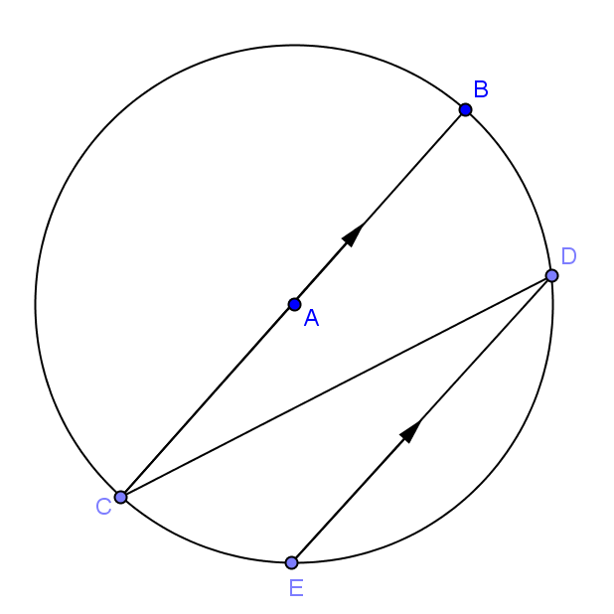
- In circle $A$, $\overline{BC}$ is a diameter, $2m\hat{CE}=m\hat{ED}$, and $\overline{BC}\left\|\overline{DE}\right.$. Find $m∠CDE$.
$22.5°$

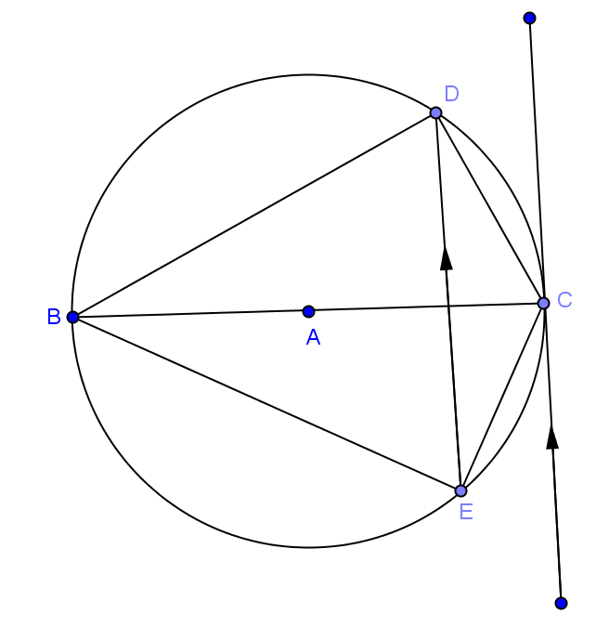
- In circle $A$, $\overline{BC}$ is a diameter and $\hat{CE}=68°$ .
  - Find $m\hat{CD}$.
$68°$

  - Find $m∠DBE$.
$68°$

  - Find $m∠DCE$
$112°$

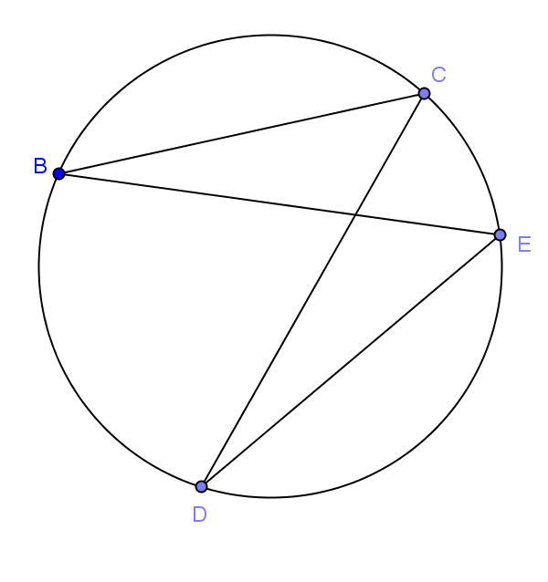
- In the circle given, $\hat{BC}≅\hat{ED}$. Prove $\overline{BE}≅\overline{DC}$
Join $\overline{CE}$.
$BC=ED$(congruent arcs have chords equal in length)
$m∠CBE=m∠EDC$ (angles inscribed in same arc are equal in measure) $m∠BCE=m∠DEC$ (angles inscribed in congruent arcs are equal in measure)
$∆BCE≅∆DEC$ (AAS)
$\overline{BE}≅\overline{DC}$ (corresponding sides of congruent triangles are congruent)

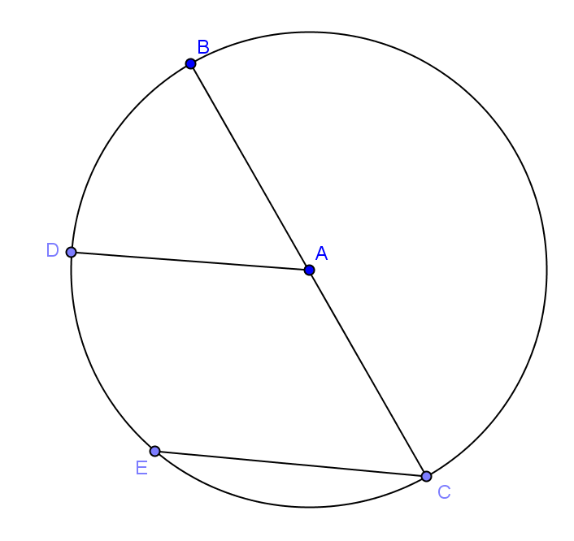
- Given circle $A$ with $\overline{AD}\left\|\overline{CE}\right.$, show $\hat{BD}≅\hat{DE}$.
Join $\overline{BD}$, $\overline{DE}$, $\overline{AE}$.
$\overline{AC}=\overline{AE}=\overline{AD}=\overline{AB}$ (radii)
$∠AEC≅∠ACE, ∠AED≅∠ADE, ∠ADB≅∠ABD$ (base angles of isosceles triangles are congruent)
$∠AEC≅∠EAD$ (Alternate interior angles are congruent) $m∠ADE+m∠DEA+m∠EAD=180°$ (sum of angles of ∆) $3m∠AED=18°$ (substitution)
$m∠AED=60° ∆BAD≅ ∆DAE≅∆EAC$ (SAS)
$BD=DE$ (corresponding parts of congruent triangles)
$\hat{BD}≅\hat{DE}$ (arcs subtended by congruent chords)

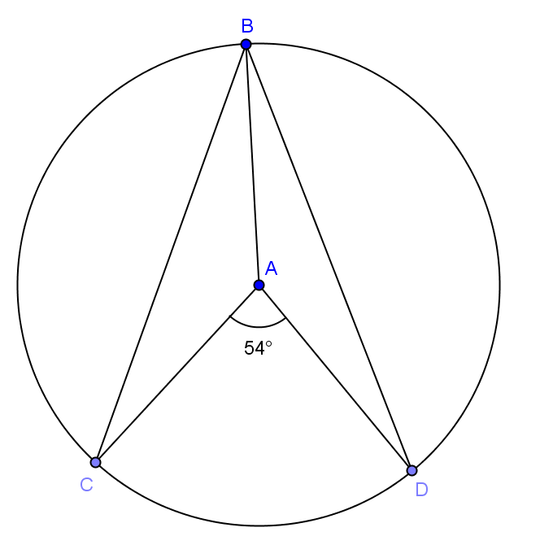
- In circle $A$, $\overline{AB}$ is a radius and $\hat{BC}≅\hat{BD}$ and $m∠CAD=54°$. Find $m∠ABC$. Complete the proof.
$BC=BD$ _____________________________

$m∠_____ = m∠_____$ _____________________________

$m∠BAC + m∠CAD + m∠BAD=$ _______________________

$2m∠_____ + 54° = 360°$ ________________________

$m∠BAC= __________$

$AB=AC$ __________________________

$m∠_____ = m∠_____$ __________________________

$2m∠ABC + m∠BAC = _____$ ___________________________

$m∠ABC = _____$
Chords of congruent arcs; $BAC$, $BAD$, angles inscribed in congruent arcs are congruent; $360°$, circle; $BAC$; $153°$; radii; $ABC$ , $ACB$, base angles of isosceles; $180°$, angles of triangle equal $180°$; $13.5°$

