Lesson 8: Arcs and Chords

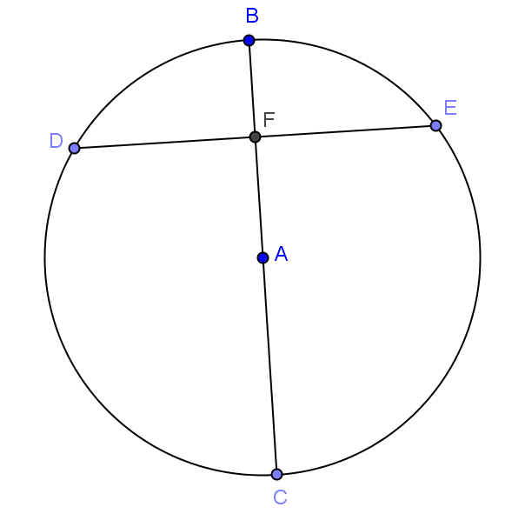
Classwork
Opening Exercise
Given circle $A$ with $\overline{ BC}⊥\overline{DE}$, $FA=6$, and $AC=10$. Find $BF$ and $DE$. Explain your work.

Exercises
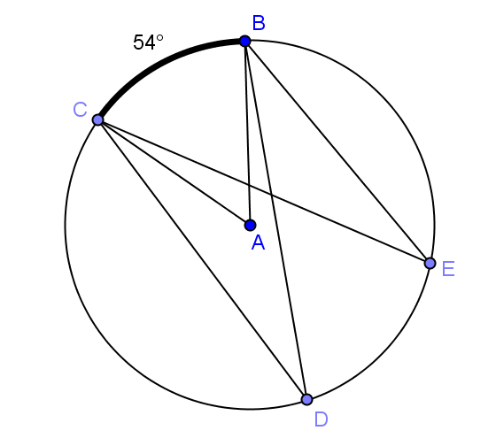
- Given circle $A$ with $m\hat{BC}=54⁰$ and $∠CDB≅∠DBE$, find $m\hat{DE}$. Explain your work.

- If two arcs in a circle have the same measure, what can you say about the quadrilateral formed by the four endpoints? Explain.

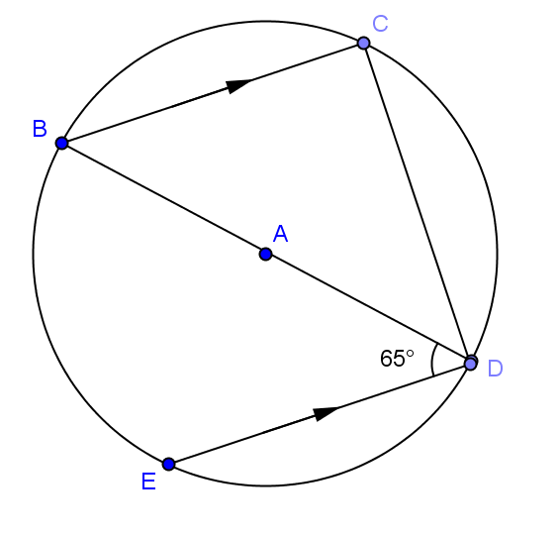
- Find the angle measure of $\hat{CD}$ and $\hat{ED}$.

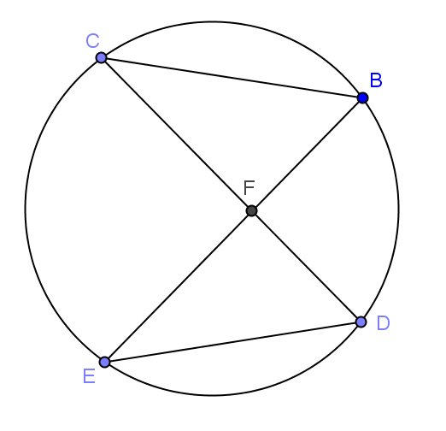
- $m\hat{CB}=m\hat{ED}$ and $m\hat{BC}:m\hat{BD}:m\hat{EC}=1:2:4$. Find
  - $m∠BCF$

  - $m∠EDF$

  - $m∠CFE$

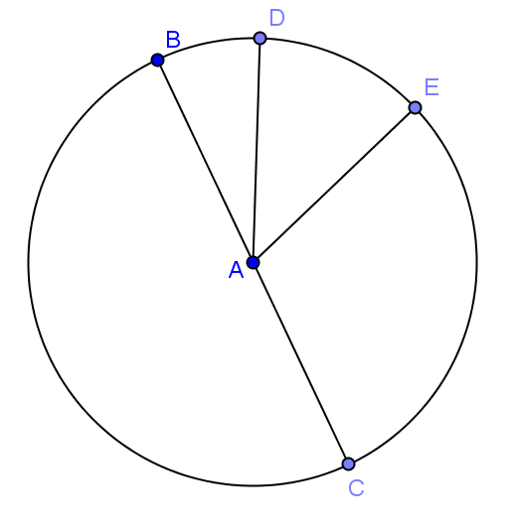
- $\overline{BC}$ is a diameter of circle $A$. $m\hat{BD}:m\hat{DE}:m\hat{EC}=1:3:5$. Find
  - $m\hat{BD}$

  - $m\hat{DEC}$

  - $m\hat{ECB}$

Lesson Summary
Theorems:
- Congruent chords have congruent arcs.
- Congruent arcs have congruent chords.
- Arcs between parallel chords are congruent.
Problem Set
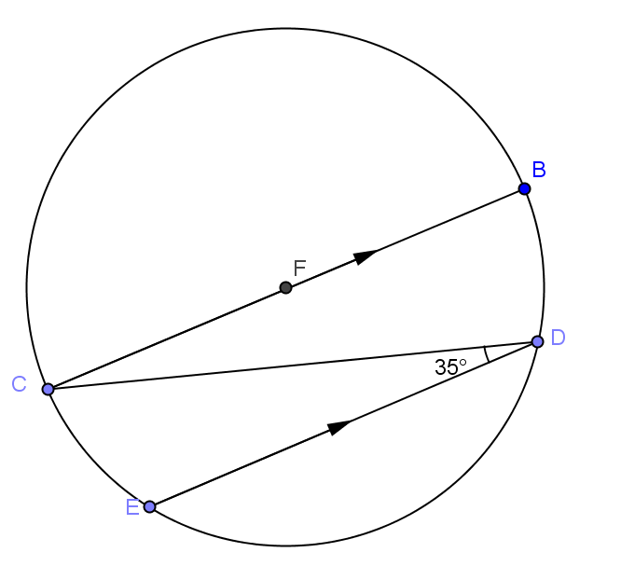
- Find
  - $m\hat{CE}$
  - $m\hat{BD}$
  - $m\hat{ED}$

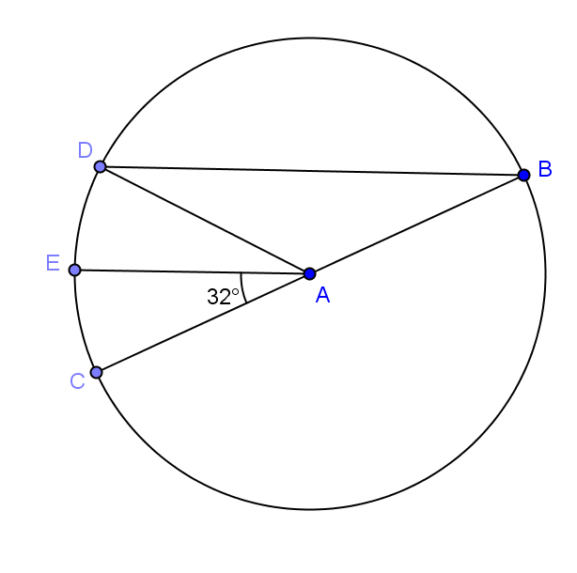
- In circle $A$, $\overline{BC}$ is a diameter, $m\hat{CE}=m\hat{ED}$, and $m∠CAE=32⁰$.
  - Find $m∠CAD$.
  - Find $m∠ADC$.

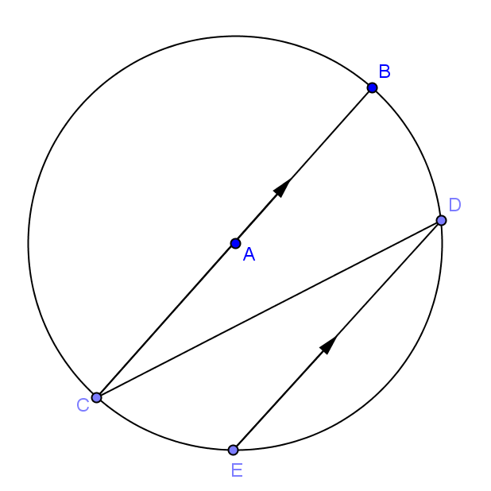
- In circle $A$, $\overline{BC}$ is a diameter, 2$m\hat{CE}=m\hat{ED}$, and $\overline{BC}\left\|\overline{DE}\right.$. Find $m∠CDE$.

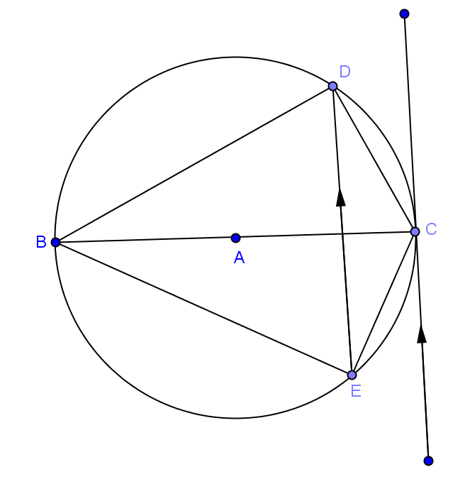
- In circle $A$, $\overline{BC}$ is a diameter and $\hat{CE}=68⁰$ .
  - Find $m\hat{CD}$.
  - Find $m∠DBE$.
  - Find $m∠DCE$

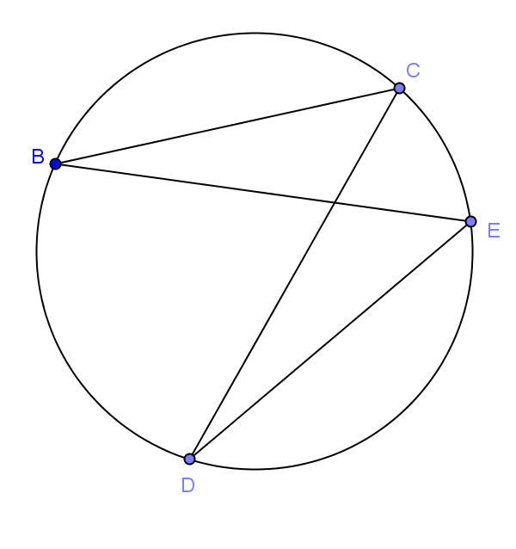
- In the circle given, $\hat{BC}≅\hat{ED}$. Prove $\overline{BE}≅\overline{DC}$.

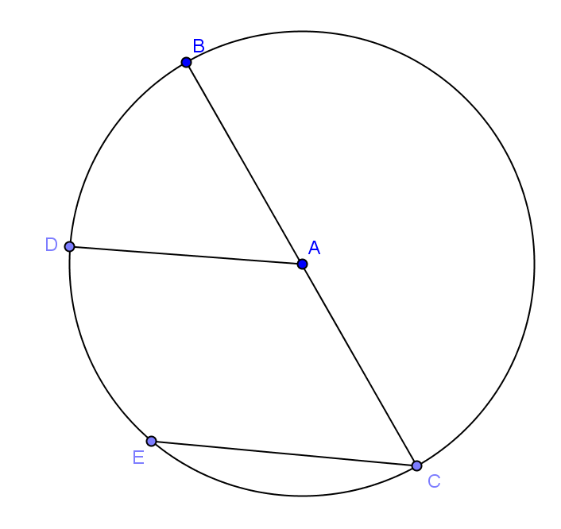
- Given circle $A$ with $\overline{AD}\left\|\overline{CE}\right.$, show $\hat{BD}≅\hat{DE}$.

- In circle $A$, $\overline{AB}$ is a radius and $\hat{BC}≅\hat{BD}$ and $m∠CAD = 54⁰$. Find $m∠ABC$. Complete the proof.
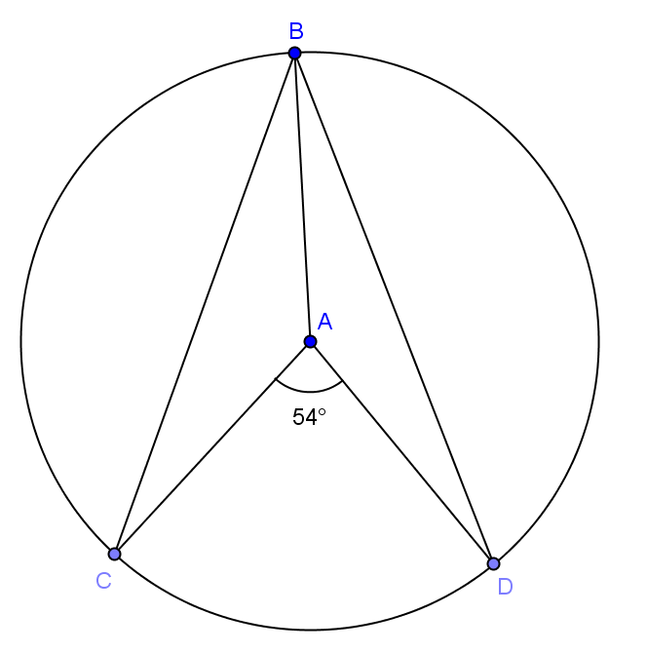
$BC = BD$ _____________________________

$m∠_____ = m∠_____$ _____________________________

$m∠BAC + m∠CAD + m∠BAD$ = _________________________

$2m∠_____ + 54⁰ = 360⁰$ _____________________________

$m∠BAC = __________$

$AB = AC$ _____________________________

$m∠_____ = m∠_____$ _____________________________

$2m∠ABC + m∠BAC =$_____________________________

$m∠ABC = _____$

