Lesson 7: The Angle Measure of an Arc

Student Outcomes
- Define the angle measure of arcs, and understand that arcs of equal angle measure are similar.
- Restate and understand the inscribed angle theorem in terms of arcs: The measure of an inscribed angle is half the angle measure of its intercepted arc.
- Explain and understand that all circles are similar.

Lesson Notes
Lesson 7 introduces the angle measure of an arc and finishes the inscribed angle theorem. Only in this lesson is the inscribed angle theorem stated in full: “The measure of an inscribed angle is half the angle measure of its intercepted arc.” When we state the theorem in terms of the intercepted arc, the requirement that the intercepted arc is in the interior of the angle that intercepts it guarantees the measure of the inscribed angle is half the measure of the central angle. In Lesson 7, we will also calculate the measure of angles inscribed in obtuse angles. Lastly, we will address
G-C.A.1 and show that all circles are similar, a topic previously covered in Module 2, Lesson 14.

Classwork
Opening Exercise (5 minutes)
This Opening Exercise reviews the relationship between inscribed angles and central angles, concepts that need to be solidified before we introduce the last part of the inscribed angle theorem (arc measures). Have students complete the exercise individually and compare answers with a partner, then pull the class together to discuss. Be sure students can identify inscribed and central angles.

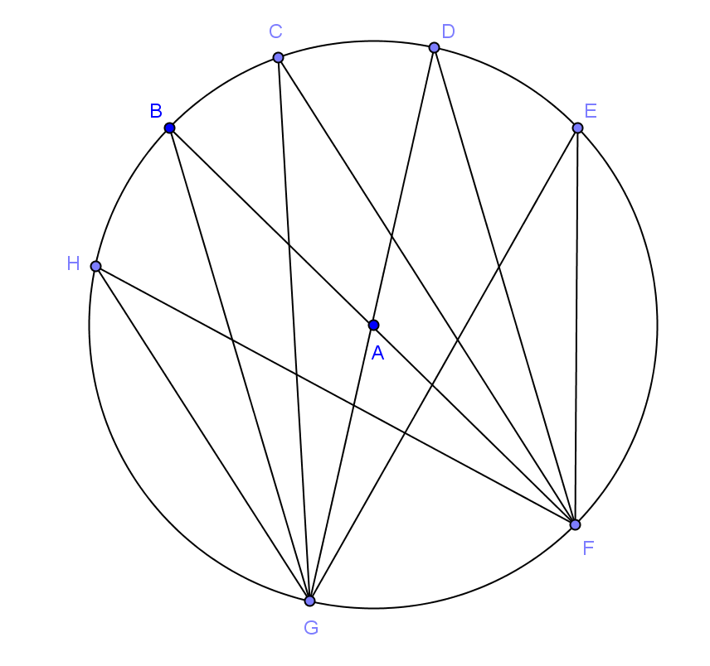
Opening Exercise
If the measure of $∠GBF$ is $17°,$ name $3$ other angles that have the same measure and explain why.
MP.3
Answers will vary. $∠GHF, ∠GCF, ∠GDF, ∠GEF,$ they are all congruent because they are inscribed in the same arc.

What is the measure of $∠GAF$? Explain.
$34°;$ it is the central angle with an inscribed arc of $17°$. The measure of the central angle is double the measure of the inscribed angle of the same arc.

Can you find the measure of $∠BAD$? Explain.
$34°; ∠BAD$ and $∠GAF$ are vertical angles and are congruent.
Discussion (15 minutes)
This lesson begins with a full class discussion that ties what students know about central angles and inscribed angles to relating these angles to the arcs they are inscribed in, which is a new concept. In this discussion, we will define some properties of arcs. As properties are defined, list them on a board or large paper so students can see them.
Scaffolding:
- Provide students a copy of the picture if they have difficulty creating the drawing.
- As definitions are given and as new terms are added, have students repeat each definition and term aloud.
- Create a definition wall.
- We have studied the relationship between central angles and inscribed angles. Can you help define an inscribed angle?
  - An angle is inscribed in an arc if the sides of the angle contain the endpoints of the arc; the vertex of the angle is a point on the circle, but not an endpoint on the arc.
- Can you help me define a central angle?
  - Answers will vary. A central angle for a circle is an angle whose vertex is at the center of the circle.
- Let’s draw a circle with an acute central angle.
  - Students draw a circle with an acute central angle.
- Display the picture below.
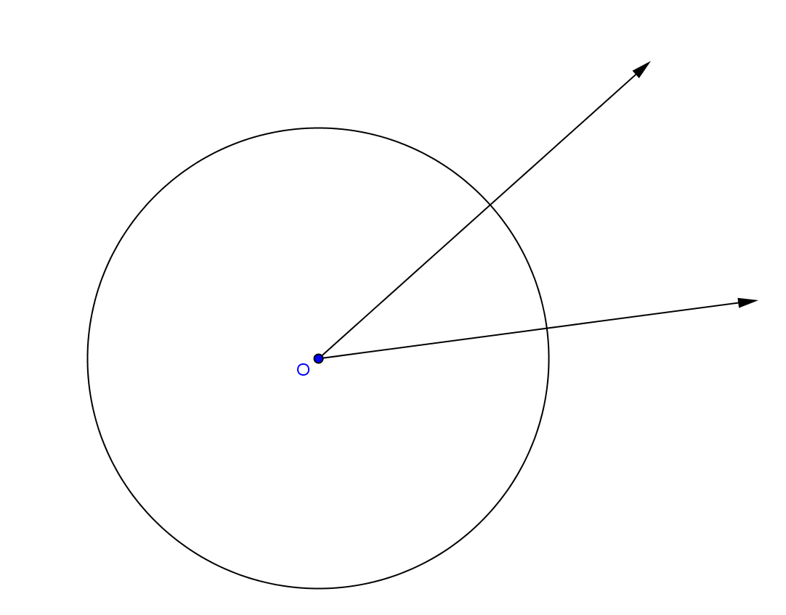

Scaffolding:
- Provide students a graphic organizer for arcs (major and minor).
- For ELL students, do choral repetition of major and minor arcs using hand gestures (arms wide for major and close together for minor).

- How many arcs does this central angle divide this circle into?
  - $2$
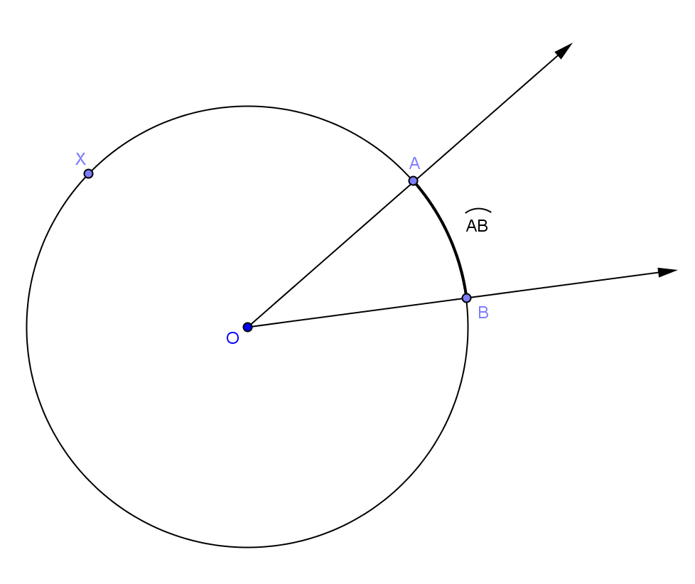
- What do you notice about the two arcs?
  - One is longer than the other is. One arc is contained in the angle and its interior, and one arc is contained in the angle and its exterior. (Students might say “inside the angle” or “outside the angle.” Help them to state it precisely.)
- In a circle with center $O$, let $A$ and $B$ be different points that lie on the circle but are not the endpoints of a diameter. The minor arc between $A$ and $B$ is the set containing $A$, $B$, and all points of the circle that are in the interior of $∠AOB$.
- Explain to your neighbor what a minor arc is, and write the definition.

- The way we show a minor arc using mathematical symbols is $\hat{AB}$ ($AB$ with an arc over them). Write this on your drawing.
- Can you predict what we call the larger arc?
  - The major arc.
- Now, let’s write the definition of a major arc.
  - In a circle with center $O$, let $A$ and $B$ be different points that lie on the circle but are not the endpoints of a diameter. The major arc is the set containing $A$, $B$, and all points of the circle that lie in the exterior of $∠AOB$.
- Can we call it $\hat{AB}$?
  - No, because we already called the minor arc $\hat{AB}$.
- We would write the major arc as $\hat{AXB}$ where $X$ is any point on the circle outside of the central angle. Label the major arc.
- Can you define a semicircle in terms of arc?
  - In a circle, let $A$ and $B$ be the endpoints of a diameter. A semicircle is the set containing $A$, $B$, and all points of the circle that lie in a given half-plane of the line determined by the diameter.
- If I know the measure of $∠AOB,$ what do you think the angle measure of $\hat{AB}$ is?
  - The same measure.
- Let’s say that statement.
  - The angle measure of a minor arc is the measure of the corresponding central angle.
- What do you think the angle measure of a semicircle is? Why?
  - $180°$. It is half a circle, and a circle measures $360°$.
- Now let’s look at $\hat{AXB}$. If the angle measure of $\hat{AB}$ is $20°$, what do you think the angle measure of $\hat{AXB}$ would be? Explain.
  - $340°$ because it is the other part of the circle not included in the $20°$. Since a full circle is $360°$, the part not included in the $20°$ would equal $340°$.
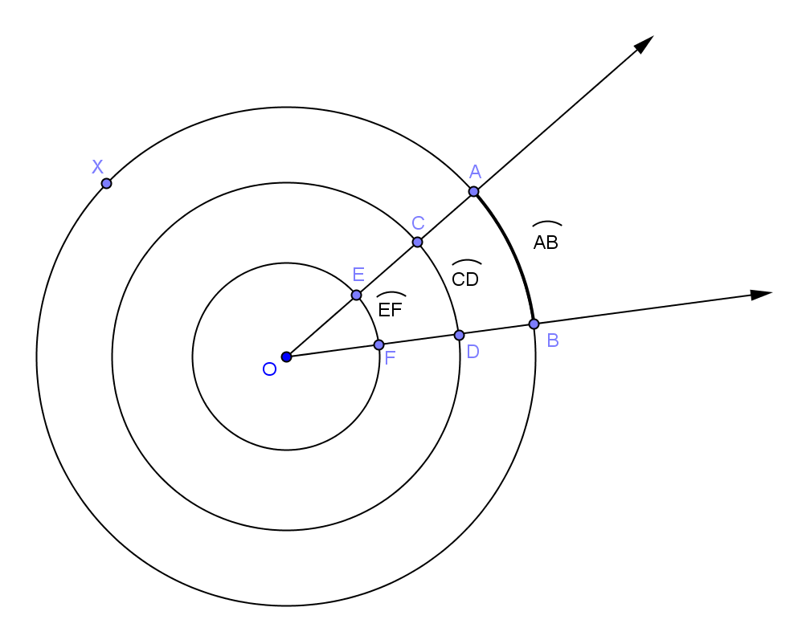
- Discuss what we have just learned about minor and major arcs and semicircles and their measures with a partner.
- Look at the diagram. If $\hat{AB}$ is $20°$, can you find the angle measure of $\hat{CD}$ and $\hat{EF}$? Explain.
  - All are $20°$ because they all have the same central angle. The circles are dilations of each other, so angle measurement is conserved and the arcs are similar.
- We are discussing angle measure of the arcs, not length of the arcs. Angle measure is only the amount of turning that the arc represents, not how long the arc is. Arcs of different lengths can have the same angle measure. Two arcs (of possibly different circles) are similar if they have the same angle measure. Two arcs in the same or congruent circles are congruent if they have the same angle measure.
- Explain these statements to your neighbor. Can you prove it?
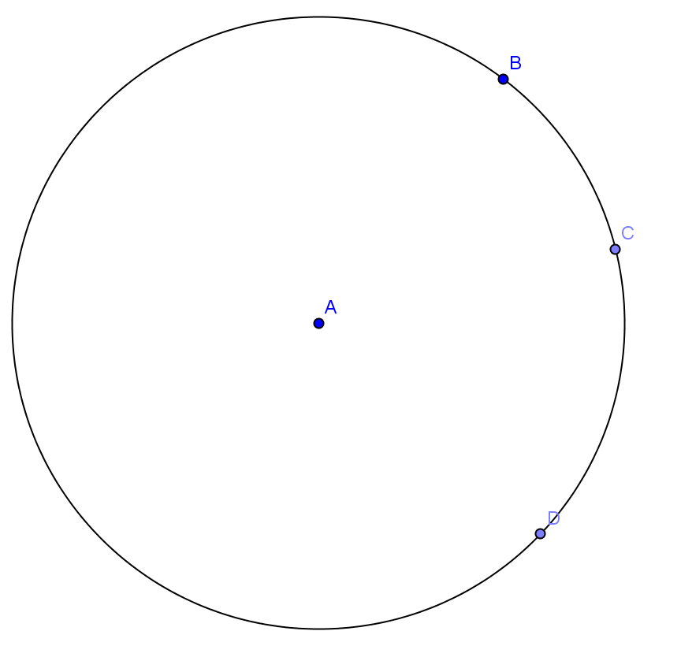
- In this diagram, I can say that $\hat{BC}$and $\hat{CD}$ are adjacent. Can you write a definition of adjacent arcs?
  - Two arcs on the same circle are adjacent if they share exactly one endpoint.
- If $\hat{BC}=25°$ and $\hat{CD}=35°$, what is the angle measure of $\hat{BD}$? Explain.
  - $60°$. Since they were adjacent, together they create a larger arc whose angle measures can be added together. Or, calculate the measure of the arc as
$360-(25+35)$, as the representation could be from $B$ to $D$ without going through point $C$.
- This is a parallel to the $180$ protractor axiom (angles add). If $AB$ and $BC$ are adjacent arcs, then $m\hat{AC}=m\hat{AB}+m\hat{BC}$.
- Central angles and inscribed angles intercept arcs on a circle. An angle intercepts an arc if the endpoints of the arc lie on the angle, all other points of the arc are in the interior of the angle, and each side of the angle contains an endpoint of the arc.
- Draw a circle and an angle that intercepts an arc and an angle that does not. Explain your drawing to your neighbor.
  - Answers will vary.
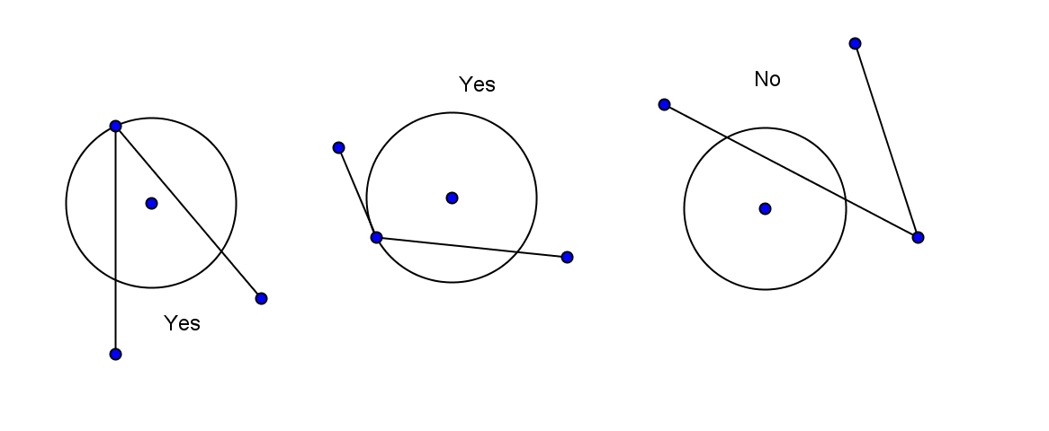

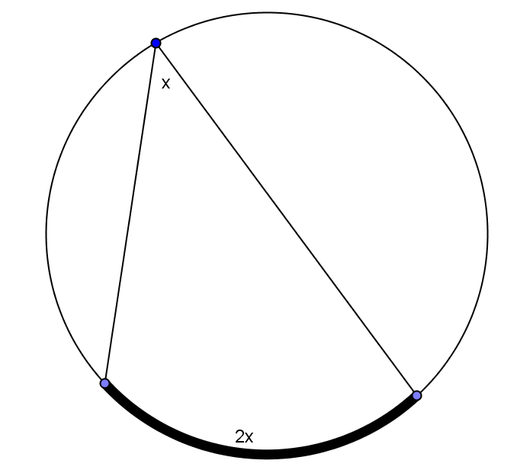
- Tell your neighbor the relationship between the measure of a central angle and the measure of the inscribed angle intercepting the same arc.
  - The measure of the central angle is double the measure of any inscribed angle that intercepts the same arc.
- Using what we have learned today, can you state this in terms of the measure of the intercepted arc?
  - The measure of an inscribed angle is half the angle measure of its intercepted arc. The measure of a central angle is equal to the angle measure of its intercepted arc.

Example 1 (8 minutes)
This example extends the inscribed angle theorem to obtuse angles; it also shows the relationship between the measure of the intercepted arc and the inscribed angle. Students will need a protractor.

Example 1
What if we started with an angle inscribed in the minor arc between $A$ and $C$?

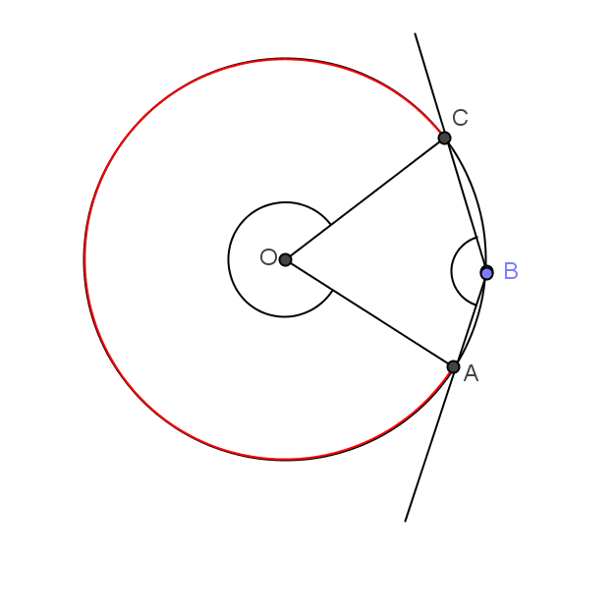
- Draw a point $B$ on the minor arc between $A$ and $C.$
  - Students draw point $B$.
- Draw the arc intercepted by $∠ABC$? Make it red in your diagram.
  - Students draw the arc and color it red.
- In your diagram, do you think the measure of an arc between $A$ and $C$ is half of the measure of the inscribed angle? Why or why not?
  - The phrasing and explanations can vary. However, there is one answer; the measure of the inscribed arc is twice the measure of the inscribed angle.
- Using your protractor, measure $∠ABC$. Write your answer on your diagram.
  - Answers will vary.
- Now measure the arc in degrees. Students may struggle with this, so ask…
- Can you think of an easier way to measure this arc in degrees?
  - We could measure $∠AOC$, and then subtract that measure from $360°$
- Write the measure of the arc in degrees on your diagram.
- Do your measurements support the inscribed angle theorem? Why or why not?
  - Yes, the measure of the inscribed angle is half the measure of its intercepted arc.
- Compare your answer and diagram to your neighbor’s answer and diagram.

- Restate the inscribed angle theorem in terms of intercepted arcs.
Scaffolding:
- Help students see the connection between the central angles and inscribed angle by color-coding.
- Outline central angle in red.
- Outline the inscribed angle that has the same intercepted arc as the central angle in blue.

  - The measure of an inscribed angle is half the angle measure of its intercepted arc.

Exercises 1–4 (5 minutes)

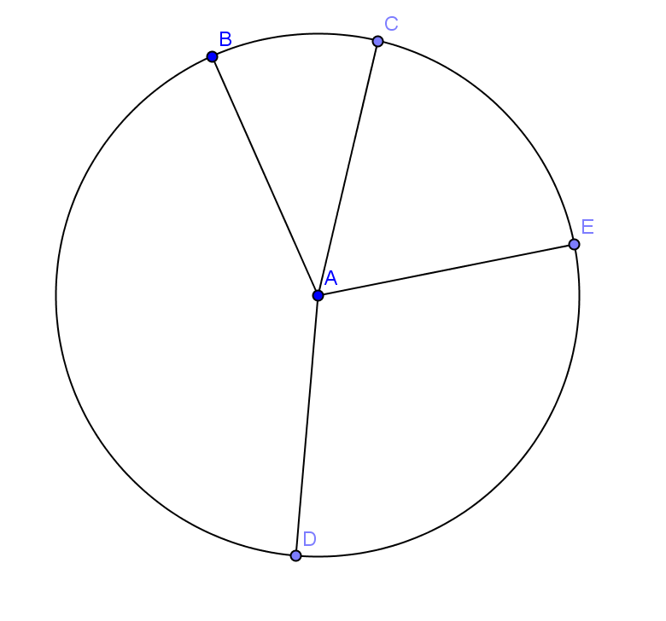
- In circle $A$, $\hat{\hat{BC}:\hat{CE}:\hat{ED}:\hat{DB}=1:2:3:4}$. Find
- $m∠BAC$
$36°$

- $m∠DAE$
$108°$

- $m\hat{DB}$
$144°$

- $m\hat{CED}$
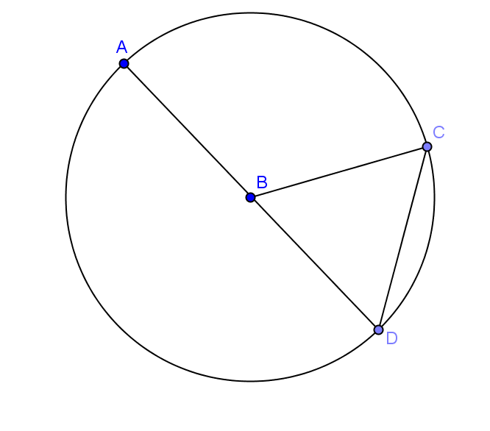
$180°$

- In circle $B$, $AB=CD$. Find
- $m\hat{CD}$
$60°$

- $m\hat{CAD}$
$300°$

- $m\hat{AD}$
$180°$
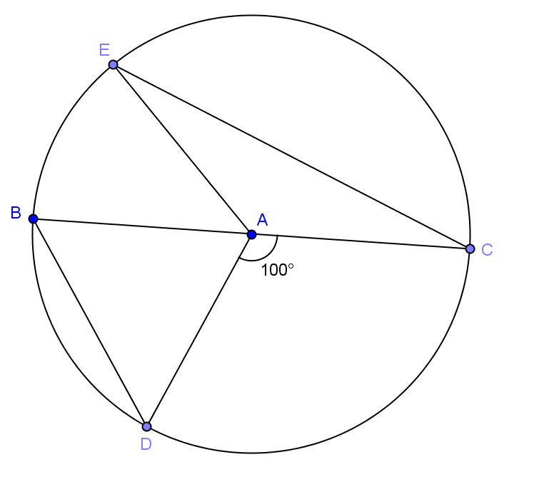
- In circle $A$, $\overline{BC}$ is a diameter and $m∠DAC=100°$. If $m\hat{EC}=2m\hat{BD}$, find
- $m∠BAE$
$20°$

- $m\hat{EC}$
$160°$

- $m\hat{DEC}$
$260°$

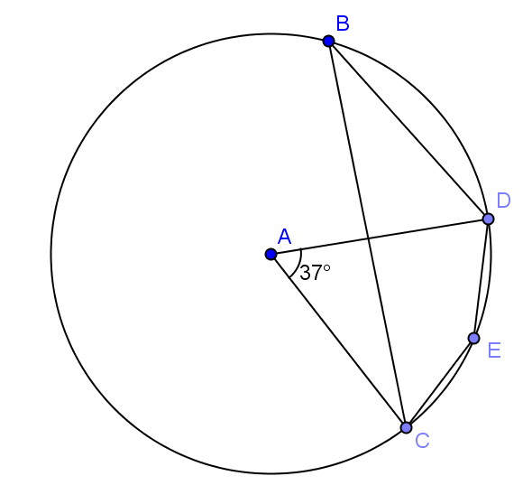
- Given circle A with $m∠CAD=37°$, find
- $m\hat{CBD}$
$323°$

- $m∠CBD$
$18.5°$

- $m∠CED$
$161.5°$

Example 2 (4 minutes)
In this example, students will ponder the question, “Are all circles similar?” This is intuitive but easy to show, as the ratio of the circumference of two circles is equal to the ratio of the diameters and the ratio of the radii.
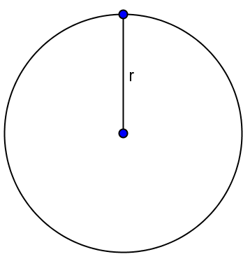
- Project the circle at right on the board.
- What is the circumference of this circle in terms of radius, $r$?
  - $2πr$
- What if we double the radius, what is the circumference?
  - $2π\left(2r\right)=4π$
- What if we triple the original radius, what is the circumference?
  - $2π\left(3\right)r=6π$
- What determines the circumference of a circle? Explain.
  - The radius. The only variable in the formula is $r$ (radius), so as radius changes, the size of the circle changes.
- Does the shape of the circle change? Explain.
  - All circles have the same shape; they are just different sizes depending on the length of the radius.
- What does this mean is true of all circles?
  - All circles are similar.

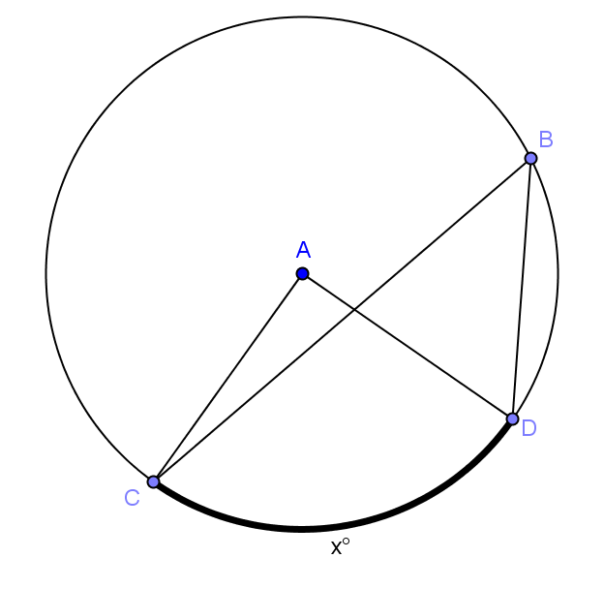
Closing (3 minutes)
Call class together, and show the diagram.
- Express the measure of the central angle and the inscribed angle in terms of the angle measure $x^{∘}$.
  - The central angle $∠CAD$ has a measure of $x^{°}.$
  - The inscribed angle $∠CBD$ has a measure of $\frac{1}{2}x^{°}.$
- State the inscribed angle theorem to your neighbor.
  - The measure of an inscribed angle is half the angle measure of its intercepted arc.

Lesson Summary
Theorems:
- Inscribed angle theorem: The measure of an inscribed angle is half the measure of its intercepted arc.
- Two arcs (of possibly different circles) are similar if they have the same angle measure. Two arcs in the same or congruent circles are congruent if they have the same angle measure.
- All circles are similar.
Relevant Vocabulary
- Arc: An arc is a portion of the circumference of a circle.
- Minor and major arc: Let $C$ be a circle with center $O$, and let $A$ and $B$ be different points that lie on $C$ but are not the endpoints of the same diameter. The minor arc is the set containing $A$, $B$, and all points of $C$ that are in the interior of $∠AOB$. The major arc is the set containing $A$, $B$, and all points of $C$ that lie in the exterior of $∠AOB$.
- Semicircle: In a circle, let $A$ and $B$ be the endpoints of a diameter. A semicircle is the set containing $A$, $B$, and all points of the circle that lie in a given half-plane of the line determined by the diameter.
- Inscribed angle: An inscribed angle is an angle whose vertex is on a circle and each side of the angle intersects the circle in another point.
- Central angle: A central angle of a circle is an angle whose vertex is the center of a circle.
- Intercepted arc of an angle: An angle intercepts an arc if the endpoints of the arc lie on the angle, all other points of the arc are in the interior of the angle, and each side of the angle contains an endpoint of the arc.

Exit Ticket (5 minutes)
Name Date
Lesson 7: Properties of Arcs

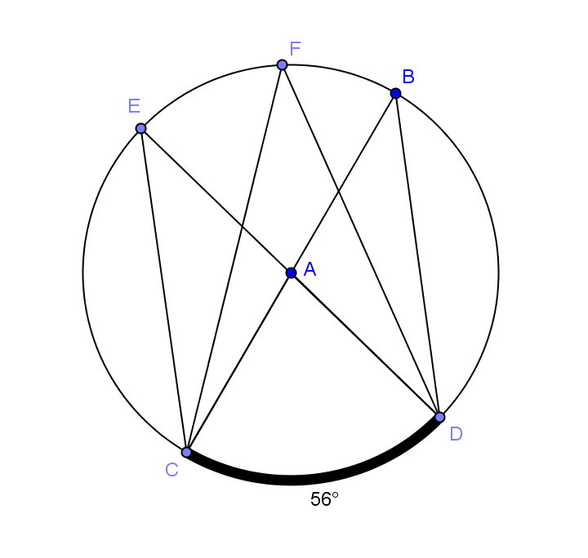
Exit Ticket

- Given circle $A$ with diameters $\overline{BC}$ and $\overline{DE}$ and $m\hat{CD}=56°$.
- Name a central angle.

- Name an inscribed angle.

- Name a chord that is not a diameter.

- What is the measure of $∠CAD$?

- What is the measure of $∠CBD$?

- Name $3$ angles of equal measure.

- What is the degree measure of $\hat{CDB}$?

Exit Ticket Sample Solutions

      - Given circle $A$ with diameters $\overline{BC}$ and $\overline{DE}$ and $m\hat{CD}=56°$
        - Name a central angle.
$∠CAD$

  - Name an inscribed angle.
Answers will vary. $∠CED$.

  - Name a chord that is not a diameter.
Answers will vary. $\overline{CE}$.

  - What is the measure of $∠CAD$?
$56°$

  - What is the measure of $∠CBD$?
$$28°$$

  - Name $3$ angles of equal measure.
$$m∠CED=m∠CFD=m∠CBD$$

  - What is the degree measure of $\hat{CDB}$?
$180°$

Problem Set Sample Solutions
The first two problems are easier and require straightforward use of the inscribed angle theorem. The rest of the problems vary in difficulty, but could be time consuming. Consider allowing students to choose the problems that they do and assigning a number of problems to be completed. You may want everyone to do Problem 8, as it is a proof with some parts of steps given as in the Opening Exercise.

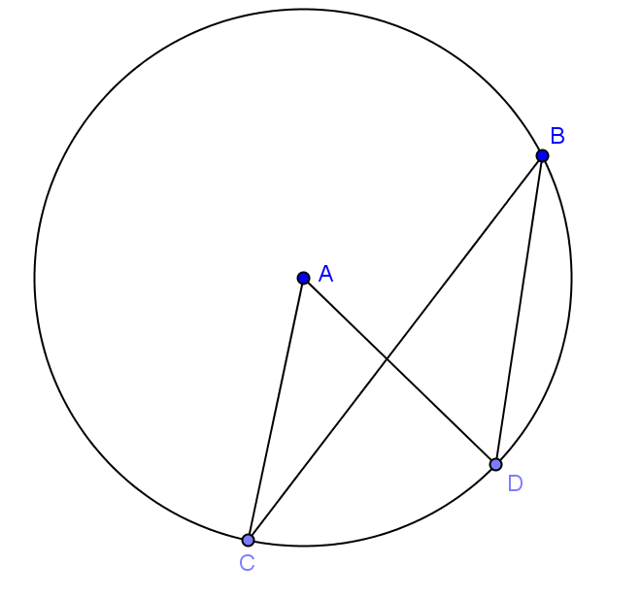
- Given circle $A$ with $m∠CAD=50⁰$,
  - Name a central angle.
$∠CAD$

  - Name an inscribed angle.
$∠CBD$

  - Name a chord.
Answers will vary. $\overline{BD}$

  - Name a minor arc.
Answers will vary. $\hat{CD}$

  - Name a major arc.
$$\hat{CBD}$$

  - Find $m\hat{CD}$,
$$50°$$

  - Find $m\hat{CBD}$.
$310°$

  - Find $m∠CBD$.
$$25°$$

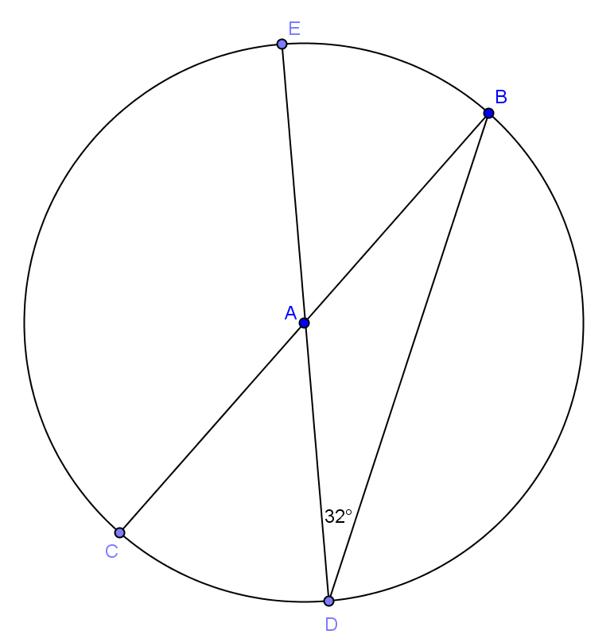
- Given circle $A$, find the measure of each minor arc.
$$m\hat{BE}=64°$$
$m\hat{CD}=64°$
$m\hat{CE}=116°$
$m\hat{BD}=116°$

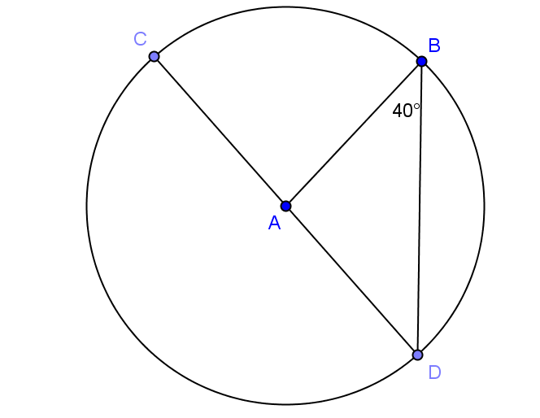
- Given circle$A$, find
  - $m∠BAD$
$$100°$$

  - $m∠CAB$
$$80°$$

  - $m\hat{BC}$
$$80°$$
  - $m\hat{BD}$
$$100°$$

  - $m\hat{BCD}$
$$260°$$

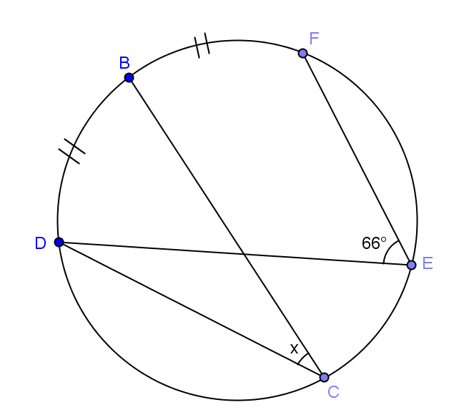
- Find the angle measure of angle $x$.

$$33°$$

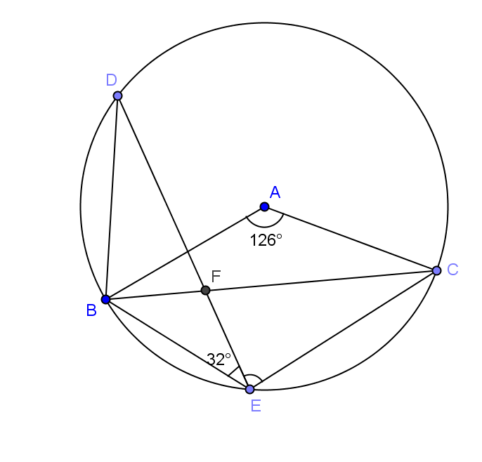
- In the figure, $m∠BAC=126°$ and $m∠BED=32°$. Find $m∠DEC$.

$$85°$$

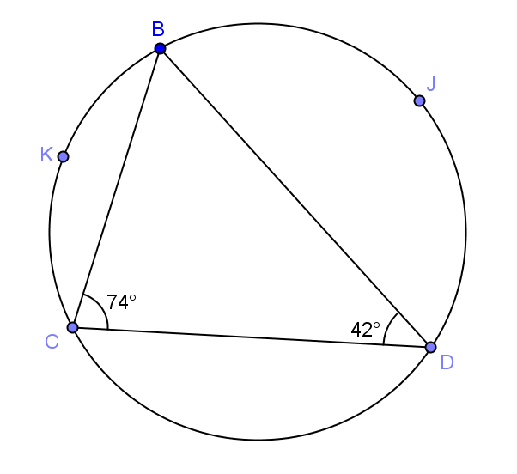
- In the figure $m∠BCD=74°$, and $m∠BDC=42^{0}$. K is the midpoint of $\hat{CB}$ and $J$ is the midpoint of $\hat{BD}$. Find $m∠KBD$ and $m∠CKJ$.

Solution: Join $BK, KC, KD, KJ, JC,$ and $JD$.

$\hat{mBK}=m\hat{KC}$ _________________________

$m∠KDC=\frac{42}{2}=2°$ __________________________

$a =$ __________ ___________________________

In $∆BCD$, $b =$ __________ ______________________________

$c =$ __________ ______________________________

$\hat{mBJ}=m\hat{JD}$ ______________________________
$m∠JCD$ = __________ ______________________________

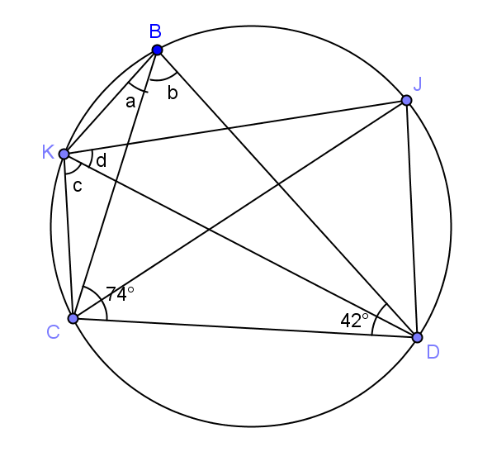
$d =$ __________ ______________________________

$m∠KBD=a+b=$__________

$m∠CKJ=c+d=$ __________

Midpoint forms congruent arcs; angle bisector; $21°$, congruent angles inscribed in same arc;$64°$, sum of angles of triangle = $180°$; $64°$, congruent angles inscribed in same arc; $37°$, angle bisector; $37°$, congruent angles inscribed in same arc;$85°$;$91°.$

