Lesson 7: The Angle Measure of an Arc

Classwork
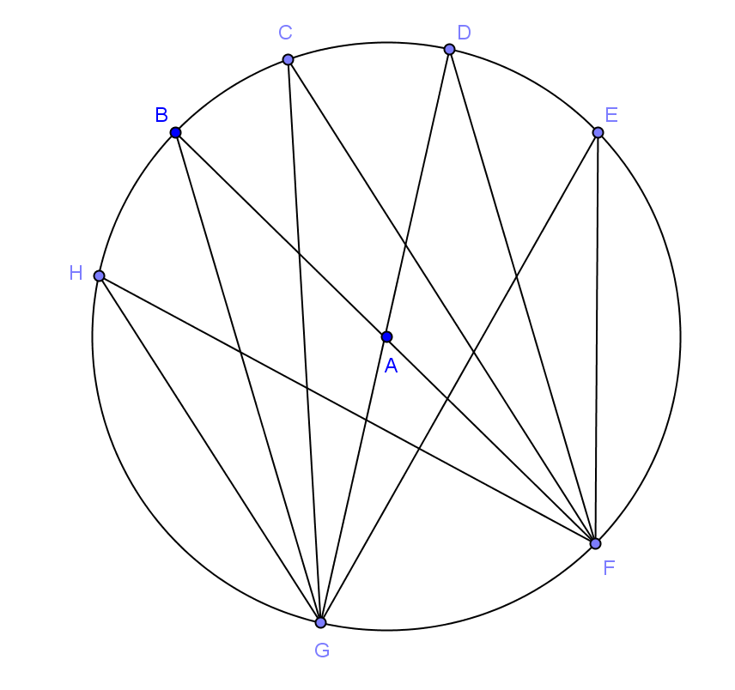
Opening Exercise
If the measure of $∠GBF$ is $17°$, name $3$ other angles that have the same measure and explain why.

What is the measure of $∠GAF$? Explain.

Can you find the measure of $∠BAD$? Explain.

Example 1
What if we started with an angle inscribed in the minor arc between $A$ and $C$?

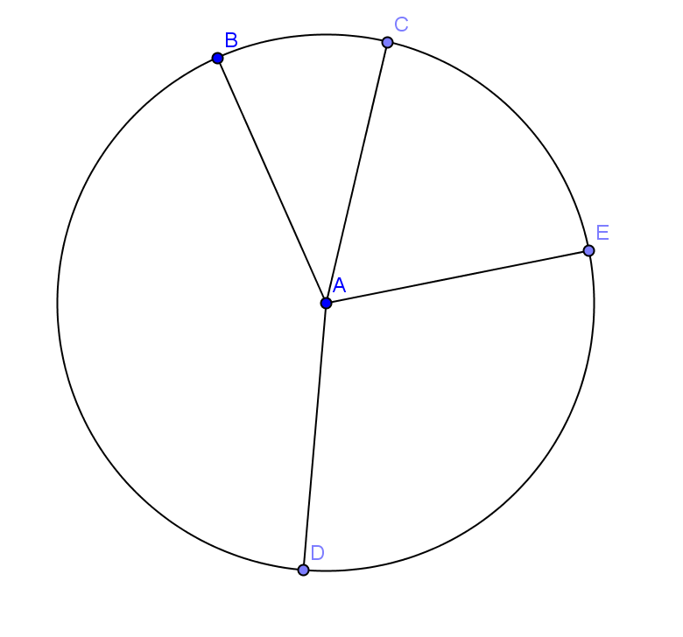
Exercises 1–4
- In circle $A$, $\hat{\hat{BC}:\hat{CE}:\hat{ED}:\hat{DB}=1:2:3:4}$. Find
  - $m∠BAC$

  - $m∠DAE$

  - $m\hat{DB}$

  - $m\hat{CED}$

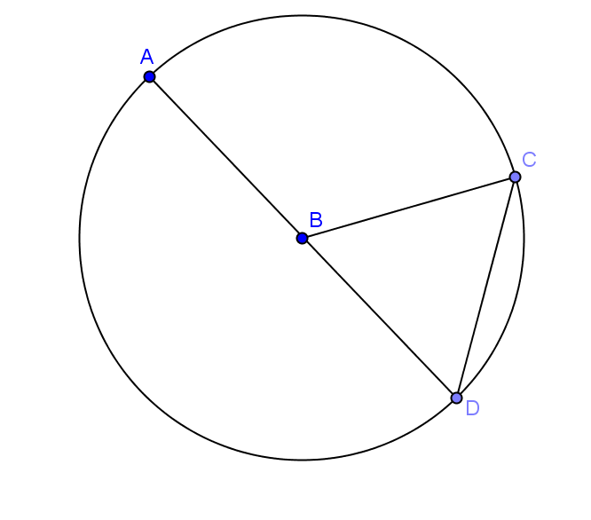
- In circle $B$, $AB=CD$. Find
  - $m\hat{CD}$

  - $m\hat{CAD}$

  - $m\hat{AD}$

- In circle $A$, $\overline{BC}$ is a diameter and $m∠DAC=100⁰$. If $m\hat{EC}=2m\hat{BD}$, find
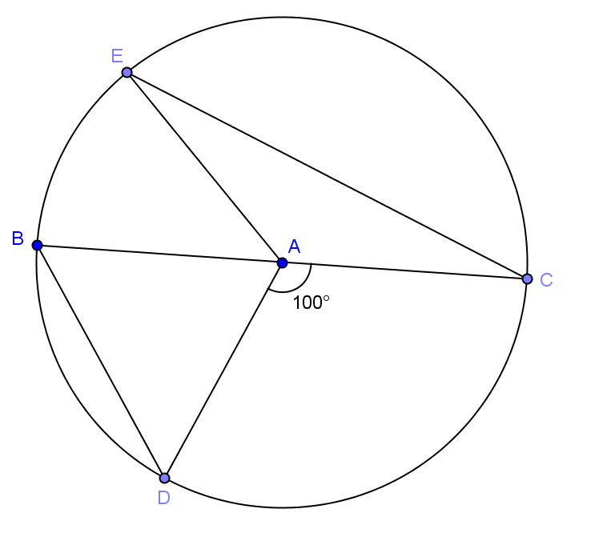
  - $m∠BAE$

  - $m\hat{EC}$

  - $m\hat{DEC}$

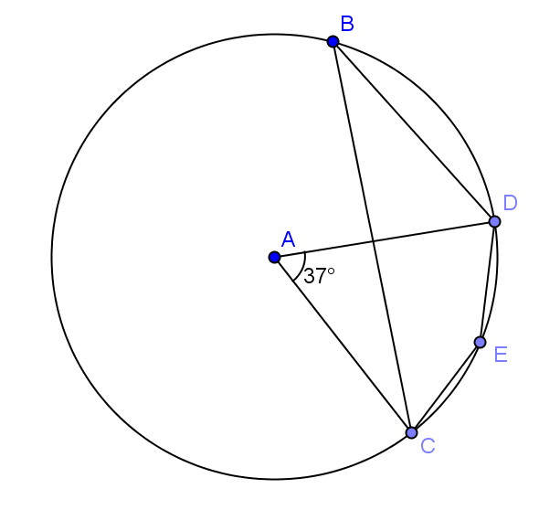
- Given circle A with $m∠CAD=37⁰$, find
  - $m\hat{CBD}$

  - $m∠CBD$

  - $m∠CED$

Lesson Summary
Theorems:
- Inscribed angle theorem: The measure of an inscribed angle is half the measure of its intercepted arc.
- Two arcs (of possibly different circles) are similar if they have the same angle measure. Two arcs in the same or congruent circles are congruent if they have the same angle measure.
- All circles are similar.
Relevant Vocabulary
- Arc: An arc is a portion of the circumference of a circle.
- Minor and major arc: Let $C$ be a circle with center $O$, and let $A$ and $B$ be different points that lie on $C$ but are not the endpoints of the same diameter. The minor arc is the set containing $A$, $B$, and all points of $C$ that are in the interior of $∠AOB$. The major arc is the set containing $A$, $B$, and all points of $C$ that lie in the exterior of $∠AOB$.
- Semicircle: In a circle, let $A$ and $B$ be the endpoints of a diameter. A semicircle is the set containing $A$, $B$, and all points of the circle that lie in a given half-plane of the line determined by the diameter.
- Inscribed angle: An inscribed angle is an angle whose vertex is on a circle and each side of the angle intersects the circle in another point.
- Central angle: A central angle of a circle is an angle whose vertex is the center of a circle.
- Intercepted arc of an angle: An angle intercepts an arc if the endpoints of the arc lie on the angle, all other points of the arc are in the interior of the angle, and each side of the angle contains an endpoint of the arc.

Problem Set

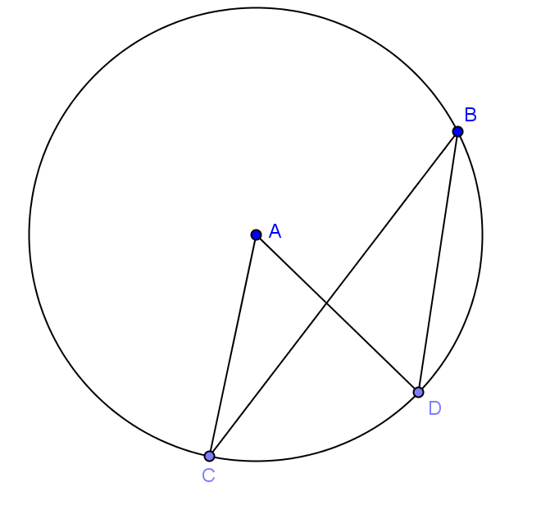
- Given circle $A$ with $m∠CAD=50⁰$,
  - Name a central angle.
  - Name an inscribed angle.
  - Name a chord.
  - Name a minor arc.
  - Name a major arc.
  - Find $m\hat{CD}$,
  - Find $m\hat{CBD}$.
  - Find $m∠CBD$.

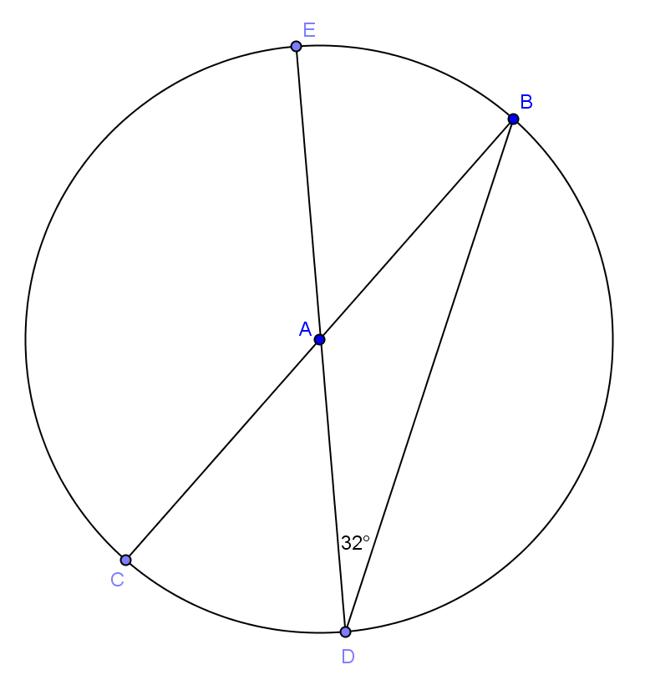
- Given circle $A$, find the measure of each minor arc.

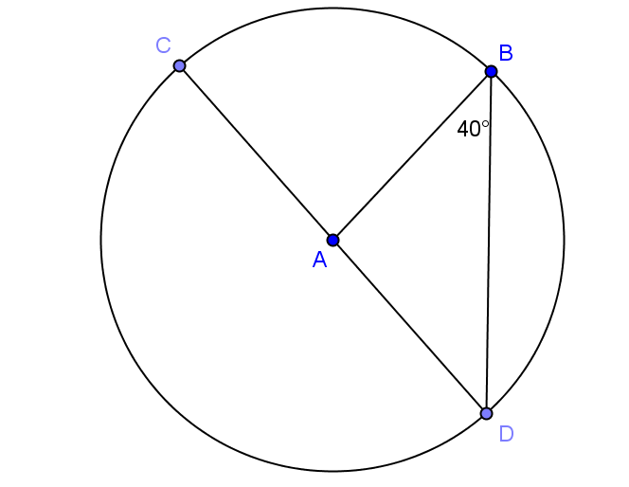
- Given circle $A$, find
  - $m∠BAD$
  - $m∠CAB$
  - $m\hat{BC}$
  - $m\hat{BD}$
  - $m\hat{BCD}$

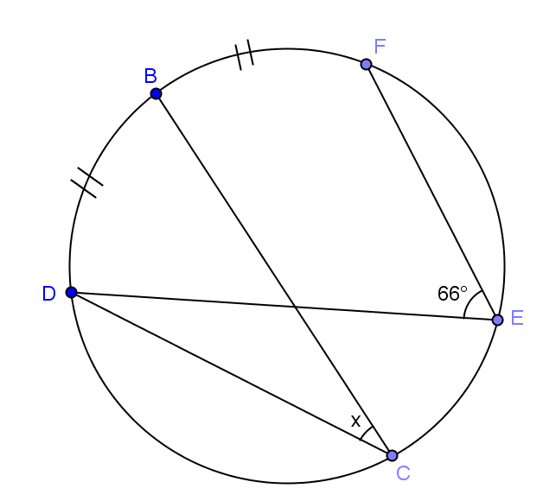
- Find the angle measure of angle $x$.

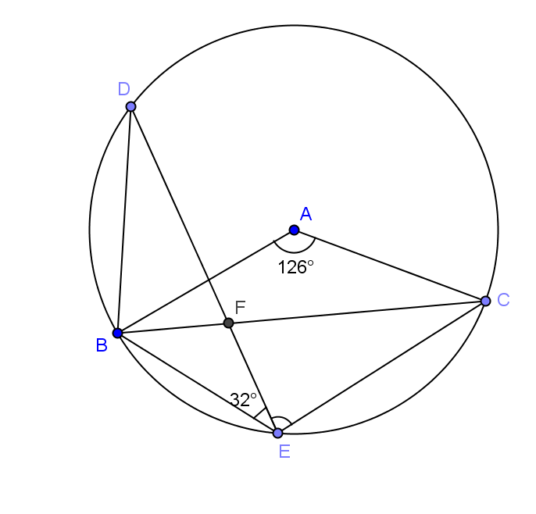
- In the figure, $m∠BAC=126⁰$ and $m∠BED=32⁰$. Find $m∠DEC$.

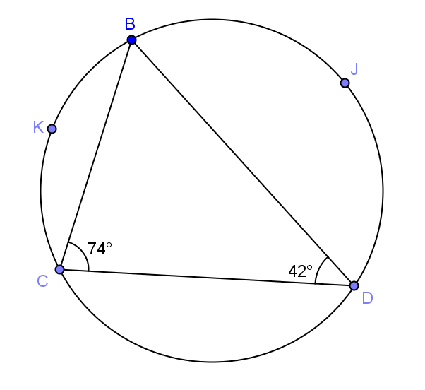
- In the figure $m∠BCD=74⁰$, and $m∠BDC=42^{0}$. $K$ is the midpoint of $\hat{CB}$ and $J$ is the midpoint of $\hat{BD}$. Find $m∠KBD$ and $m∠CKJ$.
Solution: Join $BK, KC, KD, KJ, JC$, and $JD$.

$\hat{mBK}=m\hat{KC}$ ______________________________

$m∠KDC= \frac{42}{2}=21⁰$ ______________________________

a = __________ _______________________________

In $∆BCD$, b = __________ ______________________________

c = __________ ______________________________

$\hat{mBJ}=m\hat{JD}$ ______________________________

$m∠JCD$ = __________ ______________________________

d = __________ ______________________________

$m∠KBD=a+b=$__________

$m∠CKJ=c+d=$ __________

