Lesson 6: Unknown Angle Problems with Inscribed Angles in Circles
Student Outcomes
- Use the inscribed angle theorem to find the measures of unknown angles.
- Prove relationships between inscribed angles and central angles.

Lesson Notes
Lesson 6 continues the work of Lesson 5 on the inscribed angle theorem. Many of the problems in Lesson 6 have chords that meet outside of the circle, and students are looking at relationships between triangles formed within circles and finding angles using their knowledge of the inscribed angle theorem and Thales’ theorem. When working on unknown angle problems, present them as puzzles to be solved. Students are to use what is known to find missing pieces of the puzzle until they find the piece asked for in the problem. Calling these puzzles instead of problems will encourage students to persevere in their work and see it more as a fun activity.

Classwork
Opening Exercise (10 minutes)
Scaffolding:
- Create a Geometry Axiom/Theorem wall, similar to a Word Wall, so students will have easy reference. Allow students to create colorful designs and display their work. For example, a student draws a picture of an inscribed angle and a central angle intercepting the same arc and color codes it with the angle relationship between the two noted. Students could be assigned axioms, theorems, or terms to illustrate so that all students would have work displayed.
- For advanced learners, present the problem from the Opening Exercise and ask them to construct the proof without the guided steps.
Allow students to work in pairs or groups of three and work through the proof below, writing their work on large paper. Some groups may need more guidance, and others may need you to model this problem. Call students back together as a class, and have groups present their work. Use this as an informal assessment of student understanding. Compare work and clear up misconceptions. Also, talk about different strategies groups used.

Opening Exercise
In a circle, a chord $\overline{DE}$ and a diameter $\overline{AB}$ are extended outside of the circle to meet at point $C$. If $m∠DAE=46°$, and $m∠DCA=32°$, find $m∠DEA.$
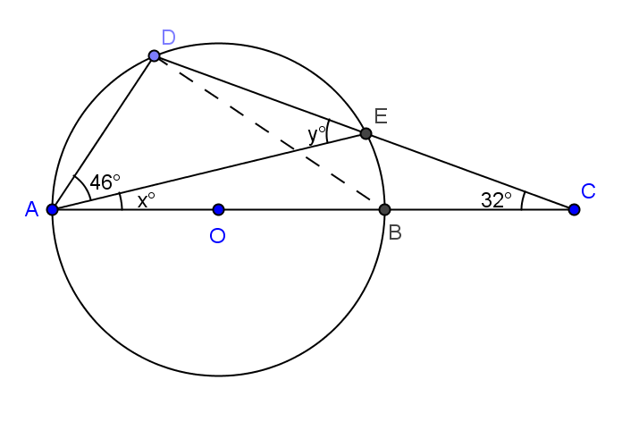

Let $m∠DEA=y, m∠EAE=x$
MP.3

In $∆ABD, m∠DBA= y$ Reason angles inscribed in same arc are congruent

$m∠ADB=$ $90°$ Reason angle inscribed in semicircle
$∴46+x+y+90=$ $180$ Reason sum of angles of triangle $= 180°$
$x+y=$ $44$
In $∆ACE, y=x+32$ Reason Ext. angle of a triangle is equal to the sum of the remote interior
angles
$x+x+32=$ $44$ Reason substitution
$x=$ $6$
$y= 38$
$m∠DEA=$ $38°$

Exploratory Challenge (15 minutes)
Display the theorem below for the class to see. Have the students state the theorem in their own words. Lead students through the first part of the proof of the theorem with leading questions, and then divide the class into partner groups. Have half of the groups prove why $B'$ cannot be outside of the circle and half of the class prove why $B’$ cannot be inside of the circle, then as a whole class, have groups present their work and discuss.
Do the following as a whole class:
Theorem: If $A, B, B’$, and $C$ are four points with $B$ and $B’$ on the same side of line $\overset{⃡}{AC}$, and angles $∠ABC$ and $∠AB'C$ are congruent, then $A, B, B’$, and $C$ all lie on the same circle.
- State this theorem in your own words, and write it on a piece of paper. Share it with a neighbor.
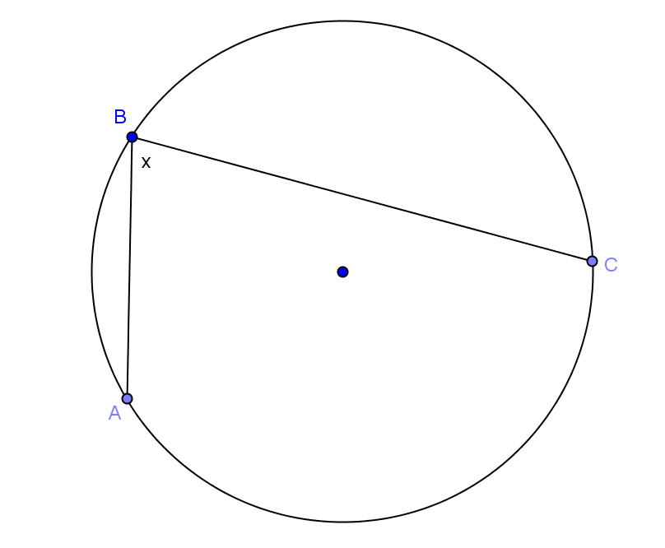
  - If we have $2$ points on a circle ($A$ and $C$), and two points between those two points on the same side ($B$ and $B'$), and if we draw two angles that are congruent ($∠ABC$and$∠AB'C$), then all of the points ($A, B, B'$, and $C$) lie on the same circle.
- Let’s start with points $A, B$, and $C$. Draw a circle containing points $A, B$, and $C$.
  - Students draw a circle with points $A, B,$ and $C$ on the circle.
- Draw $∠ABC$.
  - Students draw $∠ABC$.
- Do we know the measure of $∠ABC$?
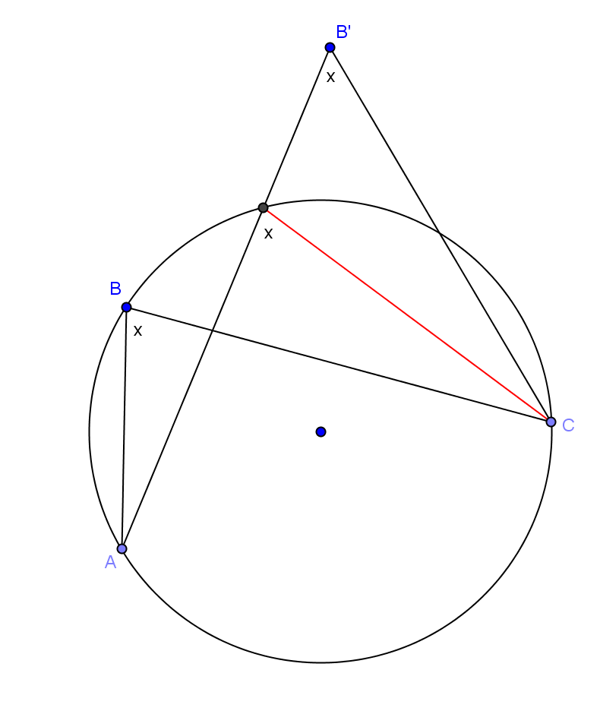
  - No. If students want to measure it, remind them that all circles drawn by their classmates are different, so we are finding a general case.
- Since we don’t know the measure of this angle, assign it to be the variable $x$, and label your drawing.
  - Students label diagram.
- In the theorem, we are told that there is another point $B’$. What else are we told about $B’$?
  - $B’$ lies on the same side of $\overset{⃡}{AC}$ as $B$.
  - $∠ABC ≈∠AB'C$
- What are we trying to prove?
  - $B’$ lies on the circle too.
Assign half the class this investigation. Let them work in pairs, and provide leading questions as needed.
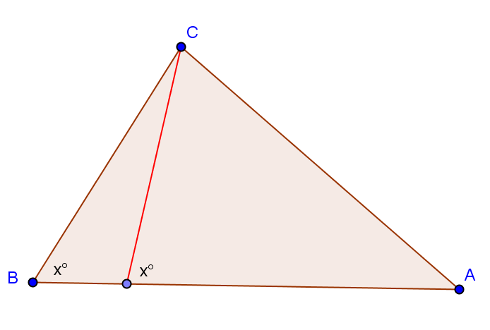
- Let’s look at a case where $B’$ is not on the circle. Where could $B’$ lie?
  - Outside of the circle or inside the circle.
- Let’s look at the case where it lies outside of the circle first. Draw B’ outside of your circle and draw $∠AB'C$.
  - Students draw $B’$ and $∠AB'C$.

- What is mathematically wrong with this picture?
  - Answers will vary. We want students to see that the inscribed angle formed where $\overline{AB'}$ intersects the circle has a measure of $x$ since it is inscribed in the same arc as $∠ABC$ not $∠AB'C$. See diagram.
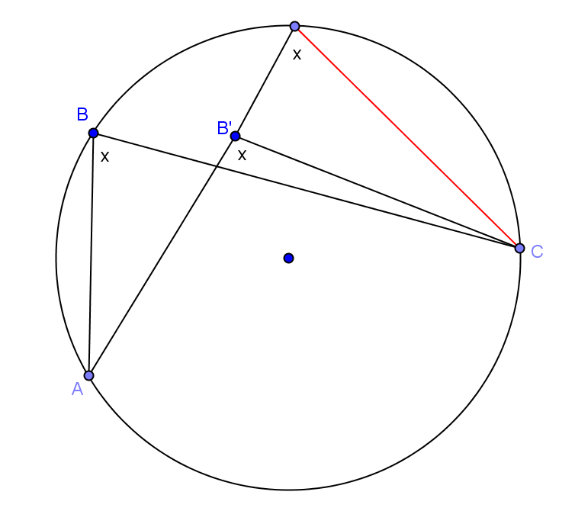
- To further clarify, have students draw the triangle $∆AB'C$ with the inscribed segment as shown. Further discuss what is mathematically incorrect with the angles marked $x$ in the triangle.
- What can we conclude about $B’$?
  - $B’$ cannot lie outside of the circle.
Assign the other half of the class this investigation. Let them work in pairs and provide leading questions as needed.
- Where else could $B’$ lie?
  - In the circle or on the circle.
- With a partner, prove that $B’$ cannot lie inside the circle using the steps above to guide you.
- Circle around as groups are working, and help where necessary, leading some groups if required.
- Call the class back together, and allow groups to present their findings. Discuss both cases as a class.
- Have students do a $30$-second Quick Write on what they just discovered.
  - If $A, B, B’$, and $C$ are $4$ points with $B$ and $B’$ on the same side of the line $\overset{⃡}{AC}$, and angles $∠ABC$ and $∠AB^{'}C$ are congruent, then $A, B, B’$, and $C$ all lie on the same circle.

Exercises 1–4 (13 minutes)
Have students work through the problems (puzzles) below in pairs or homogeneous groups of three. Some groups may need one-on-one guidance. As students complete problems, have them summarize the steps that they took to solve each problem, then post solutions at 5-minute intervals. This will give groups that are stuck hints and show different methods for solving.

Exercises 1–4
Find the value $x$ in each figure below, and describe how you arrived at the answer.
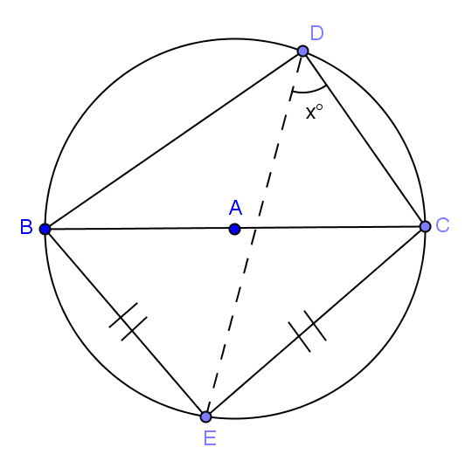  - Hint: Thales’ theorem | 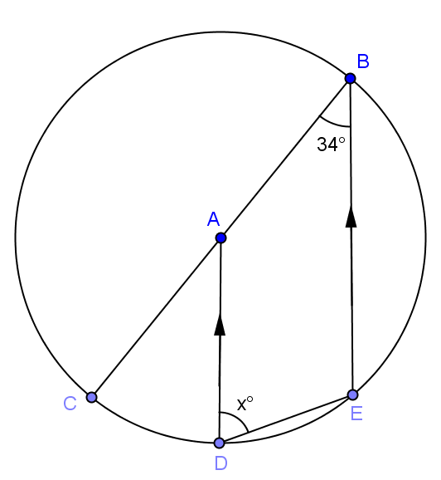
$m∠BEC=90°$inscribed in a semicircle  $m∠EBC=m∠ECB=45°$ base angles of an isosceles triangle are congruent and sum of angles of a triangle $=180°$  $m∠EBC=m∠EDC=45°$ angles inscribed in the same arc are congruent  $x=45$ | $m∠CBE=m∠CAD=34°$  corresponding angles are congruent  $m∠BAD=146°$ linear pair with $∠CAD$  $m∠ADE=\frac{1}{2}m∠BAD=73°$ inscribed  angle is half of measure of central angle intercepting same arc  $x=73$
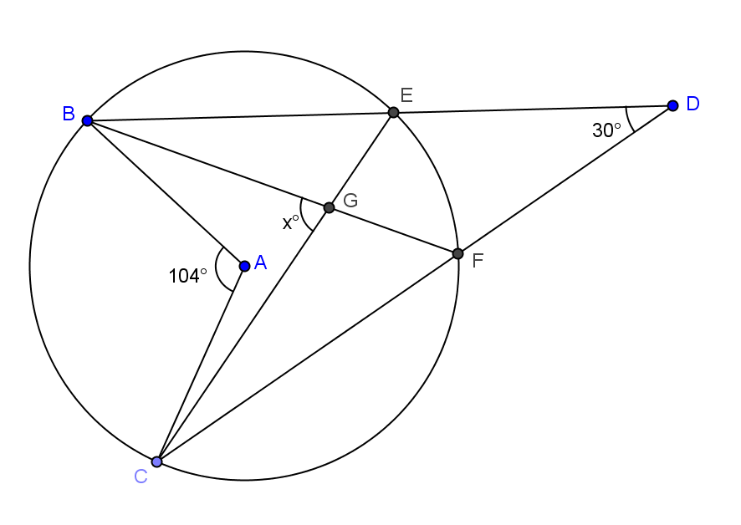 | 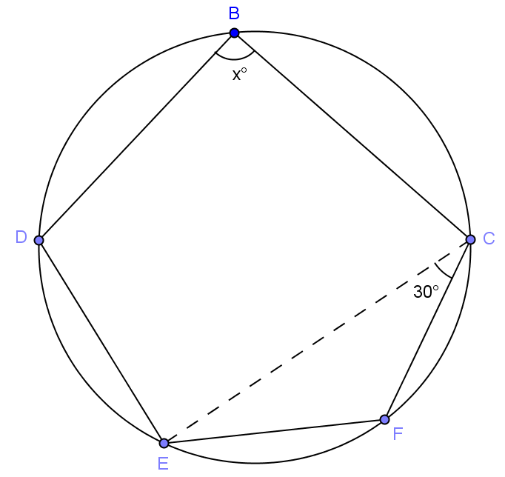
$m∠BEC=m∠CFB=\frac{1}{2}m∠BAC=52°$  inscribed angles are half the measure of the central angle intercepting the same arc  $m∠DEG=128^{0}$ linear pair with $∠BEC$  $m∠GFD=128°$ linear pair with $∠CFB$  $m∠EGF=74°$ sum of angles of a quadrilateral $m∠FOC=60°$  $x = 74$ | Draw center of circle, $O$.  $∠EOF=2m∠ECF=60°$  central angle double measure of inscribed angle intercepting same arc  $m∠DOC=180°$ sum of angles of a circle $=360°$  $x=90$ angle inscribed in a semicircle

Closing (2 minutes)
Have students do a 30-second Quick Write of what they have learned about the inscribed angle theorem. Bring the class back together and debrief. Use this as a time to informally assess student understanding and clear up misconceptions.
- Write all that you have learned about the inscribed angle theorem.
  - The measure of the central angle is double the measure of any inscribed angle that intercepts the same arc.
  - Inscribed angles that intercept the same arc are congruent.

Lesson Summary
Theorems:
- The inscribed angle theorem: The measure of a central angle is twice the measure of any inscribed angle that intercepts the same arc as the central angle
- Consequence of inscribed angle theorem: Inscribed angles that intercept the same arc are equal in measure.
- If $A$, $B$, $B’$, and $C$ are four points with $B$ and$B’$ on the same side of line $\overset{⃡}{AC}$, and angles $∠ABC$ and $∠AB'C$ are congruent, then $A$, $B$, $B’$, and $C$ all lie on the same circle.
Relevant Vocabulary
- Central angle: A central angle of a circle is an angle whose vertex is the center of a circle.
- Inscribed angle: An inscribed angle is an angle whose vertex is on a circle, and each side of the angle intersects the circle in another point.
- Intercepted arc: An angle intercepts an arc if the endpoints of the arc lie on the angle, all other points of the arc are in the interior of the angle, and each side of the angle contains an endpoint of the arc. An angle inscribed in a circle intercepts exactly one arc; in particular, the arc intercepted by a right angle is the semicircle in the interior of the angle.

Exit Ticket (5 minutes)

Name Date
Lesson 6: Unknown Angle Problems with Inscribed Angles in Circles

Exit Ticket

Find the measure of angles $x$ and $y$. Explain the relationships and theorems used.

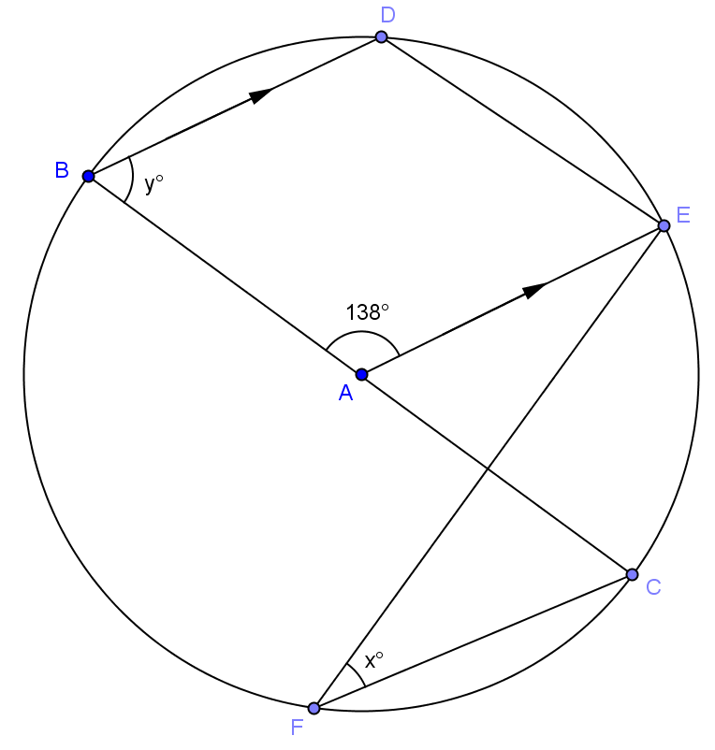

Exit Ticket Sample Solutions

Find the measures of angles $x$ and $y$. Explain the relationships and theorems used.

$m∠EAC=42^{0}$ (linear pair with $∠BAE$). $m∠EFC=\frac{1}{2}m∠EAC=21°$ (inscribed angle is half measure of central angle with same intercepted arc). $x = 21$ $m∠ABD=m∠EAC=42°$ (corresponding angles are congruent) $$y = 42$$

Problem Set Sample Solutions
The first two problems are easier and require straightforward use of the inscribed angle theorem. The rest of the problems vary in difficulty but could be time consuming. Consider allowing students to choose the problems that they do and assigning a number of problems to be completed. You may want everyone to do Problem 8, as it is a proof with some parts of steps given as in the Opening Exercise.

In Problems 1–5, find the value $x$.

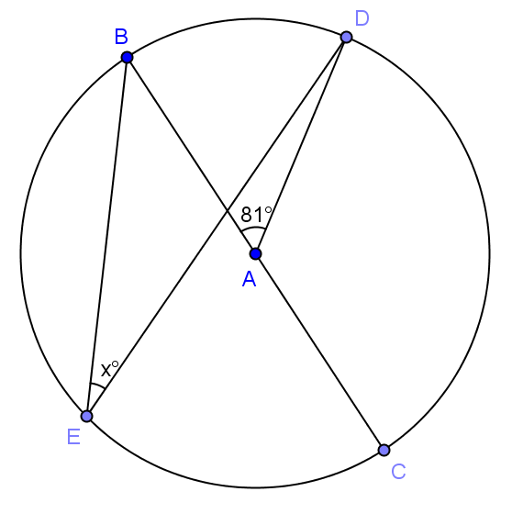

$$40.5$$

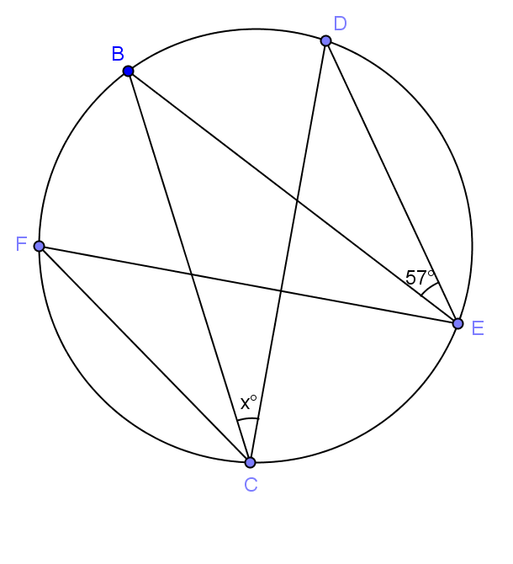

$$57$$

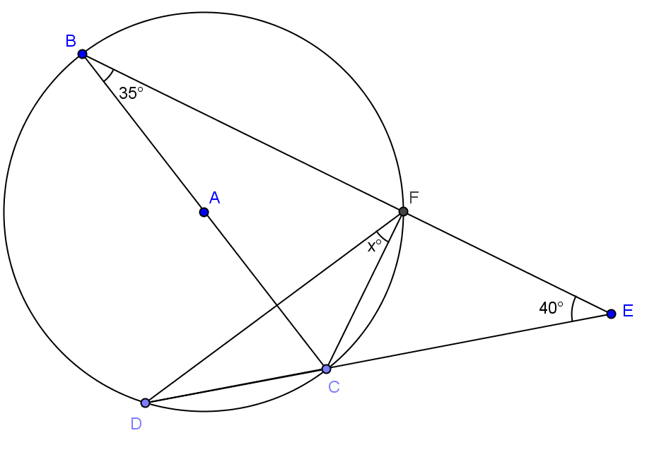

$$15$$

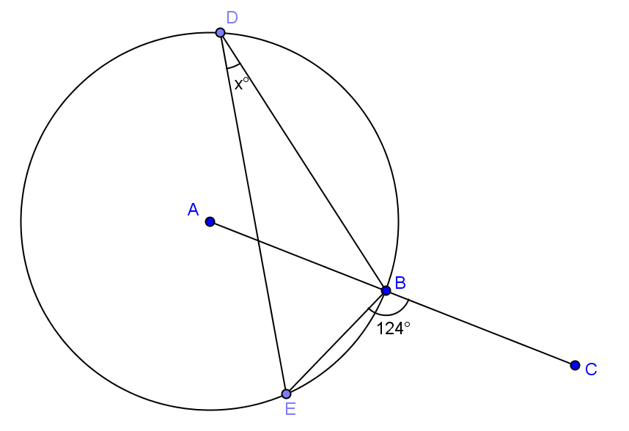

$$34$$

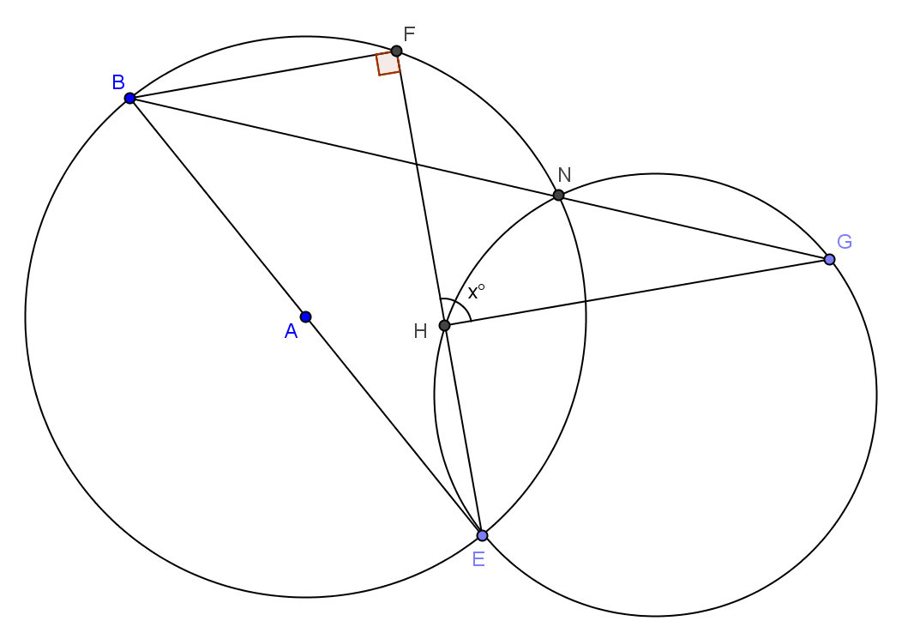

$$90$$

- If $BF = FC$, express $y$ in terms of $x$.
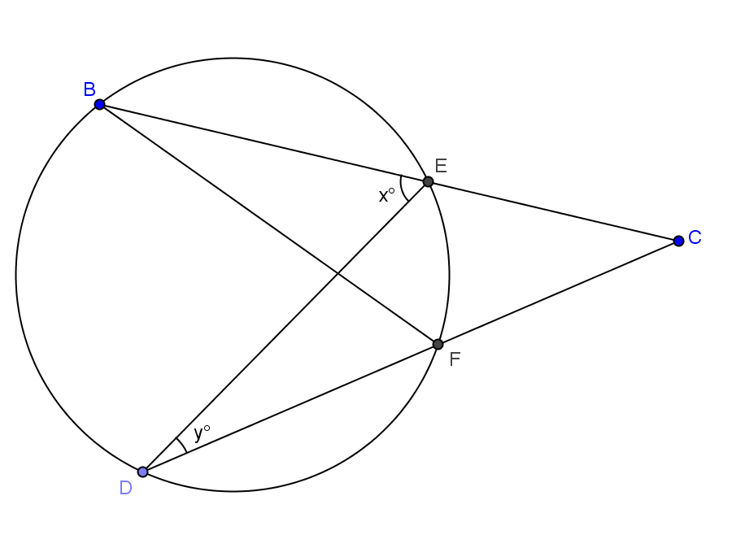

$$y=2x$$

- Find the value $x$.
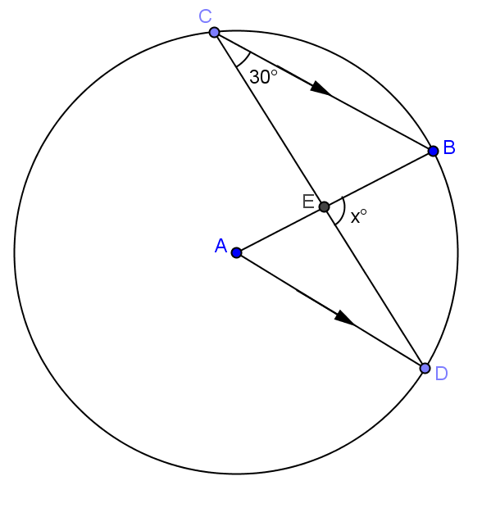

$$x=90$$

- Suppose the $m∠C=a°$. Prove that $m∠DEB=3a°$.
$D = a$ (alt.angles congruent), $∠A = 2a$ (inscribed angles half the central angle, $a + 2a + ∠AED = 180$ (angles of triangle $=180$), $∠AED = 180 – 3a, ∠AED + ∠BED = 180$ (angles form line), $180 – 3a + ∠BED = 180$ (substitution), $BED = 3a$

- In the figure below, three identical circles meet at B, F and C, E respectively. $BF$ $=$ $CE$. $A, B, C$ and $F, E, D$ lie on straight lines.
Prove $ACDF$ is a parallelogram.
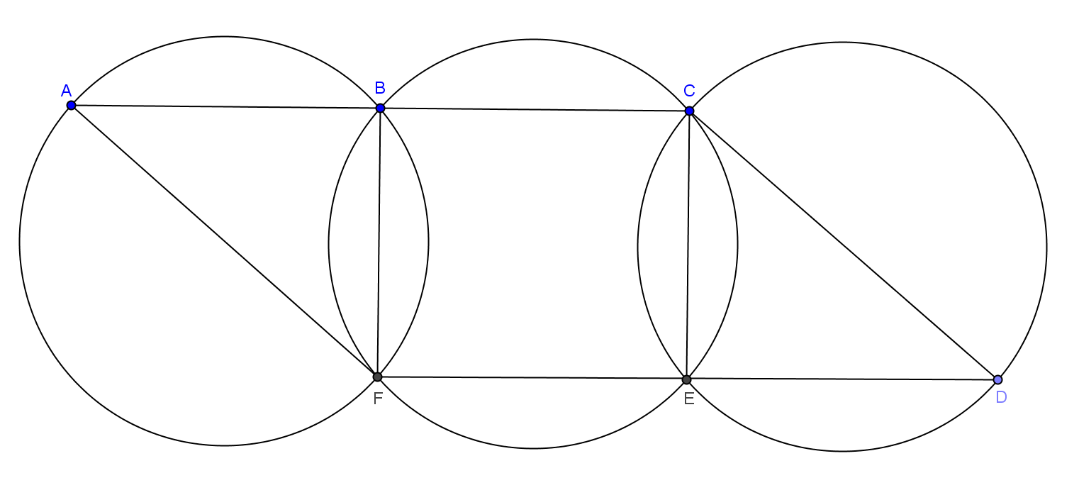

Proof:
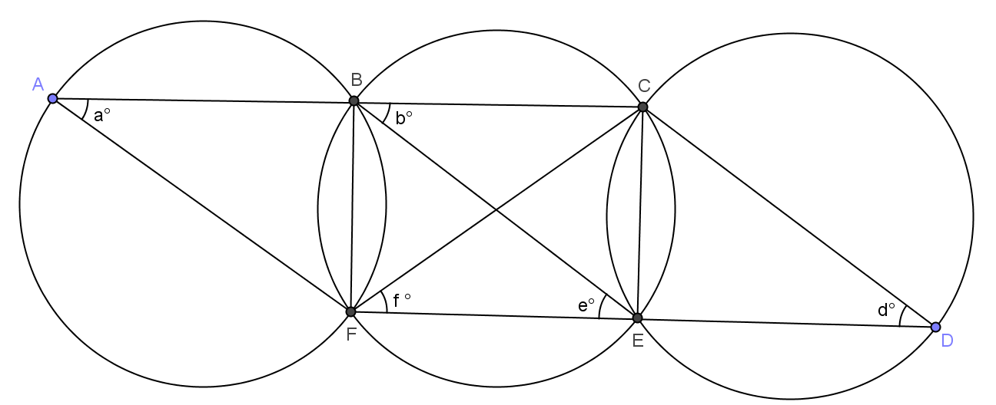

Join $BE$ and $CF$.

$BF$ $=$ $CE$ Reason: ______________________________

$a=$ __________ $=$ __________ $=$ __________ $=d$ Reason: ______________________________

__________ $=$ __________

$\overline{AC}∥\overline{FD}$ Alternate angles are equal.

__________ $=$ __________

$\overline{AF}∥\overline{BE}$ Corresponding angles are equal.

__________ $=$ __________

$\overline{BE}∥\overline{CD}$ Corresponding angles are equal.

$\overline{AF} ∥\overline{BE}∥\overline{CD}$

$ACDF$ is a parallelogram.

Given; $b$, $f$, $e$, angles inscribed in congruent arcs are congruent; $∠CBE=∠FEB; ∠A=∠CBE; ∠D=∠BF$

