Lesson 6: Unknown Angle Problems with Inscribed Angles in Circles

Classwork
Opening Exercise
In a circle, a chord $\overline{DE}$ and a diameter $\overline{AB}$ are extended outside of the circle to meet at point $C$. If $m∠DAE=46⁰$, and $m∠DCA=32⁰$, find $m∠DEA.$
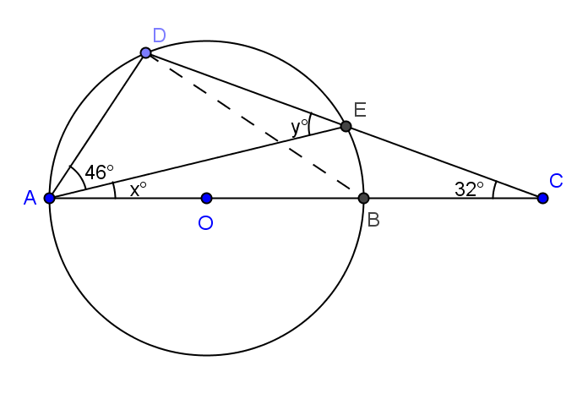

Let $m∠DEA=y, m∠EAE=x$

In $∆ABD, m∠DBA=$ Reason

$m∠ADB=$ Reason
$∴46+x+y+90=$ Reason
$x+y=$
In $∆ACE, y=x+32$ Reason
$x+x+32=$ Reason
$x=$
$y=$
$m∠DEA=$
Exercises 1–4
Find the value $x$ in each figure below, and describe how you arrived at the answer.
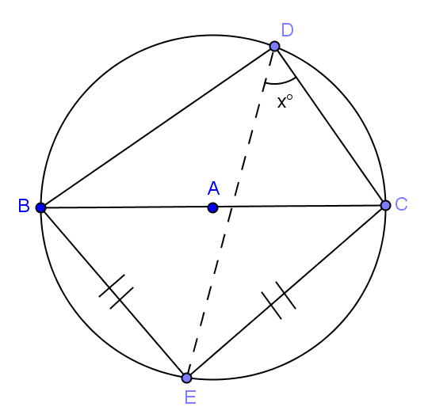  - Hint: Thales’ theorem | 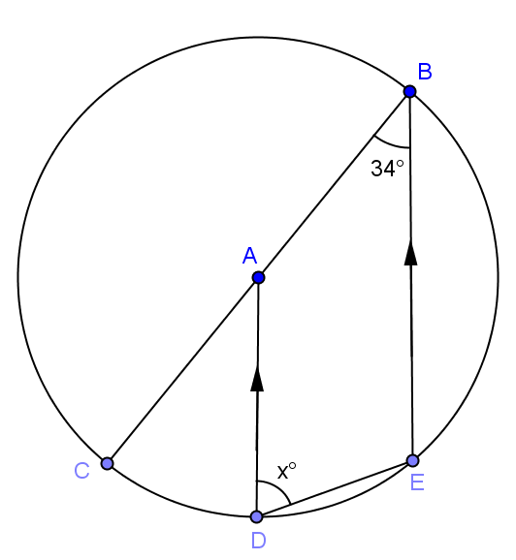
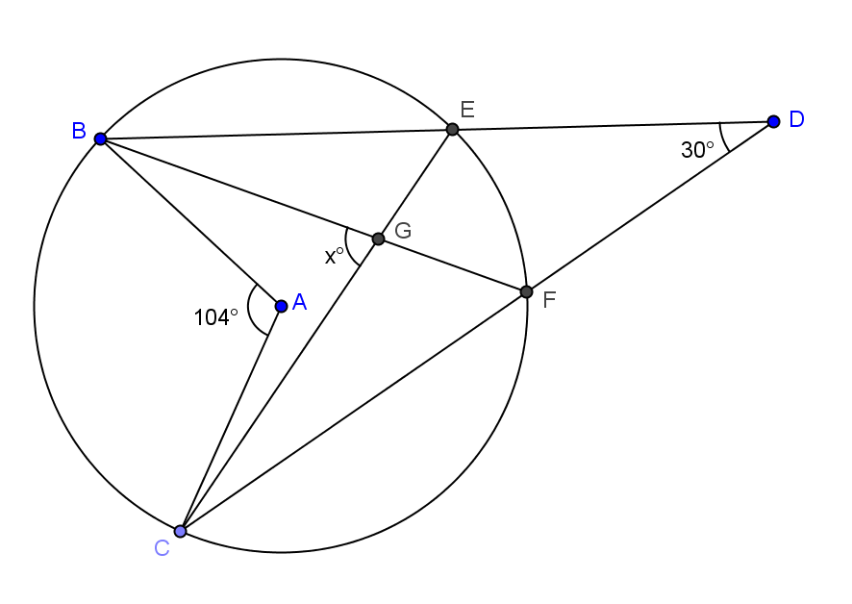 | 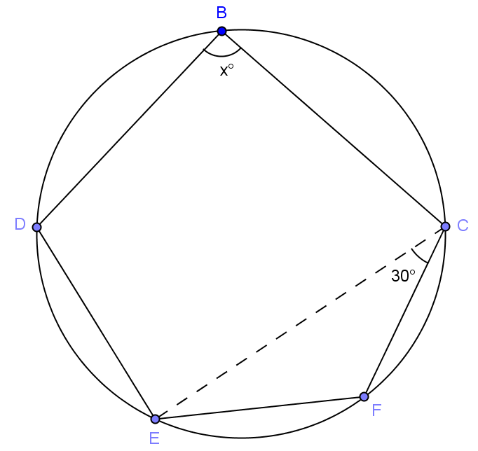
Lesson Summary:
Theorems:
- The inscribed angle theorem: The measure of a central angle is twice the measure of any inscribed angle that intercepts the same arc as the central angle
- Consequence of inscribed angle theorem: Inscribed angles that intercept the same arc are equal in measure.
- If $A$, $B$, $B’$, and $C$ are four points with $B$ and $B’$ on the same side of line $\overset{⃡}{AC}$, and angles $∠ABC$ and $∠AB'C$ are congruent, then $A$, $B$, $B’$, and $C$ all lie on the same circle.
Relevant Vocabulary
- Central angle: A central angle of a circle is an angle whose vertex is the center of a circle.
- Inscribed angle: An inscribed angle is an angle whose vertex is on a circle, and each side of the angle intersects the circle in another point.
- Intercepted arc: An angle intercepts an arc if the endpoints of the arc lie on the angle, all other points of the arc are in the interior of the angle, and each side of the angle contains an endpoint of the arc. An angle inscribed in a circle intercepts exactly one arc, in particular, the arc intercepted by a right angle is the semicircle in the interior of the angle.

Problem Set

In Problems 1–5, find the value $x$.

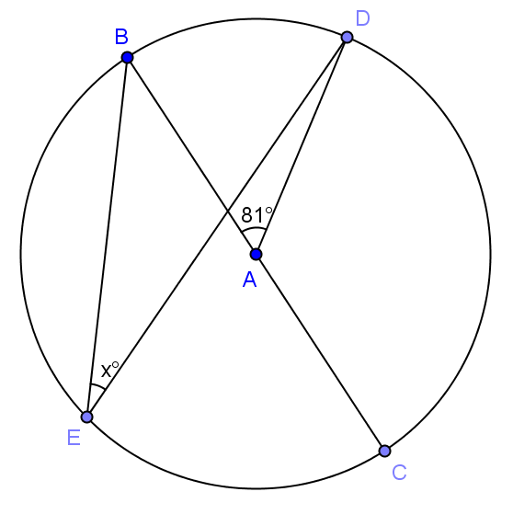

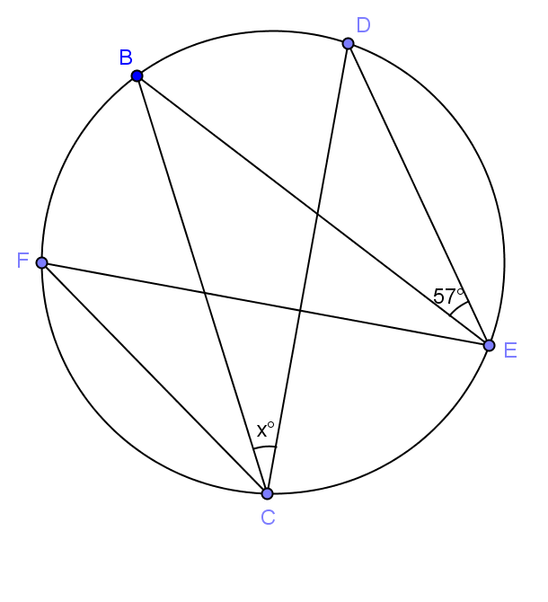

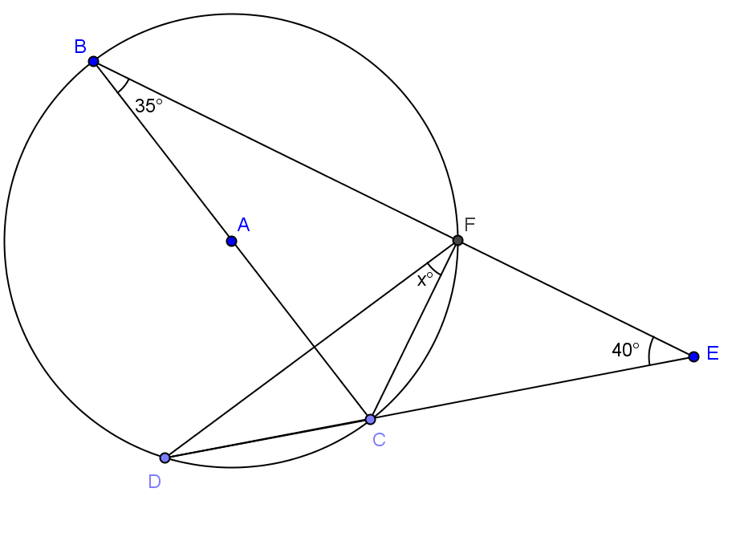

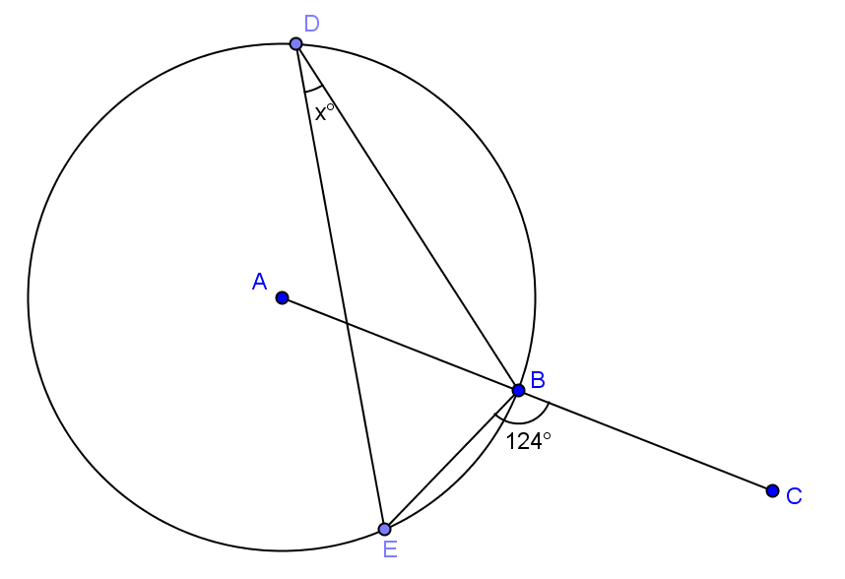

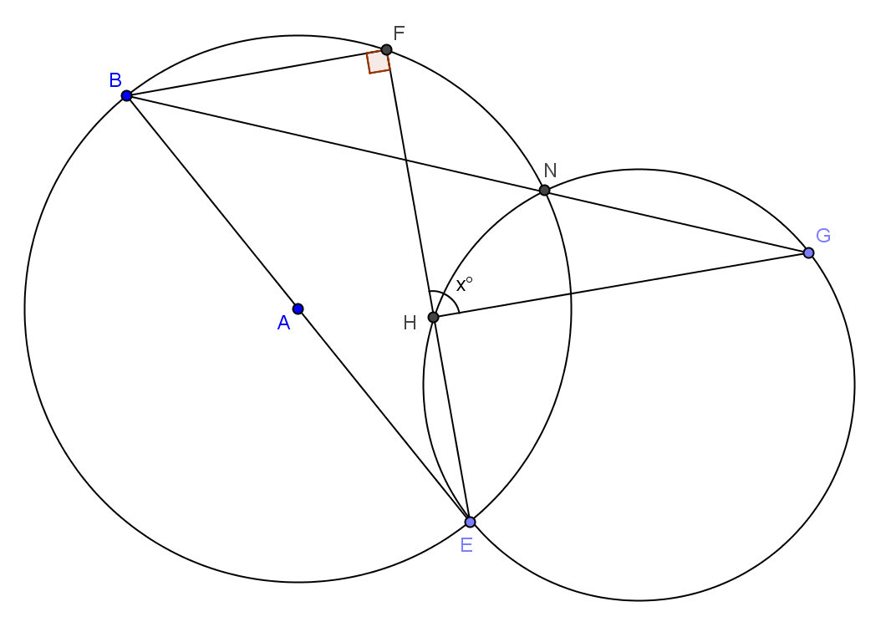

- If $BF = FC$, express $y$in terms of $x$.

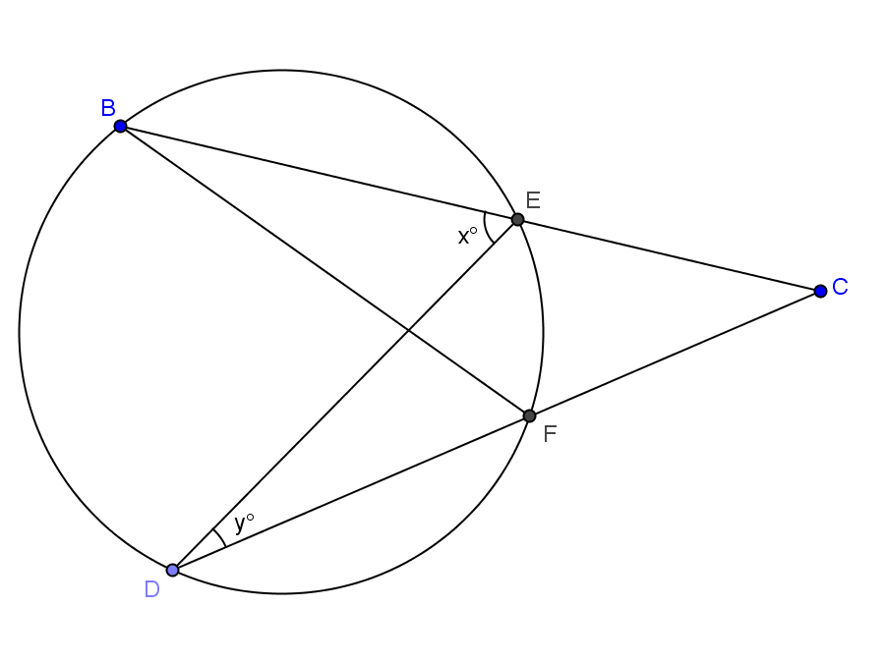

  - Find the value $x$.
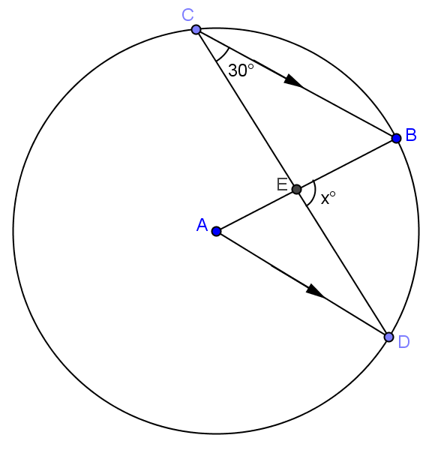

  - Suppose the $m∠C=a⁰$. Prove that $m∠DEB=3a⁰$.

- In the figure below, three identical circles meet at $B$, $F$ and $C$, E respectively. $BF=CE$. $A$, $B$, $C$ and $F$, $E$, $D$ lie on straight lines.
Prove $ACDF$ is a parallelogram.
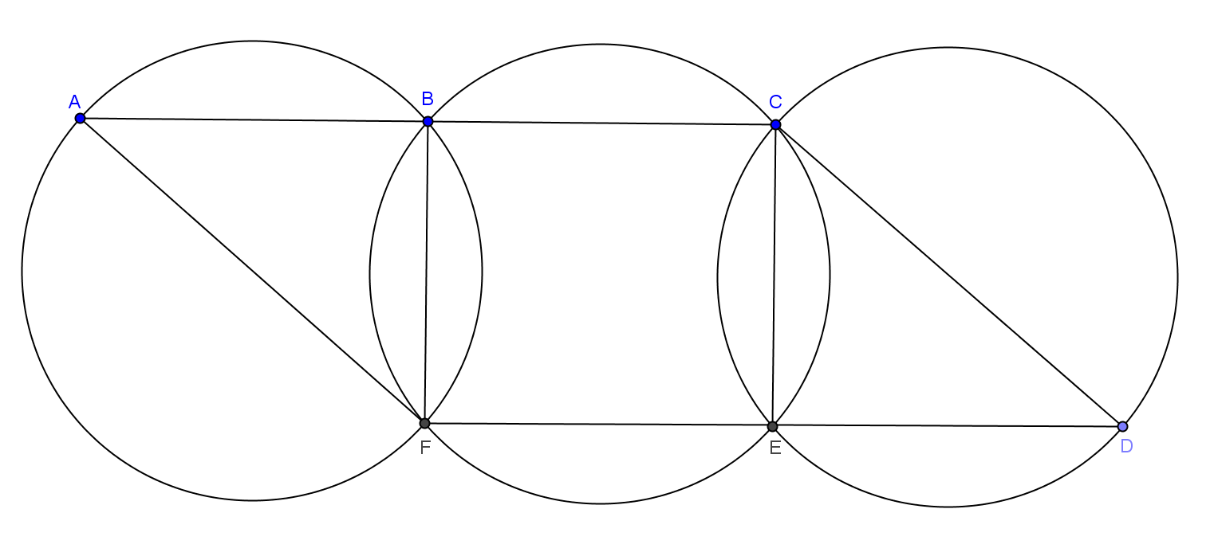

Proof:
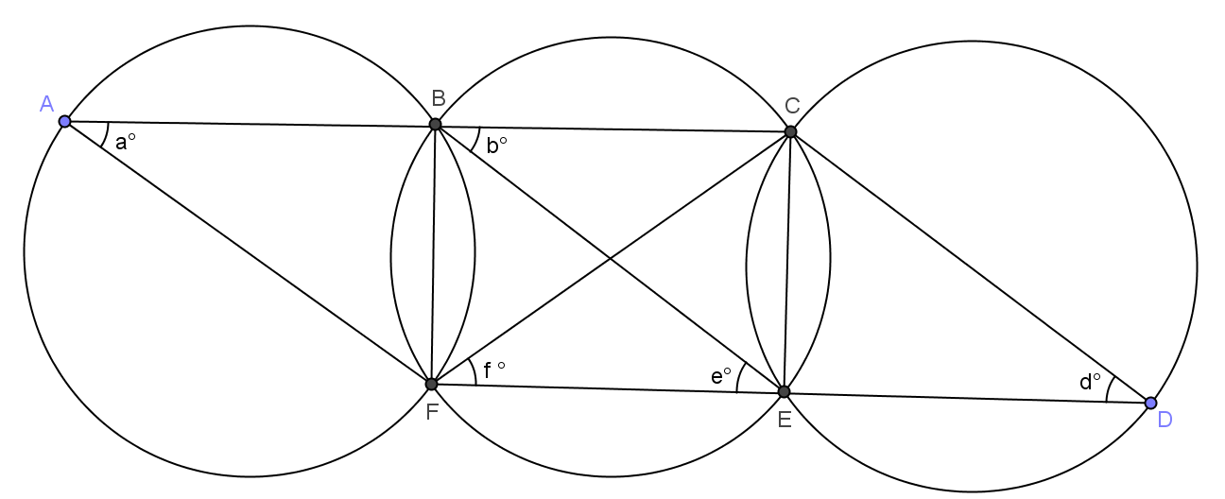

Join $BE$ and $CF$.

$BF=CE$ Reason: ______________________________

$a$ $=$ __________ $=$ __________ $=$ __________ $= d$ Reason: ______________________________

__________ $=$ __________

$\left.\overline{AC}\right\|\overline{FD}$ Alternate angles are equal.

__________ $=$ __________

$\left.\overline{AF}\right\|\overline{BE}$ Corresponding angles are equal.

__________ $=$ __________

$\left.\overline{BE}\right\|\overline{CD}$ Corresponding angles are equal.

$\left.\overline{AF}\right\|\left.\overline{BE}\right\|\overline{CD}$

$ACDF$ is a parallelogram.

