Lesson 5: Inscribed Angle Theorem and its Applications

Student Outcomes
- Prove the inscribed angle theorem: The measure of a central angle is twice the measure of any inscribed angle that intercepts the same arc as the central angle.
- Recognize and use different cases of the inscribed angle theorem embedded in diagrams. This includes recognizing and using the result that inscribed angles that intersect the same arc are equal in measure.

Lesson Notes
Lesson 5 introduces but does not finish the inscribed angle theorem. The statement of the inscribed angle theorem in this lesson should be only in terms of the measures of central angles and inscribed angles, not the angle measures of intercepted arcs. The measure of the inscribed angle is deduced and the central angle is given, not the other way around in Lesson 5. This lesson only includes inscribed angles and central angles that are acute or right. Obtuse angles will not be studied until Lesson 7.
The Opening Exercise and Examples 1 and 2 are the complete proof of the inscribed angle theorem (central angle version).

Classwork
Opening
Lead students through a discussion of the Opening Exercise (an adaptation of Lesson 4 Problem Set 6), and review terminology, especially intercepted arc. Knowing the definition of intercepted arc is critical for understanding this and future lessons. The goal is for students to understand why the Opening Exercise supports, but is not a complete proof of the inscribed angle theorem, and then to make diagrams of the remaining cases, which are addressed in Examples 1–2 and Exercise 1.
Scaffolding:
- Include a diagram in which point B and angle ABC are already drawn.

Opening Exercise (7 minutes)
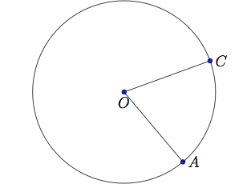
Opening Exercise
- $A$ and $C$ are points on a circle with center $O$.
  - Draw a point $B$ on the circle so that $\overline{AB}$ is a diameter. Then draw the angle $∠ABC$.

  - What angle in your diagram is an inscribed angle?
$$∠ABC$$

  - What angle in your diagram is a central angle?
$$∠AOC$$

  - What is the intercepted arc of angle $∠ABC$?
Minor arc $\hat{AC}$

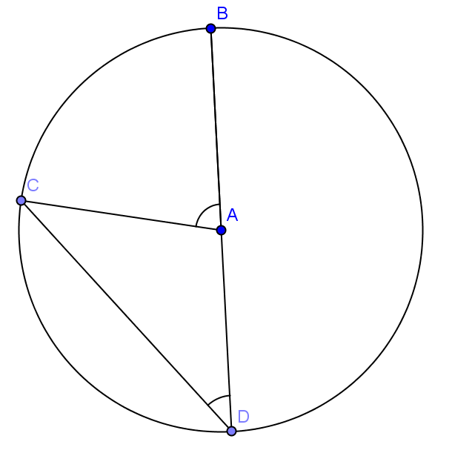
  - What is the intercepted arc of $∠AOC$ ?
Minor arc $\hat{AC}$

2. The measure of the inscribed angle is $x$ and the measure of the central angle is $y$. Find $m∠CAB$ in terms of $x$?
We are given$m∠D=x,$ and we know that $AB = AC = AD$, so $∆CAD$ is an isosceles triangle, meaning $m∠ACD$ is also $x$. The sum of the angles of a triangle is $180$, so $m∠CAD= 180-2x$. $∠CAD$ and $∠CAB$ are supplementary meaning that
$m∠CAB$ $=180 – (180 – 2x) = 2x$; therefore, $y = 2x.$

Relevant Vocabulary
Inscribed angle theorem (as it will be stated in Lesson 7): The measure of an inscribed angle is half the angle measure of its intercepted arc.
Inscribed angle: An inscribed angle is an angle whose vertex is on a circle, and each side of the angle intersects the circle in another point.
Arc intercepted by an angle: An angle intercepts an arc if the endpoints of the arc lie on the angle, all other points of the arc are in the interior of the angle, and each side of the angle contains an endpoint of the arc. An angle inscribed in a circle intercepts exactly one arc; in particular, the arc intercepted by a right angle is the semicircle in the interior of the angle.

Exploratory Challenge (10 minutes)
Review the definition of intercepted arc, inscribed angle, and central angle and then state the inscribed angle theorem. Then highlight the fact that we have proved one case but not all cases of the inscribed angle theorem (the case in which a side of the angle passes through the center of the circle). Sketch drawings of various cases to set up; for instance, Example 1 could be the inside case and Example 2 could be the outside case. You may want to sketch them in a place where you can refer to them throughout the class.
Scaffolding:
- Post drawings of each case as they are studied in the class as well as the definitions of inscribed angles, central angles, and intercepted arcs.
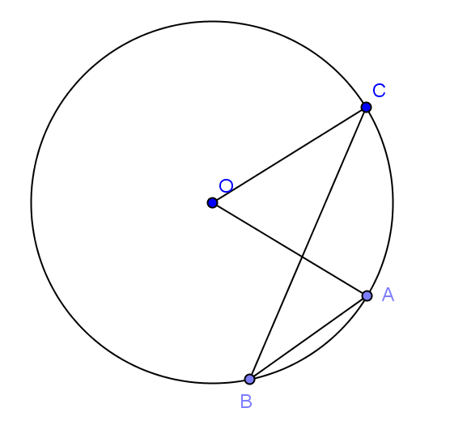
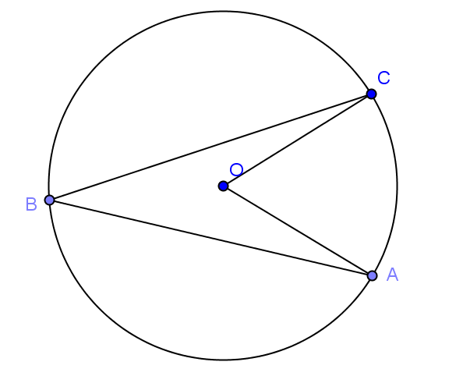

- What do you notice that is the same or different about each of these pictures?
MP.7
  - Answers will vary.
- What arc is intercepted by $∠ABC$?
  - The minor arc $\hat{AC}$
- How do you know this arc is intercepted by $∠ABC$?
  - The endpoints of the arc ($A$ and $C$) lie on the angle.
  - All other points of the arc are inside the angle.
  - Each side of the angle contains one endpoint of the arc.
- Theorem: The measure of a central angle is twice the measure of any inscribed angle that intercepts the same arc as the central angle.
- Today we’re going to talk about the inscribed angle theorem. It says the following: The measure of a central angle is twice the measure of any inscribed angle that intercepts the same arc as the central angle. Does the Opening Exercise satisfy the conditions of the inscribed angle theorem?
  - Yes. $∠ABC$ is an inscribed angle and $∠AOC$ is a central angle both of which intercept the same arc.
- What did we show about the inscribed angle and central angle with the same intersected arc in the Opening Exercise?
  - That the measure of $∠AOC$ is twice the measure of $∠ABC$.
  - This is because $△OBC$ is an isosceles triangle whose legs are radii. The base angles satisfy
$m∠B=m∠C=x$. So,$y=2x$ because the exterior angle of a triangle is equal to the sum of the measures of the opposite interior angles.
- Does the conclusion of the Opening Exercise match the conclusion of the inscribed angle theorem?
  - Yes.
- Does this mean we have proven the inscribed angle theorem?
  - No. The conditions of the inscribed angle theorem say that $∠ABC$ could be any inscribed angle. The vertex of the angle could be elsewhere on the circle.
- How else could the diagram look?
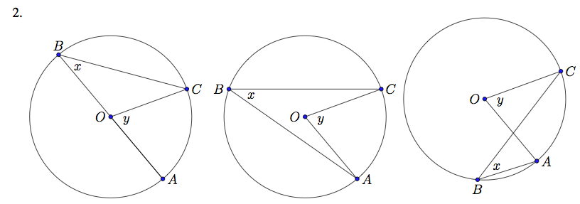
  - Students may say that diagram could have the center of the circle be inside, outside, or on the inscribed angle. The Opening Exercise only shows the case when the center is on the inscribed angle. (Discuss with students that the precise way to say “inside the angle” is to say “in the interior of the angle.”)

  - We still need to show the cases when the center is inside and outside the inscribed angle.

- There is one more case, when $B$ is on the minor arc between $A$ and $C$ instead of the major arc.
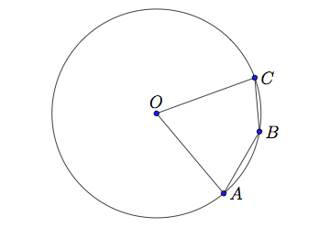
  - If students ask where the $x$ and $y$ are in this diagram, say we’ll find out in Lesson 7.
Scaffolding:
- Before doing Examples 1 and 2, or instead of going through the examples, teachers could do an exploratory activity using the triangles shown in Exercise 3 parts (a), (b), and (c). Have students measure the central and inscribed angles, intercepting the same arc with a protractor, then log the measurements in a table, and look for a pattern.
Examples 1–2 (10 minutes)
These examples prove the second and third case scenarios – the case when the center of the circle is inside or outside the inscribed angle and the inscribed angle is acute. Both use similar computations based on the Opening Exercise. Example 1 is easier to see than Example 2. For Example 2, you may want to let students figure out the diagram on their own, but then go through the proof as a class.
Go over proofs of Examples 1–2 with the case when angle $∠ABC$ is acute. If a student draws $B$ so that angle $∠ABC$ is obtuse, save the diagram for later when doing Lesson 7.
Note that the diagrams for the Opening Exercise as well as Examples 1–2 have been labeled so that in each diagram, $O$ is the center, $∠ABC$ is an inscribed angle, and $∠AOC$ is a central angle. This consistency highlights parallels between the computations in the three cases.

Example 1
$A$ and $C$ are points on a circle with center $O$.

  - What is the intercepted arc of $∠COA$? Color it red.
Minor arc $\hat{AC}$

  - Draw triangle $AOC$. What type of triangle is it? Why?
An isosceles triangle because $OC=OA$ (they are radii of the same circle).
  - What can you conclude about $m∠OCA$ and $m∠OAC$? Why?
They are equal because base angles of an isosceles triangle are equal in measure.

  - Draw a point $B$ on the circle so that $O$ is in the interior of the inscribed angle $∠ABC$.
The diagram should resemble the inside case of the discussion diagrams.

  - What is the intercepted arc of angle $∠ABC$? Color it green.
Minor arc $\hat{AC}$

  - What do you notice about arc $\hat{AC}$?
It is the same arc that was intercepted by the central angle.

  - Let the measure of $∠ABC$ be $x$ and the measure of $∠AOC$ be $y$. Can you prove that $y=2x$? (Hint: Draw the diameter that contains point$B$.)
Let $\overline{BD}$ be a diameter. Let $x_{1}$, $y_{1}$, $x_{2}$, and $y_{2}$ be the measures of $∠CBD, ∠COD, ∠ABD,$ and $∠AOD$, respectively. We can express $x$ and $y$ in terms of these measures: $x=x_{1}+x_{2}$, and $y=y_{1}+y_{2}.$ By the opening exercise,
$y_{1}=2x_{1}$ and $y_{2}=2x_{2}$. Thus $y=2x$.

  - Does your conclusion support the inscribed angle theorem?
Yes, even when the center of the circle is in the interior of the inscribed angle, the measure of the inscribed angle is equal to half the measure of the central angle that intercepts the same arc.
  - If we combine the Opening Exercise and this proof, have we finished proving the inscribed angle theorem?
No. We still have to prove the case where the center is outside the inscribed angle.

Example 2
$A$ and $C$ are points on a circle with center $O$.

  - Draw a point $B$ on the circle so that $O$ is in the exterior of the inscribed angle $∠ABC$.
The diagram should resemble the outside case of the discussion diagrams.

  - What is the intercepted arc of angle $∠ABC$? Color it yellow.
Minor arc $\hat{AC}$

  - Let the measure of $∠ABC$ be $x$, and the measure of $∠AOC$ be $y$. Can you prove that $y=2x$? (Hint: Draw the diameter that contains point$B$.)
Let $\overline{BD}$ be a diameter. Let $x_{1}$, $y_{1}$, $x_{2}$, and $y_{2}$ be the measures of $∠CBD, ∠COD, ∠ABD,$ and $∠AOD$, respectively. We can express $x$ and $y$ in terms of these measures:
$x=x_{2}-x_{1}$ and $y=y_{2}-y_{1}$ By the Opening Exercise, $y_{1}=2x_{1}$ and $y_{2}=2x_{2}$. Thus, $y=2x$.

  - Does your conclusion support the inscribed angle theorem?
Yes, even when the center of the circle is in the exterior of the inscribed angle, the measure of the inscribed angle is equal to half the measure of the central angle that intercepts the same arc.

  - Have we finished proving the inscribed angle theorem?
We have shown all cases of the inscribed angle theorem (central angle version). We do have one more case to study in Lesson 7, but it is ok not to mention it here. The last case is when the location of $B$ is on the minor arc between $A$ and $C$.

Ask students to summarize the results of these theorems to each other before moving on.

Exercises 1–5 (10 minutes)
Exercises are listed in order of complexity. Students do not have to do all problems. Problems can be specifically assigned to students based on ability.
Exercises 1–5
- Find the measure of the angle with measure $x$.
- $m∠D = 25°$  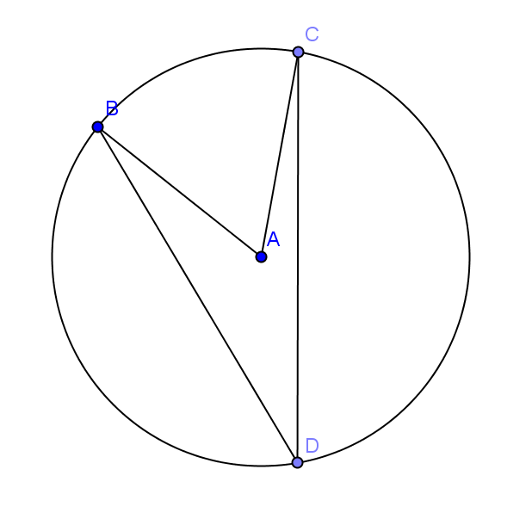  $$x$$  $50°$ | - $m∠D = 15°$  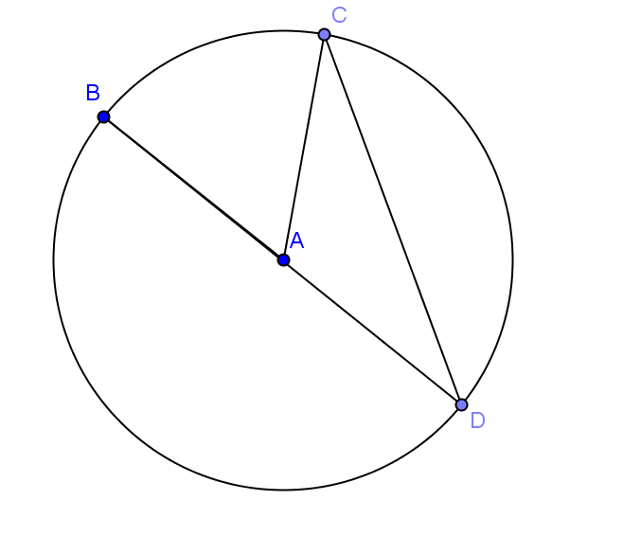  $$x$$  $150°$ | - $m∠BAC = 90°$  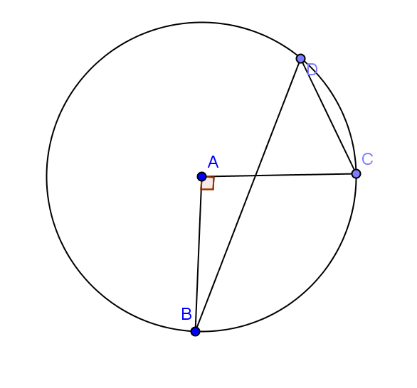  $$x$$  $$x$$  $45°$

- $m∠B = 32°$  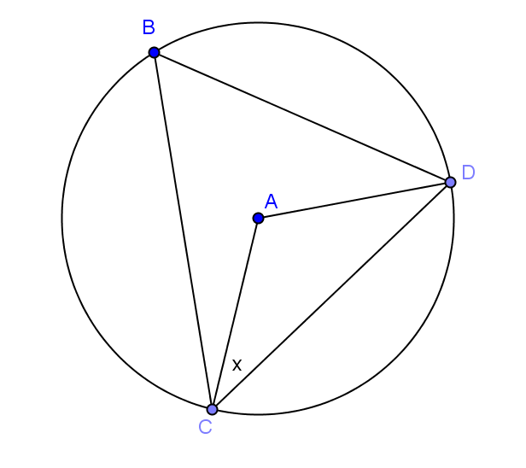  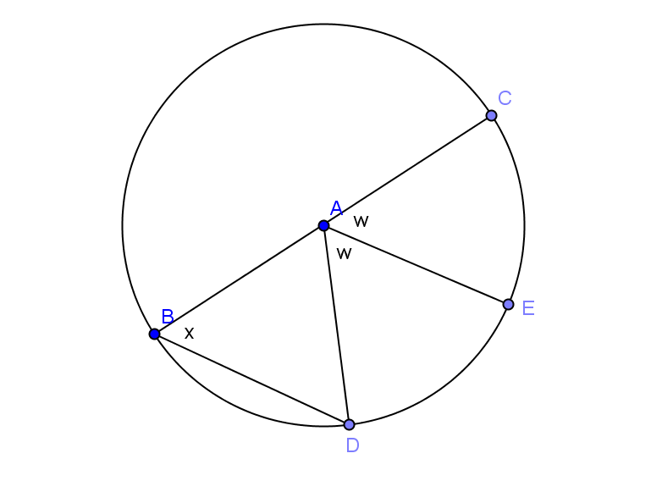  $58°$ | $$x=w=60°$$ | - $m∠D = 19°$  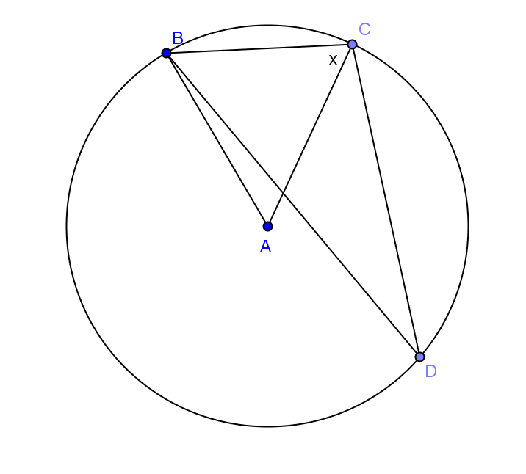  $71°$

- Toby says $∆BEA$ is a right triangle because$m∠BEA=90°$. Is he correct? Justify your answer.
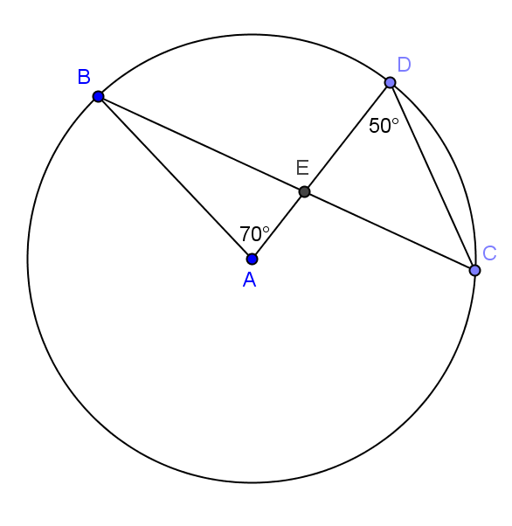
Toby is not correct. The $m∠BEA=95°$. $∠BCD$ is inscribed in the same arc as the central angle, so it has a measure of $35°$. This means that $m∠DEC=95°$ because the sum of the angles of a triangle is $180°$. $m∠BEA=m∠DEC$ since they are vertical angles, so the triangle is not right.

- Let’s look at relationships between inscribed angles.
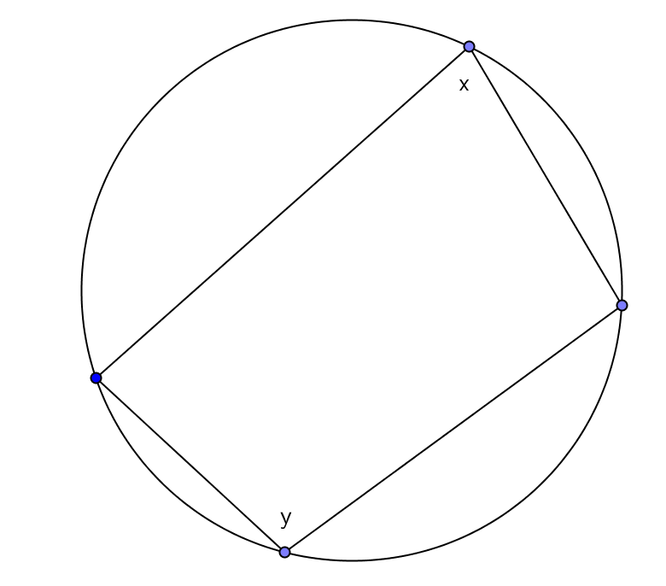
  - Examine the inscribed polygon below. Express $x$ in terms of $y$ and $y$ in terms of $x$. Are the opposite angles in any quadrilateral inscribed in a circle supplementary? Explain.
$x=180°-y$; $y=180°-x$. The angles are supplementary.

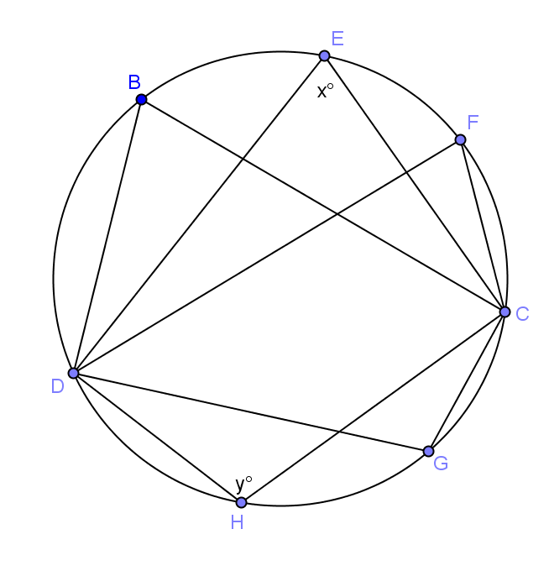
  - Examine the diagram below. How many angles have the same measure, and what are their measures in terms of $x$?
Let $C$ and $D$ be the points on the circle that the original angles contain. All the angles intercepting the minor arc between $C$ and $D$ have measure $x$, and the angles intercepting the major arc between $C$ and $D$ measure $180°-x$.

- Find the measures of the labeled angles.
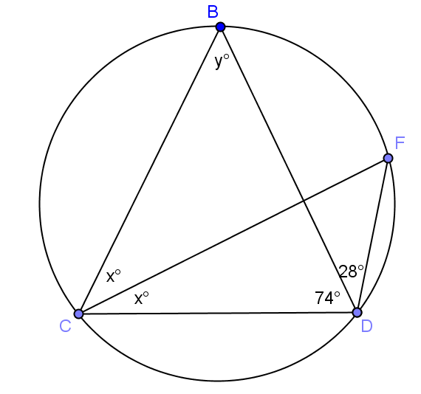  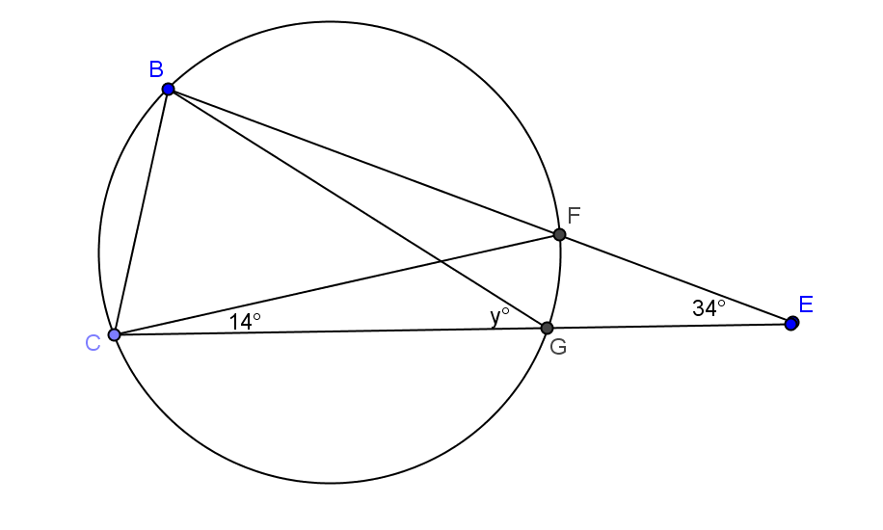  $$x=28, y=50$$ | $$y=48$$
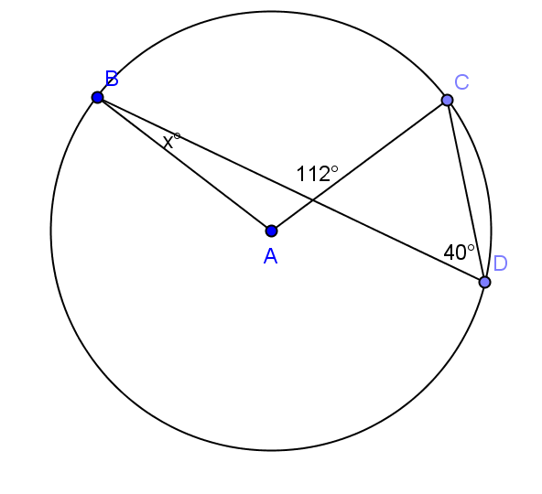  $x=32$ | 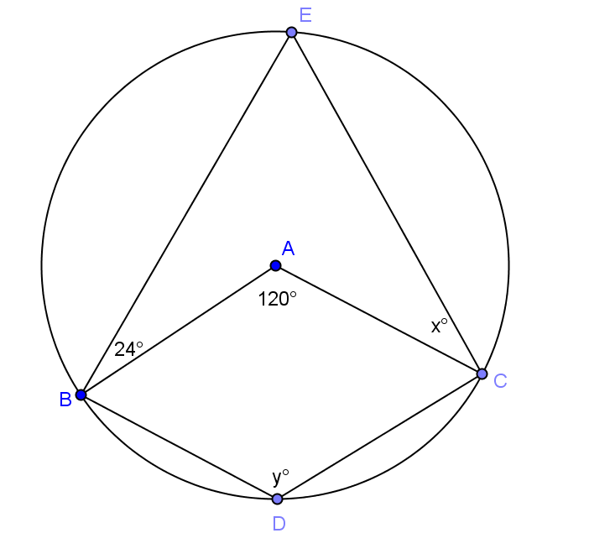  $$x=36, y=120$$
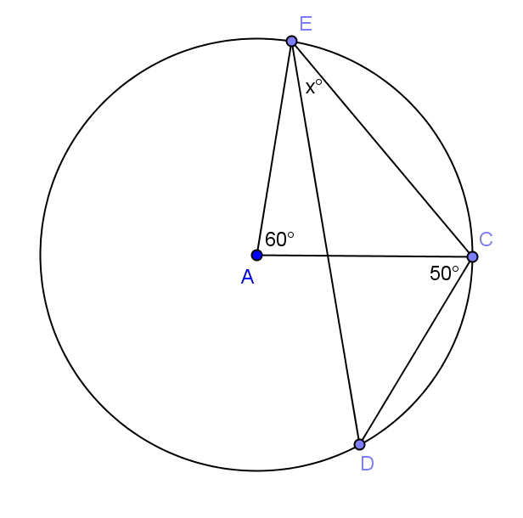  $x=40$ | 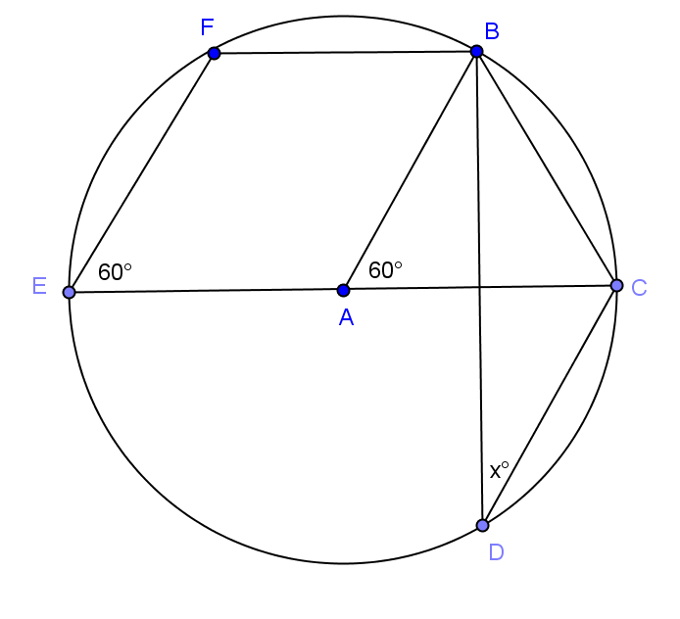  $$x=30$$

Closing (3 minutes)
- With a partner, do a 30-second Quick Write of everything that we learned today about the inscribed angle theorem.
  - Today we began by revisiting the Problem Set from yesterday as the key to the proof of a new theorem, the inscribed angle theorem. The practice we had with different cases of the proof allowed us to recognize the many ways that the inscribed angle theorem can show up in unknown angle problems. We then solved some unknown angle problems using the inscribed angle theorem combined with other facts we knew before.
  - Have students add the theorems in the Lesson Summary to their graphic organizer on circles started in Lesson 2 with corresponding diagrams.

Lesson Summary
Theorems:
- The inscribed angle theorem: The measure of a central angle is twice the measure of any inscribed angle that intercepts the same arc as the central angle.
- Consequence of inscribed angle theorem: Inscribed angles that intercept the same arc are equal in measure.
Relevant Vocabulary
- Inscribed angle: An inscribed angle is an angle whose vertex is on a circle, and each side of the angle intersects the circle in another point.
- Intercepted arc: An angle intercepts an arc if the endpoints of the arc lie on the angle, all other points of the arc are in the interior of the angle, and each side of the angle contains an endpoint of the arc. An angle inscribed in a circle intercepts exactly one arc; in particular, the arc intercepted by a right angle is the semicircle in the interior of the angle.

Exit Ticket (5 minutes)
Name Date
Lesson 5: Inscribed Angle Theorem and its Application

Exit Ticket

The center of the circle below is $O$. If angle $B$ has a measure of $15$ degrees, find the values of $x$ and $y$. Explain how you know.
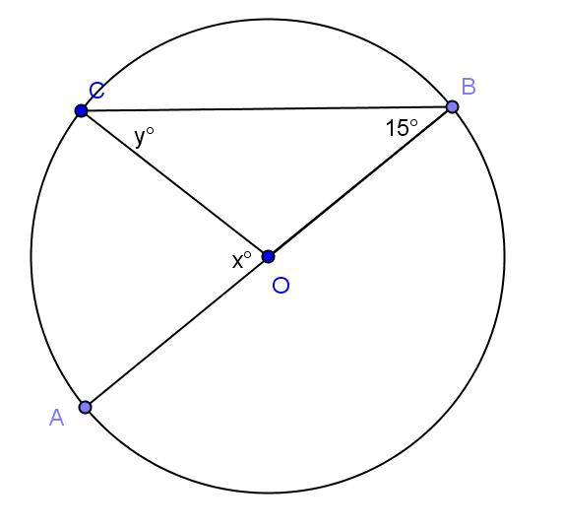

Exit Ticket Sample Solutions

The center of the circle below is $O$. If angle $B$ has a measure of $15$ degrees, find the values of $x$ and $y$. Explain how you know.

$y = 15$. Triangle $COB$ is isosceles, so base angles $∠OCB$and$∠OBC$ are congruent. $m∠OBC=15=m∠OCB.$
$x = 30$. $∠COA$ is a central angle inscribed in the same arc as inscribed angle $∠CBA$. So $m∠COA=2m∠CBA$.

Problem Set Sample Solutions
Problems 1–2 are intended to strengthen students’ understanding of the proof of the inscribed angle theorem. The other problems are applications of the inscribed angle theorem. Problems 3–5 are the most straightforward of these, followed by Problem 6, then Problems 7–9, which combine use of the inscribed angle theorem with facts about triangles, angles, and polygons. Finally, Problem 10 combines all the above with the use of auxiliary lines in its proof.

Find the value of $x$ in each exercise.
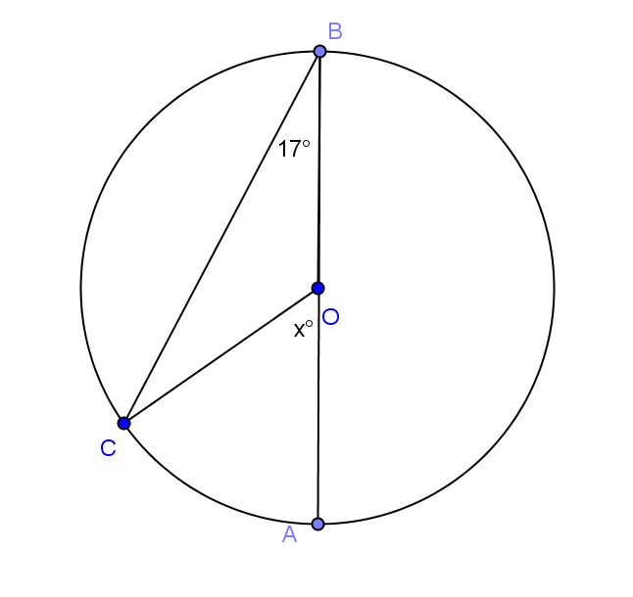  $x=34$ | 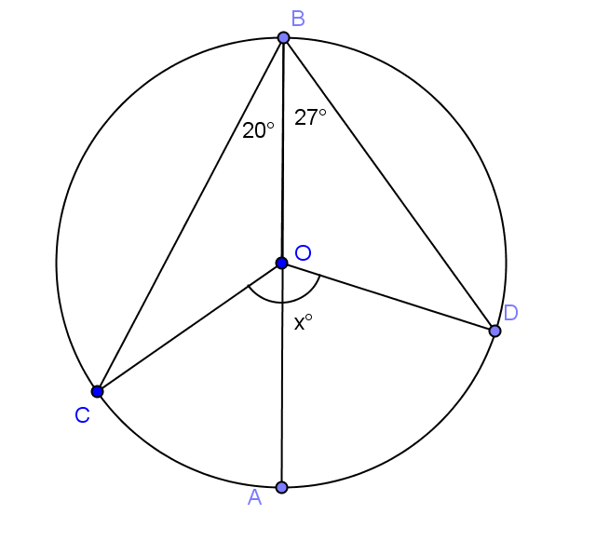  $x=94$
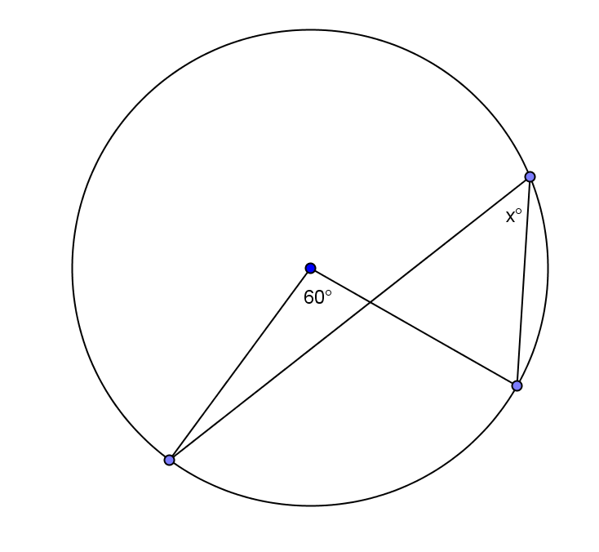  $x=30$ | 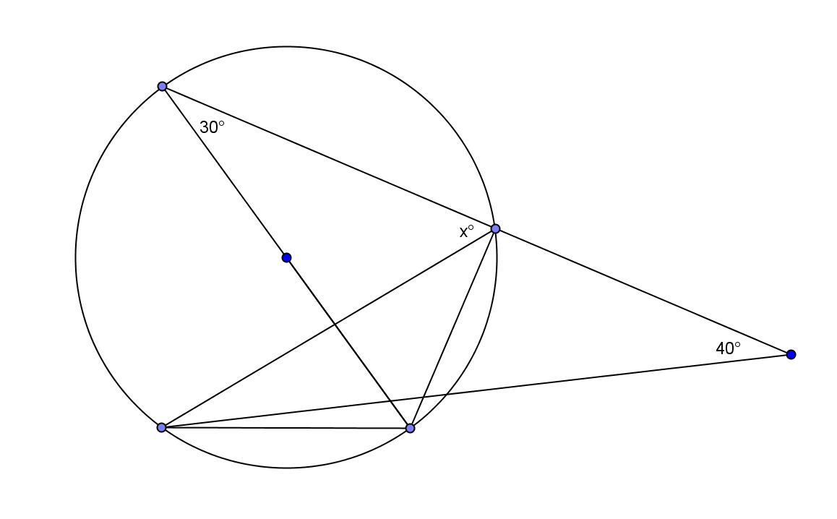  $$x=70$$
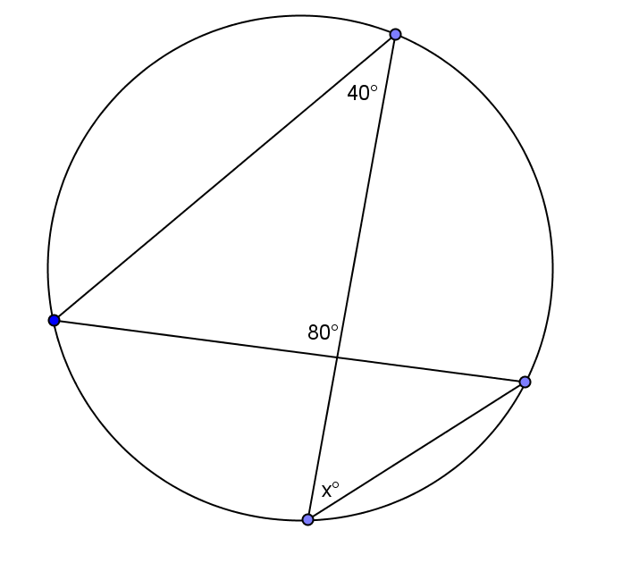  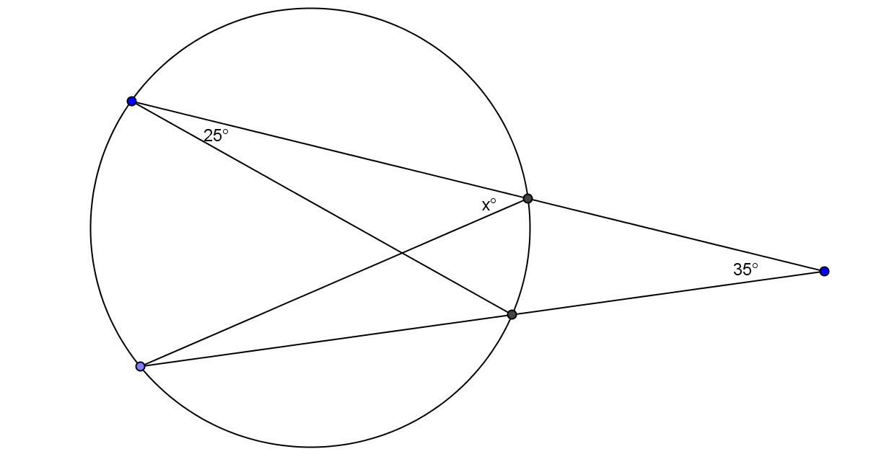  $x=60$ | $$x=60$$
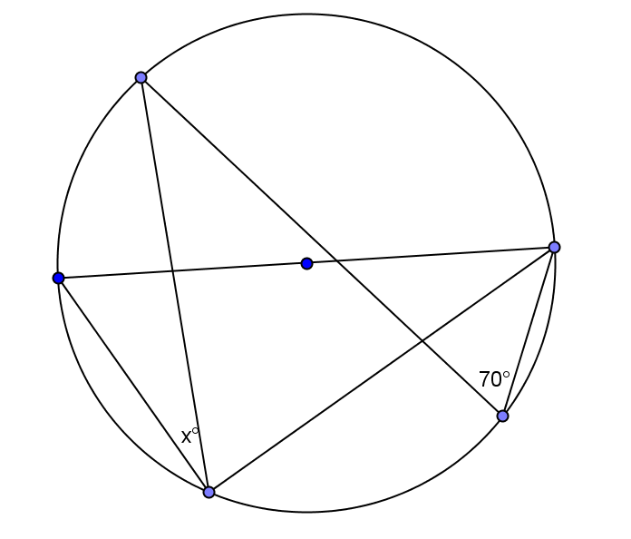  $$x=20$$ | 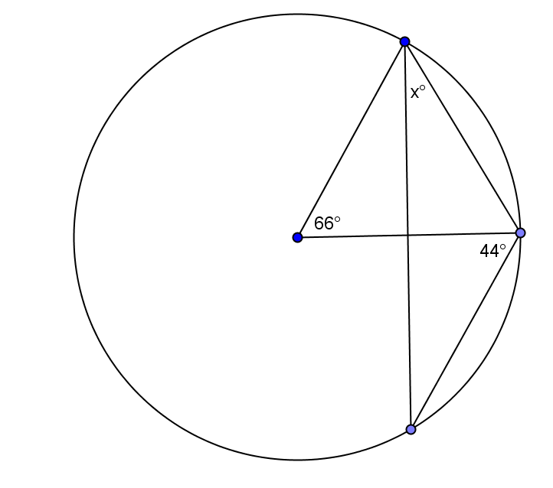  $$x=46$$

- The two circles shown intersect at $E$and$F$. The center of the larger circle, $D$, lies on the circumference of the smaller circle. If a chord of the larger circle, $\overline{FG}$, cuts the smaller circle at $H$, find $x$ and $y$.

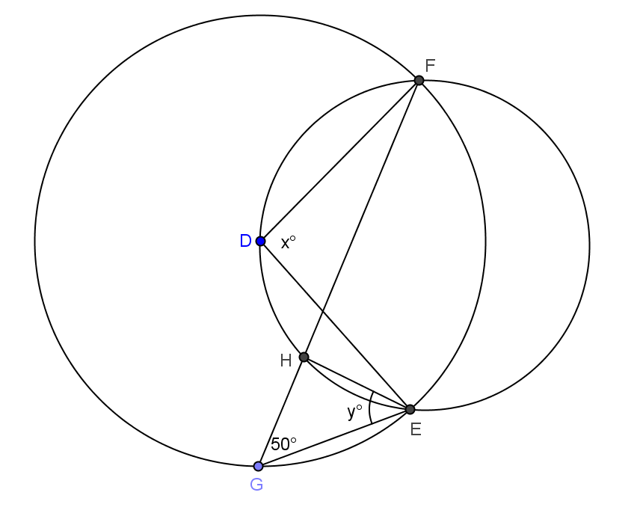

$x=100; y=50$

- How does this problem confirm the inscribed angle theorem?
$∠FDE$ is a central angle of the larger circle and is double $∠FGE$, the inscribed angle of the larger circle. $∠FDE$ is inscribed in the smaller circle and equal in measure to $∠FHE$, also inscribed in the smaller circle.

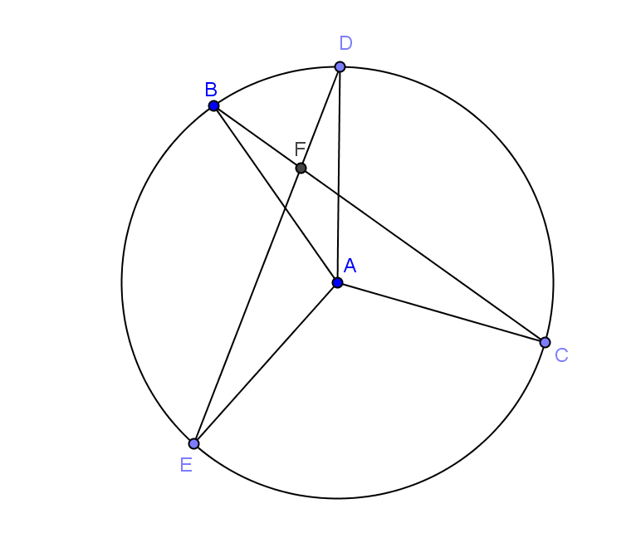
- In the figure below, $\overline{ED}$ and $\overline{BC}$ intersect at point $E$.
Prove: $m∠DAB+ m∠EAC=2(m∠BFD)$

Proof: Join $\overline{BE}$.

$m∠BED=\frac{1}{2}(m∠___________)$

$m∠EBC=\frac{1}{2}(m∠___________)$

In $△EBF$,

$m∠BEF+ m∠EBF=m∠___________$

$\frac{1}{2}(m∠___________) +\frac{1}{2}(m∠___________)=m∠___________$

$∴ m∠DAB+ m∠EAC=2(m∠BFD)$

$$BAD; EAC; BFD; DAB, EAC, BFD$$

