Lesson 5: Inscribed Angle Theorem and its Applications

Classwork
Opening Exercise
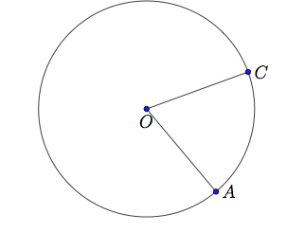
- $A$ and $C$ are points on a circle with center $O$.
  - Draw a point $B$ on the circle so that $\overline{AB}$ is a diameter. Then draw the angle $∠ABC$.

  - What angle in your diagram is an inscribed angle?

  - What angle in your diagram is a central angle?

  - What is the intercepted arc of angle $∠ABC$?

  - What is the intercepted arc of $∠AOC$ ?

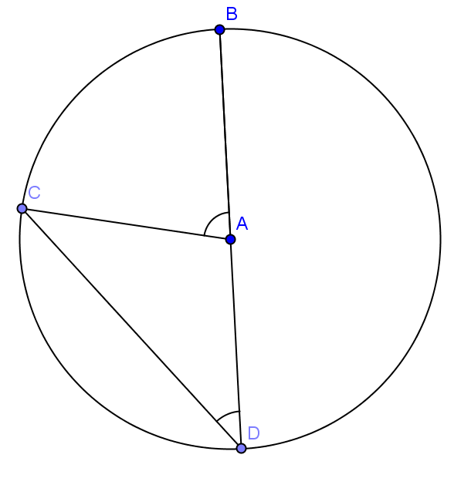
2. The measure of the inscribed angle is $x$ and the measure of the central angle is $y$. Find $m∠CAB$ in terms of $x$.

Example 1
$A$ and $C$ are points on a circle with center $O$.
  - What is the intercepted arc of $∠COA$? Color it red.

  - Draw triangle $AOC$. What type of triangle is it? Why?

  - What can you conclude about $m∠OCA$ and $m∠OAC$? Why?

  - Draw a point $B$ on the circle so that $O$ is in the interior of the inscribed angle $∠ABC$.

  - What is the intercepted arc of angle $∠ABC$? Color it green.

  - What do you notice about arc $\hat{AC}$?

  - Let the measure of $∠ABC$ be $x$ and the measure of $∠AOC$ be $y$. Can you prove that $y=2x$? (Hint: Draw the diameter that contains point$B$.)

  - Does your conclusion support the inscribed angle theorem?

  - If we combine the opening exercise and this proof, have we finished proving the inscribed angle theorem?

Example 2
$A$ and $C$ are points on a circle with center $O$.

  - Draw a point $B$ on the circle so that $O$ is in the exterior of the inscribed angle $∠ABC$.

  - What is the intercepted arc of angle $∠ABC$? Color it yellow.

  - Let the measure of $∠ABC$ be $x$, and the measure of $∠AOC$ be $y$. Can you prove that $y=2x$? (Hint: Draw the diameter that contains point$B$.)

  - Does your conclusion support the inscribed angle theorem?

  - Have we finished proving the inscribed angle theorem?

Exercises 1–5
- Find the measure of the angle with measure $x$.
- $m∠D = 25°$  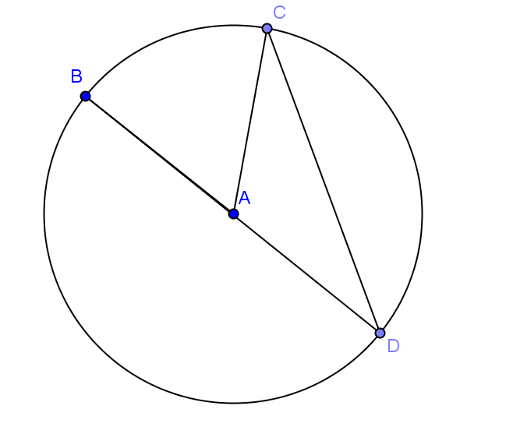  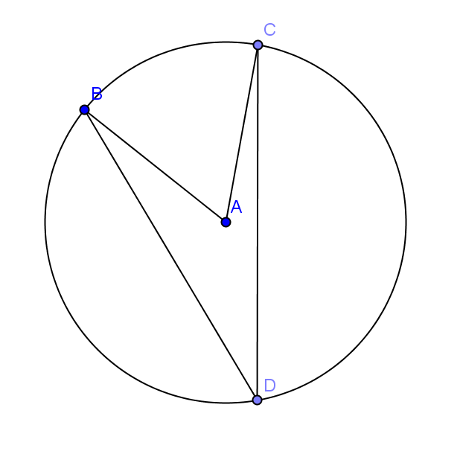  x  x | - $m∠D = 15°$ | - $m∠BAC = 90°$  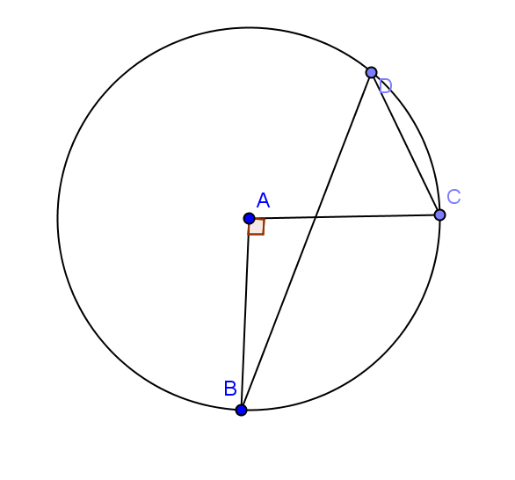  x  x
- $m∠B = 32°$  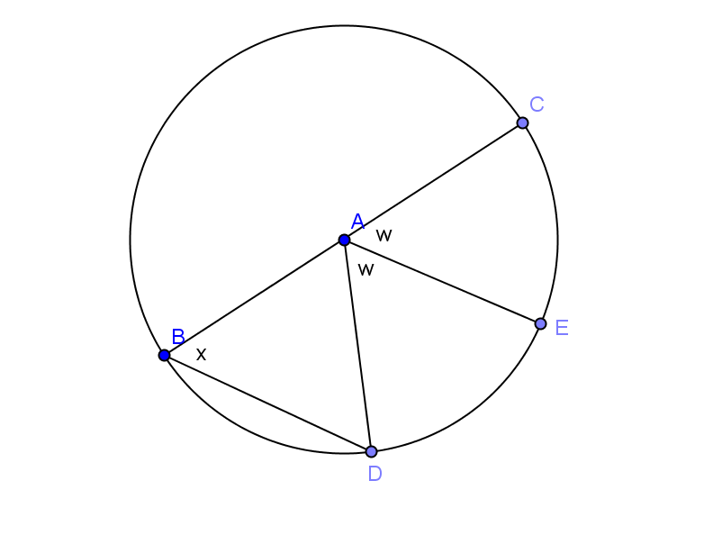  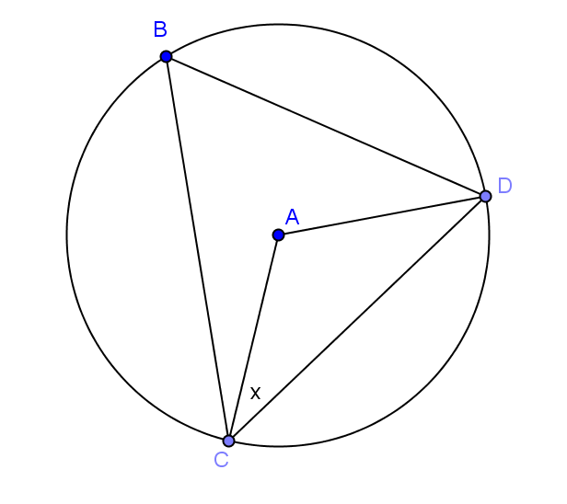 | 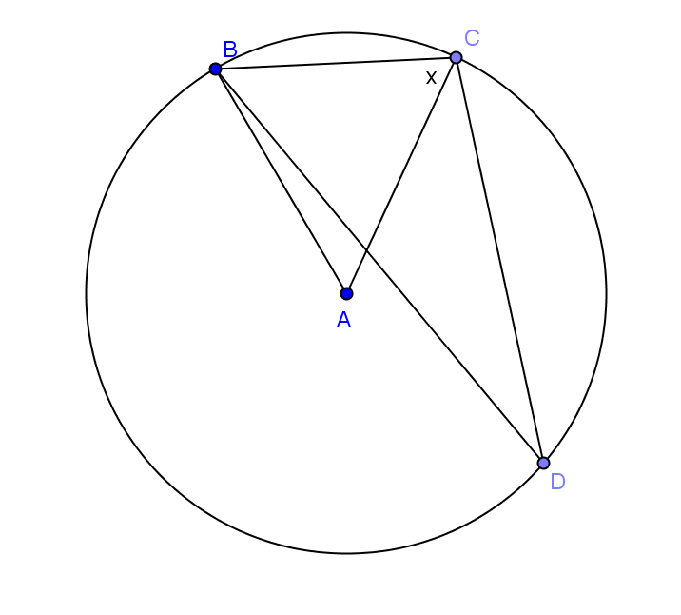 | - $m∠D = 19°$

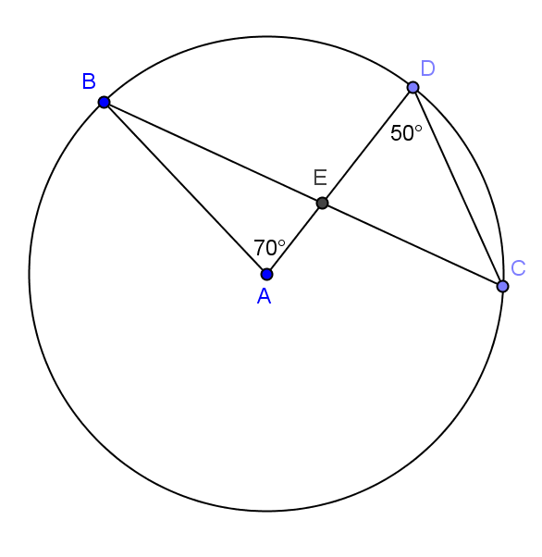
- Toby says$∆BEA$ is a right triangle because$m∠BEA=90°$. Is he correct? Justify your answer.

- Let’s look at relationships between inscribed angles.
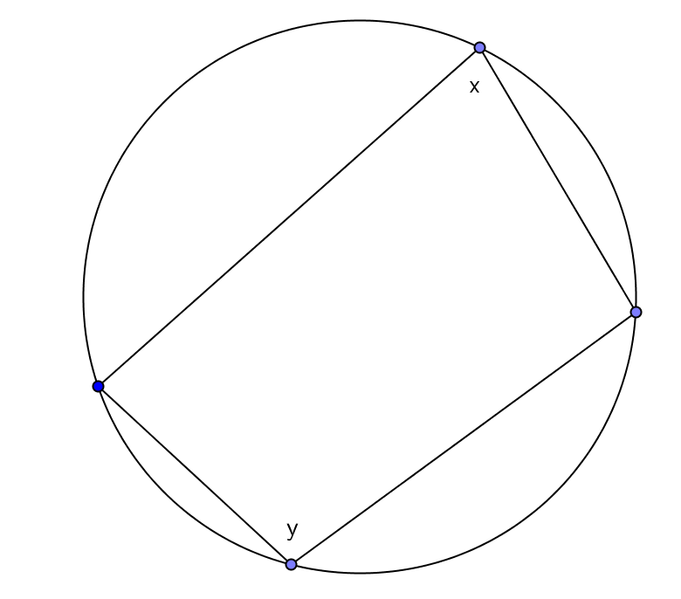
  - Examine the inscribed polygon below. Express $x$ in terms of $y$ and $y$ in terms of $x$. Are the opposite angles in any quadrilateral inscribed in a circle supplementary? Explain.

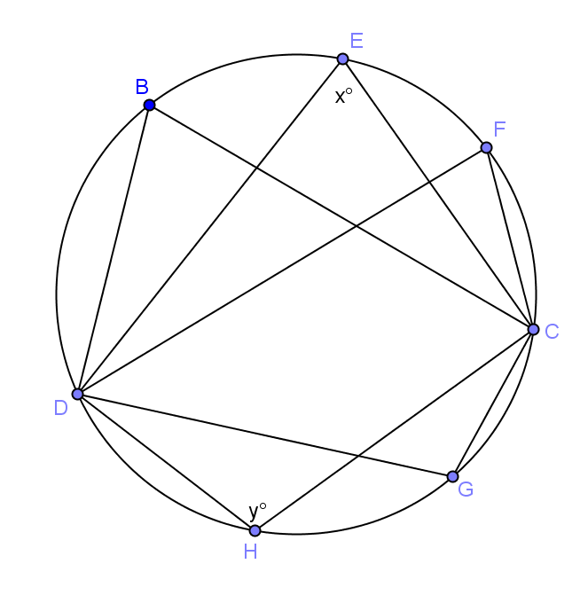
  - Examine the diagram below. How many angles have the same measure, and what are their measures in terms of $x$?

- Find the measures of the labeled angles.
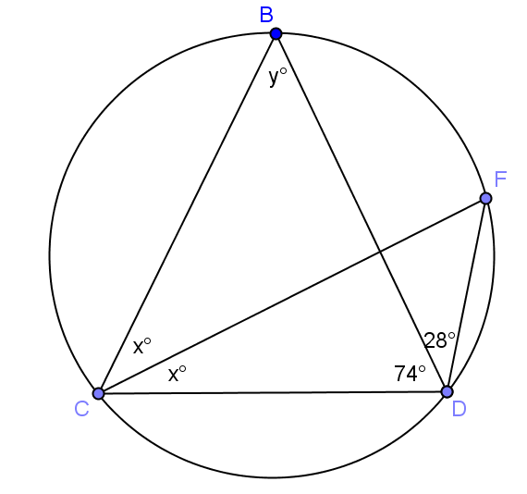 | 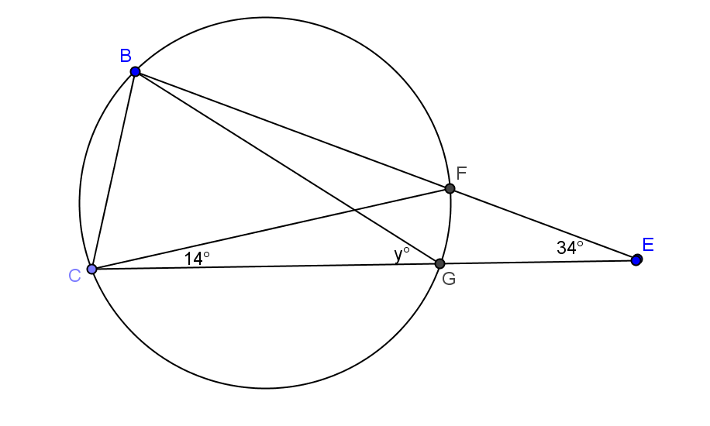
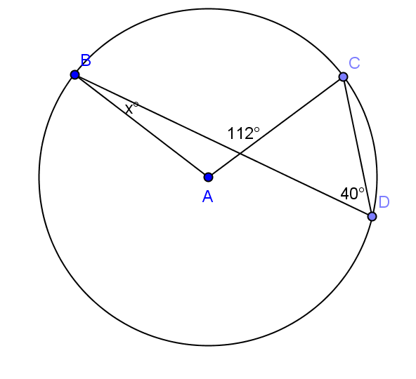 | 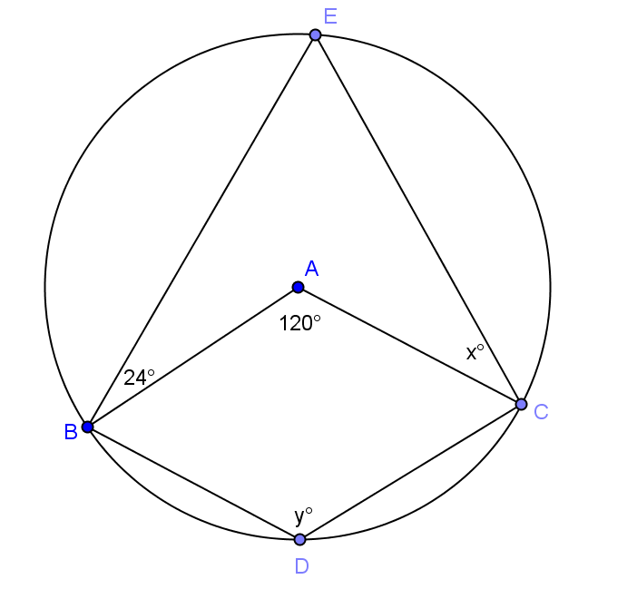
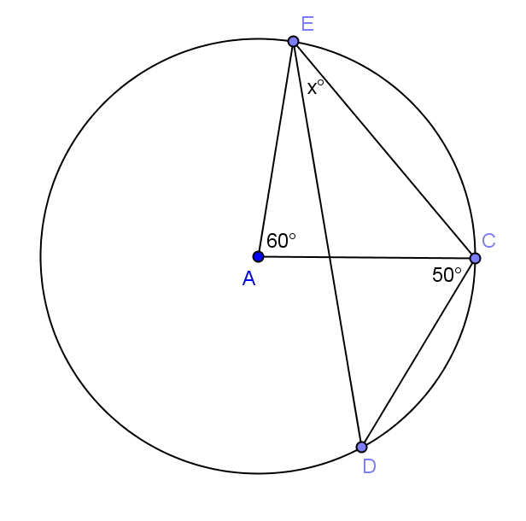 | 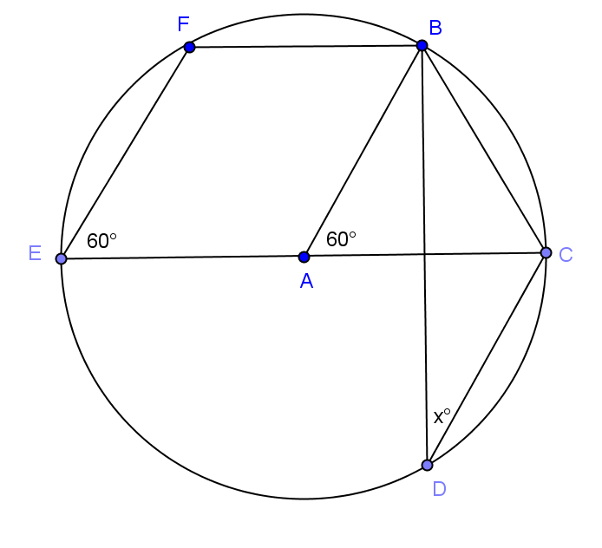
Lesson Summary
Theorems:
- The inscribed angle theorem: The measure of a central angle is twice the measure of any inscribed angle that intercepts the same arc as the central angle.
- Consequence of inscribed angle theorem: Inscribed angles that intercept the same arc are equal in measure.
Relevant Vocabulary
- Inscribed angle: An inscribed angle is an angle whose vertex is on a circle, and each side of the angle intersects the circle in another point.
- Intercepted arc: An angle intercepts an arc if the endpoints of the arc lie on the angle, all other points of the arc are in the interior of the angle, and each side of the angle contains an endpoint of the arc. An angle inscribed in a circle intercepts exactly one arc, in particular, the arc intercepted by a right angle is the semicircle in the interior of the angle.

Problem Set

Find the value of $x$ in each exercise.
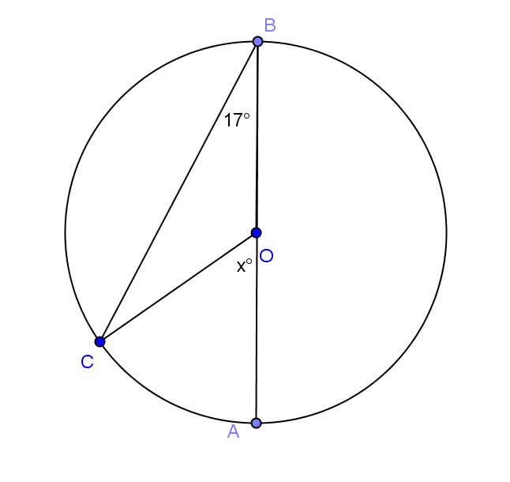 | 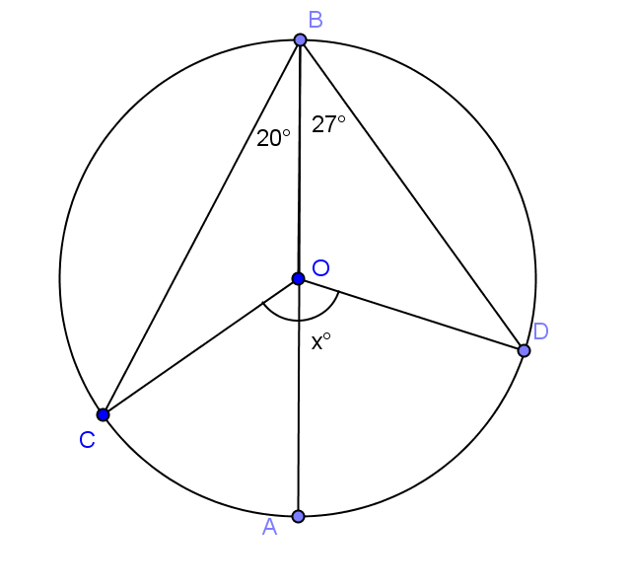
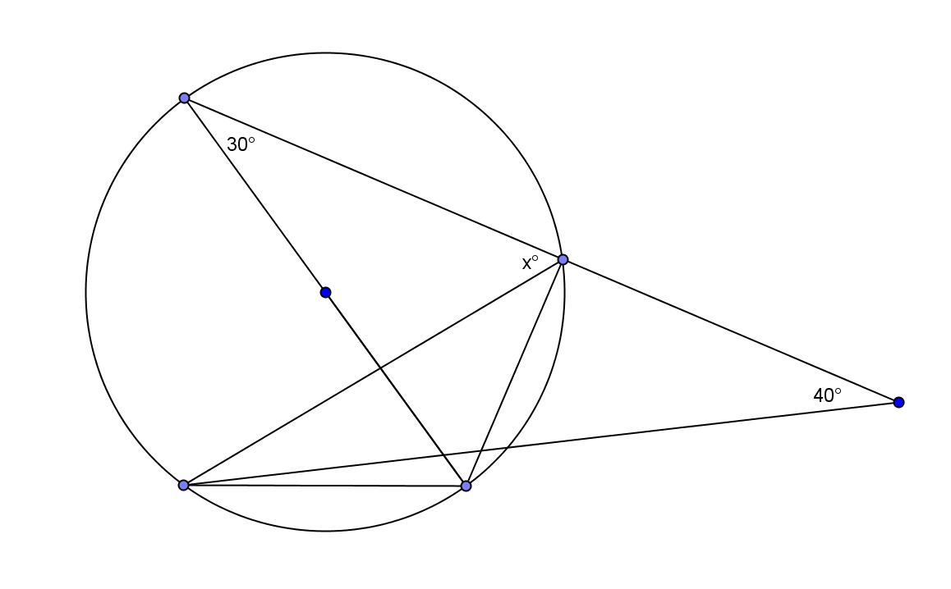
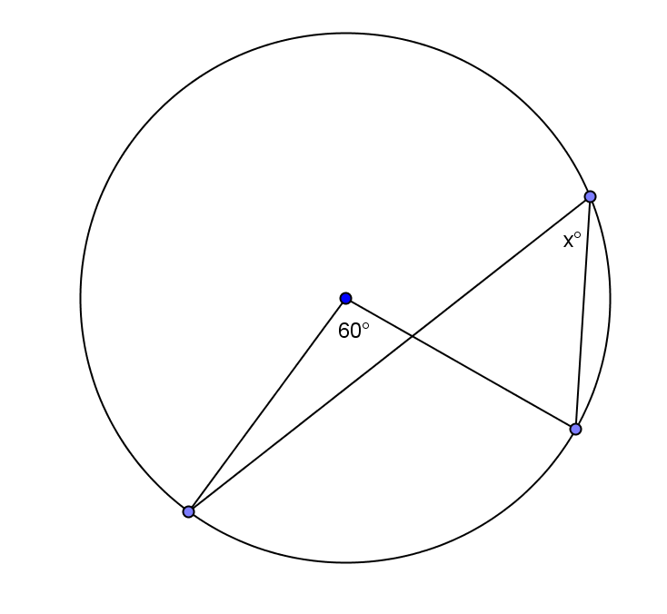
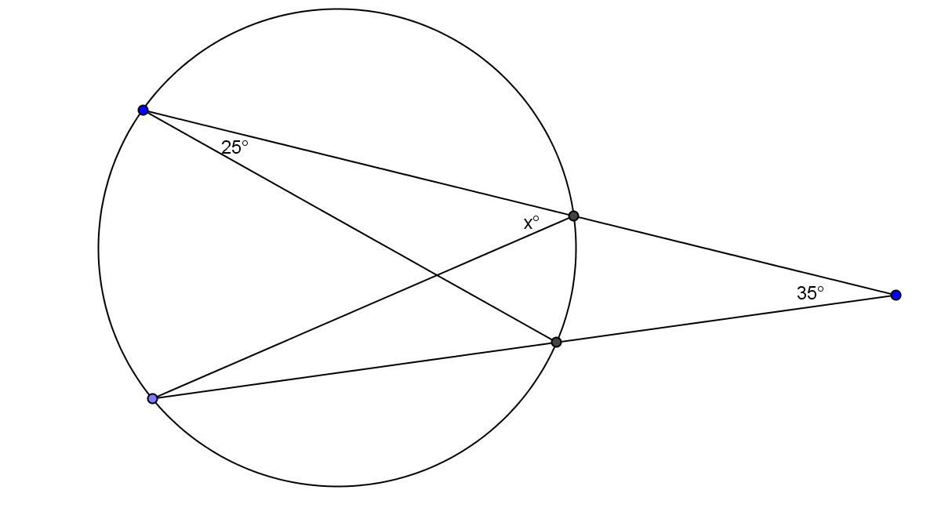
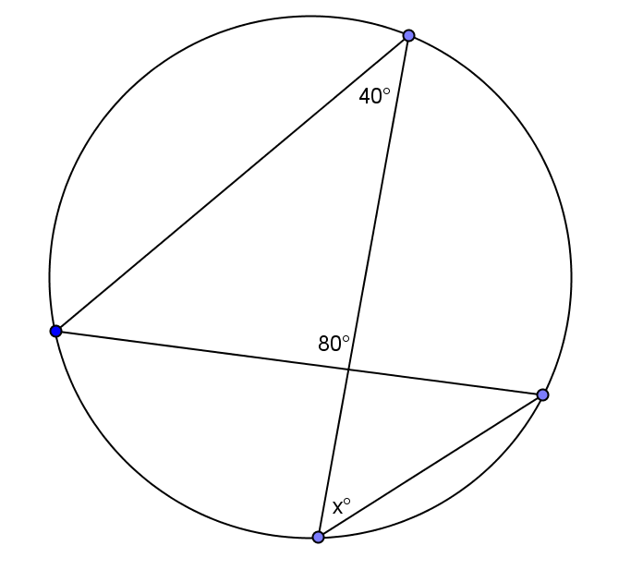
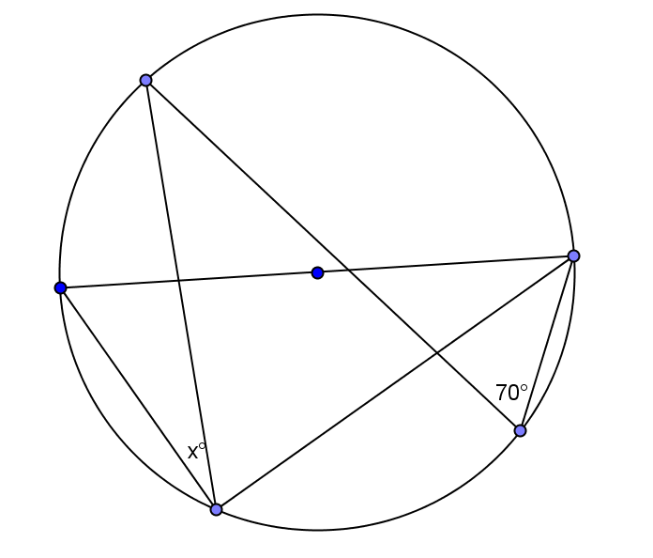 | 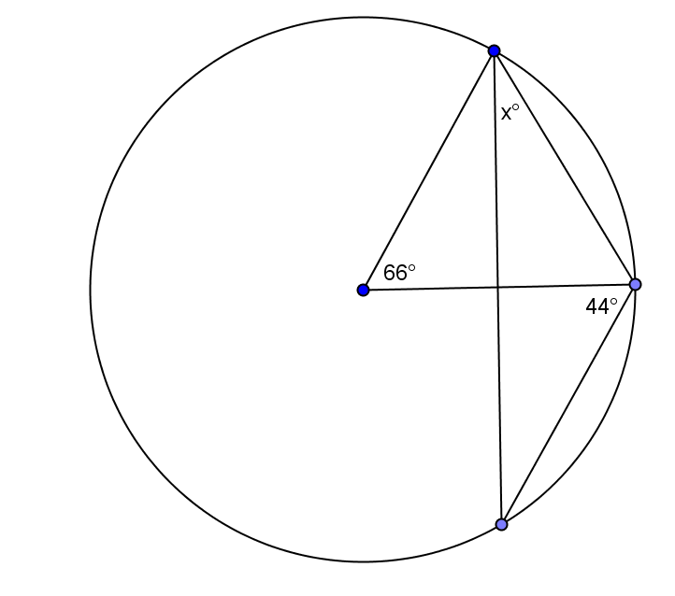

  - The two circles shown intersect at $E$and$F$. The center of the larger circle, $D$, lies on the circumference of the smaller circle. If a chord of the larger circle, $\overline{FG}$, cuts the smaller circle at $H$, find $x$ and $y$.
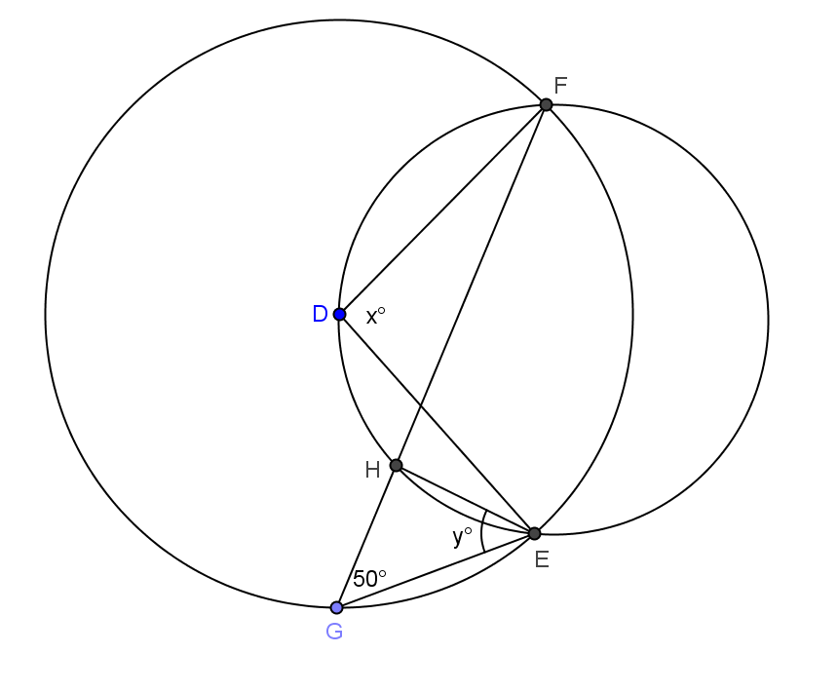

  - How does this problem confirm the inscribed angle theorem?

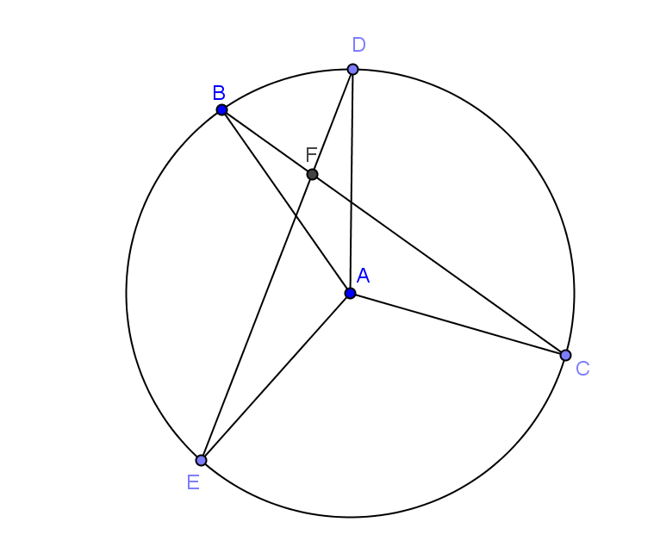
- In the figure below, $\overline{ED}$ and $\overline{BC}$ intersect at point E.
Prove: $m∠DAB+ m∠EAC=2(m∠BFD)$

Proof: Join $\overline{BE}$.
$$m∠BED= \frac{1}{2}(m∠___________)$$

$$m∠EBC= \frac{1}{2}(m∠___________)$$

In $∆EBF$,

$m∠BEF+ m∠EBF=m∠___________$

$$\frac{1}{2}(m∠___________) +\frac{1}{2}(m∠___________)=m∠___________$$

$∴ m∠DAB+ m∠EAC=2(m∠BFD)$

