|  |
| --- |
|  |

Lesson 4: Experiments with Inscribed Angles

Student Outcomes

* Explore the relationship between *inscribed angles* and *central angles* and their *intercepted arcs*.

Lesson Notes

As with Lesson 1 in this module, students use simple materials to explore the relationship between different types of angles in circles. In Lesson 1, the exploration was limited to angles inscribed in diameters; in this lesson, we extend the concept to include all inscribed angles.

This lesson sets up concepts taught in Lessons 5–7. Problem 6 of the Problem Set is particularly important in setting up Lesson 5. Problem 7 of the Problem Set is an extension and will be revisited in Lesson 7.

Classwork

Have available for each student (or group) a straight edge, white paper, and trapezoidal paper cutouts, created by slicing standard colored sheets of paper or cardstock from edge to edge using a paper cutter. There should be a variety of trapezoids with different acute angles available.

Opening Exercise (5 minutes)

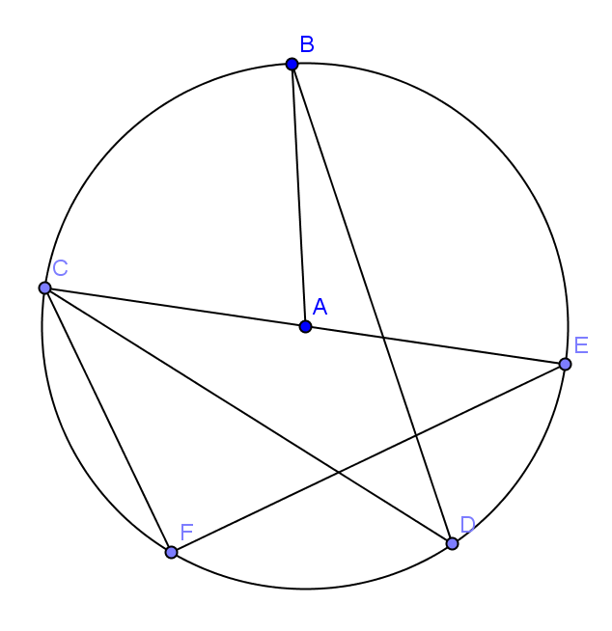Project the circle shown on the board. Have students identify the *central angle, inscribed angle, minor arc, major arc,* and *intercepted arc of an angle.* Have students write the definition of each in their own words, and then discuss the formal definitions. This vocabulary could be introduced with a series of prompts such as:

* is a minor arc. is a major arc. Explain the difference between a major arc and minor arc.
* is an inscribed angle. is a central angle. Explain the difference between an inscribed angle and a central angle.
* and both intercept arc . Explain what you think it means for an angle to intercept an arc.

Opening Exercise

Arc: **An arc is a portion of the circumference of a circle.**

Minor and major arc: **Let be a circle with center , and let and be different points that lie on but are not the endpoints of the same diameter. The minor arc is the set containing , , and all points of that are in the interior of . The major arc is the set containing , , and all points of that lie in the exterior of . Examples: Minor Arc . Major Arc . Answers will vary.**

Inscribed angle: **An inscribed angle is an angle whose vertex is on a circle and each side of the angle intersects the circle in another point. Examples: . Answers will vary.**

Central angle: **A central angle of a circle is an angle whose vertex is the center of a circle. Examples: Answers will vary.**

Intercepted arc of an angle. **An angle intercepts an arc if the endpoints of the arc lie on the angle, all other points of the arc are in the interior of the angle, and each side of the angle contains an endpoint of the arc. Examples: . Answers will vary.**

**Exploratory Challenge 1 (10 minutes)**

Exploratory Challenge 1

Your teacher will provide you with a straight edge, a sheet of colored paper in the shape of a trapezoid, and a sheet of plain white paper.

*Scaffolding:*

* If students are struggling with acute and obtuse angles of a trapezoid being supplementary, have them confirm by folding or tearing the trapezoid into segments containing the angles and putting them together as they did in Grade 5, Module 6.
* Display the definition of supplementary angles.
* Draw points no more than inches apart in the middle of the plain white paper, and label them and .
* Use the acute angle of your colored trapezoid to plot a point on the white sheet by placing the colored cutout so that the points and are on the edges of the acute angle and then plotting the position of the vertex of the angle. Label that vertex
* Repeat several times. Name the points , , ….

The students’ task is as appears below:



**A**

**B**

**C**

**D**

* As students receive their materials, ask them to label the acute angle of the trapezoid. What is the relationship between the acute angle and the obtuse angle?
  + *They are supplementary.*
* As students complete the point-plotting, ask, “What shape do the plotted points form?”
  + *The points seem to be the major arc of a circle.*
* How can you find the minor arc of the circle? Explain how you know.

**MP.3**

**&**

**MP.7**

* + *We can find the minor arc of the circle by pushing the supplementary angle of the trapezoid through the two original points from above. If the acute angle creates a major arc, the supplementary angle would produce a smaller (minor) arc.*
* How does this relate to the work we did on Thales’ theorem in Lesson 1?
  + *In Lesson 1, we showed that a triangle created by connecting the endpoints of a diameter with any other point on a circle is a right triangle. We used a right angle (a corner of a plain piece of paper) to create our original semicircle. Here, we are using the acute and obtuse angles of a trapezoid to create major and minor arcs of a circle.*

**Exploratory Challenge 2 (10 minutes)**

Have students further explore the angles formed by connecting points and in their drawing with any one of the points they marked at the vertex (…) as it was moved through points and .

* When you trace over the angles formed by points and and the vertex point (…) you marked, what do you notice about the measures of the angles you drew?
  + *All angles drawn with a vertex on the major arc have the same measure – the measure of the acute angle of the trapezoid.*
* What happens when you trace over the angles formed by points and and the vertex of the obtuse angle?
  + *All angles drawn with a vertex on the minor arc have the same measure – the measure of the obtuse angle of the trapezoid.*

Eexploratory Challenge 2

**MP.8**

* 1. Draw several of the angles formed by connecting points and on your paper with any of the additional points you marked as the acute angle was “pushed” through the points (, , ,…). What do you notice about the measures of these angles?

All angles have the same measure – the measure of the acute angle on the trapezoid.

* 1. Draw several of the angles formed by connecting points and on your paper with any of the additional points you marked as the obtuse angle was “pushed” through the points from above. What do you notice about the measures of these angles?

All angles have the same measure – the measure of the obtuse angle on the trapezoid.

**Exploratory Challenge 3 (10 minutes)**

Continue the exploration, providing each student with several copies of the circle at the end of the lesson, a straightedge, and scissors. They will select a point on the circle and create an inscribed angle. Each student will cut out his or her angle and compare it to the angle of several neighbors. All students started with the same arc thus, all inscribed angles will have the same measure. This can also be confirmed using protractors to measure the angles instead of cutting the angles out or modeled by the teacher.

Exploratory Challenge 3

* 1. Draw a point on the circle, and label it . Create angle .
  2. is called an inscribed angle. Can you explain why?

The vertex is on the circle, and the sides of the angle pass through points that are also on the circle.

* 1. Arc is called the intercepted arc. Can you explain why?

It is the arc cut in the circle by the inscribed angle.

* 1. Carefully cut out the inscribed angle, and compare it to the angles of several of your neighbors.
  2. What appears to be true about each of the angles you drew?

All appear to have the same measure.

* 1. Draw another point on a second circle, and label it point. Create angle , and cut it out. Compare and . What appears to be true about the two angles?

All appear to have the same measure.

* 1. What conclusion may be drawn from this? Will all angles inscribed in the circle from these two points have the same measure?

All angles inscribed in the circle from these two points will have the same measure.

* 1. Explain to your neighbor what you have just discovered.

**Exploratory Challenge 4 (3 minutes)**

Extend the exploration, using the circle given, select two points on the circle (B and C), and use those two points as endpoints of an intercepted arc for a central angle.

Exploratory Challenge 4

* 1. 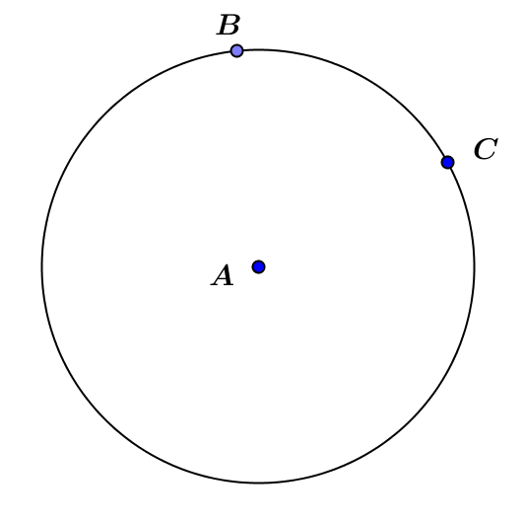In the circle below, draw the angle formed by connecting points and to the center of the circle.
  2. Is an inscribed angle? Explain.

No. The vertex is not on the circle; the vertex is the center of the circle.

* 1. Is it appropriate to call this *the* central angle? Why or why not?

The acute angle () is formed by connecting points and to the center point (), so it would be appropriate to call this a central angle.

* 1. What is the intercepted arc?

The intercepted arc is .

* 1. Is the measure of the same as the measure of one of the inscribed angles in Example 2?

No, the measure of is greater.

* 1. Can you make a prediction about the relationship between the inscribed angle and the central angle?

The inscribed angle is about half the central angle. The central angle is double the inscribed angle.

Closing (2 minutes)

Have students explain to a partner the answer to the prompt below, and then call the class together to review the Lesson Summary.

* What is the difference between an inscribed angle and a central angle?

Lesson Summary

**All inscribed angles from the same intercepted arc have the same measure.**

Relevant Vocabulary

* Arc: An *arc* is a portion of the circumference of a circle.
* Minor and major arc: Let be a circle with center , and let and be different points that lie on but are not the endpoints of the same diameter. The *minor arc* is the set containing , , and all points of that are in the interior of . The *major arc* is the set containing , , and all points of that lie in the exterior of *.*
* Inscribed angle: An *inscribed* *angle* is an angle whose vertex is on a circle, and each side of the angle intersects the circle in another point.
* Central angle: A *central angle* of a circle is an angle whose vertex is the center of a circle.
* Intercepted arc of an angle: An angle *intercepts* an arc if the endpoints of the arc lie on the angle, all other points of the arc are in the interior of the angle, and each side of the angle contains an endpoint of the arc.

Exit Ticket (5 minutes)

Name Date

Lesson 4: Experiments with Inscribed Angles

Exit Ticket

Joey marks two points on a piece of paper, as we did in the Exploratory Challenge, and labels them and . Using the trapezoid shown below, he pushes the acute angle through points and from below several times so that the sides of the angle touch points and , marking the location of the vertex each time. Joey claims that the shape he forms by doing this is the minor arc of a circle and that he can form the major arc by pushing the obtuse angle through points and from above. “The obtuse angle has the greater measure, so it will form the greater arc,” states Joey.

Ebony disagrees, saying that Joey has it backwards. “The acute angle will trace the major arc,” claims Ebony.



**A**

**B**

**C**

**D**

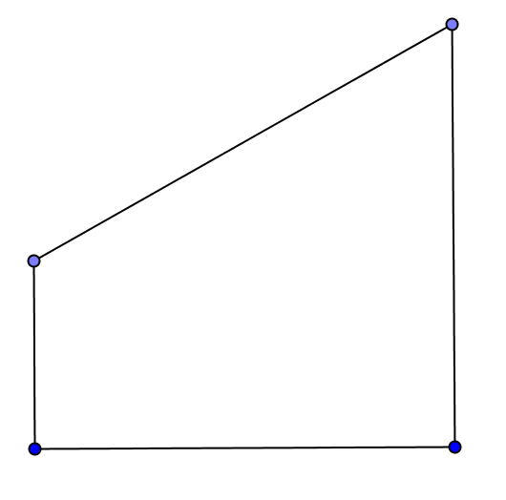

**C**

1. Who is correct, Joey or Ebony? Why?
2. How are the acute and obtuse angles of the trapezoid related?
3. If Joey pushes one of the right angles through the two points, what type of figure is created? How does this relate to the major and minor arcs created above?

Exit Ticket Sample Solutions

Joey marks two points on a piece of paper, as we did in the Exploratory Challenge, and labels them and . Using the trapezoid shown below, he pushes the acute angle through points and from below several times so that the sides of the angle touch points and , marking the location of the vertex each time. Joey claims that the shape he forms by doing this is the minor arc of a circle and that he can form the major arc by pushing the obtuse angle through points and from above. “The obtuse angle has the greater measure, so it will form the greater arc,” states Joey.

Ebony disagrees, saying that Joey has it backwards. “The acute angle will trace the major arc,” claims Ebony.



**A**

**B**

**C**

**D**



**C**

1. Who is correct, Joey or Ebony? Why?

***Ebony is correct. The acute angle vertex traces out the major arc of the circle.***

1. How are the acute and obtuse angles of the trapezoid related?

They are supplementary.

1. If Joey pushes one of the right angles through the two points, what type of figure is created? How does this relate to the major and minor arcs created above?

A semicircle is created. Both arcs will be the same measure ().

Problem Set Sample Solutions

1. Using a protractor, measure both the inscribed angle and the central angle shown on the circle below.

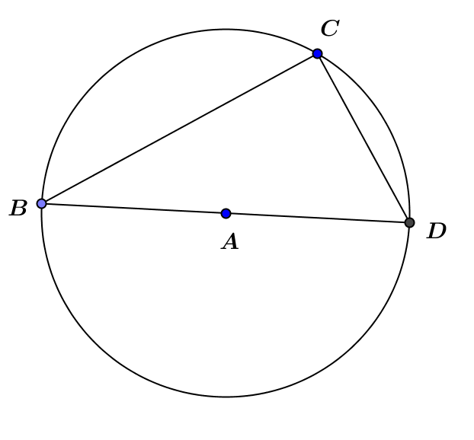

= __________ = __________

1. Using a protractor, measure both the inscribed angle and the central angle shown on the circle below.

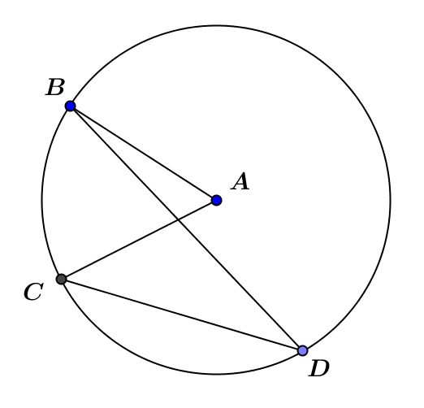

= __________ = __________

1. Using a protractor, measure both the inscribed angle and the central angle shown on the circle below.

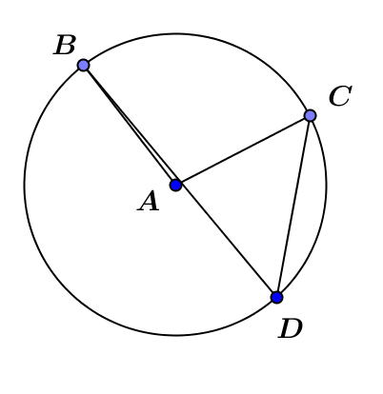

= __________ = __________

1. What relationship between the measure of the inscribed angle and the measure of the central angle that intercept the same arc is illustrated by these examples?

The measure of the inscribed angle appears to be half the measure of the central angle that intercepts the same arc.

1. Is your conjecture at least true for inscribed angles that measure ?

Yes, according to Thales’ theorem, if and are points on a circle where is a diameter of the circle, then is a right angle. Since a diameter represents an angle, our conjecture is always true for angles that measure .

1. 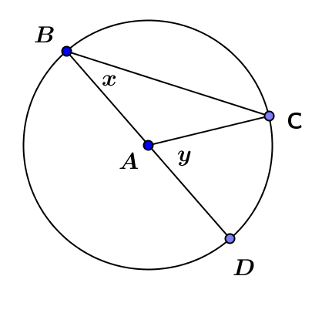Prove that in the diagram below.

is an isosceles triangle since all radii of a circle are congruent. Therefore, In addition, since the measure of an exterior angle of a triangle is equal to the sum of the measures of the opposite interior angles. By substitution, , or .

1. Red () and blue () lighthouses are located on the coast of the ocean. Ships traveling are in safe waters as long as the angle from the ship () to the two lighthouses () is always less than or equal to some angle called the “danger angle.” What happens to as the ship gets closer to shore and moves away from shore? Why do you think a larger angle is dangerous?

The closer the boat is to the shore, the larger will be, and as the boat moves away from shore, gets smaller. smaller means the ship is in deeper water, which is safer for ships.



**Blue ()**

**Red ()**

**Ship ()**

Example 2

