Lesson 4: Experiments with Inscribed Angles

Classwork

Opening Exercise

**Arc:**

**Minor and major arc:**

**Inscribed angle:**

**Central angle:**

**Intercepted arc of an angle:**

Exploratory Challenge 1

Your teacher will provide you with a straight edge, a sheet of colored paper in the shape of a trapezoid, and a sheet of plain white paper.

* Draw points no more than inches apart in the middle of the plain white paper, and label them and .
* Use the acute angle of your colored trapezoid to plot a point on the white sheet by placing the colored cutout so that the points and are on the edges of the acute angle and then plotting the position of the vertex of the angle. Label that vertex
* Repeat several times. Name the points , , ….

Exploratory Challenge 2

* 1. Draw several of the angles formed by connecting points and on your paper with any of the additional points you marked as the acute angle was “pushed” through the points (, , ,…). What do you notice about the measures of these angles?
  2. Draw several of the angles formed by connecting points and on your paper with any of the additional points you marked as the obtuse angle was “pushed” through the points from above. What do you notice about the measures of these angles?

Exploratory Challenge 3

* 1. Draw a point on the circle, and label it . Create angle .
  2. is called an inscribed angle. Can you explain why?
  3. Arc is called the intercepted arc. Can you explain why?
  4. Carefully cut out the inscribed angle, and compare it to the angles of several of your neighbors.
  5. What appears to be true about each of the angles you drew?
  6. Draw another point on a second circle, and label it point . Create angle , and cut it out. Compare and . What appears to be true about the two angles?
  7. What conclusion may be drawn from this? Will all angles inscribed in the circle from these two points have the same measure?
  8. Explain to your neighbor what you have just discovered.

Exploratory Challenge 4

* 1. In the circle below, draw the angle formed by connecting points and to the center of the circle.

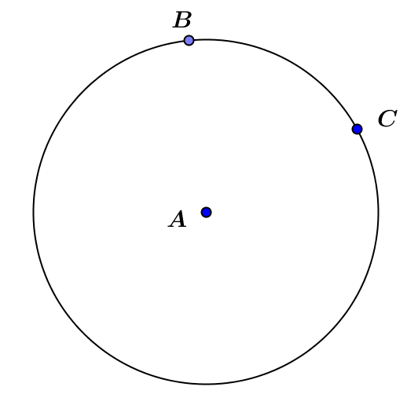

* 1. Is an inscribed angle? Explain.

* 1. Is it appropriate to call this *the* central angle? Why or why not?
  2. What is the intercepted arc?
  3. Is the measure of the same as the measure of one of the inscribed angles in Example 2?
  4. Can you make a prediction about the relationship between the inscribed angle and the central angle?

Lesson Summary

All inscribed angles from the same intercepted arc have the same measure.

**Relevant Vocabulary**

* Arc: An *arc* is a portion of the circumference of a circle.
* Minor and major arc: Let be a circle with center , and let and be different points that lie on but are not the endpoints of the same diameter. The *minor arc* is the set containing , , and all points of that are in the interior of . The *major arc* is the set containing , , and all points of that lie in the exterior of *.*
* Inscribed angle: An *inscribed* *angle* is an angle whose vertex is on a circle, and each side of the angle intersects the circle in another point.
* Central angle: A *central angle* of a circle is an angle whose vertex is the center of a circle.
* Intercepted arc of an angle: An angle *intercepts* an arc if the endpoints of the arc lie on the angle, all other points of the arc are in the interior of the angle, and each side of the angle contains an endpoint of the arc.

Problem Set

1. Using a protractor, measure both the inscribed angle and the central angle shown on the circle below.

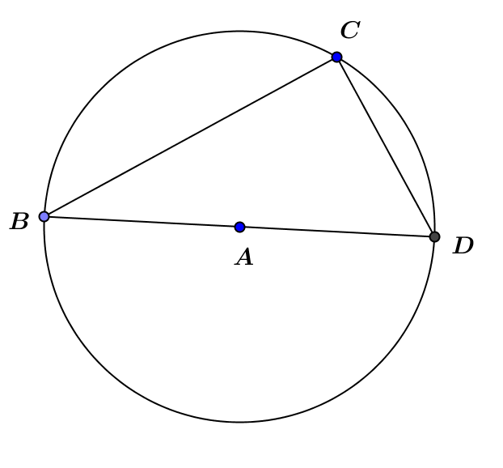

= __________ = __________

1. 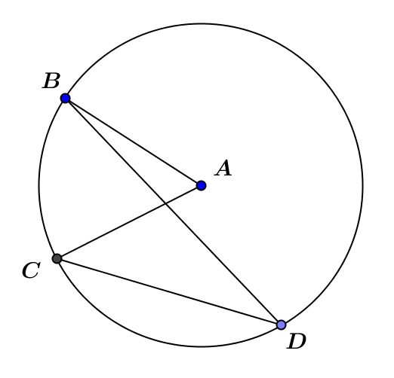Using a protractor, measure both the inscribed angle and the central angle shown on the circle below.

= __________ = __________

1. Using a protractor, measure both the inscribed angle and the central angle shown on the circle below.

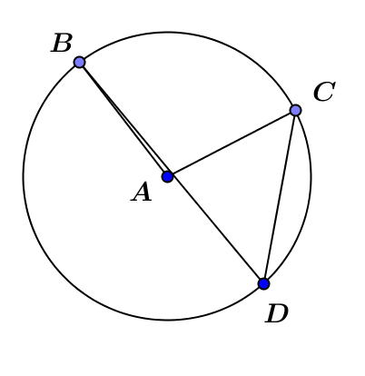 = __________ = __________

1. What relationship between the measure of the inscribed angle and the measure of the central angle that intercept the same arc is illustrated by these examples?
2. Is your conjecture at least true for inscribed angles that measure ?
3. Prove that in the diagram below.

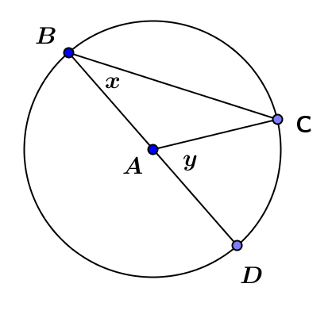

1. Red () and blue () lighthouses are located on the coast of the ocean. Ships traveling are in safe waters as long as the angle from the ship () to the two lighthouses () is always less than or equal to some angle called the “danger angle.” What happens to as the ship gets closer to shore and moves away from shore? Why do you think a larger angle is dangerous?



**Blue ()**

**Red ()**

**Ship ()**