Lesson 3: Rectangles Inscribed in Circles

Student Outcomes
- Inscribe a rectangle in a circle.
- Understand the symmetries of inscribed rectangles across a diameter.

Lesson Notes
Have students use a compass and straightedge to locate the center of the circle provided. If necessary, remind students of their work in Module 1 on constructing a perpendicular to a segment and of their work in Lesson 1 in this module on Thales’ theorem. Standards addressed with this lesson are G-C.A.2 and G-C.A.3.
Scaffolding:
Display steps to construct a perpendicular line at a point.
- Draw a segment through the point, and using a compass mark a point equidistant on each side of the point.
- Label the endpoints of the segment $A$ and $B$.
- Draw circle $A$ with center $A$ and radius $\overline{AB}$.
- Draw circle $B$ with center $B$ and radius $\overline{BA}$.
- Label the points of intersection as $C$ and $D$.
- Draw $\overset{⃡}{CD}$.
- For students struggling with constructions due to eye-hand coordination or fine motor difficulties, provide set squares to construct perpendicular lines and segments.
- For advanced learners, give directions without steps and have them construct from memory.
Classwork
Opening Exercise (9 minutes)
Students will follow the steps provided and use a compass and straightedge to find the center of a circle. This exercise reminds students about constructions previously studied that will be needed in this lesson and later in this module.
Opening Exercise
Using only a compass and straightedge, find the location of the center of the circle below. Follow the steps provided.

- Draw chord $\overline{AB}$.
- Construct a chord perpendicular to $\overline{AB}$ at endpoint $B$.
- Mark the point of intersection of the perpendicular chord and the circle as point $C$.
- $\overline{AC}$is a diameter of the circle. Construct a second diameter in the same way.
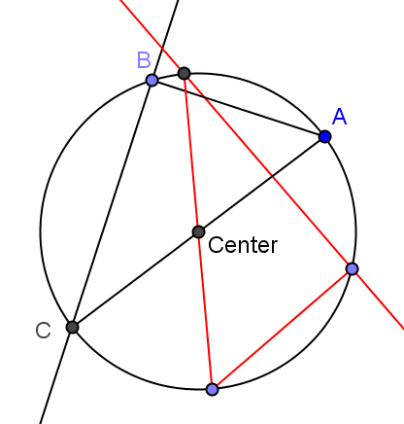
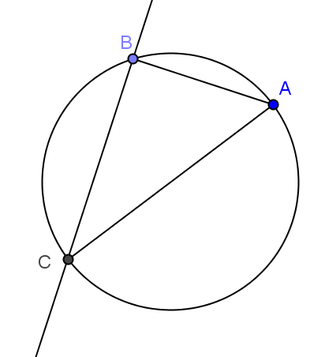
- Where the two diameters meet is the center of the circle.

Explain why the steps of this construction work.
The center is equidistant from all points on the circle. Since the diameter goes through the center, the intersection of any two diameters is a point on both diameters and must be the center.

Exploratory Challenge (10 minutes)
Guide students in constructing a rectangle inscribed in a circle by constructing a right triangle (as in the Opening Exercise) and rotating the triangle about the center of the circle. Have students explore an alternate method, such as drawing a single chord, then constructing perpendicular chords three times. Review relevant vocabulary.
MP.1
- How can you use a right triangle (such as the one you constructed in the Opening Exercise above) to produce a rectangle whose four vertices lie on the circle?
  - We can rotate the triangle $180°$ around the center of the circle (or around the midpoint of the diameter, which is the same thing).

Exploratory Challenge
Construct a rectangle such that all four vertices of the rectangle lie on the circle below.

- Suppose we wanted to construct a rectangle with vertices on the circle, but we didn't want to use a triangle. Is there a way we could do this? Explain.
  - We can construct a chord anywhere on the circle, then construct the perpendicular to one of its endpoints, and then repeat this twice more to construct our rectangle.
- How can you be sure that the figure in the second construction is a rectangle?
  - We know it is a rectangle because all four angles are right angles.

Relevant Vocabulary
Inscribed polygon: A polygon is inscribed in a circle if all vertices of the polygon lie on the circle.

Exercises 1–5 (20 minutes)
For each exercise, ask students to explain why the construction is certain to produce the requested figure and to explain the symmetry across the diameter of each inscribed figure. Before students begin the exercises, ask the class, “What is symmetry?” Have a discussion, and let the students explain symmetry in their own words. They should describe symmetry as a reflection across an axis so that a figure lies on itself. Exercise 5 is a challenge exercise and can either be assigned to advanced learners or covered as a teacher-led example. In Exercise 5, students prove the converse of Thales’ theorem that they studied in Lesson 1.

Exercises 1–5
- Construct a kite inscribed in the circle below, and explain the construction using symmetry.

Construct $△ABC$ as before, but this time reflect it across the diameter. It is a kite because, by reflection, there are two opposite pairs of congruent adjacent sides.

- Given a circle and a rectangle, what must be true about the rectangle for it to be possible to inscribe a congruent copy of it in the circle?
The diagonals of the rectangle must be the length of the diameter of the circle.

- The figure below shows a rectangle inscribed in a circle.

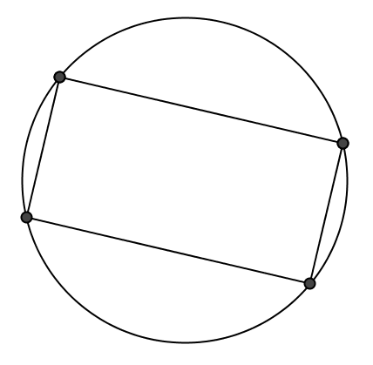

  - List the properties of a rectangle.
Opposite sides parallel and congruent, four right angles, diagonals congruent, and bisect each other.

  - List all the symmetries this diagram possesses.
Opposite sides are congruent, all four angles are congruent, diagonals are congruent, the figure may be reflected onto itself across the perpendicular bisector of the sides of the rectangle, the figure may be rotated onto itself with either a $180°$ or a $360°$ rotation either clockwise or counterclockwise.

  - List the properties of a square.
Opposite sides parallel, all sides congruent, four right angles, diagonals congruent, bisect each other, and are perpendicular.

  - List all the symmetries of the diagram of a square inscribed in a circle.
In addition to the symmetries listed above, all four sides are congruent, the figure may be reflected onto itself across the diagonals of the square, the figure may be rotated onto itself with either a $90°$ or a $270°$ rotation either clockwise or counterclockwise.

- A rectangle is inscribed into a circle. The rectangle is cut along one of its diagonals and reflected across that diagonal to form a kite. Draw the kite and its diagonals. Find all the angles in this new diagram, given that the acute angle between the diagonals of the rectangle in the original diagram was $40°$.
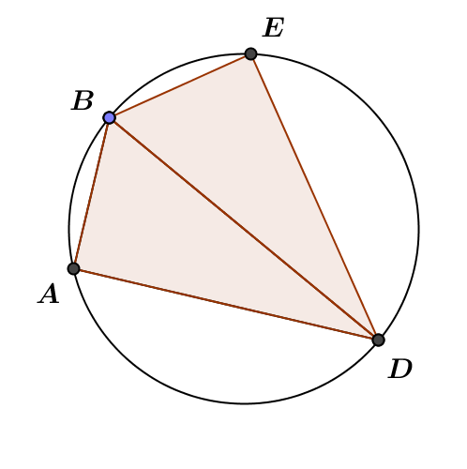
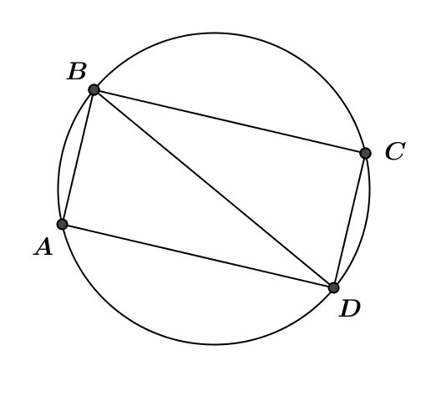
Draw diagrams such as the following:

Given $m∠ADB=40°$. Then $m∠BDE=40°$;$m∠BAD=m∠BED=90°$; $m∠ABD=m∠EBD=50°$;$m∠ABE=100°$; $m∠ADE=80°$.

- CHALLENGE: Show that the 3 vertices of a right triangle are equidistant from the midpoint of the hypotenuse by showing that the perpendicular bisectors of the legs pass through the midpoint of the hypotenuse. (This is called the Side-splitter theorem.)
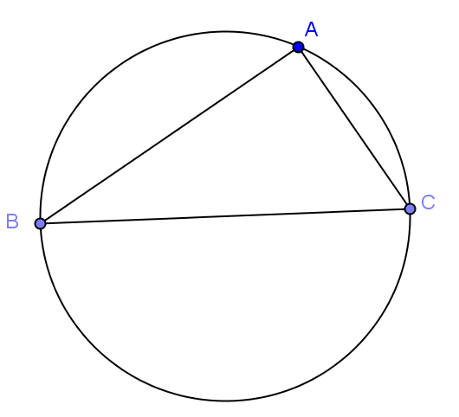
- Draw the perpendicular bisectors of $\overline{AB}$and$\overline{AC}$.

- Label the point where they meet $P$. What is point $P$?
The center of the circle.

- What can be said about the distance from $P$ to each vertex of the triangle? What is the relationship between the circle and the triangle?
Point $P$ is equidistant from the three vertices of the triangle $A$, $B,$ and $C,$ so the circle is circumscribed about $△ABC$.

- Repeat this process, this time sliding $B$ to another place on the circle and call it $B'$. What do you notice?
You get the same center.

- Using what you have learned about angles, chords, and their relationships, what does the position of point $P$ depend on? Why?
The position of $P$ depends only on $m∠ABC$, not the position of $B$ as long as $B$ and $B'$ are on the same side of $\overline{AC}.$ $∠ABC$ and $∠AB'C$ have the same measure because they are inscribed in the same arc. The center of the circle in both cases is $P$.

Closing (1 minute)
Have students discuss the question with a neighbor or in groups of 3. Call the class back together and review the definition below.
- Explain how the symmetry of a rectangle across the diameter of a circle helps inscribe a rectangle in a circle.
  - Since the rectangle is composed of two right triangles with the diameter as the hypotenuse, it is possible to construct one right triangle and then reflect it across the diameter.
Lesson Summary
Relevant Vocabulary
Inscribed polygon: A polygon is inscribed in a circle if all vertices of the polygon lie on the circle.

Exit Ticket (5 minutes)
Name Date
Lesson 3: Rectangles Inscribed in Circles

Exit Ticket

Rectangle $ABCD$ is inscribed in circle $P$. Boris says that diagonal $AC$ could pass through the center, but it does not have to pass through the center. Is Boris correct? Explain your answer in words, or draw a picture to help you explain your thinking.

Exit Ticket Sample Solutions

Rectangle $ABCD$ is inscribed in circle $P$. Boris says that diagonal $AC$ could pass through the center, but it does not have to pass through the center. Is Boris correct? Explain your answer in words, or draw a picture to help you explain your thinking.
Boris is not correct. Since each vertex of the rectangle is a right angle, the hypotenuse of the right triangle formed by each angle and the diagonal of the rectangle must be the diameter of the circle (by the work done in Lesson 1 of this module). The diameter of the circle passes through the center of the circle; therefore, the diagonal passes through the center.

Problem Set Sample Solutions

- Using only a piece of $8.5×11$ inch copy paper and a pencil, find the location of the center of the circle below.

Lay the paper across the circle so that its corner lies on the circle. The points where the two edges of the paper cross the circle are the endpoints of a diameter. Mark those points, and draw the diameter using the edge of the paper as a straightedge. Repeat to get a second diameter. The intersection of the two diameters is the center of the circle.

- Is it possible to inscribe a parallelogram that is not a rectangle in a circle?
No, although it is possible to construct an inscribed polygon with one pair of parallel sides (i.e., a trapezoid); a parallelogram requires that both pairs of opposite sides be parallel and both pairs of opposite angles be congruent. A parallelogram is symmetric by 180 degree rotation about its center and has NO other symmetry unless it is a rectangle. Two parallel lines and a circle create a figure that is symmetric by a reflection across the line through the center of the circle that is perpendicular to the two lines. If a trapezoid is formed with vertices where the parallel lines meet the circle, the trapezoid has reflectional symmetry. Therefore, it cannot be a parallelogram-—-UNLESS it is a rectangle.

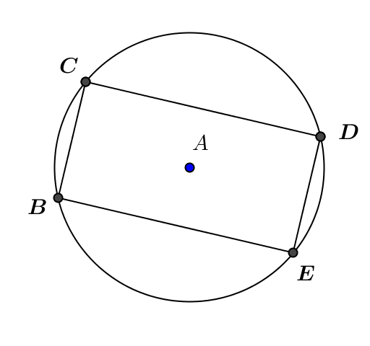
- In the figure, $BCDE$ is a rectangle inscribed in circle $A$. $DE=8$; $BE=12$. Find $AE$.
$$2\sqrt{13}$$

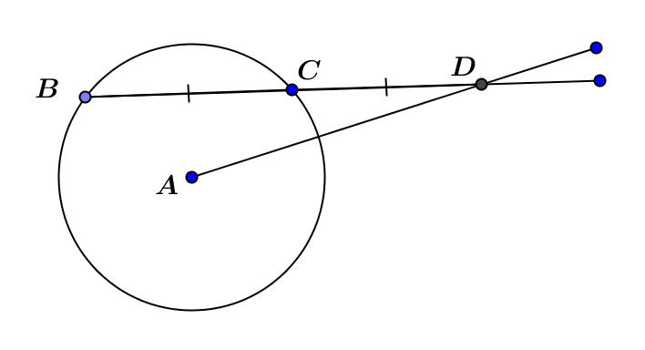
- Given the figure, $BC=CD=8$ and $AD=13$.
Find the radius of the circle.
Mark the midpoint of $\overline{BC}$ as point $E$. $BE=EC=4$, so $ED=12$. $△EAD$ is a right triangle, so by the Pythagorean theorem,
$EA=5$. Using the Pythagorean theorem again givens
$AC=\sqrt{41}$.

- In the figure, $\overline{\overline{DF}}$and $\overline{BG}$ are parallel chords $14$ cm apart. $DF=12$cm, $AB=10$ cm, and $\overline{EH}⊥\overline{BG}$.
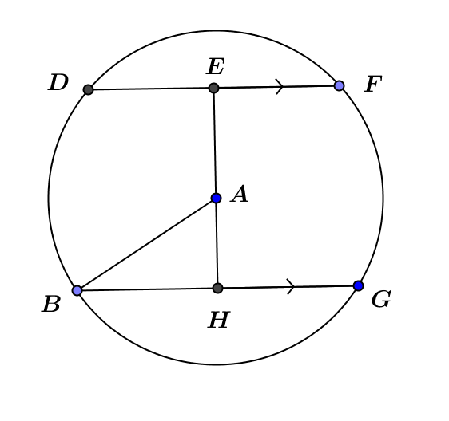
Find $BG$.
Draw $△DEA$. $m∠DEA=90°$, $DE=6$, $DA=10$. By Pythagorean theorem, $EA=8$.
In $△ABH$, $m∠AHB=90°$, $AB=10$, $AH=6$, so $BH=8$. This means $BG=16$.
$16$ cm

- Use perpendicular bisectors of the sides of a triangle to construct a circle that circumscribes the triangle.
(Students did a construction similar to this in Geometry, Module 1, Lesson 4).
Draw any triangle.
Construct the perpendicular bisector of the sides.
The perpendicular bisectors meet at the circumcenter.
Using the center and the distance to one vertex as a radius, draw the circle.

