Lesson 3: Rectangles Inscribed in Circles

Classwork
Opening Exercise
Using only a compass and straightedge, find the location of the center of the circle below. Follow the steps provided.
- Draw chord $\overline{AB}$.
- Construct a chord perpendicular to $\overline{AB}$ at endpoint $B$.
- Mark the point of intersection of the perpendicular chord and the circle as point $C$.
- $\overline{AC}$ is a diameter of the circle. Construct a second diameter in the same way.
- Where the two diameters meet is the center of the circle.

Explain why the steps of this construction work.

Exploratory Challenge
Construct a rectangle such that all four vertices of the rectangle lie on the circle below.

Exercises
- Construct a kite inscribed in the circle below, and explain the construction using symmetry.

- Given a circle and a rectangle, what must be true about the rectangle for it to be possible to inscribe a congruent copy of it in the circle?

- The figure below shows a rectangle inscribed in a circle.
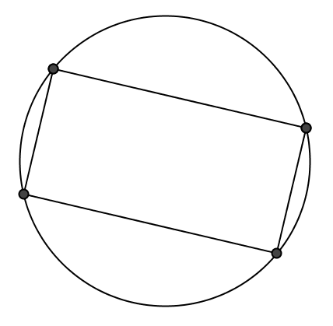
  - List the properties of a rectangle.

  - List all the symmetries this diagram possesses.

  - List the properties of a square.

  - List all the symmetries of the diagram of a square inscribed in a circle.

- A rectangle is inscribed into a circle. The rectangle is cut along one of its diagonals and reflected across that diagonal to form a kite. Draw the kite and its diagonals. Find all the angles in this new diagram, given that the acute angle formed by the diagonal of the rectangle in the original diagram was $40°$.

- Challenge: Show that the three vertices of a right triangle are equidistant from the midpoint of the hypotenuse by showing that the perpendicular bisectors of the legs pass through the midpoint of the hypotenuse.
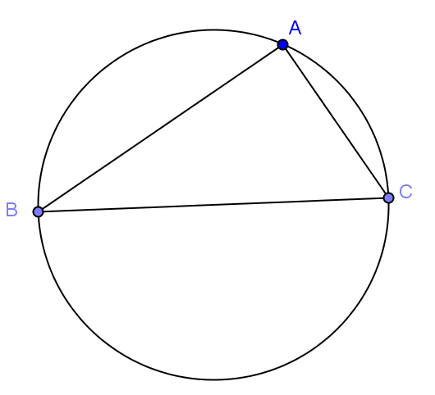
  - Draw the perpendicular bisectors of $\overline{AB}$ and $\overline{AC}$.

  - Label the point where they meet $P$. What is point $P$?

  - What can be said about the distance from $P$ to each vertex of the triangle? What is the relationship between the circle and the triangle?

  - Repeat this process, this time sliding $B$ to another place on the circle and call it $B'$. What do you notice?

  - Is there a relationship between $m∠ABC$ and $m∠AB'C$? Explain.

Lesson Summary
Relevant Vocabulary
Inscribed Polygon: A polygon is inscribed in a circle if all vertices of the polygon lie on the circle.
Problem Set

Figures are not drawn to scale.
- Using only a piece of $8.5×11$ inch copy paper and a pencil, find the location of the center of the circle below.

- Is it possible to inscribe a parallelogram that is not a rectangle in a circle?

- In the figure, $BCDE$ is a rectangle inscribed in circle $A$. $DE=8;BE=12$. Find $AE$.
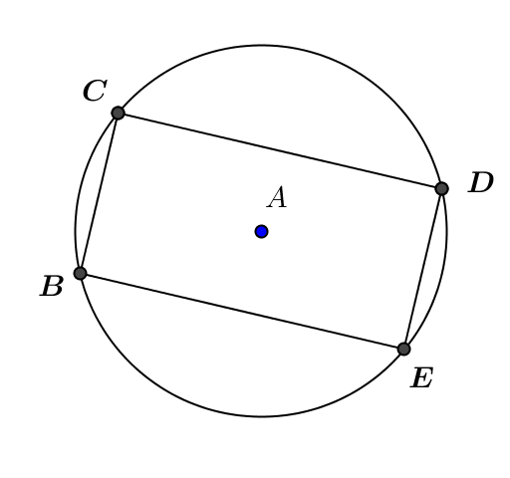

- Given the figure, $BC=CD=8$ and $AD=13$. Find the radius of the circle.
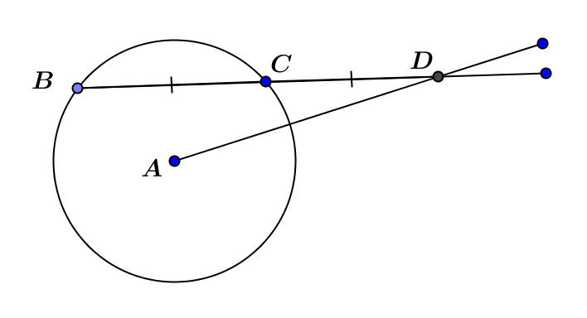
- In the figure, $\overline{DF}$ and $\overline{BG}$ are parallel chords $14 cm$ apart. $DF=12 cm$, $AB=10 cm$, and $\overline{EH}⊥\overline{BG}$. Find $BG$.
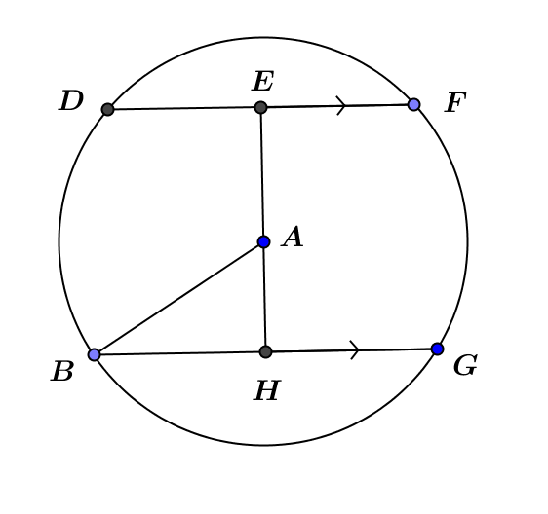

- Use perpendicular bisectors of the sides of a triangle to construct a circle that circumscribes the triangle.

