Lesson 2: Circles, Chords, Diameters, and Their Relationships

Student Outcomes
- Identify the relationships between the diameters of a circle and other chords of the circle.

Lesson Notes
Students are asked to construct the perpendicular bisector of a line segment and draw conclusions about points on that bisector and the endpoints of the segment. They relate the construction to the theorem stating that any perpendicular bisector of a chord must pass through the center of the circle.

Classwork
Opening Exercise (4 minutes)
Scaffolding:
Post a diagram and display the steps to create a perpendicular bisector used in Lesson 4 of Module 1.
- Label the endpoints of the segment $A$ and $B$.
- Draw circle $A$ with center $A$ and radius $\overline{AB}$.
- Draw circle $B$ with center $B$ and radius $\overline{BA}$.
- Label the points of intersection as $C$ and $D$.
- Draw $\overset{⃡}{CD}$.

Opening Exercise
Construct the perpendicular bisector of line segment $\overline{AB}$ below (as you did in Module 1).
Draw another line that bisects $\overline{AB}$ but is not perpendicular to it.
List one similarity and one difference between the two bisectors.
Answers will vary. All points on the perpendicular bisector are equidistant from points $A$ and $B$. Points on the other bisector are not equidistant from points A and B. The perpendicular bisector meets $\overline{AB}$ at right angles. The other bisector meets at angles that are not congruent.

You may wish to recall for students the definition of equidistant:
Equidistant:. A point $A$ is said to be equidistant from two different points $B$ and $C$ if $AB=AC$.
Points $B$ and $C$ can be replaced in the definition above with other figures (lines, etc.) as long as the distance to those figures is given meaning first. In this lesson, we will define the distance from the center of a circle to a chord. This definition will allow us to talk about the center of a circle as being equidistant from two chords.

Discussion (12 minutes)
Ask students independently or in groups to each draw chords and describe what they notice. Answers will vary depending on what each student drew.
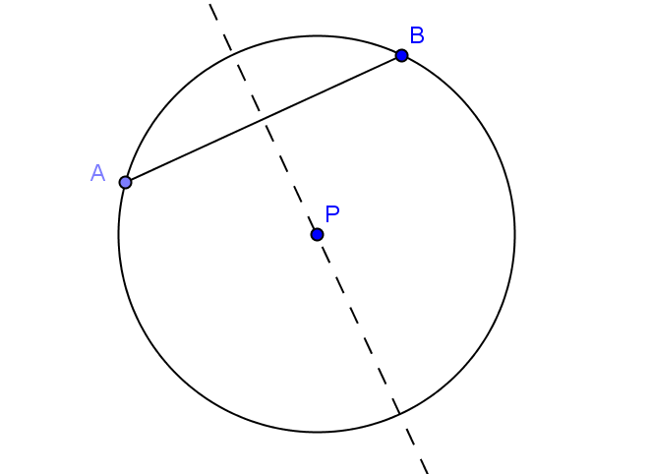
Lead students to relate the perpendicular bisector of a line segment to the points on a circle, guiding them toward seeing the relationship between the perpendicular bisector of a chord and the center of a circle.
- Construct a circle of any radius, and identify the center as point $P$.
- Draw a chord, and label it $\overline{AB}$.
- Construct the perpendicular bisector of $\overline{AB}$.
- What do you notice about the perpendicular bisector of $\overline{AB}$?
  - It passes through point P, the center of the circle.
- Draw another chord and label it $\overline{CD}$.
- Construct the perpendicular bisector of $\overline{CD}$.
- What do you notice about the perpendicular bisector of $\overline{CD}$?
  - It passes through point $P$, the center of the circle.
- What can you say about the points on a circle in relation to the center of the circle?
  - The center of the circle is equidistant from any two points on the circle.
MP.3
&
MP.7
- Look at the circles, chords, and perpendicular bisectors created by your neighbors. What statement can you make about the perpendicular bisector of any chord of a circle? Why?
  - It must contain the center of the circle. The center of the circle is equidistant from the two endpoints of the chord because they lie on the circle. Therefore, the center lies on the perpendicular bisector of the chord. That is, the perpendicular bisector contains the center.
- How does this relate to the definition of the perpendicular bisector of a line segment?
Scaffolding:
- Review the definition of central angle by posting a visual guide.
- A central angle of a circle is an angle whose vertex is the center of a circle.

  - The set of all points equidistant from two given points (endpoints of a line segment) is precisely the set of all points on the perpendicular bisector of the line segment.

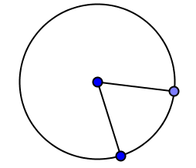

Exercises 1–6 (20 minutes)
Assign one proof to each group, and then jigsaw, share, and gallery walk as students present their work.

Exercises 1–6
- Prove the theorem: If a diameter of a circle bisects a chord, then it must be perpendicular to the chord.
Draw a diagram similar to that shown below.

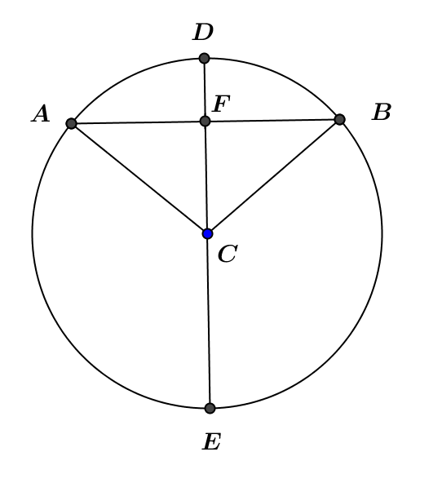

Given: Circle $C$ with diameter $\overline{DE}$, chord $\overline{AB}$ , and $AF=BF$.
Prove: $\overline{DE}⊥\overline{AB}$
$AF=BF$ Given
$FC=FC$ Reflexive property
$AC=BC$ Radii of the same circle are equal in measure
$△AFC≅△BFC$ SSS
$m∠AFC=m∠BFC$ Corresponding angles of congruent triangles are equal in measure
$∠AFC$ and $∠BFC$ are right angles Equal angles that form a linear pair each measure $90°$
$\overline{DE}⊥\overline{AB}$ Definition of perpendicular lines
OR
$AF=BF$ Given
$AC=BC$ Radii of the same circle are equal in measure
$m∠FAC=m∠FBC$ Base angles of an isosceles are equal in measure
$△AFC≅ △BFC$ SAS
$m∠AFC=m∠BFC$ Corresponding angles of congruent triangles are equal in measure
$∠AFC$ and $∠BFC$ are right angles Equal angles that form a linear pair each measure $90°$
$\overline{DE}⊥\overline{AB}$ Definition of perpendicular lines

- Prove the theorem: If a diameter of a circle is perpendicular to a chord, then it bisects the chord.
Use a diagram similar to that in Exercise 1 above.
Given: Circle $C$ with diameter $\overline{DE}$, chord $\overline{AB}$ , and $\overline{DE}⊥\overline{AB}$
Prove: $\overline{DE}$ bisects $\overline{AB}$
$\overline{DE}⊥\overline{AB}$ Given
$∠AFC$ and $∠BFC$ are right angles Definition of perpendicular lines
$△AFC$ and $△BFC$ are right triangles Definition of right triangle
$∠AFC≅$ $∠BFC$ All right angles are congruent
$FC=FC$ Reflexive property
$AC=BC$ Radii of the same circle are equal in measure

$△AFC≅ △BFC$ HL
$AF=BF$ Corresponding sides of congruent triangles are equal in length
$\overline{DE}$ bisects $\overline{AB}$ Definition of segment bisector
OR
$\overline{DE}⊥\overline{AB}$ Given
$∠AFC$ and $∠BFC$ are right angles Definition of perpendicular lines
$∠AFC≅$ $∠BFC$ All right angles are congruent
$AC=BC$ Radii of the same circle are equal in measure
$m∠FAC=m∠FBC$ Base angles of an isosceles triangle are congruent
$m∠ACF=m∠BCF$ Two angles of triangle are equal in measure, so third angles are equal
$△AFC≅△BFC$ ASA
$AF=BF$ Corresponding sides of congruent triangles are equal in length
$\overline{DE}$ bisects $\overline{AB}$ Definition of segment bisector

- The distance from the center of a circle to a chord is defined as the length of the perpendicular segment from the center to the chord. Note that, since this perpendicular segment may be extended to create a diameter of the circle, therefore, the segment also bisects the chord, as proved in Exercise 2 above.
Prove the theorem: In a circle, if two chords are congruent, then the center is equidistant from the two chords.
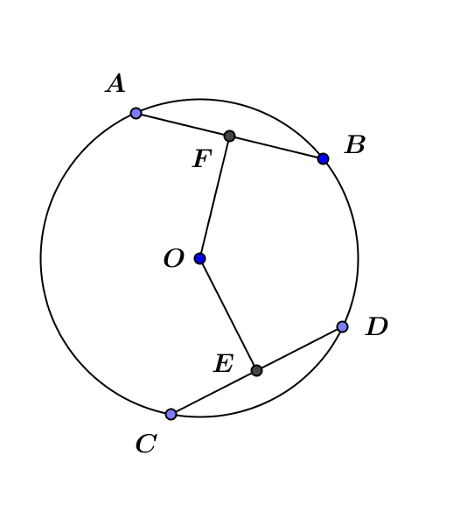
Use the diagram below.

Given: Circle $O$ with chords $\overline{AB}$ and $\overline{CD}$; $AB=CD$; $F$ is the midpoint of $\overline{AB}$ and $E$ is the midpoint of $CD$.
Prove: $OF=OE$
$AB=CD$ Given
$\overline{OF}⊥\overline{AB}$; $\overline{OE}⊥\overline{CD}$ If a diameter of a circle bisects a chord, then the diameter must be perpendicular to the chord.
$∠AFO$ and $∠DEO$ are right angles Definition of perpendicular lines
$△AFO$ and $△DEO$ are right triangles Definition of right triangle
E and $F$ are midpoints of $\overline{CD}$ and $\overline{AB}$ Given
$AF=DE$ $AB=CD$ and $F$ and $E$ are midpoints of $\overline{AB}$ and $\overline{CD}$
$AO=DO$ All radii of a circle are equal in measure
$△AFO≅ △DEO$ HL
$OE=OF$ Corresponding sides of congruent triangles are equal in length

- Prove the theorem: In a circle, if the center is equidistant from two chords, then the two chords are congruent.
Use the diagram below.

Given: Circle $O$ with chords $\overline{AB}$ and $\overline{CD}$; $OF=OE$; $F$ is the midpoint of $\overline{AB}$ and $E$ is the midpoint of $CD$
Prove: $AB=CD$
$OF=OE$ Given
$\overline{OF}⊥\overline{AB}$; $\overline{OE}⊥\overline{CD}$ If a diameter of a circle bisects a chord, then it must be perpendicular to the chord.
$∠AFO$ and $∠DEO$ are right angles Definition of perpendicular lines.
$△AFO$ and $△DEO$ are right triangles Definition of right triangle.
$AO=DO$ All radii of a circle are equal in measure.
$△AFO≅ △DEO$ HL
$AF=DE$ Corresponding sides of congruent triangles are equal in length.
$F$ is the midpoint of $\overline{AB}$, and $E$ is the
midpoint of $CD$ Given
$AB=CD$ $AF=DE$ and $F$ and $E$ are midpoints of $\overline{AB}$ and $\overline{CD}$.

- A central angle defined by a chord is an angle whose vertex is the center of the circle and whose rays intersect the circle. The points at which the angle’s rays intersect the circle form the endpoints of the chord defined by the central angle.
Prove the theorem: In a circle, congruent chords define central angles equal in measure.
Use the diagram below.
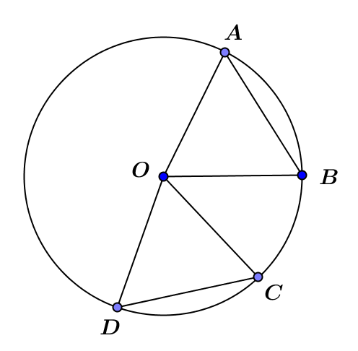

We are given that the two chords ($\overline{AB}$ and $\overline{CD}$) are congruent. Since all radii of a circle are congruent, $\overline{AO}≅$ $BO≅ \overline{CO}≅ \overline{DO}$. Therefore, $△ABO≅ △CDO$ by SSS. $∠AOB≅$ $∠COD$ since corresponding angles of congruent triangles are equal in measure.

- Prove the theorem: In a circle, if two chords define central angles equal in measure, then they are congruent.
Using the diagram from Exercise 5 above, we now are given that $m∠AOB=m$ $∠COD$. Since all radii of a circle are congruent, $\overline{AO}≅$ $\overline{BO}≅ \overline{CO}≅ \overline{DO}$. Therefore, $△ABO≅△CDO$ by SAS. $\overline{AB}≅\overline{CD}$ because corresponding sides of congruent triangles are congruent

Closing (4 minutes)
Have students write all they know to be true about the diagrams below. Bring the class together, go through the Lesson Summary, having students complete the list that they started, and discuss each point.
A reproducible version of the graphic organizer shown is included at the end of the lesson.

Diagram | Explanation of Diagram | Theorem or Relationship
 | Diameter of a circle bisecting a chord | If a diameter of a circle bisects a chord, then it must be perpendicular to the chord.  If a diameter of a circle is perpendicular to a chord, then it bisects the chord.
 | Two congruent chords equidistance from center | If two chords are congruent, then the center is equidistant from the two chords.  If the center is equidistant from two chords, then the two chords are congruent.
 | Congruent chords | Congruent chords define central angles equal in measure.  If two chords define central angles equal in measure, then they are congruent.

Lesson Summary
Theorems about chords and diameters in a circle and their converses
- If a diameter of a circle bisects a chord, then it must be perpendicular to the chord.
- If a diameter of a circle is perpendicular to a chord, then it bisects the chord.
- If two chords are congruent, then the center is equidistant from the two chords.
- If the center is equidistant from two chords, then the two chords are congruent.
- Congruent chords define central angles equal in measure.
- If two chords define central angles equal in measure, then they are congruent.
Relevant Vocabulary
Equidistant: A point $A$ is said to be equidistant from two different points $B$ and $C$ if $AB=AC$.

Exit Ticket (5 minutes)

Name Date
Lesson 2: Circles, Chords, Diameters, and Their Relationships

Exit Ticket
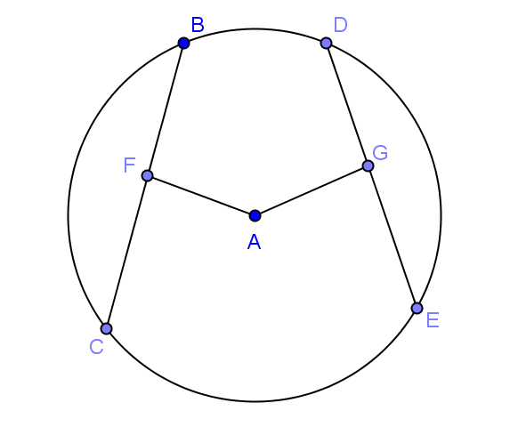
- Given circle $A$ shown, $AF=AG$ and $BC=22$. Find $DE$.

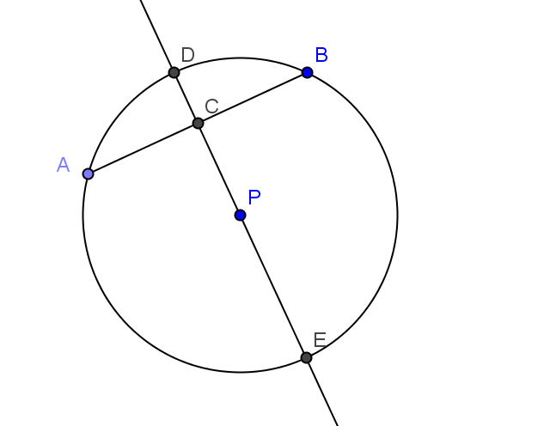
- In the figure, circle $P$ has a radius of $10$. $\overline{AB}⊥\overline{DE}$.
  - If $AB=8$, what is the length of $AC$?

  - If $DC=2$, what is the length of $AB$?

Exit Ticket Sample Solutions

- Given circle $A$ shown$, AF=AG$ and $BC=22$. Find $DE$.
$$22$$

- In the figure, circle $P$ has a radius of $10$. $\overline{AB}⊥\overline{DE}$.
- If $AB=8$, what is the length of $AC$?
$$4$$

- If $DC=2$, what is the length of $AB$?
$$12$$

Problem Set Sample Solutions

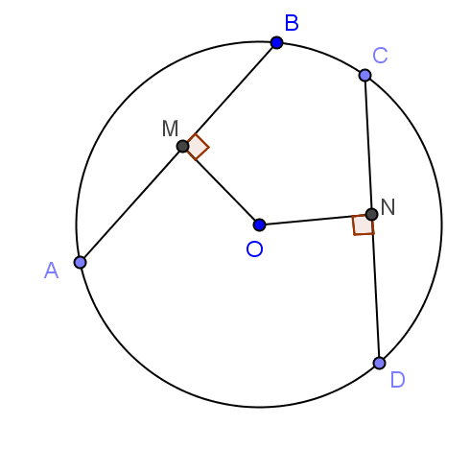
- In this drawing, $AB=30$,$OM=20$, and $ON=18$. What is $CN$?
$2\sqrt{301}$ ($≈34.7$)

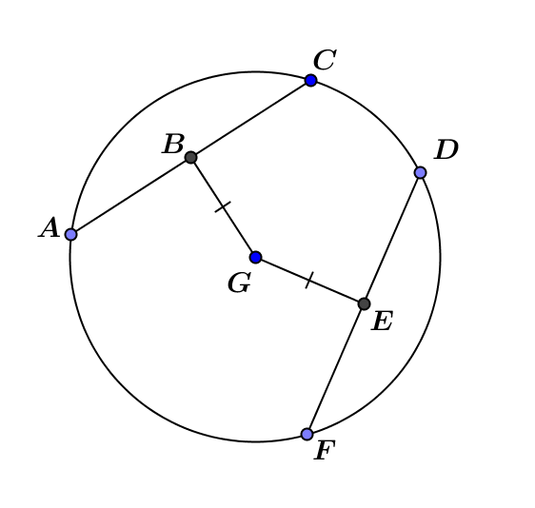
- In the figure to the right, $\overline{AC}⊥\overline{BG}$ and $\overline{DF}⊥\overline{EG}$; $EF=12$. Find $AC$.
$$24$$

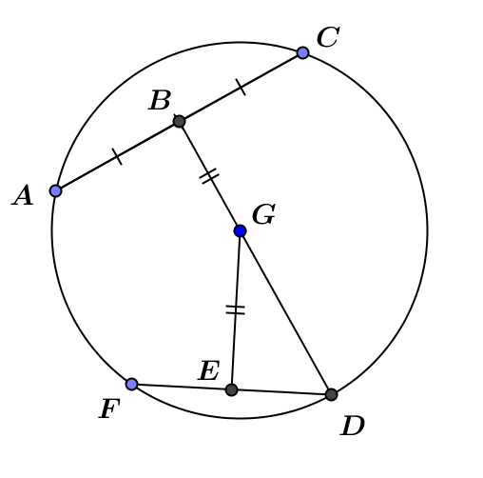
- In the figure, $AC=24$, and$DG=13$. Find $EG$. Explain your work.
$5$, $△ABG$ is a right triangle with $hypotenuse=radius=13$ and $AB=12$, so $BG=5$ by Pythagorean theorem. $BG=GE=5$.

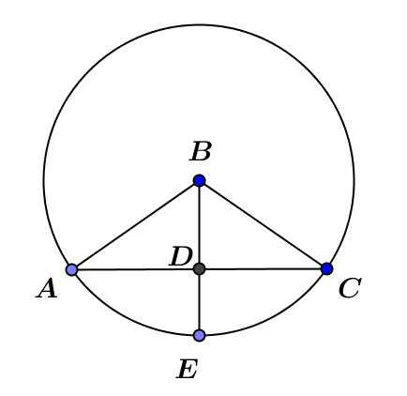
- In the figure, $AB=10, AC=16$. Find $DE$.
$$4$$

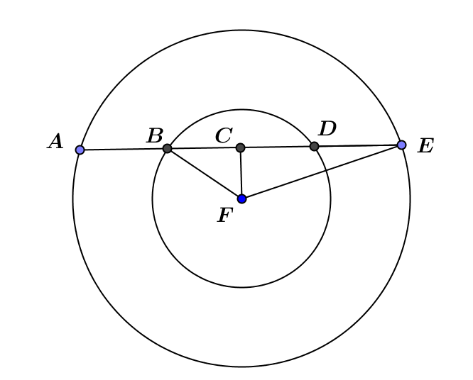
- In the figure, $CF=8,$ and the two concentric circles have radii of $10$ and $17$.
Find $DE$.
$$9$$

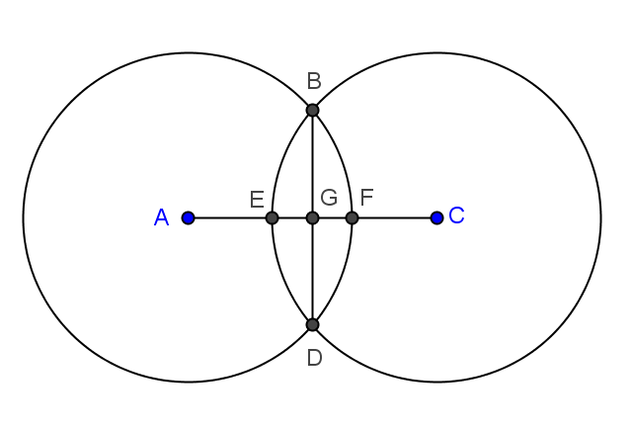
- In the figure, the two circles have equal radii and intersect at points $B$ and $D$. $A$ and $C$ are centers of the circles. $AC=8$, and the radius of each circle is $5$. $\overline{BD}⊥\overline{AC}$. Find $BD$. Explain your work.
$$6$$
$BA=BC=5$ (radii)
$AG=GC=4$
$BG=3$ (Pythagorean theorem)
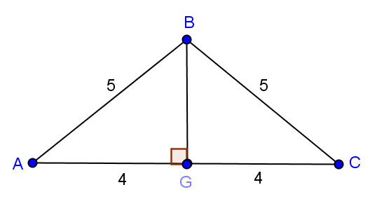
$BD=6$

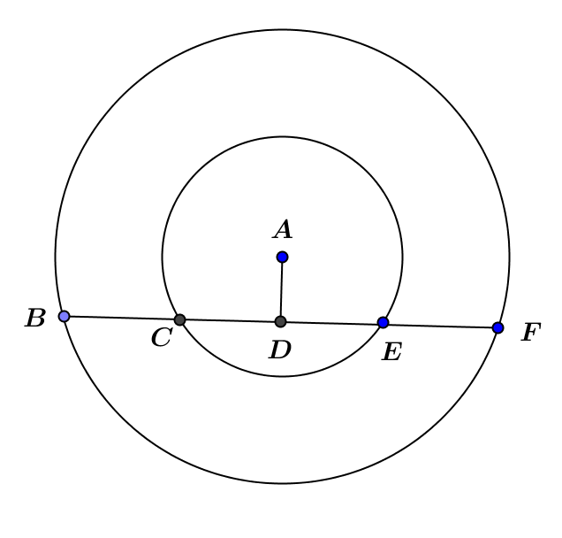
- In the figure, the two concentric circles have radii of $6$ and $14$. Chord $\overline{BF}$ of the larger circle intersects the smaller circle at $C$ and $E$. $CE=8$. $\overline{AD}⊥\overline{BF}$.
  - Find $AD$.
$$2\sqrt{5}$$

  - Find $BF$.
$$8\sqrt{11}$$

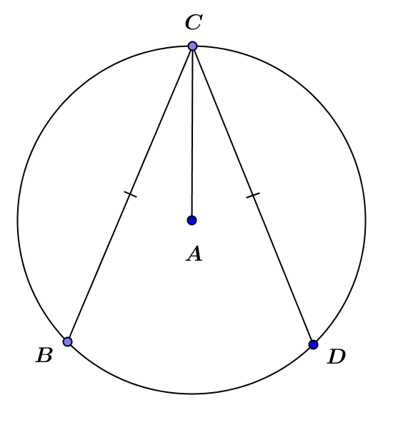
- In the figure, $A$ is the center of the circle, and $CB=CD$. Prove that $\overline{AC}$ bisects $∠BCD$.
Let $\overline{AE}$and $\overline{AF}$ be perpendiculars from $A$ to $\overline{CB}$ and $\overline{CD}$, respectively.
$CB=CD$ Given
$AE=AF$ If two chords are congruent, then the center is equidistant from the two chords.
$AC=AC$ Reflexive property
$∠CEA=∠CFA=90°$ A line joining the center and the midpoint of a chord is perpendicular to the chord.
$△CEA≅△CFA$ HL
$∠ECA=∠FCA$ Corresponding angles of congruent triangles are equal in measure.
$\overline{AC}$ bisects $∠BCD$ Definition of angle bisector

- In class, we proved: Congruent chords define central angles equal in measure.
  - Give another proof of this theorem based on the properties of rotations. Use the figure from Exercise 5.

We are given that the two chords ($\overline{AB}$ and $\overline{CD}$) are congruent. Therefore, a rigid motion exists that carries $\overline{AB}$ to $\overline{CD}$. The same rotation that carries $\overline{AB}$ to $\overline{CD}$ also carries $\overline{AO}$ to $\overline{CO}$and $\overline{BO}$ to $\overline{DO}$. The angle of rotation is the measure of $∠AOC$, and the rotation is clockwise.

  - Give a rotation proof of the converse: If two chords define central angles of the same measure, then they must be congruent.
Using the same diagram, we are given that $∠AOB≅∠COD$. Therefore, a rigid motion (a rotation) carries $∠AOB$ to $∠COD$. This same rotation carries $\overline{AO}$ to $\overline{CO}$and $\overline{BO}$ to $\overline{DO}$. The angle of rotation is the measure of $∠AOC$, and the rotation is clockwise.

Graphic Organizer on Circles

Diagram | Explanation of Diagram | Theorem or Relationship

