Lesson 2: Circles, Chords, Diameters, and Their Relationships

Classwork
Opening Exercise
Construct the perpendicular bisector of line segment $\overline{AB}$ below (as you did in Module 1).

Draw another line that bisects $\overline{AB}$ but is not perpendicular to it.
List one similarity and one difference between the two bisectors.

Exercises 1–6
- Prove the theorem: If a diameter of a circle bisects a chord, then it must be perpendicular to the chord.

- Prove the theorem: If a diameter of a circle is perpendicular to a chord, then it bisects the chord.

- The distance from the center of a circle to a chord is defined as the length of the perpendicular segment from the center to the chord. Note that, since this perpendicular segment may be extended to create a diameter of the circle, therefore, the segment also bisects the chord, as proved in Exercise 2 above.
Prove the theorem: In a circle, if two chords are congruent, then the center is equidistant from the two chords.
Use the diagram below.
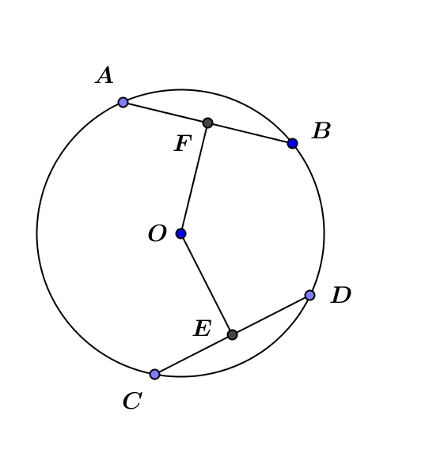

- Prove the theorem: In a circle, if the center is equidistant from two chords, then the two chords are congruent.
Use the diagram below.

- A central angle defined by a chord is an angle whose vertex is the center of the circle and whose rays intersect the circle. The points at which the angle’s rays intersect the circle form the endpoints of the chord defined by the central angle.
Prove the theorem: In a circle, congruent chords define central angles equal in measure.
Use the diagram below.
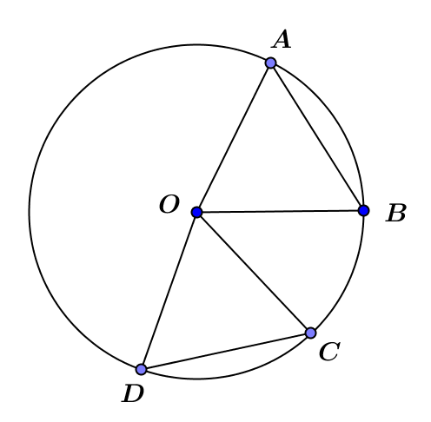

- Prove the theorem: In a circle, if two chords define central angles equal in measure, then they are congruent.

Lesson Summary
Theorems about chords and diameters in a circle and their converses:
- If a diameter of a circle bisects a chord, then it must be perpendicular to the chord.
- If a diameter of a circle is perpendicular to a chord, then it bisects the chord.
- If two chords are congruent, then the center is equidistant from the two chords.
- If the center is equidistant from two chords, then the two chords are congruent.
- Congruent chords define central angles equal in measure.
- If two chords define central angles equal in measure, then they are congruent.

Relevant Vocabulary
Equidistant: A point $A$ is said to be equidistant from two different points $B$ and $C$ if $AB=AC$.

Problem Set

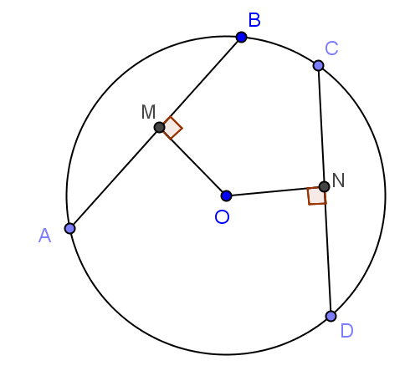
- In this drawing, $AB=30, OM=20,$and $ON=18$. What is $CN$?

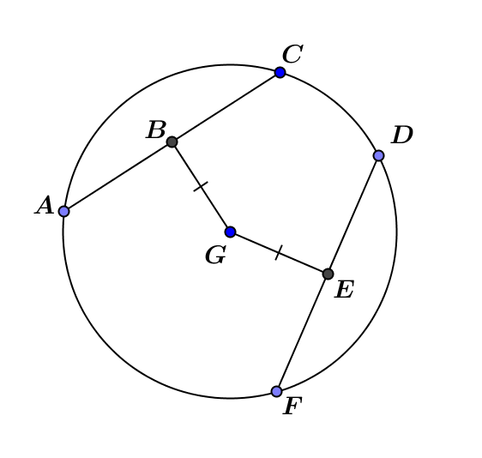
- In the figure to the right, $\overline{AC}⊥\overline{BG}$ and $\overline{DF}⊥\overline{EG}$; $EF=12.$ Find $AC$.

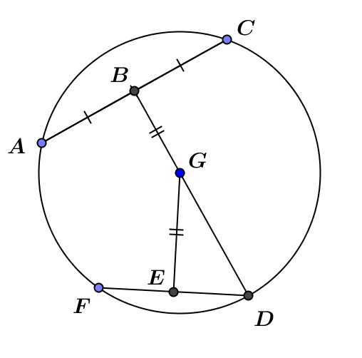
- In the figure, $AC=24$, and$DG=13$. Find $EG$. Explain your work.

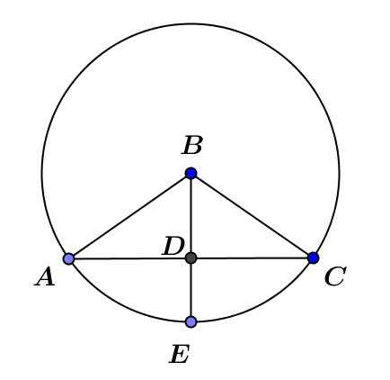
- In the figure, $AB=10, AC=16.$ Find $DE$.

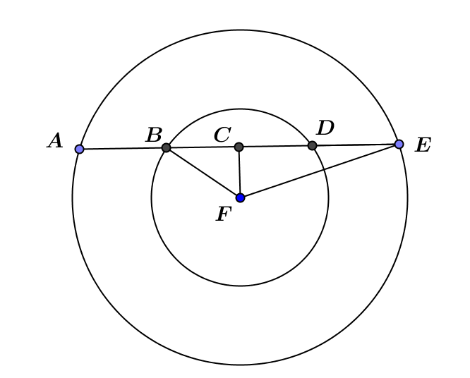
- In the figure, $CF=8$, and the two concentric circles have radii of $10$ and $17$. Find $DE$.

- In the figure, the two circles have equal radii and intersect at points $B$ and $D$. $A$ and $C$ are centers of the circles. $AC=8$, and the radius of each circle is $5$. $\overline{BD}⊥\overline{AC}$. Find $BD$. Explain your work.
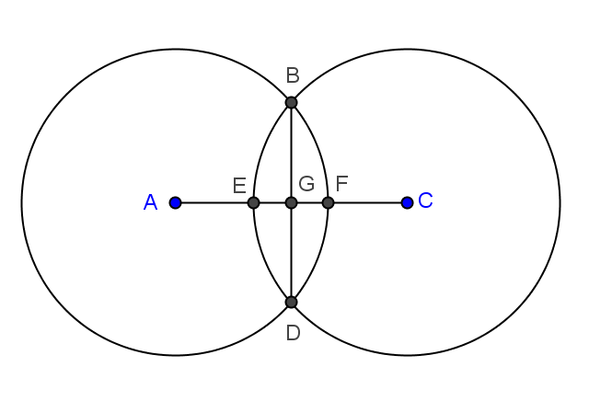

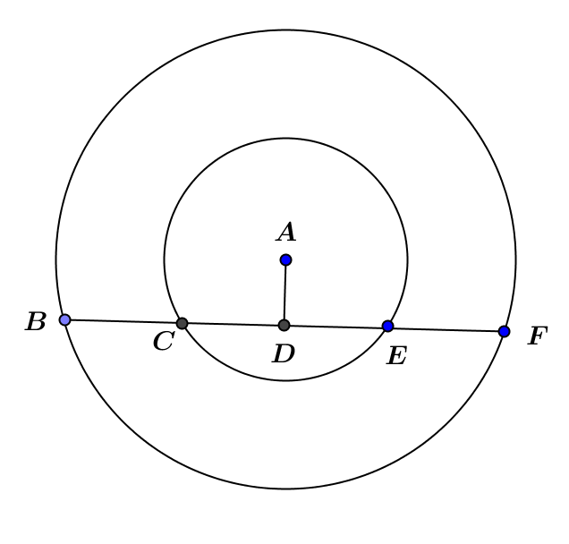
- In the figure, the two concentric circles have radii of $6$ and $14$. Chord $\overline{BF}$ of the larger circle intersects the smaller circle at $C$ and $E$. $CE=8$. $\overline{AD}⊥\overline{BF}$.
  - Find $AD$.
  - Find $BF$.

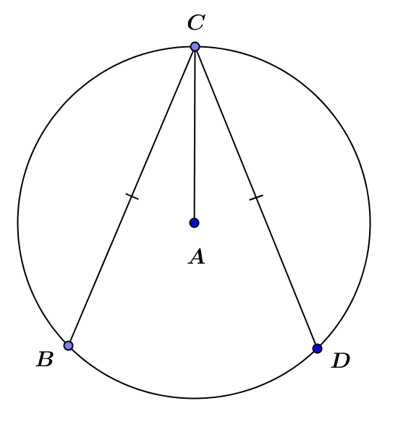
- In the figure, $A$ is the center of the circle, and $CB=CD$. Prove that $\overline{AC}$ bisects $∠BCD$.

- In class, we proved: Congruent chords define central angles equal in measure.
  - Give another proof of this theorem based on the properties of rotations. Use the figure from Exercise 5.
  - Give a rotation proof of the converse: If two chords define central angles of the same measure, then they must be congruent.

