|  |
| --- |
|  |

Lesson 1: Thales’ Theorem

Student Outcomes

* Using observations from a *pushing* puzzle, explore the converse of *Thales’ theorem*: If is a right triangle, then and are three distinct points on a circle with a diameter.
* Prove the statement of *Thales’ theorem*: If and are three different points on a *circle* with a *diameter*, then is a right angle.

Lesson Notes

Every lesson in this module is about an overlay of two intersecting lines and a circle. This will be pointed out to students later in the module, but keep this in mind as you are presenting lessons.

In this lesson, students investigate what some say is the oldest recorded result, with proof, in the history of geometry – Thales’ theorem, attributed to Thales of Miletus (c. 624-c. 546 BCE), about 300 years before Euclid. Beginning with a simple experiment, students explore the converse of Thales’ theorem. This motivates the statement of Thales’ theorem, which students then prove using known properties of rectangles from Module 1.

Classwork

Opening

Students explore the converse of Thales’s theorem with a *pushing* puzzle. Give each student a sheet of plain white paper, a sheet of colored cardstock, and a colored pen. Provide several minutes for the initial exploration before engaging students in a discussion of their observations and inferences.

*Scaffolding:*

* For students with eye-hand coordination or visualization problems, model the Opening Exercise as a class, and then provide students with a copy of the work to complete the exploration.
* For advanced learners, explain the paper pushing puzzle, and let them come up with a hypothesis on what they are creating and how they can prove it without seeing questions.

Opening Exercise (5 minutes)

Opening Exercise

* 1. Mark points and on the sheet of white paper provided by your teacher.
  2. Take the colored paper provided, and “push” that paper up between points and on the white sheet.
  3. Mark on the white paper the location of the corner of the colored paper, using a different color than black. Mark that point . See the example below.



A

B

C

* 1. Do this again, pushing the corner of the colored paper up between the black points but at a different angle. Again, mark the location of the corner. Mark this point .
  2. Do this again and then again, multiple times. Continue to label the points. What curve do the colored points (, , …) seem to trace?

**MP.7**

**&**

**MP.8**

**Discussion (8 minutes)**

* What curve do the colored points (, , …) seem to trace?
  + *They seem to trace a semicircle.*
* If that is the case, where might the center of that semicircle be?
  + *The midpoint of the line segment connecting points and on the white paper will be the center point of the semicircle.*
* What would the radius of this semicircle be?
  + *The radius is half the distance between points and (or the distance between point and the midpoint of the segment joining points and ).*
* Can we prove that the marked points created by the corner of the colored paper do indeed lie on a circle? What would we need to show? Have students do a 30-second Quick Write, and then share as a whole class.
  + *We need to show that each marked point is the same distance from the midpoint of the line segment connecting the original points and .*

**Exploratory Challenge (12 minutes)**

Allow students to come up with suggestions for **how** to prove that each marked point from the Opening Exercise is the same distance from the midpoint of the line segment connecting the original points and . Then offer the following approach.

* Have students draw the right triangle formed by the line segment between the two original points and and any one of the colored points (, …) created at the corner of the colored paper; then construct a rotated copy of that triangle underneath it. A sample drawing might be as follows:



A

B

C

A’

B’

C’

Allow students to read the question posed and have a few minutes to think independently and then share thoughts with an elbow partner. Lead students through the questions below.

It may be helpful to have students construct the argument outlined in Steps (a)-(b) below several times for different points on the same diagram. The idea behind the proof is that no matter which colored point is chosen, the distance from that colored point to the midpoint of the segment between points and must be the same as the distance from any other colored point to that midpoint.

Exploratory Challenge

Choose one of the colored points (, ...) that you marked. Draw the right triangle formed by the line segment connecting the original two points and and that colored point. Draw a rotated copy of the triangle underneath it.

Label the acute angles in the original triangle as and , and label the corresponding angles in the rotated triangle the same.

Todd says ’ is a rectangle. Maryam says is a quadrilateral, but she’s not sure it’s a rectangle. Todd is right but doesn’t know how to explain himself to Maryam. Can you help him out?

* 1. What composite figure is formed by the two triangles? How would you prove it?

A rectangle is formed. We need to show that all four angles measure .

* + 1. What is the sum of and ? Why?

; the sum of the acute angles in any right triangle is .

* + 1. How do we know that the figure whose vertices are the colored points (, …) and points and is a rectangle?

All four angles measure . The colored points (, …) are constructed as right angles, and the angle at points and measures , which is .

* 1. Draw the two diagonals of the rectangle. Where is the midpoint of the segment connecting the two original points and ? Why?

The midpoint of the segment connecting points and is the intersection of the diagonals of the rectangle because the diagonals of a rectangle are congruent and bisect each other.

* 1. Label the intersection of the diagonals as point . How does the distance from point to a colored point (, …) compare to the distance from to points and ?

The distances from to each of the points are equal.

* 1. Choose another colored point, and construct a rectangle using the same process you followed before. Draw the two diagonals of the new rectangle. How do the diagonals of the new and old rectangle compare? How do you know?

One diagonal is the same (the one between points and ), but the other is different since it is between the new colored point and its image under a rotation. The new diagonals intersect at the same point because diagonals of a rectangle intersect at their midpoints, and the midpoint of the segment connecting points and has not changed. The distance from to each colored point equals the distance from to each original point and . By transitivity, the distance from to the first colored point, , equals the distance from to the second colored point, .

* 1. How does your drawing demonstrate that all the colored points you marked do indeed lie on a circle?

**MP.3**

**&**

**MP.7**

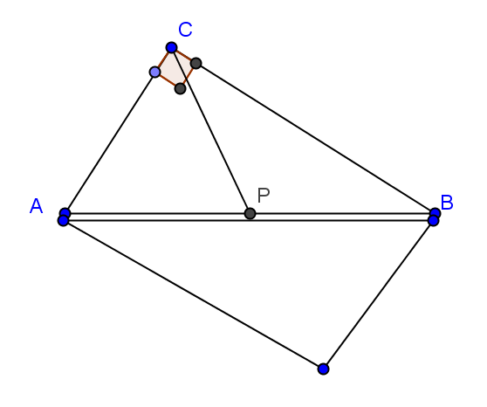For any colored point, we can construct a rectangle with that colored point and the two original points, and , as vertices. The diagonals of this rectangle intersect at the same point because diagonals intersect at their midpoints, and the midpoint of the diagonal between points and is . The distance from to that colored point equals the distance from to points and . By transitivity, the distance from to the first colored point, , equals the distance from to any other colored point.

By definition, a circle is the set of all points in the plane that are the same distance from a given center point. Therefore, each colored point on the drawing lies on the circle with center and a radius equal to half the length of the original line segment joining pints and .

* Take a few minutes to write down what you have just discovered, and share that with your neighbor.
* We have proven the following theorem:

**Theorem**: Given two points and , let point be the midpoint between them. If is a point such that is right, then .

In particular, that means that point is on a circle with center and diameter .

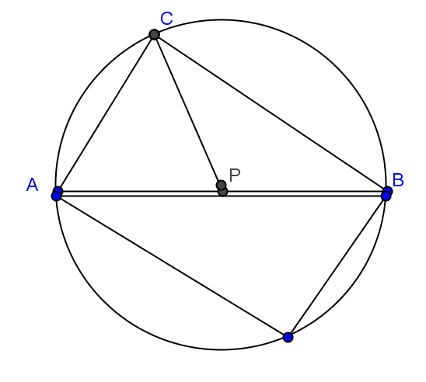

* This demonstrates the relationship between right triangles and circles.

**Theorem**: If is a right triangle with the right angle, then and are three distinct points on a circle with a diameter.

**Proof**: If is a right angle, and is the midpoint between points and then implies that a circle with center and radius contains the points and .

* This last theorem is the converse of Thales’ theorem, which is discussed below in Example 1.
* Review definitions previously encountered by students as stated in Relevant Vocabulary.

**Relevant Vocabulary**

**Circle:**  Given a point in the plane and a number , the *circle* with center and radius is the set of all points in the plane that are distance from the point .

**Radius:** May refer either to the line segment joining the center of a circle with any point on that circle (a *radius*) or to the length of this line segment (the *radius*).

**Diameter:** May refer either to the segment that passes through the center of a circle whose endpoints lie on the circle (a diameter) or to the length of this line segment (the diameter).

**Chord:** Given a circle , and let and be points on . The segment is a *chord* of

**Central angle:** A *central angle* of a circle is an angle whose vertex is the center of a circle.

|  |  |  |  |  |
| --- | --- | --- | --- | --- |
| **Circle** | **Radius** | **Diameter** | **Chord** | **Central Angle** |
|  |  |  |  |  |

Point out to students that and are examples of central angles.

Example 1 (8 minutes)

Share with students that they have just recreated the converse of what some say is the oldest recorded result, with proof, in the history of geometry –Thales’ theorem, attributed to Thales of Miletus (c. 624- c. 546 BCE), some three centuries before Euclid! See Wikipedia, for example, on why the theorem might be attributed to Thales although it was clearly known before him. <http://en.wikipedia.org/wiki/Thales%27_Theorem>.

Lead students through parts (a)–(b), and then let them struggle with a partner to determine a method to prove Thales’ theorem. If students are particularly struggling, give them the hint in the scaffold box. Once students have developed a strategy, lead the class through the remaining parts of this example.

Example 1

In the Exploratory Challenge, you proved the converse of a famous theorem in geometry. Thales’ theorem states: *If and are three distinct points on a circle and segment is a diameter of the circle, then is right.*

Notice that, in the proof in the Exploratory Challenge, you started with a right angle (the corner of the colored paper) and created a circle. With Thales’ theorem, you must start with the circle, and then create a right angle.

Prove Thales’ theorem.

* 1. 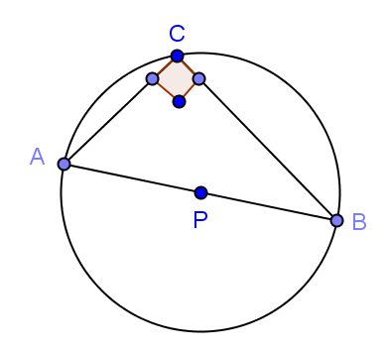Draw circle with distinct points and on the circle and diameter . Prove that is a right angle.
  2. Draw a third radius (). What types of triangles are and   
     ? How do you know?

They are isosceles triangles. Both sides of each triangle are radii of circle and are, therefore, of equal length.

* 1. Using the diagram that you just created, develop a strategy to prove Thales’ theorem.

*Scaffolding:*

* If students are struggling to develop a strategy to prove Thales’ Theorem, give them this hint:

Draw a third radius, and use the result, also known to Thales, that the base angles of an isosceles triangle are congruent.

Look at each of the angle measures of the triangles, and see if we can prove is 90°.

**MP.1**

* 1. Label the base angles of as and the bases of as . Express the measure of in terms of and .

The measure of is .

* 1. How can the previous conclusion be used to prove that is a right angle?

because the sum of the angle measures in a triangle is . Then, , so is a right angle.

Exercises 1–2 (5 minutes)

Allow students to do Exercises 1–2 individually and then compare answers with a neighbor. Use this as a means of informal assessment, and offer help where needed.

Exercises 1–2

1. is a diameter of the circle shown. The radius is cm, and cm.
2. Find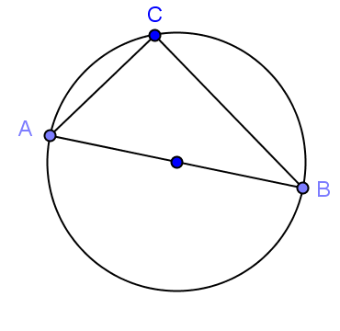 .

1. Find .

cm

* 1. Find .

cm

1. 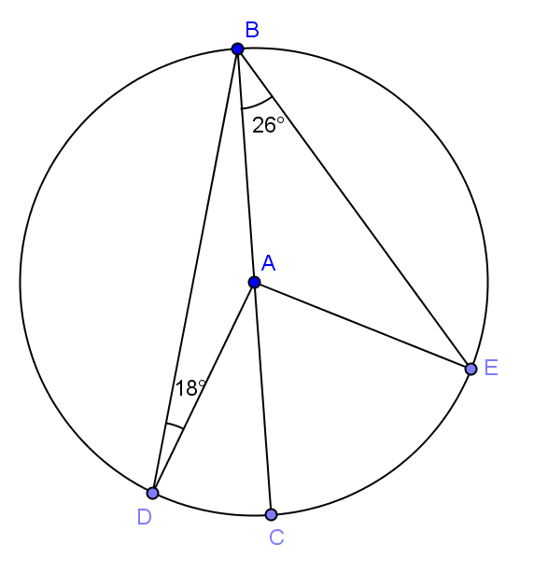In the circle shown, is a diameter with center A.
   1. Find .

* 1. Find .

* 1. Find .

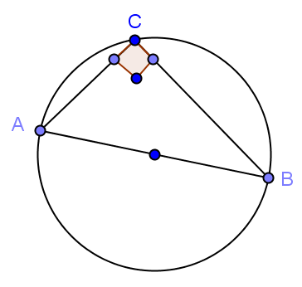Closing (2 minutes)

Give students a few minutes to explain the prompt to their neighbor, and then call the class together and share. Use this time to informally assess understanding and clear up misconceptions.

* Explain to your neighbor the relationship that we have just discovered between a right triangle and a circle. Illustrate this with a picture.
  + *If is a right triangle and the right angle is , and are distinct points on a circle and is the diameter of the circle.*

Lesson Summary

Theorems:

* **Thales’ theorem: If , and are three different points on a circle with a diameter, then is a right angle.**
* **Converse of Thales’ theorem: If is a right triangle with the right angle, then and are three distinct points on a circle with a diameter.**
* **Therefore, given distinct points and on a circle, is a right triangle with the right angle if and only if is a diameter of the circle.**
* **Given two points and , let point be the midpoint between them. If is a point such that is right, then .**

Relevant Vocabulary

* Circle: Given a point in the plane and a number , the *circle* with center and radius is the set of all points in the plane that are distance from the point .
* Radius: May refer either to the line segment joining the center of a circle with any point on that circle (a *radius*) or to the length of this line segment (the *radius*).
* Diameter: May refer either to the segment that passes through the center of a circle whose endpoints lie on the circle (a *diameter*) or to the length of this line segment (the *diameter*).
* Chord*:*  Given a circle , and let and be points on . The segment is called a *chord* of
* Central angle: A *central angle* of a circle is an angle whose vertex is the center of a circle.

Exit Ticket (5 minutes)

Name Date

Lesson 1: Thales’ Theorem

Exit Ticket

Circle is shown below.

1. Draw two diameters of the circle.
2. Identify the shape defined by the endpoints of the two diameters.
3. Explain why this shape will always result.

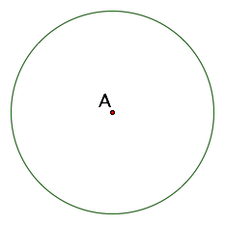

Exit Ticket Sample Solutions

Circle is shown below.

1. Draw two diameters of the circle.
2. Identify the shape defined by the endpoints of the two diameters.
3. Explain why this shape will always result.



The shape defined by the endpoints of the two diameters will always form a rectangle. According to Thales’ theorem, whenever an angle is drawn from the diameter of a circle to a point on its circumference, then the angle formed is a right angle. All four endpoints represent angles drawn from the diameter of the circle to a point on its circumference; therefore, each of the four angles is a right angle. The resulting quadrilateral will, therefore, be a rectangle by definition of rectangle.

Problem Set Sample Solutions

1. , , and are three points on a circle, and angle is a right angle. What’s wrong with the picture below? Explain your reasoning.

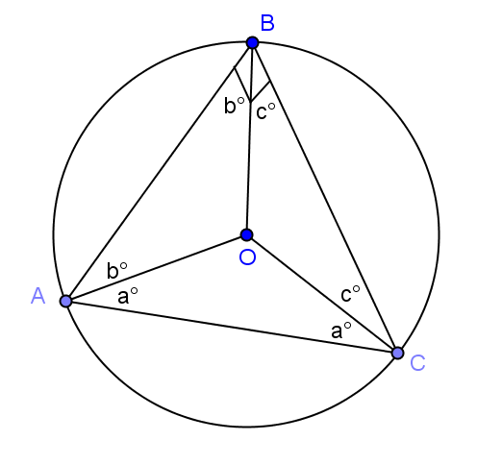

***Draw in three radii (from to each of the three triangle vertices), and label congruent base angles of each of the three resulting isosceles triangles. See diagram to see angle measures In the “big” triangle (***)*,* we get . Using the distributive property and division, we obtain and . But we also have . Substitution results in , giving a value of contradiction.

1. Show that there is something mathematically wrong with the picture below.



Draw three radii ( and ). Label as and as . Also label as and as since is isosceles (both sides are radii). If is a right angle (as indicated on the drawing), then . Since is isosceles, . Similarly, . Now adding the angles of results in . Using the distributive property and division, we obtain . Substitution takes us to , which is a contradiction. Therefore, the figure above is mathematically impossible.

1. In the figure below, is the diameter of a circle of radius miles. If miles, what is ?



miles

1. In the figure below, is the center of the circle, and is a diameter.



* 1. Find .
  2. If , what is ?

1. is a diameter of a circle, and is another point on the circle. The point lies on the line such that   
   . Show that . (Hint: Draw a picture to help you explain your thinking!)

Since (given), (both are right angles, by Thales’ theorem and by the angle addition postulate), and (reflexive property), then by . It follows that (corresponding sides of congruent triangles) and that (by definition of congruent angles).

1. Inscribe in a circle of diameter such that is a diameter. Explain why:
   1. *.*

*is the hypotenuse, and . Since sine is the ratio of the opposite side to the hypotenuse,* *will necessarily equal the length of the opposite side, that is, the length of .*

* 1. *.*

*is the hypotenuse, and . Since cosine is the ratio of the adjacent side to the hypotenuse, will necessarily equal the length of the adjacent side, that is, the length of .*