Lesson 1: Thales’ Theorem

Classwork

Opening Exercise

* 1. Mark points and on the sheet of white paper provided by your teacher.
  2. Take the colored paper provided, and “push” that paper up between points and on the white sheet.
  3. Mark on the white paper the location of the corner of the colored paper, using a different color than black. Mark that point . See the example below.



A

B

C

* 1. Do this again, pushing the corner of the colored paper up between the black points but at a different angle. Again, mark the location of the corner. Mark this point .
  2. Do this again and then again, multiple times. Continue to label the points. What curve do the colored points (, , …) seem to trace?

**Exploratory Challenge**

Choose one of the colored points (, ...) that you marked. Draw the right triangle formed by the line segment connecting the original two points and and that colored point. Draw a rotated copy of the triangle underneath it.

Label the acute angles in the original triangle as and , and label the corresponding angles in the rotated triangle the same.

Todd says ’ is a rectangle. Maryam says is a quadrilateral, but she’s not sure it’s a rectangle. Todd is right but doesn’t know how to explain himself to Maryam. Can you help him out?

* 1. What composite figure is formed by the two triangles? How would you prove it?
     1. What is the sum of and ? Why?
     2. How do we know that the figure whose vertices are the colored points (, …) and points and is a rectangle?
  2. Draw the two diagonals of the rectangle. Where is the midpoint of the segment connecting the two original points and ? Why?
  3. Label the intersection of the diagonals as point . How does the distance from point to a colored point (, …) compare to the distance from to points and ?
  4. Choose another colored point, and construct a rectangle using the same process you followed before. Draw the two diagonals of the new rectangle. How do the diagonals of the new and old rectangle compare? How do you know?
  5. How does your drawing demonstrate that all the colored points you marked do indeed lie on a circle?

**Example 1**

In the Exploratory Challenge, you proved the converse of a famous theorem in geometry. Thales’ theorem states: *If and are three distinct points on a circle and segment is a diameter of the circle, then is right.*

Notice that, in the proof in the Exploratory Challenge, you started with a right angle (the corner of the colored paper) and created a circle. With Thales’ theorem, you must start with the circle, and then create a right angle.

Prove Thales’ theorem.

* 1. Draw circle with distinct points and on the circle and diameter . Prove that is a right angle.
  2. Draw a third radius (). What types of triangles are and ? How do you know?
  3. Using the diagram that you just created, develop a strategy to prove Thales’ theorem.
  4. Label the base angles of as and the bases of as . Express the measure of in terms of and .
  5. How can the previous conclusion be used to prove that is a right angle?

Exercises 1–2

1. is a diameter of the circle shown. The radius is , and .
   1. Find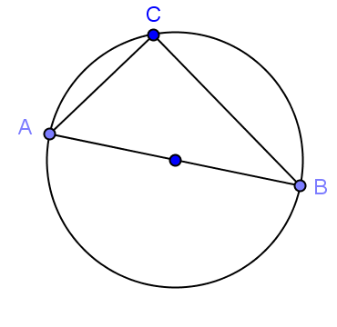 .

* 1. Find .
  2. Find .

1. 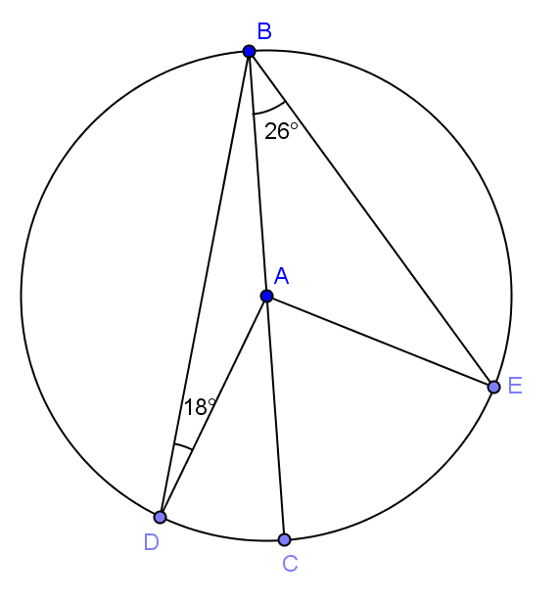In the circle shown, is a diameter with center .
   1. Find .
   2. Find .
   3. Find .

Lesson Summary

**Theorems:**

* **Thales’ theorem**: If , and are three different points on a circle with a diameter, then is a right angle.
* **Converse of Thales’ theorem**: If is a right triangle with the right angle, then and are three distinct points on a circle with a diameter.
* Therefore, given distinct points and on a circle, is a right triangle with the right angle if and only if is a diameter of the circle.
* Given two points and , let point be the midpoint between them. If is a point such that is right, then .

**Relevant Vocabulary**

* **Circle**: Given a point in the plane and a number , the *circle* with center and radius is the set of all points in the plane that are distance from the point .
* **Radius**: May refer either to the line segment joining the center of a circle with any point on that circle (a *radius*) or to the length of this line segment (the *radius*).
* **Diameter**: May refer either to the segment that passes through the center of a circle whose endpoints lie on the circle (a *diameter*) or to the length of this line segment (the *diameter*).
* **Chord***:*  Given a circle , and let and be points on . The segment is called a *chord* of
* **Central angle**: A *central angle* of a circle is an angle whose vertex is the center of a circle.

Problem Set

1. , , and are three points on a circle, and angle is a right angle. What’s wrong with the picture below? Explain your reasoning.



1. Show that there is something mathematically wrong with the picture below.



1. In the figure below, is the diameter of a circle of radius miles. If miles, what is ?



1. In the figure below, is the center of the circle, and is a diameter.



* 1. Find .
  2. If , what is ?

1. is a diameter of a circle, and is another point on the circle. The point lies on the line such that   
   . Show that . (Hint: Draw a picture to help you explain your thinking!)
2. Inscribe in a circle of diameter such that is a diameter. Explain why:
   1. .
   2. .