|  |
| --- |
|  |

Lesson 26: Projecting a 3-D Object onto a 2-D Plane

Student Outcomes

* Students learn to project points in 3-dimensional space onto a 2-dimensional plane.
* Students learn how to simulate 3-dimensional turning on a 2-dimensional screen.

Lesson Notes

Students engage the mathematics that provides a foundation for animations like the kind seen in video games. In particular, students learn to take points in 3-dimensional space and map them onto a 2-dimensional plane in the same way that a programmer would seek to model the 3-D world on a 2-D screen. Students also analyze the 2-D projection of a path followed by an object being rotated through 3-dimensional space.

Classwork

In the context of this lesson, the statement will be used to describe a plane in 3-dimensional space that is parallel to the -plane. However, the same statement could be used to describe a line in the coordinate plane that is parallel to the -axis, or to describe a point on the number line. This series of exercises gives students an opportunity to look for and make use of structure as they learn to differentiate between these situations based on context. Students may represent their responses to the questions using words, pictures, or graphs.

**MP.7**

**Discussion (4 minutes): Visualizing**

* On the real number line, there is exactly one point whose coordinate is :



* Describe the set of points in whose -coordinate is . Give several specific examples of such points.
  + *The set of points whose -coordinate is consists of points that are unit above the -axis. This set of points forms a line that is parallel to the -axis. For example, this set includes the points , , and .*

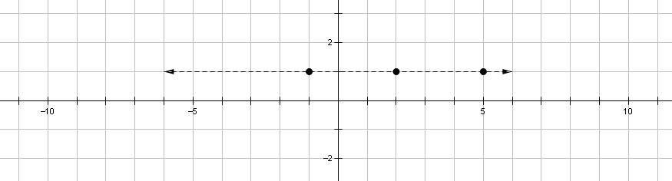

* Describe the set of points in whose -coordinate is . Give several specific examples of such points.
  + *The set of points whose -coordinate is consists of points that are unit to the right of the -plane. This set of points forms a plane that is parallel to the -plane. For example, this set includes the points , , and .*



**Discussion (11 minutes): Projections**

* Now imagine that the plane represents a TV screen, with the origin located where your eye is. Suppose we have a point in 3-dimensional space that we wish to project on to the screen. We will call the image . How should we go about locating ?
  + *must be located at a point on the screen that lies on the line that connects* *to* .

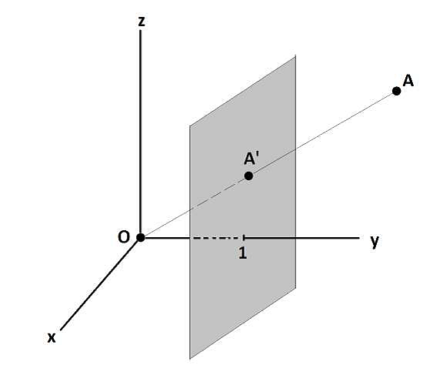

* Good! We would like to be able to describe the line through and , then find out where it hits our screen. Before we attempt to do this, let’s examine the 2-dimensional case to see if we can get any ideas.
* Suppose you have a screen located along the line , and the origin is located where your eye is. Let’s take the point and project it onto this screen. Where is the image of ? Take a few moments to think about this, then discuss your thoughts with the students around you. In a few minutes, please be ready to present your argument to the class.

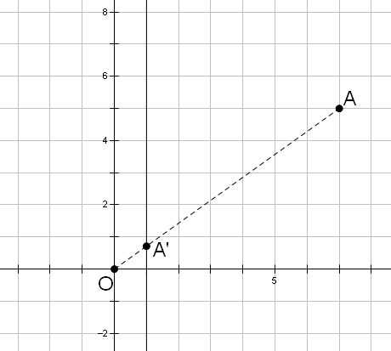

* Any point on the line joining and makes a triangle that is similar to in the figure below. Thus the coordinates of must satisfy the proportion . In the case of , which lies on our screen, the   
  -coordinate must be . Thus its -coordinate can be found by solving , so . In summary, the image of point is the point .

*Scaffolding:*

Show students the diagram at the left, and assist them with cues such as the following:

* What can we say about the triangles in the figure?
* Can you write an equation that shows the relationship between the lengths in the figure?

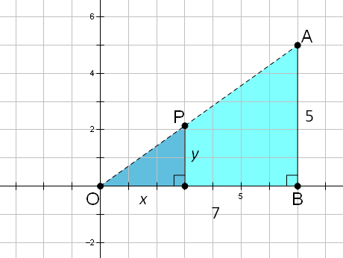

* Next we will attempt to describe the set of points on the line through and using a parameter . In other words, describe the points on this line as . Justify your answer.
  + *We have* . *We know this is correct because the coordinates satisfy the proportion* .
* To round out our discussion, we will look at this from one more point of view. Give a geometric description of the transformation .
  + *This is a dilation of the point , where the origin is the center of the dilation, and the parameter represents the scale factor.*
* We know that a point and its image lie on the same line through the origin when dilations are involved, so our work with the projection makes sense from that perspective as well. Do you see how we can find the image of using the parametric description of points on the line through and ?
  + *Yes, we can find the value of that makes the -coordinate . With , we have . Thus, the  
    -coordinate must be .*

Exercises 1–3 (2 minutes)

Give students time to work on the problems below, then ask them to share their work with a partner. When they are ready, select students to present their solutions to the class.

Exercises

1. Describe the set of points , where represents a real number.

The point is a dilation of the point with scale factor . Thus each such point lies on the line that joins to the origin.

1. Project the point onto the line .

We need the value of that makes , so . Thus, , and so the image is .

1. Project the point onto the line .

We need the value of that makes , so . Thus, , and so the image is .

Discussion (8 minutes): Projecting a Point onto a Plane

* We have just examined the problem of projecting a point in 2-dimensional space onto a 1-dimensional screen. Now let’s return to the 3-dimensional problem from the start of this discussion.
* Suppose that the point is located at . We want to project this point onto the plane . In order to do this, let’s describe the line through and parametrically. We practiced these descriptions in a   
  2-dimensional context. Can you see how to extend this to the 3-dimensional case?
  + *We should have , which is a dilation of the point with scale factor .*
* We expect points of this form to lie on the line through and . Let’s use similar triangles to confirm this just as we did in the 2-dimensional case. Can you make an argument that and are in fact on the same line through the origin? The diagram below may help with this.

*Scaffolding:*

Show students the diagram at the left and give them the following cues as needed:

* Find the height of each triangle.
* The base of each triangle is a segment in the   
  -plane. How could we find the length of each base?

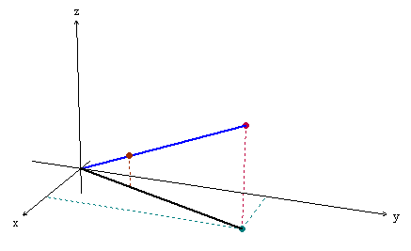

* + *The large triangle contains the points , , and .*
  + *The small triangle contains the points , , and .*
  + *The vertical segments are in the ratio . The ratio of the segments in the -plane is also , proving that the triangles are similar.*
  + *The long segment in the -plane has length .*
  + *The short segment in the -plane has length .*

Thus, we have . This confirms that the ratio of the corresponding sides is , proving that the triangles are similar. From this we conclude that the original point and its dilated image both lie on the same line through the origin.

* Now return to the problem at hand: What is the image of when it is projected onto the plane?  
  ?
  + *We want the value of that takes the -coordinate to , so we need , which gives .   
    So the image must be .*



* Now we will do some more practice with 3-D projections onto a 2-D screen.

Exercises 4–5 (3 minutes)

Give students time to work on the problems below. Ask them to share their work with a partner when they are ready. Select students to present their solutions to the class at an appropriate time.

1. Project the point onto the plane .

We need the value of that makes , so . Thus, the image is .

1. Project the point onto the plane .

We need the value of that makes , so . Thus, the image is .

Example (10 minutes): Rotations in 3D

In this example, students explore rotations around one of the coordinate axes.

* Recall that the matrix represents a rotation in 3-dimensional space about the -axis.   
  As varies, what path does trace out in 3-dimensional space?
  + *The path is a circle whose center is .*
* Now turn your attention to the screen, that is, the plane where . What is the path traced out by the projected image of as varies?
  + *The rotated image is the point* .
  + *To calculate the image of the point when it is projected onto the screen, we need the value of that causes* , *which is* .
  + *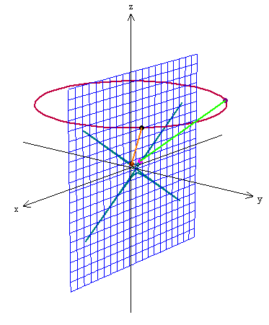Thus, the projected image is* . *Using graphing software we get the following path, which appears to be a hyperbola:*
* If instead we wanted to model a rotation of around the -axis, what matrix should be used?
  + *We should use* . *This leaves the -coordinate fixed and has the structure of a rotation matrix.*
* As varies, let’s project the points onto the plane . Describe the path traced out.
  + *The rotated image is the point* .
  + *To calculate the image of the point when it is projected onto the screen, we need the value of that causes* , *which is* .
  + *Thus, the projected image is* . *Using graphing software we get the following path, which is a circle. This circle is simply a smaller version of the circle traced out during the rotation:*

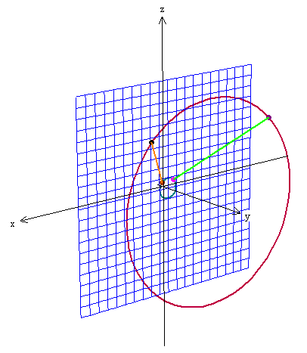

* These examples demonstrate how programmers give viewers the impression that objects are turning on the screen.

Closing (2 minutes)

* Use your journal to write a brief summary of what you learned in today’s lesson.
  + *We learned how to project points in 3-D space onto a plane which represents a 2-D screen.*
  + *We learned how to model a 3-D rotation using a 2-D screen.*

Exit Ticket (5 minutes)

Name Date

Lesson 26: Projecting a 3-D Object onto a 2-D Plane

Exit Ticket

1. Consider the plane defined by and the points, and .
   1. Find the projections of and onto the plane if the eye is placed at the origin.
   2. Consider ; does it make sense to find the projection of onto ? Explain.
2. Consider an object located at and rotating around the -axis. At what value will the object be out of sight of the plane ?

Exit Ticket Sample Solutions

1. Consider the plane defined by and the points, and .
   1. Find the projections of and onto the plane if the eye is placed at the origin.
   2. Consider ; does it make sense to find the projection of onto ? Explain.

No, .

1. Consider an object located at and rotating around the -axis. At what value will the object be out of sight of the plane ?

*To rotate around the -axis and project onto , . To project onto , . The projection would be . The value of that would make the object out of site is when . This occurs when or when .*

Problem Set Sample Solutions

1. A cube in -D space has vertices .
   1. How do we know that these vertices trace a cube?

*The edges between the vertices form right angles, and all have length of units.*

* 1. What is the volume of the cube?

*cubic units*

* 1. Let . Find the eight points on the screen that represent the vertices of this cube (some may be obscured).
  2. What do you notice about your result in part (c)?

Some of the points went to the same position. These were points that lay along the same path from the camera. Some points were dilated by a factor of and some by a factor of depending on how far they were from the plane in the -direction.

1. An object in 3-D space has vertices .
   1. What kind of shape is formed by these vertices?

It appears this is a pyramid with a square base.

* 1. Let . Find the five points on the screen that represent the vertices of this shape.

1. Consider the shape formed by the vertices given in Problem 2.
   1. Write a transformation matrix that will rotate each point around the -axis degrees.
   2. Project each rotated point onto the plane if .

First we rotate each point: .

* 1. Is this the same as rotating the values you obtained in Problem 3 by ?

Yes. Since the projection is interpreted as a dilation, order does not matter.

1. In technical drawings, it is frequently important to preserve the scale of the objects being represented. In order to accomplish this, instead of a perspective projection, an orthographic projection is used. The idea behind the orthographic projection is that the points are translated at right angles to the screen (the word stem *ortho*- means *straight* or *right*). To project onto the -plane for instance, we can use the matrix .
   1. Project the cube in Problem 1 onto the -plane by finding the 8 points that correspond to the vertices.
   2. What do you notice about the vertices of the cube after projecting?

They form a square with all points being mapped to points.

* 1. What shape is visible on the screen?

It is a square with sides of length .

* 1. Is the area of the shape that is visible on the screen what you expected from the original cube? Explain.

The area of the visible shape is , which is the same as the area of any of the faces of the original cube.

* 1. Summarize your findings from parts (a)–(d).

Orthographic projections preserve the scale of objects, but much of the original information is lost.

* 1. State the orthographic projection matrices for the -plane and the -plane.

For -plane:

For -plane:

* 1. In regard to the dimensions of the orthographic projection matrices, what causes the outputs to be   
     two-dimensional?

The transformation matrices are , meaning they can operate on 3-dimensional points but generate   
2-dimensional outputs.

1. Consider the point in the field of view from the origin through the plane .
   1. Find the projection of onto the plane .

Since the point is in the field of view, we know that , and we get: .

* 1. Find a matrix such that finds the projection of onto the plane .
  2. How does the matrix change if instead of projecting onto , we project onto , for some real number ?

The numerator of each fraction will be instead of .

* 1. Find the scalars that will generate the image of onto the planes and , assuming the image exists. Describe the scalars in words.

and . Whenever we are projecting onto a plane parallel to the -, -, or -planes, the scalar by which we multiply the point is always going to be the reciprocal of -, -, or -coordinate times the -, -, or -location of the plane.

Extension:

1. Instead of considering the rotation of a point about an axis, consider the rotation of the camera. Rotations of the camera will cause the screen to rotate along with it, so that to the viewer, the screen appears immobile.
   1. If the camera rotates around the -axis, how does the computer world appear to move?

A rotation of about the -axis.

* 1. State the rotation matrix we could use on a point to simulate rotating the camera and computer screen by about the -axis but in fact keeping the camera and screen fixed.
  2. If the camera rotates around the -axis, how does the computer world appear to move?

A rotation of about the -axis.

* 1. State the rotation matrix we could use on a point to simulate rotating the camera and computer screen by about the -axis but in fact keeping the camera and screen fixed.
  2. If the camera rotates around the -axis, how does the computer world appear to move?

A rotation of about the -axis.

* 1. State the rotation matrix we could use on a point to simulate rotating the camera and computer screen by about the -axis but in fact keeping the camera and screen fixed.
  2. What matrix multiplication could represent the camera starting at a relative angle ? Apply the transformations in the order --. Do not find the product.