Lesson 25: First-Person Computer Games

Student Outcomes
- Through discovery, students will understand how challenging it is to project three-dimensional objects onto a two-dimensional space.
- Students will understand that vanishing points can be used to project three-dimensional objects onto two-dimensional space. They will demonstrate this process by showing how a cube is projected onto the two-dimensional surface of a screen.
- Students will recognize that projecting three-dimensional images onto a two-dimensional surface can be accomplished by applying linear transformation matrices to the pre-image points.

Lesson Notes
The ALICE program should be downloaded before starting the lesson. In homework assigned prior to this lesson, students should become familiar with the ALICE 3.1 program. After sharing their experiences creating and manipulating objects in ALICE, students will discuss the projection of three-dimensional objects onto two-dimensional space and will attempt a projection of a cube onto a flat screen, which should help them appreciate the difficulty of sketching a two-dimensional projection of a three-dimensional object by hand. They will also use right-triangle trigonometry to explore how projections onto different-sized screens affect the viewer’s field of vision. Through a discussion of the historical development of perspective drawing, they will learn how vanishing points can be used to create realistic two-dimensional representations of three-dimensional objects. They will apply this understanding by revisiting the task of projecting a cube onto a two-dimensional screen and form conjectures about how vectors, representing points on the three-dimensional objects, can be multiplied by matrices to generate two-dimensional projections (N-VM.C.11). This will prepare them to apply matrix multiplication to generate two-dimensional projections in the next lesson.

Classwork
Opening (3 minutes)
Open the ALICE 3.1 program, and encourage students to share briefly the types of items they created or manipulated while exploring the program. Allow a few volunteers to demonstrate their new skills.

Discussion (2 minutes)
- Are the objects created in ALICE actually three-dimensional, and if not, how can we describe them?
  - They are representations or projections of three-dimensional objects onto a two-dimensional screen.
- How do people create realistic looking three-dimensional objects on a flat surface?
  - Answers may vary and could include the concept of depicting the object from a certain vantage point.

Exploratory Challenge (10 minutes)
The ALICE program Projection_No_Wires should be displayed. Note: If the program is not available, the example could be completed using a clear plastic sheet (such as a sheet protector or transparency sheet), a small cube, and a larger ball. Student volunteers could change the position of the objects to represent the different vantage points shown in the scene from the Alice program.
When the program opens, the instructor should click “run.” Typing $5$ should display a blue cube to the right of a gray rectangle.
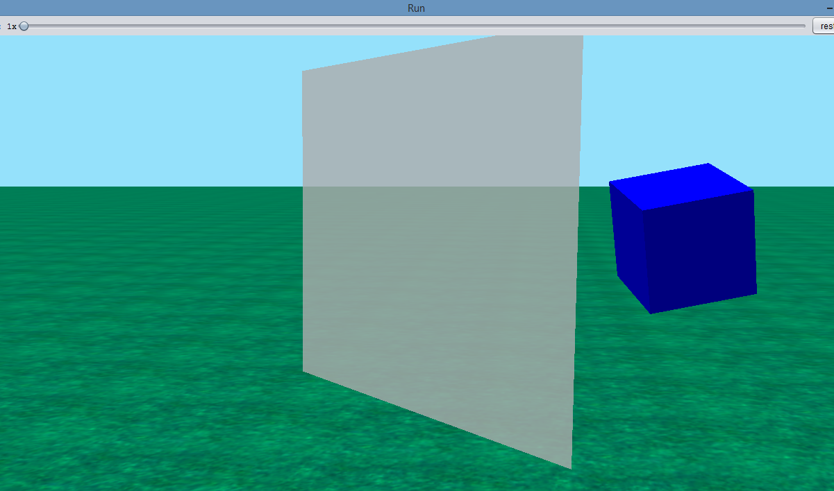
Explain to the students that the cube is a three-dimensional object that needs to be projected onto a screen represented by the gray rectangle. By typing $2$ when the program is run, students will be able to see the viewpoint of an observer’s eye looking forward through the screen to the cube and a red sphere behind it. Note: If the real objects are being used, the sheet would be directly in front of the viewer’s eye, with the cube in the foreground and the larger ball directly behind the cube.
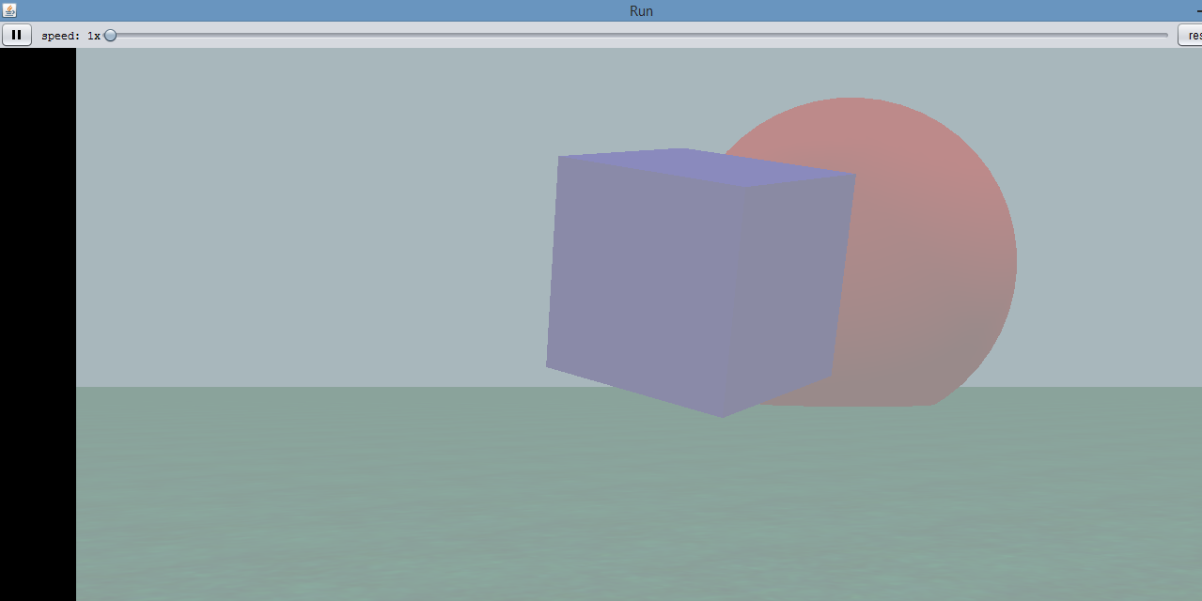
Typing $4$ will provide a wide view of the scene.

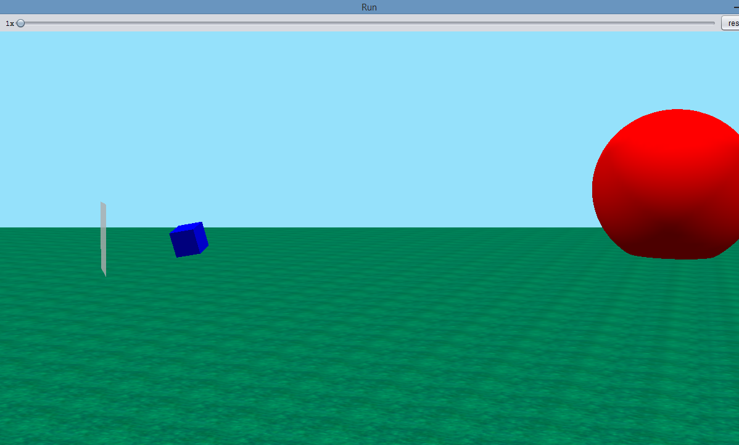
After discussing the different viewpoints, provide each student with a copy of the image shown in the example. Have the students attempt the construction. After a few minutes, they should share their ideas with a partner. Then the teacher should facilitate a discussion that emphasizes the difficulty of projecting the cube onto the screen by hand. The program projection should be shown to help students visualize what the projection of the cube onto the screen represents, that is, the points where the line segments from the viewer’s eye to the cube intersect the surface of the screen. This is viewpoint $5$, where the “strings” represent the line of sight from the viewer to the cube.
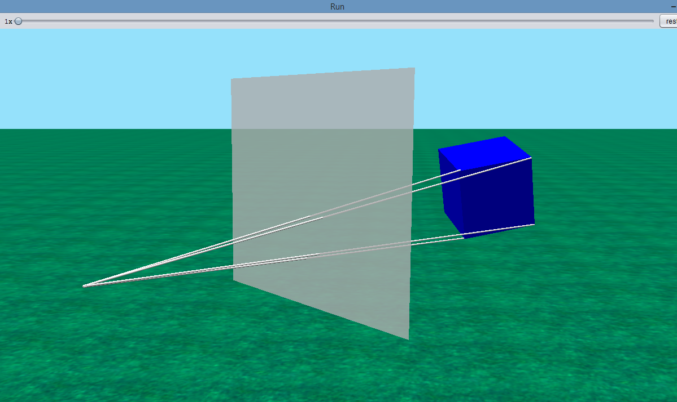
- The first screen we saw is viewpoint $5$. The blue cube represents the three-dimensional object to be projected onto a two-dimensional screen, which is represented by the gray rectangle. Now when we look at viewpoint $2$, how did the appearance of the scene change?
  - The screen is in the foreground, with the blue cube and a red sphere behind it.
- So viewpoint $2$ could represent the vantage point of a viewer looking directly at a TV screen. You could think of the screen as a window through which the viewer looks at the real-world objects on the other side. Now let’s look at viewpoint $4$. How does this viewpoint change the appearance of the scene?
  - Answers may vary but will probably indicate that this seems to be a wide view from the side, and the sphere looks much larger than the cube.
- How is it possible that viewpoints $2$ and $4$ could represent the same scene?
  - They show the objects from different positions. Viewpoint $2$ is from the perspective of a viewer looking at the two objects directly in front of him or her, and viewpoint $4$ is shown from a perspective that is to the side of the objects.
- Why does the relative size of the sphere look so different between the viewpoints?
  - Answers may vary, but students might recognize that when two objects are aligned in a viewer’s line of sight, a much smaller object in the foreground can appear to be similar in size to a much larger object in the background (e.g., one’s index finger placed a few inches directly in front of one’s eyes might look similar in height to a building in front of the viewer a mile away).
- Now look at the example. It is drawn from a similar vantage point to viewpoint $5$ in the ALICE program. By drawing line segments from the point in the lower left corner of the diagram (which represents the viewer’s eye) to the vertices of the cube, we can represent the viewer’s line of sight. Once we draw the line segments in, how can we draw an image of the cube on the screen?
  - Answers will vary but might include that the vertices of the projection are located where the line segments intersect the rectangle.
- Now that you have tried to draw the image of the cube projected on the screen, how would you characterize the activity, and what challenges did you face?
  - Most students will struggle with the construction and may not complete it. They might suggest that it is hard to see the points where the line segments intersect the screen. (Note: They will complete this activity later in the lesson through step-by-step instructions—the diagram later in the lesson shows the correctly drawn projection.)
- Let’s look at another program in ALICE. In this program, the cube is “attached” to the viewer’s eye by strings. In viewpoint $5$, you can see where the strings intersect the screen. The intersection of the viewer’s line of sight and the screen represents the projection of the cube onto the screen. This is difficult to represent on paper.
Exploratory Challenge
MP.1
&
MP.4
In this drawing task, the “eye” or the “camera” is the point, and the shaded figure is the “TV screen.” The cube is in the
3-D universe of the computer game.
By using lines drawn from each vertex of the cube to the point, draw the image of the 3-D cube on the screen.
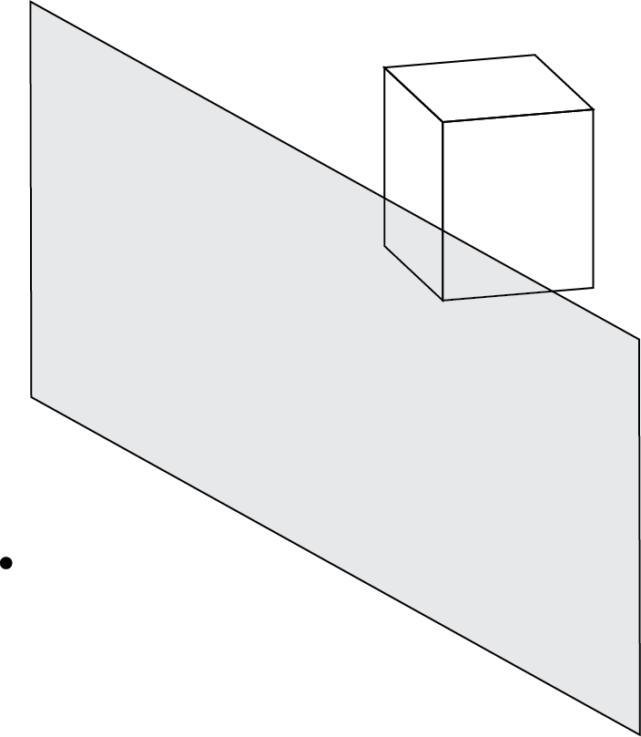
Scaffolding:
- Advanced students could be asked to project the cube onto the screen without further prompting.
- Model how the first vertex is drawn to the “eye,” and have students sketch the remaining line segments independently.
- If the ALICE software is unavailable, a transparent sheet could be used to represent the screen. A volunteer could hold a wooden block on one side of the screen, and pieces of twine could be used to help students “see” the line of sight from the viewer’s eye to a point on the block. The point of intersection between the twine and the transparency sheet would represent the two-dimensional projection of the point on the block onto the screen.

Example (5 minutes)
This example allows students to use right-triangle trigonometry to explore an additional challenge programmers have in projecting images onto a screen: limitations on the field of view. The students will apply trigonometry to determine the effect of screen size on a horizontal field of view. This example should be completed as part of a teacher-led discussion. Alternatively, the students could complete the problem in pairs and share their responses after a few minutes.
- How does a person’s peripheral vision compare with the field of view of a screen? Explain your answer.
  - The field of view of the screen is smaller. When you look at a screen, you can generally see objects in your peripheral vision that are to the right and left of the screen.
- We have experienced the limiting effect of a screen on our field of view. If we model the field of view of a television screen with a diagram, what components do we need to include?
  - The screen; the field of view, which is the angle formed by the rays representing the line of sight of the viewer to the right and left ends of the screen; the width of the screen; the distance from the middle of the screen to the viewer’s eyes
- What does our model look like when all these components are included?
  - Two right triangles are formed, each with leg lengths of $\frac{w}{2}$ and $d$, acute angle $\frac{θ}{2}$ formed by $d$, and the line of sight to the right or left side of the screen.
- How can we use trigonometry to find the line of sight of the person sitting in front of the television screen?
  - We can apply the inverse tangent function to the ratio of $\frac{w}{2}$ and $d$ to find $\frac{θ}{2}$.

- How does your own experience with screen viewing compare with our findings regarding the relationship between screen size, distance from a screen, and field of view?
  - Answers will vary but should address that larger screens, such as movie theater screens, require a greater viewing distance for a comfortable field of view than smaller screens (similarly a comfortable viewing distance from a television screen is usually greater than that for a computer screen).
Example
When three-dimensional objects are projected onto screens with finite dimensions, it often limits the field of view (FOV), or the angle the scene represents. This limiting effect can vary based on the size of the screen and position of the observer.
  - Sketch a diagram that could be used to calculate a viewer’s field of view $θ$ in relation to the horizontal width of the screen $w$ and the distance the viewer is from the screen $d$.
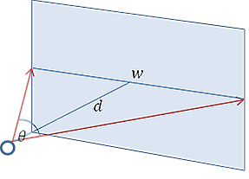

  - Assume that a person is sitting directly in front of a television screen whose width is $48 inches$ at a distance of $8 feet$ from the screen. Use your diagram and right-triangle trigonometry to find the viewer’s horizontal field of view $θ$.
$$\tan\left(\frac{θ}{2}\right)=\frac{\frac{w}{2}}{d} \\ \tan\left(\frac{θ}{2}\right)=\frac{\frac{4}{2}}{8}=0.25 \\ \tan^{-1}\left(0.25\right)=\frac{θ}{2} \\ 14°≈\frac{θ}{2} \\ θ≈28°$$

  - How far would a viewer need to be from the middle of a computer screen with a width of $15 inches$ to produce the same field of view as the person in front of the television?
$$tan\left(\frac{θ}{2}\right){=\frac{\frac{w}{2}}{d}} \\ tan\left(\frac{28}{2}\right){=\frac{\frac{15}{2}}{d}} \\ d=\frac{\frac{15}{2}}{\tan{14°}}≈30 inches$$

  - Write a general statement about the relationship between screen size and field of view.
The smaller the screen, the closer a viewer must be to the screen to result in a given horizontal FOV.
Discussion (8 minutes): Development of Perspective in Renaissance Art
This discussion will expose students to the difficulties artists have faced historically in representing three-dimensional objects on a two-dimensional surface.
- We have now experienced the challenges of trying to represent a three-dimensional object on a two-dimensional surface and explored some of the visual challenges in representing scenes on a surface with finite dimensions. Let us see how artists addressed the challenge of projecting images during the medieval and Renaissance periods.
Display an image that is similar to the one found at this site as well as the two images shown:
http://c300221.r21.cf1.rackcdn.com/medieval-painting-1384196679_org.jpg
 |  | 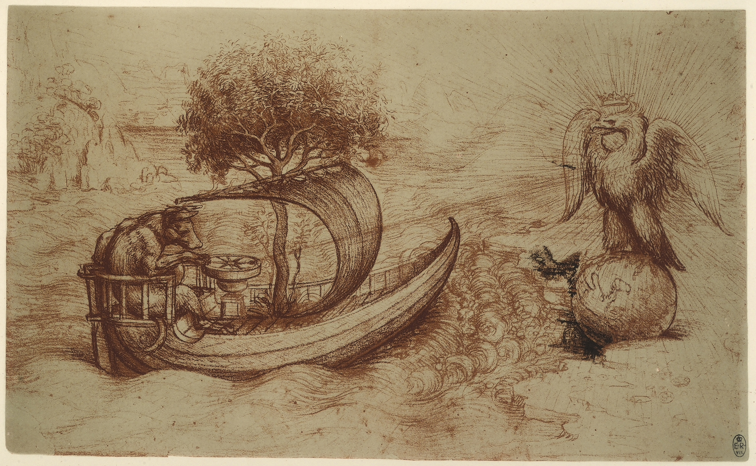
Giotto di Bondone. Scala.  Licensed from Art Resource, NY |  | Leonardo da Vinci. Alinari.  Licensed from Art Resource, NY
Have the students, in small groups, compare, and contrast the paintings, focusing on the depiction of three-dimensional images. Facilitate a discussion based on the students’ findings, and provide a brief explanation of the history of the development of linear perspective in art:
- How do the images differ in presenting realistic images of three-dimensional objects?
  - Answers will vary, but should address that the image of the meal does not realistically represent the table, e.g., it looks like the food is falling off the table; the second image provides a sense of a top and bottom of the hill but some figures look unrealistic, e.g., the black sheep looks like it is floating on the hill; the painting with the eagle realistically portrays the objects.
- This first painting you looked at is an example of a painting from the Middle Ages. In the early 1300s, artists generally created works that appeared flat, without distinguishing between the foreground and background or accounting for differences in the size of objects leading to scenes that looked unrealistic, e.g., floors and tables that tilted up.

- In the early 1300s, an artist named Giotto di Bondone was the first Italian painter to attempt to paint using perspective, trying to represent objects with a realistic impression of their size and depth. He is credited with applying algebra to help place distant lines in his paintings. An example of his work is the second painting you looked at. In what ways does this painting show an improvement in representing realistic three-dimensional objects in two-dimensional space when you compare it to the first painting?
  - Answers will vary but might address the illusion of depth between the left (upper) and right (lower) parts of the painting
- In the early 1400s, the artist Filipo Brunelleschi was attributed with advancing the use of linear perspective in art. In particular, he made use of a vanishing point, a point to which all lines in a painting would converge. The use of these lines helped artists to create the illusion of depth. Here is a simple example of using a vanishing point to create perspective:
 | A rectangle with a vanishing point at its center.
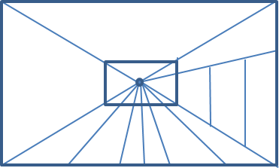 | A room with floor, back wall, and side door constructed using the vanishing point.
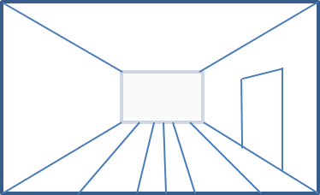 | A room with extraneous parts of the line segments erased.
- How was the vanishing point used to create the elements in the room? Share your ideas with a partner.
  - Answers will vary but should include that each of the line segments for the floor, ceiling, and door were created using line segments that intersect the vanishing point when extended. For the back wall, the vertices of the rectangle lie along line segments that intersect with the vanishing point.

- By the late 1400s, artists like Leonardo da Vinci were using multiple vanishing points in their artwork to create images that were very realistic, such as the following. How can you see the use of a vanishing point in this picture?
  - The lines in the drawing all converge at the vanishing point, which is at the eagle. This draws the eye to the eagle as the focal point of the drawing, in addition to creating a realistic sense of depth and size for the figures in the drawing.
- We can see the use of vanishing points in many realistic images.
One Vanishing Point  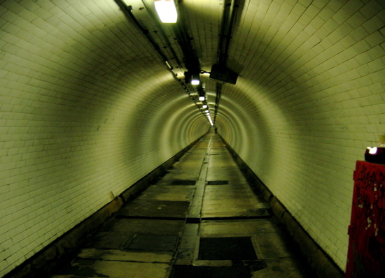  “Inside Greenwich Foot Tunnel” by C.G.P Grey,  is licensed under CC BY 2.0  http://creativecommons.org/licenses/by/2.0 | Two Vanishing Points  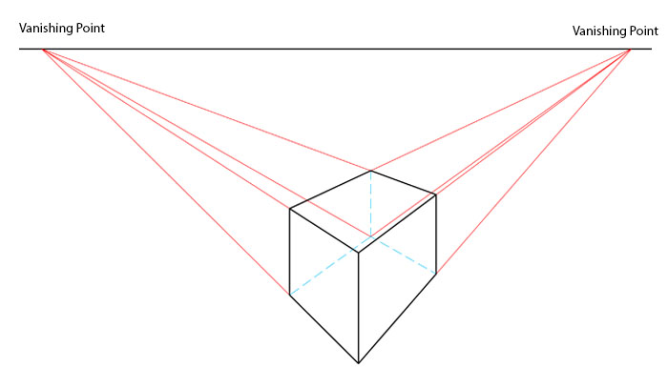  “Perspective 1” created by Ejahng,  is licensed under CC BY-SA 3.0  http://creativecommons.org/licenses/by-sa/3.0/deed.en
Three Vanishing Points  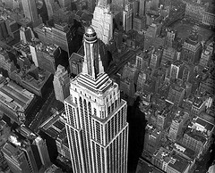  Berenice Abbott, 1934 | Multiple Vanishing Points  “UT band during Rice game” by Mary Estrada,  is licensed under CC BY 2.0  http://creativecommons.org/licenses/by/2.0

- How might the use of vanishing points to create linear perspective relate to transformations of objects in three-dimensional space?
  - Answers will vary but might address that the rescaling of objects is similar to performing linear transformations.
- And how have we transformed objects in three-dimensional space?
  - We have multiplied points by transformation matrices.
- One way to use multiple vanishing points to project a three-dimensional object into two-dimensional space by hand is to create a horizon line through the two-dimensional surface and plot one or more vanishing points along that line. We are going to use this idea to try again to project the cube onto the screen.

Exercise 1 (6 minutes)
Students should try to create the two-dimensional projection of the cube onto the screen, this time by using the horizon line and vanishing points provided. Point out to the students that the first projected point is selected arbitrarily, and the rest of the points can be found using the vanishing points. Note: It is important that the instructor works through the example prior to modeling it with students in class. This is likely to take more than one attempt. Once the students have completed the projection, have them paraphrase the procedure in writing, including an interpretation of the object they created. The students should share their projections and written responses with a partner.
Exercise 1
MP.1
&
MP.4
In this drawing task, the “eye” or the “camera” is the point, and the shaded figure is the “TV screen.” The cube is in the
3-D universe of the computer game.
By using lines drawn from each vertex of the cube to the point, draw the image of the 3-D cube on the screen. A horizon line and two additional vanishing points have been included to help you. The image point of the first vertex is shown.
Scaffolding:
- Advanced students could be prompted to create a horizon line with two endpoints as vanishing points outside the screen. They could be allowed, then, to choose the location of the line.
- Work with struggling students step-by-step through the construction as shown.
$V_{3}$
$V_{2}$
$V_{1}$
$P_{1}$
$P_{1}'$
- Draw line segments connecting the “eye” ($V_{1}$) with the vertices of the cube.
- Draw a vertical line segment on the screen from the given image point ($P_{1}'$) to the point where it intersects the line segment from $V_{1}$ to the vertex beneath it ($P_{2}'$).
$V_{3}$
$V_{2}$
$V_{1}$
$P_{1}$
$P_{1}'$
$P_{2}$
$P_{2}'$

- Draw dashed line segments connecting the two image points to vanishing points $2$ and $3$.
$V_{3}$
$V_{2}$
$V_{1}$
$P_{1}$
$P_{2}$
$P_{1}'$
$P_{2}'$

- Plot a point where each of the line segments from $V_{1}$ to the vertices intersect the line segments connecting the dashed line segments. These are the remaining image points for the vertices of the cube.
$P_{1}$
$P_{2}$
$P_{1}'$
$P_{2}'$
$P_{3}$
$P_{3}'$
$P_{4}$
$P_{4}'$
$P_{5}$
$P_{6}$
$P_{6}'$
$P_{7}$
$P_{7}'$
$V_{3}$
$V_{2}$
$V_{1}$
$P_{5}'$

- Connect the image points to form the projected image of the cube.
$V_{3}$
$V_{2}$
$V_{1}$

Exercise 2 (3 minutes)
This exercise should be completed as part of a teacher-led discussion. It will provide the opportunity for students to explore how matrix operations can be used to find the coordinates for projected points of three-dimensional objects.
Exercise 2
Let’s assume that the point $V_{1}$ in our projection diagram is at the origin and the upper right vertex of the cube is located at $\left(\begin{matrix}5 \\ 8 \\ 4\end{matrix}\right)$. If our screen represents the plane $y=2$, use matrix multiplication to determine the vector that represents the line of sight from the observer to the projected point on the screen. Explain your thinking.
The vector from the viewer to the vertex on the actual object is$\left[\begin{matrix}5 \\ 8 \\ 4\end{matrix}\right]$. Since the projected point and the actual vertex are along the same line of sight, the vector from the line of sight of the viewer to the projected point can be found by resizing the vector to the vertex so that the $y$-coordinate of the projected point is $2$. This can be accomplished by rescaling with a factor of $0.25$ using the matrix multiplication $\left[\begin{matrix}0.25 & 0 & 0 \\ 0 & 0.25 & 0 \\ 0 & 0 & 0.25\end{matrix}\right]\left[\begin{matrix}5 \\ 8 \\ 4\end{matrix}\right]=\left[\begin{matrix}1.25 \\ 2 \\ 1\end{matrix}\right]$.

Closing (3 minutes)
Students should respond to the question in writing. After a minute, they could share their predictions with a partner.
- What do you predict that computer programmers might do to represent and manipulate three-dimensional objects in two-dimensional space?
  - Answers will vary but might include determining image points by multiplying vectors by transformation matrices and applying matrix operations to represent linear transformations of the points.

Exit Ticket (5 minutes)

Name Date
Lesson 25: First-Person Computer Games

Exit Ticket

In a computer game, the camera eye is at the origin, and the tip of a dog’s nose has coordinates $\left(\begin{matrix}2 \\ 10 \\ 3\end{matrix}\right)$. If the computer screen represents the plane $y=1$, determine the coordinates of the projected point that represents the tip of the dog’s nose.

Exit Ticket Sample Solutions

In a computer game, the camera eye is at the origin, and the tip of a dog’s nose has coordinates $\left(\begin{matrix}2 \\ 10 \\ 3\end{matrix}\right)$. If the computer screen represents the plane $y=1$, determine the coordinates of the projected point that represents the tip of the dog’s nose.
The vector representing the line of sight from the viewer to the tip of the dog’s nose is $\left[\begin{matrix}2 \\ 10 \\ 3\end{matrix}\right]$ . To resize the vector so that the $y$-coordinate of the projected point is $1$, we need to rescale by a factor of $0.1$.
$\left[\begin{matrix}0.1 & 0 & 0 \\ 0 & 0.1 & 0 \\ 0 & 0 & 0.1\end{matrix}\right]\left[\begin{matrix}2 \\ 10 \\ 3\end{matrix}\right]=\left[\begin{matrix}0.2 \\ 1 \\ 0.3\end{matrix}\right]$, so the projected point is $\left(\begin{matrix}0.2 \\ 1 \\ 0.3\end{matrix}\right)$.

Problem Set Sample Solutions

- Projecting the image of a three-dimensional scene onto a computer screen has the added constraint of the screen size limiting our field of view, or FOV. When we speak of FOV, we wish to know what angle of view the scene represents. Humans have remarkably good peripheral vision. In New York State, the requirement for a driver’s license is a horizontal FOV of no less than $140°$. There is no restriction placed on the vertical field of vision, but humans normally have a vertical FOV of greater than $120°$.
  - Consider the (simulated) distance the camera is from the screen as $d$, the horizontal distance of the screen
as $w$, and the horizontal FOV as $θ$, then use the diagram below and right-triangle trigonometry to help you find $θ$ in terms of $w$ and $d$.

$$w$$
$$\frac{θ}{2}$$
$$d$$

$$tan\left(\frac{θ}{2}\right)=\frac{\frac{w}{2}}{d} \\ \frac{θ}{2}=tan^{-1}\left(\frac{\frac{w}{2}}{d}\right) \\ θ=2 tan^{-1}\left(\frac{\frac{w}{2}}{d}\right)$$

  - Repeat procedures from part (a), but this time let $h$ represent the height of the screen and $ψ$ represent the vertical FOV.
$$h$$
$$\frac{ψ}{2}$$
$$d$$

$$tan\left(\frac{ψ}{2}\right)=\frac{\frac{h}{2}}{d} \\ \frac{ψ}{2}=tan^{-1}\left(\frac{\frac{h}{2}}{d}\right) \\ ψ=2 tan^{-1}\left(\frac{\frac{h}{2}}{d}\right)$$

  - If a particular game uses an aspect ratio of $16:9$ as its standard view and treats the camera as though it were $8$ units away, find the horizontal and vertical FOVs for this game. Round your answers to the nearest degree.
$$θ=2⋅\tan^{-1}\left(\frac{\frac{16}{2}}{8}\right) \\ =2⋅\tan^{-1}\left(1\right) \\ =2⋅45 \\ =90$$
The horizontal field of view is $90°$.
$$ψ=2⋅\tan^{-1}\left(\frac{\frac{9}{2}}{8}\right) \\ =2⋅\tan^{-1}\left(\frac{4.5}{8}\right) \\ ≈2⋅29.36 \\ =58.72 \\ ≈59$$
So, the vertical field of view is about $59°$.

  - When humans sit too close to monitors with FOVs less than what they are used to in real life or in other games, they may grow dizzy and feel sick. Does the game in part (c) run the risk of that? Would you recommend this game be played on a computer or on a television with these FOVs?
The game in part (c) has a smaller field of vision than most humans are probably used to. Since computer games are played much closer and that increases the chance of dizziness and illness, this game would probably be better on a television than a computer.

- Computers regularly use polygon meshes to model three-dimensional objects. Most polygon meshes are a collection of triangles that approximate the shape of a three-dimensional object. If we define a face of a polygon mesh to be a triangle connecting three vertices of the shape, how many faces at minimum do the following shapes require?
  - A cube.
A cube normally has $6$ square faces, but it requires $2$ triangles to make a square, so a polygon mesh of a cube would have $12$ faces.

  - A pyramid with a square base.
The pyramid has $4$ triangular faces already, and would require $2$ more to make up the base, so $6$ faces.

  - A tetrahedron.
A tetrahedron is composed of $4$ triangles, so $4$ faces for its polygon mesh.

  - A rectangular prism.
A rectangular prism is the same as a cube: it has $12$ faces.

  - A triangular prism.
A triangular prism has $2$ faces make up the ends, and each side requires 2more faces, so $2+2⋅3=8$ faces.

  - An octahedron.
An octahedron is $8$ triangular pieces, so $8$ faces.

  - A dodecahedron.
A dodecahedron normally has $12$ pentagonal faces. Each pentagon requires a minimum of $3$ triangles to construct it, so a dodecahedron would have $36$ faces in its polygon mesh.

  - An icosahedron.
An icosahedron has $20$ triangular faces, so its polygon mesh does as well.

  - How many faces should a sphere have?
Answers will vary. An icosahedron is a rough approximation of a sphere, so $20$ is a good estimate, especially for graphics in the early years of computers and video games. Some students might suggest $360$, which is a good estimate of the number of lines to approximate a circle. As many faces as the computer can handle without slowing down would be the best polygon mesh for a sphere.

- In the beginning of 3-D graphics, objects were created only using the wireframes from a polygon mesh without shading or textures. As processing capabilities increased, 3-D models became more advanced, and shading and textures were incorporated into 3-D models. One technique that helps viewers visualize how shading works on a
3-D figure is to include both an “eye” and a “light source.” Vectors are drawn from the eye to the figure, and then reflected to the light (this technique is called ray tracing). See the diagram below.
“eye” or “camera”
“light source”
$$v_{l}$$
$$v_{s}$$

  - Using this technique, the hue of the object depends on the sum of the magnitudes of the vectors. Assume the eye in the picture above is located at the origin, $v_{s}$ is the vector from the eye to the location $\left(\begin{matrix}4 \\ 5 \\ 3\end{matrix}\right)$, and the light source is located at $\left(\begin{matrix}5 \\ 6 \\ 8\end{matrix}\right)$. Then find $v_{l}$, the vector from $v_{s}$ to the light source, and the sum of the magnitudes of the vectors.
$v_{l}$ is the difference between the light source and the object, so $v_{l}=\left(\begin{matrix}5 \\ 6 \\ 8\end{matrix}\right)-\left(\begin{matrix}4 \\ 5 \\ 3\end{matrix}\right)=\left(\begin{matrix}1 \\ 1 \\ 5\end{matrix}\right)$.
$$\left\|v_{l}\right\|=\sqrt{1^{2}+1^{2}+5^{2}}=\sqrt{27}=3\sqrt{3}$$
$$\left\|v_{s}\right\|=\sqrt{4^{2}+5^{2}+3^{2}}=\sqrt{16+25+9}=\sqrt{50}=5\sqrt{2}$$
$$\left\|v_{l}\right\|+\left\|{\text{v}}_{s}\right\|=3\sqrt{3}+5\sqrt{2}$$

  - What direction does light travel in real life, and how does this compare to the computer model portrayed above? Can you think of any reason why the computer only traces the path of vectors that start at the “eye”?
In reality, light travels from the light source, bouncing off objects until it reaches our eyes. If the computer starts drawing vectors at the light source, then it will draw many vectors that will never reach our “eye,” wasting resources.

