Lesson 24: Why Are Vectors Useful?

Student Outcomes
- Students apply linear transformations and vectors to understand the conditions required for a sequence of transformations to preserve the solution set to the system of equations.

Lesson Notes
Vectors are useful for representing systems of equations. Vectors (and matrices) are essential to the representation of systems of equations in higher dimensions that students will encounter in more advanced l mathematics classes. In this lesson we work with systems of linear equations in $R^{2}$, but the ideas can be extended to higher-order linear systems. Vectors are extremely useful in a wide variety of settings as a means of representing and manipulating geometric objects as well as real-world quantities. In this lesson, students will see how vectors can be applied to solving a system of equations in two variables by exploring the geometry of solving systems of equations. Students will be guided to the understanding(using pictures only) that the method of transforming systems of linear equations while preserving the solution (A-REI.C.5) can be rephrased in terms of a series of linear transformations and translations. Again, students write vectors as parametric equations to understand the coherence between their work with functions, linear transformations, and vectors. The work in this lesson will help set the stage for further application of vectors and matrices in the last three lessons of this module.

Classwork
Opening Exercise (7 minutes)
Give students time to work on the problem individually, and then compare work with a partner. Encourage students to analyze the problem in a variety of ways: algebraically, graphically, and numerically. A graphing utility could also be used.
Opening Exercise
Two particles are moving in a coordinate plane. Particle 1 is at the point $\left(\begin{matrix}2 \\ 1\end{matrix}\right)$ and moving along the velocity vector $\left(\begin{matrix}-2 \\ 1\end{matrix}\right)$. Particle 2 is at the point $\left(\begin{matrix}-1 \\ 1\end{matrix}\right)$ and moving along the velocity vector $\left(\begin{matrix}1 \\ 2\end{matrix}\right)$. Are the two particles going to collide? If so, at what point, and at what time? Assume that time is measured in seconds.
Particle 1: $\left(\begin{matrix}x(t) \\ y(t)\end{matrix}\right)=\left(\begin{matrix}2 \\ 1\end{matrix}\right)+\left(\begin{matrix}-2 \\ 1\end{matrix}\right)t$ $x\left(t\right)=2-2t$, and $y\left(t\right)=1+t$ $y=\frac{3}{2}-\frac{1}{2}x$
Particle 2: $\left(\begin{matrix}x(t) \\ y(t)\end{matrix}\right)=\left(\begin{matrix}-1 \\ 1\end{matrix}\right)+\left(\begin{matrix}1 \\ 2\end{matrix}\right)t$ $x\left(t\right)=-1+t$, and $y\left(t\right)=1+2t$ $y=3+2x$
The particles will not collide. While they do cross the same point at $\left(\begin{matrix}-0.6 \\ 1.8\end{matrix}\right)$, they do not cross this point at the same time. Particle 1 crosses this point at $t=0.4$, and Particle 2 does not cross this point until $t=0.8$.

- The two lines intersect at $(-0.6,1.8)$. Why do the particles not collide at that point?
  - They do not collide because the two particles reach that point at two different times.
Particle 1 travels along the line $y=\frac{3}{2}-\frac{1}{2}x$, and Particle 2 travels along the line $y=3+2x$.
The graphs of these lines intersect at the point $(-0.6, 1.8)$ as shown below. The blue portions of the graph show the parametric equations that represent the path of each particle on the interval $-3≤t≤3$.
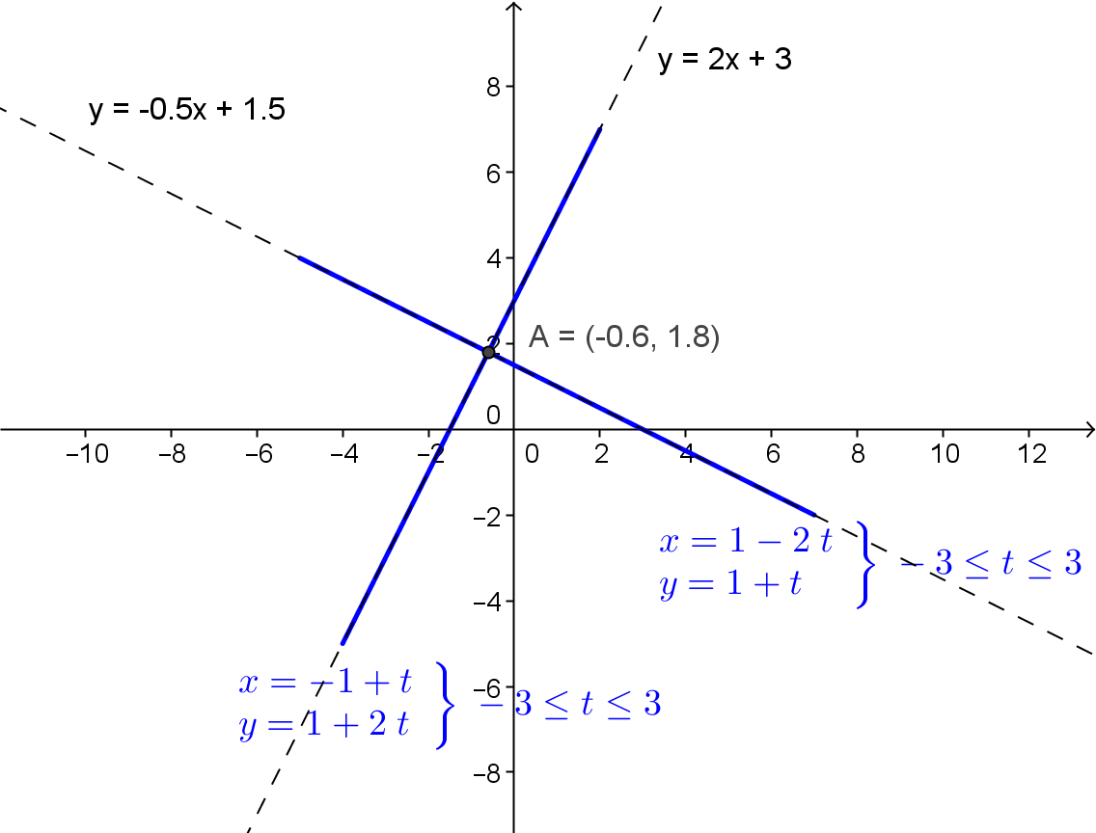

To show this result dynamically, enter the parametric equations for each particle on a graphing calculator or other graphing software, and set the $t$-interval to be $-3≤t≤3$. Be sure the calculator is set to graph the two equations simultaneously. Then, it can be seen that the particles do not arrive at the intersection point at the same $t$-value.
The table below demonstrates numerically that two particles do not pass through the intersection point at the same time. When $t=0$, both particles are at $y=1$. The intersection point of the graphs of the lines occurs when $y=1.8$, thus the two particles will never be at that $y$-value at the same time.
$$t$$ | $$x_{1}\left(t\right)=2-2t$$ | $$y_{1}\left(t\right)=1+t$$ | $$x_{2}\left(t\right)=-1+t$$ | $$y_{2}\left(t\right)=1+2t$$
$$-3$$ | $$7$$ | $$-2$$ | $$-4$$ | $$-5$$
$$-2$$ | $$5$$ | $$-1$$ | $$-3$$ | $$-3$$
$$-1$$ | $$3$$ | $$0$$ | $$-2$$ | $$-1$$
$$0$$ | $$1$$ | $$1$$ | $$-1$$ | $$1$$
$$1$$ | $$-1$$ | $$2$$ | $$0$$ | $$3$$
$$2$$ | $$-3$$ | $$3$$ | $$1$$ | $$5$$
$$3$$ | $$-5$$ | $$4$$ | $$2$$ | $$7$$
We can solve this system algebraically by solving the equation $\frac{3}{2}-\frac{1}{2}x=2x+3$ for $x$. The solution is $-0.6$.
Substituting $-0.6$ for $x$ into the parametric equations and solving for $t$ gives the following solutions:
$$2-2t=-0.6 \\ t=1.3$$
and
$$-1+t=-0.6 \\ t=0.4$$
You can see that these particles do not reach the $x$-coordinate of the intersection point at the same time and therefore will not collide.
Have students present their solution approaches to the class, highlighting different approaches.

Exercise 1 (5 minutes)
Have students continue to work with a partner through Exercise 1. Then, debrief as a class, and hold the discussion that follows. In this exercise, we represent lines using vectors as shown in previous lessons. If students are struggling to make sense of part (a), encourage them to write the parametric equations for each line, and then eliminate the $t$ parameter to write the equation of the line in terms of the variables $x$ and $y$.
Exercise 1
Consider lines $l=\left\{(x,y) | 〈x,y〉=t〈1,-2〉\right\}$, and $m=\left\{(x,y) | 〈x,y〉=t〈-1,3〉\right\}$.
  - To what graph does each line correspond?
Line $l$ corresponds to the graph of $y=-2x$. Line $m$ corresponds to the graph of $y=3x$.

  - Describe what happens to the vectors defining these lines under the transformation $A=\left(\begin{matrix}3 & 1 \\ 2 & 1\end{matrix}\right)$.
Each vector is mapped to a new vector. $〈1,-2〉→〈1,0〉$, and $〈-1,3〉→〈0,1〉$.

Students may need to be reminded that to apply the transformation $A$, they must compute $A∙v$, where $v$ is the vector that defines each line.
Scaffolding:
- Challenge advanced students to come up with their own example that illustrates the point that a linear transformation will preserve the solution set for lines that pass through the origin.
- For struggling students, provide another example showing that if the solution set is the origin, it will still be the origin after a transformation.
- Let $l=〈2,1〉$ and $m=〈1,4〉$. Use a transformation of
$A=\left(\begin{matrix}1 & 4 \\ 0 & -1\end{matrix}\right)$.
$〈2,1〉→〈6,-1〉$
and $〈1,4〉→〈17,-4〉$The solution is still $\left(0,0\right)$.

$$\left(\begin{matrix}3 & 1 \\ 2 & 1\end{matrix}\right)∙\left(\begin{matrix}1 \\ -2\end{matrix}\right)=\left(\begin{matrix}1 \\ 0\end{matrix}\right)$$
and$$\left(\begin{matrix}3 & 1 \\ 2 & 1\end{matrix}\right)∙\left(\begin{matrix}-1 \\ 3\end{matrix}\right)=\left(\begin{matrix}0 \\ 1\end{matrix}\right)$$

  - Show this transformation graphically.
The vector that defined $l$ shown in the diagram is $u=〈1,-2〉$, and the vector that defined $m$ shown in the diagram is $v=〈-1,3〉$. In the diagram the image of $l$ when transformed by $A$ results in the graph of the line $y=0$,’ and the image of $m$ when transformed by $A$ results in the graph of the line $x=0$.
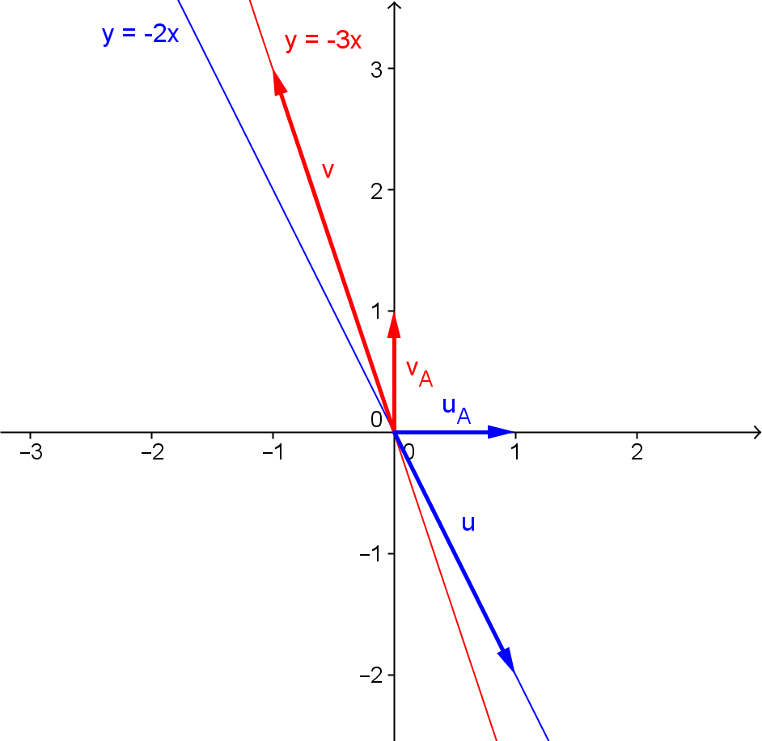
Discussion (5 minutes)
- What is the solution to the original system of equations given by $l$ and $m$?
  - The origin $\left(0,0\right)$.
- What is the solution to the system after the transformation given by $Al$ and $Am?$
  - The solution is still the origin.
- Can we say that linear transformations will preserve the solution set to a system of linear equations?
  - It seems this is true for lines that pass through the origin.
- What will happen if we apply a linear transformation to two lines that do not intersect at the origin? Do you think the solution set of the system of equations will still be preserved?
MP.3
  - Answers will vary. The solution set may be preserved because the lines are simply rotated about the intersection point. Another conjecture would be that the solution set may not be preserved because the transformation rotates the lines about the origin which will move the intersection point.

Exercise 2 (5 minutes)
This exercise has students test their conjectures by having them consider a system of equations where the graphs of the two lines do not intersect at the origin. Have students continue to work with a partner through Exercise 2. Then, debrief as a class, and continue the discussion. Use the questions below to help students begin to think about the transformations that have been applied.
- How does line $l$ in this exercise compare to line $l$ from Exercise 1? How does line $m$ in this exercise compare to line $m$ in Exercise 1?
  - The lines have the same slope but a different initial point. The new lines $l$ and $m$ have the same point $(1,1)$ when $t=0$.
- Describe these lines as transformations of the lines from Exercise 1.
  - Both lines in Exercise 2 are a translation of the original lines by the vector $\left(\begin{matrix}1 \\ 1\end{matrix}\right)$.
- Knowing the solution to Exercise 1, how can you quickly find the solution to the system of equations represented by the lines in this exercise?
- Since the solution to the original system in Exercise 1 is $(0,0)$, when the two lines are both translated by the vector $\left(\begin{matrix}1 \\ 1\end{matrix}\right)$, all points on the graph of the lines will shift $1$ unit right and $1$ unit up; therefore, the intersection point of the graphs of the lines which is the solution to the system will become $\left(1,1\right)$.
Exercise 2
Consider lines $l=\left\{(x,y) | 〈x,y〉=〈1,1〉+t〈1,-2〉\right\}$, and $m=\left\{(x,y) | 〈x,y〉=〈1,1〉+t〈-1,3〉\right\}$.
  - What is the solution to the system of equations given by lines $l$ and $m$?
The solution is$(1,1)$.

  - Describe what happens to the lines under the transformation $A=\left(\begin{matrix}3 & 1 \\ 2 & 1\end{matrix}\right)$.
Line $l$ becomes $Al=\left\{(x,y) | 〈x,y〉=〈4,3〉+t〈1,0〉\right\}$.
Line $m$ becomes $Am=\left\{(x,y) | 〈x,y〉=〈4,3〉+t〈0,1〉\right\}$.
  - What is the solution to the system of equations after the transformation?
The solution is the point $(4,3)$.

Discussion (10 minutes)
- What happened to the solution to the system when we applied a linear transformation to two lines that did not intersect at the origin?
  - The solution to the system changed.
- Why did the solution change when we applied the transformation $A$ to this system?
  - The linear transformation $A$ not only transforms the velocity vectors for each line, but it also transforms the position vector $\left(\begin{matrix}1 \\ 1\end{matrix}\right)$
- Can we say that linear transformations will preserve the solution set to a system of linear equations?
  - If the lines intersect at a point other than the origin, then the solution set is NOT preserved. In Example 2, the solution set changed after the linear transformation.
- In Exercise 2, we translated each linear equation by the vector $\left(\begin{matrix}1 \\ 1\end{matrix}\right)$ to put the solution at $(1,1)$. Could we translate any system of linear equations so that the intersection point of the graphs of the lines is $(0,0)$? Explain your reasoning.
  - The coordinates of the intersection point is the terminal point of a position vector. If we translate the linear equations by the opposite of this vector, the intersection point will be $(0,0)$.
- What if I translated a system of equations to the origin before applying a linear transformation to the system? Explain your reasoning.
  - Then I would know that the transformation would not change the solution to the system. (The solution would be the origin.)
The diagrams below can show the sequence of transformations that will preserve the solution set to a system of equations. As you continue the discussion, draw the pictures below on the board. We are not concerned with using this as an algebraic means for solving a system of equations. We are interested in the ideas behind performing these transformations which have some important ramifications in future math courses. Some of these ideas will be explored further in the Problem Set.
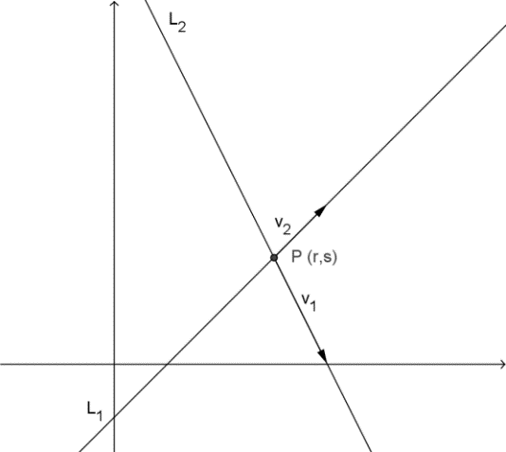
Translate the system to the origin $T_{-P}$.
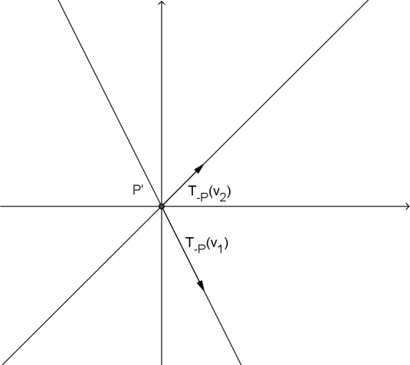

- What will happen to the solution of this new system when we apply a linear transformation?
  - If the intersection point of the graphs of the lines is $(0,0)$, then the solution to the system will not change when we apply a linear transformation. Further, there will exist a matrix that will take the vectors that define each line to the $x$- and $y$- axes when we apply the linear transformation.
- But this is not the solution to the original system of equations. What would we need to do next to find the solution?
  - We would need to reverse the translation of the transformed system.
- How can we transform this system into a system with the same solution set as the original one?
  - We can translate the system by the original vector that represented the solution to the system.
The diagram below shows the result of applying the linear transformation $A$ to the new system of equations whose graphs intersect at the origin and then the subsequent translation $T_{P}$ to return the intersection point back to the original intersection point.
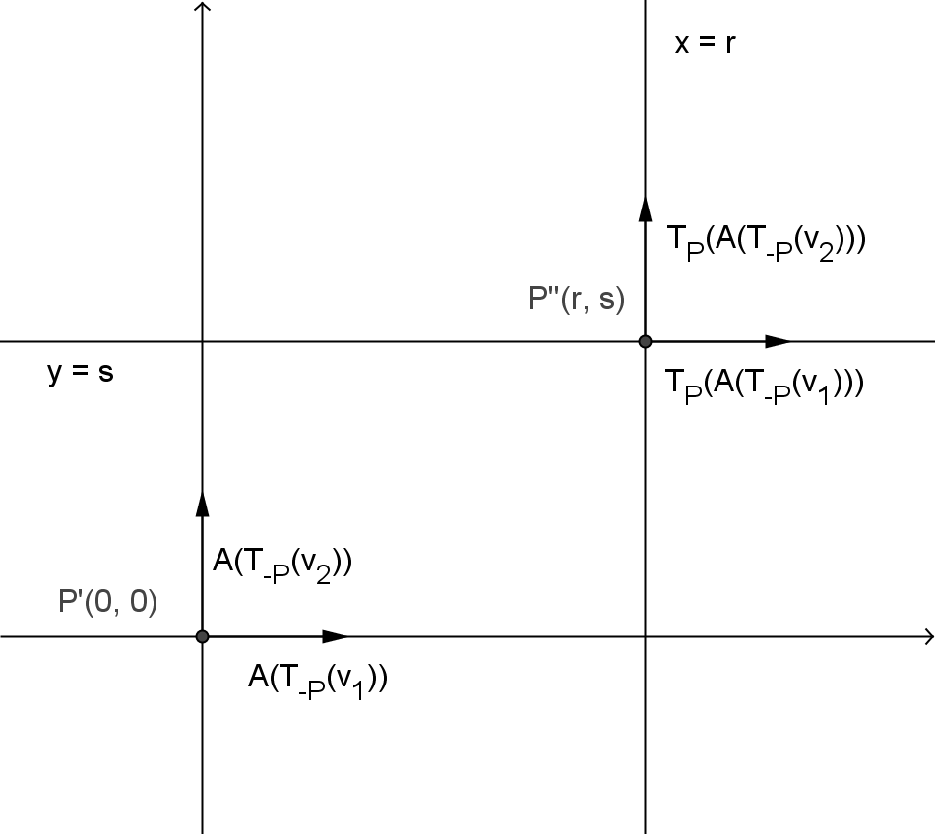
Then, translate by $T_{P}$ to return the system to the original intersection point.
Apply $A$ to $T_{-p}$ to take the lines to the $x$- and $y$-axes.

Exercise 3 (5 minutes)
The next exercise lets students practice this approach with a fairly simple system of linear equations. The lines are at right angles to one another, so the linear transformation that will map the translated system to the $x$- and $y$-axes will not be that difficult to determine. Have students continue working with their partner.

Exercise 3
The system of equations is given below. A graph of the equations and their intersection point is also shown.
$$x+y=6$$  $$x-y=2$$ | 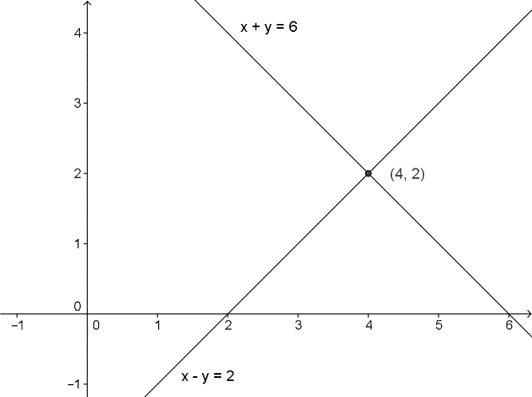

  - Write each line in the form $L\left(t\right)=p+vt$ where $p$ is the position vector whose terminal point is the solution of the system, and $v$ is the velocity vector that defines the path of a particle traveling along the line such that when $t=0$, the solution to the system is $\left(x\left(0\right),y\left(0\right)\right)$.
$L_{1}(t)=\left(\begin{matrix}4 \\ 2\end{matrix}\right)+\left(\begin{matrix}-1 \\ 1\end{matrix}\right)t$
$L_{2}\left(t\right)=\left(\begin{matrix}4 \\ 2\end{matrix}\right)+\left(\begin{matrix}1 \\ 1\end{matrix}\right)t$

  - Describe a translation that will take the point $(x\left(0\right),y\left(0\right))$ to the origin. What is the new system?
Translate the system by the vector $〈-4,-2〉$.
$$y=-x$$
$$y=x$$

  - Describe a transformation matrix $A$ that will rotate the lines to the $x$- and $y$-axes. What is the new system?
Let $A=\left(\begin{matrix}a & b \\ c & d\end{matrix}\right)$. We want $A∙\left(\begin{matrix}-1 \\ 1\end{matrix}\right)=\left(\begin{matrix}1 \\ 0\end{matrix}\right)$, and $A∙\left(\begin{matrix}1 \\ 1\end{matrix}\right)=\left(\begin{matrix}0 \\ 1\end{matrix}\right)$. Thus
$$-a+b=1$$
$$-c+d=0$$
and
$$a+b=0$$
$$c+d=1$$
Solving for $a$, $b$, $c$, and $d$ gives
$$A=\left(\begin{matrix}-\frac{1}{2} & \frac{1}{2} \\ \frac{1}{2} & \frac{1}{2}\end{matrix}\right)$$
The new system is
$$x=0$$
$$y=0$$

  - Describe a translation that will result in a system that has the same solution set as the original system. What is the new system of equations?
Translate by the vector $〈4,2〉$. The new system is
$$x=4$$
$$y=2$$
which does intersect at the point $(4,2)$, so the solution is $(4,2)$.

The diagram below details the transformations graphically.

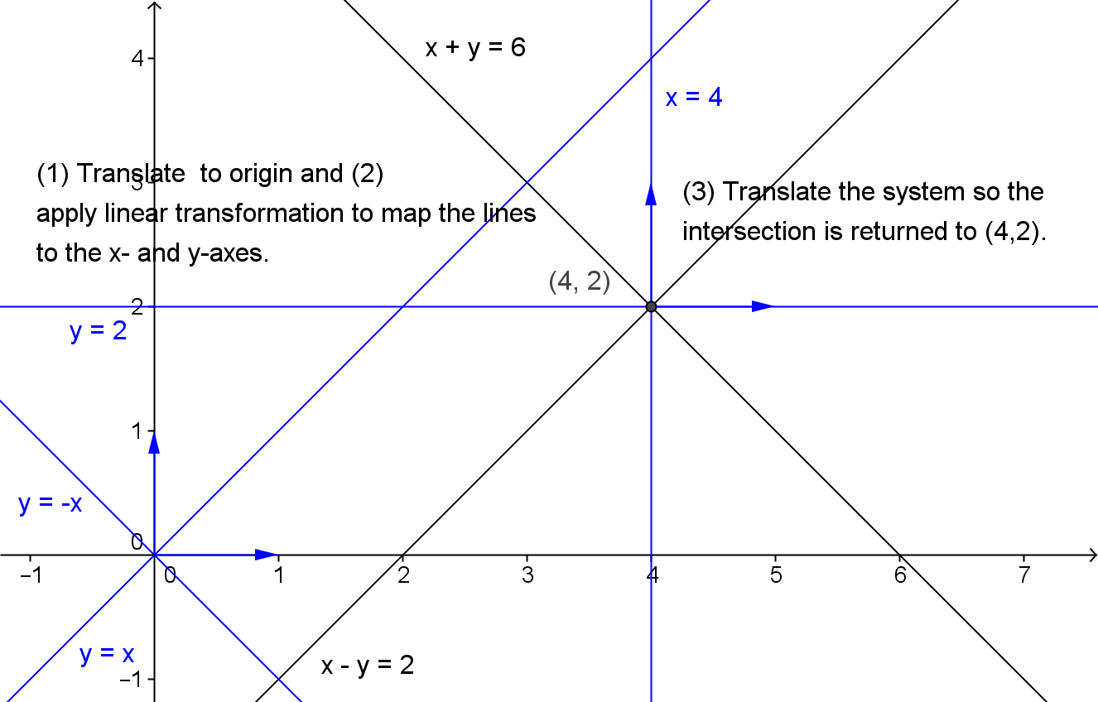

Closing (3 minutes)
Ask students to summarize the key points of the lesson first in writing and then with a partner. Share key points as a class.
- A linear transformation preserves the solution set of a system of linear equations if they intersect at the origin.
- If a system of linear equations does not intersect at the origin, the solution set may not be preserved by a linear transformation.
- A sequence of transformation can be applied to a system of equations to preserve the solution set.

Exit Ticket (5 minutes)
Name Date
Lesson 24: Why Are Vectors Useful?

Exit Ticket

- Consider the system of equations $\left\{\begin{aligned}y=5x+2 \\ y=3x\end{aligned}\right.$, and perform the following operations on an arbitrary point $\left(\begin{matrix}x \\ y\end{matrix}\right)$:
  - Rotate around the origin by $θ$.

  - Translate by the opposite of the solution to the system.

  - Apply a dilation of $2/3$.

- What effect does each of the transformations in Problem 1 have on the solution of the system and on the origin?
Exit Ticket Sample Solutions

- Consider the system of equations $\left\{\begin{aligned}y=5x+2 \\ y=3x\end{aligned}\right.$, and perform the following operations on an arbitrary point $\left(\begin{matrix}x \\ y\end{matrix}\right)$:
  - Rotate around the origin by $θ$.
$$\left(\begin{matrix}cos\left(θ\right) & -sin\left(θ\right) \\ sin\left(θ\right) & cos\left(θ\right)\end{matrix}\right)\left(\begin{matrix}x \\ y\end{matrix}\right)=\left(\begin{matrix}xcos\left(θ\right)-ysin\left(θ\right) \\ xsin\left(θ\right)+ycos\left(θ\right)\end{matrix}\right)$$

  - Translate by the opposite of the solution to the system.
$$\left(\begin{matrix}x \\ y\end{matrix}\right)-\left(\begin{matrix}-1 \\ -3\end{matrix}\right)=\left(\begin{matrix}x+1 \\ y+3\end{matrix}\right)$$

  - Apply a dilation of $2/3$.
$$\left(\begin{matrix}\frac{2}{3} & 0 \\ 0 & \frac{2}{3}\end{matrix}\right)\left(\begin{matrix}x \\ y\end{matrix}\right)=\left(\begin{matrix}\frac{2}{3}x \\ \frac{2}{3}x\end{matrix}\right)$$

- What effect does each of the transformations in Problem 1 have on the solution of the system and on the origin?
The solution of the system $\left(\begin{matrix}-1 \\ -3\end{matrix}\right)$ maps to $\left(\begin{matrix}-cos\left(θ\right)+3sin\left(θ\right) \\ -sin\left(θ\right)-3cos\left(θ\right)\end{matrix}\right)$, $\left(\begin{matrix}0 \\ 0\end{matrix}\right)$, and $\left(\begin{matrix}-\frac{2}{3} \\ -2\end{matrix}\right)$ respectively.
The origin maps to itself for the first and third transformations, which were linear transformations, and maps to the opposite of the system’s solution for the second transformation: $\left(\begin{matrix}1 \\ 3\end{matrix}\right)$.

Problem Set Sample Solutions

- Consider the system of equations $\left\{\begin{aligned}y=3x+2 \\ y=-x+14\end{aligned}\right.$.
  - Solve the system of equations.
The point $\left(3,11\right)$ is a simultaneous solution to the two equations.

  - Ilene wants to rotate the lines representing this system of equations about their solution and wishes to apply the matrix $\left(\begin{matrix}cos\left(θ\right) & -sin\left(θ\right) \\ sin\left(θ\right) & cos\left(θ\right)\end{matrix}\right)$ to any point $A$ on either of the lines. If Ilene is correct, then applying a rotation to the solution will map the solution to itself. Let $θ=90°$, and find where Ilene’s strategy maps the solution you found in part (a). What is wrong with Ilene’s strategy?
$$\left(\begin{matrix}cos\left(90\right) & -sin\left(90\right) \\ sin\left(90\right) & cos\left(90\right)\end{matrix}\right)\left(\begin{matrix}3 \\ 11\end{matrix}\right)=\left(\begin{matrix}0 & -1 \\ 1 & 0\end{matrix}\right)\left(\begin{matrix}3 \\ 11\end{matrix}\right) \\ =\left(\begin{matrix}-11 \\ 3\end{matrix}\right)$$
Her transformation does not map the pivot point to itself, so the system is not rotating around the pivot point.
  - Jasmine thinks that in order to apply a rotation to some point on either of these two lines, the entire system needs to be shifted so that the pivot point is translated to the origin. For an arbitrary point $A$ on either of the two lines, what transformation needs to be applied so that the pivot point is mapped to the origin?
To map the pivot point to the origin, we can take a translation equal to the opposite of the pivot point. In this case, that means for $A=\left(\begin{matrix}x \\ y\end{matrix}\right)$ on either of the two lines, we do the following: $\left(\begin{matrix}x \\ y\end{matrix}\right)+\left(\begin{matrix}-3 \\ -11\end{matrix}\right)$.
We see that $\left(\begin{matrix}3 \\ 11\end{matrix}\right)+\left(\begin{matrix}-3 \\ -11\end{matrix}\right)=\left(\begin{matrix}0 \\ 0\end{matrix}\right)$.

  - After applying your transformation in part (c), apply Ilene’s rotation matrix for $θ=90°$. Show that the pivot point remains on the origin. What happens to the point $\left(0,2\right)$ after both of these transformations?
$$\left(\begin{matrix}0 & -1 \\ 1 & 0\end{matrix}\right)\left(\begin{matrix}0 \\ 0\end{matrix}\right)=\left(\begin{matrix}0 \\ 0\end{matrix}\right)$$
$$\left(\begin{matrix}0 & -1 \\ 1 & 0\end{matrix}\right)\left(\left(\begin{matrix}0 \\ 2\end{matrix}\right)+\left(\begin{matrix}-3 \\ -11\end{matrix}\right)\right)=\left(\begin{matrix}0 & -1 \\ 1 & 0\end{matrix}\right)\left(\begin{matrix}-3 \\ -9\end{matrix}\right) \\ =\left(\begin{matrix}9 \\ -3\end{matrix}\right)$$
The point is translated and then rotated $90°$.

  - Although Jasmine and Ilene were able to work together to rotate the points around the pivot point, now their lines are nowhere near the original lines. What transformation will bring the system of equations back so that the pivot point returns to where it started and all other points have been rotated? Find the final image of the point $(0,2)$.
Applying the inverse translation that we did in part (c) will bring the points back to where they should be. That is, for $A'=\left(\begin{matrix}x \\ y\end{matrix}\right)$, a point on the transformed system, add $\left(\begin{matrix}x \\ y\end{matrix}\right)+\left(\begin{matrix}3 \\ 11\end{matrix}\right)$. For $\left(\begin{matrix}0 \\ 2\end{matrix}\right)$, we get
$$\left(\begin{matrix}9 \\ -3\end{matrix}\right)+\left(\begin{matrix}3 \\ 11\end{matrix}\right)=\left(\begin{matrix}12 \\ 8\end{matrix}\right)$$

  - Summarize your results in parts (a)–(e).
To rotate a system of equations around its solution $\left(\begin{matrix}a \\ b\end{matrix}\right)$, we apply the following transformations to any arbitrary point $\left(\begin{matrix}x \\ y\end{matrix}\right)$:
$$\left(\begin{matrix}cos\left(θ\right) & -sin\left(θ\right) \\ sin\left(θ\right) & cos\left(θ\right)\end{matrix}\right)\left(\left(\begin{matrix}x \\ y\end{matrix}\right)-\left(\begin{matrix}a \\ b\end{matrix}\right)\right)+\left(\begin{matrix}x \\ y\end{matrix}\right)$$
We translate the system so that the solution is mapped to the origin, then rotate the system, and then apply the inverse translation.

Extension:
- Let $b_{1}=\left(\begin{matrix}1 \\ 0\end{matrix}\right)$ and $b_{2}=\left(\begin{matrix}0 \\ 1\end{matrix}\right)$. Then answer the following questions.
  - Find $1⋅b_{1}+0⋅b_{2}$.
$$1⋅\left(\begin{matrix}1 \\ 0\end{matrix}\right)+0⋅\left(\begin{matrix}0 \\ 1\end{matrix}\right)=\left(\begin{matrix}1 \\ 0\end{matrix}\right)+\left(\begin{matrix}0 \\ 0\end{matrix}\right)=\left(\begin{matrix}1 \\ 0\end{matrix}\right)=b_{1}$$

  - Find $0⋅b_{1}+1⋅b_{2}$.
$$0⋅\left(\begin{matrix}1 \\ 0\end{matrix}\right)+1⋅\left(\begin{matrix}0 \\ 1\end{matrix}\right)=\left(\begin{matrix}0 \\ 0\end{matrix}\right)+\left(\begin{matrix}0 \\ 1\end{matrix}\right)=\left(\begin{matrix}0 \\ 1\end{matrix}\right)=b_{2}$$

  - Find $1⋅b_{1}+1⋅b_{2}$.
$$1⋅\left(\begin{matrix}1 \\ 0\end{matrix}\right)+1⋅\left(\begin{matrix}0 \\ 1\end{matrix}\right)=\left(\begin{matrix}1 \\ 0\end{matrix}\right)+\left(\begin{matrix}0 \\ 1\end{matrix}\right)=\left(\begin{matrix}1 \\ 1\end{matrix}\right)$$

  - Find $3⋅b_{1}+2⋅b_{2}$.
$$3⋅\left(\begin{matrix}1 \\ 0\end{matrix}\right)+2⋅\left(\begin{matrix}0 \\ 1\end{matrix}\right)=\left(\begin{matrix}3 \\ 0\end{matrix}\right)+\left(\begin{matrix}0 \\ 2\end{matrix}\right)=\left(\begin{matrix}3 \\ 2\end{matrix}\right)$$

  - Find $0⋅b_{1}+0⋅b_{2}$.
$$0⋅\left(\begin{matrix}1 \\ 0\end{matrix}\right)+0⋅\left(\begin{matrix}0 \\ 1\end{matrix}\right)=\left(\begin{matrix}0 \\ 0\end{matrix}\right)+\left(\begin{matrix}0 \\ 0\end{matrix}\right)=\left(\begin{matrix}0 \\ 0\end{matrix}\right)$$

  - Find $x⋅b_{1}+y⋅b_{2}$ for $x,y$ real numbers.
$$x⋅\left(\begin{matrix}1 \\ 0\end{matrix}\right)+y⋅\left(\begin{matrix}0 \\ 1\end{matrix}\right)=\left(\begin{matrix}x \\ 0\end{matrix}\right)+\left(\begin{matrix}0 \\ y\end{matrix}\right)=\left(\begin{matrix}x \\ y\end{matrix}\right)$$

  - Summarize your results from parts (a)–(f). Can you use $b_{1}$ and $b_{2}$ to define any point in $R^{2}$?
In each case, the resultant vector was always equal to the scalar multiplied by the first vector for the
$x$-coordinate and the scalar multiplied by the second vector for the $y$-coordinate.

- Let $b_{1}=\left(\begin{matrix}3 \\ 2\end{matrix}\right)$ and $b_{2}=\left(\begin{matrix}-2 \\ 3\end{matrix}\right)$. Then answer the following questions.
  - Find $1⋅b_{1}+1⋅b_{2}$.
$$1⋅\left(\begin{matrix}3 \\ 2\end{matrix}\right)+1⋅\left(\begin{matrix}-2 \\ 3\end{matrix}\right)=\left(\begin{matrix}3 \\ 2\end{matrix}\right)+\left(\begin{matrix}-2 \\ 3\end{matrix}\right)=\left(\begin{matrix}1 \\ 5\end{matrix}\right)$$

  - Find $0⋅b_{1}+1⋅b_{2}$.
$$0⋅\left(\begin{matrix}3 \\ 2\end{matrix}\right)+1⋅\left(\begin{matrix}-2 \\ 3\end{matrix}\right)=\left(\begin{matrix}0 \\ 0\end{matrix}\right)+\left(\begin{matrix}-2 \\ 3\end{matrix}\right)=\left(\begin{matrix}-2 \\ 3\end{matrix}\right)=b_{2}$$

  - Find $1⋅b_{1}+0⋅b_{2}$.
$$1⋅\left(\begin{matrix}3 \\ 2\end{matrix}\right)+0⋅\left(\begin{matrix}-2 \\ 3\end{matrix}\right)=\left(\begin{matrix}3 \\ 2\end{matrix}\right)+\left(\begin{matrix}0 \\ 0\end{matrix}\right)=\left(\begin{matrix}3 \\ 2\end{matrix}\right)=b_{1}$$

  - Find $-4⋅b_{1}+2⋅b_{2}$.
$$-4⋅\left(\begin{matrix}3 \\ 2\end{matrix}\right)+2⋅\left(\begin{matrix}-2 \\ 3\end{matrix}\right)=\left(\begin{matrix}-12 \\ -8\end{matrix}\right)+\left(\begin{matrix}-4 \\ 6\end{matrix}\right)=\left(\begin{matrix}-16 \\ -2\end{matrix}\right)$$

  - Solve $r⋅b_{1}+s⋅b_{2}=0$.
$$r⋅\left(\begin{matrix}3 \\ 2\end{matrix}\right)+s⋅\left(\begin{matrix}-2 \\ 3\end{matrix}\right)=\left(\begin{matrix}0 \\ 0\end{matrix}\right) \\ \left(\begin{matrix}3r \\ 2r\end{matrix}\right)+\left(\begin{matrix}-2s \\ 3s\end{matrix}\right)=\left(\begin{matrix}0 \\ 0\end{matrix}\right) \\ \left(\begin{matrix}3r-2s \\ 2r+3s\end{matrix}\right)=\left(\begin{matrix}0 \\ 0\end{matrix}\right) \\ 3r=2s⇒r=\frac{2}{3}s \\ 2\left(\frac{2}{3}s\right)+3s=0 \\ \frac{4}{3}s+3s=0 \\ 4s+9s=0 \\ 13s=0 \\ s=0 \\ r=\frac{2}{3}⋅0=0$$
So both $r$ and $s$ are zero.

  - Solve $r⋅b_{1}+s⋅b_{2}=\left(\begin{matrix}22 \\ -7\end{matrix}\right)$.
$$r⋅\left(\begin{matrix}3 \\ 2\end{matrix}\right)+s⋅\left(\begin{matrix}-2 \\ 3\end{matrix}\right)=\left(\begin{matrix}22 \\ -7\end{matrix}\right) \\ \left(\begin{matrix}3r \\ 2r\end{matrix}\right)+\left(\begin{matrix}-2s \\ 3s\end{matrix}\right)=\left(\begin{matrix}22 \\ -7\end{matrix}\right) \\ \left(\begin{matrix}3r-2s \\ 2r+3s\end{matrix}\right)=\left(\begin{matrix}22 \\ -7\end{matrix}\right)$$
Thus, $r=\frac{22}{3}+\frac{2}{3}s$, and we get $2\left(\frac{22}{3}+\frac{2}{3}s\right)+3s=-7$.
$$\frac{44}{3}+\frac{4}{3}s+3s=-7 \\ 44+4s+9s=-21 \\ 13s=-65 \\ s=-5 \\ r=\frac{22}{3}+\frac{2}{3}\left(-5\right)=\frac{22}{3}-\frac{10}{3}=\frac{12}{3}=4$$
So $r=4$ and $s=-5$.

  - Is there any point $\left(\begin{matrix}x \\ y\end{matrix}\right)$ that cannot be expressed as a linear combination of $b_{1}$ and $b_{2}$
(i.e., where $r⋅b_{1}+s⋅b_{2}=\left(\begin{matrix}x \\ y\end{matrix}\right)$ has real solutions, for $x,y$ real numbers)?
No. There was nothing special about the point $\left(\begin{matrix}22 \\ -7\end{matrix}\right)$. We could have substituted in any other two values, performed the same steps, and arrived at a valid solution.

  - Explain your response to part (g) geometrically.
Answers may vary. $b_{1}$ and $b_{2}$ are two vectors that intersect at the origin. They are not parallel, so through linear transformations, we can arrive at any point $\left(\begin{matrix}x \\ y\end{matrix}\right)$. Alternatively, you can think of the equations
$3r-2s=x$ and $2r-3s=y$ as lines in terms of $r$ and $s$; then these lines are not parallel and thus are always consistent when used in a system of linear equations.

