Lesson 24: Why Are Vectors Useful?

Classwork
Opening Exercise
Two particles are moving in a coordinate plane. Particle 1 is at the point $\left(\begin{matrix}2 \\ 1\end{matrix}\right)$ and moving along the velocity vector $\left(\begin{matrix}-2 \\ 1\end{matrix}\right)$. Particle 2 is at the point $\left(\begin{matrix}-1 \\ 1\end{matrix}\right)$ and moving along the velocity vector $\left(\begin{matrix}1 \\ 2\end{matrix}\right)$. Are the two particles going to collide? If so, at what point, and at what time? Assume that time is measured in seconds.

Exercise 1
Consider lines $l=\left\{(x,y) | 〈x,y〉=t〈1,-2〉\right\}$, and $m=\left\{(x,y) | 〈x,y〉=t〈-1,3〉\right\}$.
  - To what graph does each line correspond?

  - Describe what happens to the vectors defining these lines under the transformation $A=\left(\begin{matrix}3 & 1 \\ 2 & 1\end{matrix}\right)$.

  - Show this transformation graphically.

Exercise 2
Consider lines $l=\left\{(x,y) | 〈x,y〉=〈1,1〉+t〈1,-2〉\right\}$, and $m=\left\{(x,y) | 〈x,y〉=〈1,1〉+t〈-1,3〉\right\}$.
  - What is the solution to the system of equations given by lines $l$ and $m$?

  - Describe what happens to the lines under the transformation $A=\left(\begin{matrix}3 & 1 \\ 2 & 1\end{matrix}\right)$.

  - What is the solution to the system of equations after the transformation?

Exercise 3
The system of equations is given below. A graph of the equations and their intersection point is also shown.
$$x+y=6$$  $$x-y=2$$ | 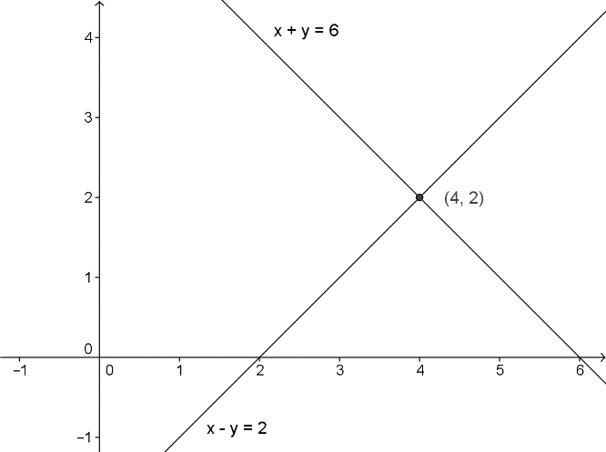

  - Write each line in the form $L\left(t\right)=p+vt$ where $p$ is the position vector whose terminal point is the solution of the system, and $v$ is the velocity vector that defines the path of a particle traveling along the line such that when $t=0$, the solution to the system is $\left(x\left(0\right),y\left(0\right)\right)$.

  - Describe a translation that will take the point $(x\left(0\right),y\left(0\right))$ to the origin. What is the new system?

  - Describe a transformation matrix $A$ that will rotate the lines to the $x$- and $y$-axes. What is the new system?

  - Describe a translation that will result in a system that has the same solution set as the original system. What is the new system of equations?

Problem Set

- Consider the system of equations $\left\{\begin{aligned}y=3x+2 \\ y=-x+14\end{aligned}\right.$.
  - Solve the system of equations.
  - Ilene wants to rotate the lines representing this system of equations about their solution and wishes to apply the matrix $\left(\begin{matrix}cos\left(θ\right) & -sin\left(θ\right) \\ sin\left(θ\right) & cos\left(θ\right)\end{matrix}\right)$ to any point $A$ on either of the lines. If Ilene is correct, then applying a rotation to the solution will map the solution to itself. Let $θ=90°$, and find where Ilene’s strategy maps the solution you found in part (a). What is wrong with Ilene’s strategy?
  - Jasmine thinks that in order to apply a rotation to some point on either of these two lines, the entire system needs to be shifted so that the pivot point is translated to the origin. For an arbitrary point $A$ on either of the two lines, what transformation needs to be applied so that the pivot point is mapped to the origin?
  - After applying your transformation in part (c), apply Ilene’s rotation matrix for $θ=90°$. Show that the pivot point remains on the origin. What happens to the point $\left(0,2\right)$ after both of these transformations?
  - Although Jasmine and Ilene were able to work together to rotate the points around the pivot point, now their lines are nowhere near the original lines. What transformation will bring the system of equations back so that the pivot point returns to where it started and all other points have been rotated? Find the final image of the point $(0,2)$.
  - Summarize your results in parts (a)–(e).

Extension:
- Let $b_{1}=\left(\begin{matrix}1 \\ 0\end{matrix}\right)$ and $b_{2}=\left(\begin{matrix}0 \\ 1\end{matrix}\right)$. Then answer the following questions.
  - Find $1⋅b_{1}+0⋅b_{2}$.
  - Find $0⋅b_{1}+1⋅b_{2}$.
  - Find $1⋅b_{1}+1⋅b_{2}$.
  - Find $3⋅b_{1}+2⋅b_{2}$.
  - Find $0⋅b_{1}+0⋅b_{2}$.
  - Find $x⋅b_{1}+y⋅b_{2}$ for $x,y$ real numbers.
  - Summarize your results from parts (a)–(f). Can you use $b_{1}$ and $b_{2}$ to define any point in $R^{2}$?

- Let $b_{1}=\left(\begin{matrix}3 \\ 2\end{matrix}\right)$ and $b_{2}=\left(\begin{matrix}-2 \\ 3\end{matrix}\right)$. Then answer the following questions.
  - Find $1⋅b_{1}+1⋅b_{2}$.
  - Find $0⋅b_{1}+1⋅b_{2}$.
  - Find $1⋅b_{1}+0⋅b_{2}$.
  - Find $-4⋅b_{1}+2⋅b_{2}$.
  - Solve $r⋅b_{1}+s⋅b_{2}=0$.
  - Solve $r⋅b_{1}+s⋅b_{2}=\left(\begin{matrix}22 \\ -7\end{matrix}\right)$.
  - Is there any point $\left(\begin{matrix}x \\ y\end{matrix}\right)$ that cannot be expressed as a linear combination of $b_{1}$ and $b_{2}$
(i.e., where $r⋅b_{1}+s⋅b_{2}=\left(\begin{matrix}x \\ y\end{matrix}\right)$ has real solutions, for $x,y$ real numbers)?
  - Explain your response to part (g) geometrically.

