Lesson 23: Why Are Vectors Useful?

Student Outcomes
- Students solve problems involving physical phenomena that can be represented by vectors.

Lesson Notes
Vectors are generally described as a quantity that has both a magnitude and a direction. In the next two lessons, students will work on examples that give a context to that description. The most basic definition of a vector is that it is a description of a shift or translation. Students will see that any physical operation that induces a shift of some kind is often thought of as a vector. Hence, vectors are prevalent in mathematics, science, and engineering. For example, force is often interpreted as a vector in physics because a force exerted on an object is a push of some magnitude that causes the object to shift in some direction. In this lesson, students will solve problems involving velocity as well as other quantities, such as force, that can be represented by a vector (N-VM.A.3). Students will make use of the law of cosines and the law of sines when working with non-right triangles (G-SRT.D.11). Students will continue to work on adding and subtracting vectors (N-VM.B.4) but will interpret the resulting magnitude and direction within a context. The focus of this lesson is using vectors to model real-world phenomena, in particular focusing on relating abstract representations to real-world aspects (MP.2).

Classwork
Opening (5 minutes)
Ask students to brainstorm real-world situations where vectors might be useful. Engage students by showing the vector video from NBC Learn on the science of NFL football (http://www.nbclearn.com/nfl/cuecard/51220). Remind students that vectors are used to describe anything that has both a direction and a magnitude.
- List these phenomena on the board, an interactive board, or index cards given to students. Have students sort the phenomena into two categories—those that can be described by vectors and those that cannot—and then explain the rationale behind their sorting. Discuss student choices and rationales as a class.
  - Position of a moving object
  - Wind
  - Position of a ball that has been thrown
  - Temperature
  - Mass
  - Velocity of a ball that has been thrown
  - Volume
  - Water current
- Phenomena that could be described using a vector:
  - Wind, position of a ball that has been thrown, velocity of a ball that has been thrown, water current because all have a direction and a magnitude.
- Phenomena that could not be described using a vector:
  - Temperature, mass, volume because these are just measurements with no magnitude and direction.
- Why would the position of a moving object need to be described as a vector rather than a scalar?
  - Just knowing how far it moved would not be enough information to locate the object. You would also need to know the direction.

Opening Exercise (5 minutes)
Give students time to work on the opening exercise independently, and then discuss as a group.
Opening Exercise
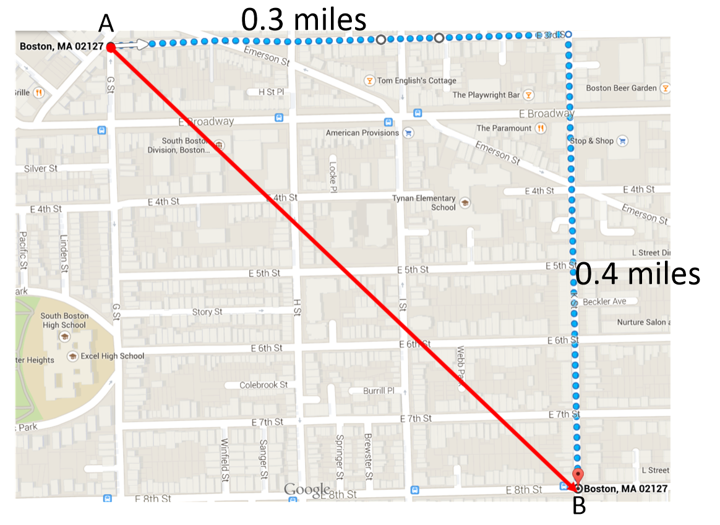
Suppose a person walking through South Boston, MA travels from point $A$ due east along E 3rd Street for $0.3 miles$ and then due south along K Street for $0.4 miles$ to end on point $B$ (as shown on the map).
  - Find the magnitude and direction of vector $\vec{AB}$.
$\left|AB\right|=\sqrt{0.3^{2}+0.4^{2}}=0.5 miles$
$θ=tan^{-1}\left(\frac{0.4}{0.3}\right)=53.1°$
  - What information does vector $\vec{AB}$ provide?
MP.2
The magnitude tells us that the person’s displacement was $0.5 miles$. In other words, the person ended up $0.5 miles$ from the point where he or she started. The angle tells us that the person traveled $53.1°$ south of east.

- Why is a vector a useful way to map a person’s location?
  - It tells us the actual distance between the starting and ending point and also the direction in which the person traveled.
- If I knew just the direction, could I map the person’s position?
  - No. We could draw an arrow in the correct direction but wouldn’t know where to put the endpoint.
- If I knew just the magnitude, could I map the person’s position?
  - No. The person could have traveled in any direction.

Example 1 (10 minutes)
Discuss the example as a class before giving students time to work on solving the problem. Provide students with grid paper as needed. Debrief as a class, and guide students as necessary.
Example 1
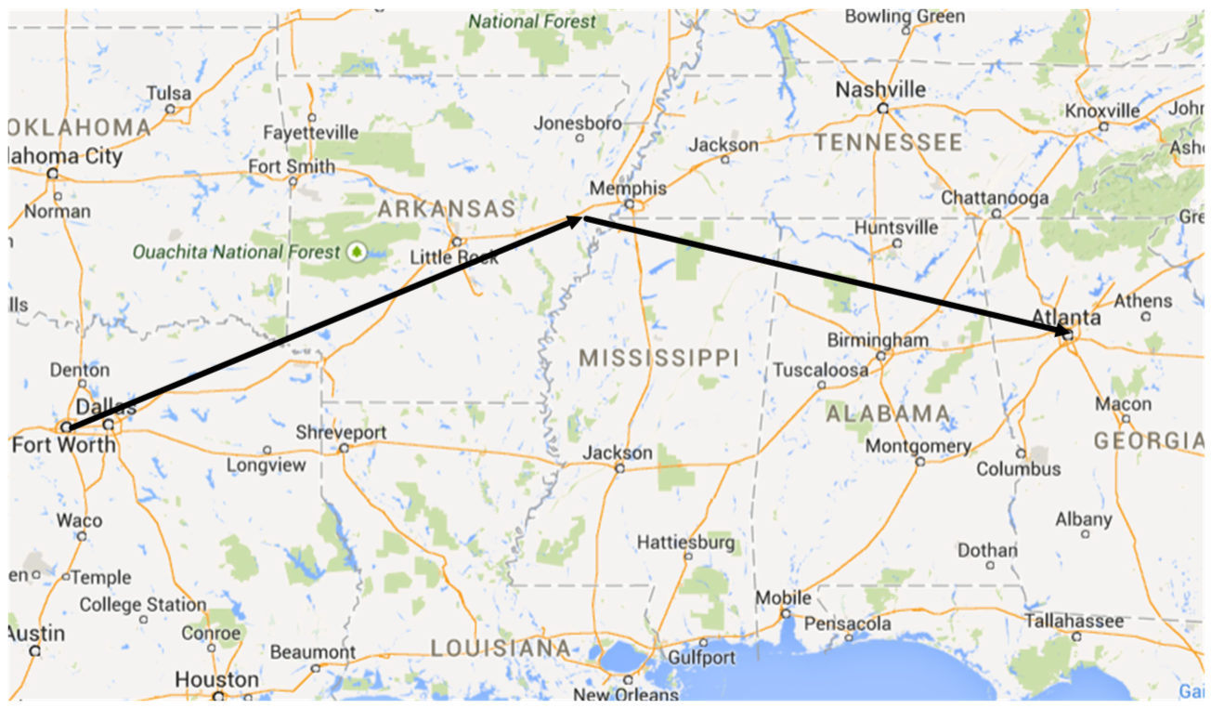
An airplane flying from Dallas-Fort Worth to Atlanta veers off course to avoid a storm. The plane leaves Dallas-Fort Worth traveling $50°$ east of north and flies for $450 miles$ before turning to travel $70°$ east of south for $350 miles$. What is the resultant displacement of the airplane? Include both the magnitude and direction of the displacement.
$x_{1}=450\cos\left(40°\right)=344.720$
$y_{1}=450\sin\left(40°\right)=289.254$
$x_{2}=344.720+328.892=673.612$
$y_{2}=289.254-119.707=169.547$
$d=\sqrt{{673.612}^{2}+{169.547}^{2}}=694.622 miles$
$θ=\tan^{\text{-1}}\left(\frac{169.547}{673.612}\right)=14.1°$
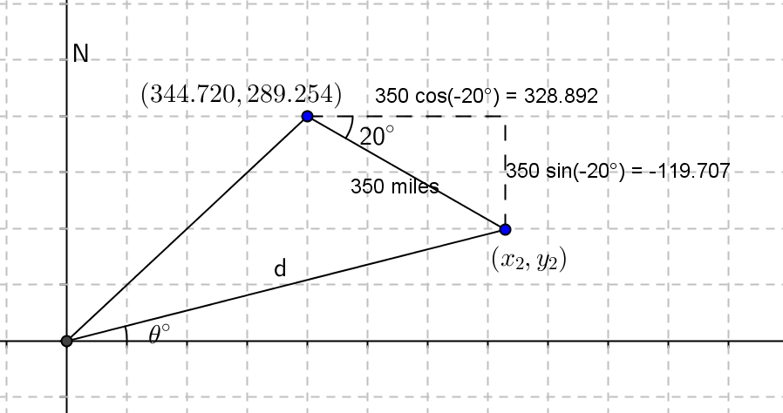

The resultant displacement is $694.622 miles$ at $75.9°$ east of north.

Exercises 1–4 (17 minutes)
Allow students time to work in groups stopping to debrief as students complete the exercises.
Exercises 1–4
- A motorized robot moves across the coordinate plane. Its position $\left(\begin{matrix}x(t) \\ y(t)\end{matrix}\right)$ at time $t seconds$ is given by $\left(\begin{matrix}x(t) \\ y(t)\end{matrix}\right)=a+tv$ where $a=\left(\begin{matrix}4 \\ -10\end{matrix}\right)$ and $=\left(\begin{matrix}-4 \\ 3\end{matrix}\right)$ . The units of distance are measured in meters.
Scaffolding:
For students who are struggling, use a graphing utility to reinforce the concept. Have them graph
$x\left(t\right)=4-4t$ and $y\left(t\right)=-10+3t$ in parametric mode on the graphing calculator.
  - Where is the robot at time $t=0$?
$\left(\begin{matrix}4 \\ -10\end{matrix}\right)$

  - Plot the path of the robot.
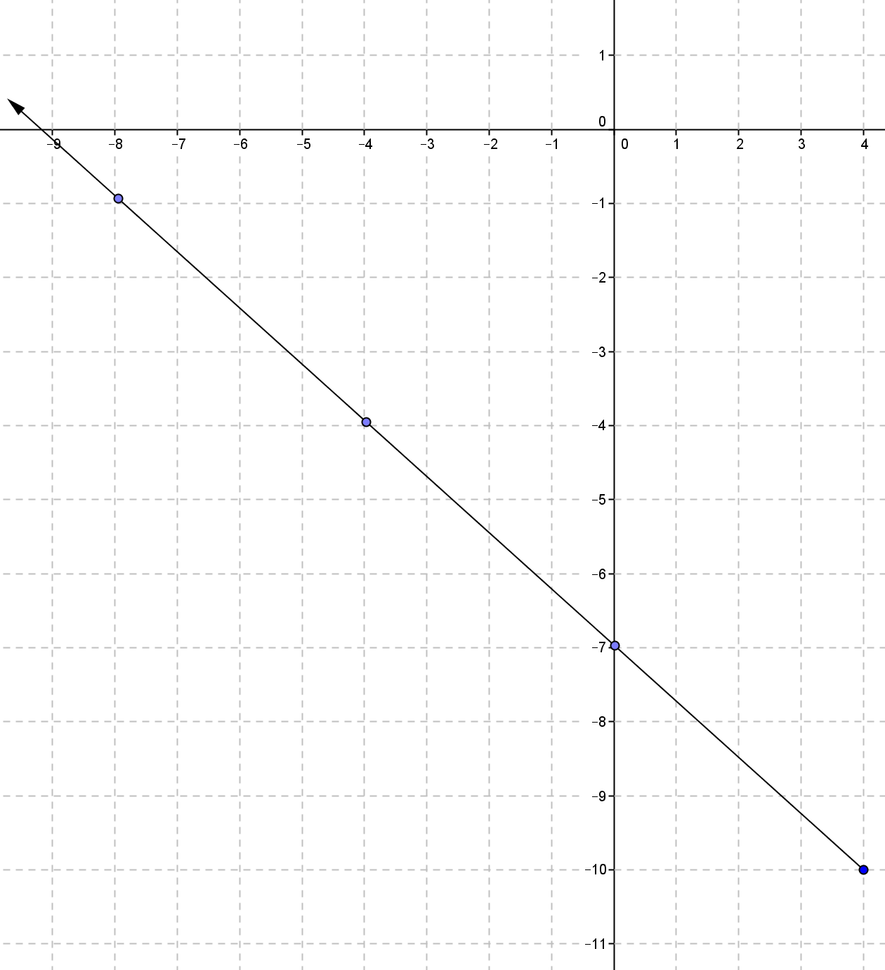

  - Describe the path of the robot.
The robot is moving along the line $y=-\frac{3}{4}x-7$.

  - Where is the robot $10 seconds$ after it starts moving?
$\left(\begin{matrix}-36 \\ 20\end{matrix}\right)$

  - Where is the robot when it is $10 meters$ from where it started?
$\left(\begin{matrix}-4 \\ -4\end{matrix}\right)$

  - Is the robot traveling at a constant speed? Explain, and if the speed is constant, state the robot’s speed.
Yes, the robot is traveling at a constant speed of $5 m/s$. For every one second that elapses, the robot moves $3 units$ up and $4 units$ to the left which means the robot moves $5 meters$ every second.

- What was the speed of the robot?
MP.2
  - The speed was $5 m/s$.
- How did you determine the speed?
  - I knew the robot moved $3 units$ up and $4 units$ to the left each second. I used the Pythagorean theorem to find the actual distance the robot traveled.
- What is the relationship between the speed and vector $v$?
  - The magnitude of a vector is its length. The length can be determined by the product of the constant speed for a given number of time units.
Make the point that vector $v$ is the velocity of the robot, and the magnitude of the velocity vector is the speed of the robot. Velocity is a vector because it has both a magnitude and a direction. Speed and time results in the magnitude of a vector.
- How could we interpret vector $v$ in terms of the velocity of the robot?
  - Vector $v$ is the velocity of the robot. It tells us both the speed and the direction of the robot.
- How could we interpret vector $v$ in terms of the speed of the robot?
  - The magnitude of vector $v$ is the distance traveled or the length of the vector. It tells us how fast the robot is moving but not the direction in which the robot moves.

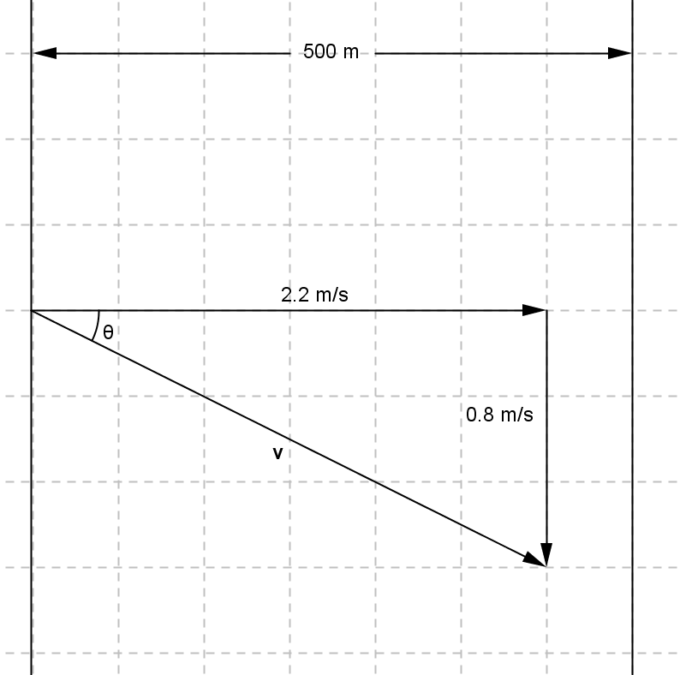
- A row boat is crossing a river that is $500 m$ wide traveling due east at a speed of $2.2 m/s$. The river’s current is $0.8 m/s$ due south.
  - What is the resultant velocity of the boat?
$\left|v\right|=\sqrt{2.2^{2}+0.8^{2}}=2.34 m/s$
$θ=tan^{-1}\left(\frac{0.8}{2.2}\right)=20.0°$

  - How long does it take for the boat to cross the river?
$t=\frac{500}{2.2}=227.273 seconds$

  - How far downstream is the boat when it reaches the other side?
$d=0.8\left(227.273\right)=181.818 m$
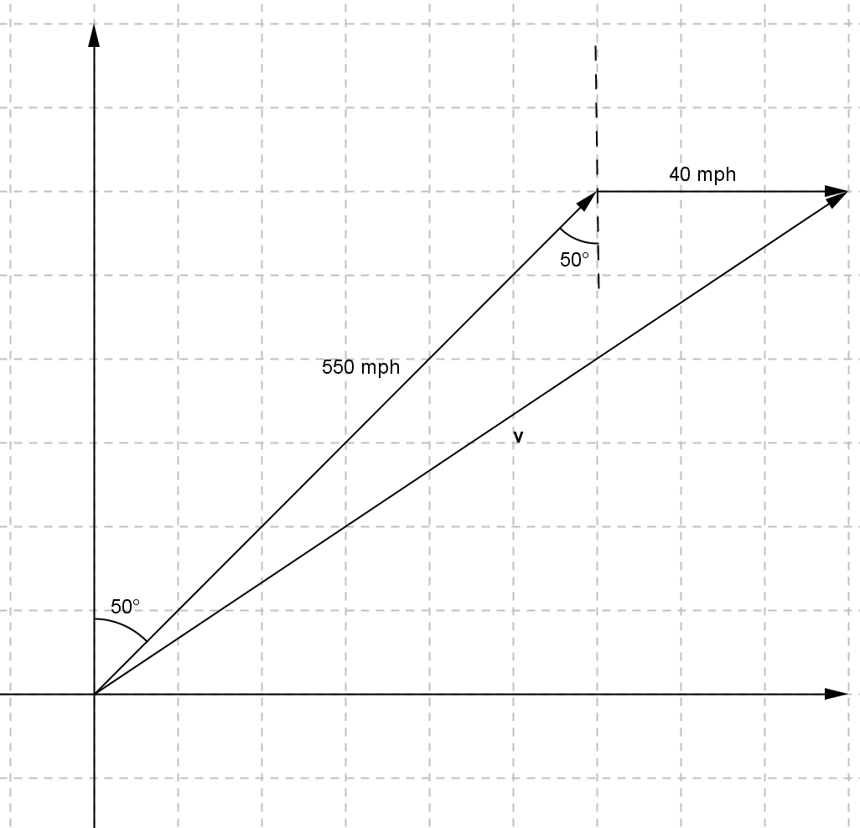
- Consider the airplane from Example 1 that leaves Dallas-Fort Worth with a bearing of $50°$. (Note that the bearing is the number of degrees east of north.) The plane is traveling at a speed of $550 mph$. There is a crosswind of $40 mph$ due east. What is the resultant velocity of the airplane?
$\left|v\right|=\sqrt{550^{2}+40^{2}-2\left(550\right)\left(40\right)cos130°}=576.526 mph$

Another physical operation that is often interpreted in physics as a vector is force. A force exerted on an object is a push of some magnitude in some direction which causes the object to have a tendency to shift.
Force is often defined in units of newtons (N). One newton is defined as the force required to accelerate an object with a mass of one kilogram ($1 kg$) one meter per second ($1 m/\sec^{2}$).

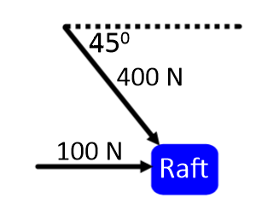
- A raft floating in the water experiences an eastward force of $100 N$ due to the current of the water and a southeast force of $400 N$ due to wind.
  - In what direction will the boat move?
$36.5°$ south of east

  - What is the magnitude of the resultant force on the boat?
$475.992 N$

  - If the force due to the wind doubles, does the resultant force on the boat double? Explain or show work that supports your answer.
No. If the force of the wind doubles, the resultant force on the boat is $873.577 N$

Closing (3 minutes)
Ask students to write a brief answer to the question, “Why are vectors useful?” and then share responses with a partner. Then, share responses as a class.
- Why are vectors useful?
  - Vectors can be used to describe any sort of physical phenomena that have both a magnitude and a direction. They are useful for describing a moving object’s displacement or velocity where just a single number would not provide an adequate description.

Exit Ticket (5 minutes)

Name Date
Lesson 23: Why Are Vectors Useful?

Exit Ticket

A hailstone is traveling through the sky. Its position $\left(\begin{matrix}x(t) \\ y(t) \\ z(t)\end{matrix}\right)$ in meters is given by $\left(\begin{matrix}x(t) \\ y(t) \\ z(t)\end{matrix}\right)=\left(\begin{matrix}0 \\ 0 \\ 2160\end{matrix}\right)+\left(\begin{matrix}3 \\ -2 \\ -9\end{matrix}\right)t$ where $t$ is the time in seconds since the hailstone began being tracked.
  - If $x(t)$ represents an east-west location, how quickly is the hailstone moving to the east?

  - If $y(t)$ represents a north-south location, how quickly is the hailstone moving to the south?

  - What could be causing the east-west and north-south velocities for the hailstone?

  - If $z(t)$ represents the height of the hailstone, how quickly is the hailstone falling?

  - At what location will the hailstone hit the ground (assume $z=0$ is the ground)? How long will this take?

  - What is the overall speed of the hailstone? To the nearest meter, how far did the hailstone travel from $t=0$ to the time it took to hit the ground?
Exit Ticket Sample Solutions

A hailstone is traveling through the sky. Its position $\left(\begin{matrix}x(t) \\ y(t) \\ z(t)\end{matrix}\right)$ in meters is given by $\left(\begin{matrix}x(t) \\ y(t) \\ z(t)\end{matrix}\right)=\left(\begin{matrix}0 \\ 0 \\ 2160\end{matrix}\right)+\left(\begin{matrix}3 \\ -2 \\ -9\end{matrix}\right)t$ where $t$ is the time in seconds since the hailstone began being tracked.
  - If $x(t)$ represents its east-west location, how quickly is the hailstone moving to the east?
$$3 m/s$$

  - If $y(t)$ represents its north-south location, how quickly is the hailstone moving to the south?
$$2 m/s$$

  - What could be causing the east-west and north-south velocities for the hailstone?
Wind is probably the number one factor affecting the speed of the hailstone.

  - If $z(t)$ represents the height of the hailstone, how quickly is the hailstone falling?
$$9 m/s$$

  - At what location will the hailstone hit the ground (assume $z=0$ is the ground)? How long will this take?
The hailstone will hit the ground at $t=2160÷9=240 seconds$, which is $4 minutes$. In $4 minutes$ it will move $720 meters$ to the east and $480 meters$ to the south to impact at $\left(\begin{matrix}720 \\ 480 \\ 0\end{matrix}\right)$.

  - What is the overall speed of the hailstone? To the nearest meter, how far did the hailstone travel from $t=0$ to when it hit the ground?
The hailstone is traveling at $\sqrt{3^{2}+2^{2}+9^{2}}=\sqrt{94} meters per second$. It traveled
$240\sqrt{94}≈2327 meters$.

Problem Set Sample Solutions

- Suppose Madison is traveling due west for $0.5 miles$ and then due south for $1.2 miles$.
  - Draw a picture of this scenario with her starting point labeled $A$, ending point $B$, and include the vector $\vec{AB}$.

  - State the value of $\vec{AB}$.
$$\vec{AB}=\left(\begin{matrix}-0.5 \\ -1.2\end{matrix}\right)$$

  - What is the magnitude and direction of $\vec{AB}$?
$$\left\|\left(\begin{matrix}-0.5 \\ -1.2\end{matrix}\right)\right\|=\sqrt{0.5^{2}+1.2^{2}}=\sqrt{1.69}=1.3$$
$$tan^{-1}\left(\frac{12}{5}\right)≈67.380⇒247.380°$$
The vector has a magnitude of $1.3$ and a direction of $247.380°$ from east, or $67.380°$ south of west.

- An object’s azimuth is the angle of rotation of its path measured clockwise from due north. For instance, an object traveling due north would have an azimuth of $0°$, and due east would have an azimuth of $90°$.
  - What are the azimuths for due south and due west?
$180°$ and $270°$

  - Consider a craft on an azimuth of $215°$ traveling $30 knots$.
    - Draw a picture representing the situation.

    - Find the vector representing this craft’s speed and direction.
This vector is $215°$ from north, which is the same as saying $55°$ south of west. Thus, the $x$-coordinate of the vector will be $30 cos\left(55\right)≈17.207$, and the $y$-coordinate will be $30 sin\left(55\right)≈24.575$. The vector is represented by $\left(\begin{matrix}-17.207 \\ -24.575\end{matrix}\right)$.

- Bearings can be given from any direction, not just due north. For bearings, like azimuths, clockwise angles are represented by positive degrees and counterclockwise angles are represented by negative degrees. A ship is traveling $30°$ east of north at $18 kn$, then turns $20°$, maintaining its speed.
  - Draw a picture representing the situation.
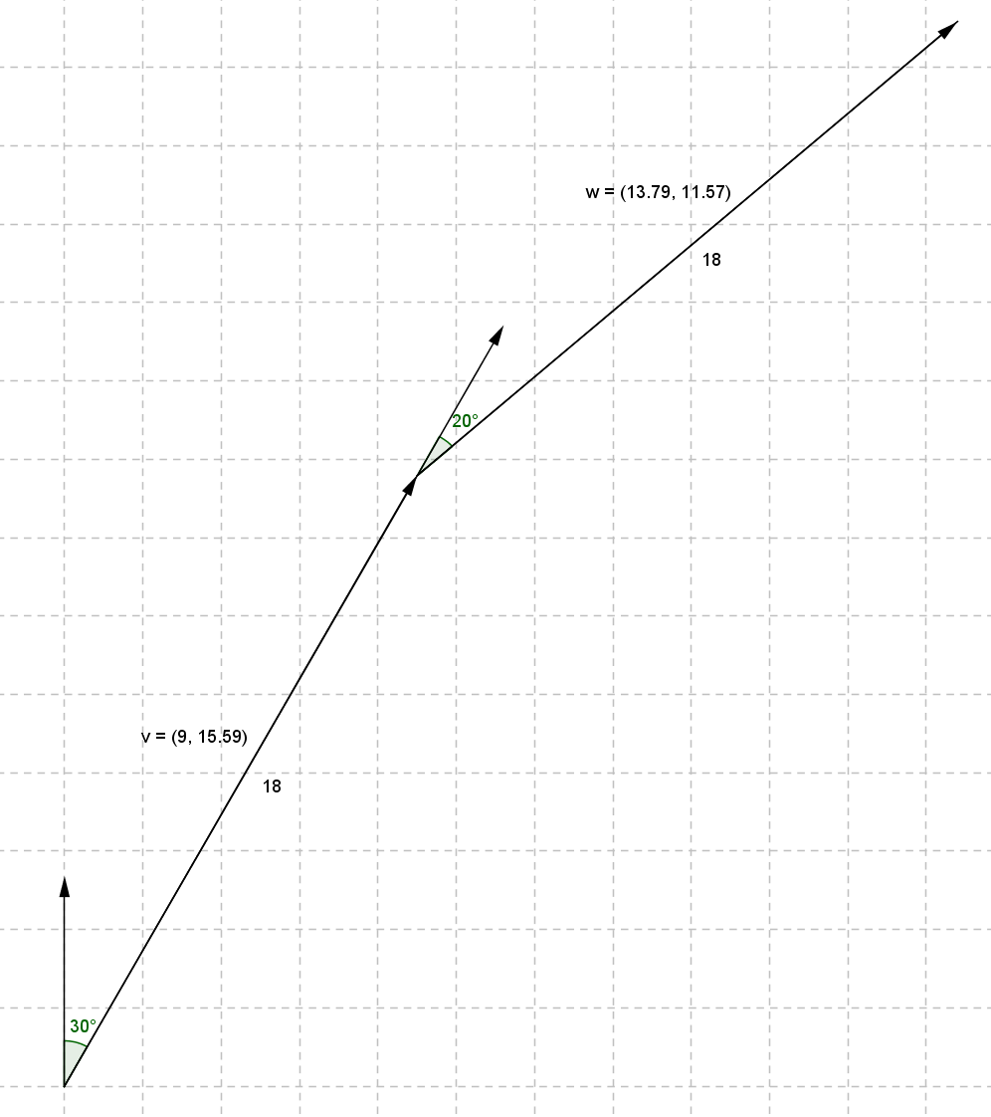

  - Find vectors $v$ and $w$ representing the first and second bearing.
$v=\left(\begin{matrix}9 \\ 9\sqrt{3}\end{matrix}\right)≈\left(\begin{matrix}9 \\ 15.588\end{matrix}\right)$,$w=\left(\begin{matrix}18 sin(50) \\ 18 cos(50)\end{matrix}\right)≈\left(\begin{matrix}13.789 \\ 11.570\end{matrix}\right)$

  - Find the sum of $v$ and $w$. What does $v+w$ represent?
$$v+w≈\left(\begin{matrix}22.789 \\ 27.159\end{matrix}\right)$$
The sum represents the ship’s position relative to its starting point.

  - If the ship travels for one hour along each bearing, then how far north of its starting position has it traveled? How far east has it traveled?
The ship has traveled $22.789 nautical miles$north and $27.159 nautical miles$ east.

- A turtle starts out on a grid with coordinates $\left(\begin{matrix}4 \\ -6.5\end{matrix}\right)$ where each unit is one furlong. Its horizontal location is given by the function $x\left(t\right)=4+-2t$, and its vertical location is given by $y\left(t\right)=-6.5+3t$ for $t$ in hours.
  - Write the turtle’s location using vectors.
$\left(\begin{matrix}x(t) \\ y(t)\end{matrix}\right)=\left(\begin{matrix}4 \\ -6.5\end{matrix}\right)+\left(\begin{matrix}-2 \\ 3\end{matrix}\right)t$

  - What is the speed of the turtle?
The turtle is traveling at $\sqrt{2^{2}+3^{2}}=\sqrt{13} furlongs per hour$.

  - If a hare’s location is given as $\left(\begin{matrix}x_{h}(t) \\ y_{h}(t)\end{matrix}\right)=\text{a}+t\text{v}$ where $\text{a}=\left(\begin{matrix}23 \\ -35\end{matrix}\right)$ and $\text{v}=\left(\begin{matrix}-8 \\ 12\end{matrix}\right)$, then what is the speed of the hare? How much faster is the hare traveling than the turtle?
The hare is traveling at a speed of $\sqrt{8^{2}+12^{2}}=\sqrt{208} furlongs per hour$.
$\sqrt{208}=4\sqrt{13}$ which is $4$ times faster than the turtle.

  - Which creature will reach $\left(\begin{matrix}-1 \\ 1\end{matrix}\right)$ first?
The turtle will reach $\left(\begin{matrix}-1 \\ 1\end{matrix}\right)$ at $t=2.5$, and the hare will reach it at $t=3$, so the turtle will beat the hare by half an hour.

- A rocket is launched at an angle of $33°$ from the ground at a rate of $50 m/s$.
  - How fast is the rocket traveling up to the nearest m/s?
The rocket is traveling up at a rate of $50⋅sin\left(33\right)≈27 m/s$.

  - How fast is the rocket traveling to the right to the nearest m/s?
The rocket is traveling to the right at a rate of $50⋅cos\left(33\right)≈42 m/s$.

  - What is the rocket’s velocity vector?
The velocity vector is $\left(\begin{matrix}42 \\ 27\end{matrix}\right)$.

  - Does the magnitude of the velocity vector agree with the set-up of the problem? Why or why not?
$\left\|\left(\begin{matrix}42 \\ 27\end{matrix}\right)\right\|=\sqrt{{42}^{2}+{27}^{2}}=\sqrt{2493}≈49.92995$
This is effectively the original speed and is only different because of rounding errors.

  - If a laser is in the path of the rocket and would like to strike the rocket, in what direction does the laser need to be aimed? Express your answer as a vector.
If the laser is in the path of the rocket, then that means it needs to be aimed in the opposite direction the rocket is traveling, which is $\left(\begin{matrix}-42 \\ -27\end{matrix}\right)$.

- A boat is drifting downriver at a rate of $5 nautical miles per hour$. If the occupants of the boat want to travel to the shore, do they need to overcome the current downriver? Use vectors to explain why or why not.
The occupants do not need to overcome the stream since the stream is moving downriver, and they only want to move perpendicular to that. Since they will be moving perpendicular, their motions will have no impact on the downriver rate, nor should they. Any effort fighting the current will only waste resources. Orthogonal vectors do not affect the position.

- A group of friends moored their boats together and fell asleep on the lake. Unfortunately, their lashings came undone in the night, and they have drifted apart. Gerald’s boat traveled due west along with the current of the lake which moves at a rate of $\frac{1}{2} mi/hr$ and Helena’s boat was pulled southeast by some pranksters and set drifting at a rate of $2 mi/hr$.
  - If the boats came untied three hours ago, how far apart are the boats?
Gerald traveled $1.5 miles$ to the west, and Helena traveled $6 miles$ to the southeast. Using the law of cosines, we see that they are $\sqrt{{\left(1.5\right)}^{2}+6^{2}-2⋅1.5⋅6⋅cos\left(135\right)}=\sqrt{2.25+36+9\sqrt{2}}≈7.13 miles$ away from each other.

  - If Gerald drops anchor, then in what direction does Helena need to travel in order to reunite with Gerald?
$\left(\begin{matrix}1.5+3\sqrt{2} \\ 3\sqrt{2}\end{matrix}\right)$

- Consider any two vectors in space, $u$ and $v$ with $θ$ the angle between them.
  - Use the law of cosines to find the value of $\left\|\text{u}-\text{v}\right\|$.
${\left\|u-v\right\|}^{2}={\left\|u\right\|}^{2}+{\left\|v\right\|}^{2}-2\left\|u\right\|\left\|v\right\|cos\left(θ\right)$
$\left\|u-v\right\|=\sqrt{{\left\|u\right\|}^{2}+{\left\|v\right\|}^{2}-2\left\|u\right\|\left\|v\right\|cos\left(θ\right)}$

  - Use the law of sines to find the value of $ψ$, the angle between $u-v$ and $u$. State any restrictions on the variables.
$$\frac{sin\left(θ\right)}{\left\|u-v\right\|}=\frac{sin\left(ψ\right)}{\left\|u\right\|} \\ ψ=sin^{-1}\left(\frac{\left\|u\right\|sin\left(θ\right)}{\left\|u-v\right\|}\right)$$
The inverse sine only returns values between $-90°$ and $90°$, so if the angle is greater than this, then trig identities need to be used to help find the value.

