Lesson 23: Why Are Vectors Useful?

Classwork
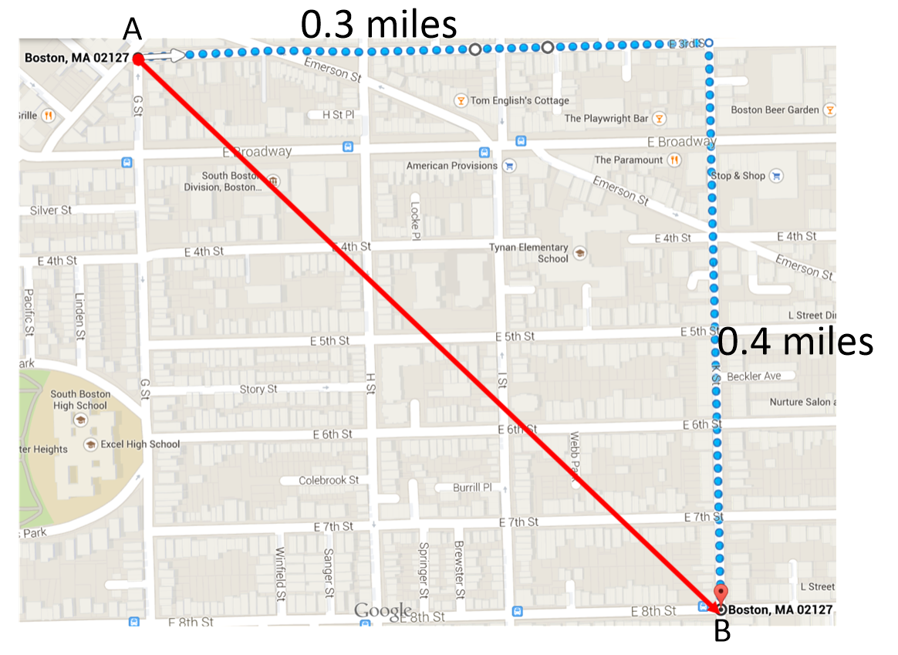
Opening Exercise
Suppose a person walking through South Boston, MA travels from point $A$ due east along E 3rd Street for $0.3 miles$ and then due south along K Street for $0.4 miles$ to end on point $B$ (as shown on the map).
  - Find the magnitude and direction of vector $\vec{AB}$.

  - What information does vector $\vec{AB}$ provide?

Example 1
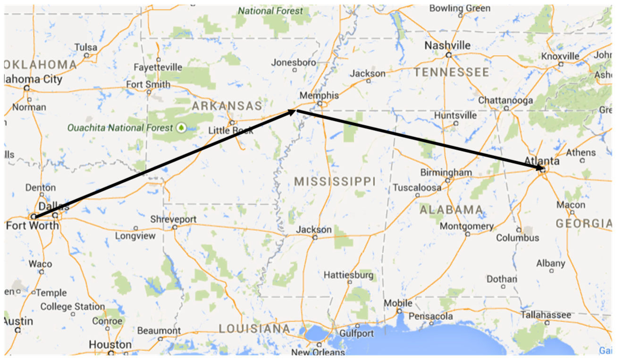
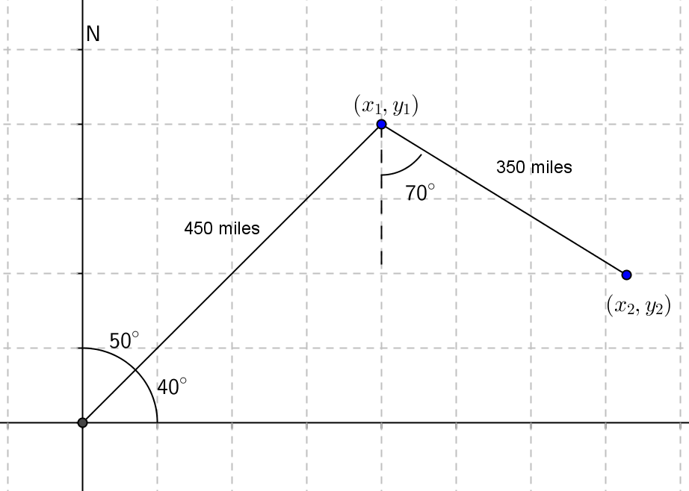
An airplane flying from Dallas-Fort Worth to Atlanta veers off course to avoid a storm. The plane leaves Dallas-Fort Worth traveling $50°$ east of north and flies for $450 miles$ before turning to travel $70°$ east of south for $350 miles$. What is the resultant displacement of the airplane? Include both the magnitude and direction of the displacement.

Exercises 1–4
- A motorized robot moves across the coordinate plane. Its position $\left(\begin{matrix}x(t) \\ y(t)\end{matrix}\right)$ at time $t seconds$ is given by
$\left(\begin{matrix}x(t) \\ y(t)\end{matrix}\right)=a+tv$ where $a=\left(\begin{matrix}4 \\ -10\end{matrix}\right)$ and $v=\left(\begin{matrix}-4 \\ 3\end{matrix}\right)$. The units of distance are measured in meters.
  - Where is the robot at time $t=0$?

  - Plot the path of the robot.

  - Describe the path of the robot.

  - Where is the robot $10 seconds$ after it starts moving?

  - Where is the robot when it is $10 meters$ from where it started?

  - Is the robot traveling at a constant speed? Explain, and if the speed is constant, state the robot’s speed.

- A row boat is crossing a river that is $500 m$ wide traveling due east at a speed of $2.2 m/s$. The river’s current is $0.8 m/s$ due south.
  - What is the resultant velocity of the boat?

  - How long does it take for the boat to cross the river?

  - How far downstream is the boat when it reaches the other side?

- Consider the airplane from Example 1 that leaves Dallas-Fort Worth with a bearing of $50°$. (Note that the bearing is the number of degrees east of north.) The plane is traveling at a speed of $550 mph$. There is a crosswind of $40 mph$ due east. What is the resultant velocity of the airplane?

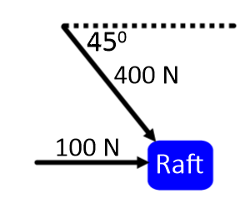
- A raft floating in the water experiences an eastward force of $100$N due to the current of the water and a southeast force of $400$ N due to wind.
  - In what direction will the boat move?

  - What is the magnitude of the resultant force on the boat?

  - If the force due to the wind doubles, does the resultant force on the boat double? Explain or show work that supports your answer.

Problem Set

- Suppose Madison is traveling due west for $0.5 miles$ and then due south for $1.2 miles$.
  - Draw a picture of this scenario with her starting point labeled $A$, ending point $B$, and include the vector $\vec{AB}$.
  - State the value of $\vec{AB}$.
  - What is the magnitude and direction of $\vec{AB}$?

- An object’s azimuth is the angle of rotation of its path measured clockwise from due north. For instance, an object traveling due north would have an azimuth of $0°$, and due east would have an azimuth of $90°$.
  - What are the azimuths for due south and due west?
  - Consider a craft on an azimuth of $215°$ traveling $30 knots$.
    - Draw a picture representing the situation.
    - Find the vector representing this craft’s speed and direction.

- Bearings can be given from any direction, not just due north. For bearings, like azimuths, clockwise angles are represented by positive degrees and counterclockwise angles are represented by negative degrees. A ship is traveling $30°$ east of north at $18 kn$, then turns $20°$, maintaining its speed.
  - Draw a picture representing the situation.
  - Find vectors $v$ and $w$ representing the first and second bearing.
  - Find the sum of $v$ and $w$. What does $v+w$ represent?
  - If the ship travels for one hour along each bearing, then how far north of its starting position has it traveled? How far east has it traveled?

- A turtle starts out on a grid with coordinates $\left(\begin{matrix}4 \\ -6.5\end{matrix}\right)$ where each unit is one furlong. Its horizontal location is given by the function $x\left(t\right)=4+-2t$, and its vertical location is given by $y\left(t\right)=-6.5+3t$ for $t$ in hours.
  - Write the turtle’s location using vectors.
  - What is the speed of the turtle?
  - If a hare’s location is given as $\left(\begin{matrix}x_{h}(t) \\ y_{h}(t)\end{matrix}\right)=a+tv$ where $a=\left(\begin{matrix}23 \\ -35\end{matrix}\right)$ and $v=\left(\begin{matrix}-8 \\ 12\end{matrix}\right)$, then what is the speed of the hare? How much faster is the hare traveling than the turtle?
  - Which creature will reach $\left(\begin{matrix}-1 \\ 1\end{matrix}\right)$ first?

- A rocket is launched at an angle of $33°$ from the ground at a rate of $50 m/s$.
  - How fast is the rocket traveling up to the nearest m/s?
  - How fast is the rocket traveling to the right to the nearest m/s?
  - What is the rocket’s velocity vector?
  - Does the magnitude of the velocity vector agree with the set-up of the problem? Why or why not?
  - If a laser is in the path of the rocket and would like to strike the rocket, in what direction does the laser need to be aimed? Express your answer as a vector.

- A boat is drifting downriver at a rate of $5 nautical miles per hour$. If the occupants of the boat want to travel to the shore, do they need to overcome the current downriver? Use vectors to explain why or why not.

- A group of friends moored their boats together and fell asleep on the lake. Unfortunately, their lashings came undone in the night, and they have drifted apart. Gerald’s boat traveled due west along with the current of the lake which moves at a rate of $\frac{1}{2}mi/hr$ and Helena’s boat was pulled southeast by some pranksters and set drifting at a rate of $2 mi/hr$.
  - If the boats came untied three hours ago, how far apart are the boats?
  - If Gerald drops anchor, then in what direction does Helena need to travel in order to reunite with Gerald?

- Consider any two vectors in space, $u$ and $v$ with $θ$ the angle between them.
  - Use the law of cosines to find the value of $\left\|u-v\right\|$.
  - Use the law of sines to find the value of $ψ$, the angle between $u-v$ and $u$. State any restrictions on the variables.

