Lesson 21: Vectors and the Equation of a Line

Student Outcomes
- Students write the equation for a line in $R^{2}$ or $R^{3}$ using vectors.
- Students write the parametric equations for a line in $R^{2}$ or $R^{3}$.
- Students convert between parametric equations and the slope-intercept form of a line in $R^{2}.$

Lesson Notes
In Algebra I, students wrote equations in the following forms to represent lines in the plane:
- Slope-intercept form: $y=mx+b$
- Point-slope form: $y-y_{1}=m(x-x_{1})$
- Standard form: $ax+by=c$.
In Algebra II students studied functions, this lesson introduces parametric equations to students showing the connection of functions to vectors (N-VM.C.11). We are looking for ways to describe a line in $R^{3}$ so we are not restricted to two-dimensions and can model real-life scenarios. This requires using vectors and parameters and writing parametric equations which give us a way to move and model three dimensional models with our two-dimensional system. Thus, we start by reconsidering how to describe a line in the plane using vectors and parameters, and then we apply this description to lines in $R^{3}$. The shift to describing a line using vectors to indicate the direction of the line requires that students think geometrically about lines in the plane instead of algebraically.
Lessons 21 and 22 are important as they set the mathematical foundation for students to understand the definition of vectors.

Classwork
Opening Exercise (3 minutes)
The purpose of the second exercise below is to remind students how to graph a line by using the slope to generate points on the line. Encourage students to think geometrically, not algebraically, for this exercise.
Opening Exercise
  - Find three different ways to write the equation that represents the line in the plane that passes through points $(1,2)$ and $(2,-1)$.
The following four equations show different forms of the equation that represents the line through $\left(1,2\right)$and$(2,-1)$.
MP.7
$$\left(y-2\right)=-3\left(x-1\right) \\ y+1=-3\left(x-2\right) \\ y=-3x+5 \\ 3x+y=5$$
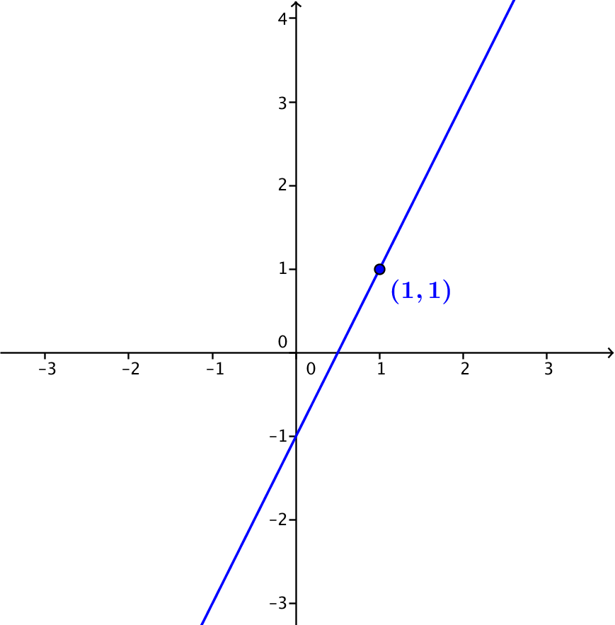
  - Graph the line through point $(1,1)$ with slope $2.$

Discussion (12 minutes)
- In the Opening Exercise, you found three different equations to represent a specific line in the plane.
- Consider the point-slope form of a line: $y-y_{1}=m(x-x_{1})$. With the equation in this form, we know that the line passes through point $(x_{1}, y_{1})$ and has slope $m.$ Using this information, we can draw the line as we did in Opening Exercise 2.
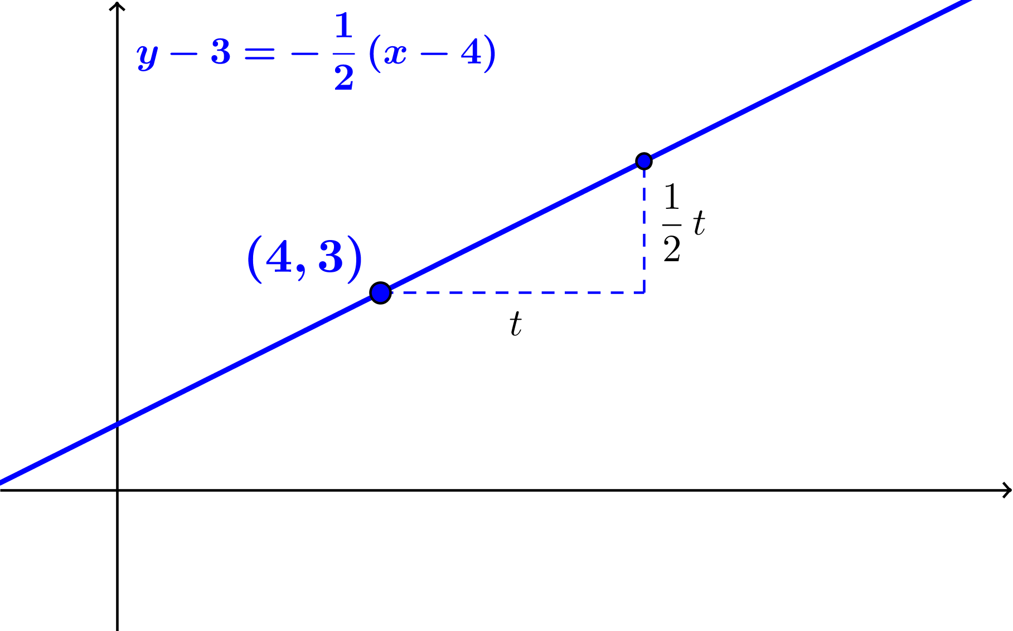
- Suppose that the equation of a line $l$ is $y-3= \frac{1}{2}\left(x-4\right).$ Then we know that $l$ passes through the point $(4,3)$ and has slope $\frac{1}{2}$. This means that if we start at point $(4,3)$ and move $t$ units horizontally, we need to move $\frac{1}{2}$ $t$ units vertically to arrive at a new point on the line.

That is, all points on line $l$ can be found by moving $t$ units right and $\frac{1}{2} t$ units up from $\left(4,3\right)$ or by moving $t$ units left and $\frac{1}{2}$ $t$ units down from $(4,3)$.
- How could the process of finding a new point on line $l$ be found using vectors?
MP.7
  - A new point on line $l$ can be found by adding a multiple of the vector $v=\left[\begin{aligned}1 \\ \frac{1}{2}\end{aligned}\right]$ to the vector $\left[\begin{aligned}4 \\ 3\end{aligned}\right]$ that represents point $(4,3)$.
- What point do we find when we let $t=-1?$ When we let $t=6$? When we let $t=0?$ When we let $t=-4?$
  - If $t=-1$, then the new point is represented by $\left[\begin{aligned}x \\ y\end{aligned}\right]=\left[\begin{aligned}4 \\ 3\end{aligned}\right]-\left[\begin{aligned}1 \\ \frac{1}{2}\end{aligned}\right]=\left[\begin{aligned}3 \\ 2\frac{1}{2}\end{aligned}\right]$.
  - If $t=6$, then the new point is represented by $\left[\begin{aligned}x \\ y\end{aligned}\right]=\left[\begin{aligned}4 \\ 3\end{aligned}\right]+\left[\begin{aligned}1 \\ \frac{1}{2}\end{aligned}\right]⋅6=\left[\begin{aligned}4 \\ 3\end{aligned}\right]+\left[\begin{aligned}6 \\ 3\end{aligned}\right]=\left[\begin{aligned}10 \\ 6\end{aligned}\right].$
  - If $t=0$, then the new point is represented by $\left[\begin{aligned}x \\ y\end{aligned}\right]=\left[\begin{aligned}4 \\ 3\end{aligned}\right]+\left[\begin{aligned}1 \\ \frac{1}{2}\end{aligned}\right]⋅0=\left[\begin{aligned}4 \\ 3\end{aligned}\right].$
  - If $t=-4$, then the new point is represented by $\left[\begin{aligned}x \\ y\end{aligned}\right]=\left[\begin{aligned}4 \\ 3\end{aligned}\right]+\left[\begin{aligned}1 \\ \frac{1}{2}\end{aligned}\right]⋅(-4)=\left[\begin{aligned}0 \\ 1\end{aligned}\right].$
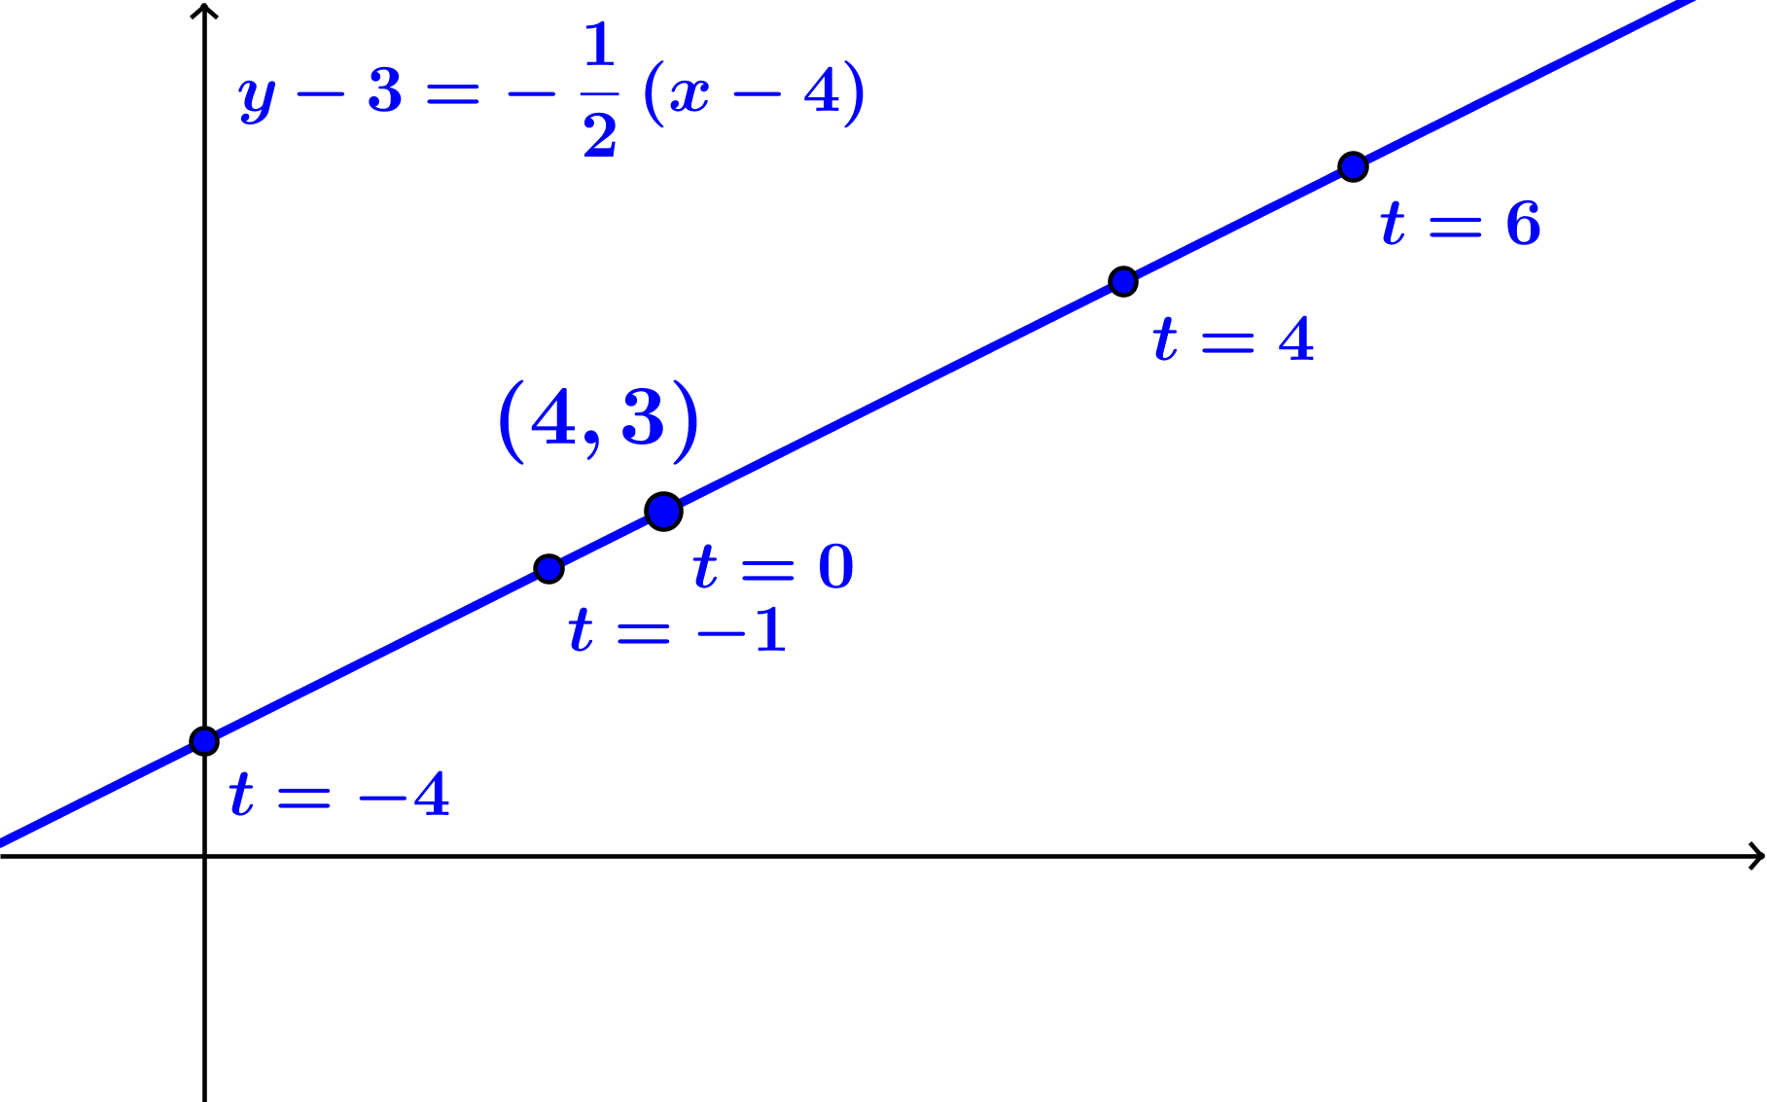

- Based on the calculations of different values of $t$, what is an equation that uses vectors to represent the points on line $l$? Explain your reasoning.
  - The points on line $l$ can be represented by $\left[\begin{aligned}x \\ y\end{aligned}\right]=\left[\begin{aligned}4 \\ 3\end{aligned}\right]+\left[\begin{aligned}1 \\ \frac{1}{2}\end{aligned}\right]t$ for real numbers $t$. This is a vector equation of the line $l.$The vector $\overset{⃑}{v}=\left[\begin{aligned}4 \\ 3\end{aligned}\right]$ is a direction vector for the line. There are many different ways to choose the starting point and the direction vector, so the vector form of a line is not unique.
- Both $x$ and $y$ are both functions of the real number $t$, which is called a parameter$.$ We can rewrite
Scaffolding:
Have students create a Frayer diagram for parametric equations. (See Module 1, Lesson 5 for an example.)
$\left[\begin{aligned}x \\ y\end{aligned}\right]=\left[\begin{aligned}4 \\ 3\end{aligned}\right]+\left[\begin{aligned}1 \\ \frac{1}{2}\end{aligned}\right]t$, as $\left[\begin{aligned}x \\ y\end{aligned}\right]=\left[\begin{aligned}4+t \\ 3+\frac{1}{2}t\end{aligned}\right]$, which means that as functions of $t$, we have
$$x\left(t\right)=4+t \\ y\left(t\right)=3+\frac{1}{2}t$$
These equations for $x$ and $y$as functions of$t$ are parametric equations of line $l$.
- Do these parametric equations agree with our original equation in point-slope form that represents line $l$? That equation is $y-3= \frac{1}{2}\left(x-4\right).$ Let’s see, using our parameterized equations:
$$y-3=\left(3+\frac{1}{2}t\right)- 3 \\ =\frac{1}{2}t \\ \frac{1}{2}\left(x-4\right)=\frac{1}{2}\left(\left(4+t\right)-4\right) \\ =\frac{1}{2}t$$

So, we see that for any point $\left(x\left(t\right), y\left(t\right)\right)$ that satisfies the parametric equations $x\left(t\right)=4+t$
and $y\left(t\right)=3+\frac{1}{2}t$, we have $y-3=\frac{1}{2}(x-4)$, so the point $\left(x\left(t\right), y\left(t\right)\right)$ is on line $l$.
- Take a few minutes and explain to your neighbor what you have learned about parametric equations.
Use the summary box below to debrief parametric equations as a class and use this as an informal assessment of student knowledge.
Let $l$ be a line in the plane that contains point$\left(x_{1}, y_{1}\right)$ and has direction vector $\overset{⃑}{v}=\left[\begin{aligned}a \\ b\end{aligned}\right]$. If the slope of line $l$ is defined, then $m=\frac{b}{a}$.
- A vector form of the equation that represents line $l$ is
$$\left[\begin{aligned}x \\ y\end{aligned}\right]=\left[\begin{aligned}x_{1} \\ y_{1}\end{aligned}\right]+\left[\begin{aligned}a \\ b\end{aligned}\right]t.$$
- Parametric equations that represent line $l$ are
$$x\left(t\right)=x_{1}+at \\ y\left(t\right)=y_{1}+bt.$$

Exercises 1–3 (10 minutes)
Have students work on this exercise in pairs or small groups. Take the time to debrief Exercise 2 and emphasize that choosing a different starting point $(x_{1}, y_{1})$ on the line $l$ or different values $a$ and $b$ so that $\frac{b}{a}$ is the slope of line $l$ will produce equivalent equations of the line that look significantly different. That is, there are multiple correct forms of the vector and parametric equations of a line.
Exercises
- Consider the line $l$ in the plane given by the equation $3x-2y=6.$
  - Sketch a graph of line $l$ on the axes provided.
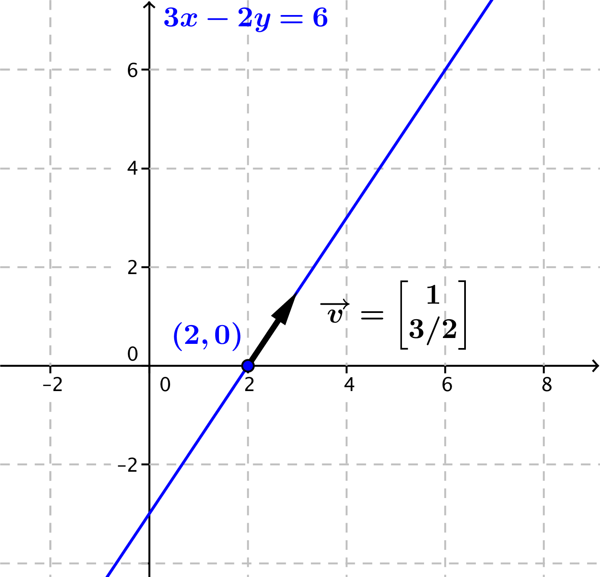

  - Find a point on line $l$ and the slope of line $l$.
Student responses for the point will vary; common choices include $(0,-3)$ or $(2,0)$. The slope of the line is $\frac{3}{2}$.
  - Write a vector equation for line $l$ using the information you found in part (b).
Student responses will vary. Sample responses are
$$\left[\begin{aligned}x \\ y\end{aligned}\right]=\left[\begin{aligned}0 \\ -3\end{aligned}\right]+\left[\begin{aligned}1 \\ 1.5 \end{aligned}\right]t$$
$$\left[\begin{aligned}x \\ y\end{aligned}\right]=\left[\begin{aligned}2 \\ 0\end{aligned}\right]+\left[\begin{aligned}1 \\ 1.5\end{aligned}\right]t.$$

  - Write parametric equations for line $l$.
Student responses will vary. Sample responses are
$$x\left(t\right)=t \\ y\left(t\right)=-3+1.5t$$
or
$$x\left(t\right)=2+t \\ y\left(t\right)=1.5t.$$

  - Verify algebraically that your parametric equations produce points on line $l.$
$$3x-2y=3\left(t\right)-2\left(-3+1.5t\right) \\ =3t+6-3t \\ =6.$$
Thus, the parametric equations $x\left(t\right)=t$and$y\left(t\right)=-3+1.5t$ produce points on line $l.$

- Olivia wrote parametric equations $x\left(t\right)=4+2t$ and $y\left(t\right)=3+3t$. Are her equations correct? What did she do differently from you?
Her equations are also correct:
$$3x-2y=3\left(4+2t\right)-2\left(3+3t\right) \\ =12+6t-6-6t \\ =6.$$
She chose the point $(4,3)$ on the line and used the vector $\left[\begin{aligned}2 \\ 3\end{aligned}\right].$

- Convert the parametric equations $x\left(t\right)=2-3t$ and $y\left(t\right)=4+t$ into slope-intercept form.
One vector form is $\left[\begin{aligned}x \\ y\end{aligned}\right]=\left[\begin{aligned}2 \\ 4\end{aligned}\right]+\left[\begin{aligned}-3 \\ 1\end{aligned}\right]t$, so the line passes through $(2,4)$ with slope $m=-\frac{1}{3}$. Then the line has equation
$$y-4=-\frac{1}{3}\left(x-2\right) \\ y=-\frac{1}{3}x+\frac{2}{3}+4 \\ y=-\frac{1}{3}x+\frac{14}{3}.$$

Discussion (4 minutes)
- A line is uniquely determined in the plane if we know a point that it passes through and its slope. Do a point and a slope provide enough to uniquely identify a line in $R^{3}$?
  - No, we have no sense of a slope in space, so a point and a slope won’t clearly identify a line in $R^{3}.$
- How can we uniquely specify a line $l$ in space?
  - If we know a point that $l$ passes through and the direction in which the line points, then we can uniquely specify that line.
- That is, we need to know a point $(x_{1}, y_{1}, z_{1})$ on line $l$ and a vector that is pointed in the same direction as $l$. Then we can start at that point $(x_{1}, y_{1}, z_{1})$, and move in the direction of the vector to find new points on $l$.

Example (5 minutes)
In this Example, we extend the process from lines in the plane to lines in space.

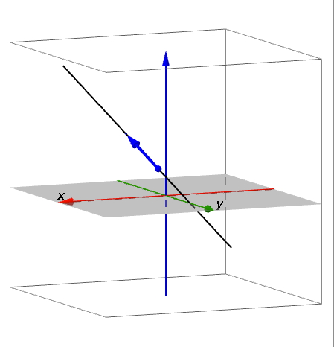
- Consider the line $l$ in space that passes through point $(1,1,2)$ and has direction vector $\overset{⃑}{v}=\left[\begin{aligned}1 \\ -3 \\ 2\end{aligned}\right]$, as shown at right.
- Can you find another point on $l$ by moving $t$ steps in the direction of $\overset{⃑}{v}$ from point $\left(1,1,2\right)$?
  - $\left[\begin{aligned}x \\ y \\ z\end{aligned}\right]=\left[\begin{aligned}1 \\ 1 \\ 2\end{aligned}\right]+\left[\begin{aligned}1 \\ -3 \\ 2\end{aligned}\right]t.$
- What are the parametric equations of $l$?$$x=1+t \\ y=1-3t \\ z=2+2t.$$
- Debrief this activity in class using the summary box below.
Let $l$ be a line in space that contains point$(x_{1}, y_{1},z_{1})$ and has direction vector $\overset{⃑}{v}=\left[\begin{aligned}a \\ b \\ c\end{aligned}\right]$.
- A vector form of the equation that represents line $l$ is
$$\left[\begin{aligned}\begin{aligned}x \\ y\end{aligned} \\ z\end{aligned}\right]=\left[\begin{aligned}x_{1} \\ y_{1} \\ z_{1}\end{aligned}\right]+\left[\begin{aligned}a \\ b \\ c\end{aligned}\right]t.$$
- Parametric equations that represent line $l$ are
$$x\left(t\right)=x_{1}+at \\ y\left(t\right)=y_{1}+bt \\ z\left(t\right)=z_{1}+ct.$$
Exercises 4–5 (4 minutes)
Keep students working in the same pairs or small groups as in the previous exercise.

- Find parametric equations to represent the line that passes through point $(4,2,9)$ and has direction vector
$$\overset{⃑}{v}=\left[\begin{aligned}2 \\ -1 \\ -3\end{aligned}\right].$$
$$\left[\begin{aligned}x \\ y \\ z\end{aligned}\right]=\left[\begin{aligned}4 \\ 2 \\ 9\end{aligned}\right]+\left[\begin{aligned}2 \\ -1 \\ -3\end{aligned}\right]t$$

$$x(t)=4+2t \\ y\left(t\right)=2-t \\ z\left(t\right)=9-3t$$

- Find a vector form of the equation of the line given by the parametric equations
$$x\left(t\right)=3t \\ y\left(t\right)=-4-2t \\ z\left(t\right)=3-t.$$
$$\left[\begin{aligned}x \\ y \\ z\end{aligned}\right]=\left[\begin{aligned}0 \\ -4 \\ 3\end{aligned}\right]+\left[\begin{aligned}3 \\ -2 \\ -1\end{aligned}\right]t$$

Closing (3 minutes)
Ask students to summarize the key points of the lesson in writing or to a partner. Some important summary elements are listed below.
Lesson Summary
Lines in the plane and lines in space can be described by either a vector equation or a set of parametric equations.
- Let $l$ be a line in the plane that contains point$\left(x_{1}, y_{1}\right)$ and has direction vector $\overset{⃑}{v}=\left[\begin{aligned}a \\ b\end{aligned}\right]$. If the slope of line $l$ is defined, then $m=\frac{b}{a}$.
A vector form of the equation that represents line $l$ is
$$\left[\begin{aligned}x \\ y\end{aligned}\right]=\left[\begin{aligned}x_{1} \\ y_{1}\end{aligned}\right]+\left[\begin{aligned}a \\ b\end{aligned}\right]t.$$
Parametric equations that represent line $l$ are
$$x\left(t\right)=x_{1}+at \\ y\left(t\right)=y_{1}+bt.$$
- Let $l$ be a line in space that contains point$(x_{1}, y_{1},z_{1})$ and has direction vector $\overset{⃑}{v}=\left[\begin{aligned}a \\ b \\ c\end{aligned}\right]$.
A vector form of the equation that represents line $l$ is
$$\left[\begin{aligned}\begin{aligned}x \\ y\end{aligned} \\ z\end{aligned}\right]=\left[\begin{aligned}x_{1} \\ y_{1} \\ z_{1}\end{aligned}\right]+\left[\begin{aligned}a \\ b \\ c\end{aligned}\right]t.$$
Parametric equations that represent line $l$ are
$$x\left(t\right)=x_{1}+at \\ y\left(t\right)=y_{1}+bt \\ z\left(t\right)=z_{1}+ct.$$

Exit Ticket (4 minutes)

Name Date
Lesson 21: Vectors and the Equation of a Line

Exit Ticket

- Find parametric equations for the line in the plane given by $y=2x+3.$

- Do $y=7-x$ and $x\left(t\right)=-1$ and $y\left(t\right)=1+7t$ represent the same line? Explain why or why not.

- Find parametric equations for the line in space that passes through point $(1,0,4)$ with direction vector $\overset{⃑}{v}=\left[\begin{aligned}3 \\ 2 \\ 1\end{aligned}\right]$.
Exit Ticket Sample Solutions

- Find parametric equations for the line in the plane given by $y=2x+3.$
This line passes through point $(0,3)$ with slope $m=2$. Then the vector form of the line is
$$\left[\begin{aligned}x \\ y\end{aligned}\right]=\left[\begin{aligned}0 \\ 3\end{aligned}\right]+\left[\begin{aligned}1 \\ 2\end{aligned}\right]t,$$
so the parametric equations are
$$x\left(t\right)=t \\ y\left(t\right)=3+2t.$$

- Do $y=7-x$ and $x\left(t\right)=-1$ and $y\left(t\right)=1+7t$ represent the same line? Explain why or why not.
We can see that if $x\left(t\right)=-1$ and $y\left(t\right)=7-t$, then $7-x=7-(-1)=8$ so $y≠7-x$, and thus the equations are not the same line.

- Find parametric equations for the line in space that passes through point $(1,0,4)$ with direction vector $\overset{⃑}{v}=\left[\begin{aligned}3 \\ 2 \\ 1\end{aligned}\right]$.
$$x\left(t\right)=1+3t \\ y\left(t\right)=0+2t \\ z\left(t\right)=4+t.$$

Problem Set Sample Solutions
The vector and parametric forms of equations in the plane and in space are not unique. There are many different forms of correct answers to these questions. One correct sample response is included, but there are many other correct responses students could provide. Problems 1–6 address lines in the plane, and Problems 7–11 address lines in space.
- Find three points on the line in the plane with parametric equations $x\left(t\right)=4-3t$ and $y\left(t\right)=1+\frac{1}{3}t$.
Student responses will vary. Using $t=0$, $t=3$, and $t=-3$ gives the three points $(4,1)$, $(-5,4)$ and $(13, 0)$.

- Find vector and parametric equations to represent the line in the plane with the given equation.
  - $y=3x-4$
Since the slope is $3=\frac{3}{1}$ and a point on the line is $(0, -4)$, a vector form of the equation is $\left[\begin{aligned}x \\ y\end{aligned}\right]=\left[\begin{aligned}0 \\ -4\end{aligned}\right]+\left[\begin{aligned}1 \\ 3\end{aligned}\right]t.$ Then the parametric equations are $x\left(t\right)=t$ and $y=-4+3t$.

  - $2x-5y=10$
First, we rewrite the equation of the line in slope-intercept form: $y=\frac{2}{5}x-2$. Since the slope is $\frac{2}{5}$ and a point on the line is $(0, -2)$, a vector form of the equation is $\left[\begin{aligned}x \\ y\end{aligned}\right]=\left[\begin{aligned}0 \\ -2\end{aligned}\right]+\left[\begin{aligned}5 \\ 2\end{aligned}\right]t.$ Then the parametric equations are $x\left(t\right)=5t$ and $y=-2+2t$.
  - $y=-x$
Since the slope is $-1$ and a point on the line is $(0, 0)$, a vector form of the equation is $\left[\begin{aligned}x \\ y\end{aligned}\right]=\left[\begin{aligned}0 \\ 0\end{aligned}\right]+\left[\begin{aligned}1 \\ -1\end{aligned}\right]t.$ Then the parametric equations are $x\left(t\right)=t$ and $y=-t$.

  - $y-2=3\left(x+1\right)$
First, we rewrite the equation of the line in slope-intercept form: $y=3x+5$. Since the slope is $3$ and a point on the line is $(0, 5)$, a vector form of the equation is $\left[\begin{aligned}x \\ y\end{aligned}\right]=\left[\begin{aligned}0 \\ 3\end{aligned}\right]+\left[\begin{aligned}1 \\ 3\end{aligned}\right]t.$ Then the parametric equations are $x\left(t\right)=t$ and $y=3+3t$.

- Find vector and parametric equations to represent the following lines in the plane.
  - the $x$-axis
A vector in the direction of the $x$-axis is $\left[\begin{aligned}1 \\ 0\end{aligned}\right]$ and the line passes through the origin $(0,0)$, so a vector form is $\left[\begin{aligned}x \\ y\end{aligned}\right]=\left[\begin{aligned}1 \\ 0\end{aligned}\right]t$. Thus, the parametric equations are $x\left(t\right)=t$ and $y\left(t\right)=0$.

  - the $y$-axis
A vector in the direction of the $y$-axis is $\left[\begin{aligned}0 \\ 1\end{aligned}\right]$ and the line passes through the origin $(0,0)$, so a vector form is $\left[\begin{aligned}x \\ y\end{aligned}\right]=\left[\begin{aligned}0 \\ 1\end{aligned}\right]t$. Thus, the parametric equations are $x\left(t\right)=0$ and $y\left(t\right)=t$.

  - the horizontal line with equation $y=4$
A vector in the direction of the line is $\left[\begin{aligned}1 \\ 0\end{aligned}\right]$ and the line passes through $(0,4)$, so a vector form is
$\left[\begin{aligned}x \\ y\end{aligned}\right]=\left[\begin{aligned}0 \\ 4\end{aligned}\right]+\left[\begin{aligned}1 \\ 0\end{aligned}\right]t$. Thus, the parametric equations are $x\left(t\right)=t$ and $y\left(t\right)=4$.

  - the vertical line with equation $x=-2$
A vector in the direction of the line is $\left[\begin{aligned}0 \\ 1\end{aligned}\right]$ and the line passes through $(-2,0)$, so a vector form is
$\left[\begin{aligned}x \\ y\end{aligned}\right]=\left[\begin{aligned}-2 \\ 0\end{aligned}\right]+\left[\begin{aligned}0 \\ 1\end{aligned}\right]t$. Thus, the parametric equations are $x\left(t\right)=-2$ and $y\left(t\right)=t$.

  - the horizontal line with equation $y=k$, for a real number $k$
A vector in the direction of the line is $\left[\begin{aligned}1 \\ 0\end{aligned}\right]$ and the line passes through $(0,k)$, so a vector form is
$\left[\begin{aligned}x \\ y\end{aligned}\right]=\left[\begin{aligned}0 \\ k\end{aligned}\right]+\left[\begin{aligned}1 \\ 0\end{aligned}\right]t$. Thus, the parametric equations are $x\left(t\right)=t$ and $y\left(t\right)=k$.

  - the vertical line with equation $x=h$, for a real number $h$
A vector in the direction of the line is $\left[\begin{aligned}0 \\ 1\end{aligned}\right]$ and the line passes through $(h,0)$, so a vector form is
$\left[\begin{aligned}x \\ y\end{aligned}\right]=\left[\begin{aligned}h \\ 0\end{aligned}\right]+\left[\begin{aligned}0 \\ 1\end{aligned}\right]t$. Thus, the parametric equations are $x\left(t\right)=h$ and $y\left(t\right)=t$.

- Find the point-slope form of the line in the plane with the given parametric equations.
  - $x\left(t\right)=2-4t$, $y\left(t\right)=3-7t$
The vector form is $\left[\begin{aligned}x \\ y\end{aligned}\right]=\left[\begin{aligned}2 \\ 3\end{aligned}\right]+\left[\begin{aligned}-4 \\ -7\end{aligned}\right]t$, so the line passes through the point $(2,3)$ with slope $m=\frac{-7}{-4}=\frac{7}{4}.$ Thus, the point-slope form of the line is $y-3=\frac{7}{4}\left(x-2\right).$

  - $x\left(t\right)=2-\frac{2}{3}t$, $y\left(t\right)=6+t$
The vector form is
$$\left[\begin{aligned}x \\ y\end{aligned}\right]=\left[\begin{aligned}2 \\ 6\end{aligned}\right]+\left[\begin{aligned}-\frac{2}{3} \\ 6\end{aligned}\right]t,$$so the line passes through the point $(2,6)$ with slope
$$m=\frac{6}{-\frac{2}{3}}=-9.$$Thus, the point-slope form of the line is $y-6=-9\left(x-2\right).$

  - $x\left(t\right)=3-t$, $y\left(t\right)=3$
The vector form is $\left[\begin{aligned}x \\ y\end{aligned}\right]=\left[\begin{aligned}3 \\ 3\end{aligned}\right]+\left[\begin{aligned}-1 \\ 0\end{aligned}\right]t$, so the line passes through the point $(3,3)$ with slope $m=0$. Thus the point-slope form of the line is $y-3=0(x-3)$, which is equivalent to $y=3$.

  - $x\left(t\right)=t$, $y\left(t\right)=t$
The vector form is $\left[\begin{aligned}x \\ y\end{aligned}\right]=\left[\begin{aligned}0 \\ 0\end{aligned}\right]+\left[\begin{aligned}1 \\ 1\end{aligned}\right]t$, so the line passes through the point $\left(0,0\right)w$ith slope $m=1$. Thus the point-slope form of the line is $y=x$.

- Find vector and parametric equations for the line in the plane through point $P$ in the direction of vector $v$.
  - $P=(1,5)$, $\overset{⃑}{v}=\left[\begin{aligned}2 \\ -1\end{aligned}\right]$
The vector form is $\left[\begin{aligned}x \\ y\end{aligned}\right]=\left[\begin{aligned}1 \\ 5\end{aligned}\right]+\left[\begin{aligned}2 \\ -1\end{aligned}\right]t$, so the parametric equations are $x\left(t\right)=1+2t$ and $y\left(t\right)=5-t$.

  - $P=(0,0)$, $\overset{⃑}{v}=\left[\begin{aligned}4 \\ 4\end{aligned}\right]$
The vector form is $\left[\begin{aligned}x \\ y\end{aligned}\right]=\left[\begin{aligned}0 \\ 0\end{aligned}\right]+\left[\begin{aligned}4 \\ 4\end{aligned}\right]t$, so the parametric equations are $x\left(t\right)=4t$ and $y\left(t\right)=4t.$

  - $P=\left(-3,-1\right)$, $\overset{⃑}{v}=\left[\begin{aligned}1 \\ 2\end{aligned}\right]$
The vector form is $\left[\begin{aligned}x \\ y\end{aligned}\right]=\left[\begin{aligned}-3 \\ -1\end{aligned}\right]+\left[\begin{aligned}1 \\ 2\end{aligned}\right]t$, so the parametric equations are $x\left(t\right)=-3+t$ and $y\left(t\right)=-1+2t.$

- Determine if the point $A$ is on the line $l$ represented by the given parametric equations.
  - $A=\left(3,1\right)$, $x\left(t\right)=1+2t$ and $y\left(t\right)=3-2t.$
Point $A$ is on the line if there is a single value of $t$ so that $3=1+2t$ and $1=3-2t.$ If $1+2t=3$, then
$t=1$. If $1=3-2t$, then $t=1$. Thus, $A$ is on the line given by these parametric equations.

  - $A=\left(0,0\right)$, $x\left(t\right)=3+6t$ and $y\left(t\right)=2+4t$
Point $A$ is on the line if there is a single value of $t$ so that $0=3+6t$ and$0=2+4t.$ If $3+6t=0$, then
$t=-\frac{1}{2}$ . If $0=2+4t$, then $t=-\frac{1}{2}$. Thus, $A$ is on the line given by these parametric equations.

  - $A=\left(2,3\right)$, $x\left(t\right)=4-2t$ and $y\left(t\right)=4+t$
Point $A$ is on the line if there is a single value of $t$ so that $2=4-2t$ and $3=4+t$. If $4-2t=2$, then
$t=1$. If $3=4+t,$ then $t=-1$. Since there is no value of $t$ that gives $4-2t=2$ and $3=4+t$, point $A$ is not on the line.

  - $A=\left(2,5\right)$, $x\left(t\right)=12+2t$ and $y\left(t\right)=15+2t$
Point $A$ is on the line if there is a single value of $t$ so that $12+2t=2$ and $15+2t=5$. If $12+2t=2$, then $t=-5$. If $15+2t=5$, then $t=-5$. Thus, $A$ is on the line given by these parametric equations.

- Find three points on the line in space with parametric equations $x\left(t\right)=4+2t$, $y\left(t\right)=6-t$, and $z\left(t\right)=t$.
Student responses will vary. Using $t=0$, $t=1$, and $t=-1$ gives the three points $(4,6,0)$, $(6,5,1)$, and $\left(2,7,-1\right).$

- Find vector and parametric equations to represent the following lines in space.
  - the $x$-axis
A vector in the direction of the $x$-axis is $\left[\begin{aligned}1 \\ 0 \\ 0\end{aligned}\right]$ and the line passes through the origin $(0,0,0)$, so a vector form is $\left[\begin{aligned}x \\ y \\ z\end{aligned}\right]=\left[\begin{aligned}1 \\ 0 \\ 0\end{aligned}\right]t$. Thus, the parametric equations are $x\left(t\right)=t$, $y\left(t\right)=0$, and $z\left(t\right)=0$.

  - the $y$-axis
A vector in the direction of the $y$-axis is $\left[\begin{aligned}0 \\ 1 \\ 0\end{aligned}\right]$ and the line passes through the origin $(0,0,0)$, so a vector form is $\left[\begin{aligned}x \\ y \\ z\end{aligned}\right]=\left[\begin{aligned}0 \\ 1 \\ 0\end{aligned}\right]t$. Thus, the parametric equations are $x\left(t\right)=0$, $y\left(t\right)=1$, and $z\left(t\right)=0$.

  - the $z$-axis
A vector in the direction of the $z$-axis is $\left[\begin{aligned}0 \\ 0 \\ 1\end{aligned}\right]$ and the line passes through the origin $(0,0,0)$, so a vector form is $\left[\begin{aligned}x \\ y \\ z\end{aligned}\right]=\left[\begin{aligned}0 \\ 0 \\ 1\end{aligned}\right]t$. Thus, the parametric equations are $x\left(t\right)=0$, $y\left(t\right)=0$, and $z\left(t\right)=1$.

- Convert the equation given in vector form to a set of parametric equations for the line $l.$
  - $\left[\begin{aligned}x \\ y \\ z\end{aligned}\right]=\left[\begin{aligned}1 \\ 1 \\ 1\end{aligned}\right]+\left[\begin{aligned}2 \\ 3 \\ 4\end{aligned}\right]t$
$x\left(t\right)=1+2t$, $y\left(t\right)=1+3t$, and $z\left(t\right)=1+4t$

  - $\left[\begin{aligned}x \\ y \\ z\end{aligned}\right]=\left[\begin{aligned}3 \\ 0 \\ 0\end{aligned}\right]+\left[\begin{aligned}0 \\ 1 \\ -2\end{aligned}\right]t$
$x\left(t\right)=3\text{,} y\left(t\right)=t$, and $z\left(t\right)=-2t$

  - $\left[\begin{aligned}x \\ y \\ z\end{aligned}\right]=\left[\begin{aligned}5 \\ 0 \\ 2\end{aligned}\right]+\left[\begin{aligned}4 \\ -3 \\ -8\end{aligned}\right]t$
$x\left(t\right)=5+4t$, $y\left(t\right)=-3t$, and $z\left(t\right)=2-8t$

- Find vector and parametric equations for the line in space through point $P$ in the direction of vector $\overset{⃑}{v}$.
  - $P=(1,4,3)$, $\overset{⃑}{v}=\left[\begin{aligned}3 \\ 6 \\ -2\end{aligned}\right]$
$\left[\begin{aligned}x \\ y \\ z\end{aligned}\right]=\left[\begin{aligned}1 \\ 4 \\ 3\end{aligned}\right]+\left[\begin{aligned}3 \\ 6 \\ -2\end{aligned}\right]t\text{;} x\left(t\right)=1+3t\text{,} y\left(t\right)=4+6t\text{,}$and$z\left(t\right)=3-2t$

  - $P=(2,2,2)$, $\overset{⃑}{v}=\left[\begin{aligned}1 \\ 1 \\ 1\end{aligned}\right]$
$\left[\begin{aligned}x \\ y \\ z\end{aligned}\right]=\left[\begin{aligned}2 \\ 2 \\ 2\end{aligned}\right]+\left[\begin{aligned}1 \\ 1 \\ 1\end{aligned}\right]t\text{;} x\left(t\right)=2+t\text{,} y\left(t\right)=2+t\text{,}$and$z\left(t\right)=2+t$

  - $P=\left(0,0,0\right)$, $\overset{⃑}{v}=\left[\begin{aligned}4 \\ 4 \\ -2\end{aligned}\right]$
$\left[\begin{aligned}x \\ y \\ z\end{aligned}\right]=\left[\begin{aligned}0 \\ 0 \\ 0\end{aligned}\right]+\left[\begin{aligned}4 \\ 4 \\ -2\end{aligned}\right]t\text{;} x\left(t\right)=4t\text{,} y\left(t\right)=4t\text{,}$and$z\left(t\right)=-2t$

- Determine if the point $A$ is on the line $l$ represented by the given parametric equations.
  - $A=(3,1,1)$, $x\left(t\right)=5-t$, $y\left(t\right)=-5+3t$, and $z\left(t\right)=9-4t$
If $A$ is on line $l$, then there is a single value of $t$ so that $5-t=3$, $-5+3t=1$, and $9-4t=1$. If $5-t=3$, then $t=2.$ If $–5+3t=1$, then $t=2$. If $9-4t=1$, then $t=2$. Thus, $A$ lies on line $l.$

  - $A=\left(1,0,2\right)$, $x\left(t\right)=7-2t$, $y\left(t\right)=3-t$, and $z\left(t\right)=4-t$
If $A$ is on line $l,$ then there is a single value of $t$so that$7-2t=1$, $3-t=0$, and $4-t=2$. If $7-2t=1$, then $t=3.$ If $3-t=0$, then $t=3$. If $4-t=2$, then $t=2$. Thus, there is no value of $t$ that satisfies all three equations, so point $A$ is not on line $l.$

  - $A=(5,3,2)$, $x\left(t\right)=8+t$, $y\left(t\right)=-t$, and $z\left(t\right)=-4-2t$
If $A$ is on line $l$, then there is a single value of $t$ so that $8+t=5$, $-t=3$, and $-4-2t=2$. If $8+t=5$, then $t=-3.$ If $–t=3$, then $t=-3$. If $-4-2t=2$, then $t=-3$. Thus, $A$ lies on line $l.$

