Lesson 21: Vectors and the Equation of a Line

Classwork
Opening Exercise
  - Find three different ways to write the equation that represents the line in the plane that passes through points $(1,2)$ and $(2,-1)$.

  - Graph the line through point $(1,1)$ with slope $2.$

Exercises
- Consider the line $l$ in the plane given by the equation $3x-2y=6.$
  - Sketch a graph of line $l$ on the axes provided.
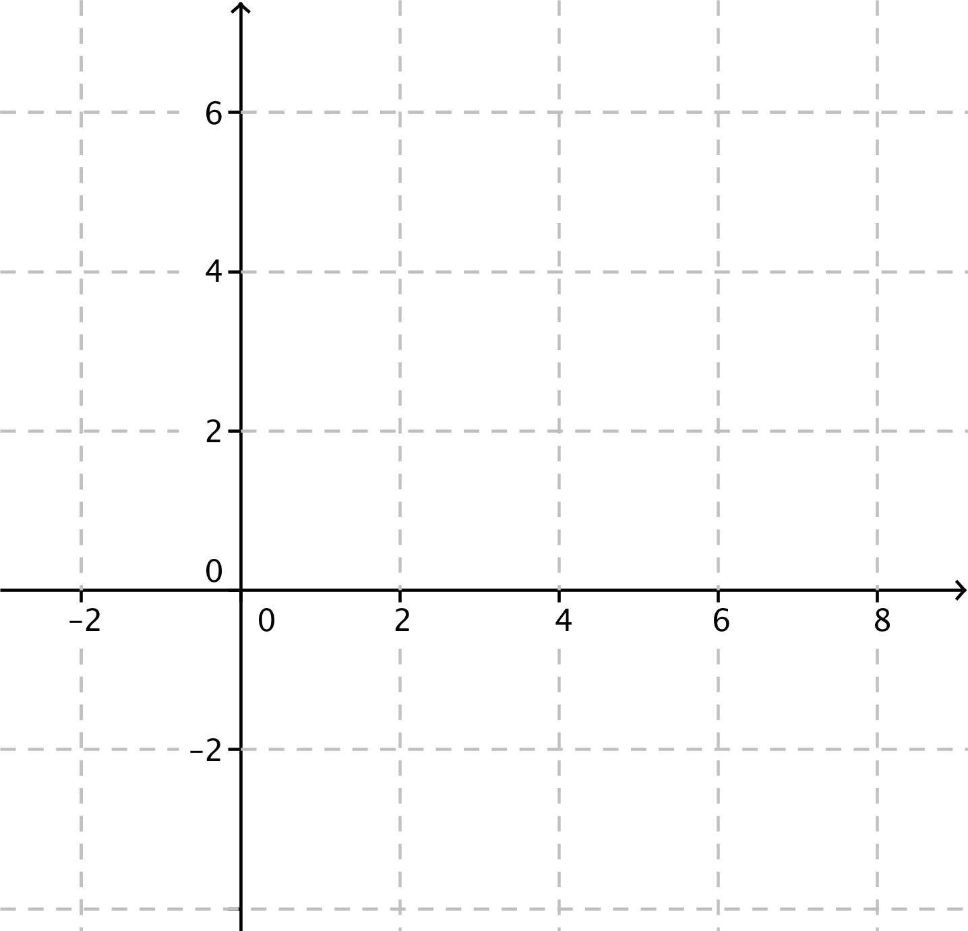

  - Find a point on line $l$ and the slope of line $l$.

  - Write a vector equation for line $l$ using the information you found in part (b).

  - Write parametric equations for line $l$.

  - Verify algebraically that your parametric equations produce points on line $l.$

- Olivia wrote parametric equations $x\left(t\right)=4+2t$ and $y\left(t\right)=3+3t$. Are her equations correct? What did she do differently from you?

- Convert the parametric equations $x\left(t\right)=2-3t$ and $y\left(t\right)=4+t$ into slope-intercept form.

- Find parametric equations to represent the line that passes through point $(4,2,9)$ and has direction vector
$$\overset{⃑}{v}=\left[\begin{aligned}2 \\ -1 \\ -3\end{aligned}\right].$$

- Find a vector form of the equation of the line given by the parametric equations
$$x\left(t\right)=3t \\ y\left(t\right)=-4-2t \\ z\left(t\right)=3-t.$$

Lesson Summary
Lines in the plane and lines in space can be described by either a vector equation or a set of parametric equations.
- Let $l$ be a line in the plane that contains point$\left(x_{1}, y_{1}\right)$ and has direction vector $\overset{⃑}{v}=\left[\begin{aligned}a \\ b\end{aligned}\right]$. If the slope of line $l$ is defined, then $m=\frac{b}{a}$.
A vector form of the equation that represents line $l$ is
$$\left[\begin{aligned}x \\ y\end{aligned}\right]=\left[\begin{aligned}x_{1} \\ y_{1}\end{aligned}\right]+\left[\begin{aligned}a \\ b\end{aligned}\right]t.$$
Parametric equations that represent line $l$ are
$$x\left(t\right)=x_{1}+at \\ y\left(t\right)=y_{1}+bt.$$
- Let $l$ be a line in space that contains point$(x_{1}, y_{1},z_{1})$ and has direction vector $\overset{⃑}{v}=\left[\begin{aligned}a \\ b \\ c\end{aligned}\right]$.
A vector form of the equation that represents line $l$ is
$$\left[\begin{aligned}\begin{aligned}x \\ y\end{aligned} \\ z\end{aligned}\right]=\left[\begin{aligned}x_{1} \\ y_{1} \\ z_{1}\end{aligned}\right]+\left[\begin{aligned}a \\ b \\ c\end{aligned}\right]t.$$
Parametric equations that represent line $l$ are
$$x\left(t\right)=x_{1}+at \\ y\left(t\right)=y_{1}+bt \\ z\left(t\right)=z_{1}+ct.$$

$$.$$

Problem Set

- Find three points on the line in the plane with parametric equations $x\left(t\right)=4-3t$ and $y\left(t\right)=1+\frac{1}{3}t$.

- Find vector and parametric equations to represent the line in the plane with the given equation.
  - $y=3x-4$
  - $2x-5y=10$
  - $y=-x$
  - $y-2=3\left(x+1\right)$

- Find vector and parametric equations to represent the following lines in the plane.
  - the $x$-axis
  - the $y$-axis
  - the horizontal line with equation $y=4$
  - the vertical line with equation $x=-2$
  - the horizontal line with equation $y=k$, for a real number $k$
  - the vertical line with equation $x=h$, for a real number $h$

- Find the point-slope form of the line in the plane with the given parametric equations.
  - $x\left(t\right)=2-4t$, $y\left(t\right)=3-7t$
  - $x\left(t\right)=2-\frac{2}{3}t$, $y\left(t\right)=6+t$
  - $x\left(t\right)=3-t$, $y\left(t\right)=3$
  - $x\left(t\right)=t$, $y\left(t\right)=t$

- Find vector and parametric equations for the line in the plane through point $P$ in the direction of vector $v$.
  - $P=(1,5)$, $\overset{⃑}{v}=\left[\begin{aligned}2 \\ -1\end{aligned}\right]$
  - $P=(0,0)$, $\overset{⃑}{v}=\left[\begin{aligned}4 \\ 4\end{aligned}\right]$
  - $P=\left(-3,-1\right)$, $\overset{⃑}{v}=\left[\begin{aligned}1 \\ 2\end{aligned}\right]$

- Determine if the point $A$ is on the line $l$ represented by the given parametric equations.
  - $A=\left(3,1\right),$ $x\left(t\right)=1+2t$ and $y\left(t\right)=3-2t.$
  - $A=\left(0,0\right)$, $x\left(t\right)=3+6t$ and $y\left(t\right)=2+4t$
  - $A=\left(2,3\right)$, $x\left(t\right)=4-2t$ and $y\left(t\right)=4+t$
  - $A=\left(2,5\right)$, $x\left(t\right)=12+2t$ and $y\left(t\right)=15+2t$

- Find three points on the line in space with parametric equations $x\left(t\right)=4+2t$, $y\left(t\right)=6-t$, and $z\left(t\right)=t$.

- Find vector and parametric equations to represent the following lines in space.
  - the $x$-axis
  - the $y$-axis
  - the $z$-axis

- Convert the equation given in vector form to a set of parametric equations for the line $l.$
  - $\left[\begin{aligned}x \\ y \\ z\end{aligned}\right]=\left[\begin{aligned}1 \\ 1 \\ 1\end{aligned}\right]+\left[\begin{aligned}2 \\ 3 \\ 4\end{aligned}\right]t$
  - $\left[\begin{aligned}x \\ y \\ z\end{aligned}\right]=\left[\begin{aligned}3 \\ 0 \\ 0\end{aligned}\right]+\left[\begin{aligned}0 \\ 1 \\ -2\end{aligned}\right]t$
  - $\left[\begin{aligned}x \\ y \\ z\end{aligned}\right]=\left[\begin{aligned}5 \\ 0 \\ 2\end{aligned}\right]+\left[\begin{aligned}4 \\ -3 \\ -8\end{aligned}\right]t$

- Find vector and parametric equations for the line in space through point $P$ in the direction of vector $\overset{⃑}{v}$.
  - $P=(1,4,3)$, $\overset{⃑}{v}=\left[\begin{aligned}3 \\ 6 \\ -2\end{aligned}\right]$
  - $P=(2,2,2)$, $\overset{⃑}{v}=\left[\begin{aligned}1 \\ 1 \\ 1\end{aligned}\right]$
  - $P=\left(0,0,0\right)$, $\overset{⃑}{v}=\left[\begin{aligned}4 \\ 4 \\ -2\end{aligned}\right]$

- Determine if the point $A$ is on the line $l$ represented by the given parametric equations.
  - $A=(3,1,1)$, $x\left(t\right)=5-t$, $y\left(t\right)=-5+3t$ and $z\left(t\right)=9-4t$
  - $A=\left(1,0,2\right)$, $x\left(t\right)=7-2t$, $y\left(t\right)=3-t$ and $z\left(t\right)=4-t$
  - $A=(5,3,2)$, $x\left(t\right)=8+t$, $y\left(t\right)=-t$ and $z\left(t\right)=-4-2t$

