Lesson 20: Vectors and Stone Bridges

Student Outcomes
- Students understand the forces involved in constructing a stone arch.
- Students add and subtract vectors given in magnitude and direction form.
- Students solve problems that can be represented by vectors.

Lesson Notes
Lesson 19 specified vectors by using either the initial and terminal point, such as $\overset{⃑}{AB}$, or by its components, such as
$v=〈1,2〉.$In this lesson, students apply the vector and magnitude form of a vector as they explore how tall a stone arch can be built without the thrust forces causing the structure to collapse.
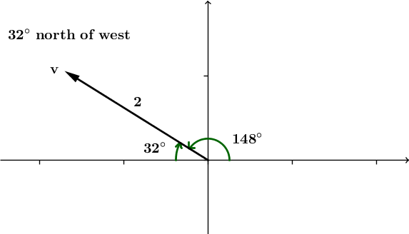
Magnitude and direction are both properties of vectors and can be used together to describe a vector. There is no universal way to represent a vector using its magnitude and direction. In this lesson and the ensuing problem set, we will use two different but equivalent methods. The magnitude of a vector is clearly defined and described as a positive number that measures the length of the directed line segment that defines the vector. The direction can be specified either by using a geographical description, or by measuring the amount of rotation $θ$ that the positive $x$-axis undergoes to align with the vector when its tail is placed at the origin. For example, consider the vector $v$ shown above. We can use magnitude and direction to describe $v$ in the following ways:
- Magnitude 2 and direction $32°$ north of west.
- Magnitude 2 and direction $148°$ from the positive $x$-axis.
There is some ambiguity in using the geographical description of direction, because $32°$ north of west is equivalent to $58°$ west of north. Thus, there is more than one valid way to use a geographic description to specify a vector. However, in application problems in physics, this type of geographic description of direction is the norm, so students should learn both approaches, and see that they are equivalent.
The construction of a stone arch is illustrated in the interactive app “Physics of Stone Arches”, available from PBS/Nova here: http://www.pbslearningmedia.org/resource/nv37.sci.engin.design.arches/physics-of-arches/.
If students have access to computers for classroom use, then adapt the opening to let them experiment with the software themselves. Otherwise, demonstrate this interactive app at the front of the classroom. The Physics of Stone Arches app will emulate the construction of a stone arch on top of a stack of blocks we will call the base column. The goal of the app is to construct an arch on as tall a base column as possible. Although the app allows users to experiment with different fortification strategies, this lesson only addresses buttressing.

There is also a GeoGebra App, NineStoneArch (http://eureka-math.org/G12M2L20/geogebra-NineStoneArch), available that you may choose to either demonstrate at the front of the room, or allow students to experiment with during the lesson. This app shows a simplified version of the force vectors in a stone arch with nine stones, allowing users to increase the weight of the individual stones as well as the height of the base columns.
This lesson addresses standards N-VM.A.3, N-VM.B.4a, and N-VM.B.4b. To extend this lesson, consider asking students to construct physical arch bridges from a substance such as floral foam or Styrofoam. You may consider extending this lesson to two days, allowing a full day for the Exploratory Challenge.
Materials needed: Protractor marked in degrees, a ruler marked in centimeters, and a computer with access to GeoGebra and the Internet.

Classwork
Opening (3 minutes)
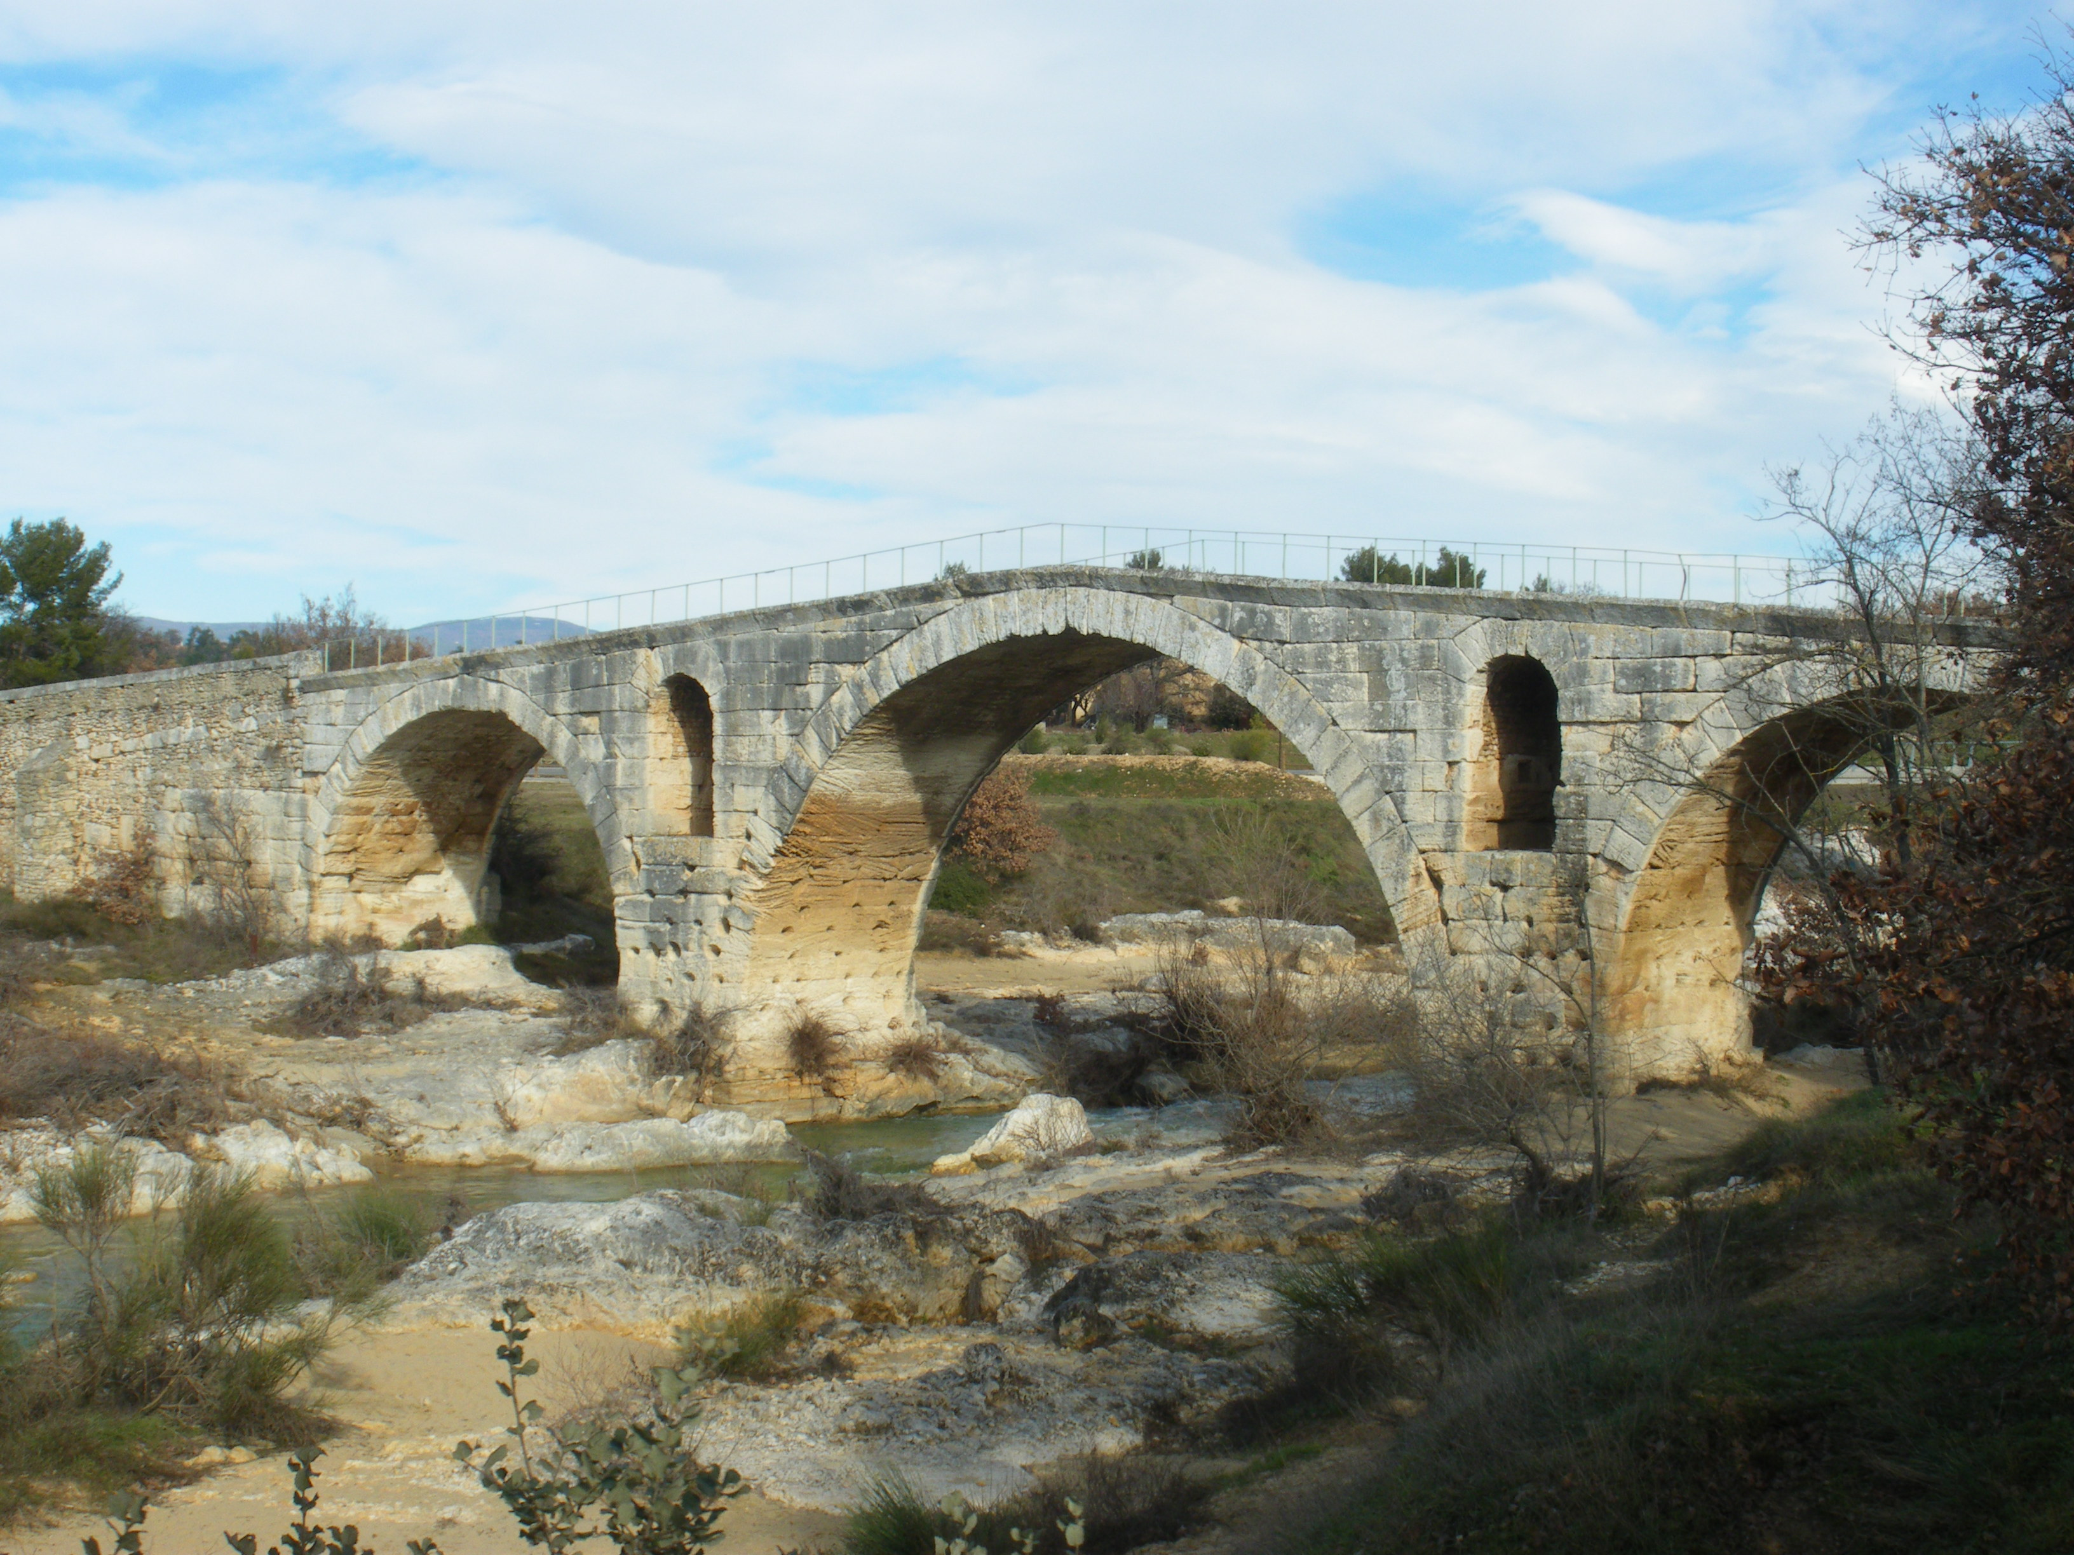
- The ancient Romans were the first to recognize the potential of arches for bridge construction. In 1994, Vittorio Galliazzo counted $931$ surviving ancient Roman bridges scattered throughout $26$ different countries. Most of these bridges were made of stone, and many have survived for more than $2,000$ years. Roman arch bridges were usually constructed using semicircular arcs, although some used arcs less than a semicircle. The Pont Julien (French for “Julien Bridge”) in southeast France, built in the year 3 BC, is based on semicircular arcs. It was used for all traffic, including car traffic, until 2005, when a replacement bridge was constructed to preserve the old bridge. This bridge was used for more than $2,000$ years!
Photograph by Veronique Pagnier, courtesy of Wikimedia Commons/Public domain
- Stone arch bridge construction centers on the idea that the arch distributes the force of gravity acting on the stone (i.e., the thrust) through the curve of the arch and into the column of stones beneath it, which we will call the base columns. If the resultant forces were not contained in the stones or the ground, the structure would collapse.
Demonstrate the Physics of Stone Arches app. Let the students guide you in constructing an arch, and watching it inevitably collapse as you add more and more blocks to the base columns. Experiment with the different types of fortification: buttresses, pinnacles, and flying buttresses. Although there is an option to select a pointed or rounded arch, this lesson only addresses the rounded arch and simple buttresses, so use your own discretion whether to explore the other possibilities.
- The Physics of Stone Arches app demonstrates an arch with nine stones. The Pont Julien contains many more stones in its three arches. To keep things simple, we will experiment with arches made of nine or fewer stones.
- Additionally, our work will not completely align with the Physics of Stone Arches app because we need to simplify the model to make it accessible to students.
- Our biggest simplification is in assuming that each stone pushes on another with a force of equal magnitude. In reality, the angle of the stone affects the magnitude of these force vectors.

Discussion (12 minutes)
This discussion relies on the GeoGebra app, G12-M2-L20-NineStoneArch.ggb. Ideally, students will be able to access this app directly, but if there are not enough available computers, then demonstrate at the front of the classroom.
- What forces are acting on the stones in the bridge?
  - Gravity, friction, compression.
Note to teacher: It is likely that students will be able to name gravity as a force acting on the stone, but possibly not friction or compression. Friction is the attractive force between stones caused by the roughness of the surface that keeps the stones from sliding away from each other. Compression is the force of one stone pushing on the one next to it. We will disregard the force of friction in our model, which is common with mathematical models.
- Have you heard the saying “For every action, there is an equal and opposite reaction?”
  - (Students will answer yes or no. Continue to explain the meaning of this statement either way.)
- “For every action there is an equal and opposite reaction” is a restatement of Newton’s third law of motion, which says “When one body exerts a force on a second body, the second body simultaneously exerts a force equal in magnitude and opposite in direction on the first body.” What does this mean for the stones in our bridge?
  - If a stone pushes down on the stone under it, the lower stone also pushes up on the stone above it in the opposite direction but with the same magnitude.
- Let’s consider the keystone, that is, the stone at the top of the bridge. This stone is often shaped differently than the others for aesthetic reasons, but for our purposes all the stones in the arch are the same shape and size. If the bridge is standing, is the keystone moving?
  - No. If the keystone is moving, then the bridge is falling down.
- What forces are acting on the keystone, and in what direction?
  - Gravity is pulling the keystone straight downward. The stone on the left is pushing upward on the left edge of the keystone in the direction perpendicular to the edge between the stones. The stone on the right is pushing upward on the right edge of the keystone in the direction perpendicular to the edge between the stones.

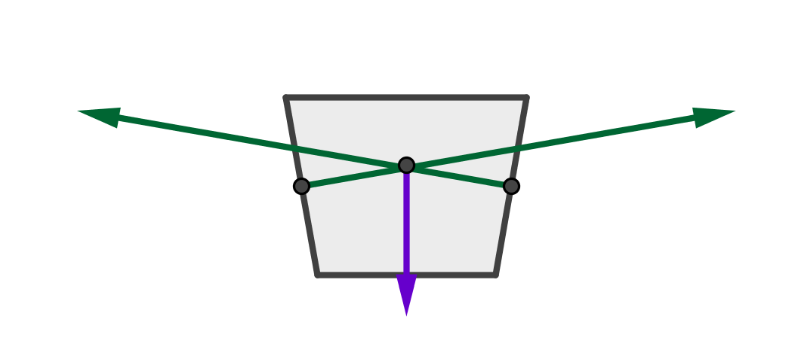
Draw or display a figure of the trapezoidal stone shown at right, marking the three force vectors acting on the stone. We do not have a way to accurately represent the magnitude of these vectors, but the two vectors on the sides should mirror each other. We will make some assumptions later in the lesson about these vectors, which will enable us to do some calculations with their magnitude and direction.

- What do we know about the sum of these three vectors acting on the keystone? Why?
  - Because the keystone is not moving, the net force acting on it is zero. That is, the three force vectors sum to zero. This means that if placed tip-to-tail, the three vectors would form a triangle.
- We are going to greatly simplify our model by assuming that all of the stones except the keystone push on each other with compression forces of equal magnitude. The weight of the keystone is carried by both the left and right sides of the arch, so it pushes on the stones to the left and right with compression forces of half of the magnitude of the other stones.
- Thus, the force vectors for each stone push downward in a direction perpendicular to the joint between the stones and, except for the forces from the keystone, the force vectors are assumed to have the same magnitude.
Display the GeoGebra app, G12-M2-L20-NineStoneArch.ggb, and show the force vectors. Except for the one from the keystone, the blue vectors all have the same magnitude, and each is perpendicular to the edge that it crosses. In the diagram, the blue vectors have an initial point at the center of mass of each stone. The green vector shows the result of adding up all of the blue force vectors. The bridge will stand or collapse based on whether or not the tip of this resultant vector is contained either in the arch itself or in the ground. The arch will stand if the vector is green, and will fall if it is red.
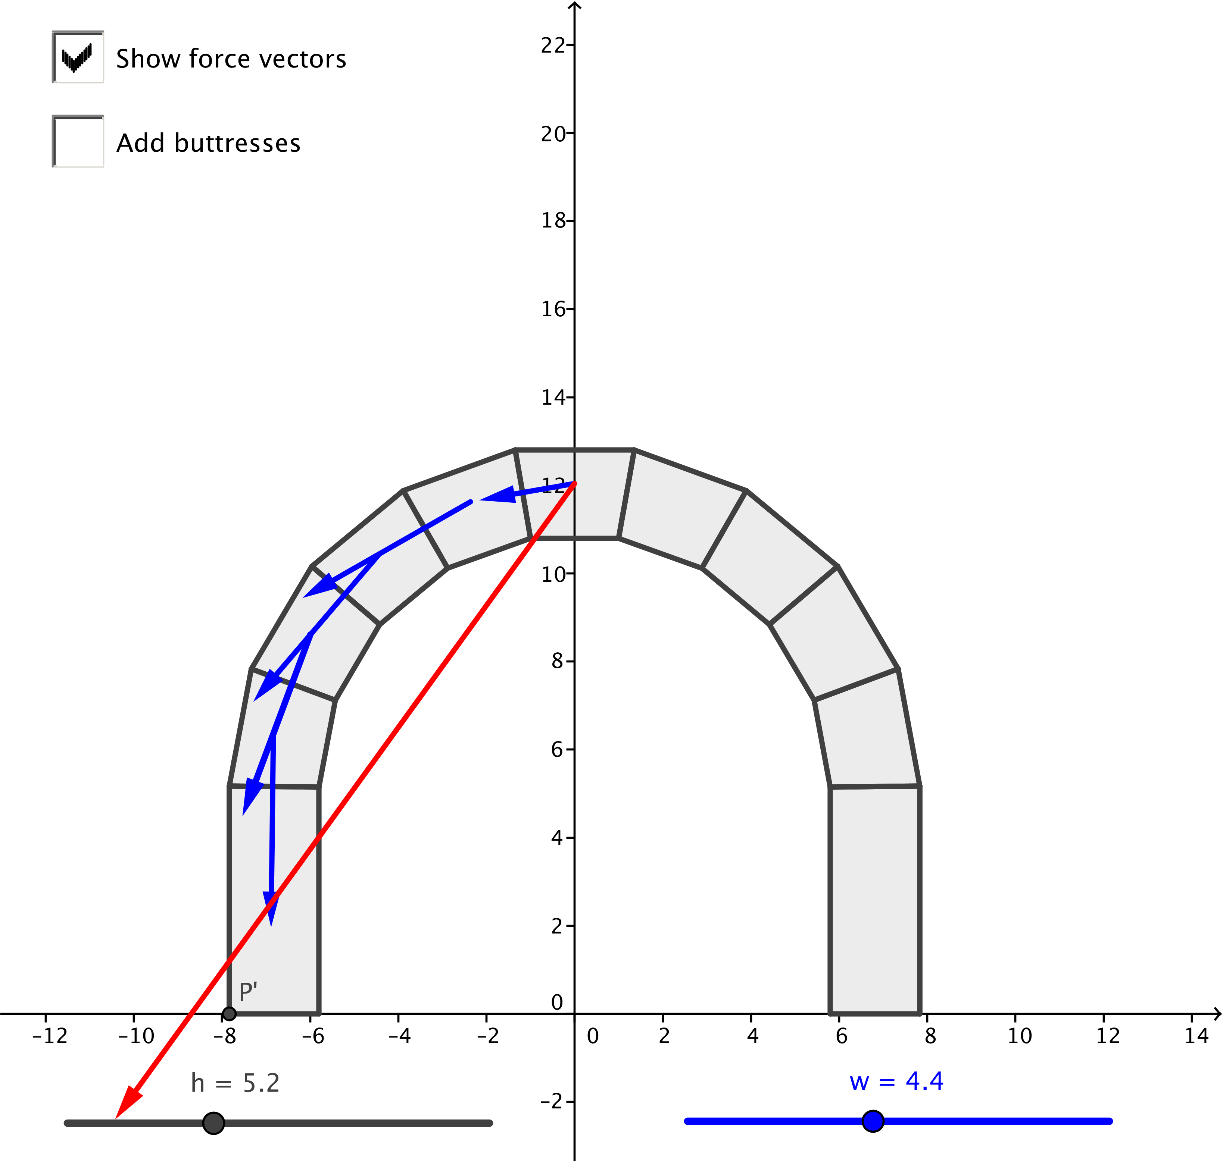
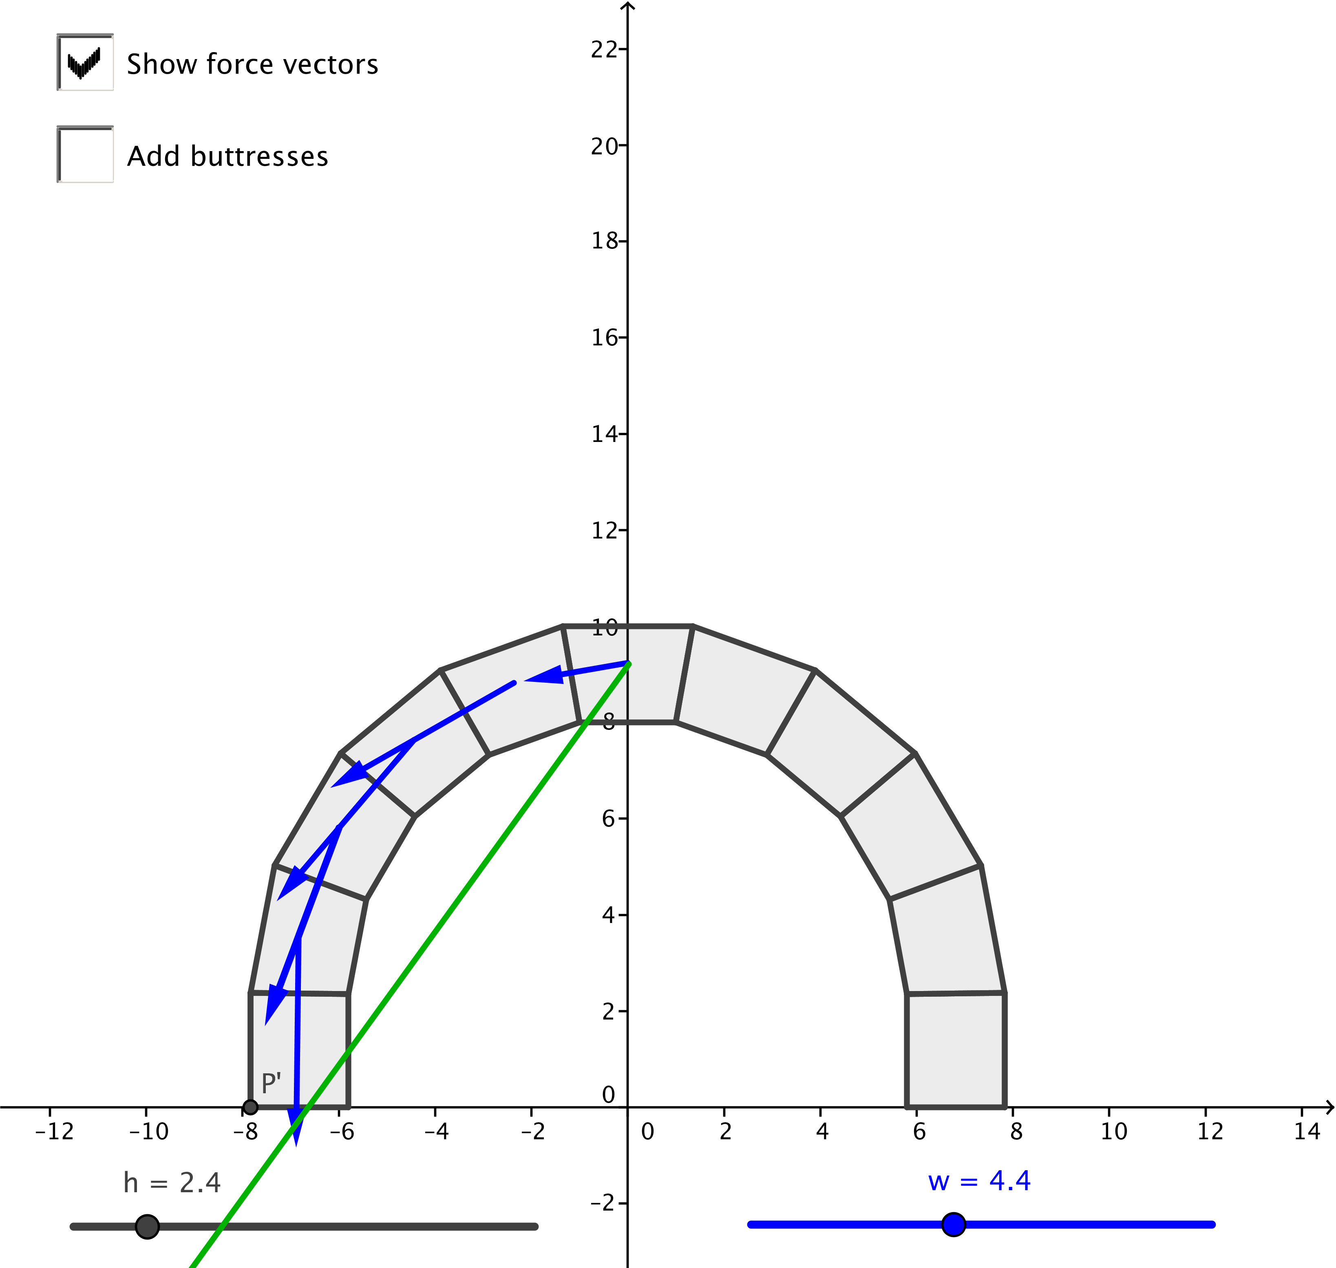
Figure 1: The resultant force is contained within the arch. The arch will stand.
Figure 2: The resultant force is not contained within the arch. The arch will collapse.

Use the GeoGebra app to explore what happens as the height $h$ of the base columns changes using the slider on the left.
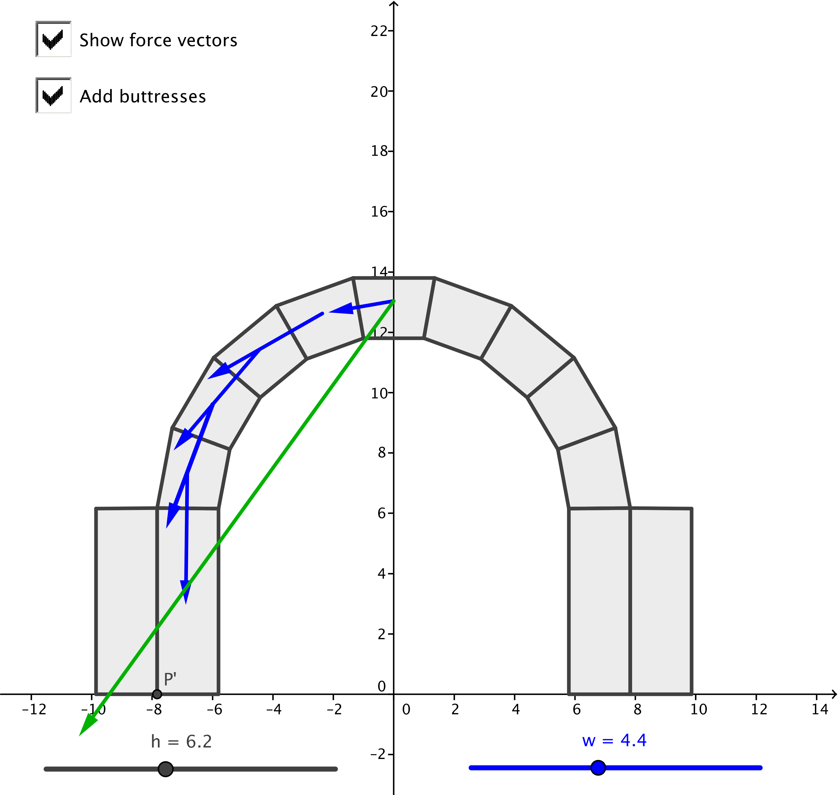
- If there is time, ask the students what should happen if they use the slider on the right to change the weight $w$ of the stones.
  - The resultant force is stronger but points in the same direction, so the weight of the stones in this model does not affect the outcome.
Check the box to add buttresses to the model and explore the result.
- When we add the buttresses, the width of each base column doubles. Does that double the maximum height of the base columns before the structure collapses?
  - No. Without the buttresses, the structure stands with base columns of height up to 4 units. With the buttresses, the structure stands with base columns of height up to 6.8 units. Adding buttresses makes the arch stronger, but does not double the maximum height of the
base columns.

Discussion (3 minutes)
This discussion describes the magnitude and direction form of a vector, which is key to
N-VM.A.3, N-VM.B.4a and N-VM.B.4b. Highlight this description before having the students start the challenge.
Scaffolding:
Use a visual approach to magnitude and direction form. Show a vector and ask students to describe it in magnitude and direction form.
- In Lesson 19, we described vectors by either specifying the coordinates of their endpoints or by specifying their components. We can also describe vectors using magnitude and direction: if we know the length of a vector and the direction in which it points, then we have uniquely identified that vector in magnitude and direction form.
- However—there are two acceptable ways for us to identify the direction of a vector.
- We can describe the direction of the vector relative to the compass points north, east, south, and west. Then we can describe the direction of the vector
$v=〈-1,1〉$ as $45°$ north of west.
- We can describe the direction of the vector as the amount of rotation $θ$, measured in degrees, that the positive horizontal axis must undergo to align with the vector when its tail is placed at the origin, for $–180<θ≤180$. Then the direction of the vector $v=〈-1,1〉$ is $135°$ from the positive horizontal axis.
- Then the magnitude and direction form of the vector $v=〈-1,1〉$ can be described in any of these ways:
- Magnitude $\sqrt{2}$, direction $45°$ north of west.
- Magnitude $\sqrt{2}$, direction $45°$ west of north.
- Magnitude $\sqrt{2}$, direction $135°$ from the positive horizontal axis.

Exploratory Challenge (20 minutes)
In these exercises, students calculate the magnitude and direction of the force vectors acting on the stones in the arch for a bridge with five arch stones. They can then test the stability of the arch by finding the sum of the three vectors acting on one side of it. To test their understanding of magnitude and direction form of vectors, this challenge does not ask students to find the component form of the vectors; the arch stability is tested geometrically.
Exploratory Challenge
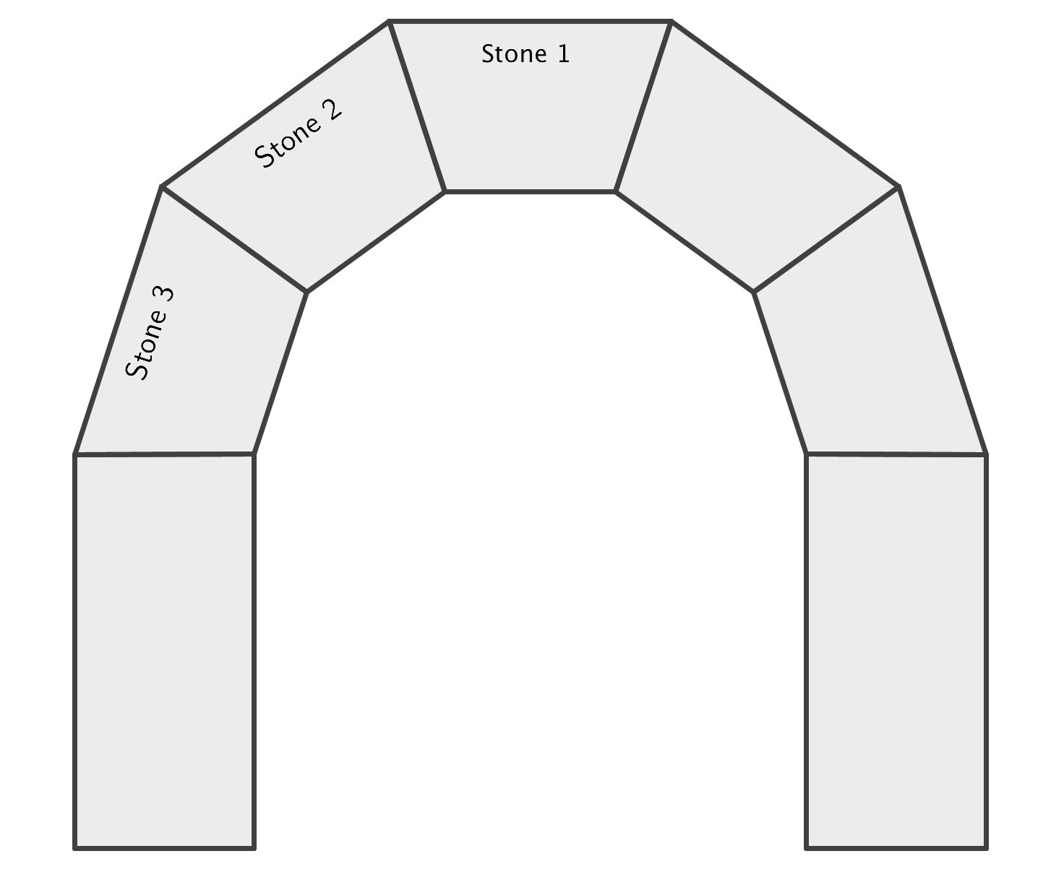
- For this Exploratory Challenge, we will consider an arch made with five trapezoidal stones on top of the base columns as shown. We will focus only on the stones labeled 1, 2 and 3.
  - We will study the force vectors acting on the keystone (stone 1) and stones 2 and 3 on the left side of the arch. Why is it acceptable for us to disregard the forces on the right side of the arch?
Due to symmetry, the forces on the right side of the arch will be the same magnitude as the forces on the left, but with directions reflected across the vertical line through the center of the keystone.

  - We will first focus on the forces acting on the keystone. Stone 2 pushes on the left side of the keystone with force vector $p_{1L}.$ The stone to the right of the keystone pushes on the right of the keystone with force vector $p_{1R}$. We know that these vectors push perpendicular to the sides of the stone, but we do not know their magnitude. All we know is that vectors $p_{1L}$ and $p_{1R}$ have the same magnitude.
    - Find the measure of the acute angle formed by $p_{1L}$ and the horizontal.

We need to consider the angles in the triangles formed by the trapezoidal stones. Since there are five stones that form the arch, each trapezoid creates a triangle with angles that measure $36°$,$72°$, and$72°$. The vector $p_{1L}$ is shown in green. Looking more closely at just the keystone, we see that the $36°$ angle is bisected by the vertical line through the center of the keystone. Thus, the angle $p_{1L}$ makes with the vertical direction is $90°+18°.$ Therefore, vector $p_{1L}$ makes an $18°$ angle with the horizontal axis.

    - Find the measure of the acute angle formed by $p_{1R}$ and the horizontal.
Due to symmetry, the acute angle formed by $p_{1R}$ and the horizontal is congruent to the acute angle formed by $p_{1L}$ and the horizontal. Thus, this angle measures $18°$.

  - Move vectors $p_{1L}$,$p_{1R}$and $g$ tip-to-tail. Why must these vectors form a triangle?
Because the keystone does not move, we know that the forces acting on the stone sum to zero. Thus, the vectors that represent these forces will form a triangle when placed tip-to-tail, as we saw in the previous lesson.

  - Suppose that vector $g$ has magnitude 1. Use triangle trigonometry together with the measure of the angles you found in part (b) to find the magnitudes of vectors $p_{1L}$ and $p_{1R}$ to the nearest tenth of a unit.
    - Find the magnitude and direction form of $g.$
We know that $g$ has magnitude $1$ and direction $–90°$ from the positive horizontal axis.

    - Find the magnitude and direction form of $p_{1L}.$
Using the figure at right, we see that there are two right triangles with angles $18°$ and $72°$. Since $g$ has magnitude $1$, these triangles have a short leg of length $1/2$. We will use $x$ to represent the magnitude of $p_{1L}$. Using triangle trigonometry, we see that
$sin\left(18°\right)=\frac{1/2}{x}$ and then $x=\frac{1}{2 sin\left(18°\right)}≈1.6.$
Thus, vector $p_{1L}$ has magnitude $1.6$ and direction $18°$ from the positive horizontal axis.

    - Find the magnitude and direction form of $p_{1R}.$
Due to symmetry, we know that $\left\|p_{1R}\right\|= \left\|p_{1L}\right\|$ so the magnitude of $p_{1R}$ is also $1.6$. Then the vector $p_{1R}$has magnitude$1.6$and direction$162°$ from the positive horizontal axis.

  - Vector $p_{1L}$ represents the force of stone $1$ pushing on the keystone, and by Newton’s third law of motion, there is an equal and opposite reaction. Thus, there is a force of the keystone acting on stone $2$ that has the same magnitude as $p_{1L}$ and the opposite direction. Call this vector $v_{1L}$.
    - Find the magnitude and direction form of $v_{1L}.$
The vector $v_{1L}$ has magnitude $1.6$ and direction $-162°$ from the positive horizontal axis.

    - Carefully draw vector $v_{1L}$ on the arch below, with initial point at the point marked $O$, which is the center of mass of the keystone. Use a protractor measured in degrees and a ruler measured in centimeters.
See the final drawing in part i.

  - We will assume that the forces $v_{2L}$ of stone 2 acting on stone 3 and $v_{3L}$ of stone 3 acting on the base column have the same magnitude as each other, and twice the magnitude as the force $v_{1L}.$ Why does it make sense that the force vector $v_{1L}$ is significantly shorter than the other two force vectors?
The keystone compresses the stones on both the left and right sides of the arch equally, so the gravitational pull on that stone is split in half down the right and left sides. Thus, it is reasonable to assume that the stones 2 and 3 act with twice the compressive force as stone 1.

  - Find the magnitude and direction form of vector $v_{2L}$, the force of stone 2 pressing on stone 3. Carefully draw vector $v_{2L}$ on the arch on page 152, placing its initial point at the terminal point of $v_{1L}.$
Scaffolding:
- Challenge advanced students or rapid finishers to calculate the maximum height of the base columns before the arch will collapse.
- Also, challenge these students to consider the effect of adding buttresses to the arch; with buttresses, what is the maximum height of the base columns before the arch will collapse?

Vector $v_{2L}$ has twice the magnitude of vector $v_{1L}$, so its magnitude is $3.2.$ Because each stone is rotated $36°$ from the neighboring stones, vector $v_{2L}$is rotated $–162°+36°= -126°$ from the horizontal. Thus, vector $v_{2L}$ has magnitude $3.2$ and direction $-126°$ from the positive horizontal axis.

  - Find the magnitude and direction form of vector $v_{3L}$, the force of stone $3$pressing on the base column. Carefully draw vector $v_{3L}$ on the arch on page 152, placing its initial point at the terminal point of $v_{2L}.$
Vector $v_{3L}$ has the same magnitude as vector $v_{2L}$ and it is rotated an additional $36°$ counterclockwise. Thus, vector $v_{3L}$ has magnitude $3.2$ and direction $–126°+36°=-90°$ from the positive horizontal axis. Thus, vector $v_{3L}$points straight downward.

  - Use the parallelogram method to find the sum of the force vectors $v_{1L}, v_{2L},$ and $v_{3L}$ on the left side of the arch.
(The diagram of the force vectors is shown below.)
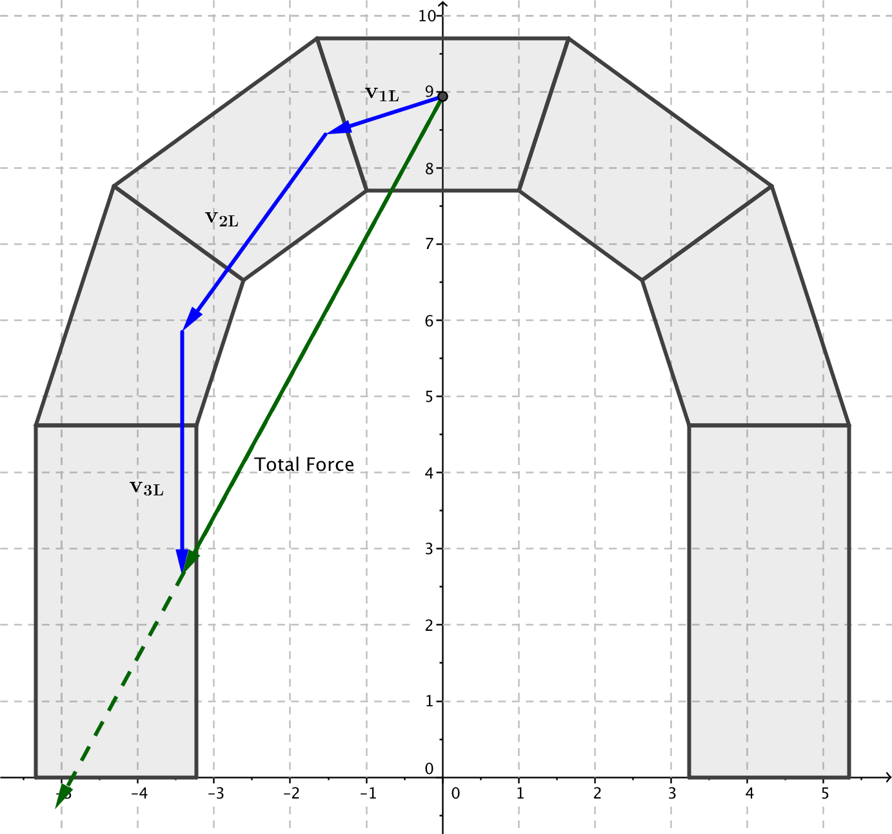

  - Will the arch stand or fall? Explain how you know.
The forces are all contained within the arch, so the arch will stand.

Plot the force vectors acting on the arch on this diagram to determine whether or not this arch will be able to stand or if it will collapse.
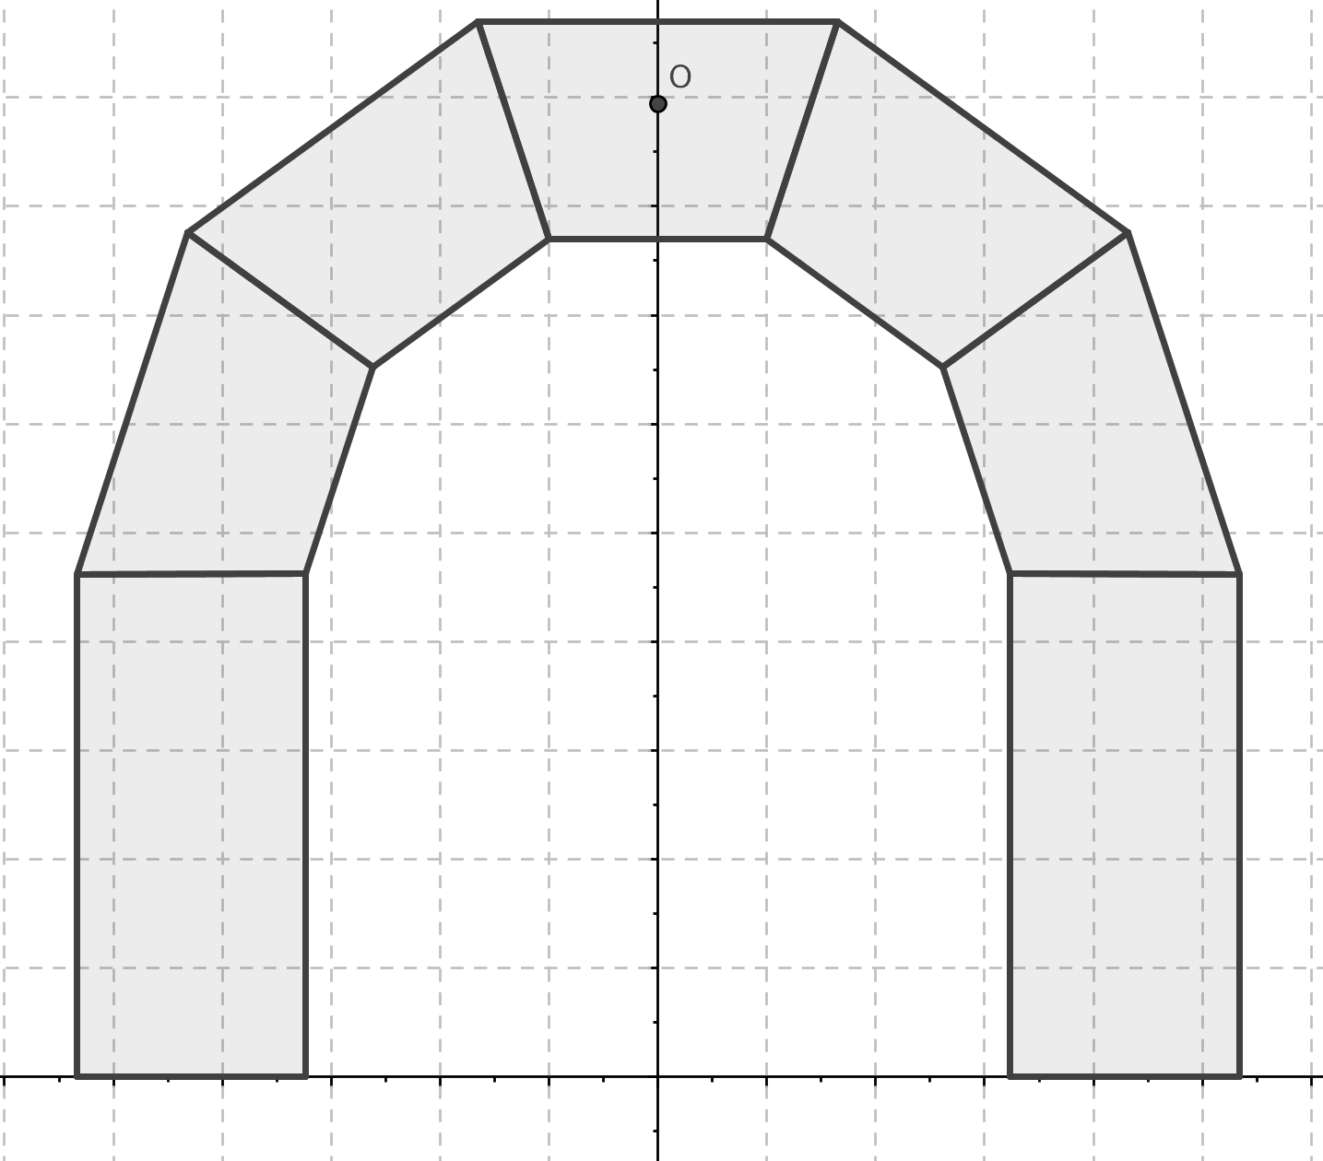

Closing (3 minutes)
Ask students to turn to a partner and explain how they found the following forces in the arch. Partner 1 can explain (a), and partner 2 can explain (b).
  - The magnitude of the force of stone 2 pushing on stone 1, which we called $p_{1L}.$
  - The total force acting on the left side of the arch.
Lesson Summary
A vector can be described using its magnitude and direction.
The direction of a vector $v$can be described either using geographical description, such as $32°$ north of west, or by the amount of rotation the positive $x$-axis must undergo to align with the vector $v$, such as rotation by $148°$ from the positive $x$-axis.

Exit Ticket (4 minutes)
Name Date
Lesson 20: Vectors and Stone Bridges

Exit Ticket

We saw in the lesson that the forces acting on a stone in a stable arch must sum to zero since the stones do not move. Now, we will consider the upper-left stone in a stable arch made of six stones. We will denote this stone
by $S.$ In the image below, $p_{L}$ represents the force acting on stone $S$from the stone on the left. Vector $p_{R}$ represents the force acting on stone $S$ from the stone on the right. Vector $g$ represents the downward force of gravity.

  - Describe the directions of vectors $g$,$p_{L}$, and $p_{R}$ in terms of rotation from the positive $x$-axis by $θ$ degrees, for $-180<θ<180$.

  - Suppose that vector $g$ has a magnitude of $1$. Find the magnitude of vectors $p_{L}$ and $p_{R}$.

  - Write vectors $g$,$p_{L}$, and $p_{R}$ in magnitude and direction form.
Exit Ticket Sample Solutions

We saw in the lesson that the forces acting on a stone in a stable arch must sum to zero since the stones do not move. We will consider the upper left stone in a stable arch made of six stones. We will denote this stone by $S.$ In the image below, $p_{L}$ represents the force acting on stone $S$from the stone on the left. Vector $p_{R}$ represents the force acting on stone $S$ from the stone on the right. Vector $g$ represents the downward force of gravity.
  - Describe the directions of vectors $g, p_{L}$, and $p_{R}$ in terms of rotation from the positive $x$-axis by $θ$ degrees, for $-180<θ≤180$.

Vector $g$ is vertical, pointing downward, so $g$ aligns with the terminal ray of rotation by $–90°$.
Vector $p_{R}$ is perpendicular to the vertical edge of the stone at point $N$, so it is horizontal and pointing to the left. Thus, $p_{R}$ aligns with the terminal ray of rotation by $180°$.
Vector $p_{L}$is perpendicular to line $\overset{⃡}{MO}$ shown at left. Thus, vector $p_{L}$ is rotated $120°$ from vertical. Hence, $p_{L}$ aligns with the terminal ray of rotation by $30°$ from horizontal.

  - Suppose that vector $g$ has a magnitude of $1$. Find the magnitude of vectors $p_{L}$ and $p_{R}$.
We need to move the vectors tip-to-tail, and since the forces sum to zero, the vectors should make a triangle. Since $g$ is vertical and $p_{R}$ is horizontal, the vectors will make a right triangle.
By part (a), the angle made by vectors $p_{R}$ and $p_{L}$ measures $30°$. We are given that $\left\|g\right\|=1$. Then we know that $sin\left(30°\right)=\frac{1}{\left\|p_{L}\right\|}$, so$\frac{1}{2}=\frac{1}{\left\|p_{L}\right\|}$ and then $\left\|p_{L}\right\|=2.$
Then $cos\left(30°\right)=\frac{\left\|p_{R}\right\|}{\left\|p_{L}\right\|}$, so $\frac{\sqrt{3}}{2}=\frac{\left\|p_{R}\right\|}{2}$ and $\left\|p_{R}\right\|=\sqrt{3}.$

  - Write vectors $g$,$p_{L}$, and $p_{R}$ in magnitude and direction form.
Vector $g$ has magnitude$1$ and direction $-90°$ from the positive horizontal axis
Vector $p_{L}$ has magnitude $2$ and direction $30°$ from the positive horizontal axis.
Vector $p_{R}$ has magnitude $\sqrt{3}$ and direction $180°$from the positive horizontal axis.
Problem Set Sample Solutions

- Vectors $v$ and $w$ are given in magnitude and direction form. Find the coordinate representation of the sum $v+w$ and the difference $v-w$. Give coordinates to the nearest tenth of a unit.
  - $v:$ magnitude $12$, direction $50°$ east of north
$w:$ magnitude $8$, direction $30°$ north of east
$$v=〈12\cos\left(40°\right)\text{,} 12\sin\left(40°\right)〉\text{;} w=〈8\text{cos}\left(30°\right)\text{,} 8\sin\left(30°\right)〉$$
$$v+w≈〈16.1, 11.7〉$$
$$v-w≈ 〈2.3, 3.7〉$$

  - $v:$ magnitude $20$, direction $54°$ south of east
$w:$ magnitude $30$, direction $18°$ west of south
$$v=〈20\cos\left(-54°\right)\text{,} 20\sin\left(-54°\right)〉\text{;} w=〈30\cos\left(-108°\right)\text{,} 30\sin\left(-108°\right)〉$$
$$\text{v}+\text{w}≈〈2.5, -44.7〉$$
$$\text{v}-\text{w}≈ 〈21.0, 14.6〉$$

- Vectors $v$ and $w$ are given by specifying the length $r$ and the amount of rotation from the positive $x$-axis. Find the coordinate representation of the sum $v+w$ and the difference $v-w$. Give coordinates to the nearest tenth of a unit.
  - $v:$ length $r=3$, rotated $12°$ from the positive $x$-axis
$w:$ length $r=4$, rotated $18°$ from the positive $x$-axis
$$v=〈3\cos\left(12°\right)\text{,} 3\sin\left(12°\right)〉\text{; }w=〈4\cos\left(18°\right)\text{,} 4\sin\left(18°\right)〉$$
$$\text{v}+\text{w}≈〈6.7, 1.9〉 \\ v-w≈ 〈-0.9, -0.6〉$$

  - $v:$ length $r=16$, rotated $162°$ from the positive $x$-axis
$w:$ length $r=44$, rotated $-18°$ from the positive $x$-axis
$$v=〈16\cos\left(162°\right)\text{,} 16\sin\left(116°\right)〉\text{;} w=〈44\cos\left(-18°\right)\text{,} 44\sin\left(-18°\right)〉$$
$$\text{v}+\text{w}≈〈26.6, 0.78〉 \\ v-w≈ 〈-57.1, 27.9〉$$

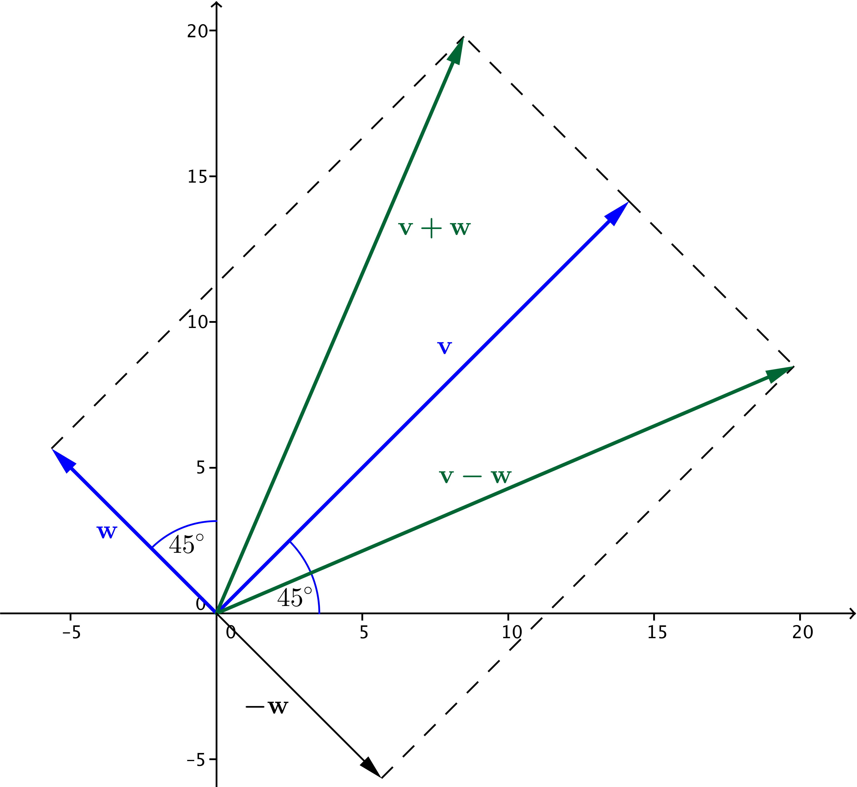
- Vectors $v$ and $w$ are given in magnitude and direction form. Find the magnitude and direction of the sum $v+w$ and the difference $v-w$. Give the magnitude to the nearest tenth of a unit and the direction to the nearest tenth of a degree.
  - $v:$magnitude $20$, direction $45°$ north of east
$w:$ magnitude $8$, direction $45°$ west of north
The tip of the vector $v$ has coordinates $\left(10\sqrt{2}, 10\sqrt{2}\right)$ and tip of vector $w$ has coordinates $\left(-4\sqrt{2}, 4\sqrt{2}\right).$ Then the sum has tip
$v+w=\left(6\sqrt{2}, 14\sqrt{2}\right).$ The rotation of $v+w$ is $θ=arctan\left(\frac{14\sqrt{2}}{6\sqrt{2}}\right)=arctan\left(\frac{7}{3}\right)$, so $θ≈66.8°$. The length of $v+w$ is $\left|v+w\right|=\sqrt{{\left(6\sqrt{2}\right)}^{2}+{\left(14\sqrt{2}\right)}^{2}}=\sqrt{464}≈21.5.$ Thus, $v+w$ has magnitude approximately $21.5$
and direction $66.8°$ north of east.
The difference has tip $v-w=\left(14\sqrt{2}, 6\sqrt{2}\right)$. The rotation of $v-w$ is $θ=arctan \left(\frac{6\sqrt{2}}{14\sqrt{2}}\right)=\arctan\left(\frac{3}{7}\right)$, so $θ≈23.2°.$ The length of
$v-w$ is $\left|v-w\right|=\sqrt{{\left(14\sqrt{2}\right)}^{2}+{\left(6\sqrt{2}\right)}^{2}}=\sqrt{464}≈21.5.$ Thus,
$v-w$ has magnitude approximately $21.5$ and direction $23.2°$ north of east.
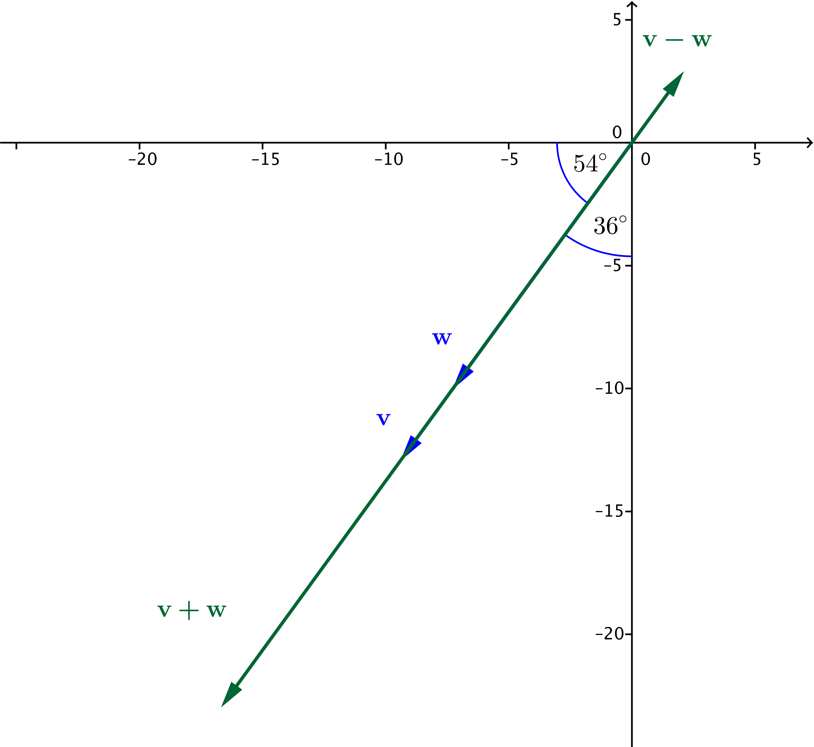
  - $v:$ magnitude $12.4$, direction $54°$ south of west
$w:$ magnitude $16.0$, direction $36°$ west of south
Since $54°$ south of west and $36°$ west of south are the same direction, vectors $\text{v}$ and $\text{w}$ are collinear. Thus, the vector $\text{v}+\text{w}$ has length $12.4+16=28.4$ and direction $54°$south of west.
The vector $\text{v}-\text{w}$ has length $\left|12.4-16\right|= 3.6$ and direction $54°$ north of east.

- Vectors $v$ and $w$ are given by specifying the length $r$ and the amount of rotation from the positive $x$-axis. Find the length and direction of the sum $v+w$ and the difference $v-w$. Give the magnitude to the nearest tenth of a unit and the direction to the nearest tenth of a degree.
  - $v:$ magnitude $r=1$, rotated $102°$ from the positive $x$-axis
$w:$ magnitude $r=\frac{1}{2}$, rotated $18°$ from the positive $x$-axis
$$v=〈\cos\left(102°\right)\text{,} \sin\left(102°\right)〉\text{; }w=〈\frac{1}{2}\cos\left(18°\right)\text{,}\frac{1}{2}\sin\left(18°\right)〉$$
$$v+w≈〈0.3, 1.1〉$$
$$\left\|v+w\right\|≈\sqrt{0.3^{2}+1.1^{2}}≈1.2$$
$$\arctan\left(\frac{1.1}{0.3}\right)≈74.7°$$
The sum $v+w$ has magnitude approximately $1.2$ and direction $74.7°$ from the positive $x$-axis.
$$\text{v}-\text{w}≈ 〈-0.7, 0.8〉$$
$$\left\|\text{v}-\text{w}\right\|≈\sqrt{0.7^{2}+0.8^{2}}≈1.1$$
$$\arctan\left(-\frac{0.8}{0.7}\right)≈-48.8°$$
Since $v-w$ lies in the second quadrant, it aligns with the terminal ray of rotation by
$180°-48.8°=131.2°.$ The vector $\text{v}-\text{w}$ has magnitude approximately $1.1$and direction $131.2°$ from the positive $x$-axis.

  - $v:$ magnitude $r=1000$, rotated $-126°$ from the positive $x$-axis
$w:$ magnitude $r=500$, rotated $-18°$ from the positive $x$-axis
$$v=〈1000\cos\left(-126°\right)\text{,} 1000\sin\left(-126°\right)〉\text{; }w=〈500\cos\left(-18\right)°\text{, }500\sin\left(-18°\right)〉$$
$$v+w≈〈-112.3, -963.5〉$$
$$\left\|v+w\right\|≈\sqrt{112.3^{2}+963.5^{2}}≈970.0$$
$$\arctan\left(\frac{-963.5}{-112.3}\right)≈83.4°$$
Since $v+w$ lies in the third quadrant, it aligns with the terminal ray of rotation by
$-\left(180°-83.4°\right)=-96.6°.$The sum $v+w$ has magnitude approximately $970$ and direction $-96.6°$
from the positive $x$-axis.
$$v-w≈ 〈-1063.3, -654.5〉$$
$$\left\|v-w\right\|≈\sqrt{1063.3^{2}+654.5^{2}}≈1248.6$$
$$\arctan\left(\frac{-654.5}{-1063.3}\right)≈31.6°$$
Since $v-w$ lies in the third quadrant, it aligns with the terminal ray of rotation by $-\left(180°-31.6°\right)=-148.4°.$The difference $v-w$ has magnitude approximately $1248.6$ and direction$-148.4°$ from the positive $x$-axis.

- You hear a rattlesnake while out on a hike. You abruptly stop hiking at point $S$ and take eight steps. Then you take another six steps. For each distance below, draw a sketch to show how the sum of your two displacements might add so that you find yourself that distance from point $S$. Assume that your steps are a uniform size.
  - $14$ steps

  - $10$ steps

  - $2$ steps
- A delivery driver travels$2.6 km$ due north, then $5.0 km$ due west, and then $4.2 km 45°$ north of west. How far is he from his starting location? Include a sketch with your answer.
He is about $9.72 km$ from his starting location.

- Morgan wants to swim directly across a river, from the east to the west side. She swims at a rate of $1 m/s$. The current in the river is flowing due north at a rate of $3 m/s$. Which direction should she swim so that she travels due west across the river?
There is no way for Morgan to swim due west if she can only swim at a rate of $1 m/s$. She would need to cancel out the north vector by swimming south at an equal rate ($3 m/s$). If she swims due south, she will still be swept downstream at a rate of$2 m/s$.

- A motorboat traveling at a speed of $4.0 m/s$ pointed east encounters a current flowing at a speed $3.0 m/s$ north.
  - What is the speed and direction that the motorboat travels?
The motorboat is traveling $5 m/s$ at a direction $36.87°$ N of E.

  - What distance downstream does the boat reach the opposite shore?
Since the vectors are perpendicular, the north flowing current does not affect the easterly direction and vice versa. It takes $\frac{20}{4}=5$ seconds to reach the other side, and in that time the boat will have moved
$3⋅5=15 m$downstream.

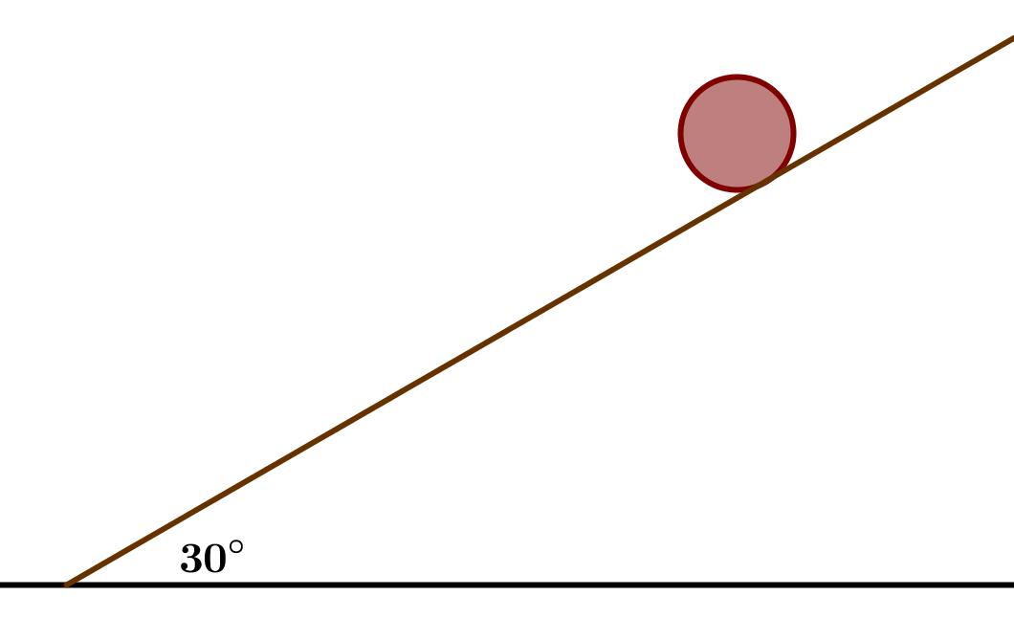
- A ball with mass $0.5 kg$ experiences a force $F$due to gravity of $4.9$Newtons directed vertically downward. If this ball is rolling down a ramp that is $30°$ inclined from the horizontal, what is the magnitude of the force that is directed parallel to the ramp? Assume that the ball is small enough so that all forces are acting at the point of contact of the ball and the ramp.
The diagram at right shows the forces that arise in this situation. We know that the magnitude of $F$ is $4.9$ N, and we need to find the magnitude of vector $v.$ The three force vectors form a $30°-60°-90°$ triangle, so we know that
$$sin\left(30°\right)=\frac{\left\|F\right\|}{\left\|v\right\|}.$$
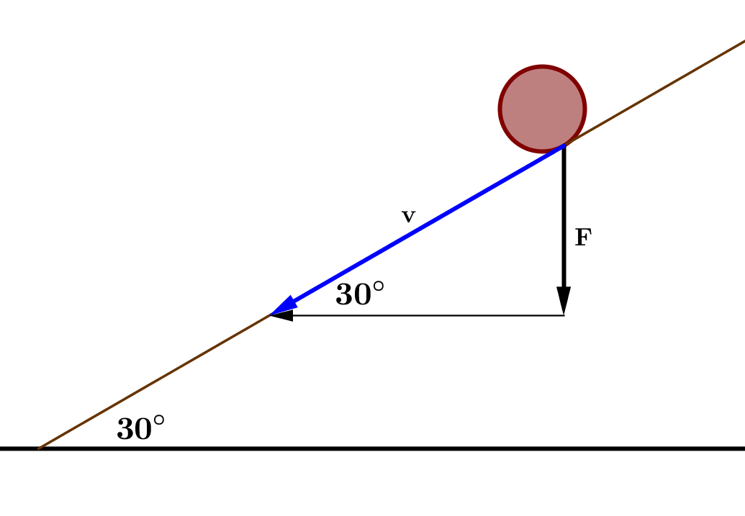
Thus,
$$v=\frac{\left\|F\right\|}{sin\left(30°\right)} \\ =2\left(4.9 N\right) \\ =9.8 N.$$
Therefore, the force along the ramp has magnitude $9.8$Newtons.

- The stars in the Big Dipper may all appear to be the same distance from Earth, but they are, in fact, very far from each other. Distances between stars are measured in light years, the distance that light travels in one year. The star Alkaid at one end of the Big Dipper is $138$ light years from Earth, and the star Dubhe at the other end of the Big Dipper is $105$ light years from earth. From the Earth, it appears that Alkaid and Dubhe are $25.7°$ apart. Find the distance in light years between stars Alkaid and Dubhe.
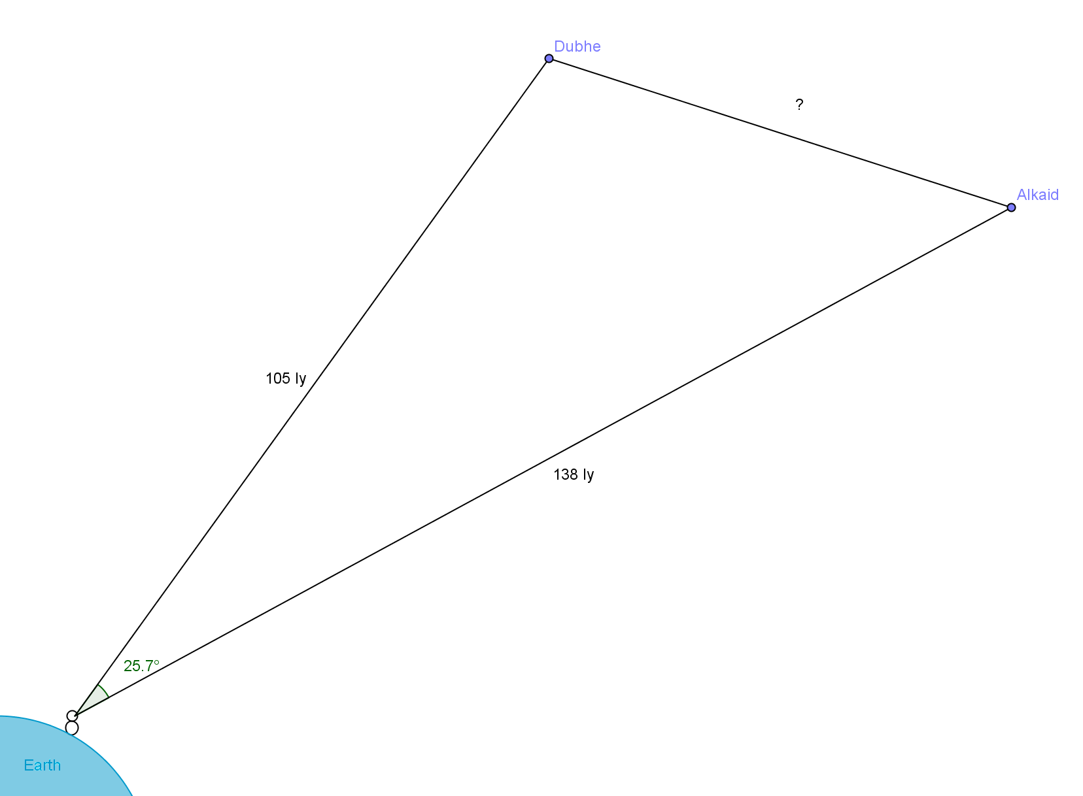
The angle of elevation does not matter and the only thing that does is the angle between them. The distance between the two stars will be the same no matter what angle we observe them, so we can treat the Alkaid star as being at a direction of $0°$ and the Dubhe star as being at a direction of $25.7°$. Then we find the difference between the two vectors, and we find that the distance between them is about $62.9$ light years.

- A radio station has selected three listeners to compete for a prize buried in a large, flat field. Starting in the center, the contestants were given a meter stick, a compass, a calculator, and a shovel. Each contestant was given the following three vectors, in a different order for each contestant.
$64.2 m$, $36°$ east of north
$42.5 m$, $20°$ south of west
$18.2 m$ due south.
The three displacements led to the point where the prize was buried. The contestant that found the prize first won. Instead of measuring immediately, the winner began by doing calculations on paper. What did she calculate?
The winner calculated the sum of the three vectors. The prize is $-2.2 m$ to the west and $19.2 m$ to the north. This is only about$19.3 m$ away from the starting position, while someone following the directions blindly would travel a total of $124.9 m$.

