Lesson 20: Vectors and Stone Arches

Classwork
Exploratory Challenge
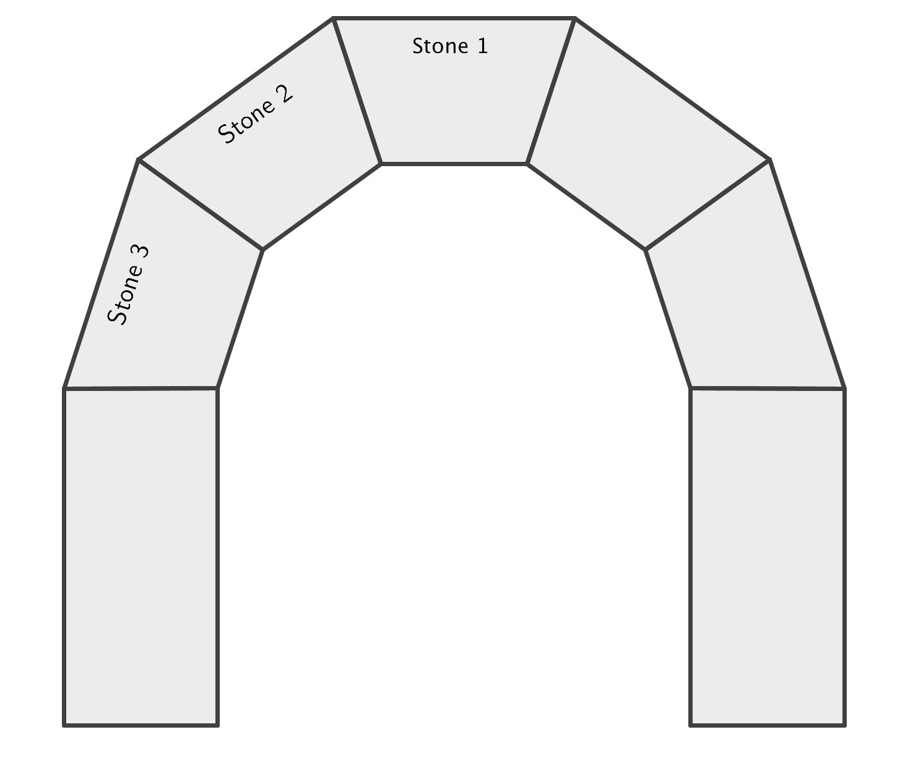
- For this Exploratory Challenge, we will consider an arch made with five trapezoidal stones on top of the base columns as shown. We will focus only on the stones labeled 1, 2 and 3.

  - We will study the force vectors acting on the keystone (stone 1) and stones 2 and 3 on the left side of the arch. Why is it acceptable for us to disregard the forces on the right side of the arch?

  - We will first focus on the forces acting on the keystone. Stone 2 pushes on the left side of the keystone with force vector $p_{1L}.$ The stone to the right of the keystone pushes on the right of the keystone with force vector $p_{1R}$. We know that these vectors push perpendicular to the sides of the stone, but we do not know their magnitude. All we know is that vectors $p_{1L}$ and $p_{1R}$ have the same magnitude.
    - Find the measure of the acute angle formed by $p_{1L}$ and the horizontal.

    - Find the measure of the acute angle formed by $p_{1R}$ and the horizontal.

  - Move vectors $p_{1L}$,$p_{1R}$and $g$ tip-to-tail. Why must these vectors form a triangle?

  - Suppose that vector $g$ has magnitude 1. Use triangle trigonometry together with the measure of the angles you found in part (b) to find the magnitudes of vectors $p_{1L}$ and $p_{1R}$ to the nearest tenth of a unit.
    - Find the magnitude and direction form of $g.$

    - Find the magnitude and direction form of $p_{1L}.$

    - Find the magnitude and direction form of $p_{1R}.$

  - Vector $p_{1L}$ represents the force of stone $1$ pushing on the keystone, and by Newton’s third law of motion, there is an equal and opposite reaction. Thus, there is a force of the keystone acting on stone $2$ that has the same magnitude as $p_{1L}$ and the opposite direction. Call this vector $v_{1L}$.
    - Find the magnitude and direction form of $v_{1L}.$

    - Carefully draw vector $v_{1L}$ on the arch below, with initial point at the point marked $O$, which is the center of mass of the keystone. Use a protractor measured in degrees and a ruler measured in centimeters.

  - We will assume that the forces $v_{2L}$ of stone $2$ acting on stone $3$ and $v_{3L}$ of stone $3$ acting on the base column have the same magnitude as each other, and twice the magnitude as the force $v_{1L}.$ Why does it make sense that the force vector $v_{1L}$ is significantly shorter than the other two force vectors?

  - Find the magnitude and direction form of vector $v_{2L}$, the force of stone $2$ pressing on stone $3$. Carefully draw vector $v_{2L}$ on the arch on page 152, placing its initial point at the terminal point of $v_{1L}.$

  - Find the magnitude and direction form of vector $v_{3L}$, the force of stone $3$pressing on the base column. Carefully draw vector $v_{3L}$ on the arch on page 152, placing its initial point at the terminal point of $v_{2L}.$

  - Use the parallelogram method to find the sum of the force vectors $v_{1L}, v_{2L},$ and $v_{3L}$ on the left side of the arch.

  - Will the arch stand or fall? Explain how you know.

Plot the force vectors acting on the arch on this diagram to determine whether or not this arch will be able to stand or if it will collapse.
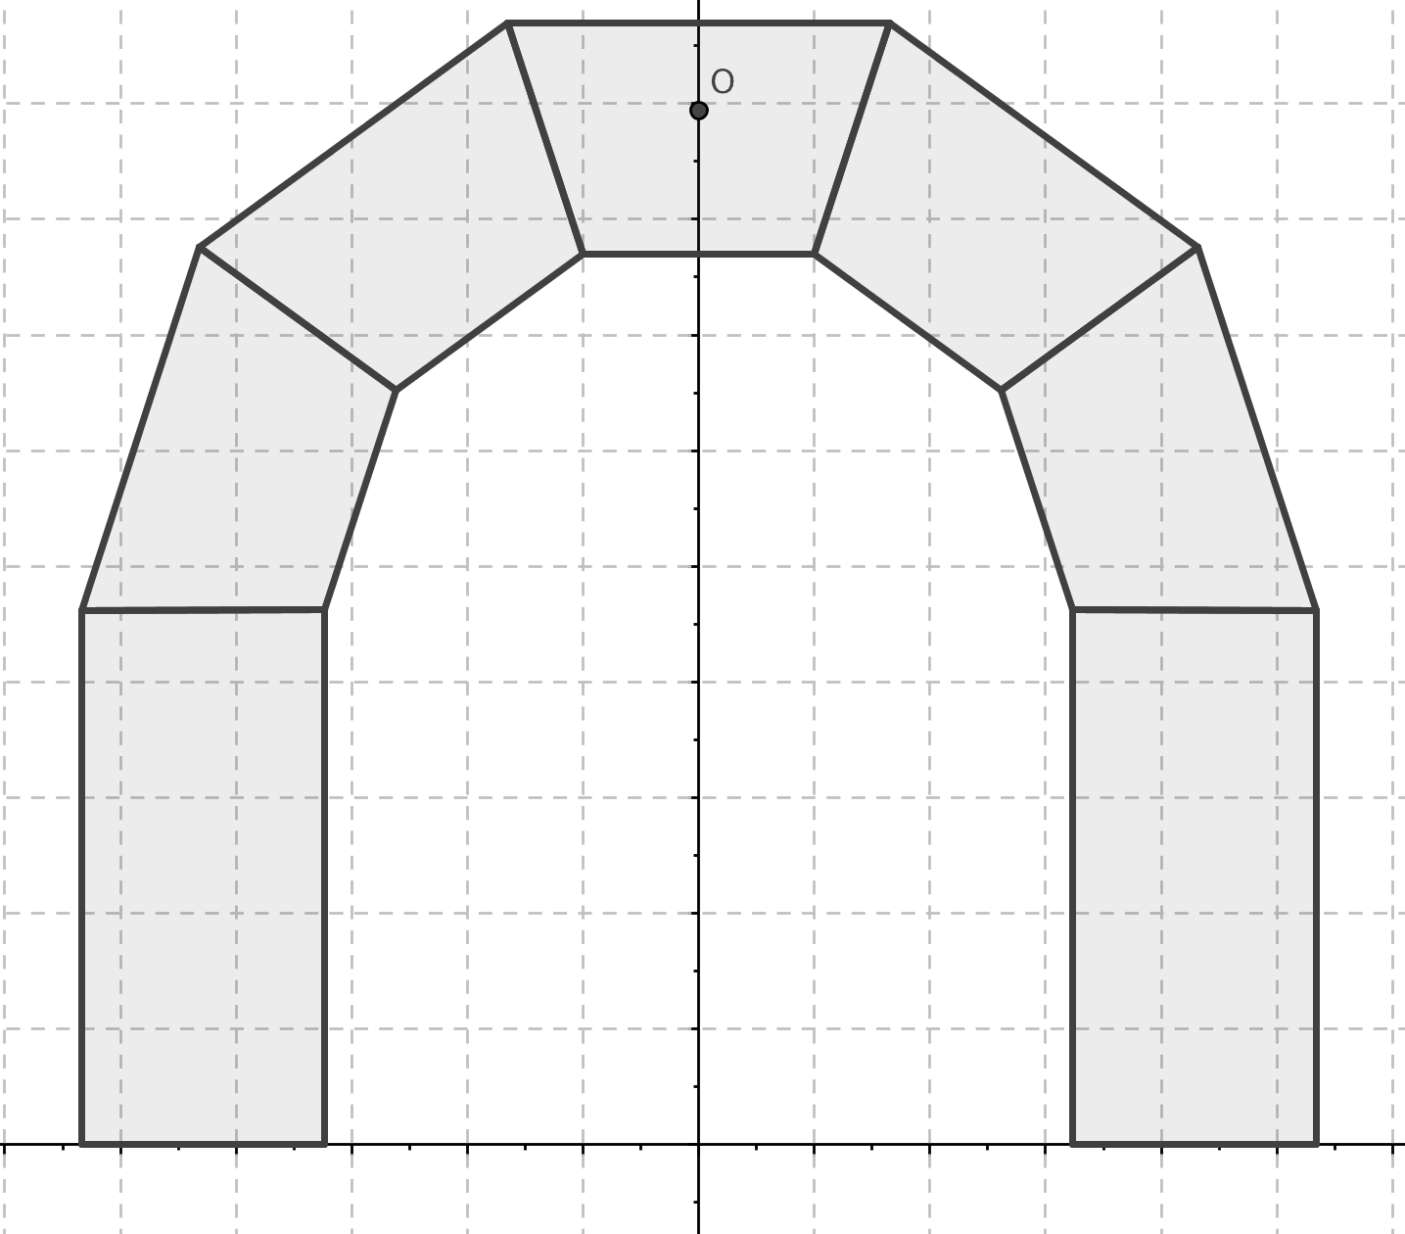

Lesson Summary
A vector can be described using its magnitude and direction.
The direction of a vector $v$can be described either using geographical description, such as $32°$ north of west, or by the amount of rotation the positive $x$-axis must undergo to align with the vector $v$, such as rotation by $148°$ from the positive $x$-axis.

Problem Set

- Vectors $v$ and $w$ are given in magnitude and direction form. Find the coordinate representation of the sum $v+w$ and the difference $v-w$. Give coordinates to the nearest tenth of a unit.
  - $v:$ magnitude $12$, direction $50°$ east of north
$w:$ magnitude $8$, direction $30°$ north of east
  - $v:$ magnitude $20$, direction $54°$ south of east
$w:$ magnitude $30$, direction $18°$ west of south

- Vectors $v$ and $w$ are given by specifying the length $r$ and the amount of rotation from the positive $x$-axis. Find the coordinate representation of the sum $v+w$ and the difference $v-w$. Give coordinates to the nearest tenth of a unit.
  - $v:$ length $r=3$, rotated $12°$ from the positive $x$-axis
$w:$ length $r=4$, rotated $18°$ from the positive $x$-axis
  - $v:$ length $r=16$, rotated $162°$ from the positive $x$-axis
$w:$ length $r=44$, rotated $-18°$ from the positive $x$-axis

- Vectors $v$ and $w$ are given in magnitude and direction form. Find the magnitude and direction of the sum $v+w$ and the difference $v-w$. Give the magnitude to the nearest tenth of a unit and the direction to the nearest tenth of a degree.
  - $v:$magnitude $20$, direction $45°$ north of east
$w:$ magnitude $8$, direction $45°$ west of north
  - $v:$ magnitude $12.4$, direction $54°$ south of west
$w:$ magnitude $16.0$, direction $36°$ west of south

- Vectors $v$ and $w$ are given by specifying the length $r$ and the amount of rotation from the positive $x$-axis. Find the length and direction of the sum $v+w$ and the difference $v-w$. Give the magnitude to the nearest tenth of a unit and the direction to the nearest tenth of a degree.
  - $v:$ magnitude $r=1$, rotated $102°$ from the positive $x$-axis
$w:$ magnitude $r=\frac{1}{2}$, rotated $18°$ from the positive $x$-axis

  - $v:$ magnitude $r=1000$, rotated $-126°$ from the positive $x$-axis
$w:$ magnitude $r=500$, rotated $-18°$ from the positive $x$-axis

- You hear a rattlesnake while out on a hike. You abruptly stop hiking at point $S$ and take eight steps. Then you take another six steps. For each distance below, draw a sketch to show how the sum of your two displacements might add so that you find yourself that distance from point $S$. Assume that your steps are a uniform size.
  - $14$ steps
  - $10$ steps
  - $2$ steps

- A delivery driver travels $2.6 km$due north, then $5.0 km$ due west, and then $4.2 km 45°$ north of west. How far is he from his starting location? Include a sketch with your answer.

- Morgan wants to swim directly across a river, from the east to the west side. She swims at a rate of $1 m/s$. The current in the river is flowing due north at a rate of $3 m/s$. Which direction should she swim so that she travels due west across the river?

- A motorboat traveling at a speed of $4.0 m/s$ pointed east encounters a current flowing at a speed $3.0 m/s$ north.
  - What is the speed and direction that the motorboat travels?
  - What distance downstream does the boat reach the opposite shore?

- A ball with mass$0.5 kg$ experiences a force $F$due to gravity of $4.9$Newtons directed vertically downward. If this ball is rolling down a ramp that is $30°$ inclined from the horizontal, what is the magnitude of the force that is directed parallel to the ramp? Assume that the ball is small enough so that all forces are acting at the point of contact of the ball and the ramp.
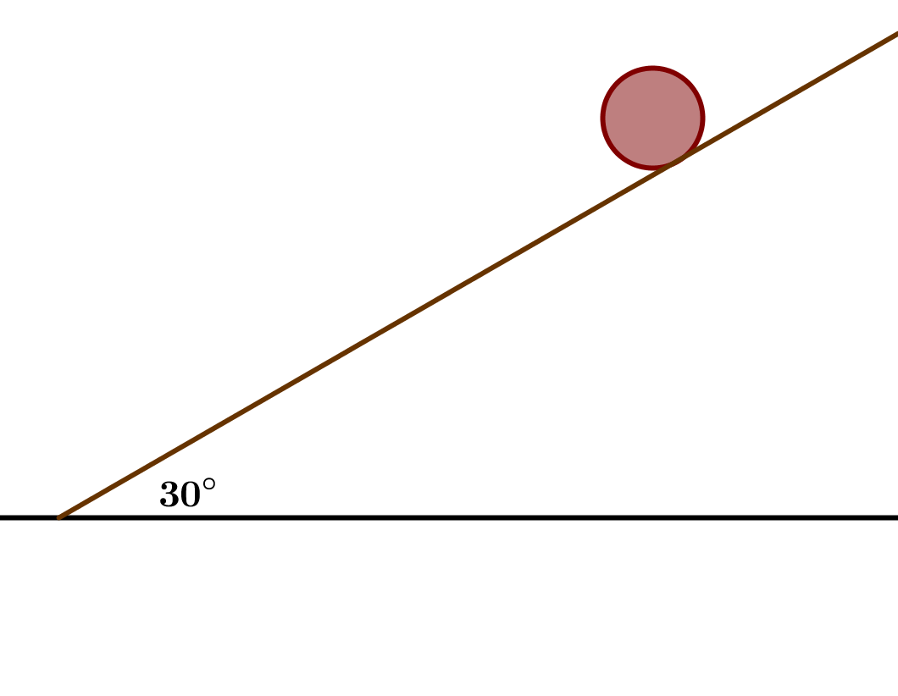

- The stars in the Big Dipper may all appear to be the same distance from Earth, but they are, in fact, very far from each other. Distances between stars are measured in light years, the distance that light travels in one year. The star Alkaid at one end of the Big Dipper is $138$ light years from Earth, and the star Dubhe at the other end of the Big Dipper is $105$ light years from earth. From the Earth, it appears that Alkaid and Dubhe are $25.7°$ apart. Find the distance in light years between stars Alkaid and Dubhe.

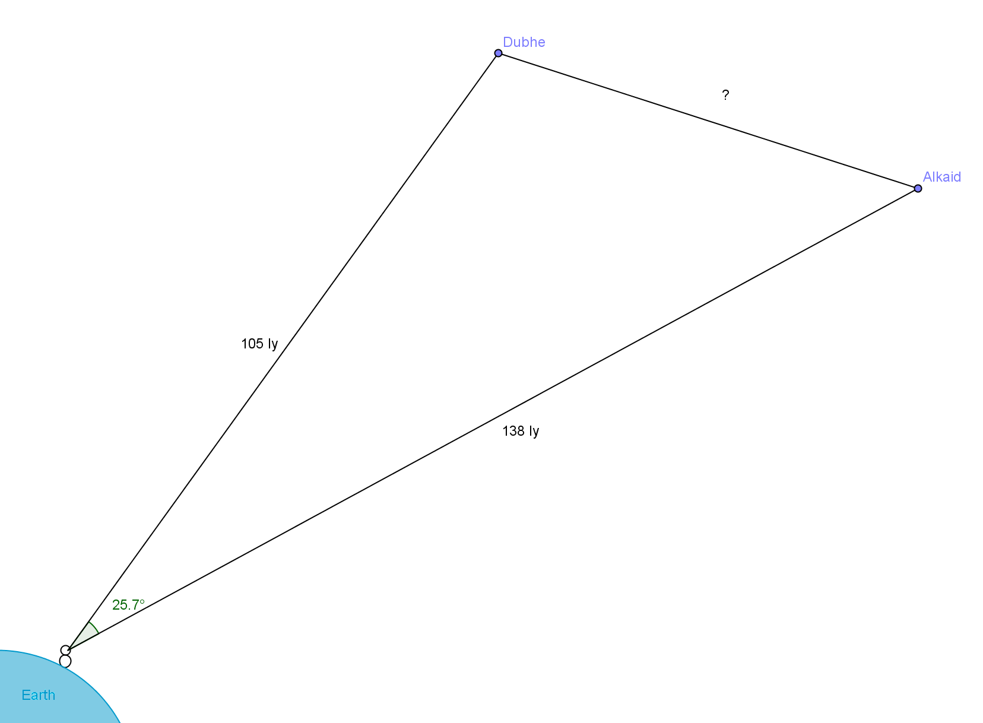

- A radio station has selected three listeners to compete for a prize buried in a large, flat field. Starting in the center, the contestants were given a meter stick, a compass, a calculator, and a shovel. Each contestant was given the following three vectors, in a different order for each contestant.
$64.2 m$, $36°$ east of north
$42.5 m$, $20°$ south of west
$18.2 m$ due south.
The three displacements led to the point where the prize was buried. The contestant that found the prize first won. Instead of measuring immediately, the winner began by doing calculations on paper. What did she calculate?

